**Heapsters_BefTuning_Postgres**

Query1: 151 msec



Query2: 210 msec



Query3: 99 msec

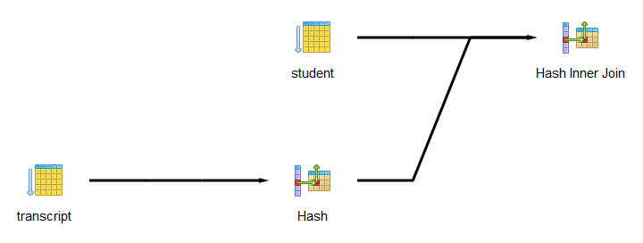

Query4: 190 msec

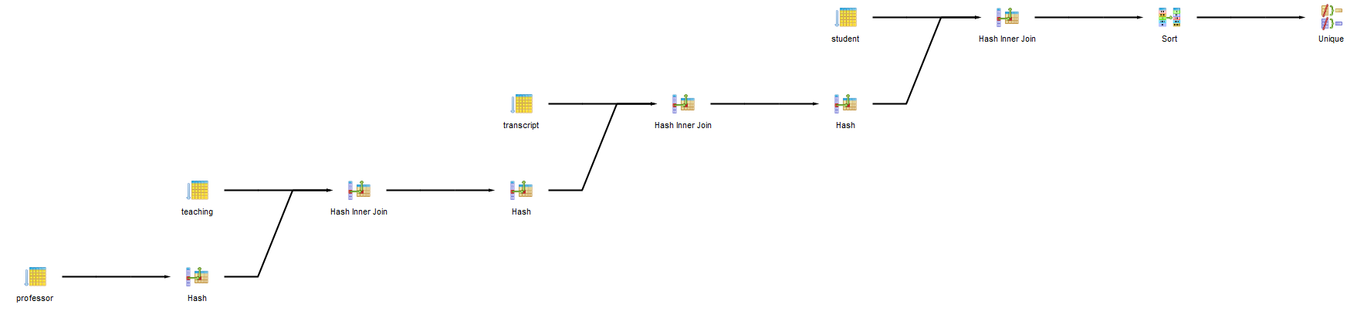

Query5: 125 msec

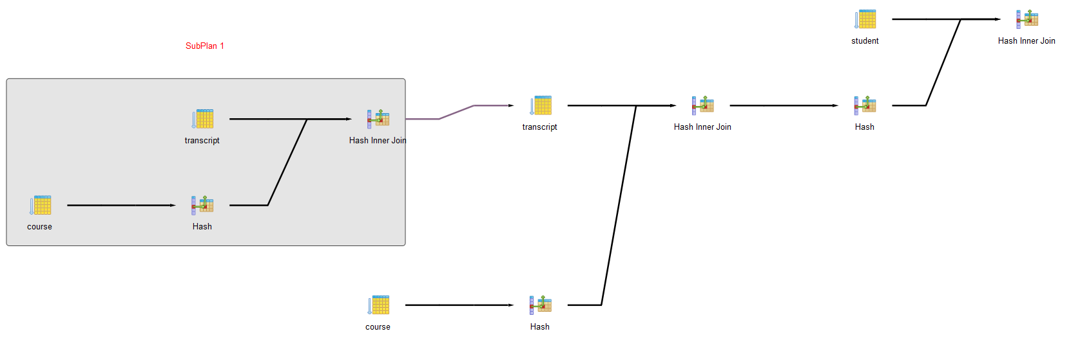

Query6: 141 msec

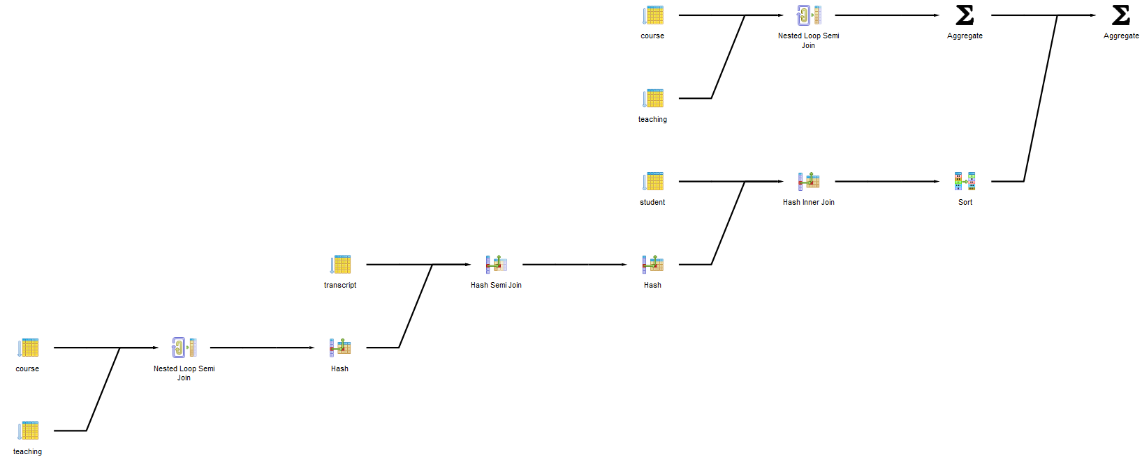

**Heapsters_AftTuning_Postgres:**

Query1: 81 msec

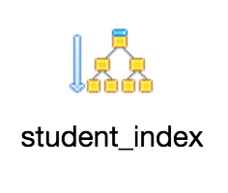

Query2: 164 msec

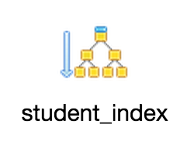

Query3: 73 msec

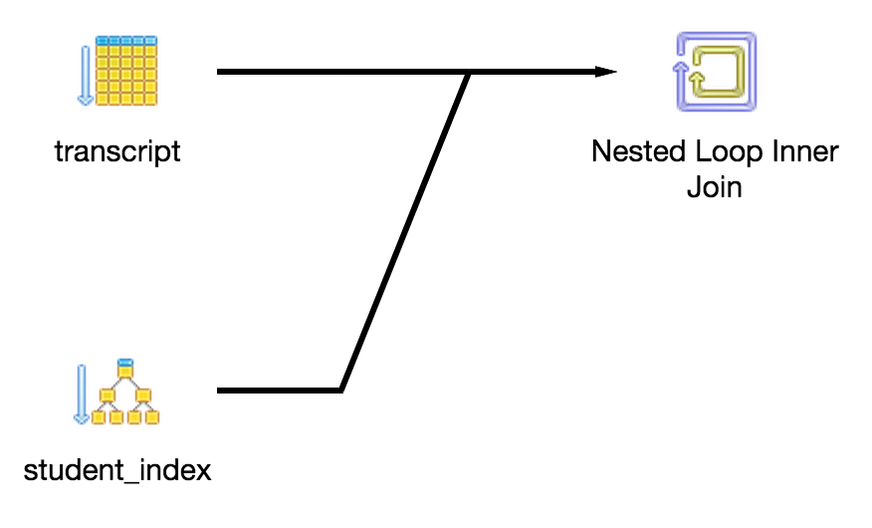

Query4: 70 msec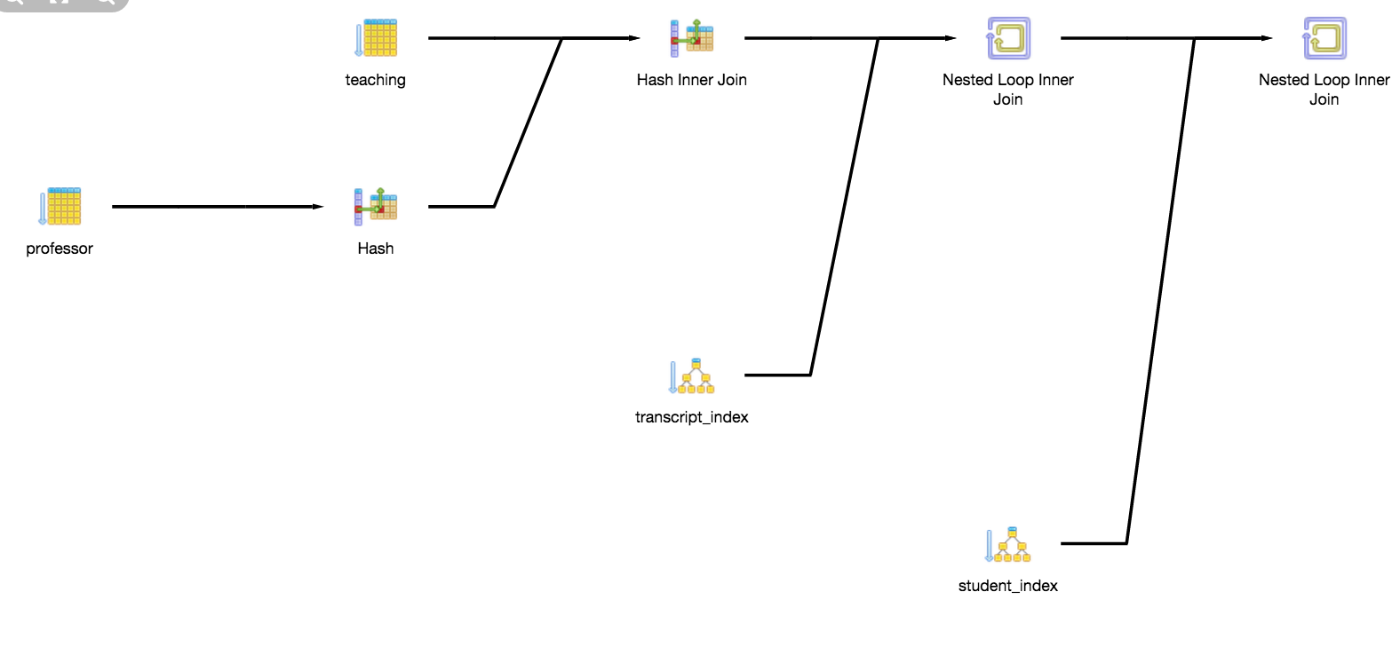

Query5: 74 msec

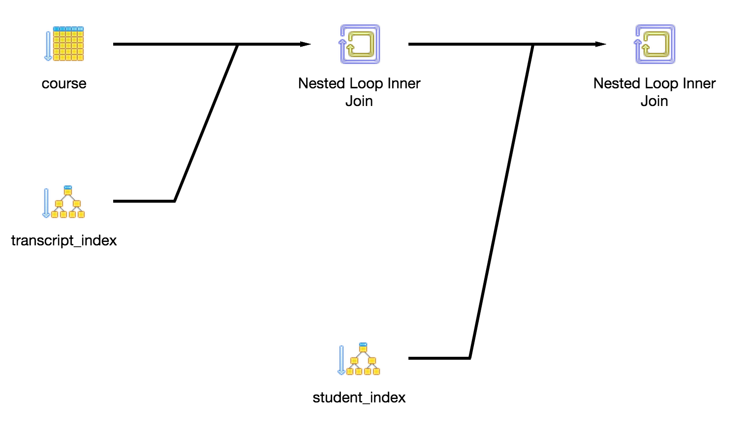

Query6: 82 msec

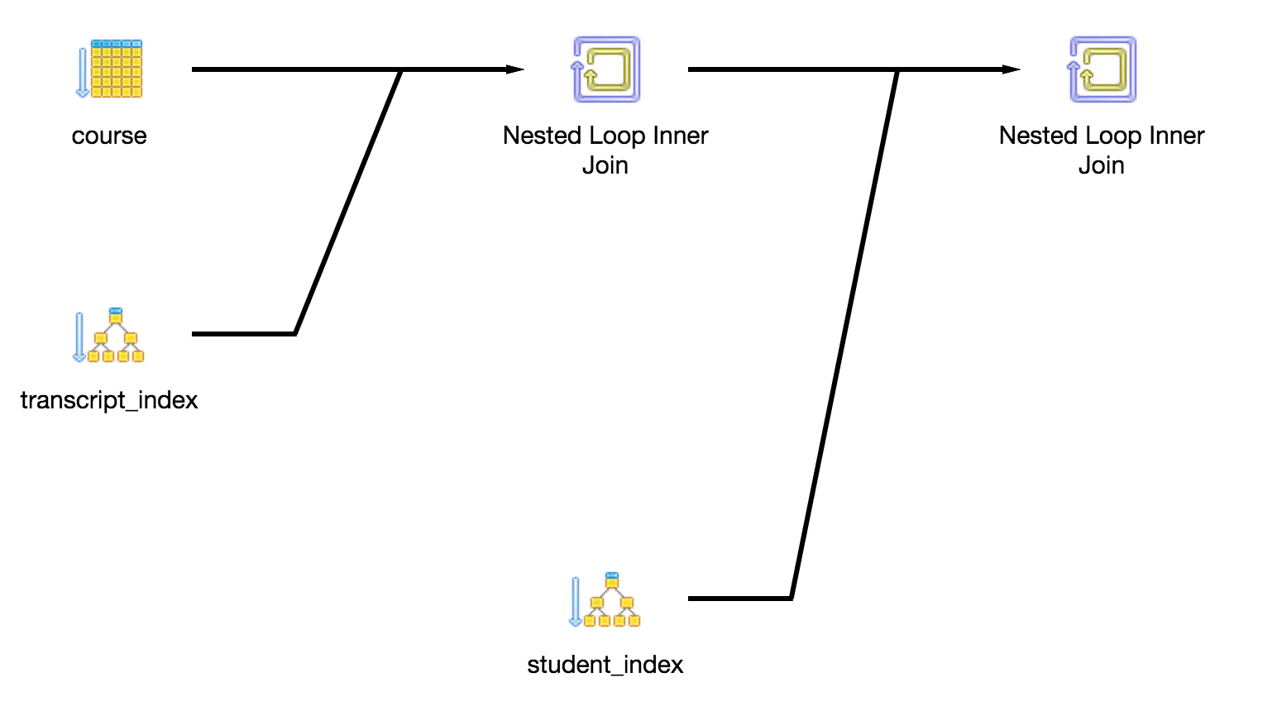

**Observations:**

Query 1:

Before - 151 msec

After - 81 msec

The runtime was faster but the plans for the queries remained the same. The only difference added to this query was indexing.

Query 2:

Before - 210 msec

After - 164 msec

The runtime was faster but the plans for the queries remained the same.The only difference added to this query was indexing.

Query 3:

Before - 99 msec

After - 73 msec

The runtime was faster and the query plans were different. Before, we used hash indexing and hash inner join. After, adding student_index definitely sped things up a little, but using a nested loop inner join was what made this query significantly more efficient.

Query 4:

Before - 190 msec

After - 70 msec

The runtime was faster but the plans for the queries were quite different. Before, we used hash indexing, sorting, and hash inner joins. After, we still used hash indexing and hash inner join, but also used nested loop inner joins. This made the program run more efficiently.

Query 5:

Before - 125 msec

After - 74 msec

The runtime was faster and the query plans were drastically different. Again, with no indexing and using multiple hash inner joins, this query was not very efficient before tuning it. The second query uses indexing and two nested inner loops to speed up the runtime.

Query 6:

Before - 141 msec

After - 82 msec

The runtime was faster but the query plans were very different. Before, we used hash indexing, hash semi joins, hash inner joins, sorting, and aggregating. After tuning, we just used nested loop inner joins which sped up the runtime.