All movie list

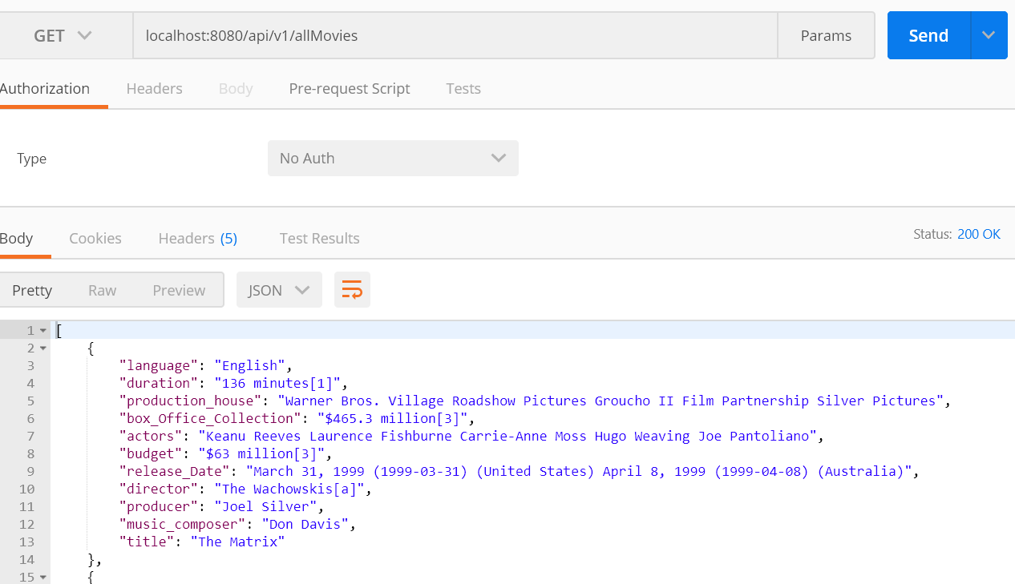

Particular Movie list

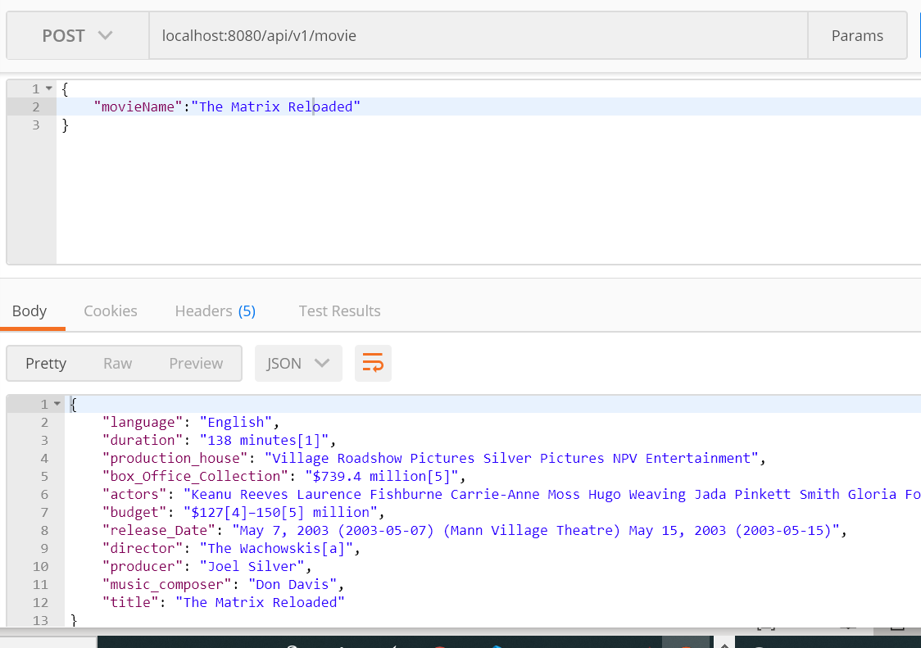

Sorted movie list

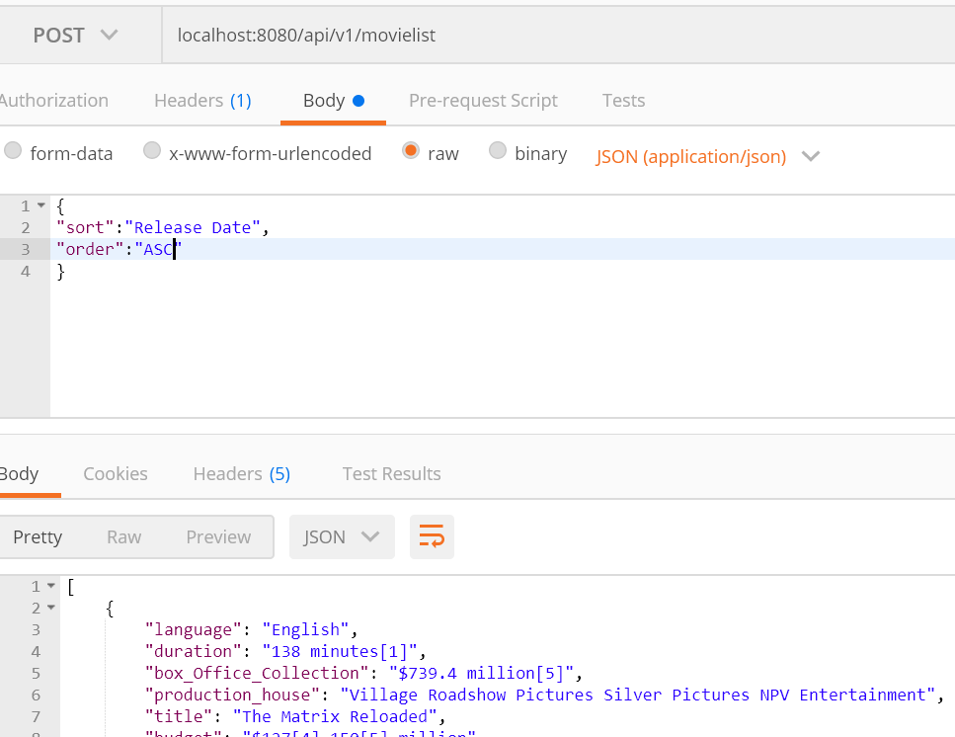

Parameter

Sort – title/Release Date

Order- asc/dsc