

ST6002CEM-Mobile Application Development

Project proposal on Boots Buy



Submitted by: Suraj Tamang

Coventry ID: 14188972

Batch: 34,’B’

Module Leader: Kiran Rana

**Table of Contents**

Introduction 4

Background of the Project 4

Problem Statement 5

Features of the project 5

Aim of the Project 6

Objectives of the Project 7

MVVM design pattern 7

Benefit of MVVM 9

GitHub Repository 10

Prototype 11

Conclusion 14

References 15

**List of Figures**

Figure 1 MVVM Architecture 9

Figure 2 Github Image 10

Figure 3 Logo 11

Figure 4 SplashScreen 11

Figure 5 Login_Page 12

Figure 6 SignUp_Page 12

Figure 7 DashBoard 13

Figure 8 Setting 14

# **Introduction**

Football Boots Buy is a simple to use tool that makes it easy to find and purchase football boots. Finding the proper boots can be challenging, regardless of your level of experience, especially if you have to look through multiple apps or websites. By collecting a large selection of football boots from many brands in one location, this app solves that issue.

Football Boots Buy saves your time by reducing the need to look somewhere else. Simply download the app, select your size, decide on a budget, and look over the available selections. Boots that meet your demands can be easily found and purchased through the app. Everyone can quickly and easily purchase the ideal football footwear from this one-stop shop.

# **Background of the Project**

In recent years, shopping for football boots has become a challenge for many players. With so many brands, models, and stores out there, it’s easy to get lost in the options. While other sports gear and equipment have moved online with specialized platforms, finding the right football boots is still a confusing and time-consuming process for many players. Often, players end up visiting multiple websites, reading countless reviews, and still can’t find exactly what they need. There’s a lack of a central place where players can compare boots based on their specific needs—whether it’s for a certain type of field, position, or playing style.

At the same time, many football boot brands and sellers struggle to stand out. While they make great products, they don’t always have the tools or the platform to showcase their boots effectively to a wide audience.

Football Boots Hub was created to solve this problem. It’s a one-stop-shop where footballers can easily browse, compare, and purchase boots from a variety of brands—all in one place. The app makes it simple to find the right pair based on personal preferences, size, and budget, so players can focus on their game, not the search for the right boots.

# **Problem Statement**

Buying the right pair of football boots is typically a frustrating and time-consuming experience for most people, whether they are playing the game for the first time or an experienced player. The reason for this is that football boots are scattered everywhere across various apps, websites, and stores, which makes it difficult for users to obtain the right pair that meets their specific needs. Shoppers usually need to navigate through several websites to compare various brands, sizes, prices, and styles, not just wasting time but also getting bewildered and making the wrong buying choices.

The Football Boots Buy app was developed in order to solve this problem. The goal of this app is to organize all football boots from different well-known companies into a single, user-friendly platform. Users may now browse a large selection of boots in one location rather than navigating between many applications or websites. The app makes purchasing quick, easy, and stress-free by letting users simplify their search by size, price range, preferred brand, and other criteria. Football Boots Buy lets customers save time and make wiser purchases by fusing ease, variety, and user-friendly features. Anyone, from the beginner to an expert player, may find the right pair of boots with easily with the app.

# **Features of the project**

• **User-Friendly Interface:** Users of any age are welcome to use the app's clear, user-friendly UI. The entire process, from searching boots to making a purchase, is easy and completely responsive.

• **Boot Catalog**: Customers are able to browse through a variety of football boots. To assist customers in making knowledgeable purchasing selections, each ad contains thorough explanations, costs, size alternatives, and excellent photos.

• **Search and Filter Options:** The app's powerful search features and filters, which let users sort products by brand, price, and size, enhance navigation.

• **Notifications and Alerts**: Push notifications keep users informed about order status, delivery updates.

• **Ratings and Reviews**: Customers can leave ratings and reviews for boots and sellers based on their experience, helping others make confident choices and promoting high-quality service.

• **Customer Support Integration**: The app features integrated customer service through phone, assisting users with inquiries related to product information, orders, payments, or returns.

# **Aim of the Project**

The Football Boots Buy project's goal is to develop a centralized, user-friendly platform that makes it easier for people of all ages and skill levels to search and buy football boots. It tries to save consumers time and effort by combining a large selection of football boots from different brands into a single app, removing the need for them to browse multiple websites or applications. With features like thorough product descriptions, excellent photos, real-time stock availability, and user reviews, the app provides a smooth shopping experience that aids users in making well-informed purchases. Users can easily find boots that fit their particular requirements, including brand, price, and size, thanks to powerful search and filter tools that further improve product discovery. The app uses push notifications to inform users of promotions, delivery updates, and order statuses. The project intends to promote trust, high-quality service, and a dependable, one-stop buying experience for football footwear through integrated customer assistance and review capabilities.

# **Objectives of the Project**

* **Simplify the Football Boot Shopping Experience**: To offer a centralized and easy-to-use platform where users can efficiently search for, compare, and buy football boots without the need to browse multiple apps or websites.
* **Enhance Accessibility and Usability for All Users**: To provide a clean, user-friendly interface that supports users of all ages and skill levels, ensuring a smooth and intuitive shopping experience.
* **Offer a Comprehensive Boot Collection**: To gather a wide range of football boots from various brands into one platform, giving users access to multiple styles, sizes, and price points in one convenient place.
* **Enable Informed Purchasing Decisions**: To equip users with detailed product descriptions, high-resolution images, pricing, size options, and customer reviews so they can choose the right boots for their needs.
* **Improve Product Discovery**: To implement advanced search and filter tools that help users quickly find boots based on specific criteria such as brand, size, or price.
* **Keep Users Updated**: To use push notifications for providing real-time updates on order status, delivery progress, restocks, and special promotions.
* **Build Trust Through Customer Feedback**: To allow customers to share honest reviews and ratings, helping future buyers make confident decisions and encouraging vendors to maintain quality.
* **Provide Reliable Customer Support**: To ensure users can quickly get help with their orders, payments, or return issues via integrated phone support.

# **MVVM design pattern**

The **MVVM (Model-View-View Model)** design pattern is a software architectural approach commonly used in modern mobile and desktop applications. It helps organize code in a clean, maintainable, and testable way by separating the user interface (UI) from the business logic and data handling.

* **Model:** The Model represents the core data and business logic of the application. It is responsible for managing and processing data from sources such as APIs, databases, or local storage. In the context of the Football Boots Buy app, the Model could include data structures for products, users, and orders, as well as functions for fetching football boots from a remote server or updating order details. The Model is designed to be independent of the user interface and only focuses on handling the underlying data.
* **View:** The View is the user interface of the application. It displays data to the user and captures user interactions such as clicks, form submissions, or selections. The View is designed to be passive and should not contain any business logic. Instead, it observes the view Model for any changes in the data and updates the UI accordingly. In the Football Boots Buy app, examples of the View include the boot catalog screen, product detail page, and the checkout interface.
* **ViewModel:** The view Model acts as the intermediary between the Model and the View. It is responsible for holding and preparing the data that the View needs to display. The ViewModel retrieves data from the Model and formats it in a way that the View can easily use. It also handles user actions from the View, such as a request to purchase a boot or filter results, and updates the Model accordingly. In the Football Boots Buy app, a BootListViewModel might retrieve a list of available boots and expose it to the UI while also handling search and filter logic.

**Figure 1: MVVM Architecture**

Figure MVVM Architecture

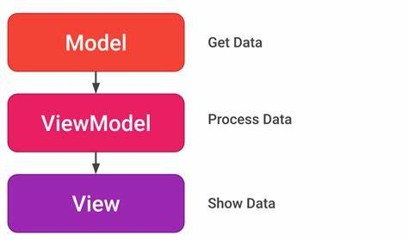

# **Benefit of MVVM**

* **Separation of Concerns:** This keeps data processing, business logic, and user interface distinct.
* **Enhanced Testability:** View Model logic can be examined separately from the user interface.
* **Improved Maintainability:** Certain components are simpler to update or refactor.
* **Supports Data Binding:** This allows for little code to be used for automatic UI updates.
* **Reusability:** View Models are transferable between different Views.
* **Parallel Development:** Designers and developers can collaborate at the same time.
* **Cleaner Code Structure:** Promotes modular and well-structured code.
* **Simplified Debugging:** Because components are separated, it is easier to track down errors.
* **Scalability:** Fit for intricate and sizable applications.

# **GitHub Repository**

Figure Github Image

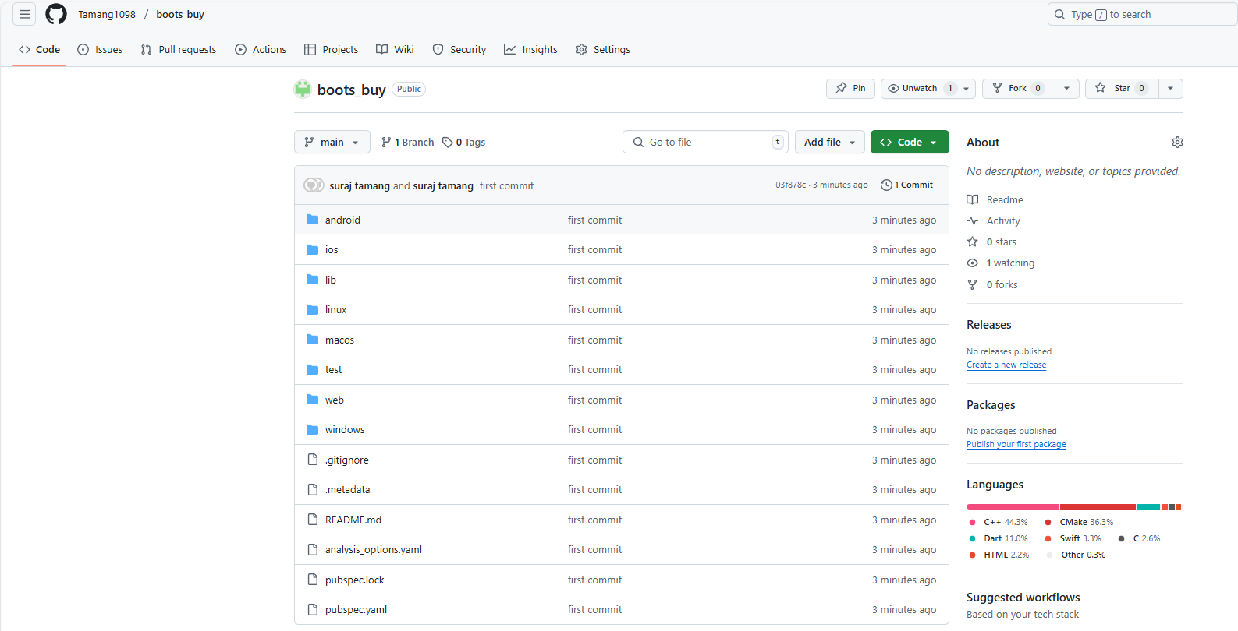

**Link:** <https://github.com/Tamang1098/boots_buy>

# 

# **Prototype**

Figure Logo

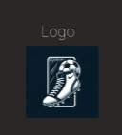

Figure SplashScreen

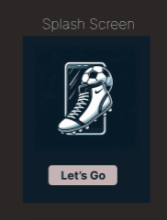

Figure Login_Page

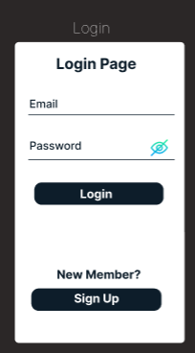

Figure SignUp_Page

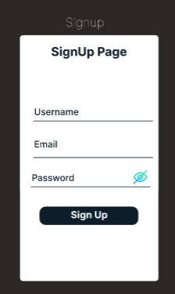

Figure DashBoard

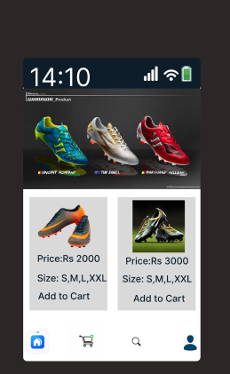

Figure Setting

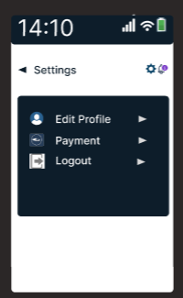

Conclusion

As part of the Mobile Application Development module, the football boots purchasing mobile application will be created with Flutter and Dart with the goal of addressing the main issues facing the football equipment industry, including a lack of secure payment methods, inconsistent size, and a restricted selection. The application will guarantee an easy and customized experience for customers by focusing essential features including size screening, cart management, product browsing, real-time order tracking, and digital wallet integration. In the future, the MERN stack within the Web API module will be used to extend the platform to the web, improving its scalability and accessibility. This upcoming edition will position the program as a comprehensive, multi-platform solution for buying football boots in Nepal by incorporating specific interfaces for buyers and administrators.

# **References**

Mishra, R. (2020, October 29). *MVVM (Model View ViewModel) Architecture Pattern in Android*. GeeksforGeeks. <https://www.geeksforgeeks.org/mvvm-model-view-viewmodel-architecture-pattern-in-android/>