

ST6003CEM- Web API Development

Boots Buy

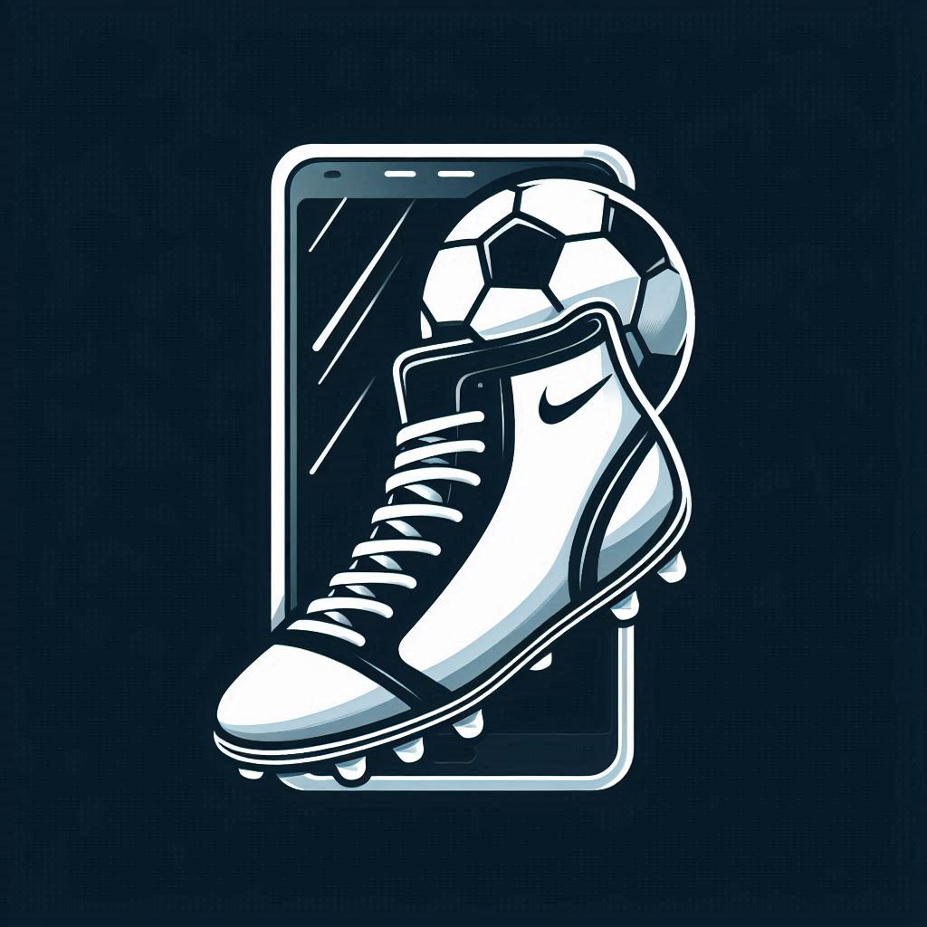

Submitted by: Suraj Tamang

Coventry ID: 14188972

Batch: 34,’B’

Module Leader: Albert Maharjan

**Table of Contents**

Introduction 4

Objectives of the Project 4

Aim of theProject 5

Background of the Project 5

Problem Statement 6

Features of the project 7

Scope of Project 8

Er Diagram 9

Prototypes 10

Conclusion 15

References 15

Figure 1MERN 7

Figure 2ER Diagram 9

Figure 3Login Page 10

Figure 4Signup Page 11

Figure 5Dahboard 12

Figure 6Setting 13

# **Introduction**

Football Footwear Buy is a website that is easy to use and helps you find and buy football shoes, No matter how much experience you have, it can be hard to find the right boots, especially if you have to look through a lot of websites. This website solves that problem by bringing together many football boots of a different brands in one place.

Football Boots Buy saves you time by making it unnecessary for you to look elsewhere. Just go to the website, pick your size, set a budget, and look at the options that are available. The website makes it easy to find and buy boots that fit your needs. This store has everything you need to find the perfect football shoes.

**Objectives of the Project**

* Simplify the Football Boot Shopping Experience.
* Enhance Accessibility and Usability for All Users.
* Offer a Comprehensive Boot Collection.
* Enable Informed Purchasing Decisions.
* Improve Product Discovery.
* Keep Users Updated.
* Build Trust Through Customer Feedback.
* Provide Reliable Customer Support.

## **Aim of the Project**

The goal of the Football Boots Buy project is to create a well-organized and easy-to-use website where people of all ages and skill levels can find and buy football boots. It tries to save users time and effort by bringing together a wide range of football boots from different brands into one website. This way, they don't have to go to several sites to find what they want. This website makes shopping easy and helps people make smart choices by letting them see user ratings, see if items are in stock right away, see great pictures and read detailed product descriptions. Strong search make it even easier for people to find boots that fit their needs like brand, price, and size. This project aims to build trust, provide high-quality service, and create a reliable, one-stop shopping experience for football shoes.

## **Background of the Project**

Football boot shopping has gotten difficult for many players in recent years. The wide range of brands, models, and outlets makes it simple to become confused by the selection. For many players, finding the right football boots remains a challenging and time-consuming task, even when other sports clothing and equipment have gone online with specialized platforms. Players frequently wind up going to several websites and reading a ton of reviews without being able to find exactly what they're looking for. Players are unable to compare boots in one location according to their individual requirements, be they for a certain position, playing style, or field type.

At the same time, a lot of football boot sellers and brands find it difficult to differentiate themselves. Even though they produce excellent goods, they don't often have the resources or the venue to market their boots to a large audience.

To address this issue, Boots Buy was established. Football players can easily browse, compare, and buy boots from a range of brands in one location at this one-stop shop. Players can concentrate on their game rather than seek for the perfect boots because the app makes it easy to discover the correct pair based on size, budget, and personal preferences.

## **Problem Statement**

For most people, whether they are seasoned players or just starting out, purchasing the proper football footwear can be a tedious and time-consuming process. This is because football boots can be found over many websites and shops, making it challenging for customers to find the ideal pair that suits their individual requirements. In order to evaluate different brands, sizes, prices, and styles, shoppers typically have to browse through multiple websites. This not only wastes time but also leaves them confused and leads to poor purchasing decisions.

To deal with this issue, the Football Boots Buy websites was created. This website's objective is to put together all football footwear from many respected companies into a single, user-friendly website. Instead of switching between numerous websites, users can now explore a wide range of boots in one place. By allowing customers to narrow down their search by size, price range, preferred brand, and other factors, this website makes buying quick, simple, and stress-free. Football Boots Buy combines simplicity, variety, and user-friendly features to help customers save time and make better decisions. The website makes it simple for all players, from novices to pros, to discover the ideal footwear.

# **Features of the project**

• **User-Friendly Interface**: The website's simple user interface is accessible to users of all ages. From looking for boots to completing a purchase, the entire experience is simple and incredibly responsive.

• **Boot Catalog**: A selection of football footwear is available for customers to browse. Each advertisement includes comprehensive explanations, prices, size options, and high-quality images to help consumers make informed decisions.

• **Search Options**: The website's strong search features and filters improve navigation by allowing users to sort products by brand.

• **Ratings and Reviews**: Based on their experiences customers may rate and review boots and sellers assisting others in making informed decisions and fostering excellent customer service.

# Scope of Project

Figure 1MERN

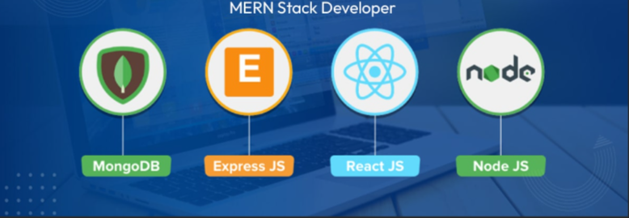

The advanced and reliable MERN stack, which consists of Express.js, React.js, Node.js, and MongoDB, is being used to develop Boots Buy website. High performance, a smooth user experience, and scalability as the platform expands are all guaranteed by the selection of this technology stack. Each element of the MERN stack is essential to creating a real-time, responsive, and effective online Boots buying system that can adapt to the changing demands of Nepali consumers.

**MongoDB**: MongoDB will serve as Boots Buy's  main database system, housing critical data such as user profiles and delivery information. It is adaptable,Because document structures enable dynamic data processing, they are ideal for the constantly evolving world of online Boots orders. Even during peak hours, the platform can manage high user and order volumes thanks to MongoDB's scalability.

**Express.js**: This backend framework will be used to control server-side functionality and API routes. By managing requests for user identification, order placement, cart management, and delivery tracking, it will provide seamless communication between the frontend and the database. Express.js's lightweight and modular design will offer the dependability and speed required for a successful Boot's buying system.

**React.js**: React.js will power Boots Buy's frontend, providing a quick, engaging, and simple user experience. Users will enjoy a smooth and responsive design across devices for everything from menu browsing and order customization to delivery tracking. Additionally, the reusable component structure of React allows for quicker development and facilitate interface maintenance as new features are added.

**Node.js**: Working as the backend runtime engine for Boots_Buy, Node.js will allow for real-time functions including order processing, live delivery status management, and secure user sessions. Node.js's non-blocking I/O approach guarantees that the platform can manage several user requests at once, resulting in fast response times and improved application performance overall.

# Er Diagram

Figure 2ER Diagram

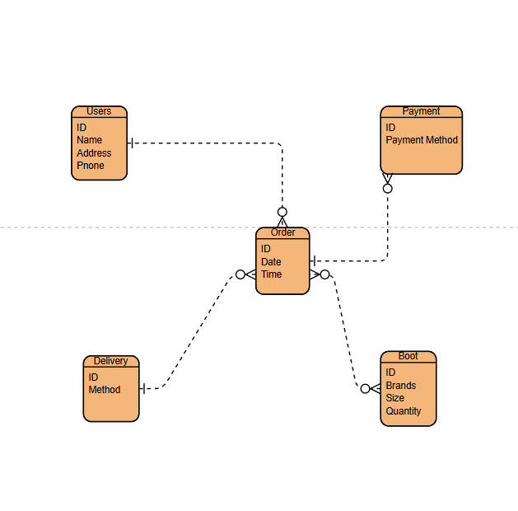

# Prototypes

Figure 3Login Page

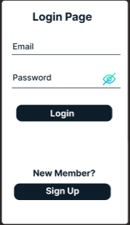

Figure 4Signup Page

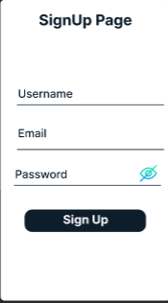

Figure 5Dahboard

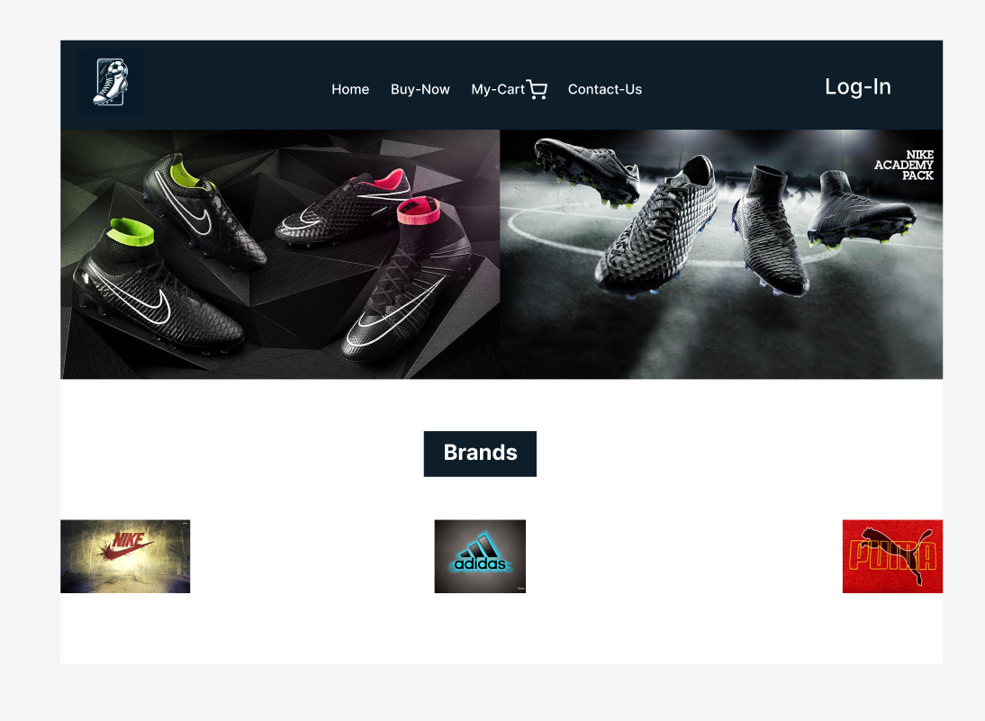

Figure 6Setting

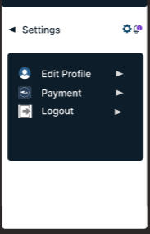

# **Conclusion**

In conclusion, the football footwear platform will be carefully developed utilizing the reliable and effective MERN stack, guaranteeing a market-oriented, scalable, and responsive web application that is suited to the requirements of Nepali athletes. The platform aims to provide a seamless experience for customers by placing a high priority on user comfort, safe payment processing, and easy product browsing and ordering. Additionally, to improve accessibility and usability on both iOS and Android devices, a mobile application will be developed utilizing Flutter and Dart.

# **References**

Jaiswal, A. (2024, November 6). *Understanding the MVC Pattern with Node.js*. DEV Community. <https://dev.to/abhishekjaiswal_4896/understanding-the-mvc-pattern-with-nodejs-1fpg>

Tyagi, D. (2020, July 5). *Why choose MERN stack?* Aeologic. <https://medium.com/aeologic/why-choose-mern-stack-323b4d95e4ea>

Supun Kavinda. (2024, November 29). *Getting Started with React: A Beginner’s Guide - Supun Kavinda - Medium*. Medium. <https://medium.com/@naskavinda/getting-started-with-react-a-beginners-guide-f47890185bd8>

Roy, J. (2019, March 20). *Why you need to choose mongodb over other databases?* Database Tutorials. <https://dbtut.com/index.php/2019/03/20/why-you-need-to-choose-mongodb-over-other-databases/>

Gupta, L. (2019, June 13). *What is REST – Learn to create timeless REST APIs*. Restfulapi.net. <https://restfulapi.net/>

Bhattacharya, B., & Bhattacharya, B. (2024, May 3). *The essential API developer skills*. Tyk API Management. <https://tyk.io/blog/the-essential-api-developer-skills/>

McConnell, A. (2022, October 31). *Website Improvement Strategy: How to Make A Site More Successful*. Inbounddesignpartners.com; Inbound Design Partners. <https://www.inbounddesignpartners.com/blog/website-improvement-strategy>