

ST6003CEM- Web API Development

Project proposal on Boots Buy



Submitted by: Suraj Tamang

Coventry ID: 14188972

Batch: 34,’B’

Module Leader: Albert Maharjan

**Table of Contents**

Introduction 4

Background of the Project 4

Problem Statement 5

Features of the project 5

Aim of the Project 6

Objectives of the Project 7

Scope of Project 7

Er Diagram 9

Prototypes 10

Conclusion 14

Reference 14

**List of Figure**

Figure 1MERN 7

Figure 2ER Diagram 9

Figure 3Login Page 10

Figure 4Signup Page 11

Figure 5Dahboard 12

Figure 6Setting 13

# **Introduction**

Finding and buying football footwear is made simple with Football footwear Buy, an easy-to-use tool. No matter the level of experience, finding the right boots might be difficult, particularly if you need to search via multiple websites. This website solves that problem by gathering a large number of football boots from multiple vendors in one place.

Football Boots Buy reduces the need for you to search elsewhere, saving you time. Just use the website, choose your size, set a spending limit, and browse the options. The website makes it simple to find and buy boots that satisfy your needs. This one-stop shop makes it easy and simple for everyone to get the perfect football shoes.

# Background of the Project

Football boot shopping has gotten difficult for many players in recent years. The wide range of brands, models, and outlets makes it simple to become confused by the selection. For many players, finding the right football boots remains a challenging and time-consuming task, even when other sports clothing and equipment have gone online with specialized platforms. Players frequently wind up going to several websites and reading a ton of reviews without being able to find exactly what they're looking for. Players are unable to compare boots in one location according to their individual requirements, be they for a certain position, playing style, or field type.

At the same time, a lot of football boot sellers and brands find it difficult to differentiate themselves. Even though they produce excellent goods, they don't often have the resources or the venue to market their boots to a large audience.

To address this issue, Boots Buy was established. Football players can easily browse, compare, and buy boots from a range of brands in one location at this one-stop shop. Players can concentrate on their game rather than seek for the perfect boots because the app makes it easy to discover the correct pair based on size, budget, and personal preferences.

# **Problem Statement**

For most people, whether they are seasoned players or just starting out, purchasing the proper football footwear can be a tedious and time-consuming process. This is because football boots can be found over many websites and shops, making it challenging for customers to find the ideal pair that suits their individual requirements. In order to evaluate different brands, sizes, prices, and styles, shoppers typically have to browse through multiple websites. This not only wastes time but also leaves them confused and leads to poor purchasing decisions.

To deal with this issue, the Football Boots Buy websites was created. This website's objective is to put together all football footwear from many respected companies into a single, user-friendly website. Instead of switching between numerous websites, users can now explore a wide range of boots in one place. By allowing customers to narrow down their search by size, price range, preferred brand, and other factors, this website makes buying quick, simple, and stress-free. Football Boots Buy combines simplicity, variety, and user-friendly features to help customers save time and make better decisions. The website makes it simple for all players, from novices to pros, to discover the ideal footwear.

# Features of the project

• **User-Friendly Interface**: The website's simple user interface is accessible to users of all ages. From looking for boots to completing a purchase, the entire experience is simple and incredibly responsive.

• **Boot Catalog**: A selection of football footwear is available for customers to browse. Each advertisement includes comprehensive explanations, prices, size options, and high-quality images to help consumers make informed decisions.

• **Search and Filter Options**: The website's strong search features and filters improve navigation by allowing users to sort products by size, price, and brand.

• **Ratings and Reviews**: Based on their experiences, customers may rate and review boots and sellers, assisting others in making informed decisions and fostering excellent customer service.

# **Aim of the Project**

The objective of the Football Boots Buy project is to provide an organized, user-friendly platform that facilitates the search and purchase of football boots for individuals of any age or skill levels. By collecting a wide range of football boots from many brands into a single website, it attempts to save users time and effort by eliminating the need for them go through multiple sites. With features like user ratings, real-time stock availability, great images, and comprehensive product descriptions, this websites makes shopping easy and helps consumers make smart choices. Strong search and filter options further enhance product discovery by making it simple for users to identify boots that meet their specific needs, such as brand, price, and size. The website uses push notifications to inform users of promotions, delivery updates, and order statuses. The project intends to promote trust, high-quality service, and a dependable, one-stop buying experience for football footwear through integrated customer assistance and review capabilities.

# **Objectives of the Project**

* Simplify the Football Boot Shopping Experience.
* Enhance Accessibility and Usability for All Users.
* Offer a Comprehensive Boot Collection.
* Enable Informed Purchasing Decisions.
* Improve Product Discovery.
* Keep Users Updated.
* Build Trust Through Customer Feedback.
* Provide Reliable Customer Support.

# **Scope of Project**

Figure MERN

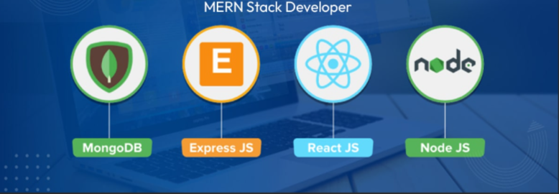

The advanced and reliable MERN stack, which consists of Express.js, React.js, Node.js, and MongoDB, is being used to develop Boots Buy website. High performance, a smooth user experience, and scalability as the platform expands are all guaranteed by the selection of this technology stack. Each element of the MERN stack is essential to creating a real-time, responsive, and effective online Boots buying system that can adapt to the changing demands of Nepali consumers.

**MongoDB**: MongoDB will serve as Boots Buy's  main database system, housing critical data such as user profiles and delivery information. It is adaptable,Because document structures enable dynamic data processing, they are ideal for the constantly evolving world of online Boots orders. Even during peak hours, the platform can manage high user and order volumes thanks to MongoDB's scalability.

**Express.js**: This backend framework will be used to control server-side functionality and API routes. By managing requests for user identification, order placement, cart management, and delivery tracking, it will provide seamless communication between the frontend and the database. Express.js's lightweight and modular design will offer the dependability and speed required for a successful Boot's buying system.

**React.js**: React.js will power Boots Buy's frontend, providing a quick, engaging, and simple user experience. Users will enjoy a smooth and responsive design across devices for everything from menu browsing and order customization to delivery tracking. Additionally, the reusable component structure of React allows for quicker development and facilitate interface maintenance as new features are added.

**Node.js**: Working as the backend runtime engine for Boots_Buy, Node.js will allow for real-time functions including order processing, live delivery status management, and secure user sessions. Node.js's non-blocking I/O approach guarantees that the platform can manage several user requests at once, resulting in fast response times and improved application performance overall.

# **Er Diagram**

Figure ER Diagram

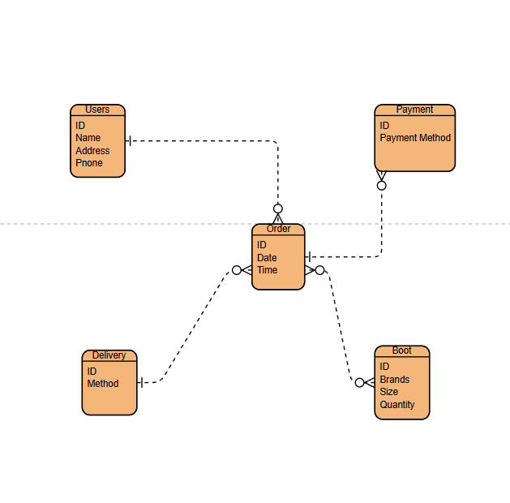

# **Prototypes**

Figure Login Page



Figure Signup Page

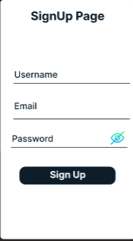

Figure Dahboard

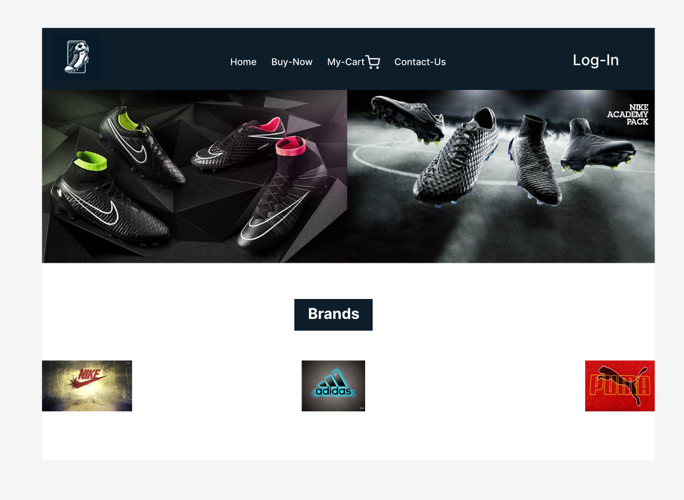

Figure Setting

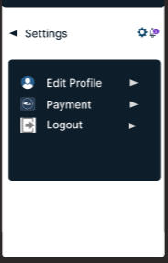

# **Conclusion**

In conclusion, the football footwear platform will be carefully developed utilizing the reliable and effective MERN stack, guaranteeing a market-oriented, scalable, and responsive web application that is suited to the requirements of Nepali athletes. The platform aims to provide a seamless experience for customers by placing a high priority on user comfort, safe payment processing, and easy product browsing and ordering. Additionally, to improve accessibility and usability on both iOS and Android devices, a mobile application will be developed utilizing Flutter and Dart.

# **Reference**

Mern-Stack.:<https://www.mongodb.com/resources/languages/mern-stack>