How Graph Size and Structure Affect the Scalability of Parallel Breadth-First Search: A Sequential versus OpenMP Study
BCSE412L Parallel Computing — Case Study CS4-S01 (Parallel Graph Processing: Parallel Breadth-First Search)
Student 1: [Name, Reg. No.] (sequential baseline) | Student 2: [Name, Reg. No.] (OpenMP parallel BFS) | Batch: [Batch ID]
School of Computer Science and Engineering, VIT Vellore — Fall Semester 2026-27

2 Abstract
Breadth-first search (BFS) is a basic graph kernel, but its parallel performance depends strongly on the shape of the graph. We compare a sequential queue-based BFS with a level-synchronous OpenMP BFS that claims vertices with an atomic compare-and-swap. Both programs share one graph format, start-vertex rule, timing convention and correctness check. We measured path, 2-D grid, uniform random and R-MAT graphs with 16,384 to 1,048,576 vertices, 1 to 4 threads and seven repetitions per setting on a 4-vCPU cloud virtual machine. All 588 timed runs produced valid BFS distances. With 4 threads on 1,048,576 vertices, the speedup over the sequential baseline was 3.88 for the random graph and 3.97 for the R-MAT graph, but only 0.58 for the grid and 0.0021 for the path. On random graphs with 262,144 vertices, throughput with 4 threads rose from 64.3 to 421.6 MTEPS as the average degree grew from 2 to 64. The results show that a plain level-synchronous BFS is limited by the amount of work in each level: graphs with many levels and small frontiers pay the barrier cost without enough work to share. We discuss limitations and outline hybrid, direction-optimizing and GPU follow-ups.
Keywords: breadth-first search, OpenMP, level-synchronous BFS, speedup, efficiency, TEPS, graph structure, scalability.

3 Introduction (along with Literature Survey)
Breadth-first search (BFS) explores a graph level by level from a start vertex and returns, for every vertex, the smallest number of edges needed to reach it. It is the building block of shortest-path queries in unweighted graphs, connected components, social-network analysis and many other algorithms, and it is the main kernel of the Graph500 list and of the GAP benchmark suite [8]. Graphs in practice have millions or billions of edges, so even a linear-time BFS takes noticeable time, and modern multicore processors offer a natural way to speed it up. BFS is, however, not an easy kernel to parallelize: the work per vertex is tiny, memory accesses are irregular, and the amount of parallel work depends on how many vertices sit on the same level, which is decided by the graph’s shape.
Sequential and parallel BFS. Sequential BFS keeps a first-in-first-out queue. It removes a vertex, looks at its neighbours, and gives every unvisited neighbour the distance of the current vertex plus one. Every vertex enters the queue once and every edge is examined a constant number of times, so the running time is O(n + m) for n vertices and m edges (Equation 1). Parallel BFS in shared memory is usually level-synchronous: all vertices of the current level (the frontier) are expanded at the same time by different threads, and a barrier separates one level from the next. Two problems must be solved. First, two threads may find the same unvisited vertex at the same moment, so the “visited” update must be atomic or the vertex may be added twice. Second, the next frontier is built by many threads, so their contributions must be combined without data races.
$T_{seq}\left(n,m\right)=O\left(n+m\right)$ (1)
Literature survey. Table 1 summarizes the eight sources we used; the discussion below compares them.
Table 1. Sources used in the literature survey.
Ref. | Topic | Main idea or finding (as far as we verified from the paper records) | Relevance to this study
[1] 2010 | Shared-memory BFS | A work-efficient parallel BFS that handles the nondeterminism of concurrent frontier updates. | Frontier construction and race handling
[4] 2010 | Multicore BFS | BFS on Intel Nehalem multicore systems with up to 64 threads; a 4-socket machine beat a 128-processor Cray XMT by 2.4× on a random-graph benchmark. | Shared-memory scaling on random graphs
[3] 2011 | Distributed BFS | Level-synchronous BFS with 1-D and 2-D partitioning; the hybrid 2-D version cut communication time by up to 3.5×; 17.8 billion edge visits per second on 40,000 cores. | Level-synchronous model, TEPS metric
[2] 2012 | Direction-optimizing BFS | Switches between top-down and bottom-up traversal to avoid examining many edges when the frontier is large. | Why large frontiers matter; future work
[8] 2015 | Benchmark | GAP benchmark suite: reference kernels, input graphs and an evaluation method for shared-memory graph processing. | Methodology: trials, graph families
[5] 2021 | Graph-processing suite | GBBS: theoretically efficient parallel algorithms for 20 graph problems that scale to a graph of 3.5 billion vertices on one 1 TB machine. | Graph size and scalability
[6] 2022 | GPU graph framework | GraphBLAST, a linear-algebra-based graph framework on the GPU. | GPU branch (not implemented here)
[7] 2024 | OpenMP BFS | OpenMP/C++ BFS with the bag data structure, evaluated on many graphs on two multicore machines. | Closest comparison to our OpenMP BFS

Comparison. Early shared-memory work addressed the problem of concurrent frontier updates [1] and reported strong results on multicore processors with random-graph benchmarks [4]; random graphs have few levels and wide frontiers, which suits parallel execution. Distributed-memory work [3] uses the same level-synchronous pattern, reports speed in traversed edges per second (TEPS) and treats communication cost as a main concern. Direction-optimizing BFS [2] observes that when the frontier is a large part of the graph, top-down BFS wastes effort on edges that lead to already visited vertices, and it fixes this by searching bottom-up. Later systems are broader in scope: GBBS [5] shows that careful shared-memory algorithms can handle graphs with billions of vertices, GraphBLAST [6] moves graph traversal to the GPU, and the 2024 OpenMP study [7] returns to the plain CPU setting and reports that speedup depends on the input graph. The GAP suite [8] standardises how such comparisons should be made.
Gap addressed here. The sources above concentrate on large machines, very large graphs or low-diameter scale-free graphs. A student or practitioner with a small multicore machine often asks a simpler question: “Is it worth parallelizing a plain level-synchronous BFS, and for which graphs?” Each level costs at least a few barriers, so graphs with many levels and small frontiers (long paths, road-like grids) should lose, while graphs with few, wide levels should win. To our knowledge of the sources listed here, this contrast is rarely shown side by side with the synchronization cost measured. We therefore compare one sequential and one OpenMP implementation on four graph structures, four sizes and three thread counts, and we relate the speedup to the amount of work per level.

4 Problem and Research Question
Problem. Given an undirected, unweighted graph G = (V, E) in adjacency-list form and a start vertex s, compute dist[v] for every vertex v (−1 if v cannot be reached from s). We compare a sequential BFS with a level-synchronous OpenMP BFS on graphs of increasing size and different structure and measure traversal time, speedup, efficiency and traversal throughput.
Research question (from the manual). How does graph size and structure affect BFS scalability?
Hypotheses.
- H1 (structure): Speedup is governed by the work available per BFS level. Random and R-MAT graphs (few, wide levels) will speed up with more threads; the path and the grid (many, narrow levels) will not.
- H2 (size): For a fixed structure, speedup and efficiency improve as the graph grows, because fixed costs (thread start-up, barriers) are shared over more work.
- H3 (density): Traversal throughput (TEPS) increases with average degree, because each vertex brings more edge work to share.

6 Methodology

6.1 Division of work and common conventions
Table 2. Individual contributions (see also the two technical notes).
 | Student 1 | Student 2 | Both
Main task | BFS theory; sequential baseline; graph generators and input format; correctness tests; baseline timing | OpenMP parallel BFS; thread configurations; speedup, efficiency, TEPS; synchronization and overhead analysis | Literature survey; experiment design; analysis; this report
Files | graph.hpp, bfs_seq.hpp, bfs_seq_main.cpp, tests/ | bfs_par.hpp, bfs_par_main.cpp | run_experiments.py, analyze.py, plot.py

To make the two parts comparable, both programs use the same graph code and the same conventions. Graph: undirected, simple (self-loops and duplicate edges removed), stored in compressed sparse row (CSR) form, which is a compact adjacency list. Start vertex: vertex 0 for path and grid; the lowest-numbered vertex of maximum degree for random and R-MAT graphs, so that the traversal always covers a large component. Timed region: one call of the BFS function, including the allocation and initialization of its own arrays and, for the parallel code, thread start-up; graph generation, validation and statistics are excluded. Correctness: every parallel result is compared with the sequential distances, and an independent validator checks that the distances form a valid BFS. Clock: std::chrono::steady_clock, in seconds.

6.2 Sequential baseline (Student 1)
The baseline is the classic queue-based BFS described in Section 3, with an array used as the queue and an integer distance array initialised to −1. It was implemented and validated before any parallel code was written, as required by the manual.

6.3 Level-synchronous OpenMP BFS (Student 2)
The whole traversal runs inside one OpenMP parallel region. For each level the following steps are executed:
- Expand. The frontier is divided among threads with an OpenMP loop (schedule dynamic, chunk 64). For every neighbour v of a frontier vertex, a thread first reads dist[v]; if it is −1 the thread tries an atomic compare-and-swap from −1 to the new level number. Exactly one thread can win, so a vertex is added to the next frontier once and no data race occurs on dist. The winner appends v to its own private buffer, so no lock is needed.
- Barrier. All threads wait until the level is fully expanded.
- Merge. One thread computes prefix sums of the buffer sizes; then each thread copies its buffer into its own disjoint slice of the next-frontier array (no atomics needed). After a second barrier one thread swaps the two frontier arrays and increases the level. The traversal stops when the new frontier is empty.
Correctness follows from two facts: vertices of level L+1 are only discovered while level L is expanded, and the barrier ensures that level L is complete before level L+1 starts. The compare-and-swap makes the visited test-and-set indivisible.

6.4 Experimental environment
Table 3. Hardware and software of the measurement machine (from data/env/environment.json).
Item | Value
CPU | Intel(R) Xeon(R) Processor @ 2.10GHz
Cores / threads available | 4 logical CPUs reported by the OS (virtual machine; physical core mapping unknown)
RAM | 15.7 GB
GPU | none used (no CUDA device/toolchain in this environment)
Operating system | Linux-6.18.44-fc-v139-x86_64-with-glibc2.39
Compiler | g++ (Ubuntu 13.3.0-6ubuntu2~24.04.1) 13.3.0
Compile command | g++ -O3 -std=c++17 -fopenmp -Wall -Wextra
OpenMP configuration | OMP_PROC_BIND=true, OMP_PLACES=cores; schedule dynamic,64 (set inside the program with omp_set_schedule); threads = 1, 2, 4
Measurement date (UTC) | 2026-10-19T11:53:21+00:00
Condition note | Anthropic cloud container (shared VM), no other workloads started by us during the run; no GPU

All results in this report come from this one machine. Speedups are therefore comparisons between implementations on the same hardware; no results from different hardware are compared. No GPU was available, so the manual’s optional GPU comparison was not performed.

6.5 Experiment design (experimental choices, not manual requirements)
- Graph structures: path (maximum depth, one vertex per level), 2-D grid (depth about 2√n), uniform random graph with average degree 16, and R-MAT graph (Graph500-like skew, edge factor 8, labels randomly permuted).
- Sizes: 2¹⁴, 2¹⁶, 2¹⁸ and 2²⁰ vertices (four sizes; the manual requires at least three). A separate density sweep uses random graphs with 2¹⁸ vertices and average degree 2, 4, 8, 16, 32 and 64.
- Threads: 1, 2 and 4 (the machine has four logical CPUs; threads are pinned to cores).
- Repetitions: one warm-up and seven timed runs per setting; the median is the main summary, and standard deviation, coefficient of variation (CV), minimum and maximum are stored. All graphs use seed 12345, and a checksum of each graph is stored to prove that the sequential and parallel runs used the identical graph.
- Total: 588 timed runs in the raw CSV (01_Common/data/raw/bfs_raw.csv).

6.6 Metrics
Execution time is the median over the repeated runs (T_{seq} for the sequential program, T_{p} for the parallel program with p threads). The baseline for every comparison is our sequential BFS on the same graph. Speedup and efficiency are
$S_{p}=\frac{T_{seq}}{T_{p}}$ (2)
$E_{p}=\frac{S_{p}}{p}=\frac{T_{seq}}{p·T_{p}}$ (3)
Throughput is measured in traversed edges per second (TEPS), using the Graph500 convention: m_{c} is the number of undirected edges inside the component reached from the start vertex, and T_{p} is the execution time. We report millions of TEPS (MTEPS).
$TEPS=\frac{m_{c}}{T_{p}}$ (4)
Synchronization wait is, summed over all levels, the time of the slowest thread’s expand phase minus the average expand time, i.e. the average time a thread waits at the end-of-level barrier. Frontier-merge time is the wall time of the merge phase. Both are measured in an extra instrumented run after each timed run, so the timers never disturb the timed run; they are shown as a share of the timed execution time and are therefore approximate. Loop-scheduling cost cannot be separated from useful work and communication time does not exist in shared memory, so both are recorded as NA.

6.7 Correctness testing and reproducibility
Correctness was tested before any timing. The test program checks 12 small graphs whose distances were worked out by hand (path from two start vertices, star, cycle, 3×3 grid, complete graph, binary tree, a disconnected graph, an isolated start vertex, a single vertex, duplicate edges with a self-loop, and a graph with a long and a short route). It then compares parallel and sequential results on generated path, grid, random, R-MAT and disconnected graphs for 1, 2, 4 and 7 threads and for static, dynamic and guided schedules, repeated many times to expose rare races, and it checks error handling for bad inputs. In total 1,402 checks passed and none failed (01_Common/logs/correctness_test_output.txt).
Everything can be rebuilt with a few commands run in the folder 01_Common (see README.md): make; make test; python3 scripts/run_experiments.py --fresh; python3 scripts/analyze.py; python3 scripts/plot.py; python3 scripts/build_docs.py. An independent audit script (scripts/audit.py) recomputes every metric from the raw CSV and checks the numbers printed in the Word tables. The raw CSV follows the manual’s column list (Speedup and Efficiency are left empty in the raw file and are computed by analyze.py from the raw times), and the runner refuses to overwrite existing raw data.

7 Results and Discussion
All 588 runs produced distances identical to the sequential result, and the correctness tests (1,402 checks: 12 hand-checked graphs plus randomized sequential-versus-parallel comparisons) passed. Raw runs, derived statistics and plotting scripts are provided in the project folder; no measurement was removed or edited.
Table 4. Summary comparison at the largest size (1,048,576 vertices). Speedup is relative to the sequential median on the same graph.
Graph | Vertices | Edges | Levels | Seq. ms | Seq. MTEPS | Speedup  1T | Speedup  2T | Speedup  4T | Effic.  4T | MTEPS  4T
Path | 1,048,576 | 1,048,575 | 1048576 | 8.2 | 128 | 0.0095 | 0.0033 | 0.0021 | 0.0005 | 0
Grid | 1,048,576 | 2,095,104 | 2047 | 13.0 | 161 | 0.59 | 0.50 | 0.58 | 0.14 | 93
Random (deg 16) | 1,048,576 | 8,388,523 | 7 | 216.1 | 39 | 1.11 | 2.26 | 3.88 | 0.97 | 151
R-MAT (ef 8) | 1,048,576 | 8,041,760 | 6 | 106.1 | 76 | 1.04 | 2.22 | 3.97 | 0.99 | 301

Table 5. Speedup with 4 threads (and median parallel time) for all sizes. Values below 1 mean the parallel version was slower.
Graph | n = 2^14 | n = 2^16 | n = 2^18 | n = 2^20
Path | 0.0019 (62.5 ms) | 0.0019 (253.2 ms) | 0.0021 (997.1 ms) | 0.0021 (3825.1 ms)
Grid | 0.089 (1.29 ms) | 0.13 (2.83 ms) | 0.24 (7.45 ms) | 0.58 (22.4 ms)
Random (deg 16) | 2.11 (0.40 ms) | 2.79 (1.85 ms) | 2.73 (7.61 ms) | 3.88 (55.7 ms)
R-MAT (ef 8) | 1.20 (0.39 ms) | 1.84 (1.55 ms) | 2.06 (5.43 ms) | 3.97 (26.8 ms)

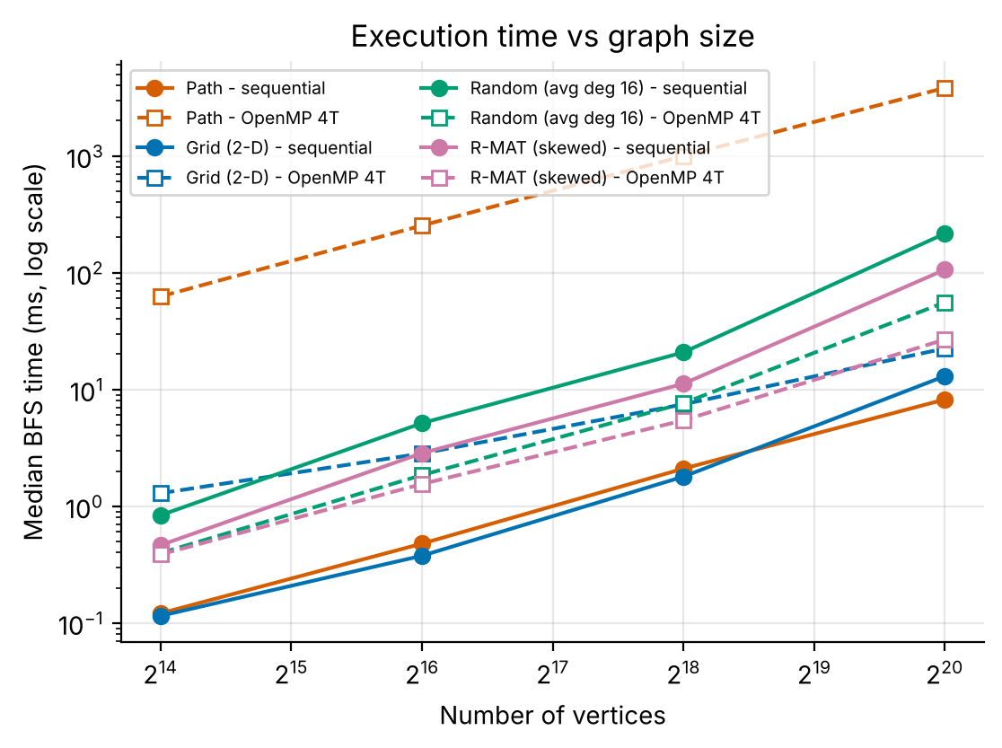 | 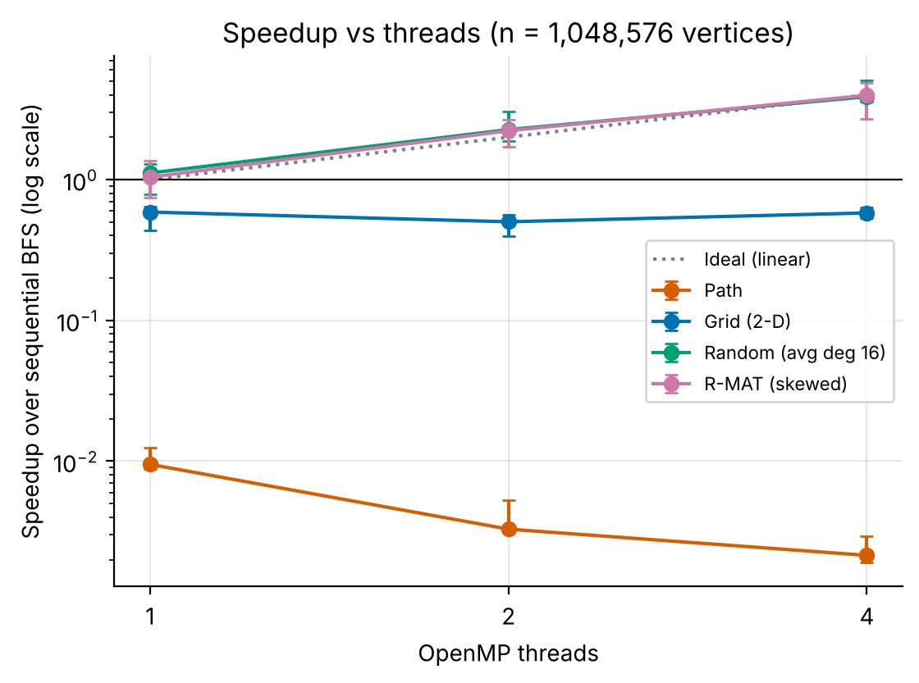
Figure 1. Median execution time versus number of vertices (log–log). Solid: sequential; dashed: OpenMP with 4 threads. | Figure 2. Speedup over the sequential baseline versus threads for 1,048,576 vertices. Markers are medians; bars run from (fastest sequential run ÷ slowest parallel run) to (slowest sequential run ÷ fastest parallel run).

7.1 Execution time and speedup
Figure 1 shows how the sequential time grows. Each step of 4× in vertices costs about 4× in time for the path, but going from 2¹⁸ to 2²⁰ vertices multiplies the sequential time by 3.9 (path), 7.3 (grid), 10.4 (random) and 9.5 (R-MAT); the throughput of the random graph falls from 101 MTEPS to 39 MTEPS. We did not measure cache events, so we can only suggest that the larger graph, which no longer fits comfortably in the fast caches, causes many more memory stalls. The parallel version behaves very differently by structure (Figure 2, Table 4; efficiency in Figure 5). On the random and R-MAT graphs with 1,048,576 vertices and 4 threads, the speedup is 3.88 and 3.97, which is close to the ideal value of 4 (efficiency 0.97 and 0.99). On the grid the parallel code was slower than the baseline at every size and thread count (speedup 0.59, 0.50 and 0.58 for 1, 2 and 4 threads); more threads did not help. On the path it was 466 times slower with four threads, and adding threads made it slower still.
Two details deserve a comment. First, with two threads the efficiency of the random and R-MAT graphs at the largest size is slightly above 1 (1.13 and 1.11), and one-thread parallel BFS is already a little faster than the sequential baseline (1.11 and 1.04). Efficiency here is measured against the sequential program, not against the one-thread parallel program, and the CV of these runs is 6–14%, so we treat these values as “about 1”, not as true superlinear scaling. Second, the very small runs (below a millisecond) have a CV of up to 50%, so their speedups are uncertain; the error bars in Figure 2 and the Speedup_Low/Speedup_High columns of the derived CSV show this.
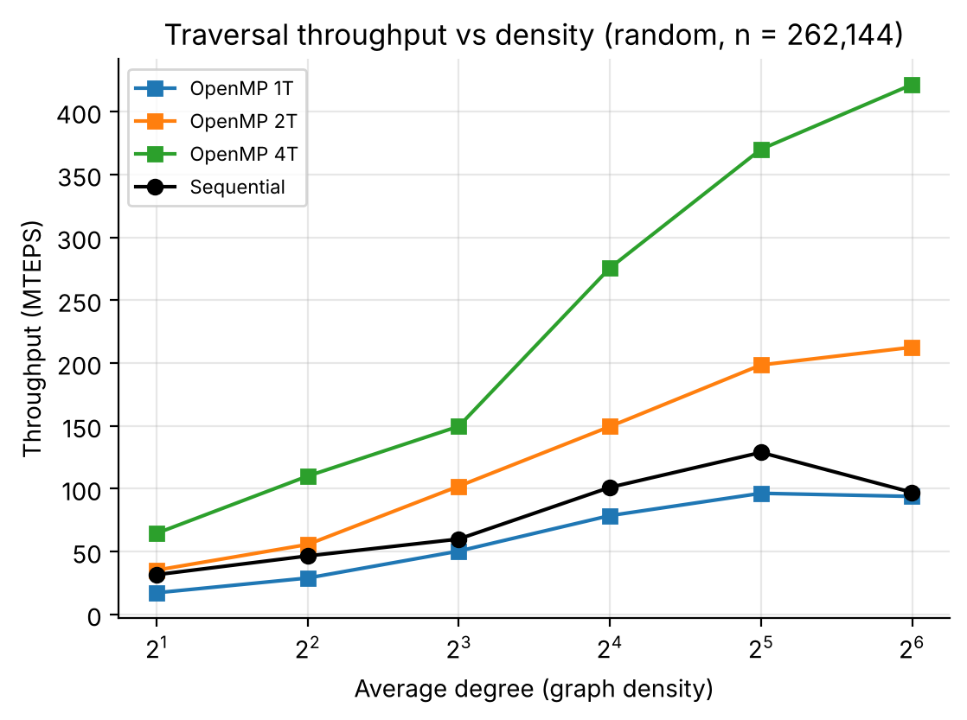 | 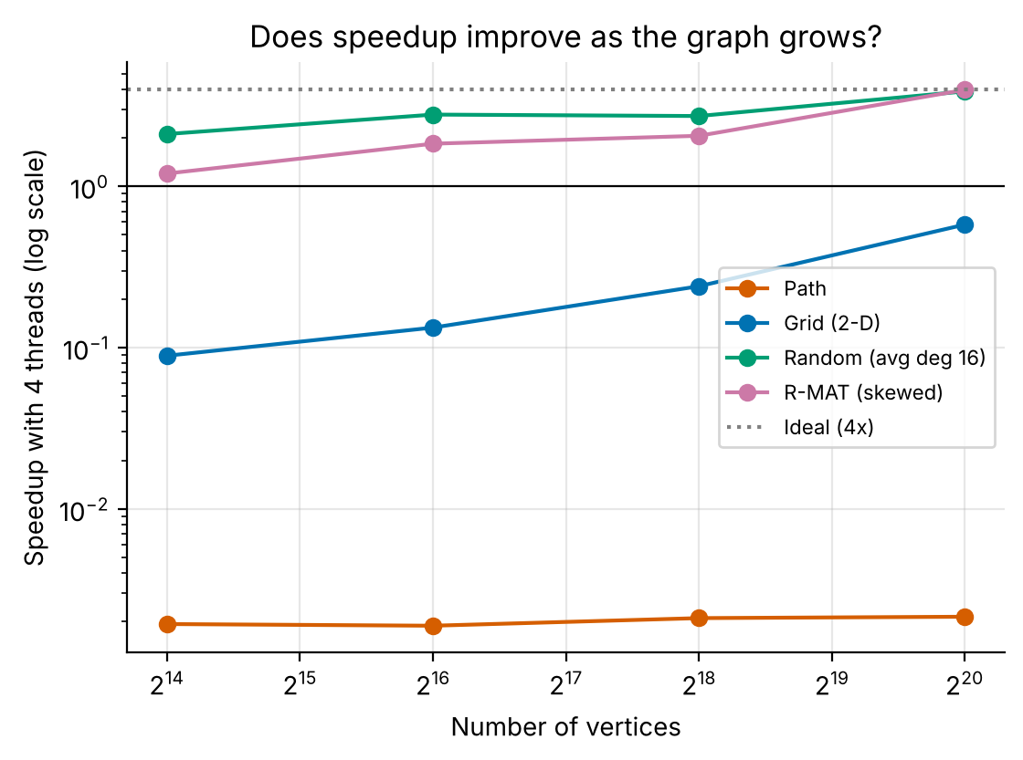
Figure 3. Traversal throughput (MTEPS) versus average degree for random graphs with 262,144 vertices. | Figure 4. Speedup with 4 threads versus graph size for the four structures.

7.2 Effect of graph size and density
Figure 4 and Table 5 show the effect of size. On the random graph the 4-thread speedup grows from 2.11 at 2¹⁴ vertices to 3.88 at 2²⁰, and on the R-MAT graph from 1.20 to 3.97; the growth is not strictly monotonic (the random graph gives 2.79 at 2¹⁶ and 2.73 at 2¹⁸, within the noise of these runs). On the grid it rises from 0.09 to 0.58 but never reaches 1. On the path it stays between 0.0019 and 0.0021: more vertices only mean more levels, so the problem does not improve with size. Figure 3 shows the effect of density. With 4 threads the throughput increases from 64.3 MTEPS (average degree 2) to 421.6 MTEPS (degree 64), while the sequential program stays between 31.5 and 128.8 MTEPS. A denser graph gives each frontier vertex more edges to scan, so there is more work between barriers and the fixed synchronization cost matters less.
Table 6. Density sweep on random graphs with 262,144 vertices (medians of 7 runs).
Avg. degree | Levels | Seq. time (ms) | Seq. MTEPS | 1T speedup / MTEPS | 2T speedup / MTEPS | 4T speedup / MTEPS
2.0 | 28 | 8.0 | 31 | 0.54 / 17 | 1.11 / 35 | 2.05 / 64
4.0 | 14 | 11.3 | 46 | 0.62 / 29 | 1.20 / 55 | 2.37 / 110
8.0 | 9 | 17.5 | 60 | 0.84 / 50 | 1.70 / 102 | 2.50 / 150
16.0 | 7 | 20.8 | 101 | 0.78 / 78 | 1.48 / 149 | 2.73 / 276
32.0 | 6 | 32.6 | 129 | 0.75 / 96 | 1.54 / 198 | 2.87 / 370
64.0 | 5 | 86.5 | 97 | 0.97 / 94 | 2.19 / 212 | 4.35 / 422

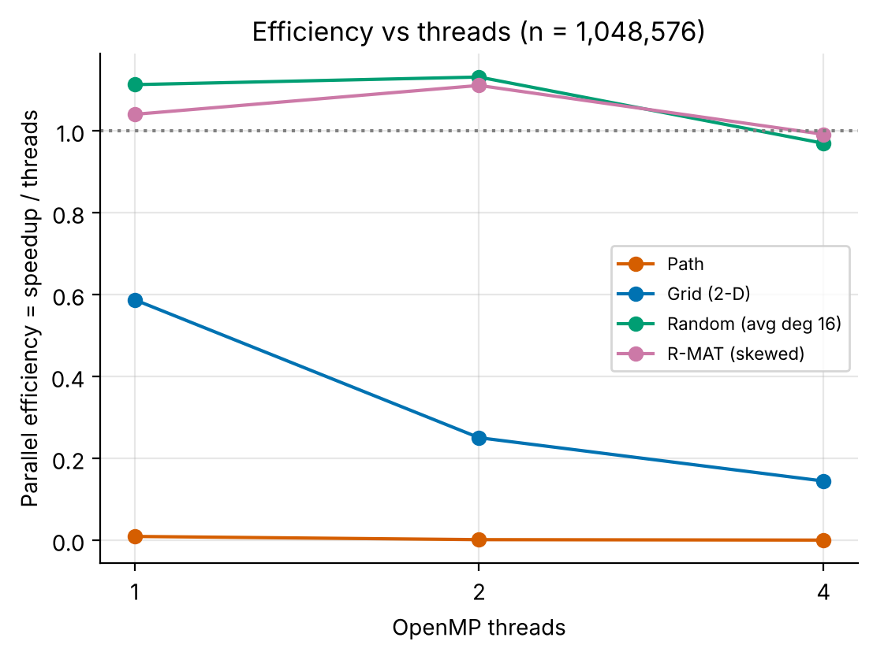 | 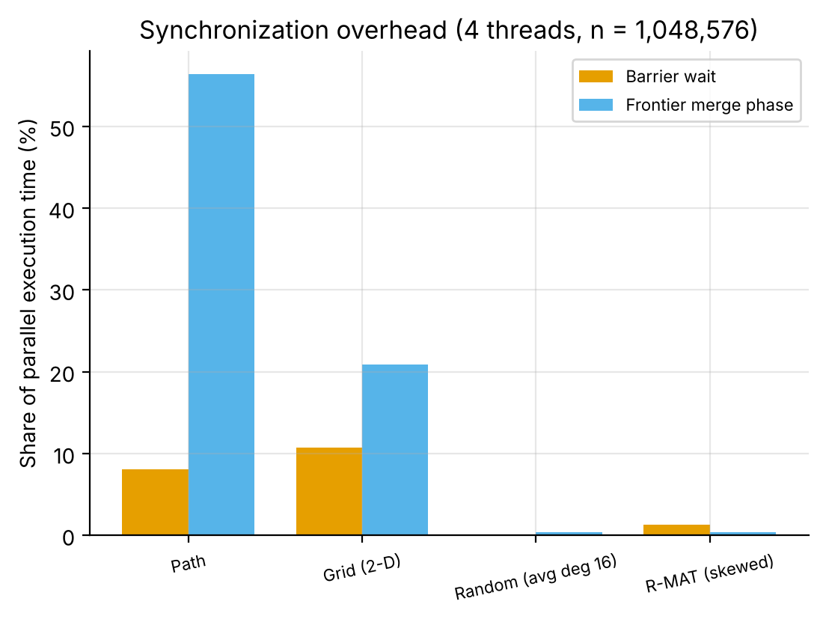
Figure 5. Parallel efficiency versus threads for 1,048,576 vertices (efficiency = speedup / threads). | Figure 6. Share of the parallel time spent waiting at the barrier and in the frontier-merge phase (4 threads, 1,048,576 vertices); approximate, from separate instrumented runs.

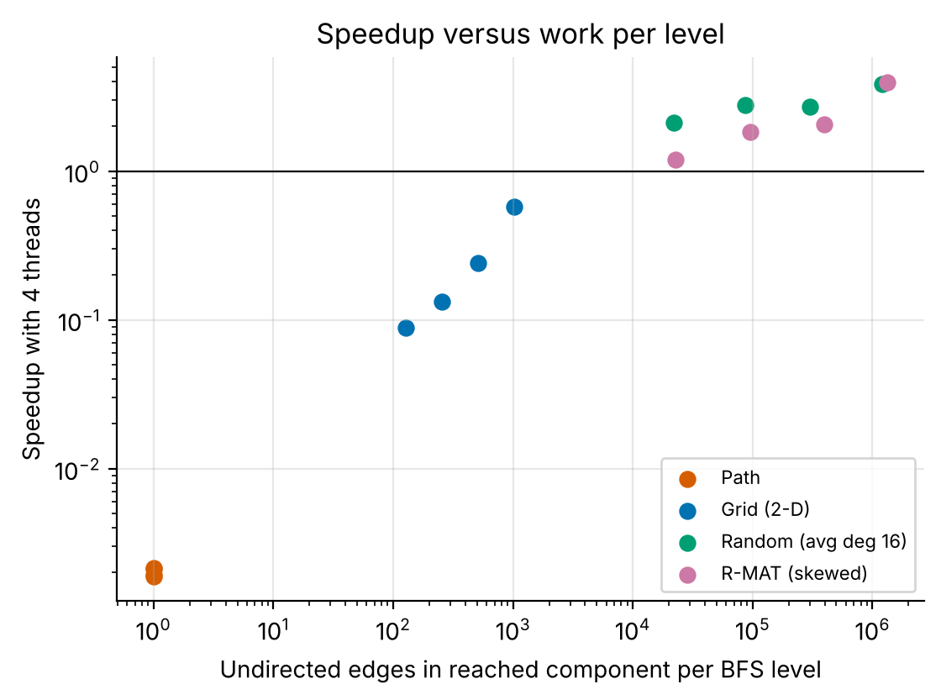
Figure 7. Speedup with 4 threads versus the average number of undirected edges in the reached component per BFS level (all four sizes of every structure).

7.3 Why the structures behave differently: synchronization and work per level
The path has one vertex per level, so there is nothing to share, yet every level still executes the full set of steps of Section 6.3. We divide the median time of the largest path by its number of levels: the cost per level is 0.82 µs with one thread, 2.38 µs with two and 3.65 µs with four, compared with 7.8 ns per vertex in the sequential program. Even with one thread the parallel code pays for its loop set-up and barrier steps, and the cost per level grows with the number of threads; the likely reason is that more threads have to meet at each barrier, but we did not test this directly. In the instrumented runs (Figure 6) the merge phase takes 56% and the barrier wait 8% of the 4-thread time on the path; the remaining time presumably lies in the expand phase and in loop start-up, which we could not time separately.
The grid has 2,047 levels and an average of about 1,023 undirected edges per level at the largest size. The sequential program needs only 6.3 µs per level, while the one-thread parallel program needs 10.8 µs per level, so the extra per-level cost is not paid back by the small amount of work, and the grid’s parallel time barely changes between one and four threads (22.1, 25.9 and 22.4 ms). The random and R-MAT graphs have only 7 and 6 levels with about 1,198,360 and 1,340,216 undirected edges per level (each edge is scanned from both ends), so the barrier wait is only 0.1% and 1.2% and the merge phase 0.3% and 0.4% of the time. Figure 7 summarises the pattern: speedup rises with the work available per level. Because structure, size and work per level change together in our data, this figure shows an association, not a controlled proof; a cleaner test would vary the number of levels while keeping the number of edges fixed.

7.4 Hypotheses and comparison with the literature
- H1 supported. Random and R-MAT graphs reached speedups of 3.88 and 3.97 with 4 threads, whereas the grid (0.58) and the path (0.0021) were slower than sequential.
- H2 partly supported. Speedup grows with size overall for random, R-MAT and grid graphs (not strictly at every step) but not for the path, and the grid still does not beat the baseline at 2²⁰ vertices.
- H3 supported for the parallel code. Throughput with 4 threads rose from 64.3 to 421.6 MTEPS; the sequential code rose less and fell slightly at degree 64.
These trends are consistent with the literature. Our random-graph results resemble the strong multicore results reported for random-graph benchmarks [4], and the observation of Beamer et al. [2] that the frontier of low-diameter graphs becomes very large matches our graphs with 5–7 levels. The 2024 OpenMP study [7] reports speedups of tens of times on 28–48 core machines (according to its abstract as we read it), and that speedup depends on the input graph. Our four-thread speedups of about 4 are in line with that picture, but the numbers cannot be compared directly because the hardware, thread counts and graphs are different. Our contribution is a small, reproducible, side-by-side measurement that makes the cost of barriers visible for graphs with many levels.

8 Limitations and Threats to Validity
- Hardware. Only one machine was used: a shared cloud virtual machine with 4 logical CPUs. We cannot tell whether these are physical cores or hyper-threads, and neighbouring workloads may disturb timings. We could test only 1, 2 and 4 threads, so saturation, NUMA effects and many-core behaviour are not visible.
- Measurement noise. The CV exceeds 15% in 13 of 84 configurations (maximum 50%), mostly for runs shorter than a millisecond, and the slowest single run was 2.5 times its median. The sequential baseline of the smallest random graph is itself noisy (CV 50%), so speedups for small graphs are uncertain. We kept every run, including these outliers, and report the median and the range; small differences (for example between two thread counts on the grid) should not be over-interpreted.
- Datasets. Only synthetic graphs were used. Real graphs (SNAP, SuiteSparse) have community structure, hubs and locality that may change the results. The largest graph has about one million vertices, small compared with the literature.
- Implementation constraints. The parallel code is a plain top-down level-synchronous BFS with one fixed schedule (dynamic, chunk 64) and one start vertex per graph. We did not tune the chunk size, use bitmaps or direction-optimization, or test many start vertices.
- Overhead measurement. Synchronization and merge times come from separate instrumented runs and are shown as a share of the timed run, so they are approximate; loop-scheduling cost was not separable. Memory use is an analytic estimate, not measured.
- Baseline choice. All speedups are relative to our own sequential BFS. A faster baseline (for example direction-optimizing BFS) would lower the speedups of the random and R-MAT graphs.
- Scope. No GPU, MPI or energy measurements were made.

9 Conclusion and Future Work
Answer to the research question. Graph structure matters more than graph size. A level-synchronous OpenMP BFS scaled almost linearly (up to 4 threads) on random and R-MAT graphs with 1,048,576 vertices (speedup 3.88 and 3.97 on 4 threads), because they have few levels with large frontiers. It was slower than the sequential baseline on the grid and about 466 times slower on the path, because every level costs a fixed synchronization overhead that is not covered by the small amount of work in each level. Growing the graph helps only when the extra vertices widen the frontiers, and denser graphs give higher throughput. In practice, a parallel BFS should only be used when the expected work per level is large.
Future research directions.
- Hybrid and adaptive traversal: switch to a sequential loop when the frontier is small and to parallel expansion when it is large, and add bottom-up steps as in direction-optimizing BFS [2]; find the frontier-size threshold on our machine.
- Real graphs and more hardware: repeat the study on SNAP/SuiteSparse road and social graphs, use more cores and NUMA machines, and test many start vertices.
- GPU implementation: compare with a CUDA or linear-algebra-based GPU BFS [6], including data-transfer cost.
- Controlled structure experiment: generate graphs with the same number of edges but different numbers of levels to separate the effect of depth from the effect of size.
- Tuning and energy: study schedule and chunk size, bitmap visited sets and the energy-delay trade-off of using more threads.

10 References
[1] C. E. Leiserson and T. B. Schardl, “A work-efficient parallel breadth-first search algorithm (or how to cope with the nondeterminism of reducers),” in Proc. 22nd ACM Symp. Parallelism in Algorithms and Architectures (SPAA ’10), 2010, pp. 303–314, doi: 10.1145/1810479.1810534.
[2] S. Beamer, K. Asanović, and D. Patterson, “Direction-optimizing breadth-first search,” in Proc. Int. Conf. High Performance Computing, Networking, Storage and Analysis (SC ’12), 2012. [Online]. Available: http://dl.acm.org/citation.cfm?id=2388996.2389013 (author copy: https://people.eecs.berkeley.edu/~krste/papers/beamer-sc2012.pdf)
[3] A. Buluç and K. Madduri, “Parallel breadth-first search on distributed memory systems,” in Proc. Int. Conf. High Performance Computing, Networking, Storage and Analysis (SC ’11), 2011. arXiv:1104.4518.
[4] V. Agarwal, F. Petrini, D. Pasetto, and D. A. Bader, “Scalable graph exploration on multicore processors,” in Proc. ACM/IEEE Int. Conf. High Performance Computing, Networking, Storage and Analysis (SC ’10), 2010, pp. 46:1–46:11, doi: 10.1109/SC.2010.46.
[5] L. Dhulipala, G. E. Blelloch, and J. Shun, “Theoretically efficient parallel graph algorithms can be fast and scalable,” ACM Trans. Parallel Comput., vol. 8, no. 1, 2021, doi: 10.1145/3434393.
[6] C. Yang, A. Buluç, and J. D. Owens, “GraphBLAST: A high-performance linear algebra-based graph framework on the GPU,” ACM Trans. Math. Softw., 2022, doi: 10.1145/3466795.
[7] S. L. Gonzaga de Oliveira, M. I. Santana, D. N. Brandão, and C. Osthoff, “An OpenMP-based breadth-first search implementation using the bag data structure,” Concurrency Comput.: Pract. Exper., vol. 36, no. 16, 2024, doi: 10.1002/cpe.8119.
[8] S. Beamer, K. Asanović, and D. Patterson, “The GAP benchmark suite,” arXiv:1508.03619, 2015 (rev. 2017).

