Individual Technical Note — Student 2
OpenMP parallel BFS, thread scaling and synchronization
CS4-S01 Parallel Breadth-First Search — BCSE412L Parallel Computing | [Student 2 name, Reg. No.] | Batch [ID]

1 My contribution
I implemented the level-synchronous parallel BFS in C++ with OpenMP (03_Girlfriend_OpenMP_BFS/bfs_par.hpp and bfs_par_main.cpp), ran it with several thread counts, measured execution time, speedup, efficiency and traversal throughput, and analysed synchronization, parallel overhead and scalability. I used the graph code, start-vertex rule, timing convention and correctness checks prepared by Student 1 so that the two programs are directly comparable.

2 Parallel design and synchronization
BFS is parallelized level by level. The frontier (the vertices at distance L) is shared among threads; the next frontier (distance L+1) is built while this happens. The whole traversal is inside one parallel region, so threads are created once, not once per level.
- Race on the visited flag. Two threads may reach the same unvisited vertex v in the same level. The distance array is an array of std::atomic<int>. A thread first reads dist[v] (cheap); if it is −1, it executes compare_exchange from −1 to L+1. Exactly one thread succeeds and only that thread appends v to the next frontier, so there are no duplicates and no lost updates. No lock is needed.
- Building the next frontier without contention. Each thread appends to its own private buffer (aligned to cache lines to avoid false sharing). After a barrier one thread computes prefix sums of the buffer sizes; every thread then copies its buffer to its own disjoint slice of the next-frontier array, so these writes need no atomics.
- Level separation. OpenMP barriers (the implicit barrier of single constructs and an explicit barrier) guarantee that level L is completely expanded before level L+1 starts. This is what makes the distances equal to the true BFS distances. One thread swaps the frontier arrays and increments the level; the others read the new values after the barrier.
- Scheduling. The expand loop uses schedule(runtime), set to dynamic with chunk 64, because the work per frontier vertex depends on its degree (R-MAT hubs). The schedule can be changed with --schedule and --chunk; the tests cover static, dynamic and guided.
Correctness evidence: parallel distances equal sequential distances in all 588 timed runs, in the 12 hand-checked cases for thread counts 1, 2, 3, 4 and 8 and all three schedules, and in randomized cross-checks (1,402 checks in total, all passed).

3 Experiments and metrics
I ran 1, 2 and 4 threads (the machine has 4 logical CPUs; threads were pinned with OMP_PROC_BIND=true, OMP_PLACES=cores) on four structures and four sizes plus a density sweep, with one warm-up and seven timed runs for each setting. Execution time is the median of the repeated runs. Speedup and efficiency (Student 1’s sequential BFS on the same graph is the baseline) and traversal throughput in TEPS (m_{c} = undirected edges in the reached component) are
$S_{p}=\frac{T_{seq}}{T_{p}}$ (1)
$E_{p}=\frac{S_{p}}{p}=\frac{T_{seq}}{p·T_{p}}$ (2)
$TEPS=\frac{m_{c}}{T_{p}}$ (3)
I report millions of TEPS (MTEPS). After each timed run I made one extra instrumented run that records, for every level, the expand time of each thread, giving the barrier wait (slowest thread minus average thread) and the time of the merge phase. These runs never contribute to Execution_Time.

4 Results
Table 1. Speedup, efficiency and throughput (medians of 7 runs; full table in 01_Common/data/derived/bfs_derived.csv).
Graph | n | 1 thread  speedup / eff. | 2 threads  speedup / eff. | 4 threads  speedup / eff. | MTEPS (4T) | MTEPS (seq.)
Path | 2^16 | 0.0073 / 0.0073 | 0.0028 / 0.0014 | 0.0019 / 0.0005 | 0 | 137
Path | 2^20 | 0.0095 / 0.0095 | 0.0033 / 0.0016 | 0.0021 / 0.0005 | 0 | 128
Grid | 2^16 | 0.27 / 0.27 | 0.18 / 0.089 | 0.13 / 0.033 | 46 | 347
Grid | 2^20 | 0.59 / 0.59 | 0.50 / 0.25 | 0.58 / 0.14 | 93 | 161
Random (deg 16) | 2^16 | 1.17 / 1.17 | 1.76 / 0.88 | 2.79 / 0.70 | 284 | 102
Random (deg 16) | 2^20 | 1.11 / 1.11 | 2.26 / 1.13 | 3.88 / 0.97 | 151 | 39
R-MAT (ef 8) | 2^16 | 0.86 / 0.86 | 0.94 / 0.47 | 1.84 / 0.46 | 308 | 168
R-MAT (ef 8) | 2^20 | 1.04 / 1.04 | 2.22 / 1.11 | 3.97 / 0.99 | 301 | 76

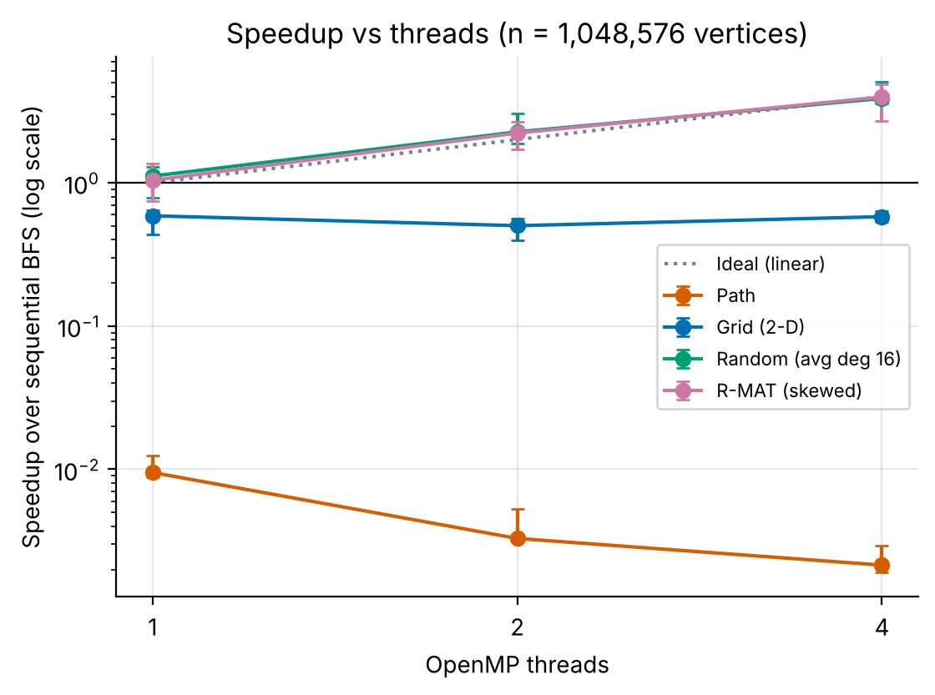 | 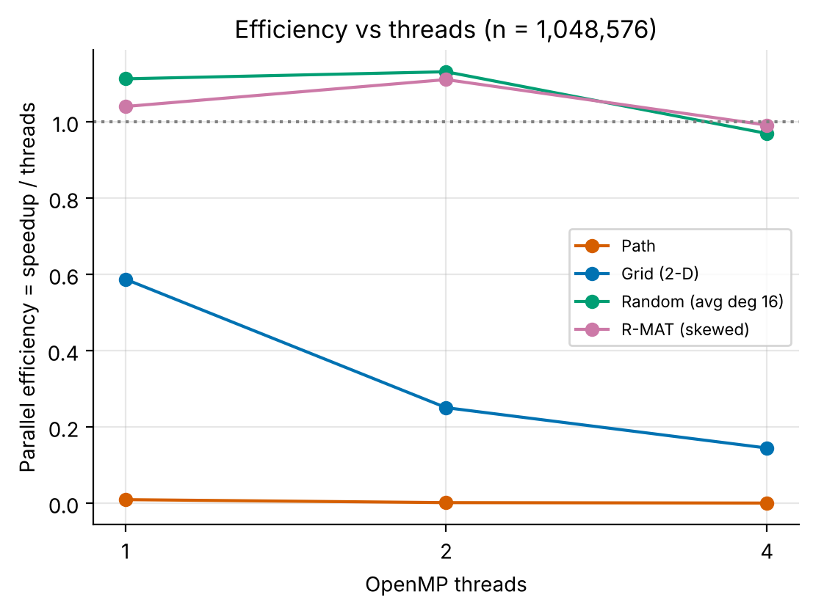
Figure 1. Speedup versus threads for 1,048,576 vertices. | Figure 2. Efficiency versus threads for 1,048,576 vertices.

Scalability across thread counts. On random and R-MAT graphs, speedup grows with threads (to 3.88 and 3.97 on four threads at 2²⁰ vertices) and efficiency stays near 0.97–0.99. At 2¹⁴ vertices the same graphs reach only 2.11 and 1.20 (efficiency 0.53 and 0.30): the whole run lasts less than a millisecond, so thread start-up and barriers take a larger share. On the grid the speedup stays below 1 (0.59, 0.50, 0.58), and on the path it falls with every added thread (0.0095, 0.0033, 0.0021).
Throughput. With four threads the random graph of 2¹⁸ vertices reaches 64.3 MTEPS at average degree 2 and 421.6 MTEPS at degree 64 (Figure 3 of the integrated report), so denser graphs make better use of the threads.

5 Synchronization and overhead analysis
Every level costs a fixed amount of synchronization, which does not depend on how much work the level contains. On the path (one vertex per level) the median time per level is 0.82 µs with one thread, 2.38 µs with two and 3.65 µs with four, against 7.8 ns for the sequential program, so the parallel code is 466 times slower with four threads. The same fixed cost is small compared with the work of a level on the random graph, which has about 1,198,360 undirected edges per level on average at 2²⁰ vertices.
Table 2. Synchronization measurements with 4 threads (from instrumented runs; approximate).
Graph (n = 2^20) | Levels | Undirected edges per level | Barrier wait (% of 4T time) | Merge phase (% of 4T time)
Path | 1048576 | 1 | 8.0 | 56.4
Grid | 2047 | 1,023 | 10.7 | 20.9
Random (deg 16) | 7 | 1,198,360 | 0.1 | 0.3
R-MAT (ef 8) | 6 | 1,340,216 | 1.2 | 0.4

The barrier wait is largest, as a share of the run, on the grid (11%) and the path (8%), and below 1.2% on the random and R-MAT graphs at this size. A plausible reason (not tested separately) is that with schedule dynamic,64 a frontier of fewer than 64 vertices is taken by a single thread while the others wait; the path and grid have many such small frontiers. The merge phase is the dominant measured overhead on the path and grid because it runs once per level. These numbers explain part but not all of the lost time; loop start-up and the barrier’s own cost inside the expand phase were not separable.

6 Limitations and what I would do next
Only up to four threads on a shared virtual machine could be tested, so saturation and NUMA effects are not visible; the CV of short runs is high; the schedule was fixed to dynamic,64; and there is no direction-optimizing or hybrid (sequential for small frontiers) variant. The next step I would try is to run small frontiers sequentially, which should remove most of the penalty on the path and grid, and to add a bottom-up step for the large frontiers of random and R-MAT graphs.

