House Price Prediction
End-to-End Machine Learning Project — King County House Sales Dataset
Author: Kalariya Tamanna
Built with Python · scikit-learn · Streamlit · Plotly

Project Overview
This project builds a complete house price prediction system using the King County House Sales dataset (21,613 records). It covers data analytics in a Jupyter Notebook (.ipynb) and an interactive Streamlit dashboard with three pages: Exploratory Data Analysis, Model Performance, and Live Price Prediction.

Dataset
Source: King County House Sales (Housing.csv) — 21,613 home sales from May 2014 to May 2015 in King County, Washington, USA. Target variable: price (sale price in USD).

Raw Features

Feature | Description
price | Target variable — sale price in USD
bedrooms / bathrooms / floors | Structural room counts
sqft_living | Interior living area (sqft)
sqft_lot | Total land lot size (sqft)
sqft_above / sqft_basement | Above-ground and basement area (sqft)
waterfront | Waterfront property flag (0/1)
view | Quality of views from property (0-4)
condition / grade | Condition rating (1-5) / Overall grade (1-13)
yr_built / yr_renovated | Year built / last renovated (0 = never)
lat / long | GPS coordinates (King County spans ~47.15-47.78 N)
sqft_living15 / sqft_lot15 | Average living area / lot size of 15 nearest neighbours
  - Engineered Features

Project Structure

Feature | Formula | Rationale
house_age | 2015 - yr_built | Captures depreciation effect
renovated_flag | 1 if yr_renovated > 0 else 0 | Renovated homes command a  premium
basement_flag | 1 if sqft_basement > 0 else 0 | Basement presence adds value
years_since_reno | 2015 - yr_renovated (or house_age if  never renovated) | More recent renovation =  higher value
sale_month | Extracted from date column | Seasonal pricing effects
sale_year | Extracted from date column | Year-over-year price trends

Methodology

Data Preprocessing

Path | Description
Housing.csv | King County source dataset
train_model.py | Standalone training script —  generates models/
requirements.txt | All Python dependencies
models/model.pkl | Saved best model (GradientBoosting)
models/scaler.pkl | StandardScaler fit on training data
notebooks/house_price_analysis.ipynb | Full EDA + training Jupyter Notebook
app/streamlit_app.py | Streamlit home page (entry point)
app/pages/1_EDA.py, 2_Model_Performance.py,  3_Predict.py | Three Streamlit dashboard pages
- Drop non-informative columns: id, date (after feature extraction), zipcode (replaced by lat/long).
- Parse the date column to extract sale_month and sale_year.
- Engineer house_age, renovated_flag, basement_flag, and years_since_reno.
- Apply log1p transformation to price to reduce right-skew (skewness: 4.02 to 0.4).
- 80/20 train/test split with random_state=42.
- StandardScaler applied to all features (fit on train set, transform both).

Models Trained
Two models from scikit-learn were trained and compared on the test set. All metrics are computed on the original price scale after reversing the log transform with expm1. The best model is saved to models/model.pkl for the Streamlit app.

Model Results
The GradientBoostingRegressor achieved the best performance with R2 = 0.889, explaining approximately 89% of the variance in house prices. The Mean Absolute Error of $72,405 means predictions are on average within ~$72K of the actual sale price.

Model | MAE | RMSE | R2
RandomForestRegressor | $72,431 | $138,095 | 0.8739
GradientBoostingRegressor (winner) | $72,405 | $129,316 | 0.8894

Streamlit Dashboard Pages

Page 1 — Exploratory Data Analysis
Dataset overview (record count, min/max price), price distribution histogram with box plot marginal (raw and log-transformed tabs), interactive Pearson correlation heatmap, box plots of price by categorical features (grade, bedrooms, condition, waterfront, floors, view),
scatter plot of any feature vs price coloured by grade, geographic price map using Plotly Mapbox with open-street-map tiles, and median price by year built line chart.
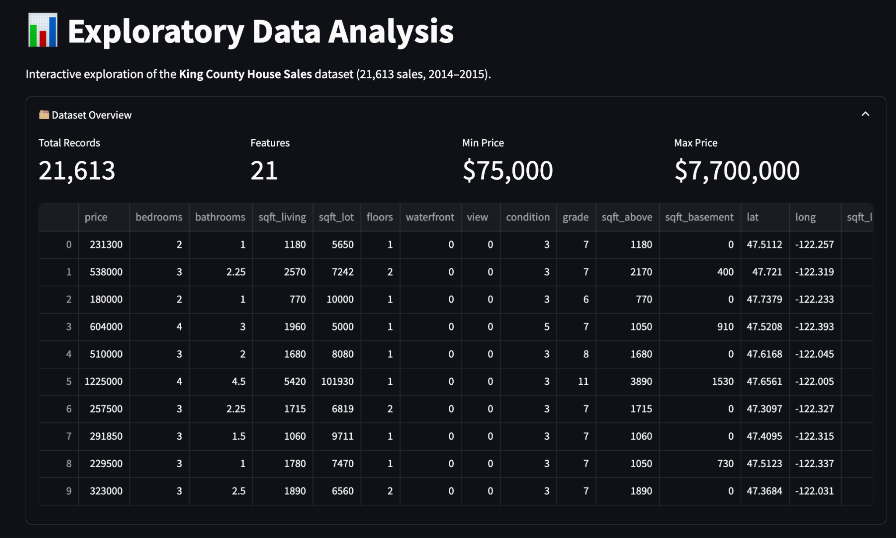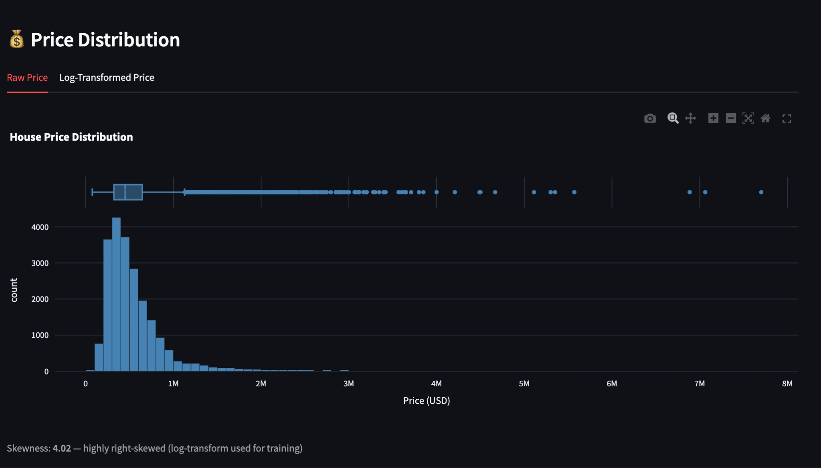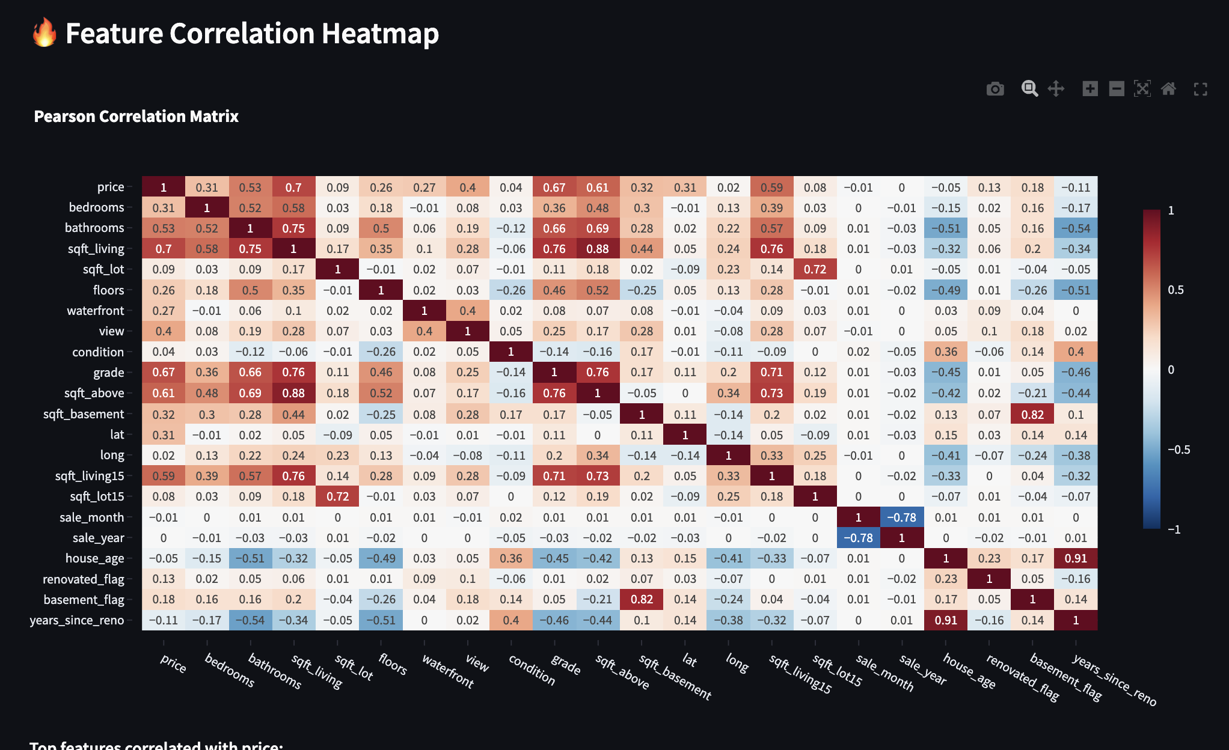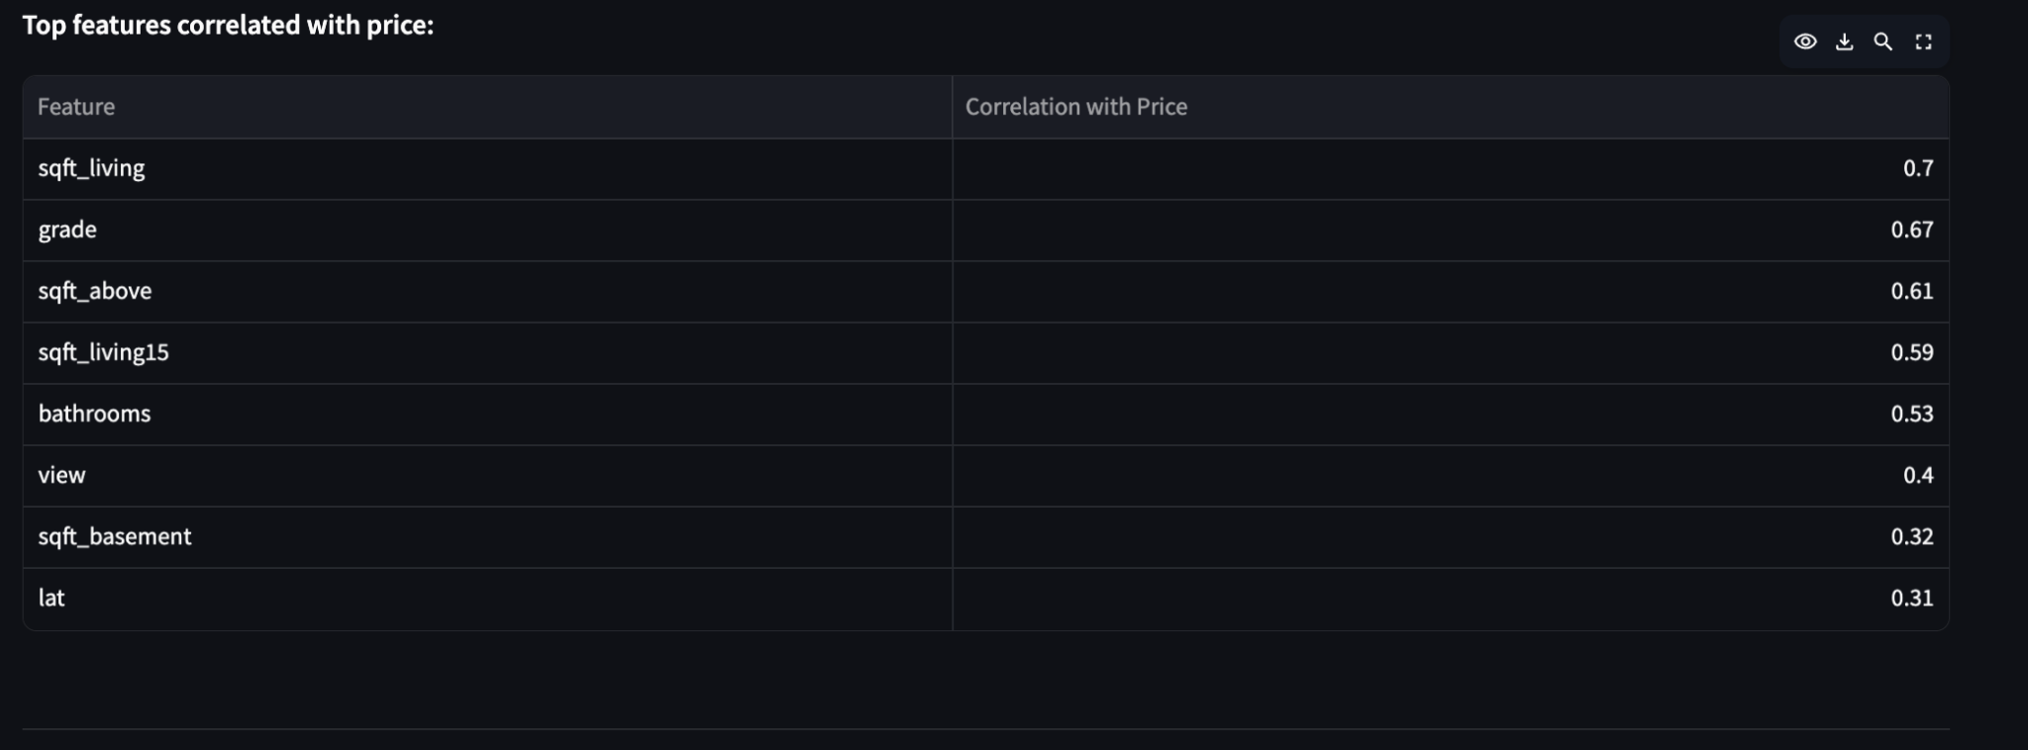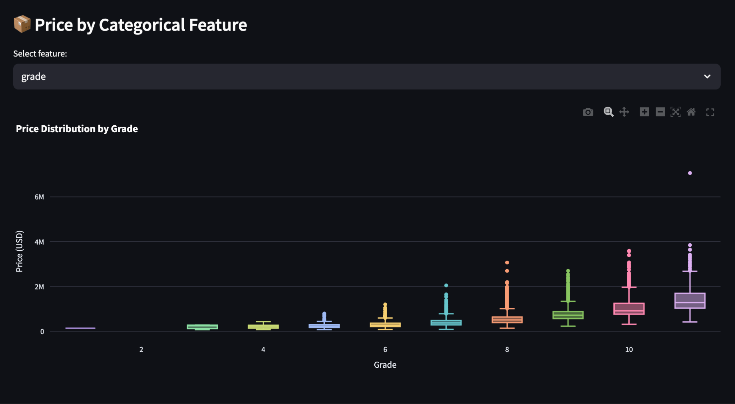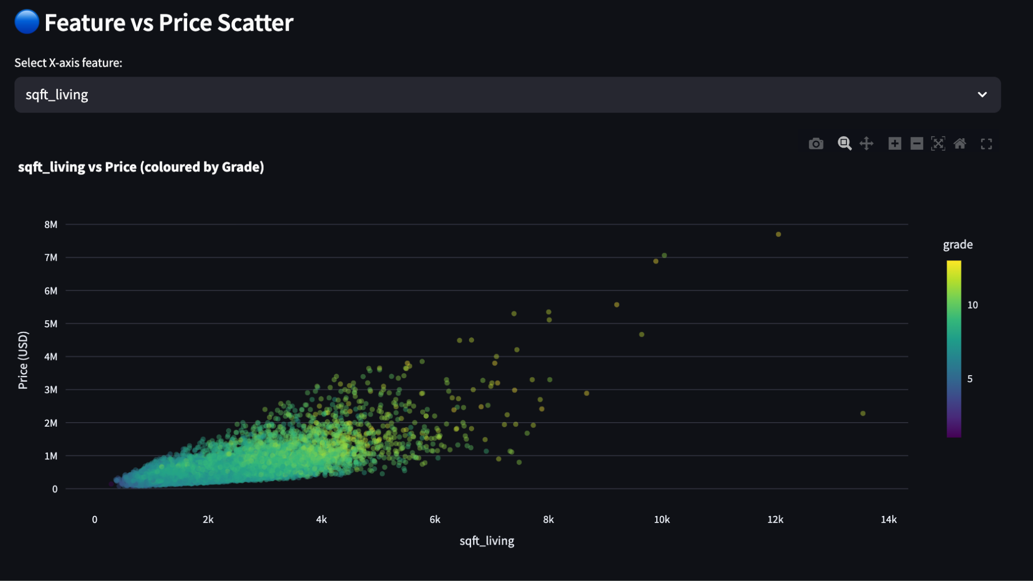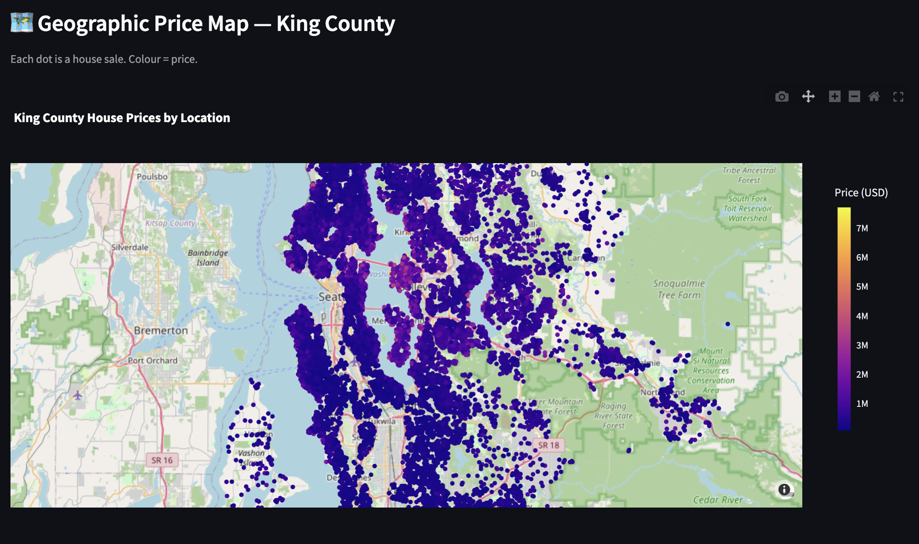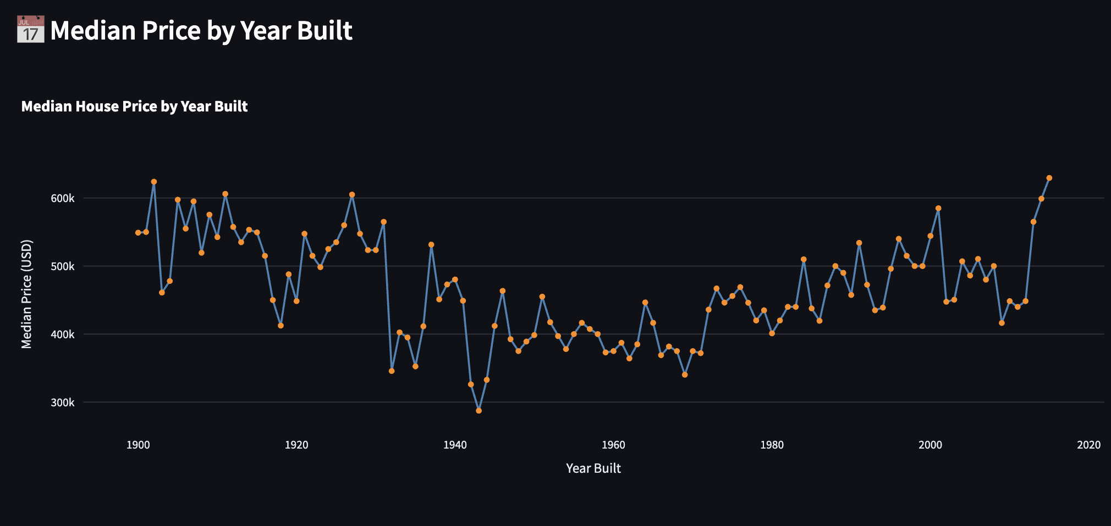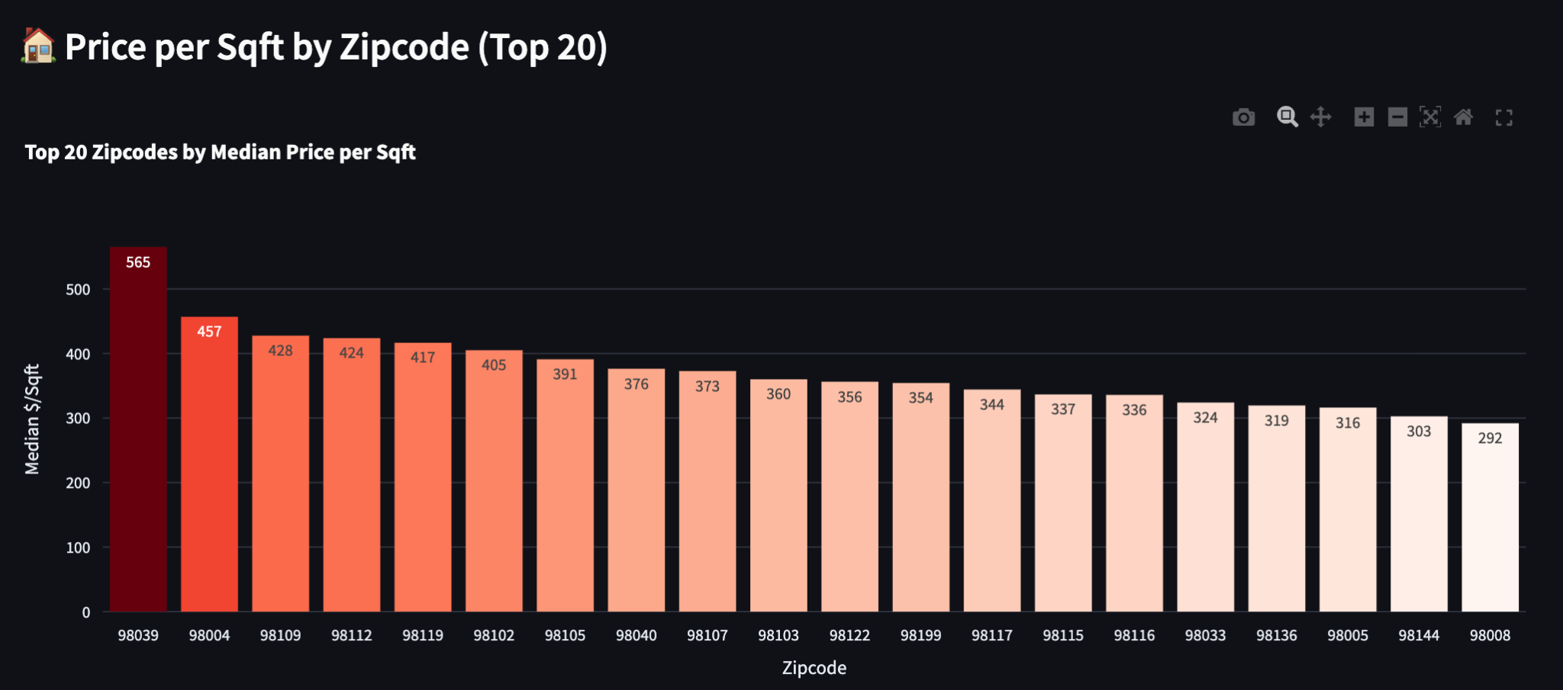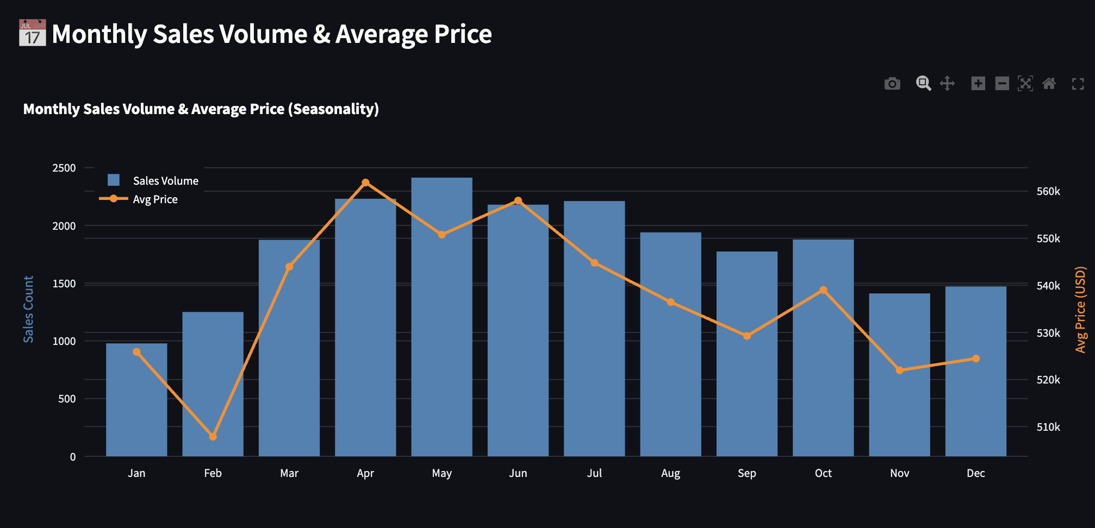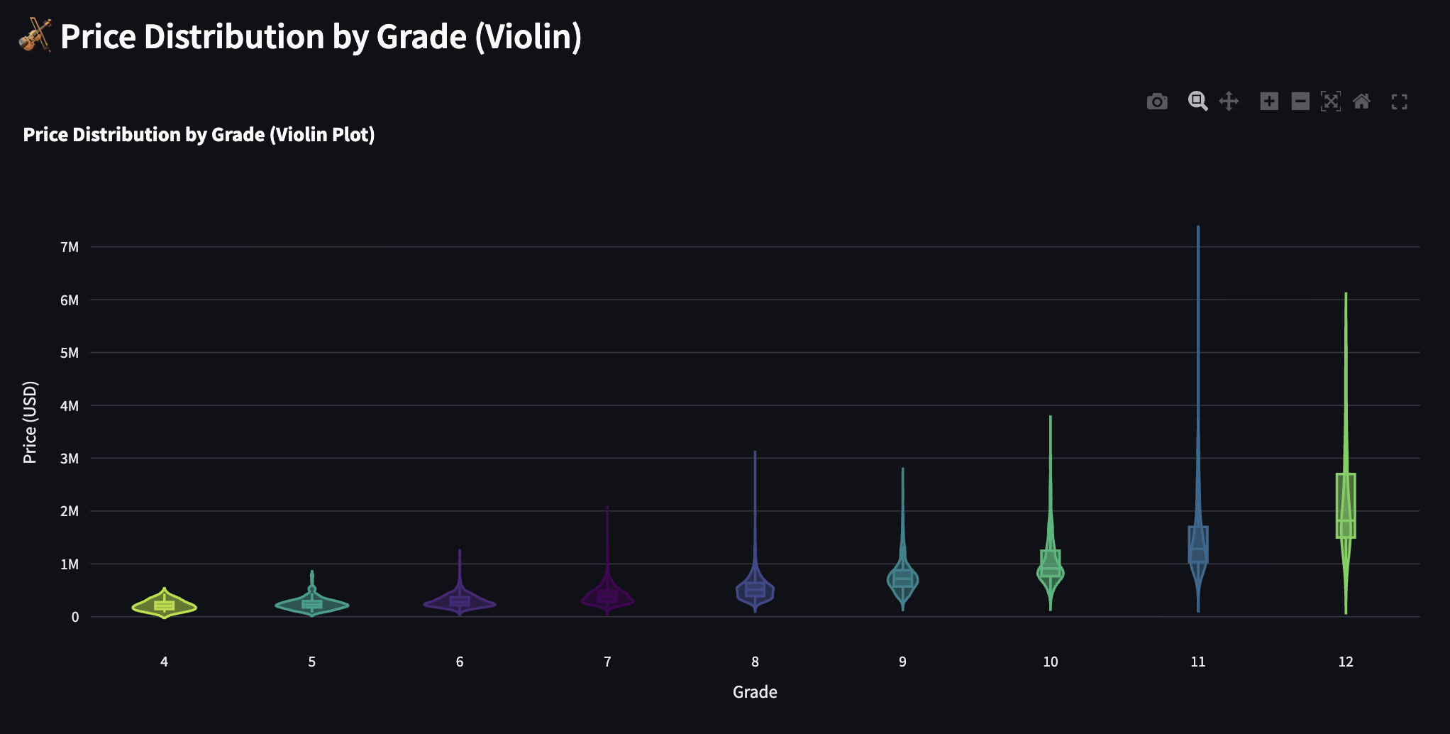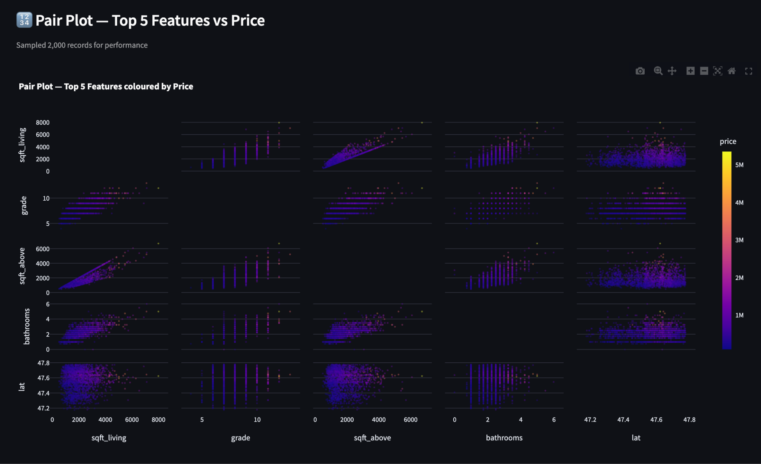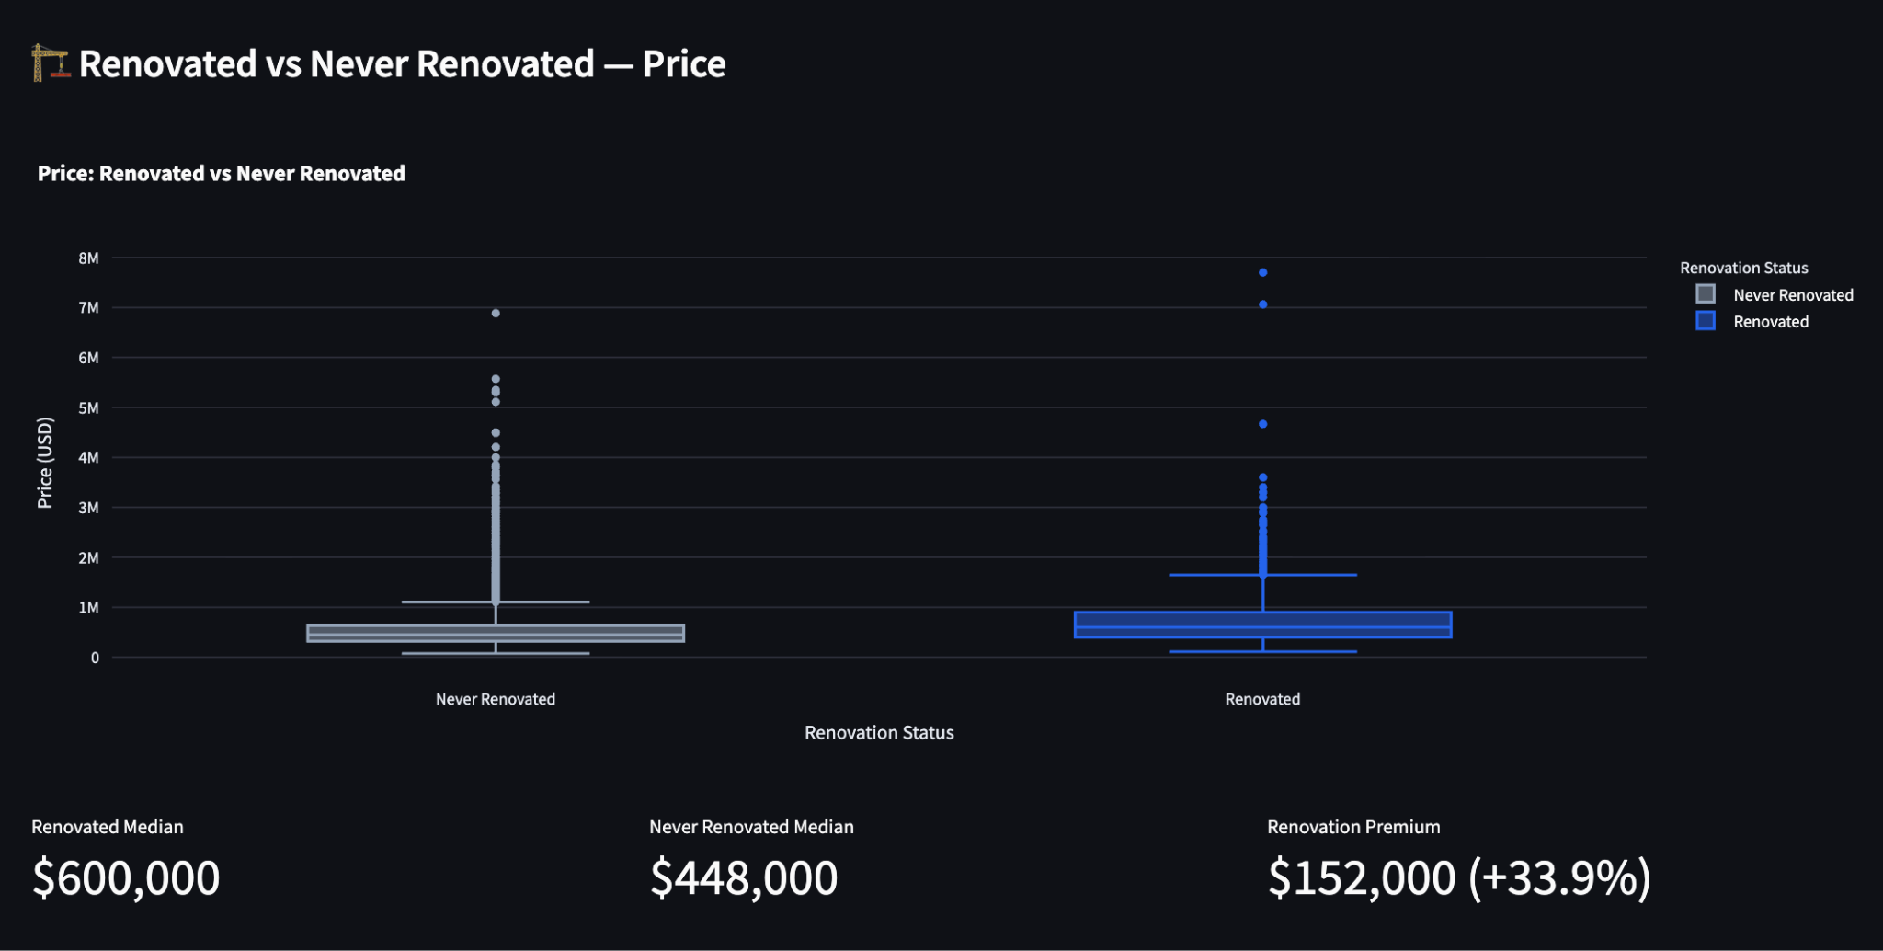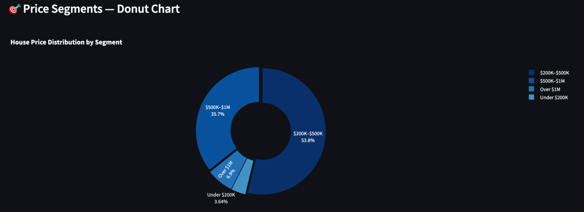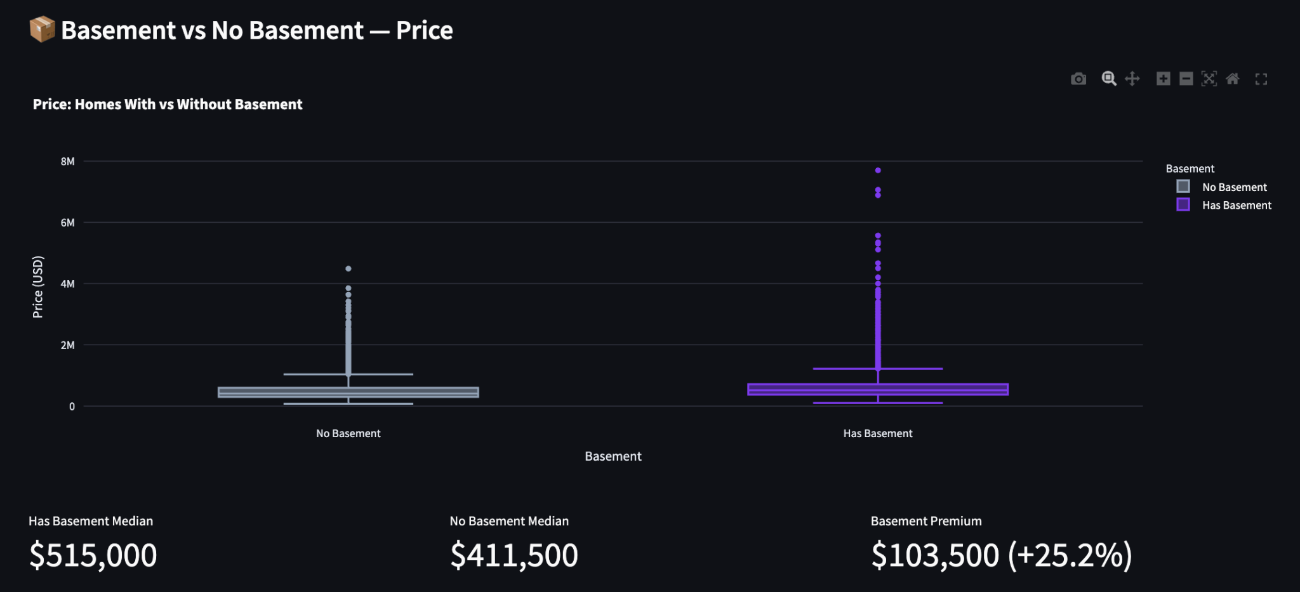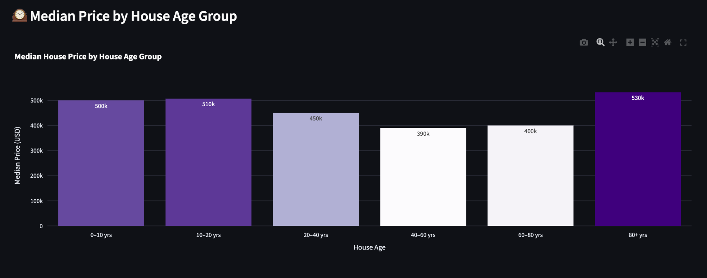

Page 2 — Model Performance
Model info banner, KPI metric cards (MAE, RMSE, R2), top-15 feature importances horizontal bar chart, actual vs predicted scatter with perfect-fit reference line, residuals histogram, and residuals vs fitted values scatter plot.
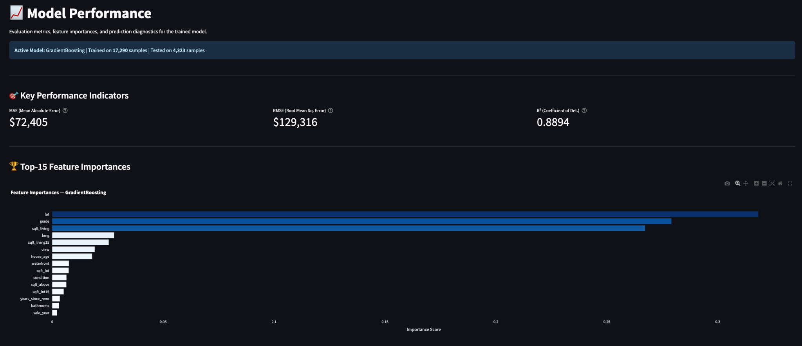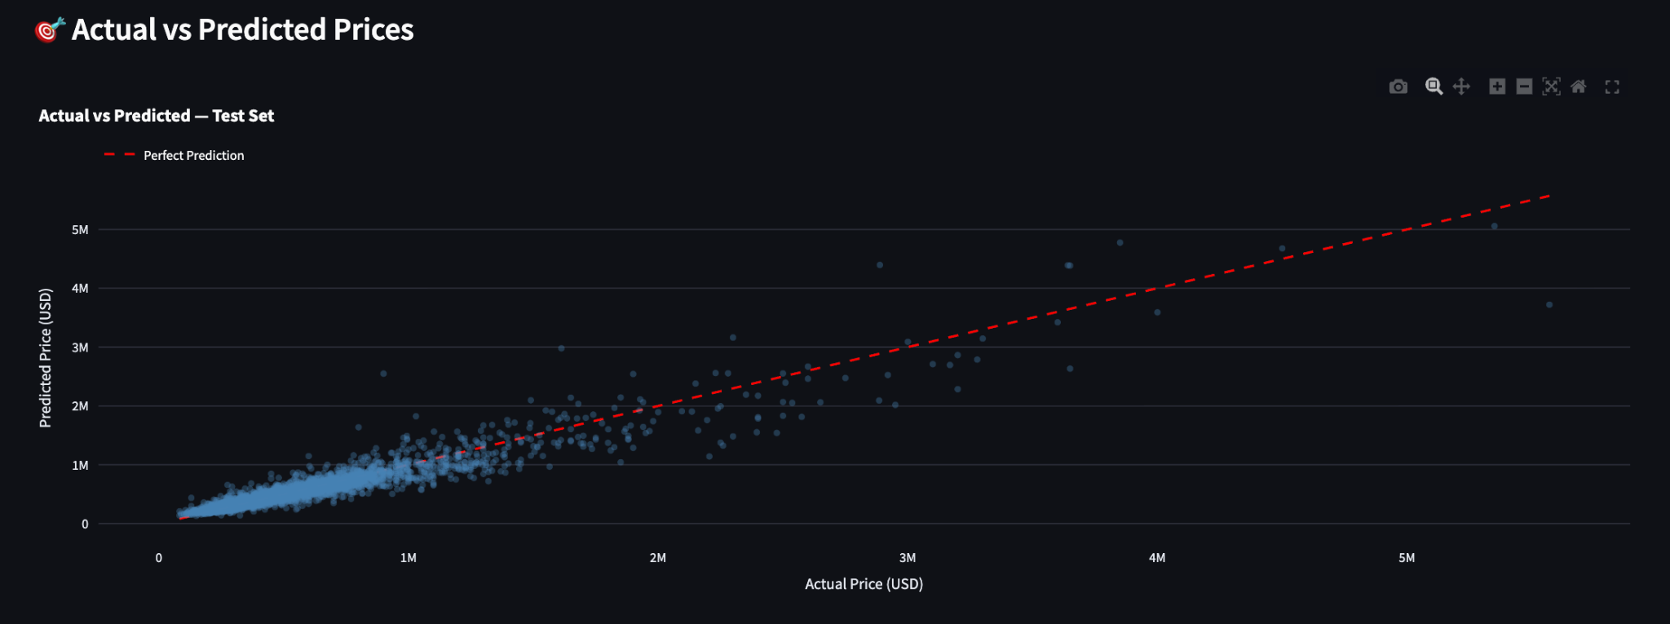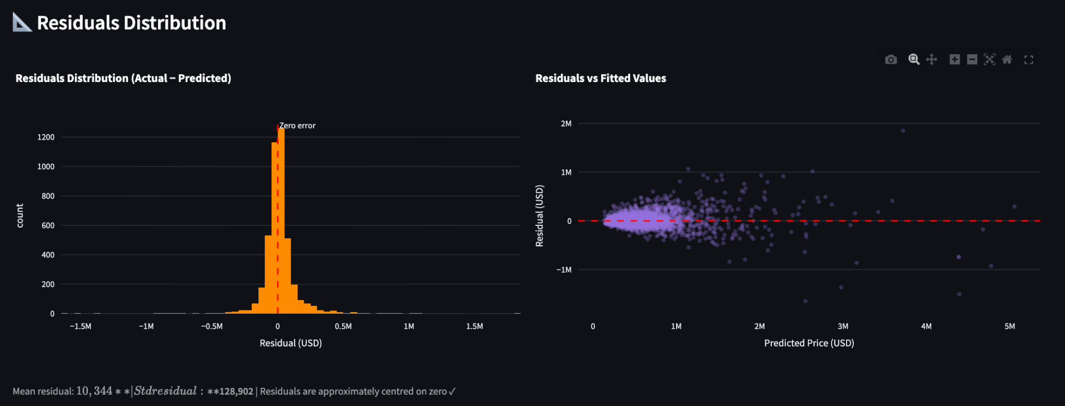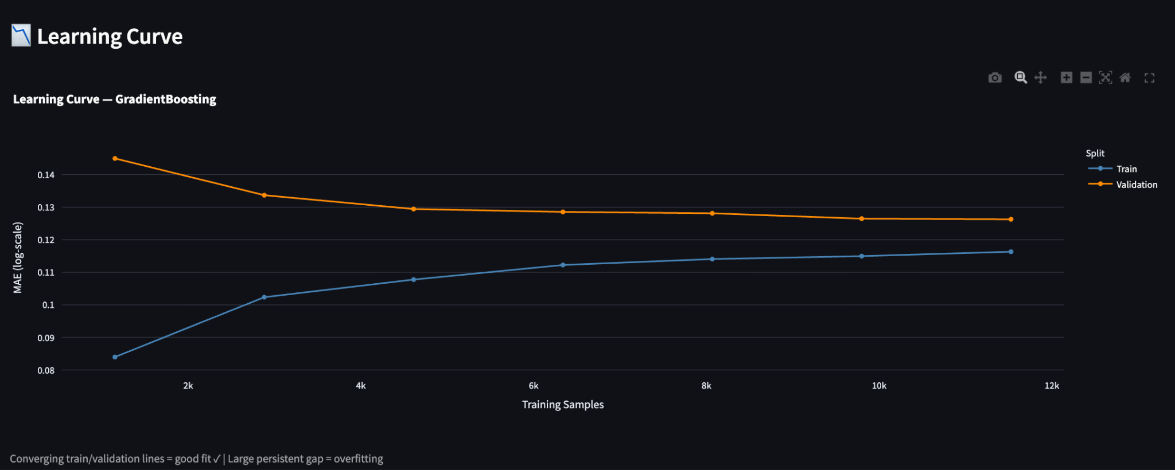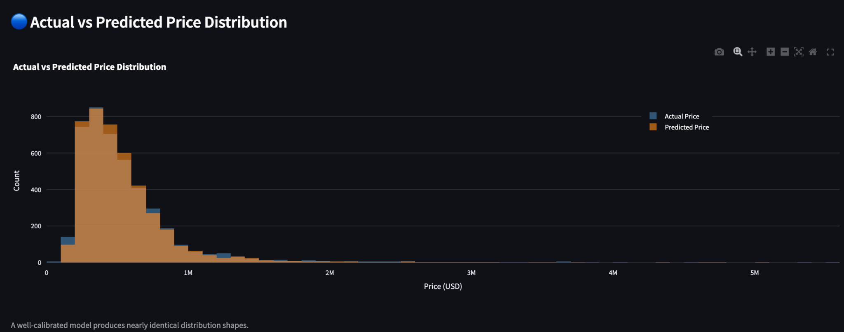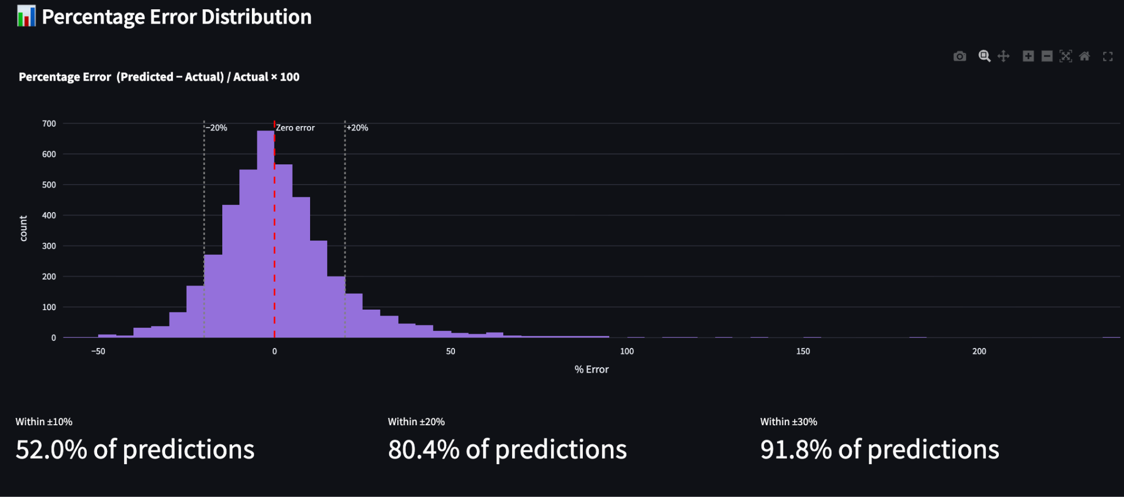

Page 3 — Interactive Price Predictor
Input form with sliders and selectboxes for all 19 raw features. Engineered features are computed automatically at prediction time. Outputs the predicted price with st.success, a confidence range of predicted price plus or minus RMSE, and an input summary table.
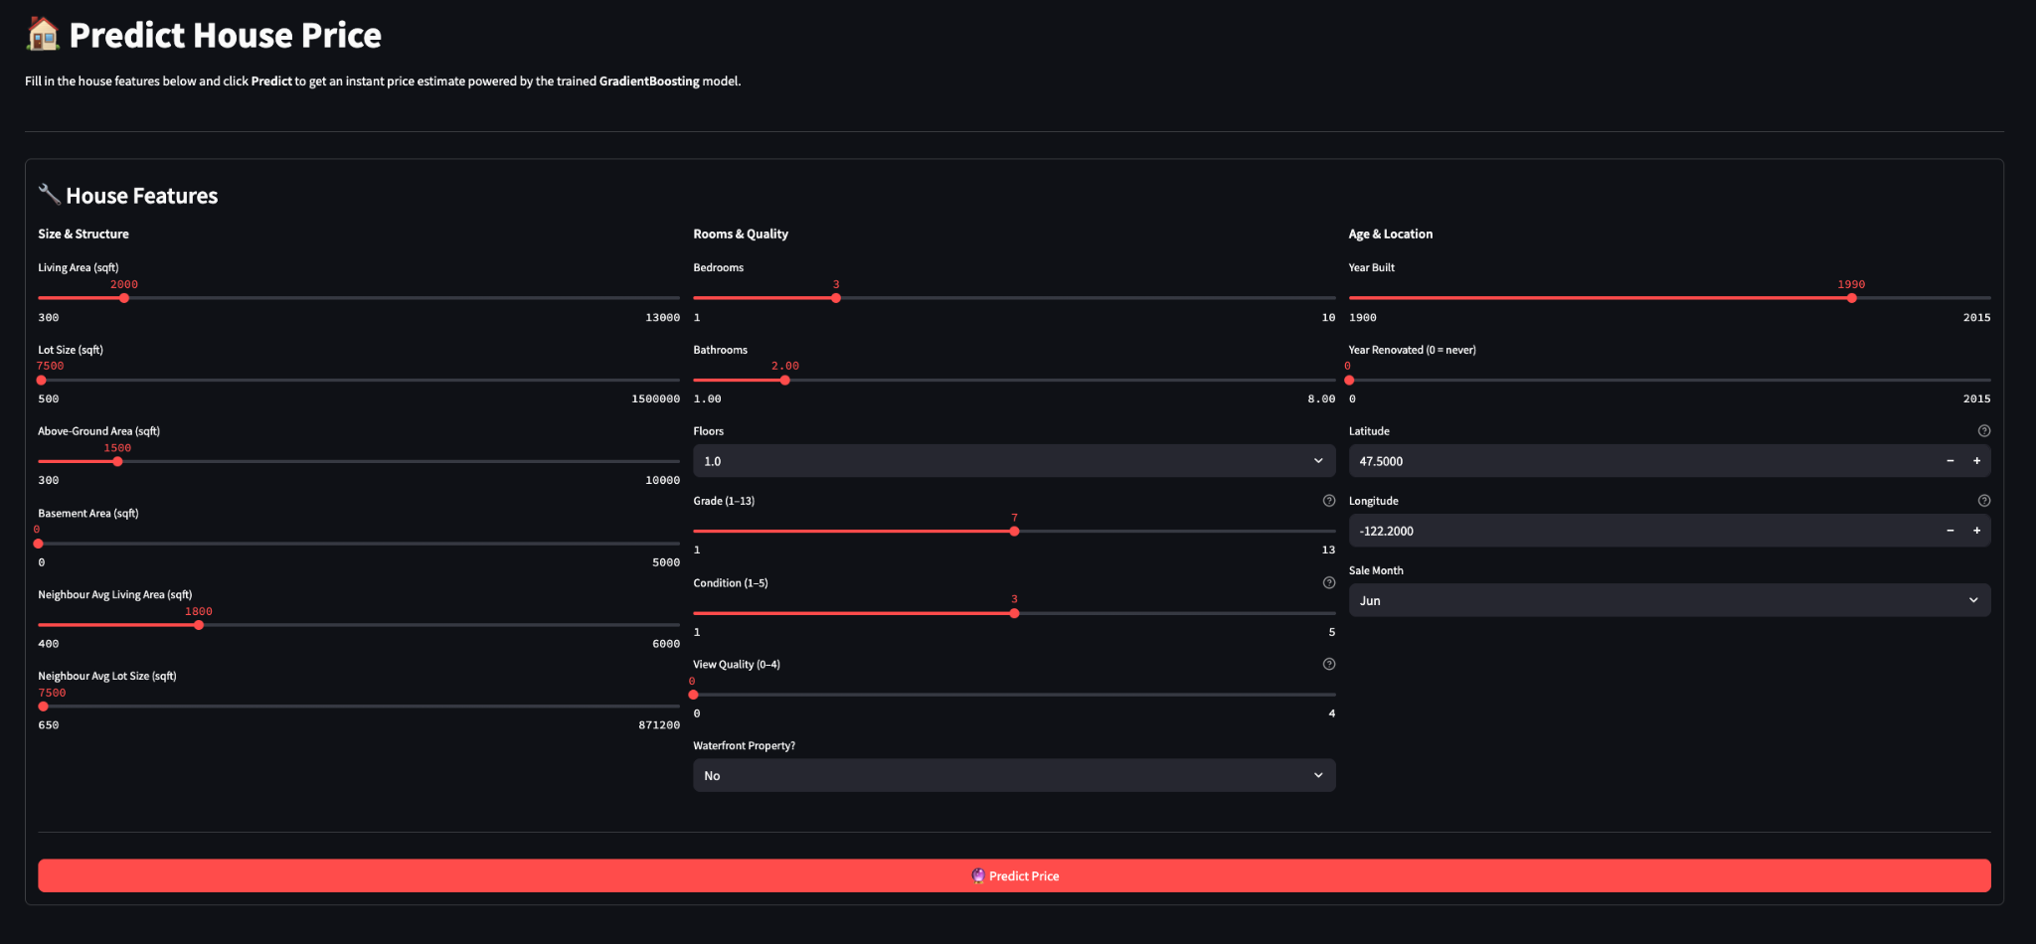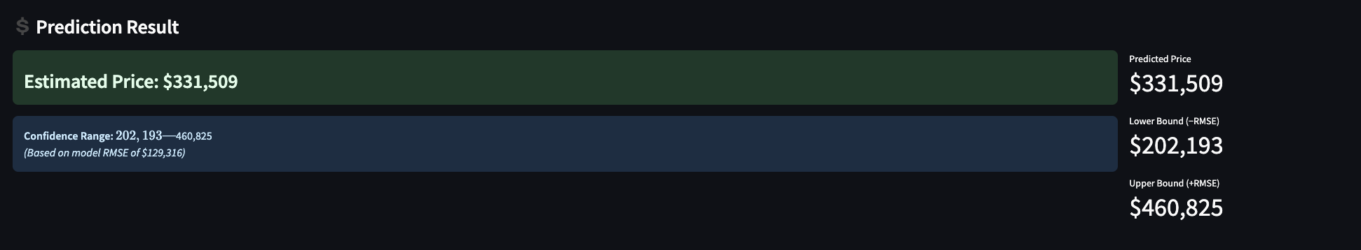

Setup and Usage
- Tech Stack

Step | Command
1. Install binary wheel (macOS) | pip3 install argon2-cffi-bindings --only-binary=:all:
2. Install dependencies | pip3 install -r requirements.txt
3. Train the model | python3 train_model.py
4. Launch Streamlit app | streamlit run app/streamlit_app.py
5. Open Jupyter Notebook | jupyter notebook notebooks/house_price_analysis.ipynb

Key Design Decisions
Log-transform price: Reduces right-skew from 4.02 to 0.4. Model trains on log1p(price); predictions reversed with expm1 before display.

Layer | Technology
Data Manipulation | pandas, numpy
Analytics Notebook | Jupyter Notebook (.ipynb), matplotlib, seaborn
ML Models | scikit-learn (RandomForestRegressor, GradientBoostingRegressor)
Model Persistence | joblib (.pkl files)
Frontend | Streamlit (multi-page app)
Interactive Charts | Plotly Express
Geographic Map | Plotly Mapbox (open-street-map, no API key required)
Drop zipcode, keep lat/long: lat and long provide a continuous spatial signal. zipcode has 70+ unique categories requiring one-hot encoding and adding noise.
Consistent train/test split: Same random_state=42 and 80/20 ratio in both notebook and Streamlit Model Performance page so reported metrics are identical.
st.cache_resource for model: The large model object is cached with st.cache_resource. DataFrames use st.cache_data for efficient Streamlit rendering.
sklearn version alignment: model.pkl must be saved using the same sklearn version that runs streamlit. A version mismatch causes a ValueError on pickle load. Always retrain after upgrading sklearn.

