**Appendix**

**Rownita Tasneem**

**Id#1813153642**

I have changed the layout of the webpages of my website in this final week. I have added the remaining part of the pages that I did not show during presentation as screen shots

**User profile**

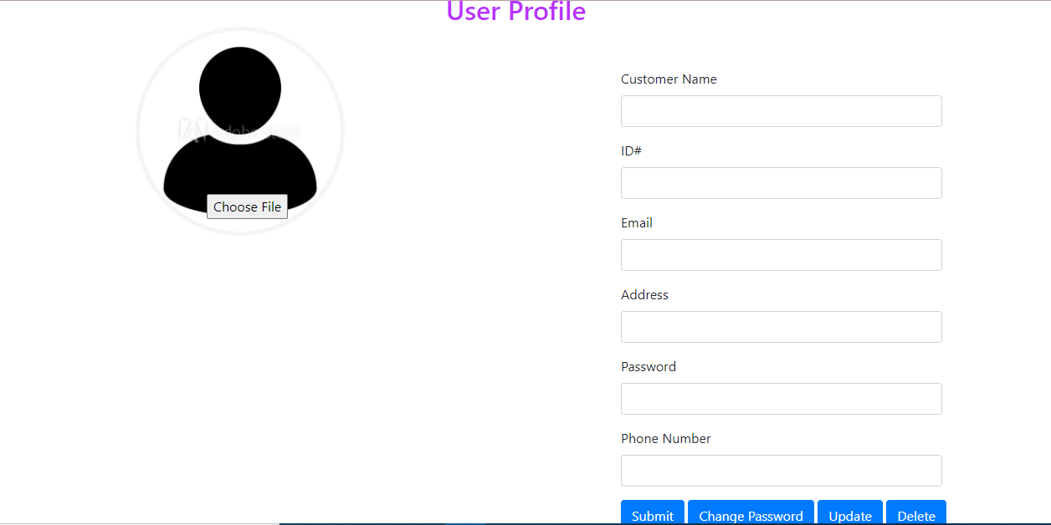

**Demo of some order pages**

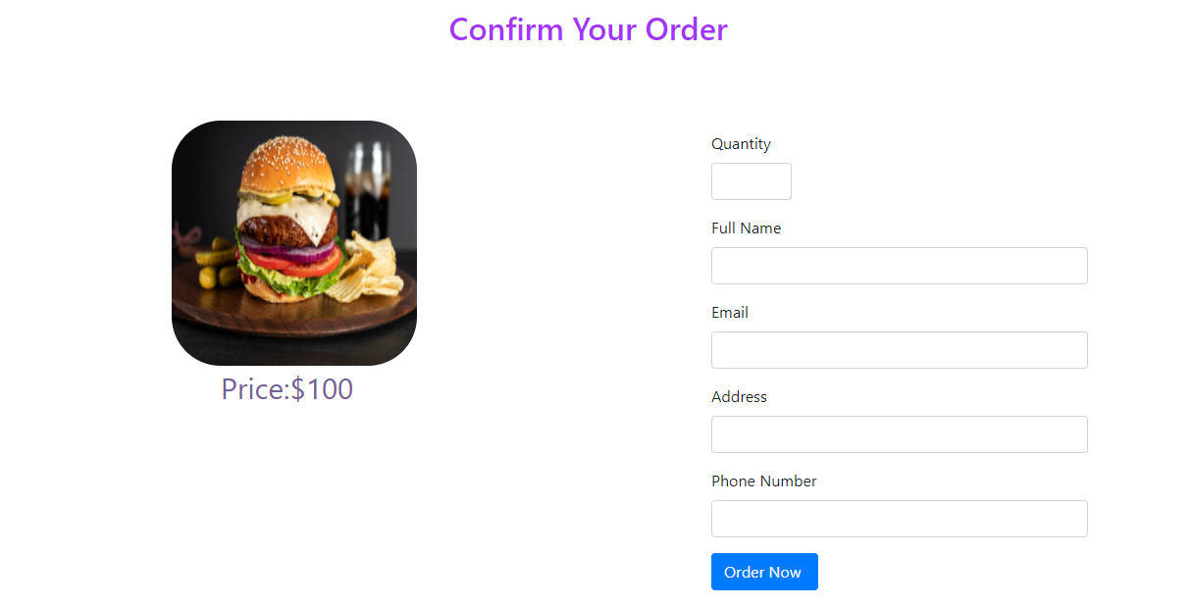

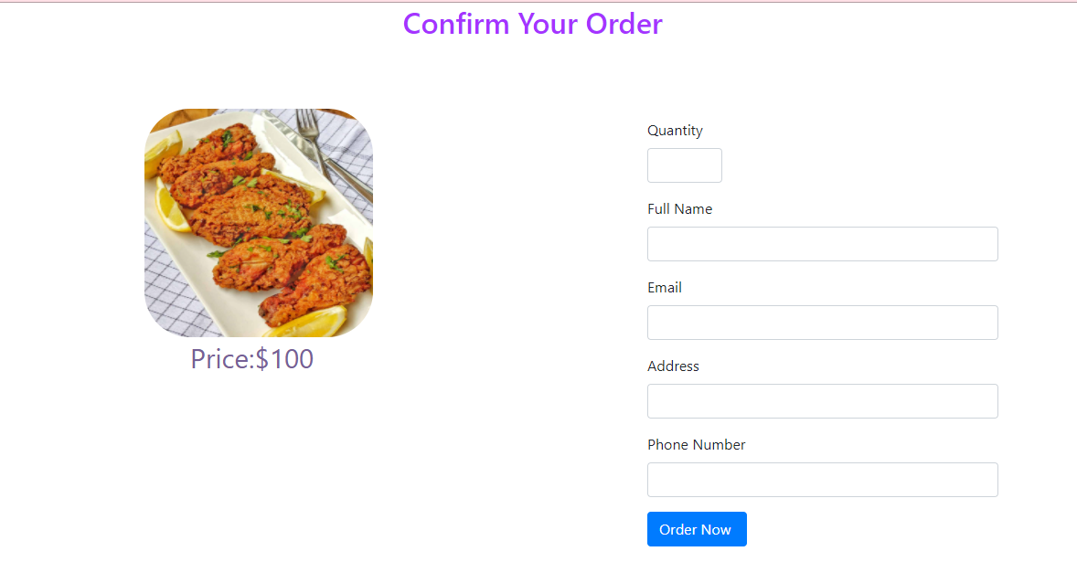

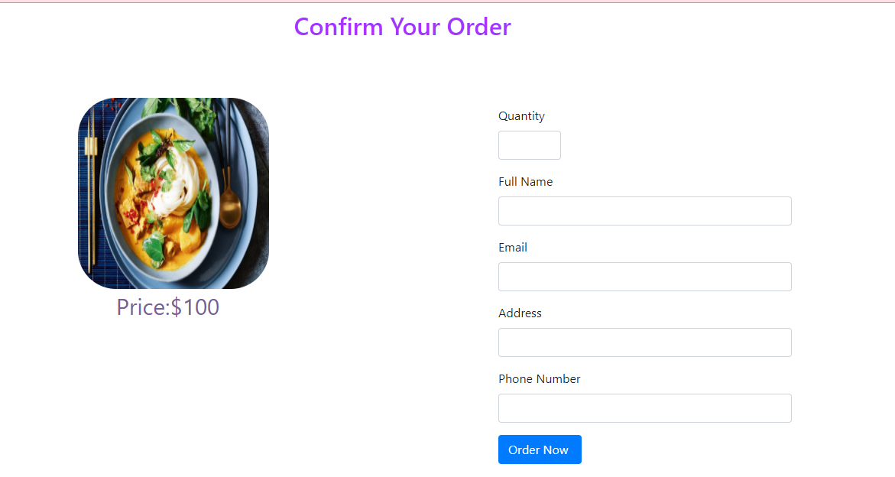

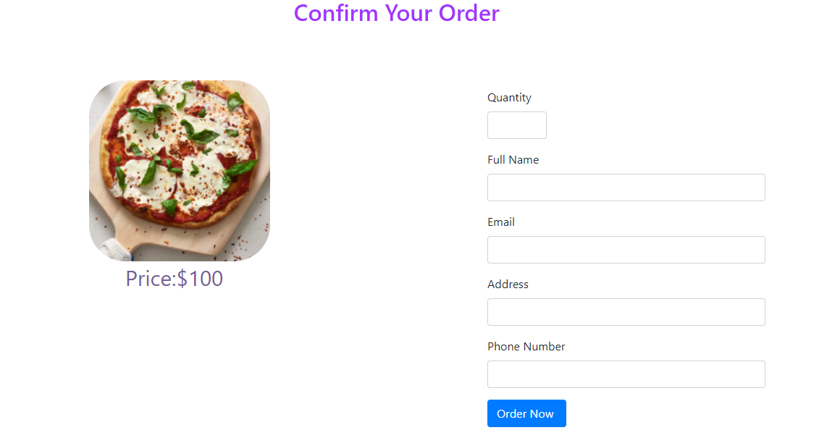

**Github link for Rownita Tasneem 1813153642**

[**https://github.com/TamannaAhsan/Online_Food_Delivery-CSE-299/tree/Rownita**](https://github.com/TamannaAhsan/Online_Food_Delivery-CSE-299/tree/Rownita)

**Works Cited for Front end and Backend :**

**Name: Rownita Tasneem**

**Id# 1813153642**

1. Vijay Thapa (2020, August 27). *Complete Website Design Course : Restaurant Project [Video].* YouTube . <https://www.youtube.com/watch?v=VaV_Ro8jpPY>

*2. Leaflet Quick Start Guide. Leaflet.* Retrieved from

<https://leafletjs.com/examples/quick-start/>

3. Technical Babaji (2020,March 2019). *How to Connect HTML Form with MySQL Database using PHP[Video].*YouTube. <https://www.youtube.com/watch?v=2HVKizgcfjo>

4. Google Maps Platform.

<https://developers.google.com/maps/documentation/javascript/places-autocomplete>