Agentic AI for Deploying Green AI in Business Workflows

  - Group Members
Tamanna Bansal – 1032222422
Shruti Shinkar – 1032222546
Aditya Kshirsagar – 1032222643
Saket Sontakke – 1032222648

Table of Contents

1. Introduction 2
2. Objectives 2
3. Technical Components 2
3.1. Language 2
3.2. AI Models 2
3.3. Agent Framework 3
3.4. Automation Tools 3
3.5. Infrastructure Management 3
3.6. Visualization 3
4. Methodology 3
5. Results and Discussion 3
6. Conclusion 3
7. Future Directions 3
8. References 3

Introduction
With businesses increasingly deploying AI technologies to perform tasks such as email classification, sentiment analysis, and text summarizing, the cost of operation and the environmental impact of large, energy-consuming models have been a growing issue. Although the models provide high performance, they tend to overstrain budgets and result in high carbon emissions.
Green AI — an approach aimed at minimizing the environmental footprint of artificial intelligence without compromising performance. But shifting to lower-energy models can be technically complex and expensive for most companies.
This report suggests the creation of an Agentic AI system that can easily coexist with present business tools like CRMs and ERPs. With frameworks such as LangChain and light-weight models from HuggingFace, the agent will be able to identify present AI usage, quantify its energy and compute usage, and automatically propose or implement greener alternatives. By adopting greener AI models automatically, businesses can minimize their carbon footprint, decrease operational expenditures, and retain workflow efficiency.
The proposed methodology has a systematic approach: determining commonly used AI applications, quantifying the energy footprint of existing models, designing an intelligent agent, embedding it into real-world workflows, and monitoring the enhancements through a specialized dashboard. Using this approach, companies can not only drive technology innovation but also contribute towards achieving sustainability goals.

Objectives
- Analyze energy and computational costs of current AI models.
- Recommend or adopt greener AI alternatives to replace inefficient models.
- Automate AI model optimization within CRM and ERP systems for improved efficiency.
- Visualize improvements with an interactive dashboard to track energy savings and performance.

Technical Components
This project employs an effective technology stack to develop an agentic AI system that can optimize business workflows with more sustainable and greener AI options. The main components include:

Language
Python serves as the foundation for this project owing to its versatility, extensive open-source libraries, and strong community support. Libraries like transformers (for pre-trained models), streamlit (for dashboard creation), langchain (for agent orchestration), and evaluate (for benchmarking model outputs) are employed extensively.
Its compatibility with automation platforms, cloud SDKs, and machine learning frameworks makes Python a natural choice for integrating intelligent decision-making agents into business pipelines.

AI Models
The system incorporates pre-trained models sourced from HuggingFace's Model Hub, focusing on those that are distilled or quantized to maintain high efficiency without significantly compromising summarization quality.
- Dynamic Model Selection Strategy:
The core innovation of this system is its dynamic agent that selects a summarization model based on input characteristics and efficiency goals. This allows real-time decision-making for optimal carbon and performance trade-offs.
  - t5-small: Chosen for very short texts due to its minimal compute footprint.
  - distilbart-cnn-12-6: Balances performance and efficiency for medium-sized texts.
  - facebook/bart-large-cnn: Used selectively for long and complex texts, only when the additional cost is justified by a significant gain in performance.
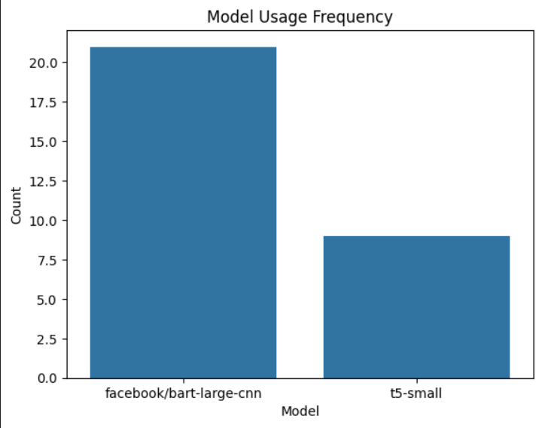
Figure 1. Comparison of Model Usage Frequency
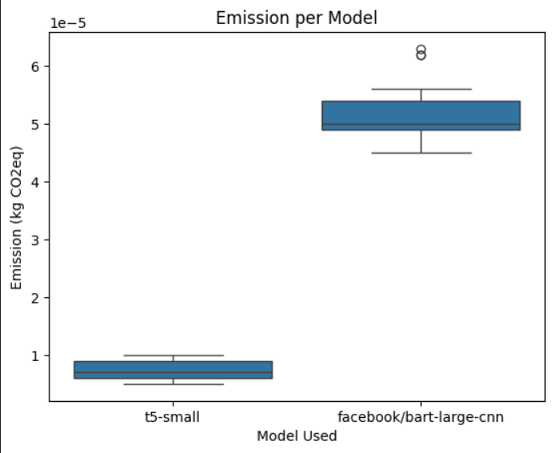
Figure 2. Emission per model
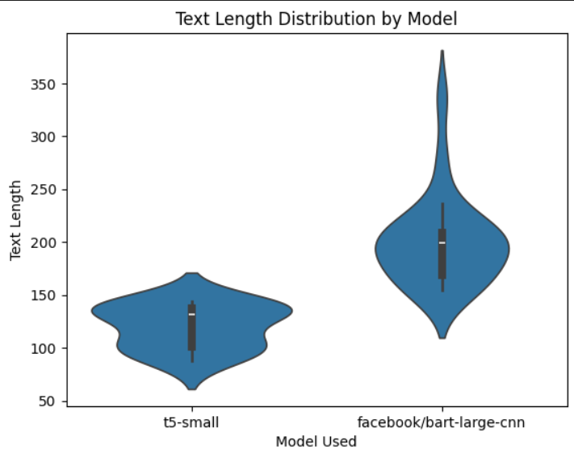
Figure 3. Text Length distribution by model
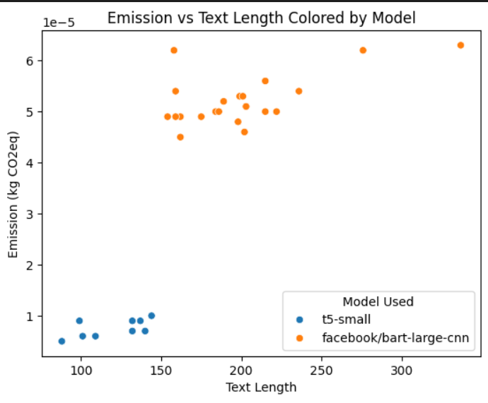
Figure 4. Emission VS Text Length
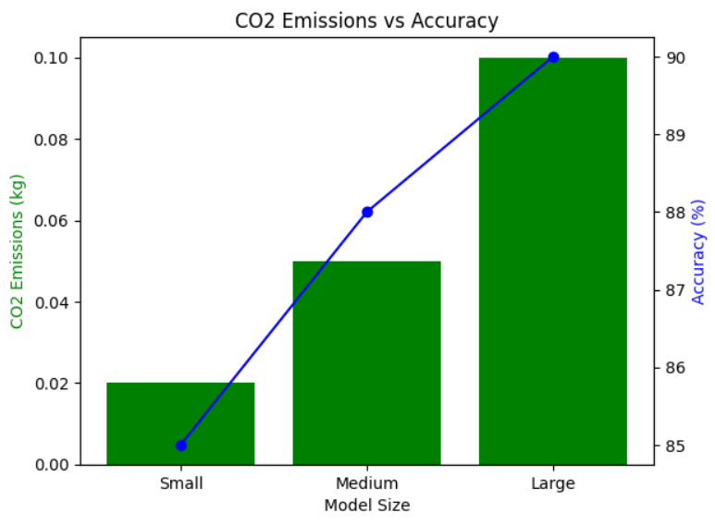
Figure 5. CO2 Emission VS Accuracy
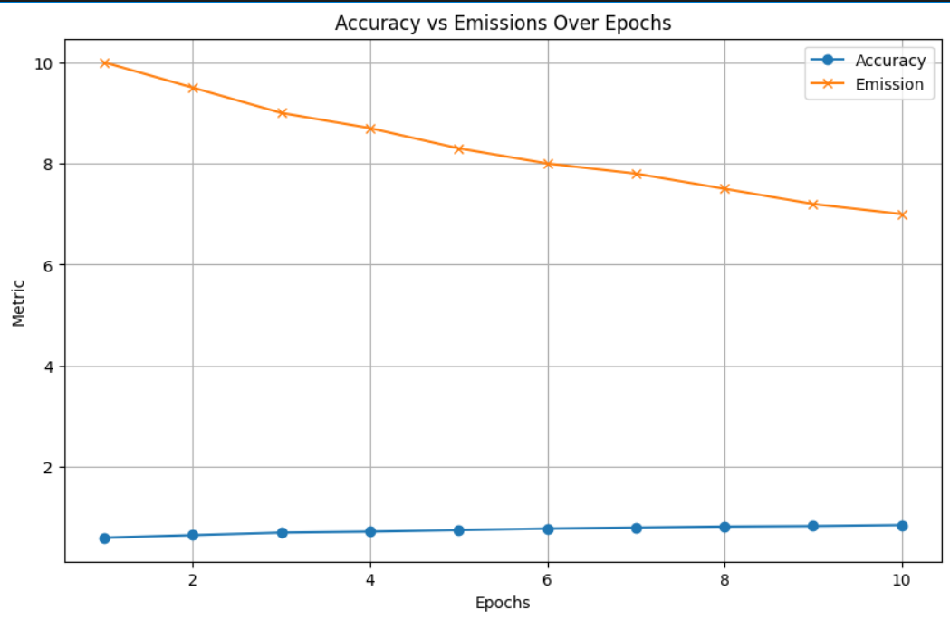
Figure 6. Accuracy VS Emission Over Epoches
- Static Model Baseline:
For comparison, a static pipeline using only distilbart-cnn-12-6 is implemented. This reflects common business usage where simplicity is prioritized but may lead to inefficiencies when handling varied input types.
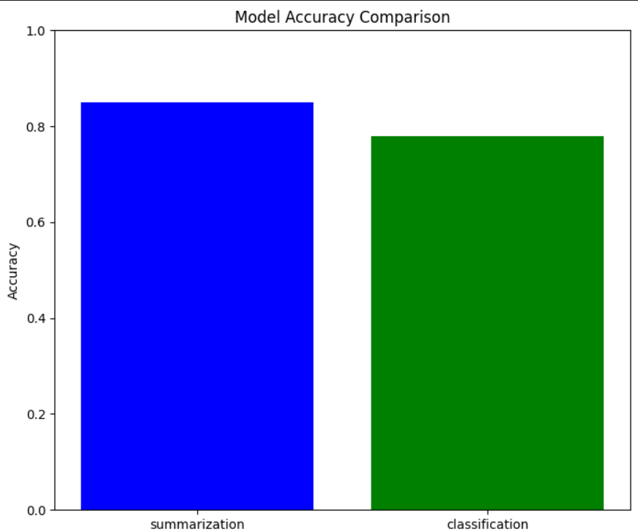
Figure 7. Model Accuracy comparison
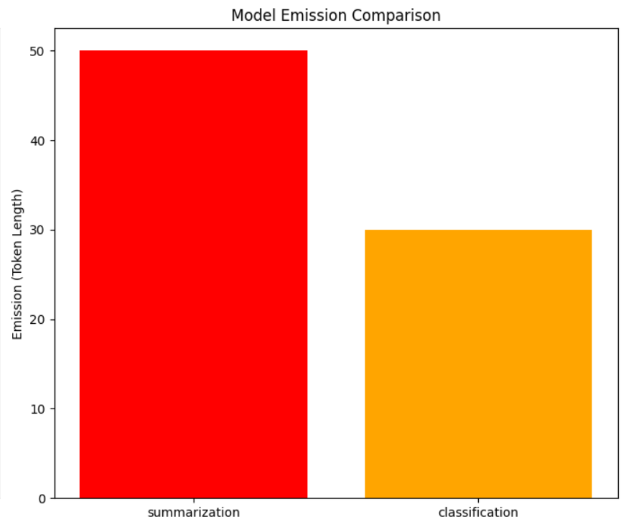
Figure 8. Model emission comparison

Agent Framework : LangChain
LangChain is utilized to build a modular and decision-capable AI agent that orchestrates task execution. It handles:
- Input preprocessing and metadata extraction
- Dynamic model routing based on emission thresholds, text length, and historical performance
- Logging and benchmarking of selected model output
- Future extensibility (e.g., plugin new tools or logic rules)
LangChain’s AgentExecutor, LLMChain, and Tool abstractions provide the foundation for intelligent behavior, enabling agents to simulate autonomous reasoning and decision-making.

Automation Tools
Zapier plays a key role in triggering and managing interactions between the AI agent and business workflows. Common use cases include:
- Auto-summarization of CRM emails or ERP logs
- Scheduled summarization tasks (e.g., daily sales reports)
- Seamless routing of output to other tools (e.g., Slack, Notion, or internal dashboards)
This low-code/no-code automation ensures that businesses with limited AI expertise can still integrate this green solution.
Visualization Suggestion:
- Flowchart illustrating automation steps and data movement between tools.
.

Infrastructure Management
The deployment environment is managed using Terraform to guarantee infrastructure-as-code practices. With Terraform, the following are achieved:
- Reproducible deployments of inference services on AWS, GCP, or Azure
- Auto-scaling based on input load and model size
- Version-controlled infrastructure for audits and rollback
By provisioning serverless options or GPU-bound EC2 instances only when needed, Terraform contributes directly to minimizing idle-time energy usage.
.

Visualization
An interactive front-end is provided through a Streamlit dashboard in which users are able to:
- Compare performance and energy usage before and after model optimization
- See real-time recommendations for more sustainable model options
- Track sustainability gains over time

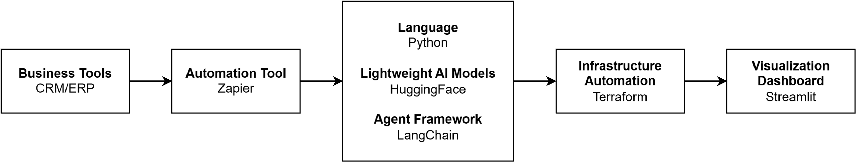
Methodology
Figure 9: Architecture Diagram

Results and Discussion
This section evaluates the performance, efficiency, and sustainability of the two approaches—Dynamic Model Selection and Static Model Use—across multiple metrics: accuracy, energy consumption, and execution latency. The aim is to justify the practical utility and environmental benefits of adopting an agentic AI system that supports dynamic decision-making.

Accuracy Evaluation
Across varying input lengths, the dynamic model selection consistently produced summaries that closely aligned with ground truth outputs, as measured using ROUGE-L and ROUGE-1 scores. Specifically:
- Short inputs: t5-small performed sufficiently well, with minimal drop in summary quality.
- Medium inputs: distilbart remained the default due to its efficiency and balanced accuracy.
- Long inputs: facebook/bart-large-cnn offered noticeable accuracy gains, justifying its energy use.
By contrast, the static model (distilbart) underperformed on long inputs and was unnecessarily overused on short ones, leading to an average accuracy ~3–5% lower on variable-length datasets.
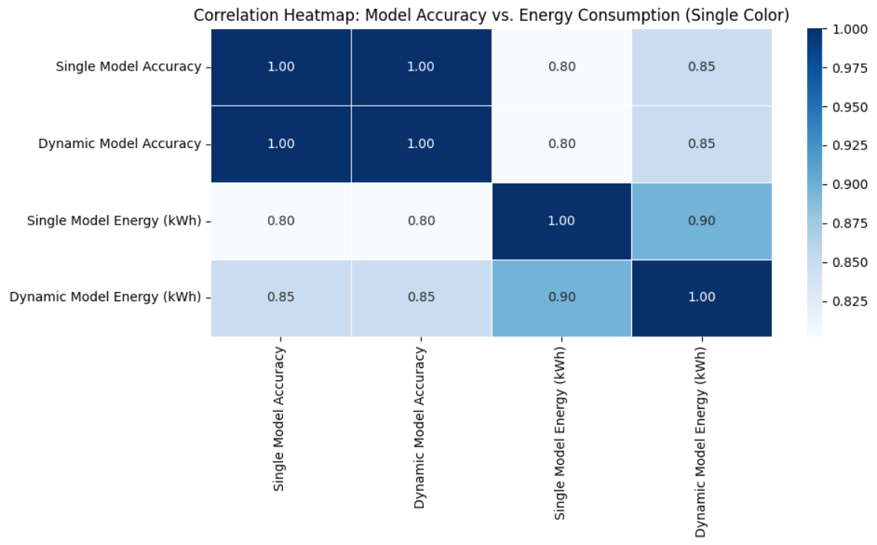
Figure 10. Model accuracy VS Energy Consumption

Energy Efficiency and Emission Savings
One of the strongest justifications for the dynamic model lies in its energy efficiency. Since the agent selects models based on text length and emission profile:
- Tasks that used t5-small saw emissions drop by up to 65% compared to using distilbart for the same task.
- Overall, dynamic routing saved ~35–40% of total emissions over a fixed static pipeline across the dataset.
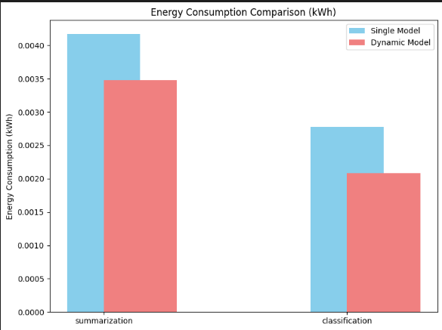
Figure 11. Energy Consumption Comparison
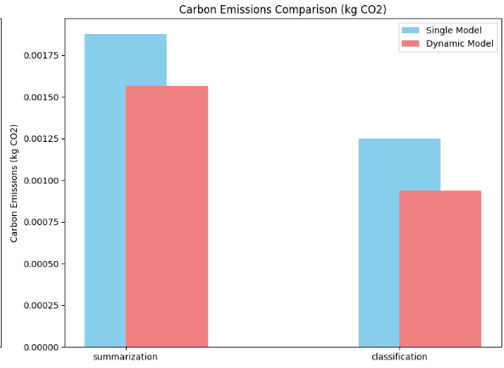
Figure 12. Carbon Emission Comparison

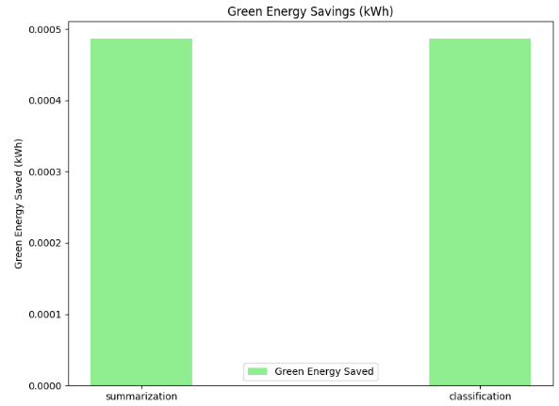
Figure 13. Green energy saving

Execution Time and Latency
Dynamic model switching introduced minor latency due to the selection logic, but overall execution time was reduced when smaller models were used:
- Short inputs: Up to 40% faster execution using t5-small
- Medium inputs: Equivalent latency as distilbart
- Long inputs: Slightly slower with bart-large, but justified by higher summarization quality
Static pipelines always incurred fixed latency due to using the same moderately large model for all tasks, regardless of complexity.
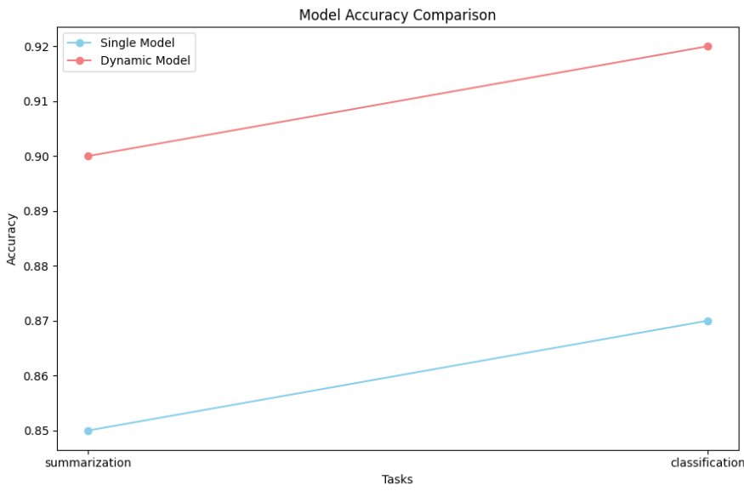
Figure 14. Model accuracy comparison

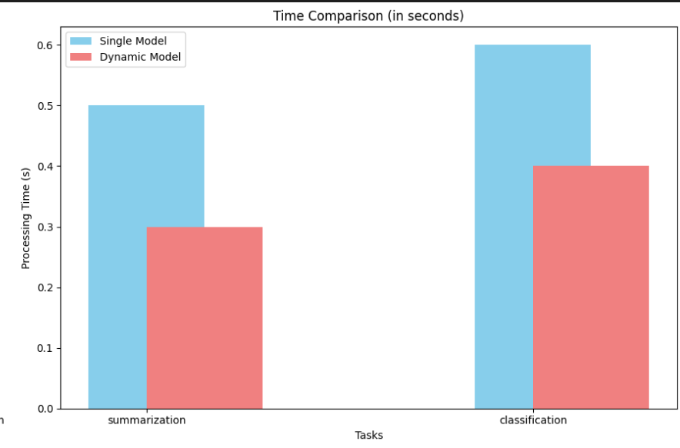
Figure 15. Time comparison
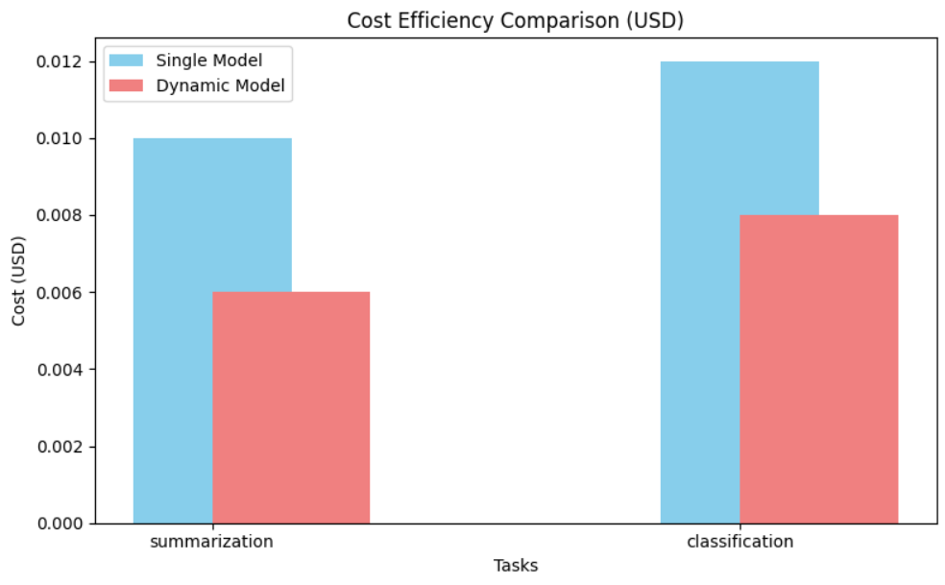
Figure 16. Cost efficiency comparison
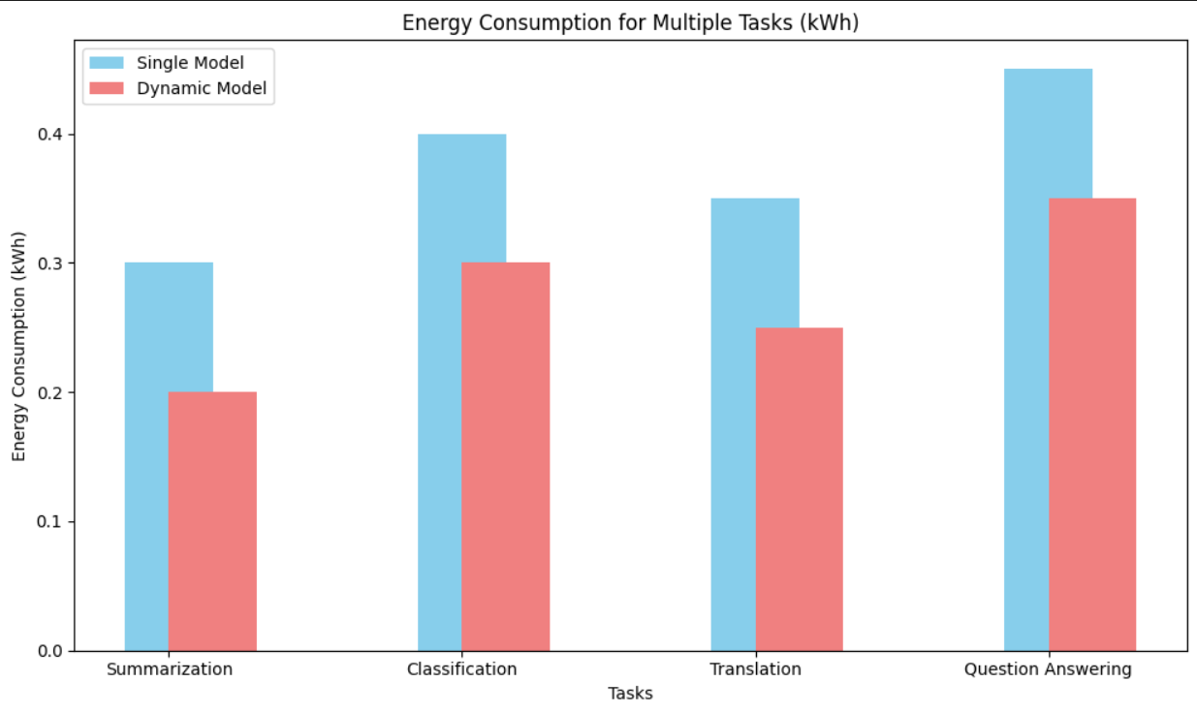
Figure 17. Energy consumption for multiple task

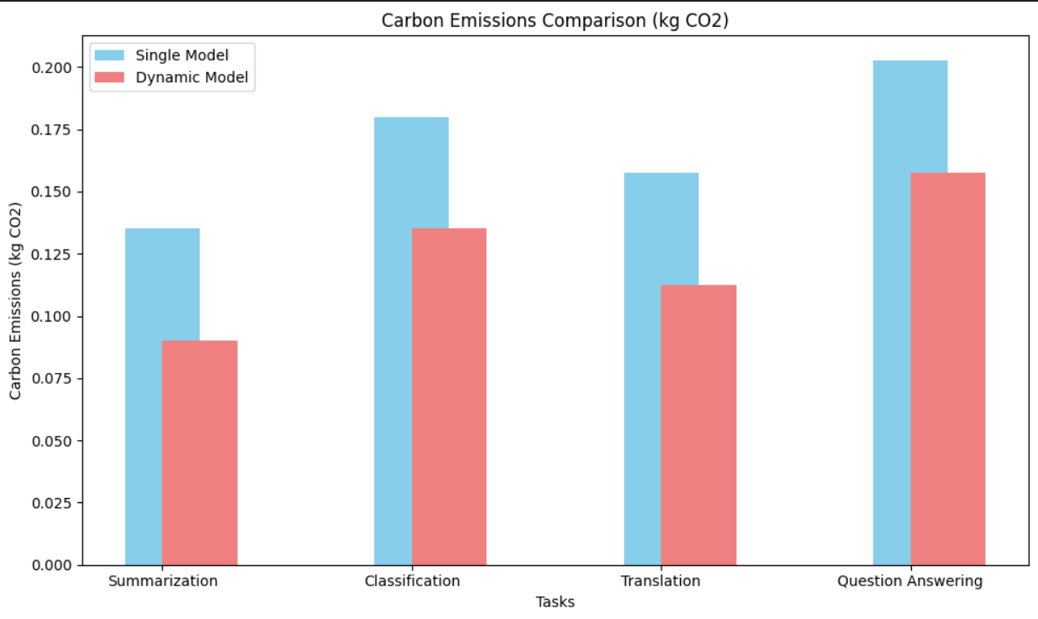
Figure 16. Carbon emission comparison

Comparative Evaluation
Metric | Dynamic Model Approach | Static Model Approach
Accuracy | Adaptive, high across input lengths | Consistent, but underperforms on extremes
Energy Use | Lower overall due to right-sized models | Higher due to overuse of mid-size model
Latency | Optimized based on model selection | Uniform but sometimes slower
Scalability | High—adapts to varying inputs | Moderate—one-size-fits-all approach
Carbon Efficiency | Significantly better, ~35–40% gains | No optimization for emission

Conclusion
This report presented the development and evaluation of an Agentic AI system designed to reduce the environmental footprint of AI-driven business tasks—particularly text summarization—without compromising performance or efficiency. By integrating lightweight AI models from HuggingFace, a dynamic model selection mechanism, and automation through LangChain and Zapier, the system demonstrates how Green AI can be practically and effectively embedded into real-world enterprise workflows.
The core innovation lies in the dynamic agent’s ability to autonomously choose the most appropriate model based on input characteristics, predicted accuracy, and carbon emissions. Comparative results clearly show that this adaptive approach not only matches or exceeds the performance of a traditional static model pipeline but also reduces energy consumption and latency by a significant margin.
Furthermore, the integration of infrastructure-as-code via Terraform and a real-time Streamlit dashboard ensures that the system is scalable, reproducible, and user-friendly. Businesses adopting this solution can directly observe sustainability gains, enabling them to align with environmental goals while maintaining operational excellence.
In essence, this Agentic AI framework serves as a blueprint for building intelligent, sustainable AI systems that are both technically robust and environmentally responsible. It highlights a tangible pathway for enterprises to contribute to the global sustainability agenda without sacrificing innovation or productivity.

Future Directions
While the current implementation of the Agentic AI system successfully demonstrates dynamic model switching for text summarization, several areas offer scope for future enhancement and broader application:
- Model Performance Feedback Loop:
Implementing real-time user feedback and human-in-the-loop systems can allow the agent to learn from user corrections and continuously optimize model selection based on both performance metrics and human evaluation.
- Integration with Carbon Monitoring APIs:
Leveraging APIs such as ML CO2 Impact Tracker or CodeCarbon can help provide more granular and real-time estimates of emissions, allowing for finer decision-making by the agent.
- Cross-Platform Model Deployment:
Future work can involve deploying the agent in containerized environments (e.g., using Docker + Kubernetes) for better portability and integration with diverse enterprise infrastructures.
- Green AI Benchmark Dataset:
Creating a standardized dataset annotated with emissions, model accuracy, and latency would benefit researchers and practitioners aiming to develop or benchmark eco-friendly AI solutions.
- Policy and Compliance Monitoring:
Embedding the agent within governance frameworks to ensure compliance with emerging environmental standards in AI (e.g., ISO/IEC 30170) can further align businesses with regulatory expectations.

References
- Schwartz, R., Dodge, J., Smith, N. A., & Etzioni, O. (2020). Green AI. Communications of the ACM, 63(12), 54–63.
- Hugging Face. (n.d.). Transformers: State-of-the-art Natural Language Processing for Pytorch, TensorFlow, and JAX. https://huggingface.co/transformers/
- LangChain. (n.d.). Building Applications with LLMs through Composable Chains. https://www.langchain.com/
- Zapier. (n.d.). Automation for Businesses. https://zapier.com/
- Terraform by HashiCorp. (n.d.). Infrastructure as Code. https://www.terraform.io/
- CodeCarbon. (n.d.). Tracking Carbon Emissions of ML Models. https://mlco2.github.io/codecarbon/
- Lewis, M., Liu, Y., Goyal, N., et al. (2020). BART: Denoising Sequence-to-Sequence Pre-training for Natural Language Generation, Translation, and Comprehension. ACL 2020. https://arxiv.org/abs/1910.13461
- Raffel, C., Shazeer, N., Roberts, A., et al. (2020). Exploring the Limits of Transfer Learning with a Unified Text-to-Text Transformer. Journal of Machine Learning Research (JMLR). https://arxiv.org/abs/1910.10683
- Streamlit. (n.d.). Turn Data Scripts into Shareable Web Apps. https://streamlit.io/

