Week 3: Advanced Data Analysis and Visualization
Uttarakhand District-Level Logistics Analysis

1. Objective
Week 3 focuses on exploratory data analysis (EDA) and visualization of the cleaned Uttarakhand logistics dataset. The purpose is to identify delivery-time patterns, cost drivers, differences between shipping modes, regional performance and potential operational bottlenecks that can guide predictive modeling in Week 4.

2. Dataset Used
The analysis uses the cleaned simulated dataset prepared in Week 2, containing 1000 unique hypothetical shipments between Uttarakhand districts. The values are simulated for educational purposes and are not claims about actual courier performance, official road distances or real transportation prices.

3. Descriptive Statistics
Statistic | distance_km | shipment_volume_units | warehouse_processing_days | actual_delivery_days | transportation_cost_inr
mean | 304.35 | 8.01 | 1.08 | 5.36 | 1091.32
50% | 301.90 | 8.00 | 1.08 | 5.60 | 1077.64
std | 102.94 | 2.59 | 0.36 | 1.19 | 245.60
min | 44.70 | 2.00 | 0.20 | 1.30 | 431.65
max | 593.10 | 16.00 | 2.04 | 8.19 | 1761.41
The mean simulated delivery time is 5.36 days and the median is 5.60 days. The average simulated transportation cost is ₹1,091.32 per shipment. The simulated late-delivery rate is 30.3%. These values describe the generated dataset only.

4. Visualization 1: Delivery-Time Distribution
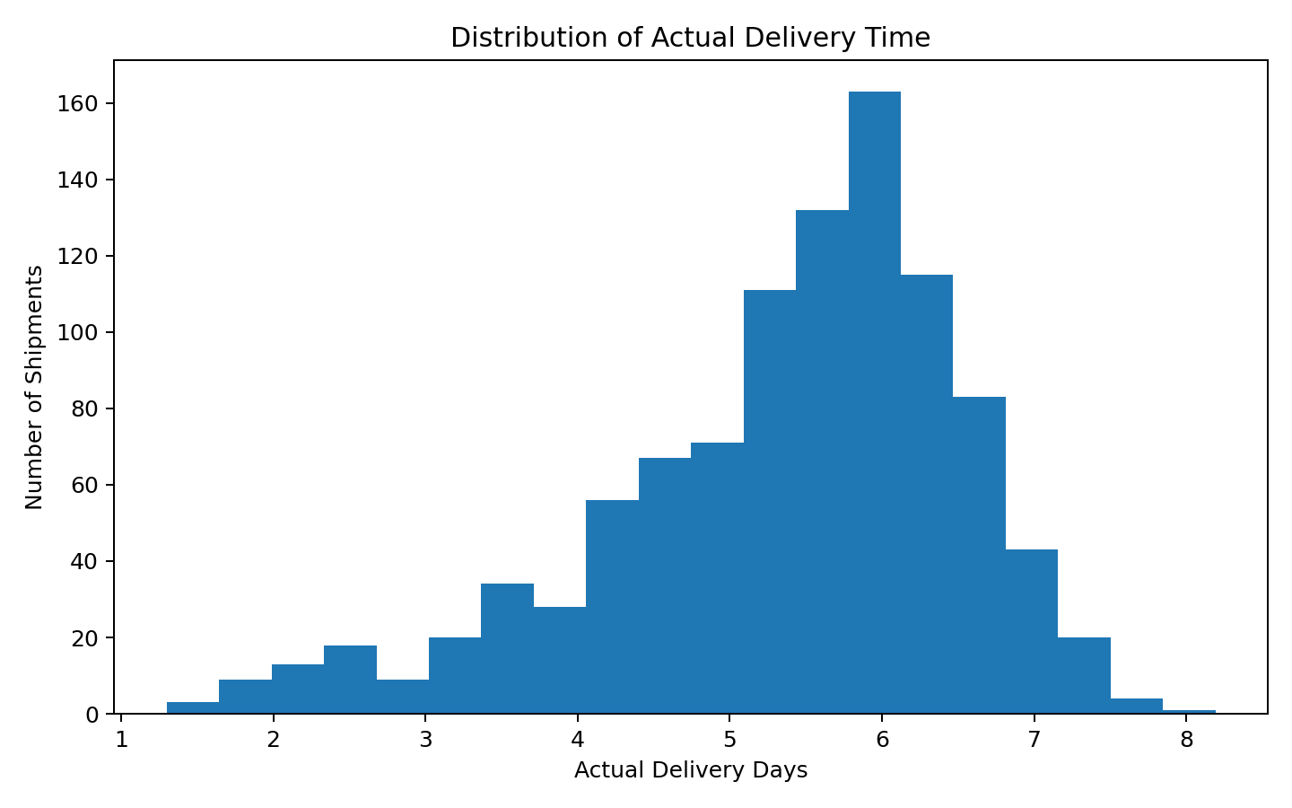
Figure 1. Distribution of actual delivery time across simulated shipments.
The histogram shows the spread of actual delivery times and helps identify the typical operating range and variability. A distribution is more informative than an average alone because it shows whether a small group of unusually long deliveries exists.

5. Visualization 2: Delivery Time by Shipping Mode
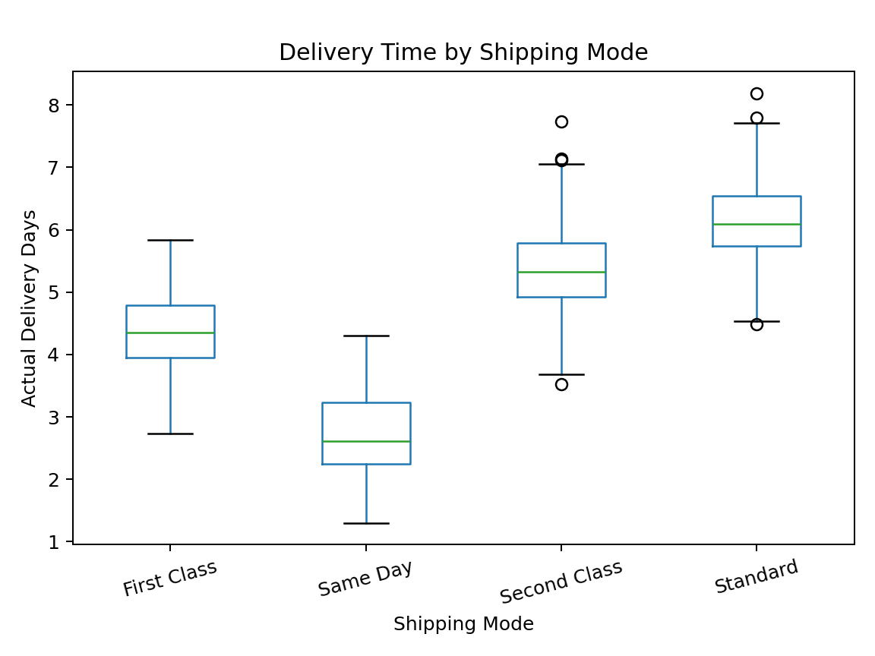
Figure 2. Distribution of actual delivery time by shipping mode.
The box plot compares delivery-time distributions across service levels. It helps evaluate whether faster shipping modes produce shorter delivery times and highlights the trade-off between service level and transportation cost.

6. Visualization 3: Transportation Cost vs Distance
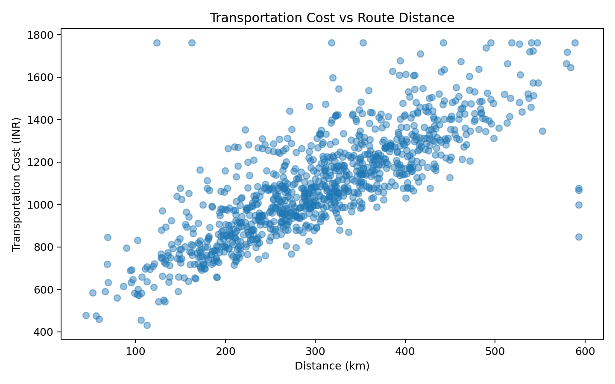
Figure 3. Relationship between route distance and simulated transportation cost.
The scatter plot shows a strong positive relationship between route distance and simulated transportation cost, with a Pearson correlation of approximately 0.81. Longer routes generally require greater transportation expenditure in the simulated scenario. The relationship is not perfectly linear because other variables, including shipment volume and shipping mode, also affect cost.

7. Visualization 4: Regional Late-Delivery Rate
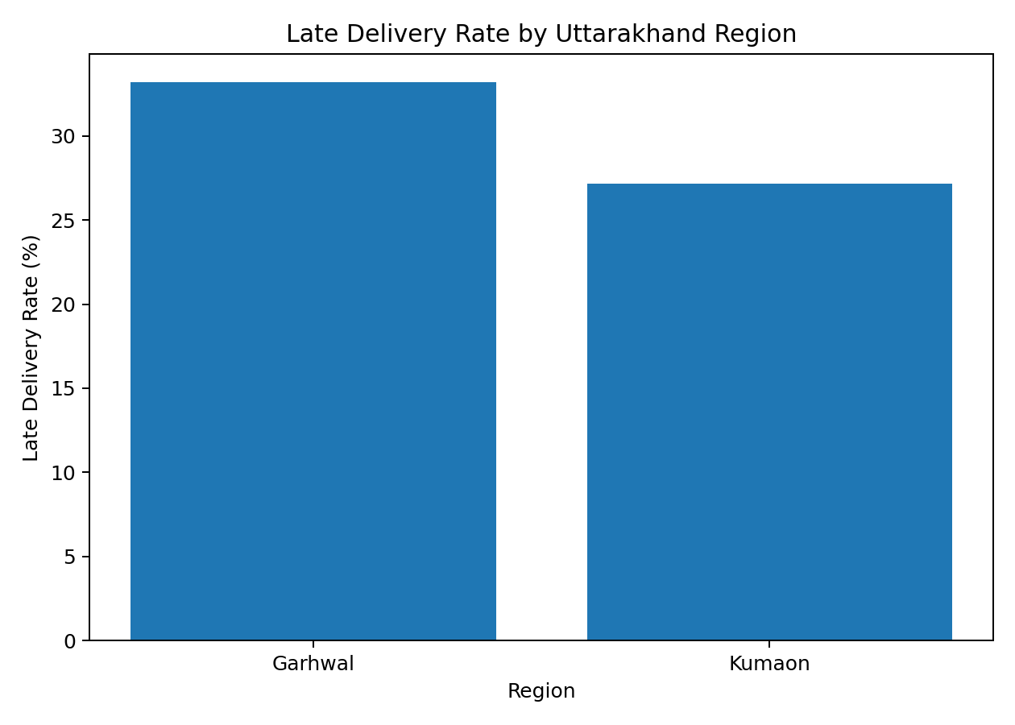
Figure 4. Simulated late-delivery rate by destination region.
The regional comparison provides a high-level view of simulated delivery reliability. Any difference between Garhwal and Kumaon should be treated as a signal for further investigation, not as evidence that one region performs worse in real life.

8. Correlation Analysis
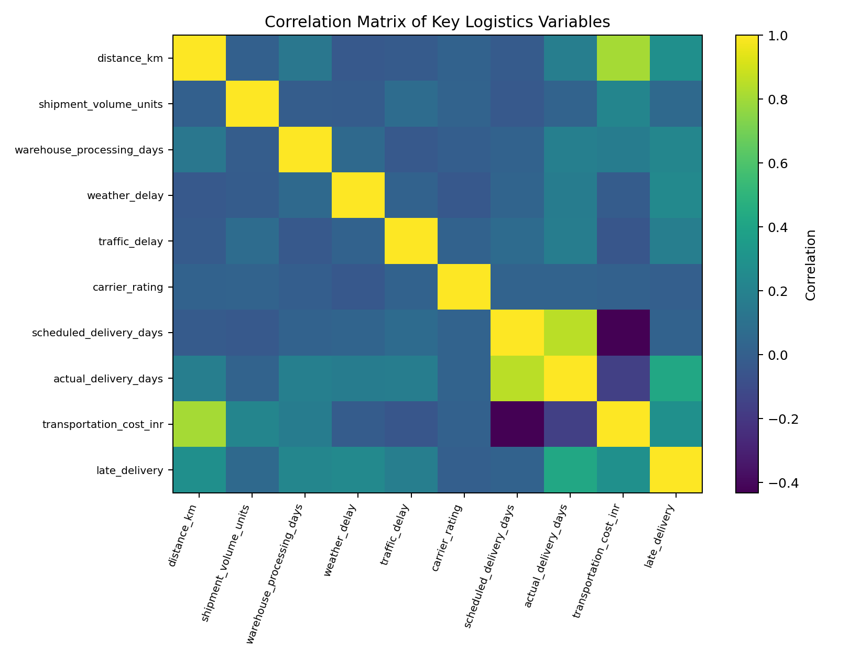
Figure 5. Correlation matrix for selected numerical logistics variables.
The correlation matrix summarizes linear relationships among key numerical variables. Distance is strongly related to transportation cost in the simulation, while delivery performance has multiple potential operational drivers. Correlation helps identify candidate relationships but does not prove causation.

9. Shipping-Mode Summary
Shipping Mode | Shipments | Avg Delivery (days) | Avg Cost | Late Rate
Same Day | 80 | 2.72 | ₹1,384 | 27.5%
First Class | 178 | 4.38 | ₹1,190 | 29.8%
Second Class | 239 | 5.36 | ₹1,074 | 30.1%
Standard | 503 | 6.12 | ₹1,018 | 31.0%

10. Analytical Insights
- The overall simulated late-delivery rate is 30.3%, so delivery reliability is an important KPI in this scenario.
- Average simulated delivery time is 5.36 days, compared with a median of 5.60 days.
- Distance and transportation cost have a Pearson correlation of approximately 0.81, indicating that route length is an important simulated cost driver.
- Shipping mode creates a service-level trade-off between planned delivery speed and transportation cost.
- Weather, traffic, warehouse processing, terrain and road condition are useful candidate variables for explaining delivery differences.
- The EDA results support using operational variables as features in Week 4's delivery-time prediction model.

11. Python Visualization Example
import pandas as pd
import matplotlib.pyplot as plt
df = pd.read_csv("data/uttarakhand_logistics_cleaned.csv")
plt.scatter(
df["distance_km"],
df["transportation_cost_inr"],
alpha=0.45
)
plt.xlabel("Distance (km)")
plt.ylabel("Transportation Cost (INR)")
plt.title("Transportation Cost vs Route Distance")
plt.show()

12. Conclusion
The EDA stage converts cleaned shipment records into interpretable logistics insights. The visualizations examine delivery-time distributions, shipping-mode differences, the distance-cost relationship, regional late-delivery patterns and correlations among operational variables. These findings provide the analytical foundation for Week 4 predictive modeling. Because the dataset is simulated, all numerical findings are educational results rather than real-world performance measurements.

