Week 4: Predictive Modeling and Optimization in Logistics
Uttarakhand District-Level Logistics Analysis

1. Objective
Week 4 develops a predictive model for actual shipment delivery time and converts predictions into practical logistics decision-support recommendations. The cleaned simulated Uttarakhand dataset from Week 2 is used as the modeling input, with actual_delivery_days as the target.

2. Problem Definition
This is a supervised regression problem because delivery time is a continuous numerical value. The model uses information available about a shipment—route, distance, terrain, service level, volume, warehouse processing, disruptions, road condition, carrier rating and scheduled delivery time—to estimate actual delivery time.

3. Feature Preparation
Shipment ID and outcome-derived fields such as late_delivery and delay_days were excluded to reduce data leakage. Categorical variables were converted using one-hot encoding. Numerical variables were standardized in the Linear Regression pipeline.
Feature group | Examples
Location | Origin and destination district
Route | Distance, terrain and road condition
Shipment | Shipping mode and shipment volume
Operations | Inventory, demand and warehouse processing
Disruptions | Weather and traffic indicators
Quality / planning | Carrier rating and scheduled delivery days

4. Train-Test Split
The dataset was divided into 80% training data and 20% testing data using random_state=42. The test set was kept separate so model performance could be evaluated on observations not used during fitting.

5. Model Selection
Linear Regression was selected as an interpretable baseline. Random Forest Regression was selected as a second model because an ensemble of decision trees can capture nonlinear relationships and interactions. Comparing both provides evidence for model selection rather than assuming a more complex algorithm is always better.

6. Evaluation Metrics
Metric | Interpretation
MAE | Average absolute prediction error, measured in days. Lower is better.
RMSE | Penalizes larger errors more strongly than MAE. Lower is better.
R² | Measures explained variation relative to a mean baseline. Higher is generally better.

7. Model Results
Model | MAE | RMSE | R² | 5-Fold CV RMSE
Linear Regression | 0.369 | 0.455 | 0.846 | 0.478
Random Forest | 0.402 | 0.504 | 0.811 | 0.535
Linear Regression achieved the lower test-set MAE (0.369 days) compared with Random Forest (0.402 days), so Linear Regression was selected for the risk-screening demonstration. The metrics are based entirely on simulated data.

8. Actual vs Predicted Delivery Time
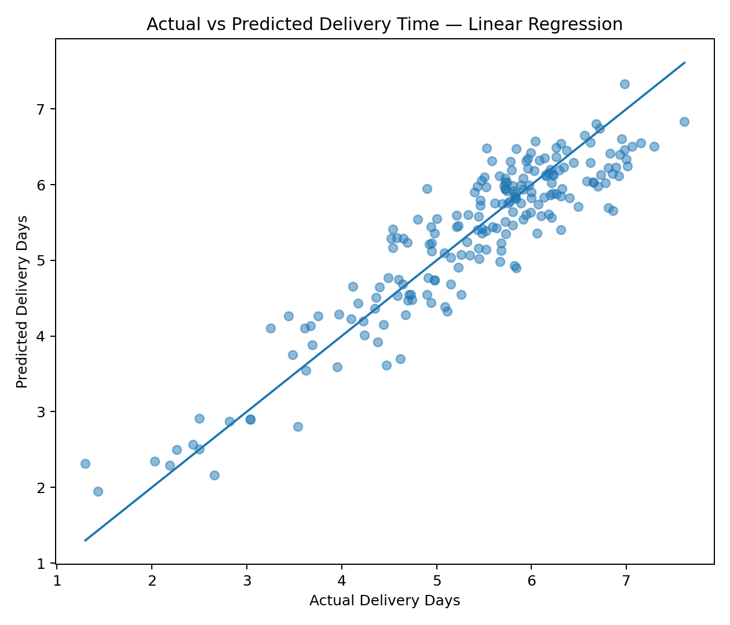
Figure 1. Actual versus predicted delivery time using Linear Regression.
Points closer to the diagonal represent smaller prediction errors. The plot complements MAE and RMSE by showing how predictions compare with actual delivery times across the test set.

9. Model Comparison
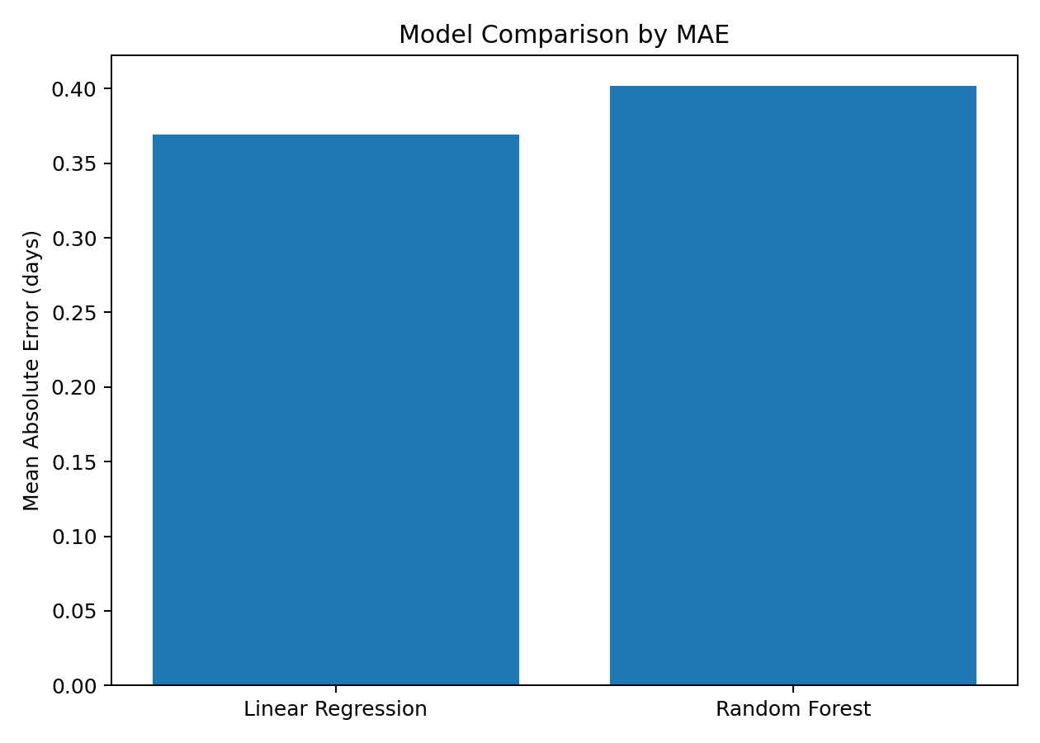
Figure 2. Mean Absolute Error comparison.
MAE is expressed in days, making the comparison easy to interpret operationally. Linear Regression produced the lower average absolute error in this simulation.

10. Risk-Based Optimization
The selected model was applied to the simulated shipments. A shipment was flagged as high risk when its predicted delivery time exceeded its scheduled delivery time. This produced 217 high-risk shipments (21.7% of the simulated dataset).
- Prioritize high-risk shipments for earlier warehouse processing.
- Review routes or carriers associated with repeated high predicted risk.
- Give additional operational attention to weather- or traffic-affected shipments.
- Use the predicted delivery time to communicate more realistic ETAs.
- Focus interventions on high-risk shipments instead of upgrading every shipment.

11. Optimization Limitation
Prediction does not prove that changing a route, carrier or shipping mode will cause a specific improvement. A real optimization study would need actual route constraints, carrier capacity, intervention costs and outcomes after interventions. Therefore, the recommendations here are decision-support strategies rather than measured savings.

12. Python Modeling Code
X_train, X_test, y_train, y_test = train_test_split(
X, y, test_size=0.20, random_state=42
)
model = Pipeline([
("preprocessor", preprocessor),
("model", LinearRegression())
])
model.fit(X_train, y_train)
pred = model.predict(X_test)
mae = mean_absolute_error(y_test, pred)
rmse = mean_squared_error(y_test, pred) ** 0.5
r2 = r2_score(y_test, pred)

13. Expected Business Impact
A production version of this workflow could help logistics teams prioritize attention rather than treating every shipment equally. High-risk predictions could support warehouse scheduling, carrier review, route planning and proactive customer communication. Any claimed improvement would need to be validated using real operational data.

14. Conclusion
Week 4 completes the project by applying supervised regression to predict actual delivery time. Linear Regression and Random Forest were evaluated using MAE, RMSE and R², with five-fold cross-validation as an additional validation check. Linear Regression performed better on the held-out test set and was used for risk screening. The model predictions were converted into a simple risk-based decision-support approach for identifying shipments likely to exceed their scheduled delivery time. Because the dataset is simulated, the results demonstrate methodology rather than real Uttarakhand logistics performance.

15. Project Limitation
The dataset is simulated. Therefore, model accuracy, risk counts and observed relationships should not be interpreted as actual performance of Uttarakhand districts or logistics companies. Real deployment would require validated shipment records, accurate route data, real weather and traffic histories, carrier information and measured intervention outcomes.

