**1.Task Description :**

Build a python program which returns the no. of paragraph , count of words, count of sentences and doc size of .txt document.

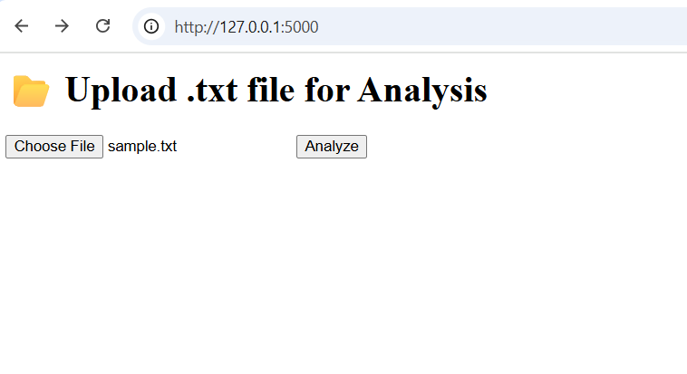**2.Task Output Screenshot :**

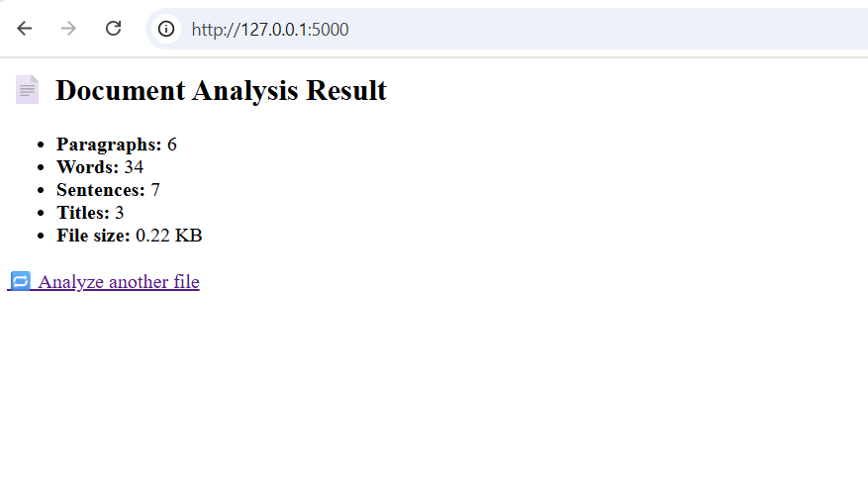

**3.Widget/Algorithm Used In Task :**

* **Paragraph Count** – Splits text by double newlines (\n\n).
* **Word Count** – Uses regex to find all words (\b\w+\b).
* **Sentence Count** – Counts punctuation marks like ., !, ?.
* **Title Detection** – Checks if all words in a line are capitalized (istitle()).– Uses os.path.getsize() to get size in KB.