|  |
| --- |
| Software Requirements Specification |
| Job Portal System |
| Tamanna Abdul Rafeek |

Table of Contents

Introduction 3

Purpose 3

Scope 4

Objectives 5

Functional Requirements 7

Primary actors of the system 7

Use Case Diagrams 8

User Stories 11

Business Process Diagram 14

Non-Functional Requirements 15

Technical Requirements 15

Conclusion 16

Job Portal

Software Requirements Specification (SRS)

Project for .NetCore/Angular Training Boot Camp

# Introduction

In today’s world, finding the right job or the right candidate for a position can be challenging. Many talented individuals struggle to find suitable job opportunities, while recruiters often find it difficult to identify the right candidates for their positions. As a result, some employees end up in roles that do not completely align with their skills.

The job portal system will provide an online platform where job seekers can find relevant job openings, and recruiters can easily connect with suitable candidates. It will make the hiring process easier and can help to reveal hidden talents.

The job portal system is a web application used to connect job seekers with job providers. It will allow job seekers to search and apply for the jobs openings online. Additionally, the portal will allow job providers to post job vacancies and manage applications. It will help users to create and manage their profiles for their job recruitment process.

## Purpose

The purpose of this document is to provide a detailed description of the requirements for the development of a Job Portal System so that the software development team can understand the project’s goals and deliver the system according to user expectations.

The document includes both functional and non-functional requirements. The system's capabilities include job postings, resume uploads, job searches and application tracking. System's performance, security, usability and scalability, ensure it to be operated effectively under varying conditions.

In short the purpose of the application is to provide the job seekers a platform to find suitable and satisfying job based on their qualification. This portal will connect job seekers with job providers. It will allow job seekers to submit their resume and apply for jobs online and job providers can post job vacancies, manage applications and select the right candidates.

## Scope

The scope of the Job Portal System is to provide an online platform where job seekers can search and apply for jobs and job providers can post job vacancies, search resumes and manage applications. Platform administrators can manage users and job posts.

#### **Main Functionalities and Features**

The Job Portal System will include the following main functionalities:

**For Job Seekers:**

* Registration and login functionality with profile management.
* Resume upload and job preference configuration.
* Job search with filters like job title, location, category and company.
* Apply for jobs, track application status and withdraw applications.
* Receive notifications and alerts for new job postings via email.

**For Job Providers:**

* Registration and login functionality with company profile creation.
* Post job vacancies with details such as title, description, salary and location.
* View and manage applications, search resumes based on criteria and contact candidates.
* Manage job postings

**For Platform Administrators:**

* User account management of job seekers and job providers.
* Job posting approval and monitoring.
* Overall system monitoring and reporting tools.
* Managing payments for premium job postings.
* Offering skill assessments for job seekers.

#### **Limitations and Exclusions**

* Integration with social media platforms for login will not be included.
* The system will not allow job seekers to create a resume from scratch.
* The system will not allow job providers to directly call candidates or conduct interview through the portal.
* The system will not provide direct payroll management or contract signing functionality.
* No support for advanced AI based job matching or recommendations beyond basic filtering.

#### **User Roles:**

#### There are mainly three types of users:

1. **Job Seekers:** These are the individuals looking for employment opportunities, who can search and apply for jobs.
2. **Job Providers:** These are the companies or individuals offering jobs who can post vacancies, search for candidates and manage applications.
3. **Platform Administrators**: Users who are responsible for overseeing the system’s functionality, managing users and approving job posts.

## Objectives

**High Level Objectives**

The Job Portal System has the following objectives that aim to address the needs of job seekers, job providers and platform administrators:

**Streamlining the Job Search Process:** Provide an intuitive and efficient platform for job seekers to search for relevant jobs, apply online and manage their applications.

**Simplifying the Recruitment Process:** Enable job providers to post job vacancies, review applications and search for qualified candidates with ease, improving recruitment efficiency.

**Centralizing Job Market Activities:** Serve as a centralized hub for employment **related** activities, facilitating interaction between job seekers and job providers.

**Ensuring Secure and Reliable Data Management:** Safeguard user data through robust security protocols, ensuring that resumes, job listings and personal information are protected.

**Providing Administrative Oversight:** Offer administrative tools to monitor the system, manage user accounts, approve job listings and maintain the overall integrity of the platform.

**Problems the System Aims to Address**

**Accessibility and Convenience for Job Seekers:** The system aims to resolve the issue of time consuming job searches by providing users with advanced filtering and search options that help them quickly find relevant job postings.

**Efficiency for Employers:** The system is designed to reduce the administrative burden on job providers by offering streamlined tools for posting jobs, managing candidates, and organizing applications, thereby addressing inefficiencies in the hiring process.

**Enhancing Communication and Transparency:** The platform improves communication between job seekers and job providers, allowing job seekers to track their application status and job providers to manage applicant data.

**Bridging the Employment Gap:** By creating a platform that connects job seekers and job providers directly, the system addresses the challenge of disconnect between available jobs and qualified candidates in the job market.

# Functional Requirements

## Primary actors of the system

1. **Job Seeker**

Job Seeker is an individual looking for job opportunities.

* **Registration and Login**: Job seekers can register, log in and recover passwords.
* **Profile Management**: Job seekers can create and edit profiles, upload resumes and manage job preferences.
* **Job Search**: Job seekers can search for jobs by filters such as location, job title, company and category.
* **Apply for Jobs**: Job seekers can apply for jobs, track application status and withdraw applications.
* **Save for Job**: Job seekers can save jobs to apply for later.
* **Job Alerts**: Job seekers can set up job alerts and receive notifications via email.
* Communication: Job seekers can communicate with employers.

1. **Job Provider**

Job Provider is a user who can be individual or an organization offering job opportunities.

* **Registration and Login**: Job Provider can register, log in and recover passwords.
* **Post Jobs**: Job Provider can create, edit and delete job postings with job descriptions.
* **Manage Applications**: Job Provider can view applicants for each job and sort resumes.
* **Resume Search**: Job Provider can search for job seekers based on specific criteria.
* Communication: Job Provider s can communicate with applicants.

1. **Platform Administrator**

A platform administrator is responsible for maintaining and overseeing the platform.

* **User Management**: Platform admin can manage user accounts for both job seekers and job providers, including suspending or deleting accounts.
* **Job Posting Approval**: Platform admin can approve or reject job postings from job providers.
* Communication: Platform admin can communicate with both job providers and job seekers.
* Payment Features: Platform admin can manage payments for premium job postings.
* **System Monitoring**: Platform admin can generate reports, monitor user activity and ensure smooth operation of the system.
* Technical Support: Platform admin can handle technical issues, troubleshoot and manage data security.

## Use Case Diagrams

1. Job Seeker

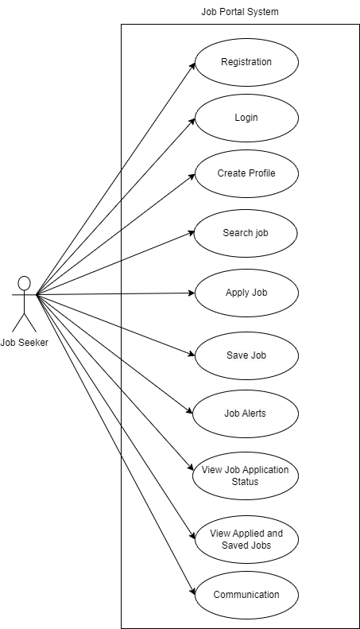

1. Job Provider

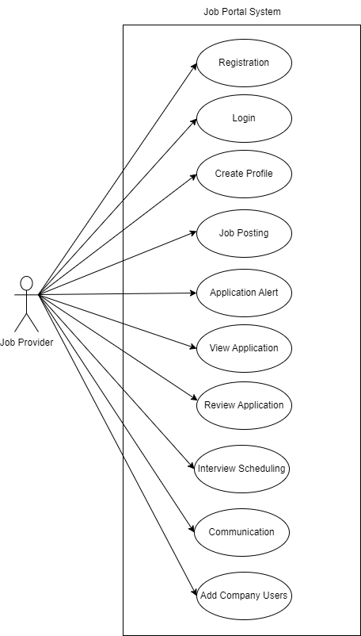

1. Platform Admin

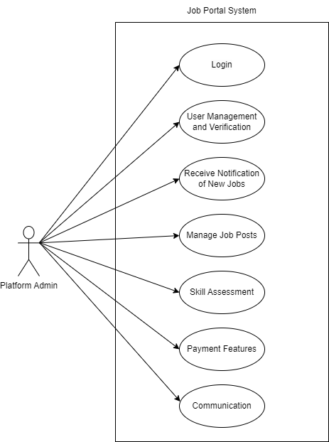

|  |  |  |
| --- | --- | --- |
| **AS A** | **I NEED TO** | **SO THAT I CAN** |
| Job Seeker | Create an account | Access the portal and apply for jobs |
| Job Seeker | Log in to my account | Access my profile and search jobs |
| Job Seeker | Create, update and view my profile with resume, skills and experience | Make employers see my profile |
| Job Seeker | Search and filter job listings based on my preferences | Find suitable job opportunities |
| Job Seeker | Save my job search filter | Search job opportunities with same filters again |
| Job Seeker | Apply for jobs by uploading my resume and cover letter | Be considered for the position and potentially secure employment |
| Job Seeker | Save job that I am interested | Apply for that job later |
| Job Seeker | Track the status of my job applications | Get information about their progress |
| Job Seeker | Set up job alerts based on my preferences | Get notification when a new job matches my profile |
| Job Seeker | View all the jobs that I’ve applied and saved | Track which all jobs I have applied and needs to be applied |
| Job Seeker | Send and receive messages with employers | Get important information about job vacancy from employers |

## User Stories

1. Job Seeker
2. Job Provider

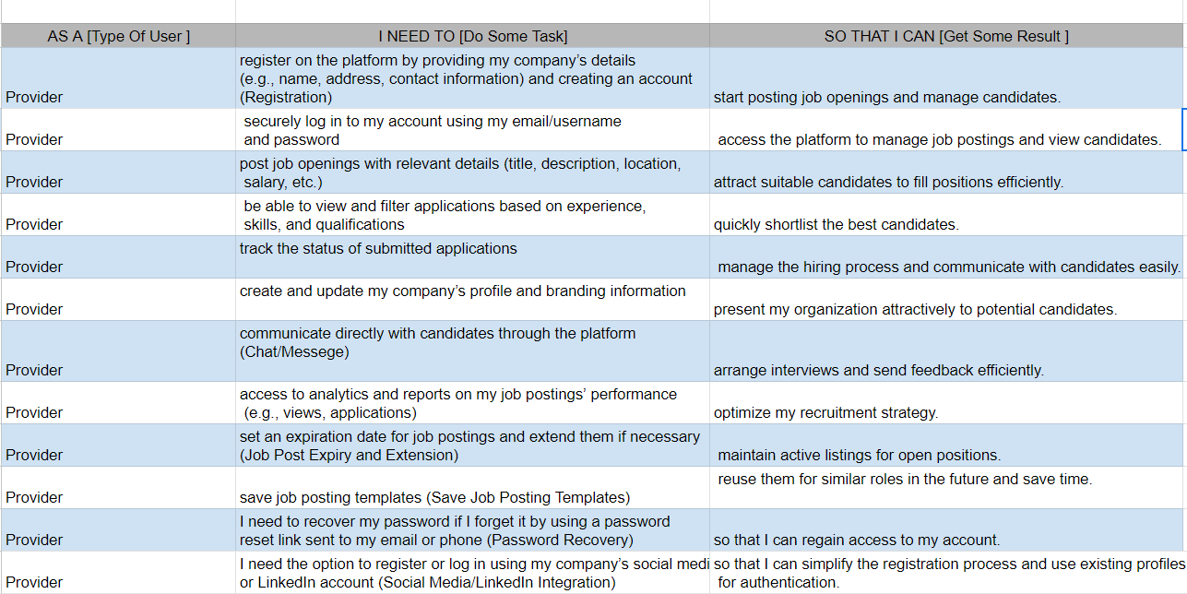

1. Platform Admin

|  |  |  |
| --- | --- | --- |
| AS A [type of user] | I NEED TO [ do some task] | SO THAT I CAN [get some result] |
|  |  |  |
| PLATFORM ADMIN | Review and approve new user accounts | Ensure that only valid users have access to the platform. |
| PLATFORM ADMIN | Edit user profiles | Update the information if necessary. |
| PLATFORM ADMIN | Review and approve job postings. | Ensure the platform guidelines. |
| PLATFORM ADMIN | Deactivate or delete the user accounts. | Maintain inactive or inappropriate accounts effectively. |
| PLATFORM ADMIN | Monitor comments and reviews left by users | Ensure they follow community guidelines. |
| PLATFORM ADMIN | Generate reports of user engagement such as no. of job views, applications submitted, and user sign-ups | Assess platform performance |
| PLATFORM ADMIN | Analyse trends in job postings and applications | Identify growth areas and user needs |
| PLATFORM ADMIN | Manage job provider and job seeker accounts for subscription plans | Ensure they have the correct level of access and features. |
| PLATFORM ADMIN | Send notification messages to job seekers and provider | Confirm their subscription, creation dates, events, etc |
| PLATFORM ADMIN | Provide roles and authentication to users. | Provide appropriate access to the platform feature depending on the type of registration. |
| PLATFORM ADMIN | Remove the old post or dead post | Display new and recent job offerings on the home page. |

## Business Process Diagram

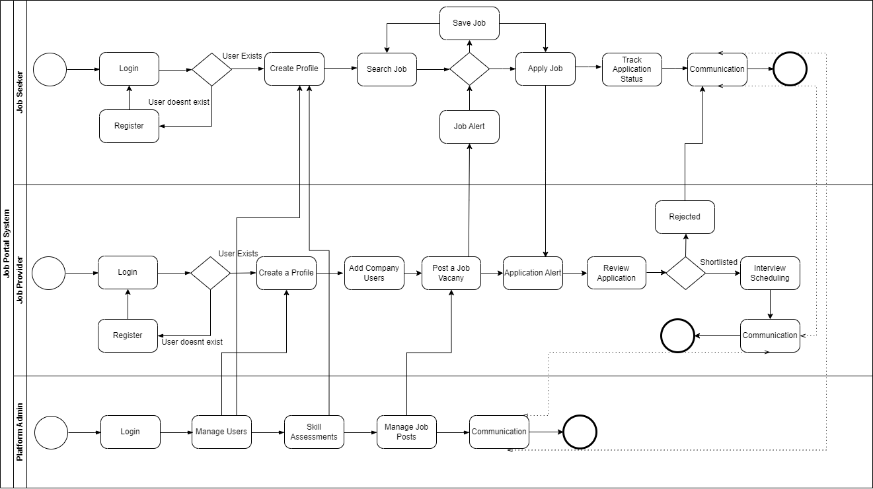

# Non-Functional Requirements

1. **Performance Requirements**

The system should handle up to 100,000 simultaneous users. Job search results should be displayed within 2 seconds.

1. **Security Requirements**

User passwords must be stored using encryption techniques. JWT(JSON Web Token) should be implemented for secure authentication. Sensitive data must be transmitted over HTTPS. Role based access control should be Implemented for different user.

1. **Usability Requirements**

The user interface must be intuitive and easy to navigate. The system should be accessible 24x7 and must meet accessibility standards.

1. **Reliability Requirements**

The system should have 99.9% uptime. In case of failure, data should be recoverable with no more than 5 minutes of data loss.

1. **Scalability**

The system should be designed to scale as the number of users increases. Cloud-based infrastructure will be used for flexible scaling options.

# Technical Requirements

#### **Software Requirements:**

* **Programming Language**: C#
* **Frameworks**:ASP.NET Core, Entity Framework Core for data access, Bootstrap for responsive design
* **Database**: Microsoft SQL Server
* IDE :Microsoft Visual Studio 2022

#### **Hardware Requirements:**

* Web Server: Microsoft IIS
* Database Server: SQL Server 2019 or later
* Minimum Client hardware: Dual-core processor, 4 GB RAM, 500 MB storage, and high-speed internet (10 Mbps)

#### **Platform Requirements:**

* **Operating Systems**: Server: Windows Server 2019 or later; Client: Windows, macOS, Linux, Android, iOS
* **Browsers:** Latest versions of Chrome, Firefox, Edge, and Safari

# Conclusion

The Software Requirements Specification document for the Job Portal System outlines the essential framework for developing a robust and user friendly platform that connects job seekers with job providers. It aims to streamline the job search and recruitment process for all users involved. It addresses common challenges in the job market by creating a centralized platform for job listings and applications. The system is designed for three main user types: job seekers, job providers and platform administrators, each with specific functionalities tailored to their needs. The use of modern technology like .NET Core will ensure a seamless user experience.

It is recommended that stakeholders remain continuously engaged throughout the development process to ensure the system aligns with user expectations and business goals. Regular updates and enhancements should be planned post launch to adapt to evolving user needs and market trends. By adhering to the specifications outlined in this SRS, the Job Portal System can be successfully developed to meet its intended objectives and provide significant value to its users.