**Ans to the Q No-02**

The figure given above is of a Hyperabola:

the figure is the a vertical hyperbola it’s euatuion has the form:

$\frac{y^{2}}{a^{2}}$- $\frac{x^{2}}{b^{2}}=1$

The eqution i will be plotting is:

$\frac{y^{2}}{{49}^{2}}$- $\frac{x^{2}}{{32}^{2}}=1$

#first we import matplotlib

#we will use pyplot for plotting

import numpy as np

import matplotlib as mpl

import matplotlib.pyplot as plt

#first creating the grid with x values and y values running from -200 to 200

x = np.linspace(-200, 200)

y = np.linspace(-200, 200)

#get x,y values from the grid

x, y = np.meshgrid(x, y)

#plot the x and Y axis

plt.axhline(0, alpha=.1)

plt.axvline(0, alpha=.1)

#set a and b value according to the hyperbolic equation

a =49

b =32

#plot hyperbolic equation

plt.contour(x, y,(y**2/a**2 - x**2/b**2) ,[1])

#add title

plt.title("HYPERBOLA\n\nEquation : y^2/49^2 - x^2/3^2 = 1")

#display the plot

plt.show()

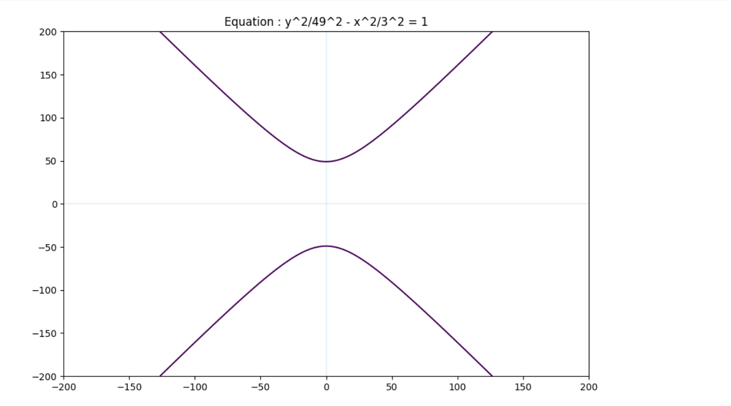

**Ans to the Q. No. : 04**

from logpy import *  
from logpy.core import lall

Specified the variable person.

# Specified the variable  
person = var()

Specified all the rules using lall. The first rule is that there are four persons.

# Specified the rules  
rules = lall(  
# There are 4 persons  
(eq, (var(), var(), var(), var()), person),

The people named Steve has a blue car-

# Steves has a blue car  
(membero, ('Steve', var(), 'blue', var()), person),

The man who has a cat lives in Canada:

# The man who has a cat lives in Canada  
(membero, (var(), 'cat', var(), 'Canada'), person),

# Matthew lives in USA  
(membero, ('Matthew', var(), var(), 'USA'), person),

# The man who has a black car lives in Australia  
(membero, (var(), var(), 'black', 'Australia'), person),

The man named Jack has a cat:

# Jack has a cat  
(membero, ('Jack', 'cat', var(), var()), person),

The man named Alfred lives in Australia:

# Alfred lives in Australia  
(membero, ('Alfred', var(), var(), 'Australia'), person),

The man who has a dog lives in France:

# Person who owns the dog lives in France  
(membero, (var(), 'dog', var(), 'France'), person),

One of the person in this group has a rabbit. Who is that man?

# Who has a rabbit?  
(membero, (var(), 'rabbit', var(), var()), person))

Run the solver with the preceding constraints:

# Run the solver  
results = run(0, person, rules)

Take out the output from the result-

output = [house for house in results[0] if 'rabbit' in house][0][0]

print the o/p:

print('\n' + output + ' is the owning of the rabbit')

print('\nAll the details are here:')

attribs = ['Name', 'Pet', 'Car Color', 'Country']

print('\n' + '\t\t\t'.join(attribs))

print('=' * 60)

for item in result[0]:

print('')

print('\t\t\t'.join([str(x) for x in item]))

Ans To The Q No. 01

print('Type of cases ')  
print('1-general case')  
print('2-Women and age less than 65')  
print('3-Disabled')  
print('4-Parent with disabled')  
print('5-Wounded freedom fighter')

# console input of option  
n=int(input('Enter option : '))  
# console input of income  
income=int(input('Enter the income(k) : '))  
if(n==1):  
if(income<=300):  
tax=0  
elif (income>300 and income<=400):  
tax=(income-300)*5/100  
elif (income>400 and income<=700):  
tax=(300*0/100)+(100*5/100)+(income-400)*10/100  
elif (income>700 and income<=1100):  
tax=(300*0/100)+(100*5/100)+(300*10/100)+(income-700)*15/100  
elif (income>1100 and income<=1600):  
tax=(300*0/100)+(100*5/100)+(300*10/100)+(400*15/100)+(income-1100)*20/100  
else:  
tax=(300*0/100)+(100*5/100)+(300*10/100)+(400*15/100)+(500*20/100)+(income-1600)*25/100

elif(n==2):  
if(income<=350):  
tax=0  
elif (income>350 and income<=450):  
tax=(income-350)*5/100  
elif (income>450 and income<=750):  
tax=(350*0/100)+(100*5/100)+(income-450)*10/100  
elif (income>750 and income<=1150):  
tax=(350*0/100)+(100*5/100)+(300*10/100)+(income-750)*15/100  
elif (income>1150 and income<=1650):  
tax=(350*0/100)+(100*5/100)+(300*10/100)+(400*15/100)+(income-1150)*20/100  
else:  
tax=(350*0/100)+(100*5/100)+(300*10/100)+(400*15/100)+(500*20/100)+(income-1650)*25/100  
    
elif(n==3):  
  
if(income<=450):  
tax=0  
elif (income>450 and income<=550):  
tax=(income-450)*5/100  
elif (income>550 and income<=850):  
tax=(450*0/100)+(100*5/100)+(income-550)*10/100  
elif (income>850 and income<=1250):  
tax=(450*0/100)+(100*5/100)+(300*10/100)+(income-850)*15/100  
elif (income>1250 and income<=1750):  
tax=(450*0/100)+(100*5/100)+(300*10/100)+(400*15/100)+(income-1250)*20/100  
else:  
tax=(450*0/100)+(100*5/100)+(300*10/100)+(400*15/100)+(500*20/100)+(income-1750)*25/100  
    
elif(n==4):  
if(income<=350):  
tax=0  
elif (income>350 and income<=450):  
tax=(income-350)*5/100  
elif (income>450 and income<=750):  
tax=(350*0/100)+(100*5/100)+(income-450)*10/100  
elif (income>750 and income<=1150):  
tax=(350*0/100)+(100*5/100)+(300*10/100)+(income-750)*15/100  
elif (income>1150 and income<=1650):  
tax=(350*0/100)+(100*5/100)+(300*10/100)+(400*15/100)+(income-1150)*20/100  
else:  
tax=(350*0/100)+(100*5/100)+(300*10/100)+(400*15/100)+(500*20/100)+(income-1650)*25/100     
    
elif(n==5):  
if(income<=475):  
tax=0  
elif (income>475 and income<=575):  
tax=(income-475)*5/100  
elif (income>575 and income<=875):  
tax=(475*0/100)+(100*5/100)+(income-575)*10/100  
elif (income>875 and income<=1275):  
tax=(475*0/100)+(100*5/100)+(300*10/100)+(income-875)*15/100  
elif (income>1275 and income<=1775):  
tax=(475*0/100)+(100*5/100)+(300*10/100)+(400*15/100)+(income-1275)*20/100  
else:  
tax=(475*0/100)+(100*5/100)+(300*10/100)+(400*15/100)+(500*20/100)+(income-1775)*25/100

print('Total tax pay ', tax,'taka')