**Project Title: 11th Hour Assistance**

**Table of Contents**

|  |  |
| --- | --- |
| **Topic** | **Page** |
| **Introduction** | **3** |
| **Motivation** | **3** |
| **Challenges** | **4** |
| **Model View Controller (MVC) Diagram** | **5** |
| **Requirements** | **6-8** |
| **Non-Functional** | **6** |
| **Functional** | **6** |
| **Tools Used** | **8** |
| **UI Screenshots** | **9-21** |
| **Debugging & Unit Test** | **22-24** |
| **Git History** | **25-27** |
| **Future Plan** | **28** |
| **Conclusion** | **28** |

**Introduction**

11th Hour Assistance is a web application where people can donate and receive blood, medical equipment with a priority on urgency. Using this app people who wants to donate can reach out to those who needs blood or medical equipment while the later can also make a request post. Based on urgency the requests will be prioritized so that everyone can know the level of emergency. Additionally, the 11th Hour will also feature an article site where people can get health tips and medical information from professionals.

**Motivations**

* The motivation can be found in the name of the application, 11Th Hour. During severe emergency people may find themselves in need of medical supplies that cannot be acquired easily. Our aim is to provide people with medical supplies during these emergencies. The emergency level feature will be implemented to address these situations.
* In time of emergency people may panic and lose composure. Having a trusted medium of medical supply can put their mind at ease.
* One of our motivation is to create a large community where people will help each other in dire situations.
* During the pandemic situation we have come to a realization that emergency can occur at any time and in any place. The scarcity of oxygen during COVID 19 is an example. We want 11Th Hour to be a solution to this.

**Challenges**

* The biggest challenge we may face is to make sure the UI is user friendly and the site is easily navigable. During emergencies we would not want our users to navigate through a confusing UI in search of their need.
* As we are in a pandemic situation the team members will have to communicate or interact via virtual platforms. as a result, even a slight miscommunication may cause serious issues while working on the project.
* Since this project is entirely team driven, we lack any client or upper-management feedback. Lacking well-defined client-requirements will make the development process a little more difficult.
* Adding to the previous point, since we lack any client-defined deadlines, proper time management will also be an issue.
* Team members are somewhat familiar with the tools that we are going to use to develop this application like Django and Visual studio. But we would like to use new tools such as react to learn something new.
* Our team members are eager to work in a professional environment. This lead us to use Version control system such as Git. Our team members are unfamiliar with it but we will try our best to exploit all the functionalities Git can offer.
* Furthermore, we would like to create API to improve reusability of our developed codes.
* Ensuring strict client security and protecting the client’s data.

**Model View Controller (MVC) Diagram**

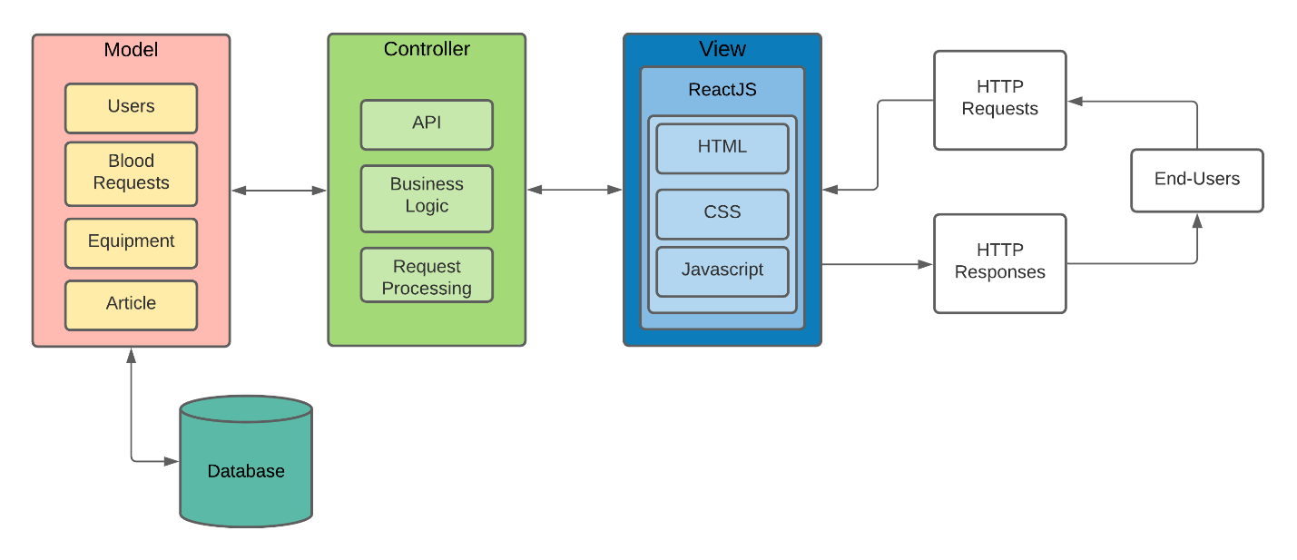

**Requirements**

**Non-Functional Requirements:**

* Our site has to thoroughly ensure user privacy and data security. Users have to provide highly sensitive information while making a request and donating medical supplies. The site must be trustworthy.
* Implementation of a user-friendly UI so that it becomes easy for one to roam the site and easily find out the medical supplies during emergencies.
* A proper connection to the database and proper management system to fetch data of a medical supply without any issues.
* 11th Hour Assistance must be easily accessible from any place at any time.
* A separate article site where Health tips and medical information will be provided by professionals.

**Functional Requirements:**

* **Medical donation, request and User authentication:** A person is required to create an account and login in order to create a request or donation post.

**Scenario:** The site is freely accessible to everyone. When making a donation post or request post or interacting in a donation post the user must login to proceed. For example, if one wants to donate blood he or she has to login as some sensible information like blood type, medical history will be needed which cannot be acquired from an anonymous user.

**There will be 3 types of users:**

1. **Admin User,**
2. **Normal User**
3. **Verified user**

**Admin:** Administrators

**Input:** email, password

**Output**: user authentication, admin panel, access to administrative functions, logout.

**User:** General end-users

**Input:** email, password

**Output:** user authentication, access to user profile, creating blood and supply donation post, creating blood and supply request post, logout.

**Verified user:** Professional medical worker.

**Input:** email, password.

**Output:** user authentication, access to user profile, creating blood and supply donation post, creating blood and supply request post, access to article, logout.

* **Creating medical donation post:** While making medical donation post user must provide information about the equipment or supplies. Personal information will not be required.

**Input:** equipment type, description, address, image

**Output:** Information saved and donation post will be created.

* **Creating medical request post:** Same as donation post,there can be two types of request post. Blood request and other medical equipment request post. While making medical request post the user must provide the detailed information of the equipment or supply needed. Based on the level of emergency, the requests will be prioritized. The request with most priority will show up at the top of the web page.

**Input:** equipment type, description, address, emergency.

**Output:** Information saved and request post will be created. Based on priority the post will be displayed.

* **Creating blood request post:** A person in need of blood can create a blood request post. There is no emergency level in this post as all blood donation posts are considered top priority.

**Input:** blood group, address.

**Output:** Information saved and request post will be created.

* **User profile:** User profiles should contain user name, user avatar, current or last known location, user status, medical history, donator status (eligible for blood donation or not.)
* **Free roaming Scenarios:** Even if a user is not logged in, he or she will have the option to freely roam the site, visit others profile to see if anyone is eligible for donation or visit some created posts.
* **Scenario:** If someone is in a great need of blood and does not have the time to login or register s/he will be able to roam the site and look for eligible donator. A person who wants to donate blood can tag himself as a donator in his or her profile. A dedicated search bar will help the visitor to track down eligible donator.

**Tools and Technologies used:**

* + **Frontend Tools:** Reactjs, Bootstrap
  + **Backend Tools:** Django REST Framework
  + **Authentication Technology:** JSON Web Token (JWT)
  + **IDE/Editor:** Sublime Text, PyCharm, Visual Studio
  + **Version Controlling System:** Git
  + **Miscellaneous:** Postman

**UI Screen Shots:**

**Authentication**

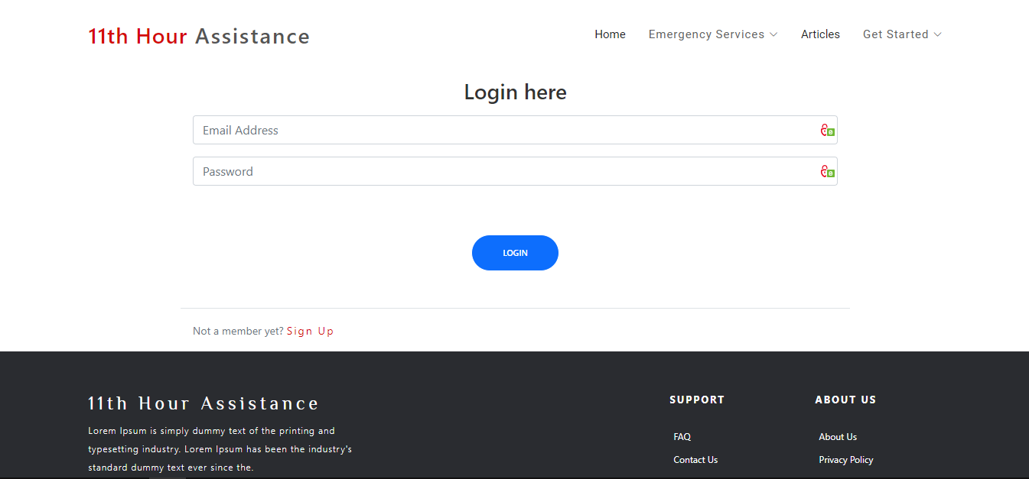**Login**

**Signup**

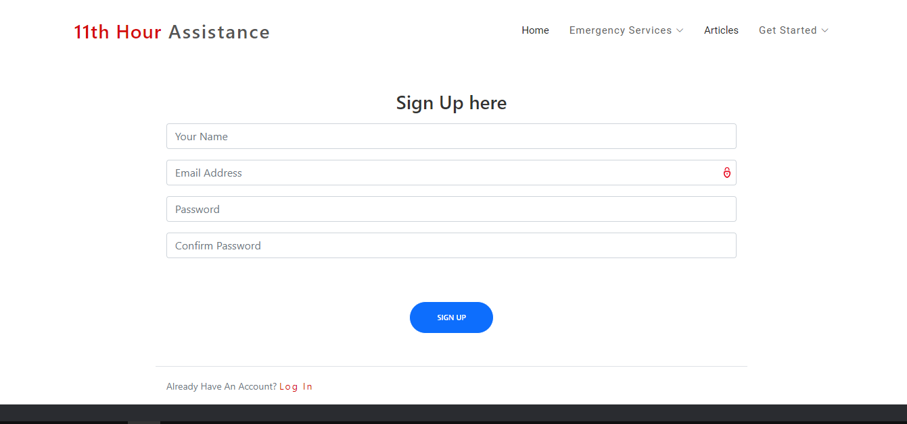

**Home**

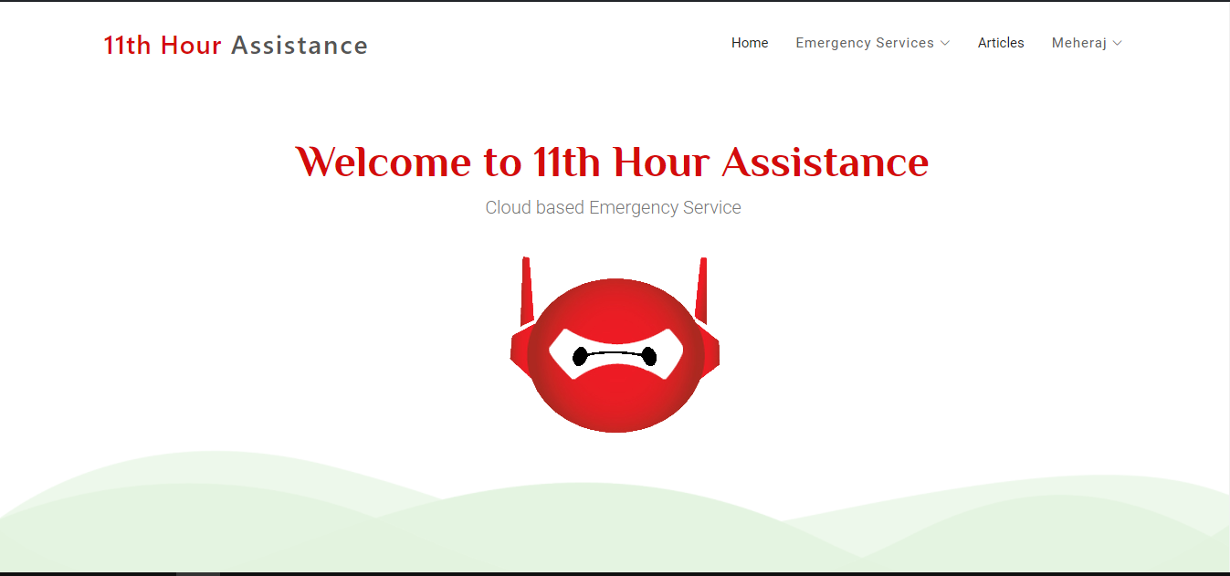

**Navigation**

**Viewing blood request posts**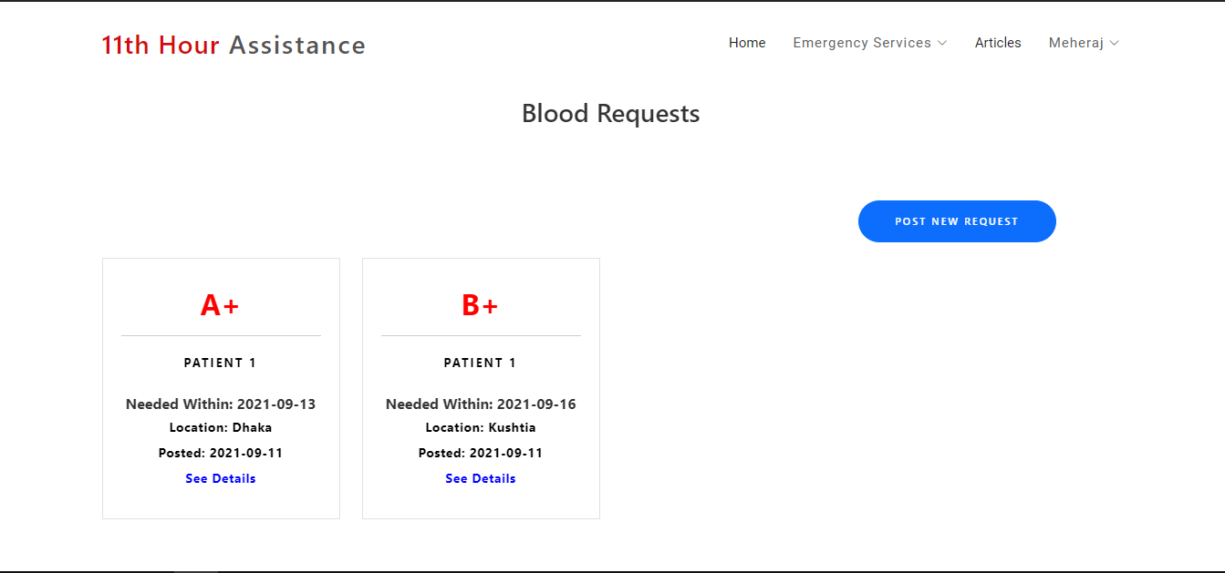

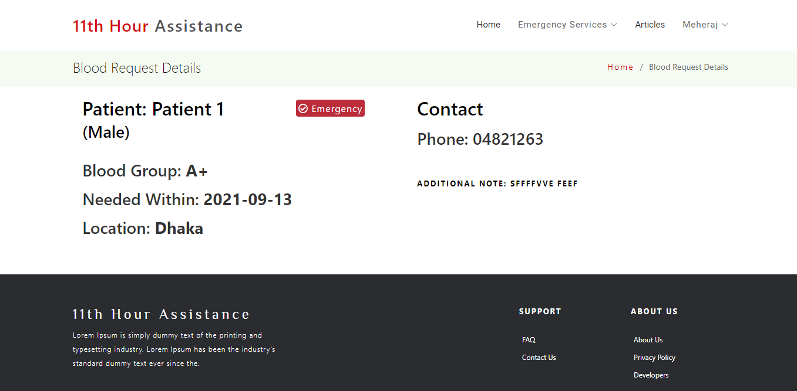**View Blood Request post**

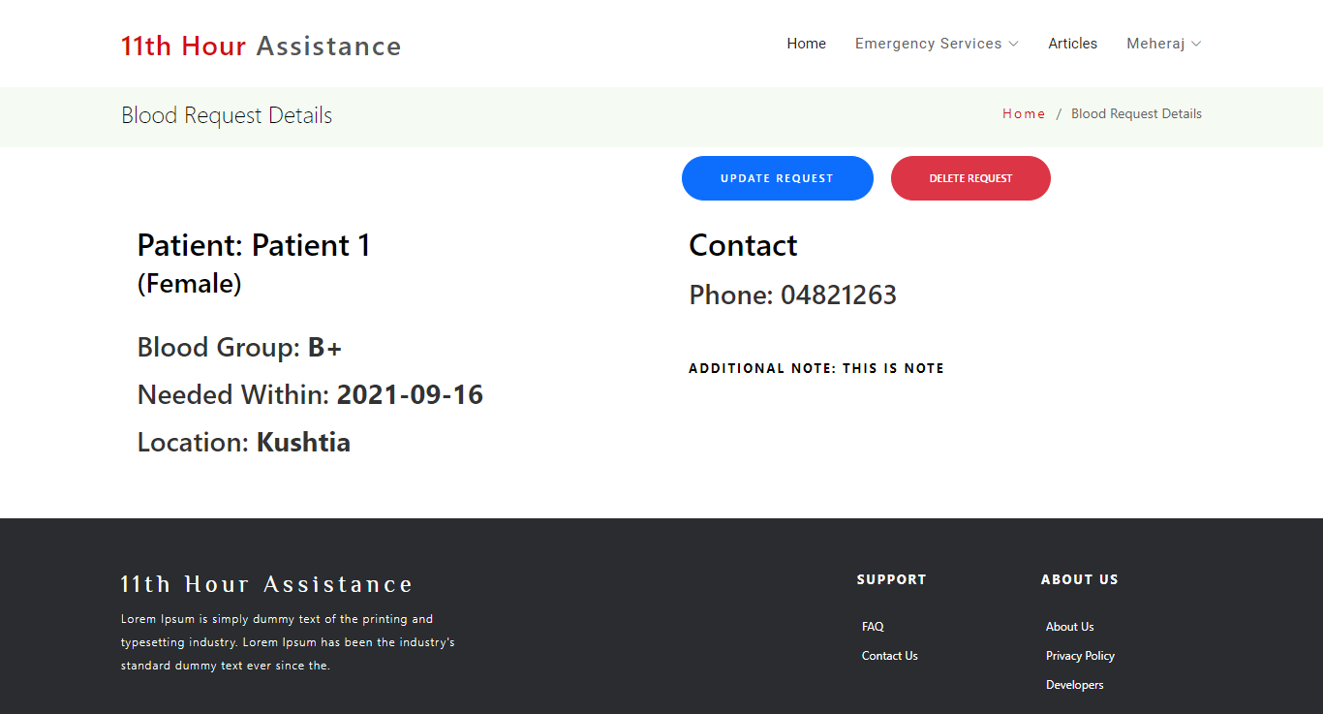**View Blood Request post (Self)**

**Viewing Equipment Request posts**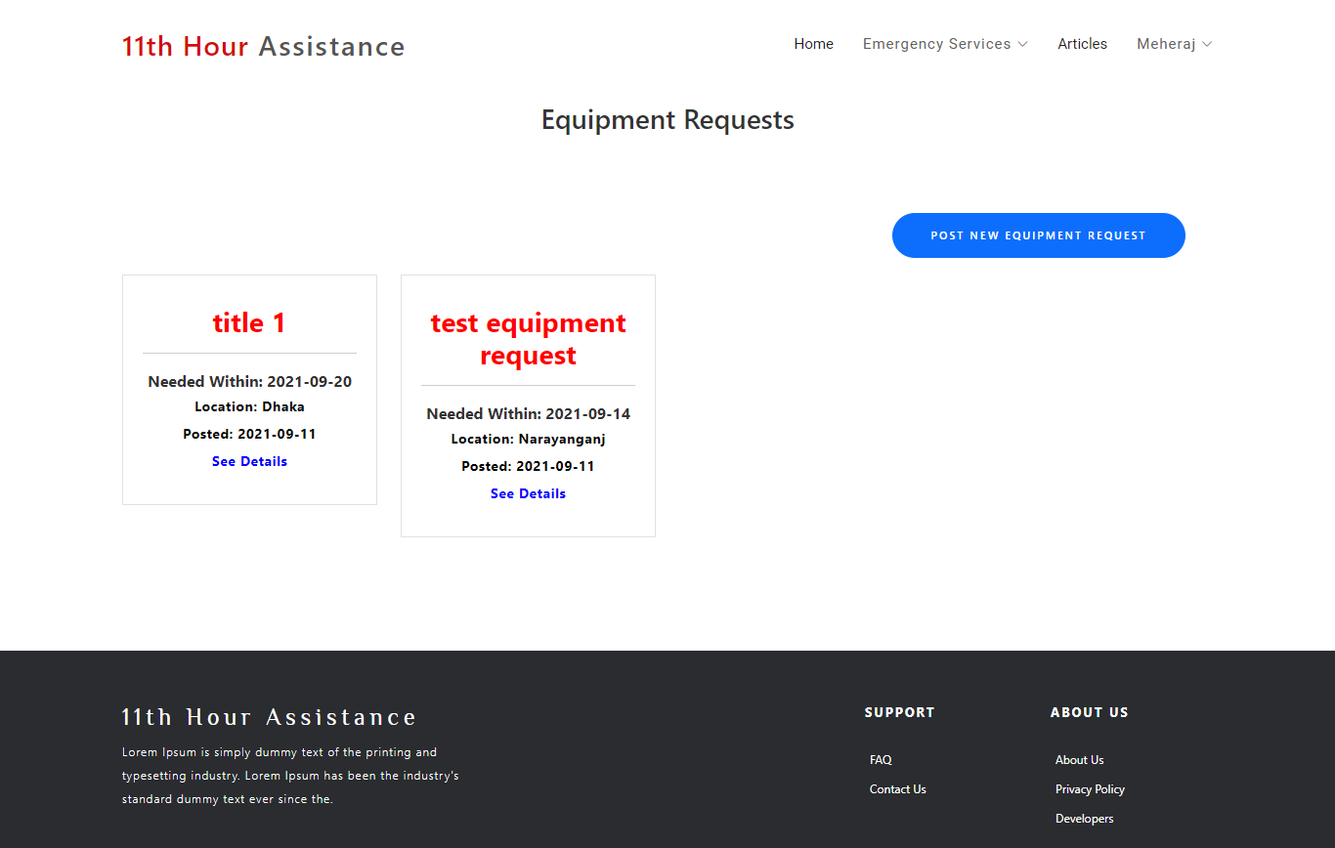

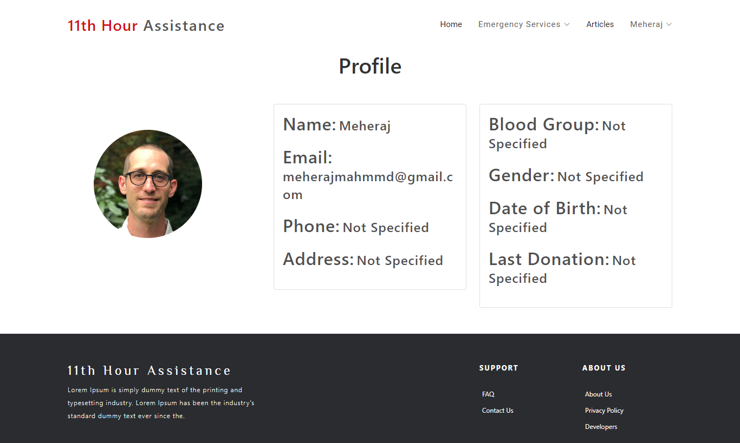 **Visit Profile**

**Actions**

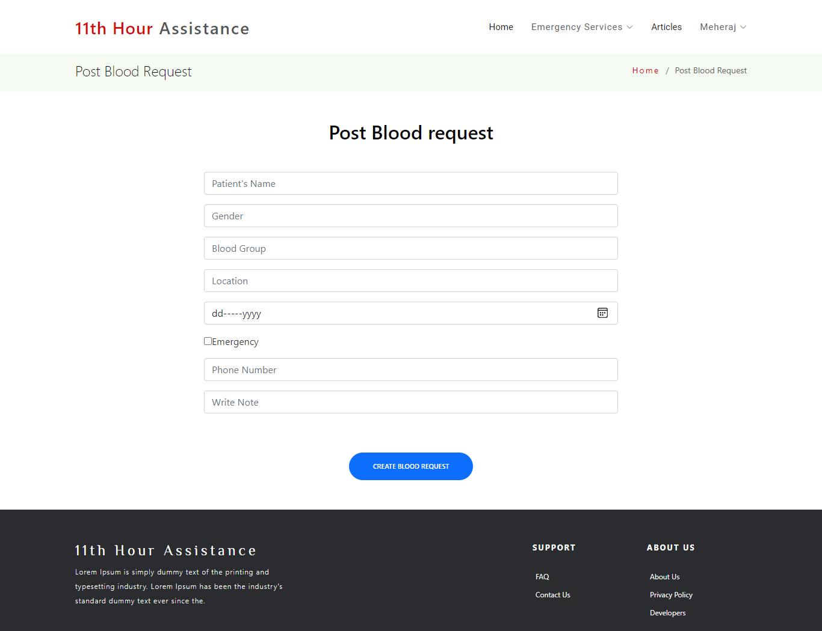**Create Blood Request post**

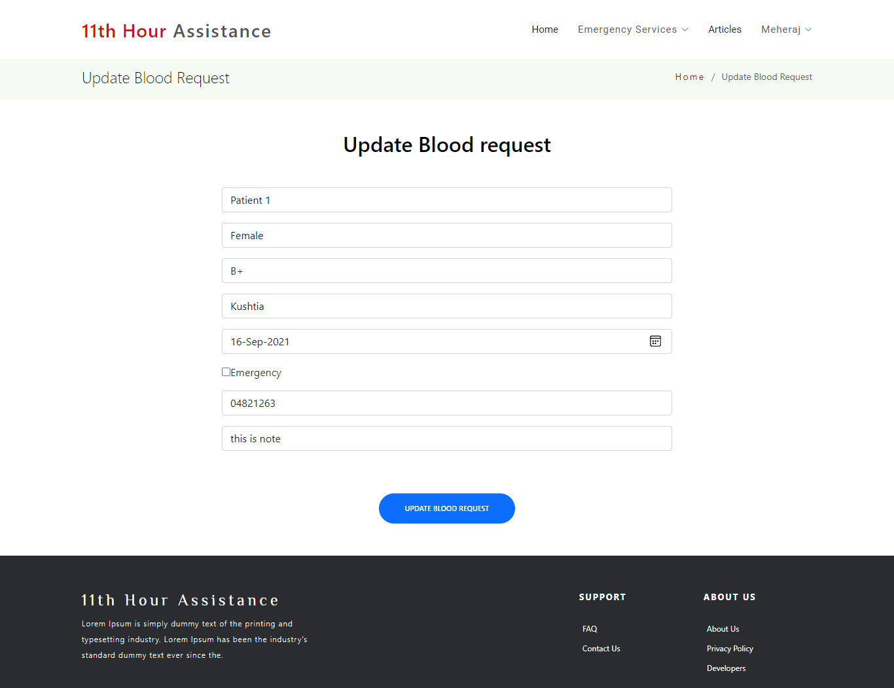**Update Blood Request post**

**Create Equipment Request post**

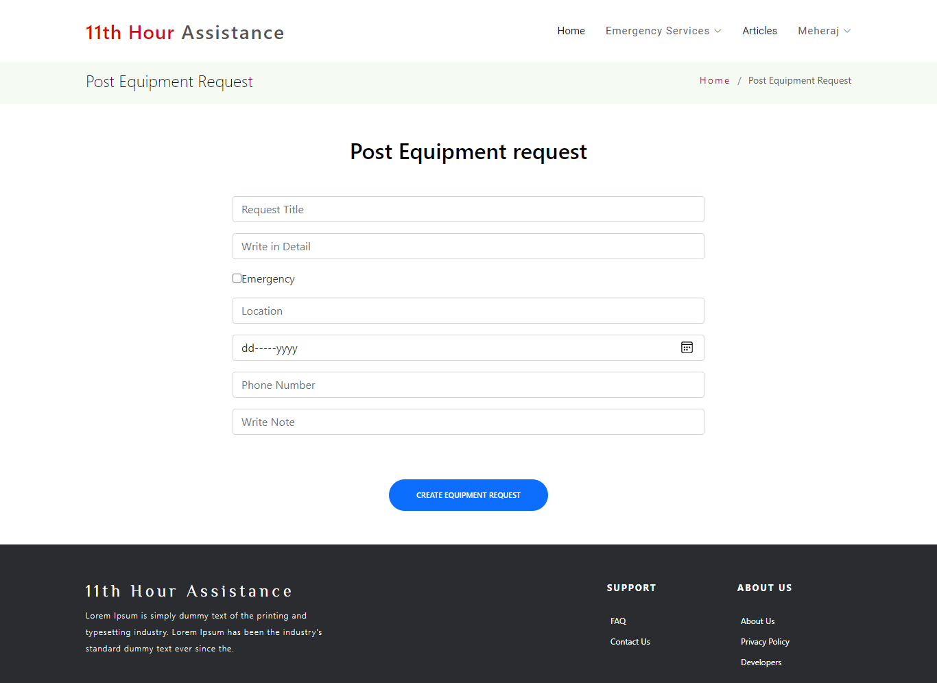

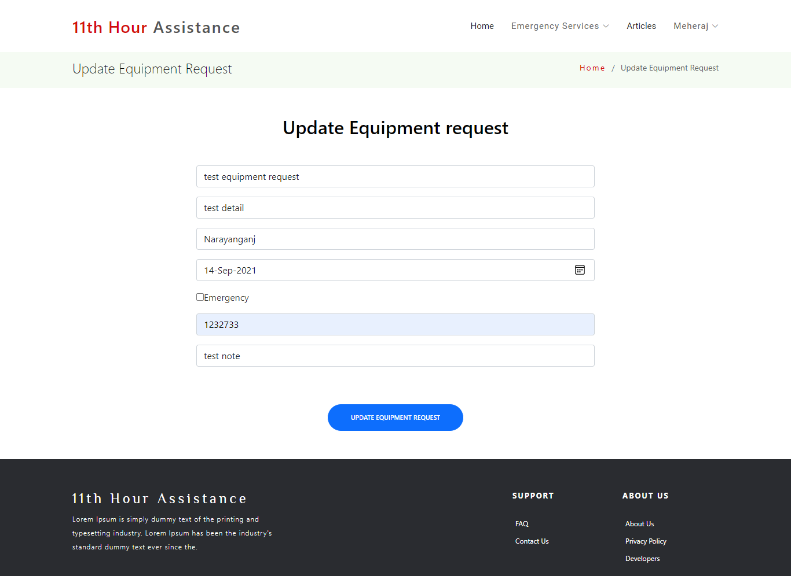**Update Equipment Request post**

**Article**

**Create Article**

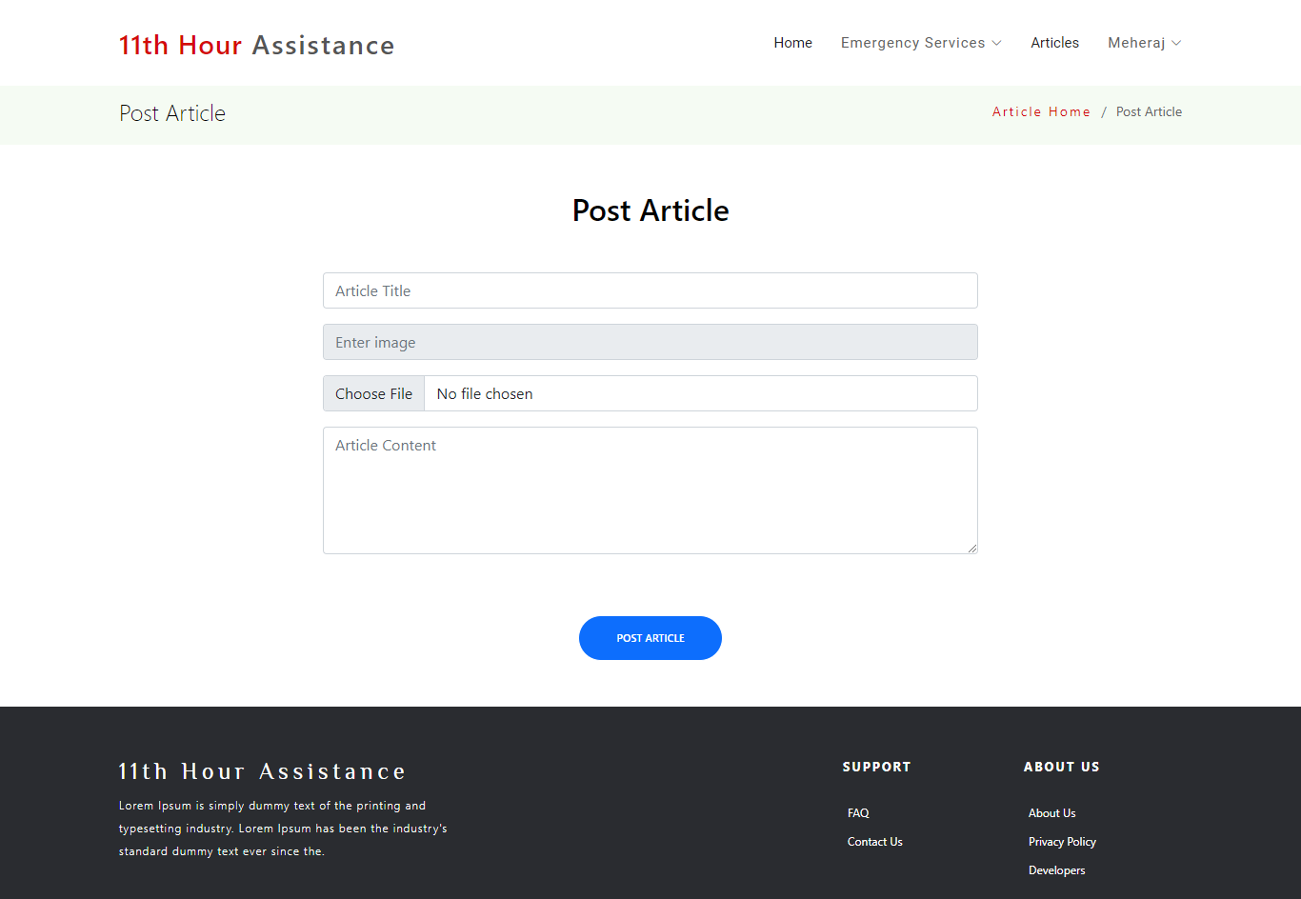

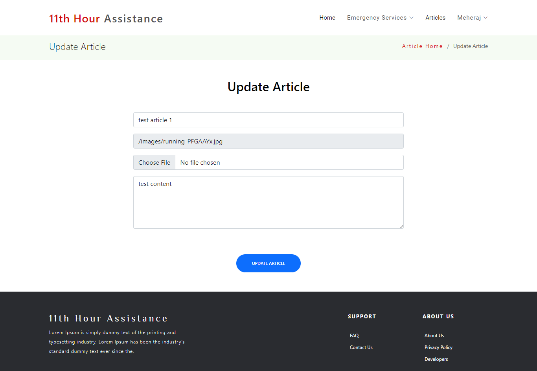**Update Article**

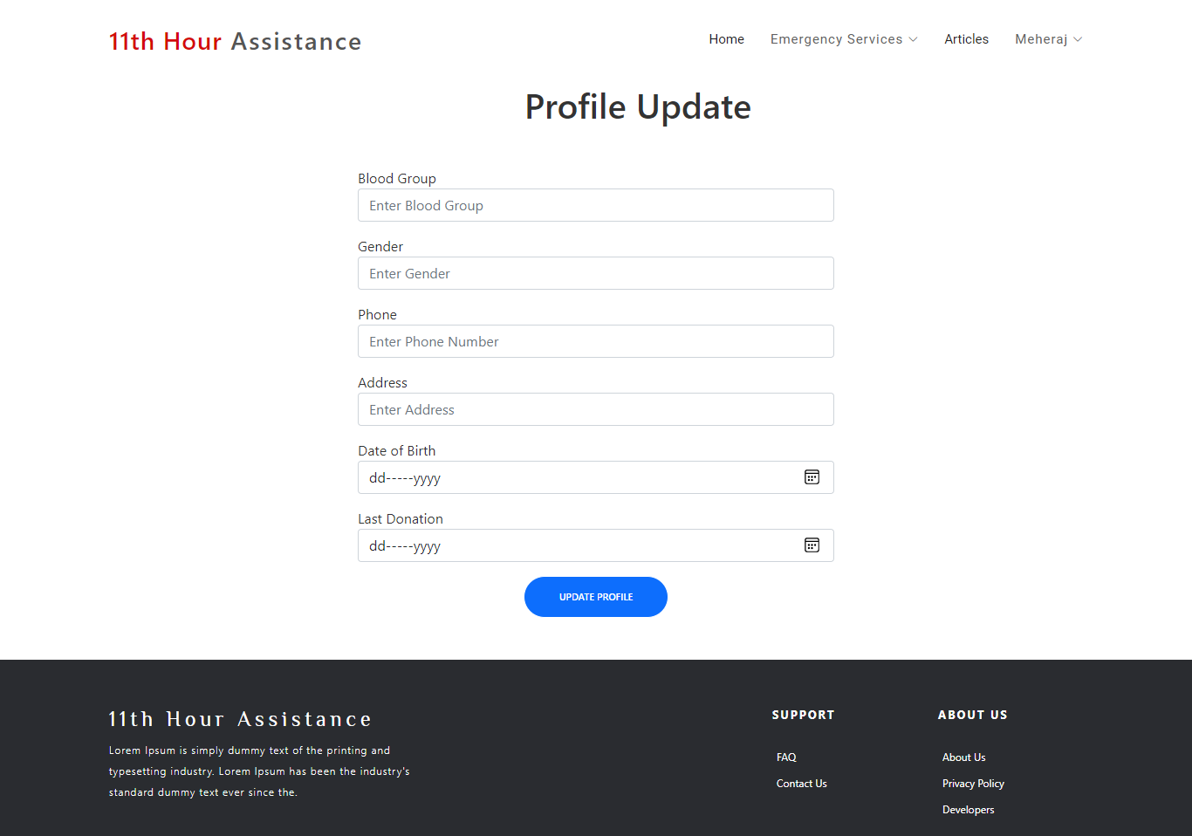**Update Profile**

**Viewing Articles**

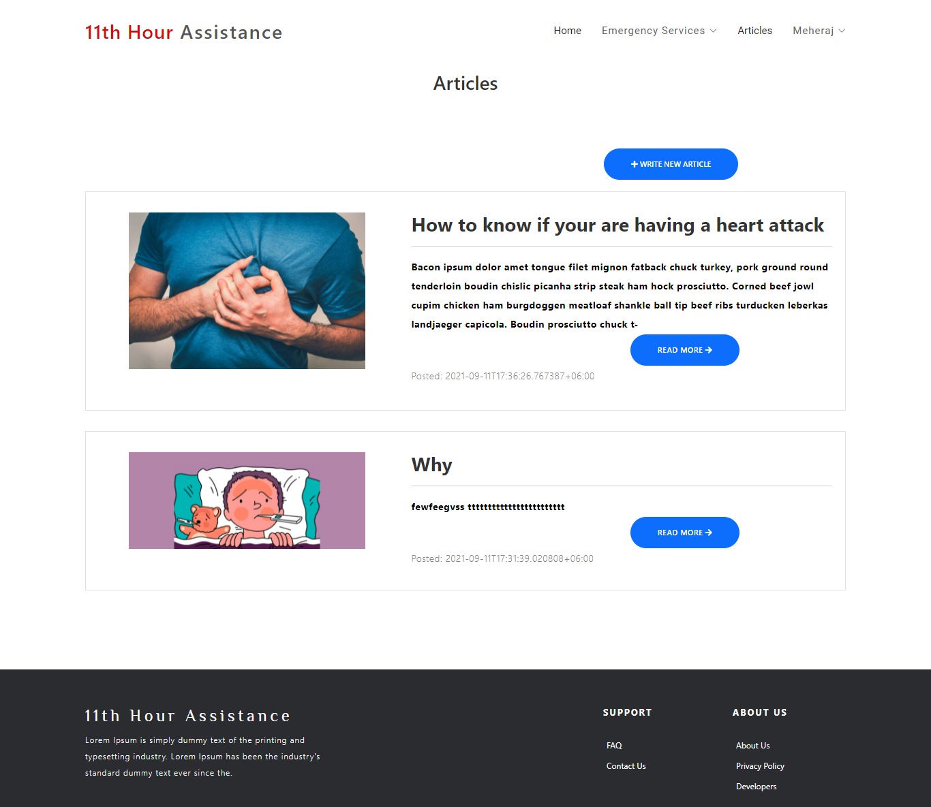

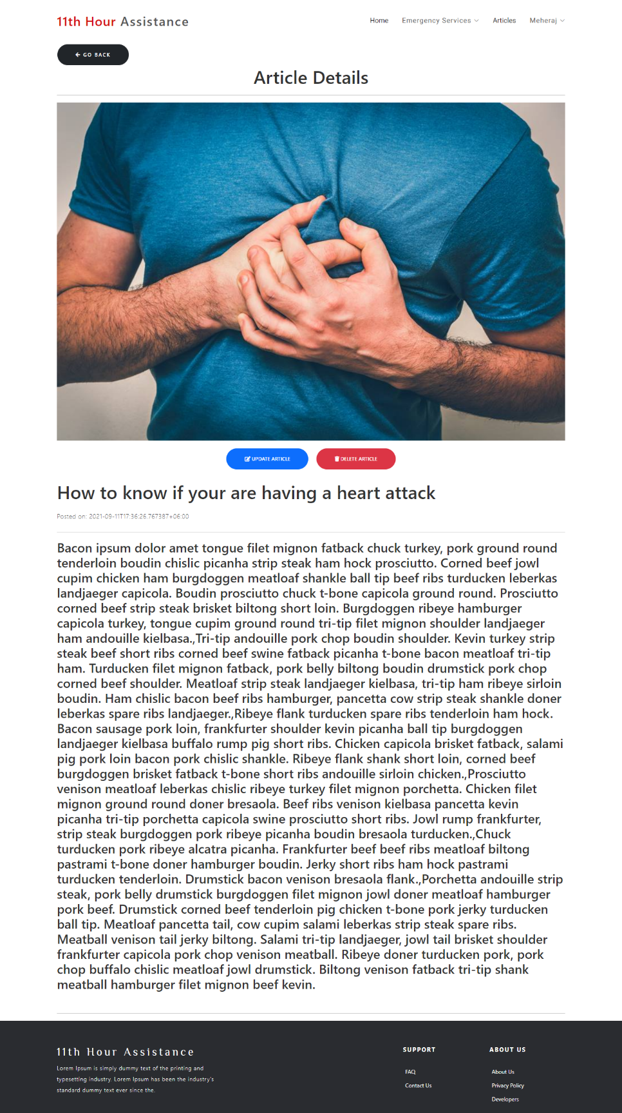**Read Article**

**Debugging:**

Debugging is an essential part in software application development. To remove the faults and making the application clean debugging process is very much required. If bugs are present in the application, it can drastically effect app performance and may can even cause freeze and crash.

While developing our project on VS Code and PyCharm a number of automated debugging tools were in our disposal. But we did not essentially rely on those tools. We simply tried to understand what is happening in each line of code when facing difficulties.

**Unit Testing:**

Test Code for “user_control” views



Testing request urls



**Future Plan:**

* We love the UI as it is but we think it can be improved so that the users can navigate more easily and smoothly. That is why we will work on the Ui and make it perfect
* Some limitations are there while customizing profile, creating posts and interacting with other’s post. We would like to improve user experience by adding new feature to these actions
* As of right now users can define emergency status in equipment posts. We would like to add more emergency features to help those who are in desperate situation
* We would like to add doctor appointment and other features to make this project a complete health care package.
* As of now this is a web application that can be accessed to any device. But we would like to bring it to hand held platform by turning it into an android app so that anyone can use it anywhere anytime

**Conclusion**

The initial goal of this app was to reach out to anyone in desire situation and in desperate need of help. At this point we are optimistic that we were able to achieve this goal. 11th Hour can live up to its name. An app that will bring help and assistance to those who are in a crisis situation. By creating a helpful community, we hope to bring aid to anyone, anywhere and at any time.