Network Analysis on Rumination

2. Methods

2.1 Network analysis

2.1.1 Removing redundant items
As a preparation step, we applied the goldbricker function from the R package networktools to search for pairs of items in the RRS, SCRS and MHS items which were highly correlated (r > 0.50) and showed highly the same pattern with other items. When such “bad pairs” were identified, reduction techniques were put into use (with the net_reduce function in R): instead of the pair, the first principal component of the two variables were kept in the data as a new, merged variable.
The RRS items required no reduction steps as the highly correlating items did not extend their pattern to more nodes (their correlations to other nodes did not violate the criteria that > 75% of these correlations did not differ significantly).

2.1.2 Network Analysis with LASSO
For the network analysis, the tuning parameter of gamma in the grahical LASSO alogrithm has been set to 0.5 value in accordance with (Bernstein, Heeren, and McNally 2019) in order to achieve sparse graphs. The final networks were chosen by the lowest values of the extended Bayesian Information Criterion (EBIC).

2.1.3. Community detection
In order to get an understanding of community of nodes and to see if nodes can be grouped into neighbourhoods, we used the igraph R package. When detecting possible communities of nodes, the detection happened with the following parameters in the spinglass algorithm: TODO: try the walktrap algorithm from igraph!

2.1.4. Expected Influence of nodes
To understand certain items’ centrality and importance, besides regularly used centrality measures (such as strength, closeness and betweenness of nodes in a network), one can also use the One- and Two-Step Expected Influence (EI) measures (Robinaugh et al, 2016). Traditionally in unweighted networks (where network edges are encoded to 0 or 1) a node’s centrality is the sum of edges, and in weighted nodes it is the sum of the edge weights. In this approach negative edges are treated the same way as positives, as the absolute values are used for centrality estimation. On the other hand, the Expected Influence metrics take into account if a node has positive and negative edges, too.

2.1.5. Identifying important nodes
In order to further elaborate the question of importance within the network, we identified bridge nodes using the functions provided by the networktools R package (Jones 2017). We estimated both one-step and two-step bridge expected influence measures which reflect the sum of edge weights connecting one node to other groups on nodes (or communities of nodes); and also express a node’s secondary influence on the rest of the network, respectively. Higher influence scores indicate that a certain node is more likely to active neighbouring nodes, subgroups of nodes or communities.

3. Results

3.1 Network plots
RSS network
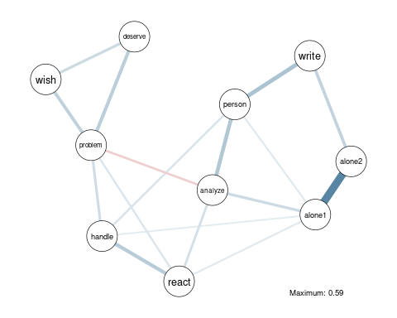
SCRS network 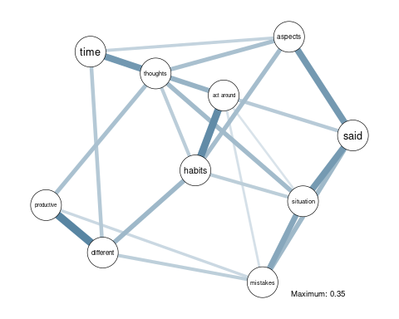
## | | | 0% | |==== | 5% | |======= | 10% | |========== | 15% | |============== | 20% | |================== | 25% | |===================== | 30% | |======================== | 35% | |============================ | 40% | |================================ | 45% | |=================================== | 50% | |====================================== | 55% | |========================================== | 60% | |============================================== | 65% | |================================================= | 70% | |==================================================== | 75% | |======================================================== | 80% | |============================================================ | 85% | |=============================================================== | 90% | |================================================================== | 95% | |======================================================================| 100%
## SCRS_4 & SCRS_2 SCRS_8 & SCRS_1
## 0.1666667 0.2222222
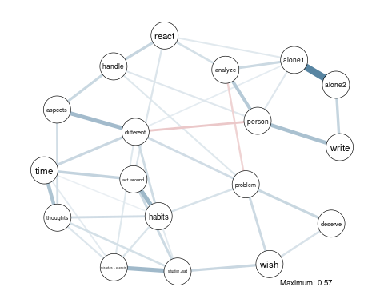

3.2 Community detection
Community mapping of RSS, MHC and SCRS with the spinglass algorithm:
RSS communities identified with parameters gamma = 0.5, spins = 25, starting temperature = 1, ending temperature = 0.01, cooling factor = 0.99.
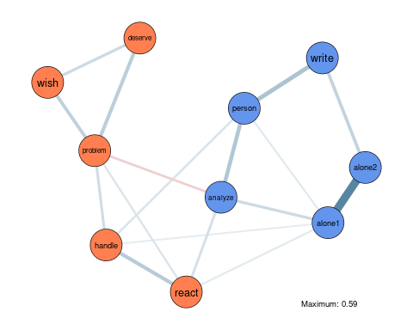
SCRS communities identified with parameters gamma = 0.5, spins = 25, starting temperature = 1, ending temperature = 0.01, cooling factor = 0.99.
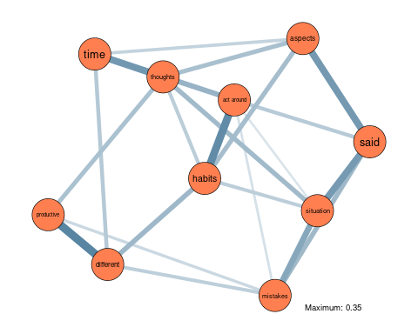
RRS and MHC combined communities identified with parameters gamma = 0.5, spins = 25, starting temperature = 1, ending temperature = 0.01, cooling factor = 0.99.
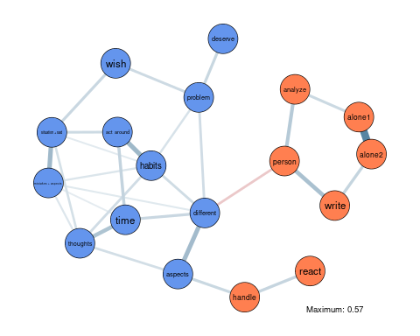

3.3 Expected Influence
In order to estimate the Expected Influence metrics, we used the expectedInf function of the networktools R package. The influence score are normalized.
RRS Expected Influence Measures
## [1] "RRS"
## [1] "RRS"
## [1] "RRS"
## [1] "RRS"
## [1] "RRS"
## [1] "RRS"
## [1] "RRS"
## [1] "RRS"
## [1] "RRS"
## [1] "RRS"
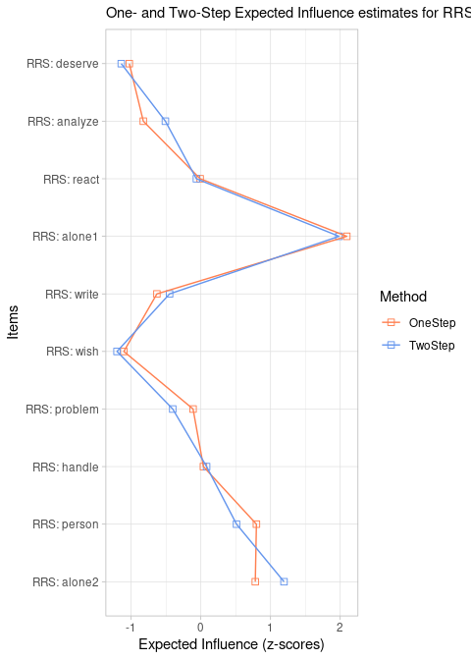
SCRS Expected Influence Measures
## [1] "SCRS"
## [1] "SCRS"
## [1] "SCRS"
## [1] "SCRS"
## [1] "SCRS"
## [1] "SCRS"
## [1] "SCRS"
## [1] "SCRS"
## [1] "SCRS"
## [1] "SCRS"
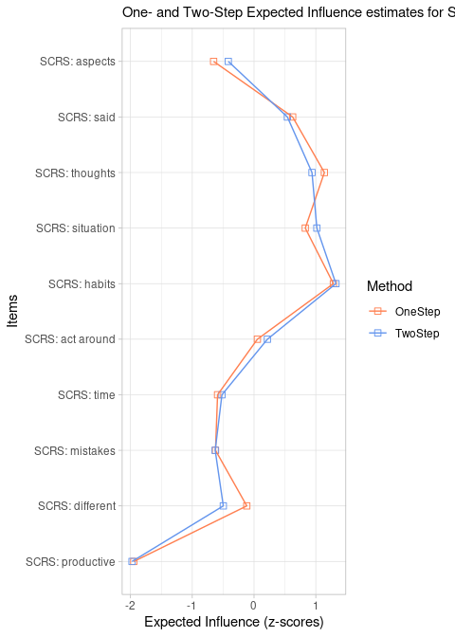
Combined RRS and SCRS Expected Influence Measures
## [1] "RRS"
## [1] "RRS"
## [1] "RRS"
## [1] "RRS"
## [1] "RRS"
## [1] "RRS"
## [1] "RRS"
## [1] "RRS"
## [1] "RRS"
## [1] "RRS"
## [1] "SCRS"
## [1] "SCRS"
## [1] "SCRS"
## [1] "SCRS"
## [1] "SCRS"
## [1] "SCRS"
## [1] "SCRS"
## [1] "SCRS"
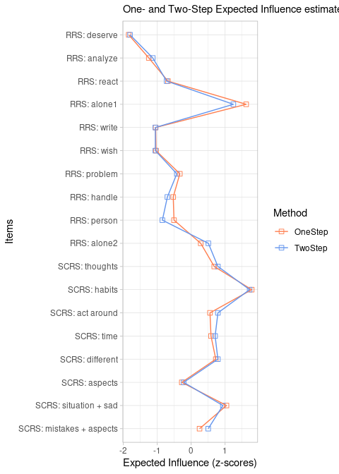

3.4 Bridge nodes
Using the networktools R library bridge expected influence measure were estimated for the three tools we used in this study. We also added aesthetics to reflect which items belonged to the same community according to our previous clustering steps.
RRS bridge estimates
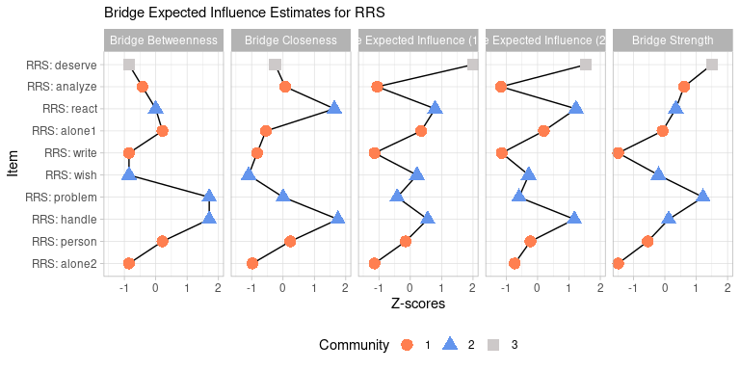
SCRS bridge estimates
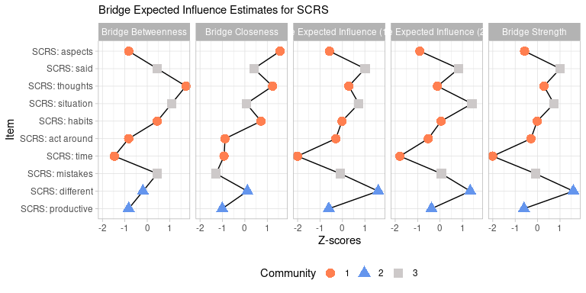
Combined RRS and SCRS bridge estimates
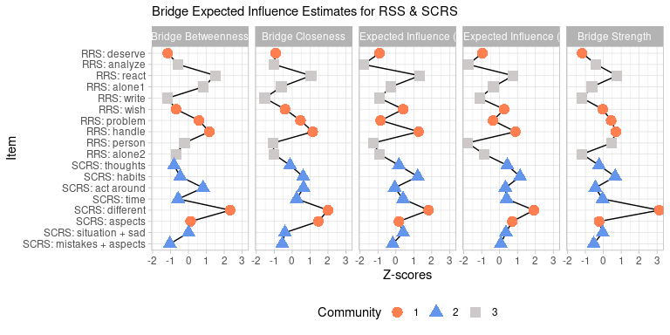

References
Bernstein, Emily E., Alexandre Heeren, and Richard J. McNally. 2019. “Reexamining Trait Rumination as a System of Repetitive Negative Thoughts: A Network Analysis.” Journal of Behavior Therapy and Experimental Psychiatry 63 (June): 21–27. https://doi.org/10.1016/j.jbtep.2018.12.005.
Jones, Payton. 2017. “Networktools: Assorted and Tools for Identifying and Important Nodes and in Networks.” In.

