Self-critical rumination - A network approach

1. Introduction
According to the Response Style Theory, rumination, or depressive rumination, is repetitive thinking about the causes, symptoms, circumstances and consequences of negative mood states and distress (Nolen-Hoeksema, 1991; E. R. Watkins, 2008). Cross-sectional and longitudinal studies (Butler & Nolen-Hoeksema, 1994; Nolen-Hoeksema et al., 1999; Whisman et al., 2020) suggest that rumination could maintain and exacerbate existing psychopathology. Depressive rumination can contribute to the onset or recurrence of several symptoms and disorders (Aldao & Nolen-Hoeksema, 2012; Lyubomirsky et al., 2015; Lyubomirsky & Nolen-Hoeksema, 1993; Nolen-Hoeksema et al., 2008; Ruscio et al., 2015; E. R. Watkins & Roberts, 2020; Whisman et al., 2020). As a trans-diagnostic characteristic (Nolen-Hoeksema & Watkins, 2011), rumination was found to predict the onset of major depressive disorder across one year in adolescent (Broderick & Korteland, 2004; Wilkinson et al., 2013) and adults samples (Nolen-Hoeksema et al., 2008), and was involved in generalized anxiety disorder (Nolen-Hoeksema, 2000) and PTSD (Moulds et al., 2020). Rumination was found to have a role in depression and anxiety (McLaughlin et al., 2014), bipolar disorder (Kovács et al., 2020), borderline personality disorder (Selby et al., 2008), social phobia (Abbott & Rapee, 2004), or psychosis (Hartley et al., 2013).
Rumination can lead to negative mood states and thoughts mutually amplify and prolong each other (E. R. Watkins & Roberts, 2020). However, consequences and effects of rumination are not specific to clinical samples, and can be identified in the background of the ruminative processes of healthy people (Ciesla & Roberts, 2007; Moulds et al., 2007). As such, rumination could interfere with effective problem-solving by reducing self-confidence (E. Watkins & Moulds, 2005); reduce willingness to engage in pleasant activities (Lyubomirsky et al., 2015); lead to elevated level of uncertainty (Ward et al., 2003), avoidance or personal difficulties (Hayes et al., 2004; Yasinski et al., 2019). As a multifaceted construct, rumination is often operationalized as depressive rumination and consequently measured by the Response Style Questionnaire RSQ, or its shorter form the Ruminative Response Scale, RRS (Nolen-Hoeksema, 1991; Treynor, 2003). Two sub-factors within the RRS: the brooding and reflective pondering (or reflection) were identified (Treynor, 2003). Brooding is a maladaptive, passive dwelling on negative events and associated affects, while reflection is a more adaptive (or less pathological) form of thinking, a non-evaluative introspection towards one’s mood. Several empirical findings support the adaptive-maladaptive distinction of brooding and reflection. Brooding alone was associated with substance use among people with history of illicit drug use (Memedovic et al., 2019), and with attentional disengagement difficulties, while controlling for depression and anxiety (Allard & Yaroslavsky, 2019). Apart from brooding and reflection, many other rumination types or facets were described in the last decades. People (especially with social phobia) tend to ruminate about their mood after a social event or performance (Abbott & Rapee, 2004). Individuals can dwell upon infuriating memories or on anger itself (Bushman et al., 2005; Pont et al., 2017). Repetitive thinking can target sadness as well (Peled & Moretti, 2009).
These results indicate that not just the style of thinking, but the content of these ruminative thoughts has special relevance (Smart et al., 2015). More recently, research has started to investigate the role that rumination plays in maintaining levels of self-criticism (Kolubinski et al., 2017; Smart et al., 2015). Self-criticism is a form of negative self-evaluation with one harshly and hostilely judging oneself, especially in the context of mistakes, failures, unreached goals or unmet standards (Rose & Rimes, 2018; Shahar et al., 2014). Self-criticism was found to be a vulnerability factor in many forms psychopathology such as depressive and anxiety disorders, binge eating or non-suicidal self injury (Glassman et al., 2007; Rose & Rimes, 2018; Shahar et al., 2014). Since rumination resulted to be a significant mediator between self-criticism and depression across 2.5 years (Spasojević & Alloy, 2001), and between self-criticism and suicidal ideation over 3 months (O’Connor & Noyce, 2008). Thus, we can assume that rumination is one of those processes by which these negative self-devaluating thoughts are sustained and connected to psychopathology. Investigating rumination in the context of self-critical thoughts is paramount, especially in light of the results of a recent meta-analysis which indicated that the harsh and persistent forms of self-criticism did not change through short-term interventions (Werner et al., 2019).
Self-critical rumination significantly differ from depressive rumination, mostly by the focus of thoughts (Smart et al., 2015). While in self-critical rumination, individuals concentrate on the their lack of self-worth or those aspects of the self of which they are ashamed of, in depressive rumination one’s attention is directed towards the symptoms of depression (Nolen-Hoeksema, 2000). Indeed, in a recent study, self-critical rumination was strongly related to shame and predicted sensitivity to stress after a perceived failure (Milia et al., 2020). Positive meta-cognitions in self-critical rumination (Kolubinski et al., 2017) likely has less importance than in depressive rumination (Papageorgiou & Wells, 2001). One can assume that in depressive rumination the positive, while in self-critical rumination the negative meta-cognitions (e.g. “I will get depressed if I don’t stop reviewing my self-critical thoughts”) are those processes which maintain the ruminative process (Kolubinski et al., 2017). The Self-Critical Rumination Scale (SCRS, (Smart et al., 2015)) showed incremental validity over other rumination scales (including the widely used RRS and RSQ) in predicting bipolar personality features and general distress. However, in the same study, SCRS and RRS were highly correlated (which is not surprising considering the above mentioned similarities between self-critical and depressive rumination), indicating that those individuals who ruminate in a more general or broader way are also likely to ruminate on numerous topics, including self-devaluating thoughts and vice versa. Previous work also supported the notion that individuals can show different forms of repetitive thought and they can ruminate and worry simultaneously, or they are able to passively brooding on something and adaptively reflect on other topics (E. R. Watkins, 2008).
Because of this multifaceted structure and the question of boundaries between the different subtypes of rumination, it could be beneficial to investigate them in a network perspective. Contrary to latent variable models, network analysis does not seek for a common cause of co-occurrence of indicators (e.g. different items of a questionnaire) but shift the focus toward the relationships and interactions between variables (Epskamp, Kruis, et al., 2017). Psychological networks have their own characteristics which differentiate them from other kinds of networks of graph theory (Epskamp, Borsboom, et al. (2017a); Epskamp & Fried (2018); Newman (2010)). Vertices (also called nodes) usually represent some psychological measures or items of a psychological assessment tool, while the edges of the network reflect the corresponding estimates of association derived from the data. In this way, in a network model the construct of rumination could be interpreted as a system in which some aspects relate or even stimulate each other, while other aspects have negative or inhibiting effects (Costantini et al., 2015). Thanks to this data-driven approach we can test how self-critical and depressive ruminative processes or the different items of the ruminative questionnaires cluster and relate to each other and we can gain important insights which could remain hidden by relying only on latent variable models (Bernstein et al., 2019). Having two rumination-related questionnaires, the Ruminative Response Style (RRS) and the Self-critical Rumination Scale (SCRS), we assumed the following hypotheses:
- Network analysis will reveal their respective internal structure previously established in the literature (such as RRS having a two-scale structure: reflection and brooding; while SCRS will show a single-scale structure);
- on the other hand, we hypothesized that in their common network, items overlapping in scope will change these clear outlines of the two measurement tools. According to our hypothesis, items of the RRS scale brooding will have non-trivial association with the self-critical aspects of rumination;
- we also assumed a combined rumination network, representing the generic (more trait-like) and the self-critical aspects of rumination will exhibit a three-component structure.
Previously, the network model was successfully applied to investigate depressive rumination by testing the original 22-item version of RRS (Bernstein et al., 2019), but to the best of our knowledge no other rumination questionnaires was investigated, especially in terms of self-critical thoughts.

2. Methods

2.1 Participants and procedure
Students from several Hungarian high schools participated in the study on a voluntary basis. The first stage of the recruitment process was to contact the heads of the schools to acquire institutional consent. Afterwards, classes were visited asking the students to participate. Since, the participants were under-aged, parents as well as students were issued with written informed consent letters. Following their consent, students were asked to fill out paper-pencil questionnaires in their own classroom within one class session. Participation in the study was anonymous and voluntary. Data collection was supervised by trained undergraduate students of psychology. No teaching staff were present. The total sample of the study comprises data from 851 participants (aged 14-19 years, females= 502 (59%), males=349 (41%) collected via convenience sampling method. The mean age was 16.1 years (SD=1.1). The protocol was designed in accordance with the Declaration of Helsinki and the study was ethically approved by the Institutional Review Board (note: the name of the university is masked for review process).

2.2 Measures
The Self-Critical Rumination Scale SCRS; (Smart et al., 2015) was used to assess those thoughts that criticize the self for perceived failures, mistakes or bad habits in a prolonged and repetitive manner. The SCRS is a self-reported, one factor scale that consists of 10 items. Participants were asked to rate the statements (i.e. “My attention is often focused on aspects of myself that I’m ashamed of”; “I criticize myself a lot for how I act around other people”) on a 4-point Likert scale from 1 (not at all) to 4 (very much). The scale showed high internal consistency in our study (Cronbach α=0.90), similarly to the original version (Cronbach α=0.92).
The short form of Ruminative Response Scale RRS; (Treynor, 2003) was used to measure mood dependent rumination, which consists of 10 items and quantifies ruminative thoughts via two dimensions (each composed of 5 items). Brooding subscale of RRS measures the maladaptive form or ruminative thinking (i.e. “What am I doing to deserve this?”), while reflective pondering (or reflection) factor measures a more adaptive form of self-reflecting thinking (i.e. “I write down what I am thinking and analyze it”). Participants are asked to indicate on a 4-point Likert scale how often the items apply to themselves when they feel down, sad or depressed (1=almost never; 4=almost always). Internal consistency of the scale was acceptable in the present study (Cronbach αs were ranging from 0.65 to 0.75). Besides the SCRS and RRS basic socio-demographic information (e.g. age, gender, parents’ level of education) was recorded.

2.3. Network modeling, descriptives and communities
In the current study, we used a sample (N=851) to construct a dense, undirected network of rumination-related psychological constructs. The vertices represent the items of the RRS and SCRS, while edges are penalized partial correlations using LASSO penalization, see (Friedman et al., 2007; Tibshirani, 1996).
We constructed individual and combined networks of RRS and SCRS with respective penalized correlation matrices using the EBICglasso function of the qgraph package (Epskamp et al., 2012). See our Git repository for other parameter specifications. In order to shrink the edges, achieve high specificity, and get a less dense network, we let the function to exclude any elements of the underlying precision matrix below a threshold value (threshold parameter set to TRUE).
The LASSO uses L1 (absolute) regularization (Friedman et al., 2007; Tibshirani, 1996). In the current study, the method resulted in a partial correlation network where edges represent direct associations between pairs of items, while the influence of all other items in the network are kept controlled. The regularization by L1 penalty lets trivially small partial correlations to be set to zero (McNally et al., 2017), thus ensure a sparse network which are more interpretable (Epskamp & Fried, 2018).
The tuning parameter of gamma in the graphical LASSO algorithm has been set to 0.5 value in accordance with (Bernstein et al., 2019; McNally et al., 2017). The final networks were chosen by the lowest values of the extended Bayesian Information Criterion (EBIC).
We applied the goldbricker function from the R package networktools (Jones, 2017) in order to search for pairs of items in the RRS, SCRS and their combined networks that were highly correlated (r > 0.75) and exhibited the same pattern with other items. After the LASSO regularization no further dimensionality reduction was necessary based upon the goldbricker evaluation.
A comparative overview of the three networks was produced with their descriptives (degree distribution) and their centrality measures (strength, closeness, betweenness) (Kolaczyk, 2020), and their One- and Two-Step Expected Influence (EI) measures to understand the cumulative importance of vertices (Bernstein et al., 2019; Donald J. Robinaugh, 2016; Heeren et al., 2018). In order to further elaborate the question of vertex importance, we identified bridge nodes using the functions provided by the networktools R package (Jones, 2017) to identify bridge vertices, in other words, connectors between sub-graphs, see and example at (Bernstein et al., 2019). We estimated both one-step and two-step bridge expected influence measures which reflect the sum of edge weights connecting one vertex to other groups on vertices (or communities); and also express a vertex’s secondary influence on the rest of the network, respectively. Higher influence scores indicate that a certain vertex is more likely to active neighbouring vertices or communities. In order to estimate the Expected Influence metrics, we used the expectedInf function of the networktools R package. In order to get an understanding of community of vertices and to see if vertices can be grouped into neighbourhoods corresponding to the previously established sub-scale structure of RRS, SCRS and investigate their separation in their combined network, we used the community detection methods available in the igraph R package (Kolaczyk, 2020). When detecting possible communities of vertices, we followed guidelines by (Bernstein et al., 2019; Kolaczyk, 2020; Reichardt & Bornholdt, 2006). In order to mitigate the effect of choice of community detection algorithms, we performed more of them available in the igraph package multiple times (B=1000).

2.4 Internal Structure with an exponential random graph model
In order to measure the impact of tools (RRS, SCRS) and their respective scales (brooding, reflection and self-critical) on the combined network structure, we constructed an exponential random graph model ERGM (Hunter, 2007). In the model of our combined network predicting edges, endogenous predictors (related to the nature of the network structure) included the number of edges in the network (edges member), and a generalization of triadic structures based on alternating sums of k-triangles (Goodreau et al., 2009; Hunter, 2007) to involve some higher-order global network structures. This predictor served as a reflection on clustering in the form of completed triangles of vertices; we used GWESP (see Goodreau et al., 2009), which stands for geometrically weighted edgewise shared partner distribution. GWESP has the advantage of taking a parametric form of the shared common vertex count distribution on each edge, giving each connecting vertex a declining positive probability of two selected vertices being connected. In order to capture exogenous effects (i.e., vertex attributes), we added tool and sub-scale as predictors, especially testing for homophily (assuming that belonging to the same tool and its scale will increase the log-odds of being connected by an edge).

2.5 Association Network Inference
In order to understand the nature of the edges in the combined association network, we utilized Association Network Inference techniques. The R package fdrtool (Strimmer, 2008a; Strimmer, 2008b) allowed us to model the probability density function and estimate $η_{0}$, the fraction of true null hypotheses in the data; and (1-$eta_{0}$) for the true alternative hypotheses. The mixture model for some statistic S thus takes the following form (where in our analysis, S is the partial correlation coefficient).
To apply adjustment due to the number of performed tests, we controlled p-value by the False Discovery Rate (FDR; the rate of false rejections against the number of rejections).

2.6. Latent Network Modeling
We constructed an eigenmodel to further explore the structure of the combined graph of RRS and SCRS (Hoff et al., 2002; Kolaczyk, 2020; methodology following Mair, 2018) and how well the network structure predicts edges. Our expectation was that sub-scales will have non-trivial impact on the resulting eigenvalues. In our two-part analysis, first we used eigenvalue decomposition in order to use the first two eigenvectors reflective to our scale- and sub-scale structures of RRS and SCRS. In the second part, we defined three conditions in the eigenmodel on top of the original model. In the first iteration we used the original eigenmodel (discussed above) without the regression component, defining the adjacency matrix as function of only the pairwise latent effects summarized in the following matrix.
In the second and third iterations, we defined an optional regression model in addition to the pairwise latent effects, where ${\text{x}}_{ij}$ is a pair-specific predictor vector. This extends our model to the following equation.
In the second iteration, we cross-validated an extended eigenmodel with Tool (RRS or SCRS) serving as nominal grouping factor of vertices. In the same manner, the third iteration tested a model with the Scales of brooding, reflection and self-critical serving as pair-wise covariate predictor effects.

2.7. Power analysis, network accuracy and stability
Accuracy and stability have an important role in estimating network parameters when samples might vary in characteristics and size (Epskamp, Borsboom, et al., 2017a, 2017b). One way of estimating network accuracy is to produce a 95% confidence interval of edge-weights with some variant of bootstrap. In the present paper, we chose the non-parametric bootstrap estimate for interpretability. Network stability is quantified with the Correlation Stability (CS-coefficient): an estimate of the maximum proportion of cases that can be dropped (with 95% certainty) to retain a correlation with the original centrality higher than some fixed threshold value (in the present paper, 0.7). Simulation studies (Epskamp, Borsboom, et al., 2017a) lead us in our expectation as the CS-coefficient should be between 0.25 and 0.5.

3. Results

3.1 Descriptives, network descriptives and community detection
Pearson correlation coefficients, Cronbach’s alphas of the scales, means and standard deviations (for the total sample, and for females and males separately) are presented in Table 1. below. The data being skewed and homoscedasticity being hurt between gender groups, we estimated 20% trimmed Cohen’s d coefficients. With medium-to-high effect sizes, Cliff’s delta suggest group differences with higher than 0.536 probability for female participants having higher scores on RRS, SCRS and RRS sub-scales. As expected (Smart et al., 2015), significant positive correlations were found between SCRS and RRS total scores (and both sub-scales), indicating that self-critical rumination somewhat differs from depressive mood related rumination, but people who are likely to ruminative self-critically are also likely to ruminate about their mood.
Sample and Scale Descriptives
 | 1. | 2. | 3. | 4.
1. RRS
2. RRS - brooding | 0.85
3. RRS - reflection | 0.82 | 0.4
4. SCRS | 0.64 | 0.44 | 0.63
female | 10.8 (2.93) | 10.71 (3.08) | 10.88 (2.77) | 25.19 (7.15)
male | 9.53 (2.76) | 9.42 (2.8) | 9.65 (2.72) | 21.23 (6.71)
Cronbach’s Alpha | 0.746 | 0.647 | 0.701 | 0.894
Cohen’s d (20% trimmed) | 0.61 | 0.465 | 0.536 | 0.532
Cliff’s delta | P(f>m)=0.644 | P(f>m)=0.577 | P(f>m)=0.587 | P(f>m)=0.625
Upper triangle reflects inter-scale Pearson correlations between sub-scales; ‘male’ and ‘female’ rows are descriptives of each scale in terms of means and standard deviations; the lower three rows are summaries of effect size measures.
The undirected, weighted, associational networks of RRS, SCRS and their combined structure can be seen below (see Figure 1). All three networks proved to be connected (any vertex is reachable from every other). Comparing diameters to mean distances, we see densely connected graphs (for the RRS network, its diameter is 0.467 compared to its mean distance of 1.822; the SCRS and the combined networks show similar ratio patterns). On the plot, vertices represent the corresponding items of each questionnaire with labels showing item number, sub-scale and a label for each item. Sub-scales are presented in a colour-coded fashion as the outer circle of each vertex. Edges are the LASSO L1-penalized partial correlation coefficients whose value is represented as shade and width of the arcs.
The RRS (order of 10, size of 17) and SCRS (order of 10, size of 16) networks are densely connected networks. Analyzing their structure, while SCRS exhibits no articulation point [cut vertex whose removal would disconnect the network; Kolaczyk (2020)]. The vertex of the ‘problem’ (“What am I doing to deserve this?”) item of RRS acts as an articulation point, as it would cut off the ‘deserve’ (“Why do I have problems other people don’t have?”) vertex from the rest of the network. Articulation points are marked with * on Figure 1. Besides size and order, on Figure 1. we also indicated the Clustering coeffient (transitivity), the diameter and the average vertex-to-vertex path lengths (mean distance).
The combined network (order: 20, size: 39) has no articulation points. The previously identified articulation point of the RRS network (problem vertex) is no longer a cut-off vertex.
In order to analyze their respective internal structures, we performed community detection using the igraph package in R. On Figure 1., the inner node point of each vertex provides colour coding for our community detection results (the presented shades correspond to the True Positive Rates of each sub-scale; in other words, the average match between the detected community and the original sub-scale).
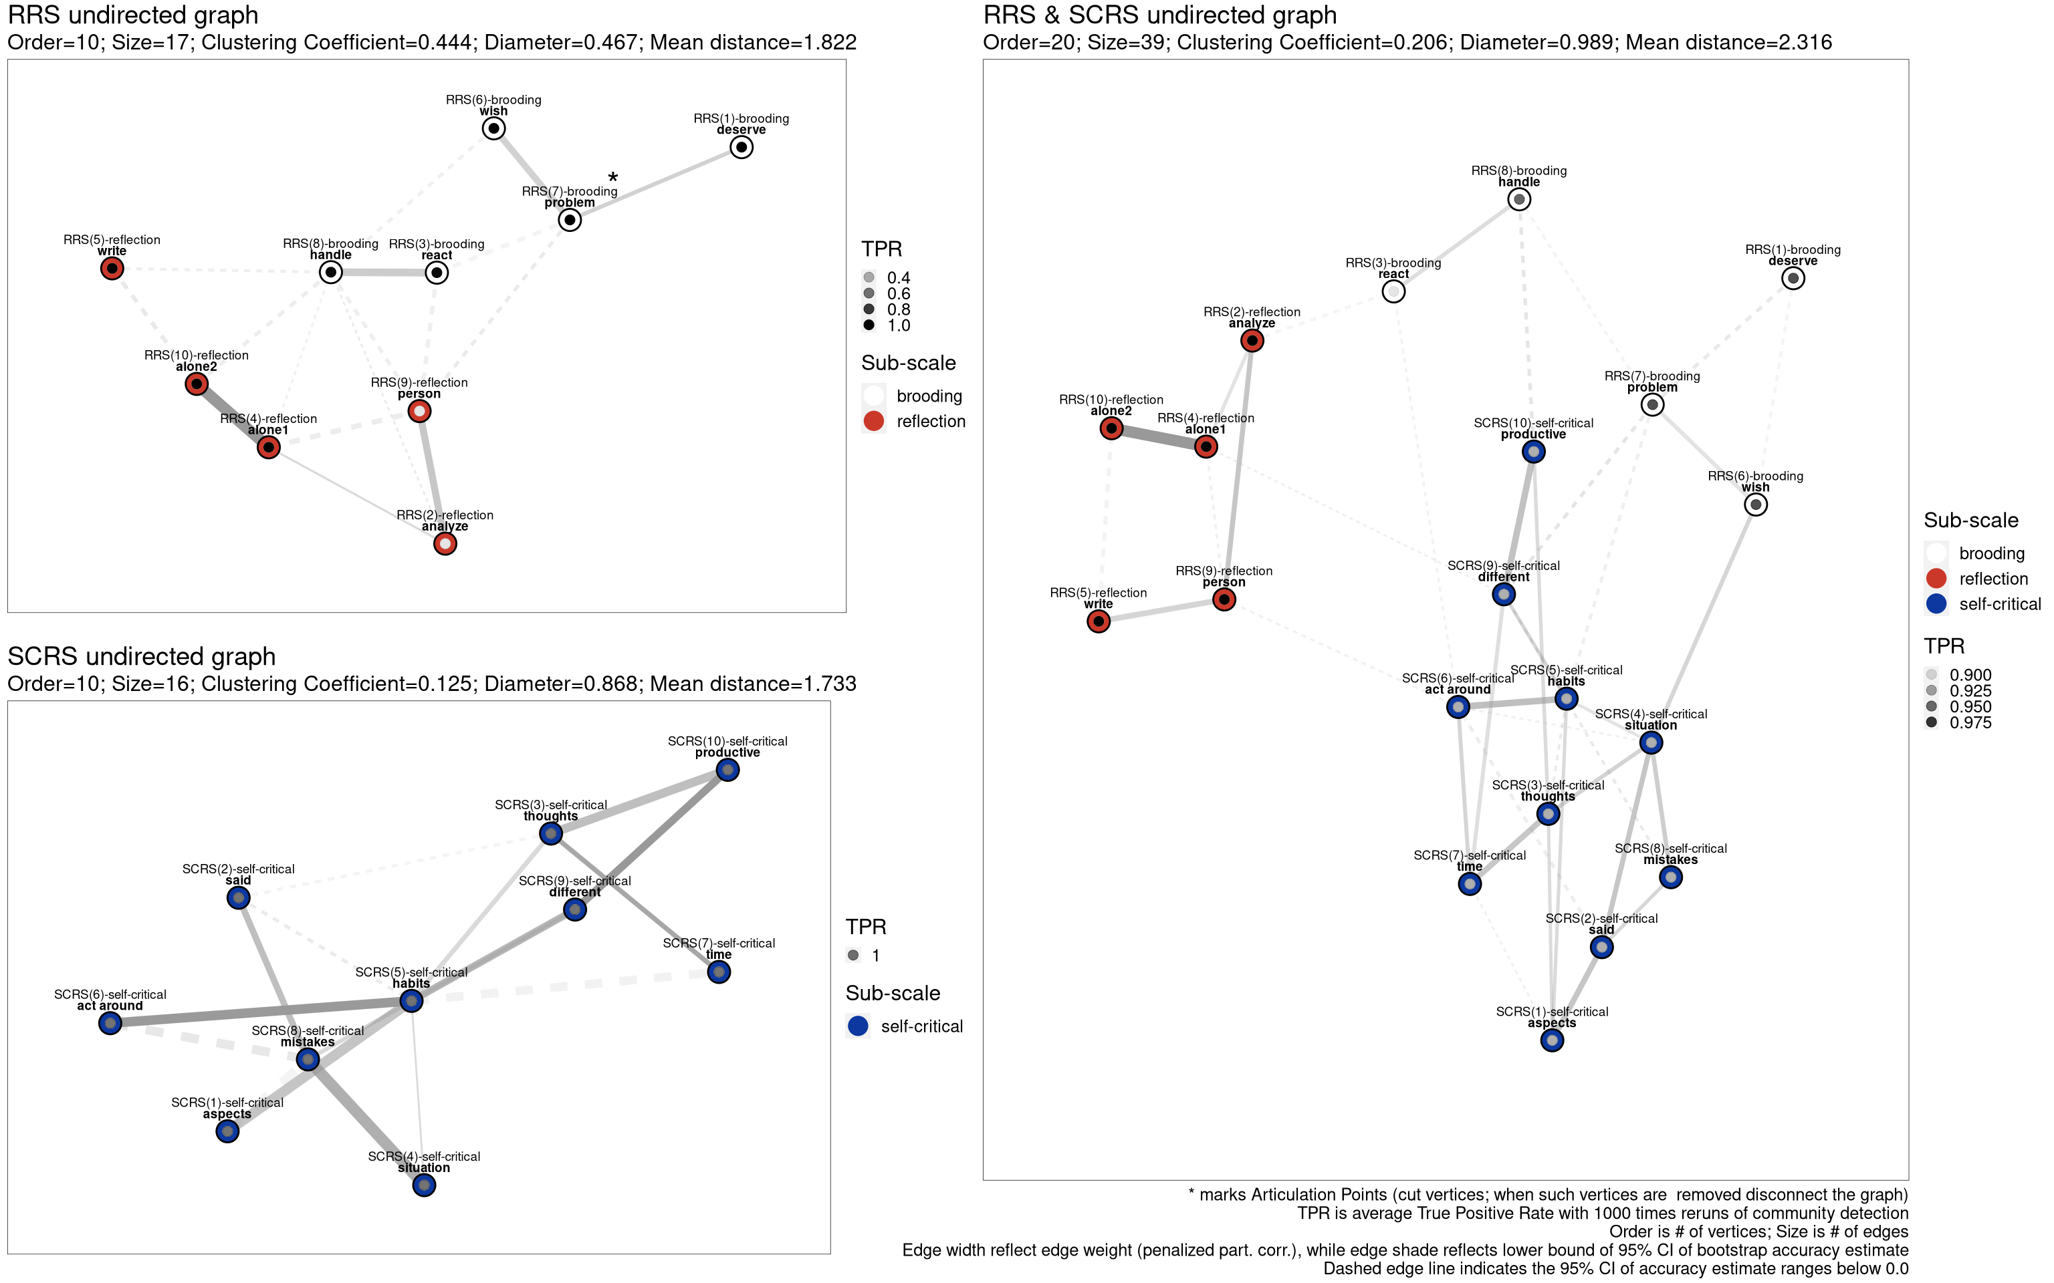
Tableau view of three graphs of rumination
As the choice of algorithm has non-trivial impact on the identified community structure, after having selected the “optimal”, the “spinglass”, the “walktrap” and (to also include hierarchical clustering) the “fast greedy” methods, we tested each a 1000 times on the three networks. We also provided an edge weight vector for community detection in the form of the LASSO-penalized partial correlation coefficients (or alternatively, omitted weights).
The RRS two-scale structure could be recreated with all four algorithms with the inclusion of the weight vector not having effect on the measures. For the sub-scale of brooding the average true positive rate (TPR) was 0.8; for reflection 0.743. In case of the reflection sub-scale, lower average TPR becomes tangible with the inspection of items 2 (“analyze”; “Analyze recent events to try to understand why you are depressed”) and 9 (“person”; “Analyze your personality to try to understand why you are depressed”) whose low TPR indicates that depending in the choice of community detection they have a chance of forming their own community or being classified as members of the brooding scale, rather than being part of reflection. The one-scale structure of the SCRS has been reestablished.
The combined rumination network shows a clear expected structure, with having high TPR for each sub-scale (on average, brooding (0.9), reflection (1) and self-critical (0.8)). Commenting on the stability of the network community structure, the RRS reflection sub-scale exhibits strong TPR rates, and the weakness of the two items from their respective stand-alone network for items 2 and 9 are no longer present in the combined graph. The RRS brooding scale has good separation in terms of TPR, except for its item 3 (react) having <0.9 TPR (“Why do I always react this way?”). The one-scale SCRS has also a separable community with high (>0.925) TPR. The combined network has large TPR of 0.9; while keeping only the spinglass algorithm (as used by Bernstein et al., 2019), we get high average 1.0 TPR for the combined graph.
Please refer to our vertex summary table in the Appendix (Table 4.) for actual descriptives, including expected influence, bridge node related statistics and average True Positive Rates for each vertex. Please note where applicable, we used the standardized the scores.

3.2 Internal Structure with an exponential random graph model
Our ERGM model was built with Markov chain Monte Carlo (MCMC) maximum likelihood estimation (1000 iterations) to obtain model parameters by generating samples from the space of possible networks allowed by the data.
ERGM model fit results with Markov chain Monte Carlo Maximum Likelihood Estimation
Term | Estimate | Std. Error | MCMC Error % | Statistic | p
# of edges | -2.238 | 0.605 | 0 | -3.699 | 0.000
GWESP [triangle] | -0.373 | 0.161 | 0 | -2.320 | 0.020
Tool (main effect) | -0.041 | 0.407 | 0 | -0.100 | 0.920
Tool (homophily effect) | -0.825 | 1.240 | 0 | -0.665 | 0.506
Scale (homophily effect) | 4.185 | 1.336 | 0 | 3.133 | 0.002
An ANOVA analysis on the overall model indicates (with df=5, Residual Deviance=143.38, p=0.000) that variables involved in the model explain the network connectivity in a highly non-trivial fashion. The detailed analysis reveals that endogenous effects such as the overall density of the network( number of edges) change the probability of the formation of an edge by 0.096), and at p<0.05 level the closed triangle formulation indicates a non-trivial impact on clustering (connectivity probability changed by 0.408). As expected, exogenous effects, such as two items belonging to the same sub-scale have a significant positive impact on connectivity (sub-scale changes edge probability by 0.985, keeping the rest of the network fixed). Tool in itself has no impact on edge formation. In terms of goodness-of-fit, observed frequencies of degree levels differ in non-significant manner from MCMC-simulated expectations. In two cases of vertex degree ($V_{d}$=3 and $V_{d}$=6), the observed frequencies are above the simulated average (6 > the expected avg. of 4.49 for $V_{d}$=3; and 4 > the expected avg. of 1.94 for $V_{d}$=6), but differences are not significant.
Regarding the expected edgewise shares partners, the only deviation from expected levels is for 1 partner, where the observed frequency is 17 against 13.28. Additional MCMC diagnostics revealed good fit of the model.

3.3 Association Network Inference
Results show low $η_{0}$ (0.051) indicating large mixing rate for the alternative hypothesis of edges having non-zero weights. The histogram of absolute correlation coefficients (see Figure 3. in Appendix) has a centered shape in contrast to the null component. The density-based FDR drops once empirical correlations reach at least $ρ$=0.1 (see the lowest section of Figure 3.).

3.4 Latent Network Modeling
Our next model was built with the eigenmodel_mcmc function of the R package eigenmodel. The function uses Markov chain Monte Carlo (MCMC) techniques to complete a model specification. By applying eigenvalue decomposition, we obtained the first two eigenvectors (see Figure 2).
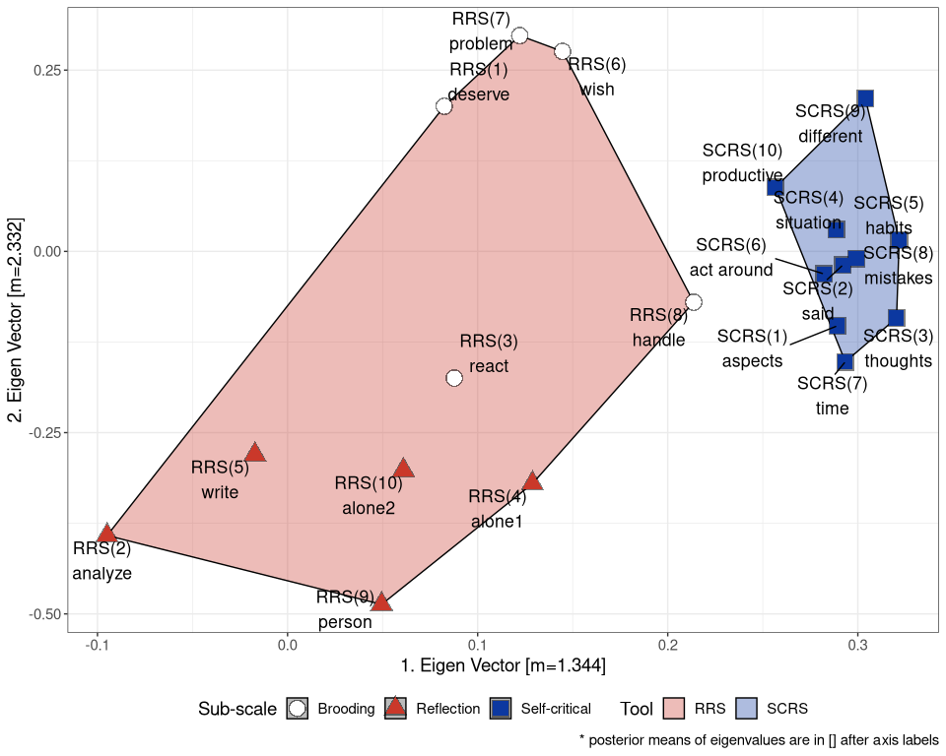
Vertices of the combined graph by the first two eigenvalues
Our visual insight from Figure 2. is that the first eigenvector serves as a separator between RRS and SCRS having a posterior mean of $\overset{‾}{ev_{1}}$=1.344. The second eigenvector seems to separate between the upper half of the two-dimensional space of SCRS and the brooding scale, and the lower half being the reflection scale ($\overset{‾}{ev_{2}}$=2.332).
In order to test the goodness-of-fit of the eigenmodel, using k-fold cross-validation (k=5), we refitted the model to a subset of the original data, using the complement 1/5 fraction for predicting the elements of the adjacency matrix of our original network. We used three different models in this part as discussed above (Section 2.6).
Summarizing the results from the eigenmodels, using the original combined network adjacency matrix as a reference, we estimated the Area Under the Curve (AUC) statistics for each model. Compared to the latent model ($AUC_{latent}$ =0.348), the inclusion of the tool-level grouping factor resulted in a better predictive model ($AUC_{latent+tool}$ = 0.637). The final model involving the scale-level vertex characteristics has the best goodness-of-fit ($AUC_{latent+scale}$ =0.725). See Figure 4. in the Appendix for the corresponding ROC curves.

3.6 Power analysis, network accuracy and stability
We used the bootnet R package to have an estimate of edge-weight accuracy with non-parametric bootstrap (2500 times sampling). The resulting accuracy estimates have been visually incorporated in Figure 1 in the following manner. Edge shade reflects the lower bound of the 95% confidence interval (CI) for each edge, while edges are presented with dashed line for cases of the CI including 0.0 edge weights. For such cases, we cannot be sure if their weight persist given different samples and varying sample characteristics. Darker shaded, continuous edges are stable according to the bootstrap estimate and they preserve their sampled nature. Edges as between the SCRS(5) and SCRS(7) items indicate moderate penalized partial correlation between items in the SCRS network ($ρ$=0.352), but the edge is presented with dashed line and has lighter shade indicating a lower stability. Examples for accurate and strong edges are RRS(4) (alone1; “Go away by yourself and think about why you feel this way”) and RRS(10) (alone2; “Go someplace alone to think about your feelings”). The edge weight for these items in their stand-alone RRS network is 0.572 (estimated edge-weight accuracy is with average 0.511 with lower and upper CI bounds of 0.454 - 0.567). These items exhibit the same pattern in the combined network with estimated edge-weight accuracy with average weight of 0.493; lower and upper CI bounds of 0.436 - 0.549.
In the SCRS network we can track a path (a graph movement [walk] without repeated edges or vertices) between SCRS 6, 5, 9 and 10 items (please refer to Table 5. for edge-level weight and accuracy estimates of SCRS).
Such edges are less likely to exhibit similar characteristics with varying samples.
Network stability estimates for our three networks were carried out by using the bootnet function from the R package bearing the same name. We performed a case dropping bootstrap to simulate scenarios where fewer and fewer cases of the original sample would have been available and quantified the stability of the centrality metrics with the Correlation Stability (CS) coefficient. Bootstrap was performed with B=2500 resamples.
Accuracy and stability statistics have been summarized for RRS, SCRS and their combined graphs in respective tables of Appendix (see Table 5., 6., and 7.).

As shown at (Epskamp, Borsboom, et al., 2017a), the Correlation Stability coefficent is ideally between 0.25 and 0.5, the latter being the cut-off point for the estimate.
Correlation Stability coefficient estimates for RRS, SCRS and their combined network
Metric | RRS | SCRS | RRS & SCRS
betweenness | 0.00 | 0.05 | 0.00
closeness | 0.13 | 0.28 | 0.00
edge | 0.67 | 0.67 | 0.67
strength | 0.21 | 0.28 | 0.52
Results indicate for betweenness centrality that neither networks tolerate much sample loss having CS-coefficients around 5% or lower. For the RRS and SCRS graphs, the closeness metrics are stable in the sense that around 13% and respectively 28% of the case can be dropped to still maintain 0.7 or higher correlation with their original estimates. The combined network’s closeness stability is low and rigid. Edge weights exhibit a constant stability of 67%. The edge strength Correlation Stability coefficients are 21% (RRS), 28% (SCRS) and 52% (combined graph) which indicates increased tolerance of sample loss in the case of the combined network of the two questionnaires.

4. Discussion
In the present paper, we examined the separation of two facets of rumination (a depressive dimension, lying along the brooding-reflection axis; and the self-critical aspects of rumination) using a network approach. In its respective network, the Ruminative Response Style Questionnaire exhibits a two-scale structure. Our community detection estimates suggest though that the reflective aspects of rumination regarding analyzing one’s self and strive to understand feelings (items 2 and 9 of RRS) have more to common with brooding, or have a tendency to emerge as a third aspect. The Self-Critical Rumination Scale proved to have a one-scale structure. Separation between scales in the combined graph is underlined by our eigenmodel, as in the two-dimensional space of the first two eigenvectors, expected grouping of RRS and SCRS items can be achieved. Items 2 and 9 are well separated from the bulk of the rest of the RRS items, supporting our above conclusion of them being a part of reflection or found a new component. Brooding has more associations with the self-critical aspects of rumination than reflection, which is highlighted by our eigenvector analysis as well as the sparse, unstable and weak edges with which reflection connects to brooding and self-critical rumination in their combined network.
We have gathered evidence of scale playing an important role in the edge-building process. According to our exponential random graph model, the internal scales of the combined network indeed have a non-trivial impact on associations between items, whereas the effect of questionnaire dissolved, no longer having an impact on the probability of edge formation. This suggest that all three scales are effective in assessing a separate facet of rumination when used together. As shown, associations within the combined network only have low chances of false discovery.
Results indicate that network associations are accurately aligned to the internal factor structure, while some associations are more sensitive to sampling characteristics and sampling variation. Edge strengths and edge weights have also high stability and relatively high resistance to sample loss, whereas betweenness is remarkably sensitive to case-dropping.
Our findings suggest that the brooding and reflective aspects of depressive rumination and the self-critical rumination are thee distinct, unique areas of the multifaceted construct of rumination. A network approach identified them as not merging with one-another, but establishing a stable and sensitive network of items.
Future steps include analyzing such data from a person-level graph perspective, where vertices are individuals, and edges can be some distance measure between vertices based upon demographics and survey data. Also, if keeping our analysis on the item-level, as in the present paper, we would extend our methodology to directed acyclic graphs (DAGs) which would allow causal assumptions to support our understanding various facets of rumination.

Appendix
Network descriptive statistics for RRS, SCRS and their combined networks
Title | Item | Scale | Label | Deg. | Str. | Bet. | Clo. | EI1 | EI2 | Br.Str. | Br.Bet. | Br.Cl. | Br.EI1 | Br.EI2 | TPR
RRS | RRS_1 | brooding | deserve | 1 | 0.14 | 0 | 0.33 | -1.57 | -1.60 | -1.15 | -0.89 | -1.60 | -1.15 | -1.37 | 1.00
 | RRS_2 | reflection | analyze | 3 | 0.34 | 0 | 0.78 | -0.82 | -0.70 | -1.00 | -0.89 | -0.09 | -1.00 | -0.69 | 0.22
 | RRS_3 | brooding | react | 3 | 0.65 | 0 | 0.41 | 0.28 | 0.40 | 0.46 | -0.08 | 0.78 | 0.46 | 0.72 | 0.96
 | RRS_4 | reflection | alone1 | 4 | 0.82 | 0 | 0.72 | 0.91 | 1.17 | 0.22 | 0.32 | 0.71 | 0.22 | 0.24 | 1.00
 | RRS_5 | reflection | write | 2 | 0.21 | 0 | 0.57 | -1.29 | -1.25 | -0.76 | -0.89 | -1.43 | -0.76 | -1.02 | 0.99
 | RRS_6 | brooding | wish | 2 | 0.38 | 0 | 0.51 | -0.69 | -0.70 | -0.63 | -0.89 | -0.77 | -0.63 | -0.65 | 1.00
 | RRS_7 | brooding | problem | 4 | 0.67 | 8 | 0.51 | 0.36 | 0.04 | 0.22 | 1.33 | 0.12 | 0.22 | 0.06 | 1.00
 | RRS_8 | brooding | handle | 7 | 0.78 | 26 | 0.81 | 0.75 | 0.68 | 1.18 | 0.32 | 0.47 | 1.18 | 1.19 | 0.96
 | RRS_9 | reflection | person | 5 | 0.88 | 16 | 0.68 | 1.11 | 0.95 | 1.94 | 1.94 | 1.55 | 1.94 | 1.77 | 0.22
 | RRS_10 | reflection | alone2 | 3 | 0.83 | 0 | 0.47 | 0.95 | 1.01 | -0.49 | -0.28 | 0.25 | -0.49 | -0.25 | 1.00
SCRS | SCRS_1 | self-critical | aspects | 2 | 0.77 | 0 | 0.19 | -0.31 | 0.29 | -0.16 | 0.53 | 0.84 | -0.16 | 0.71 | 1.00
 | SCRS_2 | self-critical | said | 3 | 0.59 | 3 | 0.30 | -0.70 | -0.75 | -0.31 | -0.74 | -0.88 | -0.31 | -0.46 | 1.00
 | SCRS_3 | self-critical | thoughts | 4 | 0.94 | 6 | 0.29 | 0.04 | -0.27 | 0.51 | -0.32 | -0.44 | 0.51 | 0.06 | 1.00
 | SCRS_4 | self-critical | situation | 2 | 0.56 | 0 | 0.27 | -0.77 | -0.73 | -0.96 | -0.74 | -1.17 | -0.96 | -1.14 | 1.00
 | SCRS_5 | self-critical | habits | 7 | 1.92 | 15 | 0.34 | 2.12 | 2.09 | 2.32 | 2.21 | 1.63 | 2.32 | 2.07 | 1.00
 | SCRS_6 | self-critical | act around | 2 | 0.74 | 0 | 0.19 | -0.37 | 0.16 | -0.11 | -0.74 | 0.96 | -0.11 | 0.17 | 1.00
 | SCRS_8 | self-critical | mistakes | 5 | 1.63 | 6 | 0.27 | 1.51 | 1.21 | 0.42 | 0.95 | 0.52 | 0.42 | 0.22 | 1.00
 | SCRS_9 | self-critical | different | 3 | 0.80 | 3 | 0.25 | -0.25 | -0.11 | 0.22 | 0.32 | 0.37 | 0.22 | 0.42 | 1.00
 | SCRS_7 | self-critical | time | 2 | 0.57 | 0 | 0.21 | -0.75 | -0.82 | -0.63 | -0.74 | -0.50 | -0.63 | -0.60 | 1.00
 | SCRS_10 | self-critical | productive | 2 | 0.67 | 0 | 0.19 | -0.52 | -1.09 | -1.30 | -0.74 | -1.32 | -1.30 | -1.44 | 1.00
Combined | RRS_1 | brooding | deserve | 2 | 0.31 | 0 | 0.11 | -1.82 | -1.80 | -1.00 | -1.05 | -0.91 | -1.00 | -0.91 | 0.96
 | RRS_2 | reflection | analyze | 3 | 0.57 | 2 | 0.13 | -0.74 | -0.79 | -0.17 | -0.35 | -0.86 | -0.17 | -0.48 | 1.00
 | RRS_3 | brooding | react | 3 | 0.45 | 15 | 0.15 | -1.23 | -1.33 | 0.47 | -0.08 | 0.23 | 0.47 | 0.23 | 0.90
 | RRS_4 | reflection | alone1 | 4 | 0.94 | 23 | 0.17 | 0.88 | 0.71 | -0.51 | 0.45 | -1.15 | -0.51 | -0.57 | 1.00
 | RRS_5 | reflection | write | 2 | 0.48 | 11 | 0.09 | -1.12 | -1.11 | -1.00 | -0.88 | -1.45 | -1.00 | -1.16 | 1.00
 | RRS_6 | brooding | wish | 3 | 0.55 | 3 | 0.12 | -0.81 | -0.78 | 0.18 | -0.52 | 0.55 | 0.18 | 0.37 | 0.96
 | RRS_7 | brooding | problem | 5 | 0.80 | 26 | 0.16 | 0.28 | 0.06 | 1.50 | 0.81 | 1.11 | 1.50 | 1.49 | 0.96
 | RRS_8 | brooding | handle | 3 | 0.49 | 7 | 0.14 | -1.08 | -1.23 | -0.31 | -0.35 | -0.20 | -0.31 | -0.37 | 0.95
 | RRS_9 | reflection | person | 4 | 0.75 | 31 | 0.16 | 0.05 | -0.21 | -0.38 | 1.07 | -0.66 | -0.38 | -0.41 | 1.00
 | SCRS_1 | self-critical | aspects | 4 | 0.69 | 5 | 0.14 | -0.19 | -0.01 | -1.00 | -1.05 | -0.83 | -1.00 | -0.94 | 0.92
 | SCRS_2 | self-critical | said | 4 | 0.86 | 0 | 0.13 | 0.51 | 0.53 | -1.00 | -0.70 | -0.58 | -1.00 | -0.90 | 0.92
 | SCRS_3 | self-critical | thoughts | 5 | 0.94 | 6 | 0.14 | 0.87 | 0.90 | -0.01 | -0.52 | 0.34 | -0.01 | 0.07 | 0.92
 | SCRS_4 | self-critical | situation | 6 | 1.11 | 28 | 0.18 | 1.61 | 1.47 | 0.18 | 0.19 | 0.31 | 0.18 | 0.12 | 0.92
 | SCRS_5 | self-critical | habits | 6 | 1.08 | 12 | 0.17 | 1.47 | 1.70 | 0.80 | 1.34 | 1.26 | 0.80 | 0.89 | 0.92
 | SCRS_6 | self-critical | act around | 6 | 0.99 | 51 | 0.18 | 1.06 | 1.15 | 0.26 | 2.22 | 0.83 | 0.26 | 0.39 | 0.92
 | SCRS_7 | self-critical | time | 4 | 0.76 | 9 | 0.14 | 0.11 | 0.34 | 0.10 | -0.52 | 0.72 | 0.10 | 0.07 | 0.92
 | SCRS_8 | self-critical | mistakes | 3 | 0.52 | 2 | 0.14 | -0.94 | -0.65 | -0.27 | -0.70 | -0.37 | -0.27 | -0.43 | 0.92
 | SCRS_9 | self-critical | different | 6 | 1.05 | 38 | 0.18 | 1.32 | 1.16 | 3.19 | 2.04 | 2.18 | 3.19 | 3.02 | 0.92
 | RRS_10 | reflection | alone2 | 2 | 0.76 | 0 | 0.07 | 0.11 | 0.13 | -1.00 | -0.88 | -1.48 | -1.00 | -1.10 | 1.00
 | SCRS_10 | self-critical | productive | 3 | 0.66 | 1 | 0.12 | -0.35 | -0.23 | -0.01 | -0.52 | 0.93 | -0.01 | 0.63 | 0.92
Deg.=Degree; Str.=Strength; Bet.=Betweenness; Clo.=Closeness; EI1= One-step Expected Influence; EI2= Two-step Expected Influence; Br.Str.=Bridge Strength; Br.Bet.=Bridge Betweenness; Br.Cl.=Bridge Closeness; Br.EI1=One-step Bridge Expected Influence; Br.EI2=Two-step Bridge Expected Influence; TPR=average True Positive Rate

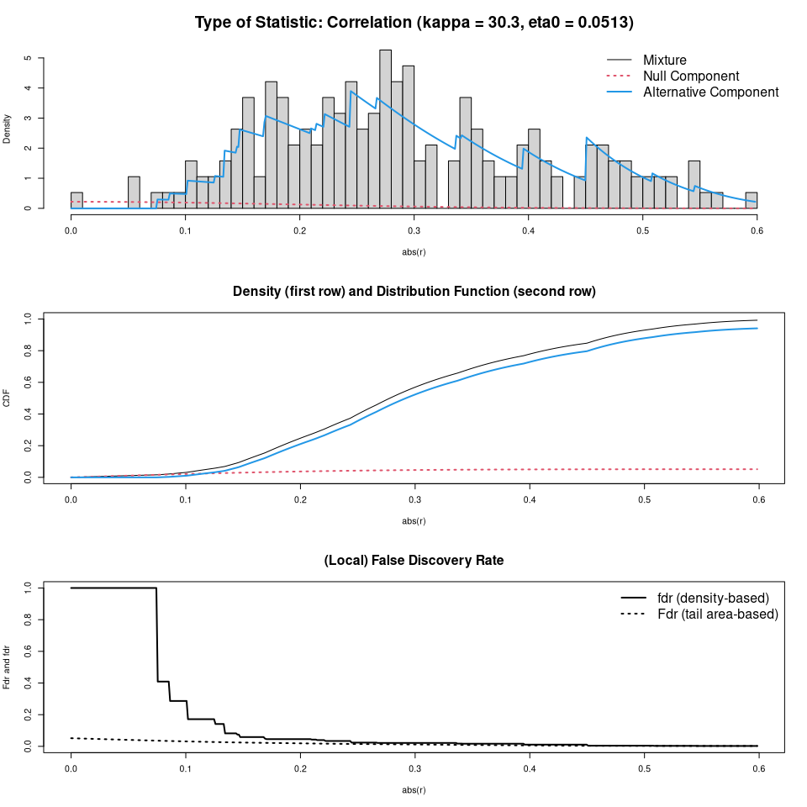
False Discovery Rate (FDR) for the combined network
Edge Accuracy and Stability Statistics for the RRS network
Vx.1 | Vx.2 | Avg. Acc. | L.B.Acc. | U.B.Acc. | Miss.%:0 | Miss.%:0.2 | Miss.%:0.4 | Miss.%:0.6 | Miss.%:0.7
RRS_1 | RRS_7 | 0.20 | 0.13 | 0.27 | 0.20 | 0.20 | 0.19 | 0.18 | 0.12
RRS_2 | RRS_4 | 0.15 | 0.08 | 0.22 | 0.16 | 0.15 | 0.14 | 0.12 | 0.08
RRS_2 | RRS_8 | 0.00 | -0.01 | 0.01 | 0.00 | 0.00 | 0.00 | 0.00 | 0.00
RRS_2 | RRS_9 | 0.25 | 0.19 | 0.32 | 0.25 | 0.25 | 0.26 | 0.24 | 0.22
RRS_3 | RRS_7 | 0.06 | -0.07 | 0.18 | 0.01 | 0.01 | 0.02 | 0.02 | 0.02
RRS_3 | RRS_8 | 0.23 | 0.16 | 0.30 | 0.23 | 0.23 | 0.23 | 0.22 | 0.17
RRS_3 | RRS_9 | 0.09 | -0.04 | 0.22 | 0.10 | 0.07 | 0.05 | 0.04 | 0.02
RRS_4 | RRS_10 | 0.51 | 0.45 | 0.57 | 0.51 | 0.51 | 0.51 | 0.51 | 0.50
RRS_4 | RRS_8 | 0.06 | -0.05 | 0.17 | 0.06 | 0.04 | 0.02 | 0.02 | 0.02
RRS_4 | RRS_9 | 0.09 | -0.03 | 0.20 | 0.10 | 0.08 | 0.05 | 0.05 | 0.03
RRS_5 | RRS_10 | 0.11 | 0.00 | 0.22 | 0.12 | 0.11 | 0.07 | 0.06 | 0.03
RRS_5 | RRS_8 | 0.00 | -0.04 | 0.04 | 0.00 | 0.00 | 0.00 | 0.00 | 0.00
RRS_6 | RRS_7 | 0.20 | 0.13 | 0.27 | 0.20 | 0.20 | 0.19 | 0.17 | 0.10
RRS_6 | RRS_8 | 0.09 | -0.04 | 0.22 | 0.11 | 0.07 | 0.05 | 0.03 | 0.02
RRS_7 | RRS_9 | 0.00 | -0.01 | 0.01 | 0.00 | 0.00 | 0.00 | 0.00 | 0.00
RRS_8 | RRS_10 | 0.00 | -0.03 | 0.04 | 0.00 | 0.00 | 0.00 | 0.00 | 0.00
RRS_8 | RRS_9 | 0.09 | -0.03 | 0.22 | 0.11 | 0.09 | 0.05 | 0.04 | 0.03
Vx.1=1st Vertex the edge attaches to; Vx.2=2nd Vertex the edge attaches to;Avg.Acc.=Average Edge Weight by Bootstrap; L.B.Acc.=Lower Bound of 95% CI for bootstrapped network accuracy; U.P.Acc.=Upper Bound of 95% CI for bootstrapped network accuracy; Statistic=type of network characteristic; Miss.%=Estimated average stability at the given missing rate of sample size
Edge Accuracy and Stability Statistics for the SCRS network
Vx.1 | Vx.2 | Avg. Acc. | L.B.Acc. | U.B.Acc. | Miss.%:0 | Miss.%:0.2 | Miss.%:0.4 | Miss.%:0.6 | Miss.%:0.7
SCRS_1 | SCRS_5 | 0.16 | 0.09 | 0.23 | 0.16 | 0.16 | 0.16 | 0.15 | 0.13
SCRS_1 | SCRS_8 | 0.04 | -0.06 | 0.13 | 0.00 | 0.02 | 0.02 | 0.01 | 0.02
SCRS_2 | SCRS_3 | 0.03 | -0.06 | 0.11 | 0.00 | 0.01 | 0.02 | 0.01 | 0.02
SCRS_2 | SCRS_5 | 0.00 | -0.03 | 0.03 | 0.00 | 0.00 | 0.00 | 0.00 | 0.00
SCRS_2 | SCRS_8 | 0.18 | 0.11 | 0.25 | 0.18 | 0.18 | 0.18 | 0.17 | 0.15
SCRS_3 | SCRS_10 | 0.18 | 0.11 | 0.24 | 0.18 | 0.18 | 0.18 | 0.17 | 0.14
SCRS_3 | SCRS_5 | 0.11 | 0.03 | 0.19 | 0.11 | 0.11 | 0.10 | 0.09 | 0.07
SCRS_3 | SCRS_7 | 0.25 | 0.18 | 0.32 | 0.25 | 0.25 | 0.25 | 0.25 | 0.25
SCRS_4 | SCRS_5 | 0.11 | 0.02 | 0.20 | 0.12 | 0.11 | 0.10 | 0.09 | 0.07
SCRS_4 | SCRS_8 | 0.23 | 0.16 | 0.29 | 0.23 | 0.23 | 0.23 | 0.23 | 0.22
SCRS_5 | SCRS_6 | 0.29 | 0.23 | 0.36 | 0.30 | 0.30 | 0.29 | 0.30 | 0.29
SCRS_5 | SCRS_7 | 0.06 | -0.05 | 0.16 | 0.04 | 0.04 | 0.04 | 0.04 | 0.04
SCRS_5 | SCRS_9 | 0.20 | 0.13 | 0.27 | 0.20 | 0.20 | 0.20 | 0.19 | 0.19
SCRS_6 | SCRS_8 | 0.09 | -0.02 | 0.19 | 0.10 | 0.08 | 0.06 | 0.05 | 0.05
SCRS_8 | SCRS_9 | 0.12 | 0.03 | 0.20 | 0.12 | 0.12 | 0.11 | 0.08 | 0.05
SCRS_9 | SCRS_10 | 0.30 | 0.23 | 0.36 | 0.30 | 0.30 | 0.30 | 0.29 | 0.29
Vx.1=1st Vertex the edge attaches to; Vx.2=2nd Vertex the edge attaches to;Avg.Acc.=Average Edge Weight by Bootstrap; L.B.Acc.=Lower Bound of 95% CI for bootstrapped network accuracy; U.P.Acc.=Upper Bound of 95% CI for bootstrapped network accuracy; Statistic=type of network characteristic; Miss.%=Estimated average stability at the given missing rate of sample size
Edge Accuracy and Stability Statistics for the RRS and SCRS network
Vx.1 | Vx.2 | Avg. Acc. | L.B.Acc. | U.B.Acc. | Miss.%:0 | Miss.%:0.2 | Miss.%:0.3 | Miss.%:0.6 | Miss.%:0.7
RRS_1 | RRS_6 | 0.06 | -0.09 | 0.22 | 0.00 | 0.01 | 0.01 | 0.00 | 0.01
RRS_1 | RRS_7 | 0.13 | -0.03 | 0.29 | 0.16 | 0.11 | 0.07 | 0.03 | 0.01
RRS_2 | RRS_3 | 0.06 | -0.09 | 0.21 | 0.00 | 0.01 | 0.01 | 0.01 | 0.01
RRS_2 | RRS_4 | 0.13 | 0.01 | 0.26 | 0.15 | 0.13 | 0.10 | 0.04 | 0.02
RRS_2 | RRS_9 | 0.24 | 0.17 | 0.30 | 0.24 | 0.24 | 0.24 | 0.19 | 0.11
RRS_3 | RRS_8 | 0.16 | 0.04 | 0.28 | 0.17 | 0.16 | 0.13 | 0.06 | 0.02
RRS_3 | SCRS_6 | 0.03 | -0.08 | 0.14 | 0.00 | 0.00 | 0.00 | 0.00 | 0.00
RRS_4 | RRS_10 | 0.49 | 0.44 | 0.55 | 0.49 | 0.49 | 0.49 | 0.49 | 0.46
RRS_4 | RRS_9 | 0.06 | -0.08 | 0.19 | 0.01 | 0.02 | 0.01 | 0.02 | 0.01
RRS_4 | SCRS_9 | 0.02 | -0.07 | 0.10 | 0.00 | 0.00 | 0.00 | 0.00 | 0.00
RRS_5 | RRS_10 | 0.06 | -0.08 | 0.21 | 0.01 | 0.01 | 0.01 | 0.00 | 0.00
RRS_5 | RRS_9 | 0.19 | 0.09 | 0.29 | 0.20 | 0.19 | 0.17 | 0.08 | 0.03
RRS_6 | RRS_7 | 0.14 | 0.00 | 0.28 | 0.16 | 0.13 | 0.09 | 0.04 | 0.02
RRS_6 | SCRS_4 | 0.17 | 0.08 | 0.26 | 0.17 | 0.17 | 0.15 | 0.09 | 0.05
RRS_7 | RRS_8 | 0.06 | -0.08 | 0.21 | 0.00 | 0.01 | 0.01 | 0.01 | 0.00
RRS_7 | SCRS_5 | 0.07 | -0.06 | 0.21 | 0.03 | 0.03 | 0.03 | 0.02 | 0.01
RRS_7 | SCRS_9 | 0.12 | -0.01 | 0.25 | 0.14 | 0.11 | 0.07 | 0.05 | 0.04
RRS_8 | SCRS_10 | 0.12 | -0.01 | 0.25 | 0.15 | 0.12 | 0.09 | 0.04 | 0.03
RRS_9 | SCRS_6 | 0.02 | -0.07 | 0.12 | 0.00 | 0.00 | 0.00 | 0.00 | 0.00
SCRS_1 | SCRS_2 | 0.24 | 0.17 | 0.30 | 0.24 | 0.24 | 0.24 | 0.23 | 0.18
SCRS_1 | SCRS_3 | 0.14 | 0.05 | 0.23 | 0.15 | 0.15 | 0.13 | 0.09 | 0.05
SCRS_1 | SCRS_5 | 0.15 | 0.06 | 0.24 | 0.16 | 0.15 | 0.14 | 0.11 | 0.06
SCRS_1 | SCRS_7 | 0.05 | -0.07 | 0.17 | 0.01 | 0.01 | 0.02 | 0.01 | 0.01
SCRS_2 | SCRS_4 | 0.24 | 0.18 | 0.31 | 0.24 | 0.24 | 0.24 | 0.24 | 0.19
SCRS_2 | SCRS_6 | 0.07 | -0.05 | 0.19 | 0.07 | 0.04 | 0.03 | 0.01 | 0.02
SCRS_2 | SCRS_8 | 0.16 | 0.08 | 0.24 | 0.16 | 0.16 | 0.15 | 0.11 | 0.07
SCRS_3 | SCRS_10 | 0.15 | 0.05 | 0.24 | 0.16 | 0.16 | 0.14 | 0.10 | 0.06
SCRS_3 | SCRS_4 | 0.17 | 0.10 | 0.25 | 0.17 | 0.17 | 0.17 | 0.14 | 0.09
SCRS_3 | SCRS_5 | 0.08 | -0.04 | 0.20 | 0.09 | 0.06 | 0.05 | 0.03 | 0.02
SCRS_3 | SCRS_7 | 0.23 | 0.17 | 0.30 | 0.24 | 0.24 | 0.23 | 0.23 | 0.16
SCRS_4 | SCRS_5 | 0.11 | 0.00 | 0.22 | 0.12 | 0.11 | 0.09 | 0.06 | 0.04
SCRS_4 | SCRS_6 | 0.03 | -0.07 | 0.14 | 0.00 | 0.01 | 0.01 | 0.01 | 0.01
SCRS_4 | SCRS_8 | 0.20 | 0.13 | 0.27 | 0.20 | 0.20 | 0.20 | 0.18 | 0.13
SCRS_5 | SCRS_6 | 0.29 | 0.22 | 0.36 | 0.29 | 0.29 | 0.29 | 0.28 | 0.25
SCRS_5 | SCRS_9 | 0.17 | 0.10 | 0.25 | 0.17 | 0.17 | 0.17 | 0.15 | 0.10
SCRS_6 | SCRS_7 | 0.17 | 0.09 | 0.25 | 0.17 | 0.17 | 0.17 | 0.12 | 0.08
SCRS_7 | SCRS_9 | 0.14 | 0.03 | 0.24 | 0.14 | 0.14 | 0.12 | 0.09 | 0.06
SCRS_8 | SCRS_9 | 0.09 | -0.03 | 0.21 | 0.12 | 0.09 | 0.06 | 0.03 | 0.02
SCRS_9 | SCRS_10 | 0.26 | 0.20 | 0.33 | 0.27 | 0.27 | 0.27 | 0.27 | 0.21
Vx.1=1st Vertex the edge attaches to; Vx.2=2nd Vertex the edge attaches to;Avg.Acc.=Average Edge Weight by Bootstrap; L.B.Acc.=Lower Bound of 95% CI for bootstrapped network accuracy; U.P.Acc.=Upper Bound of 95% CI for bootstrapped network accuracy; Statistic=type of network characteristic; Miss.%=Estimated average stability at the given missing rate of sample size
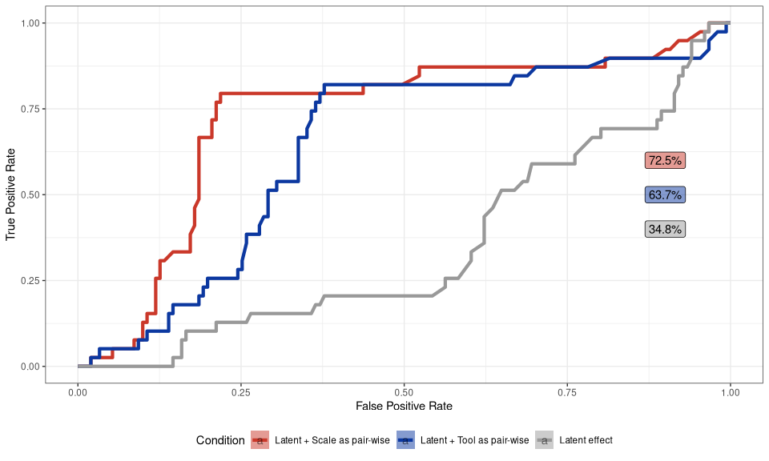 ## References
Abbott, M. J., & Rapee, R. M. 2004. Post-event rumination and negative self-appraisal in social phobia before and after treatment. Journal of Abnormal Psychology, 113(1), 136–144. https://doi.org/10.1037/0021-843x.113.1.136
Aldao, A., & Nolen-Hoeksema, S. 2012. When are adaptive strategies most predictive of psychopathology? Journal of Abnormal Psychology, 121(1), 276–281. https://doi.org/10.1037/a0023598
Allard, E. S., & Yaroslavsky, I. 2019. Attentional disengagement deficits predict brooding, but not reflection, over a one-year period. Frontiers in Psychology, 10. https://doi.org/10.3389/fpsyg.2019.02282
Bernstein, E. E., Heeren, A., & McNally, R. J. 2019. Reexamining trait rumination as a system of repetitive negative thoughts: A network analysis. Journal of Behavior Therapy and Experimental Psychiatry, 63, 21–27. https://doi.org/10.1016/j.jbtep.2018.12.005
Broderick, P. C., & Korteland, C. 2004. A prospective study of rumination and depression in early adolescence. Clinical Child Psychology and Psychiatry, 9(3), 383–394. https://doi.org/10.1177/1359104504043920
Bushman, B. J., Bonacci, A. M., Pedersen, W. C., Vasquez, E. A., & Miller, N. 2005. Chewing on it can chew you up: Effects of rumination on triggered displaced aggression. Journal of Personality and Social Psychology, 88(6), 969–983. https://doi.org/10.1037/0022-3514.88.6.969
Butler, L. D., & Nolen-Hoeksema, S. 1994. Gender differences in responses to depressed mood in a college sample. Sex Roles, 30(5-6), 331–346. https://doi.org/10.1007/bf01420597
Ciesla, J. A., & Roberts, J. E. 2007. Rumination, negative cognition, and their interactive effects on depressed mood. Emotion, 7(3), 555–565. https://doi.org/10.1037/1528-3542.7.3.555
Costantini, G., Epskamp, S., Borsboom, D., Perugini, M., Mõttus, R., Waldorp, L. J., & Cramer, A. O. J. 2015. State of the aRt personality research: A tutorial on network analysis of personality data in r. Journal of Research in Personality, 54, 13–29. https://doi.org/10.1016/j.jrp.2014.07.003
Donald J. Robinaugh, R. J. M., Alexander J. Millner. 2016. Identifying highly influential nodes in the complicated grief network. J Abnorm Psychol., 125(6). https://doi.org/10.1037/abn0000181
Epskamp, S., Borsboom, D., & Fried, E. I. 2017a. Estimating psychological networks and their accuracy: A tutorial paper. Behavior Research Methods, 50(1), 195–212. https://doi.org/10.3758/s13428-017-0862-1
Epskamp, S., Borsboom, D., & Fried, E. I. 2017b. Estimating psychological networks and their accuracy: Supplementary materials.
Epskamp, S., Cramer, A. O. J., Waldorp, L. J., Schmittmann, V. D., & Borsboom, D. 2012. Qgraph: Network visualizations of relationships in psychometric data. Journal of Statistical Software, 48(4). https://doi.org/10.18637/jss.v048.i04
Epskamp, S., & Fried, E. I. 2018. A tutorial on regularized partial correlation networks. Psychological Methods, 23(4), 617–634. https://doi.org/10.1037/met0000167
Epskamp, S., Kruis, J., & Marsman, M. 2017. Estimating psychopathological networks: Be careful what you wish for. PLOS ONE, 12(6), e0179891. https://doi.org/10.1371/journal.pone.0179891
Friedman, J., Hastie, T., & Tibshirani, R. 2007. Sparse inverse covariance estimation with the graphical lasso. Biostatistics, 9(3), 432–441. https://doi.org/10.1093/biostatistics/kxm045
Glassman, L. H., Weierich, M. R., Hooley, J. M., Deliberto, T. L., & Nock, M. K. 2007. Child maltreatment, non-suicidal self-injury, and the mediating role of self-criticism. Behaviour Research and Therapy, 45(10), 2483–2490. https://doi.org/10.1016/j.brat.2007.04.002
Goodreau, S. M., Kitts, J. A., & Morris, M. 2009. Birds of a feather, or friend of a friend? Using exponential random graph models to investigate adolescent social networks. Demography, 46(1), 103–125. https://doi.org/10.1353/dem.0.0045
Hartley, S., Haddock, G., Sa, D. V. e, Emsley, R., & Barrowclough, C. 2013. An experience sampling study of worry and rumination in psychosis. Psychological Medicine, 44(8), 1605–1614. https://doi.org/10.1017/s0033291713002080
Hayes, S. C., Strosahl, K., Wilson, K. G., Bissett, R. T., Pistorello, J., Toarmino, D., Polusny, M. A., Dykstra, T. A., Batten, S. V., Bergan, J., Stewart, S. H., Zvolensky, M. J., Eifert, G. H., Bond, F. W., Forsyth, J. P., Karekla, M., & McCurry, S. M. 2004. Measuring experiential avoidance: A preliminary test of a working model. The Psychological Record, 54(4), 553–578. https://doi.org/10.1007/bf03395492
Heeren, A., Jones, P. J., & McNally, R. J. 2018. Mapping network connectivity among symptoms of social anxiety and comorbid depression in people with social anxiety disorder. Journal of Affective Disorders, 228, 75–82. https://doi.org/10.1016/j.jad.2017.12.003
Hoff, P. D., Raftery, A. E., & Handcock, M. S. 2002. Latent space approaches to social network analysis. Journal of the American Statistical Association, 97(460), 1090–1098. https://doi.org/10.1198/016214502388618906
Hunter, D. R. 2007. Curved exponential family models for social networks. Social Networks, 29(2), 216–230. https://doi.org/10.1016/j.socnet.2006.08.005
Jones, P. 2017. Networktools: Assorted and tools for identifying and important nodes and in networks.
Kolaczyk, G. C. E. D. 2020. Statistical analysis of network data with r. Springer-Verlag GmbH. https://www.ebook.de/de/product/39334469/gabor_csardi_eric_d_kolaczyk_statistical_analysis_of_network_data_with_r.html
Kolubinski, D. C., Nikčević, A. V., Lawrence, J. A., & Spada, M. M. 2017. The metacognitions about self-critical rumination questionnaire. Journal of Affective Disorders, 220, 129–138. https://doi.org/10.1016/j.jad.2017.06.002
Kovács, L. N., Takacs, Z. K., Tóth, Z., Simon, E., Schmelowszky, Ágoston, & Kökönyei, G. 2020. Rumination in major depressive and bipolar disorder a meta-analysis. Journal of Affective Disorders, 276, 1131–1141. https://doi.org/10.1016/j.jad.2020.07.131
Lyubomirsky, S., Layous, K., Chancellor, J., & Nelson, S. K. 2015. Thinking about rumination: The scholarly contributions and intellectual legacy of susan nolen-hoeksema. Annual Review of Clinical Psychology, 11(1), 1–22. https://doi.org/10.1146/annurev-clinpsy-032814-112733
Lyubomirsky, S., & Nolen-Hoeksema, S. 1993. Self-perpetuating properties of dysphoric rumination. Journal of Personality and Social Psychology, 65(2), 339–349. https://doi.org/10.1037/0022-3514.65.2.339
Mair, P. 2018. Modern psychometrics with r. Springer International Publishing. https://www.ebook.de/de/product/33047896/patrick_mair_modern_psychometrics_with_r.html
McLaughlin, K. A., Aldao, A., Wisco, B. E., & Hilt, L. M. 2014. Rumination as a transdiagnostic factor underlying transitions between internalizing symptoms and aggressive behavior in early adolescents. Journal of Abnormal Psychology, 123(1), 13–23. https://doi.org/10.1037/a0035358
McNally, R. J., Mair, P., Mugno, B. L., & Riemann, B. C. 2017. Co-morbid obsessivecompulsive disorder and depression: A bayesian network approach. Psychological Medicine, 47(7), 1204–1214. https://doi.org/https://doi.org/10.1017/S0033291716003287
Memedovic, S., Slade, T., Ross, J., Darke, S., Mills, K. L., Marel, C., Burns, L., Lynskey, M., & Teesson, M. 2019. Rumination and problematic substance use among individuals with a long-term history of illicit drug use. Drug and Alcohol Dependence, 203, 44–50. https://doi.org/10.1016/j.drugalcdep.2019.05.028
Milia, C., Kolubinski, D. C., & Spada, M. M. 2020. The effects of self-critical rumination on shame and stress: An experimental study. Behavioural and Cognitive Psychotherapy, 49(3), 272–286. https://doi.org/10.1017/s1352465820000727
Moulds, M. L., Bisby, M. A., Wild, J., & Bryant, R. A. 2020. Rumination in posttraumatic stress disorder: A systematic review. Clinical Psychology Review, 82, 101910. https://doi.org/10.1016/j.cpr.2020.101910
Moulds, M. L., Kandris, E., Starr, S., & Wong, A. C. M. 2007. The relationship between rumination, avoidance and depression in a non-clinical sample. Behaviour Research and Therapy, 45(2), 251–261. https://doi.org/10.1016/j.brat.2006.03.003
Newman, M. E. J. 2010. Networks - an introduction. Oxford University Press.
Nolen-Hoeksema, S. 2000. The role of rumination in depressive disorders and mixed anxiety/depressive symptoms. Journal of Abnormal Psychology, 109(3), 504–511. https://doi.org/10.1037/0021-843x.109.3.504
Nolen-Hoeksema, S. 1991. Responses to depression and their effects on the duration of depressive episodes. Journal of Abnormal Psychology, 100(4), 569–582. https://doi.org/10.1037/0021-843x.100.4.569
Nolen-Hoeksema, S., Larson, J., & Grayson, C. 1999. Explaining the gender difference in depressive symptoms. Journal of Personality and Social Psychology, 77(5), 1061–1072. https://doi.org/10.1037/0022-3514.77.5.1061
Nolen-Hoeksema, S., & Watkins, E. R. 2011. A heuristic for developing transdiagnostic models of psychopathology. Perspectives on Psychological Science, 6(6), 589–609. https://doi.org/10.1177/1745691611419672
Nolen-Hoeksema, S., Wisco, B. E., & Lyubomirsky, S. 2008. Rethinking rumination. Perspectives on Psychological Science, 3(5), 400–424. https://doi.org/10.1111/j.1745-6924.2008.00088.x
O’Connor, R. C., & Noyce, R. 2008. Personality and cognitive processes: Self-criticism and different types of rumination as predictors of suicidal ideation. Behaviour Research and Therapy, 46(3), 392–401. https://doi.org/10.1016/j.brat.2008.01.007
Papageorgiou, C., & Wells, A. 2001. Metacognitive beliefs about rumination in recurrent major depression. Cognitive and Behavioral Practice, 8(2), 160–164. https://doi.org/10.1016/s1077-7229(01)80021-3
Peled, M., & Moretti, M. M. 2009. Ruminating on rumination: Are rumination on anger and sadness differentially related to aggression and depressed mood? Journal of Psychopathology and Behavioral Assessment, 32(1), 108–117. https://doi.org/10.1007/s10862-009-9136-2
Pont, A. du, Rhee, S. H., Corley, R. P., Hewitt, J. K., & Friedman, N. P. 2017. Rumination and psychopathology: Are anger and depressive rumination differentially associated with internalizing and externalizing psychopathology? Clinical Psychological Science, 6(1), 18–31. https://doi.org/10.1177/2167702617720747
Reichardt, J., & Bornholdt, S. 2006. Statistical mechanics of community detection. Physical Review, 74(1).
Rose, A. V., & Rimes, K. A. 2018. Self-criticism self-report measures: Systematic review. Psychology and Psychotherapy: Theory, Research and Practice, 91(4), 450–489. https://doi.org/10.1111/papt.12171
Ruscio, A. M., Gentes, E. L., Jones, J. D., Hallion, L. S., Coleman, E. S., & Swendsen, J. 2015. Rumination predicts heightened responding to stressful life events in major depressive disorder and generalized anxiety disorder. Journal of Abnormal Psychology, 124(1), 17–26. https://doi.org/10.1037/abn0000025
Selby, E. A., Anestis, M. D., & Joiner, T. E. 2008. Understanding the relationship between emotional and behavioral dysregulation: Emotional cascades. Behaviour Research and Therapy, 46(5), 593–611. https://doi.org/10.1016/j.brat.2008.02.002
Shahar, B., Doron, G., & Szepsenwol, O. 2014. Childhood maltreatment, shame-proneness and self-criticism in social anxiety disorder: A sequential mediational model. Clinical Psychology &Amp$\mathsemicolon$ Psychotherapy, 22(6), 570–579. https://doi.org/10.1002/cpp.1918
Smart, L. M., Peters, J. R., & Baer, R. A. 2015. Development and validation of a measure of self-critical rumination. Assessment, 23(3), 321–332. https://doi.org/10.1177/1073191115573300
Spasojević, J., & Alloy, L. B. 2001. Rumination as a common mechanism relating depressive risk factors to depression. Emotion, 1(1), 25–37. https://doi.org/10.1037/1528-3542.1.1.25
Strimmer, K. 2008a. Fdrtool: A versatile r package for estimating local and tail area-based false discovery rates. Bioinformatics, 24(12), 1461–1462. https://doi.org/10.1093/bioinformatics/btn209
Strimmer, K. 2008b. A unified approach to false discovery rate estimation. BMC Bioinformatics, 9(1). https://doi.org/10.1186/1471-2105-9-303
Tibshirani, R. 1996. Regression shrinkage and selection via the lasso. Journal of the Royal Statistical Society: Series B (Methodological), 58(1), 267–288. https://doi.org/10.1111/j.2517-6161.1996.tb02080.x
Treynor, W. 2003. Cognitive Therapy and Research, 27(3), 247–259. https://doi.org/10.1023/a:1023910315561
Ward, A., Lyubomirsky, S., Sousa, L., & Nolen-Hoeksema, S. 2003. Can’t quite commit: Rumination and uncertainty. Personality and Social Psychology Bulletin, 29(1), 96–107. https://doi.org/10.1177/0146167202238375
Watkins, E. R. 2008. Constructive and unconstructive repetitive thought. Psychological Bulletin, 134(2), 163–206. https://doi.org/10.1037/0033-2909.134.2.163
Watkins, E. R., & Roberts, H. 2020. Reflecting on rumination: Consequences, causes, mechanisms and treatment of rumination. Behaviour Research and Therapy, 127, 103573. https://doi.org/10.1016/j.brat.2020.103573
Watkins, E., & Moulds, M. 2005. Distinct modes of ruminative self-focus: Impact of abstract versus concrete rumination on problem solving in depression. Emotion, 5(3), 319–328. https://doi.org/10.1037/1528-3542.5.3.319
Werner, A. M., Tibubos, A. N., Rohrmann, S., & Reiss, N. 2019. The clinical trait self-criticism and its relation to psychopathology: A systematic review update. Journal of Affective Disorders, 246, 530–547. https://doi.org/10.1016/j.jad.2018.12.069
Whisman, M. A., Pont, A. du, & Butterworth, P. 2020. Longitudinal associations between rumination and depressive symptoms in a probability sample of adults. Journal of Affective Disorders, 260, 680–686. https://doi.org/10.1016/j.jad.2019.09.035
Wilkinson, P. O., Croudace, T. J., & Goodyer, I. M. 2013. Rumination, anxiety, depressive symptoms and subsequent depression in adolescents at risk for psychopathology: A longitudinal cohort study. BMC Psychiatry, 13(1). https://doi.org/10.1186/1471-244x-13-250
Yasinski, C., Hayes, A. M., Ready, C. B., Abel, A., Görg, N., & Kuyken, W. 2019. Processes of change in cognitive behavioral therapy for treatment-resistant depression: Psychological flexibility, rumination, avoidance, and emotional processing. Psychotherapy Research, 30(8), 983–997. https://doi.org/10.1080/10503307.2019.1699972

