Supplemental Materials

Reexamining trait rumination as a system of repetitive negative thoughts: A network analysis

Stability of Edge Weights
We used non-parametric bootstrapping to calculate 95% confidence intervals (CIs) for all edges in the network; this procedure within the R package bootnet (Epskamp et al., 2018) includes sampling the data with 1,000 replacements and recalculating edges to yield a distribution of edge weight values. Figure S1 depicts the resultant sampling variation. The red line represents the values of the edge weights from the initial model ordered from largest to smallest (top to bottom). We can be most confident in edges for which the corresponding gray horizontal line (representing a single edge weight) does not cross the vertical line, representing a partial correlation of zero. Note that the present CIs should not be interpreted to be testing whether each edge is significantly different from zero; through the graphical LASSO, edges were only included in the initial network and thus in this bootstrapping procedure if they were significantly different from zero. Results indicated that the edges are fairly stable as a large number of them exhibit values significantly greater than zero.
Moreover, using a bootstrapped difference test (Epskamp et al., 2018), we tested for significant differences between edge-weights (see Figure S2). Gray boxes indicate no significant difference in the pairwise comparison of edges and black boxes reflect a significant difference. Colored boxes along the diagonal represent the magnitude and sign of the edge weight (i.e. darker green indicates strong positive edges and darker red indicates strong negative edges). Several of the edge-weights were significantly stronger than most others. Examples include job—fut, passive—feel, lonely—sad, deserve—problem, and analyze—person.
Stability of Centrality Estimates
We implemented a subset bootstrap procedure to estimate the stability of expected influence estimates (Costenbader & Valente, 2003). This procedure, implemented via the R package bootnet (Epskamp et al., 2018) involves repeatedly correlating centrality metrics of the original dataset with centrality metrics calculated from a subsample of participants (i.e. 1,000 person-dropping bootstraps). If correlation values do not decline substantially as participants are removed, we can be reasonably confident of its stability. Figure S3 presents the average correlation between expected influence estimates in the bootstrapped samples and the original estimates as a function of the percentage of participants in the bootstrapped sample. Expected influence was highly stable. We also calculated the centrality stability correlation coefficient (CS-coefficient) to quantify the effects of this person-dropping procedure. The CS-coefficient represents the maximum proportion of participants that can be dropped while maintaining 95% probability that the correlation between centrality metrics from the full data set and the subset data are at least .70. In order to be considered stable, Epskamp et al. (2018) suggest the resulting CS-coefficient should not be < 0.25 and preferably ≥ 0.50. The value of the CS-coefficient was high, CS-coefficient = .751.

References
Costenbader, E., & Valente, T.W. (2003). The stability of centrality measures when networks are sampled. Social Networks, 25, 283-307. DOI:10.1016/S0378-8733(03)00012-1
Epskamp, S., Borsboom, D., & Fried, E. I. (2018). Estimating psychological networks and their accuracy: A tutorial paper. Behavior Research Methods, 50, 195-212.

Figure S1. Non-parametric bootstrapped confidence intervals of estimated edges
Note. x-axis represents edge weight values. Red line depicts edge weights from the graphical LASSO network. Each horizontal gray line represents the CI for a single edge.
Figure S2. Non-parametric bootstrapped difference test for edges
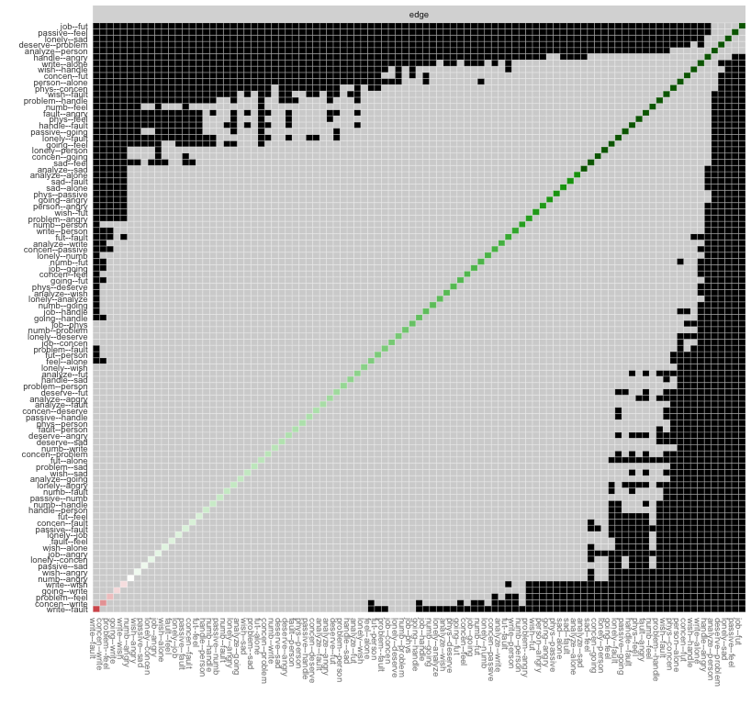

Note. Non-parametric bootstrapped difference test for edges. Significant pairwise differences in edge weights are depicted in black boxes. Gray boxes indicate no significant difference.
Figure S3. Person-dropping bootstrapped estimates of one-step expected influence
Note. Estimates reflect correlations between one-step expected influence metrics from the original dataset with metrics calculated from a subsample of participants. Higher correlations indicate greater stability.

