SITREP INTELLIGENCE — FEATURE SUMMARY
The application, screen by screen
All screenshots below are taken from the running application (FastAPI backend + web frontend on localhost). The interface is shown in English; the final section shows the same application in French to illustrate the multilingual design. All interface translations (FR / EN / PT) were generated with AI as part of the build.

1 · Overview dashboard
The landing screen answers 'where does the outbreak stand today?' at a glance: cumulative confirmed cases, deaths, CFR%, affected health zones, patients in isolation and infected health workers — each with its 24-hour movement — plus the epidemic curve and per-province / per-zone breakdowns. Every number comes from the structured 'facts' datasets extracted from the reports, not from free text.
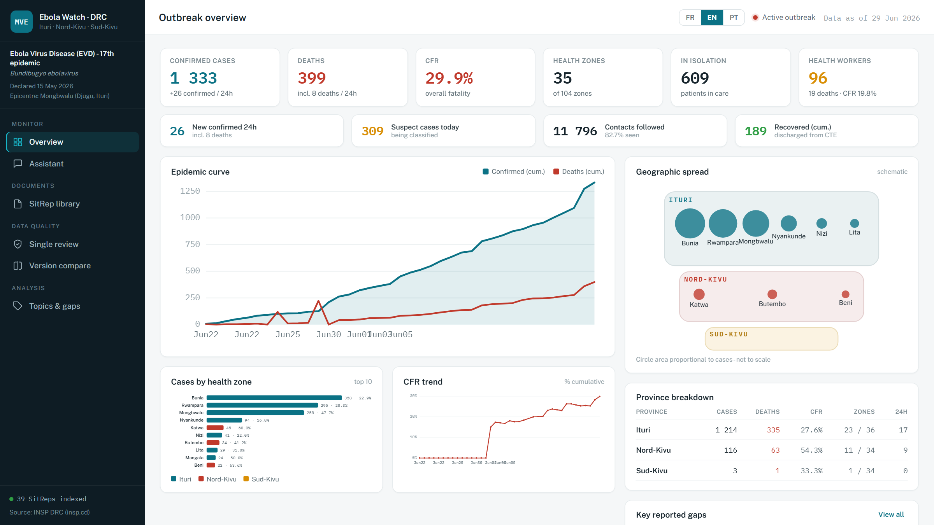
Overview dashboard (English) — live data from the latest indexed SitRep.

2 · Grounded chat assistant
The assistant answers questions about the outbreak using RAG: it retrieves the most relevant report excerpts and must answer from them, citing SitRep number, date and page. For exact figures it calls the query_data tool (structured datasets), and for trends it calls plot_chart to render a chart in the conversation. The answer below was generated live by Claude.
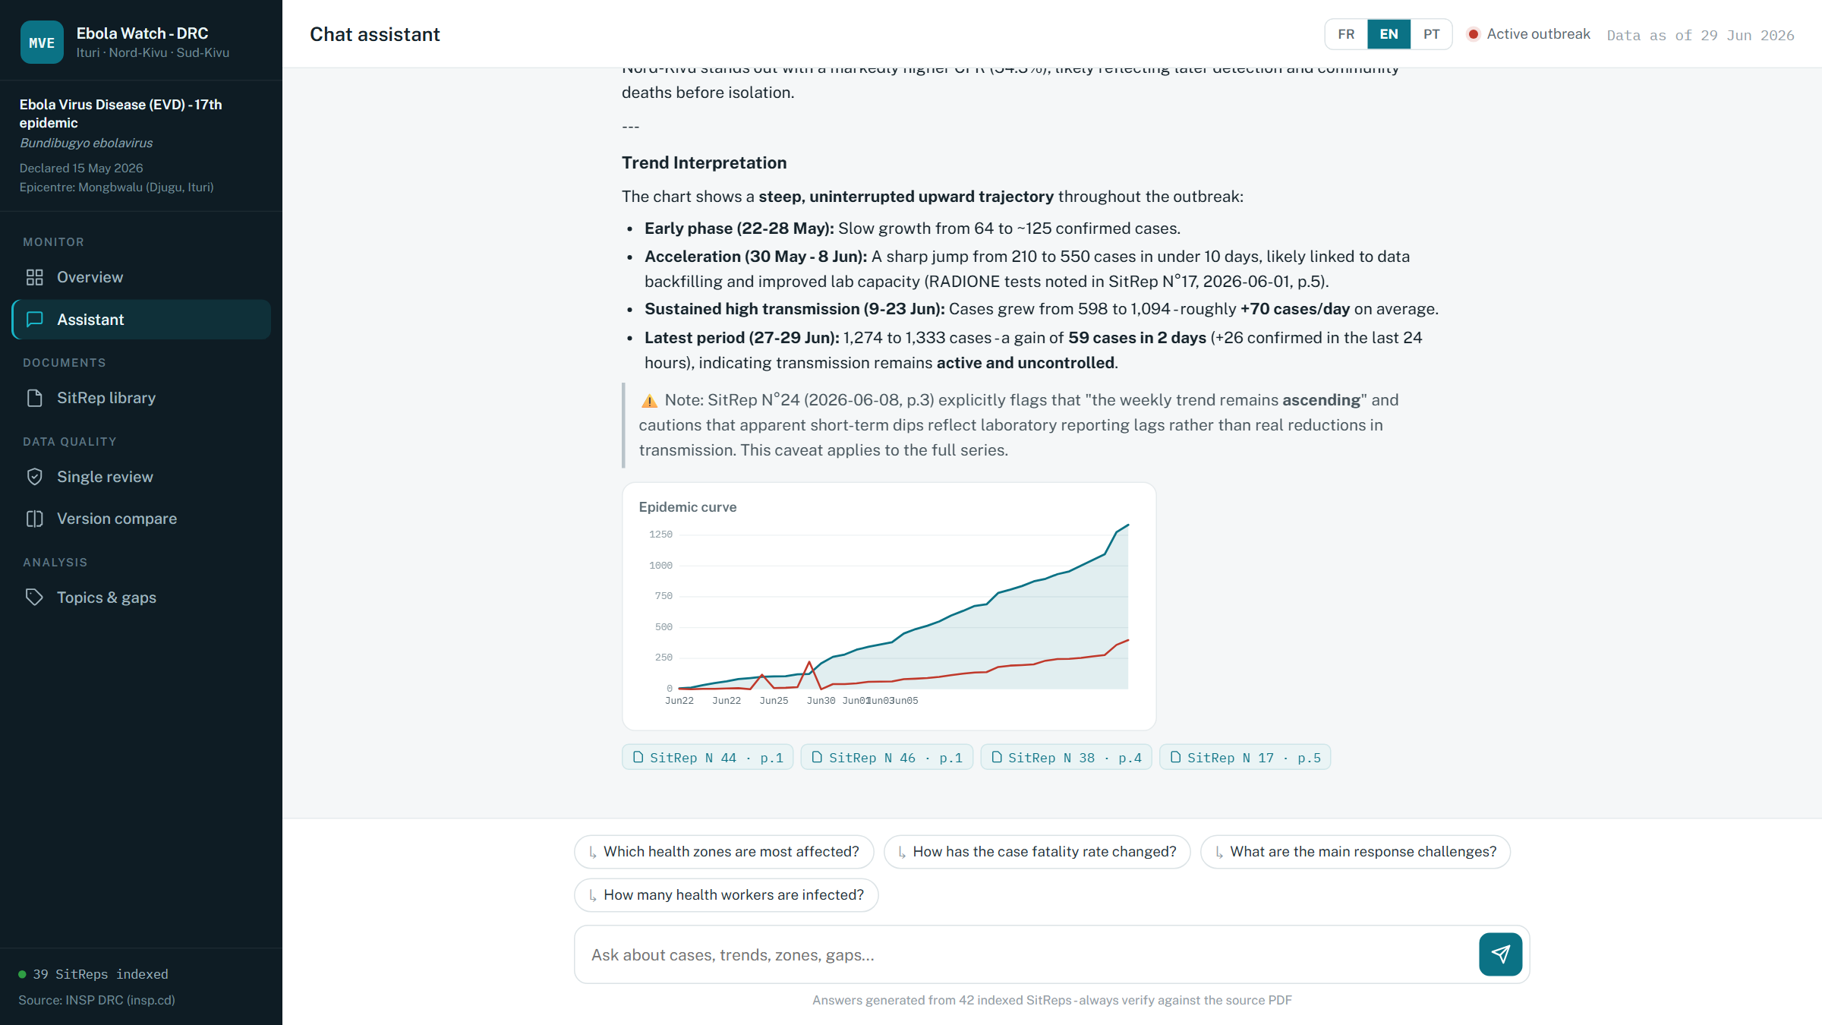
Chat assistant (English) — a grounded, cited answer with source references.

3 · SitRep library & one-click ingestion
The library lists every report in the corpus with its number, date and status. Adding a new report takes one action — paste an INSP page URL, a direct PDF link, or upload a file — and the pipeline does the rest: download, text extraction, number/date detection, AI extraction of structured facts, and semantic indexing. Progress is streamed step by step to the screen.
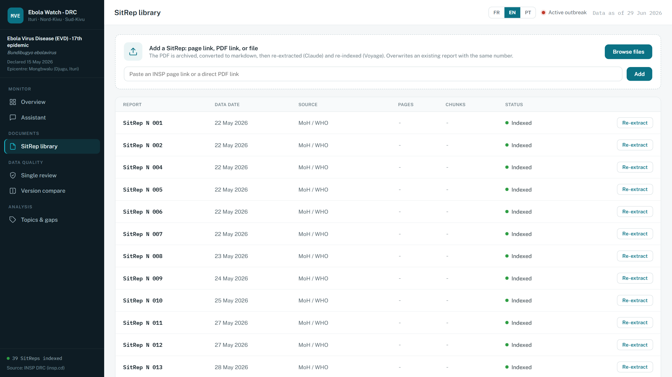
SitRep library (English) — the corpus, with URL/file ingestion at the top.

4 · Single-report quality review
One report is assessed the way a careful reviewer would read it: arithmetic (do provinces sum to the total?), internal consistency (do daily deaths reconcile with cumulative deaths?), timeliness, plausibility and geographic coverage. The result is an overall score, five dimension scores and a list of concrete issues, each tagged High / Medium / Low with its location in the document.
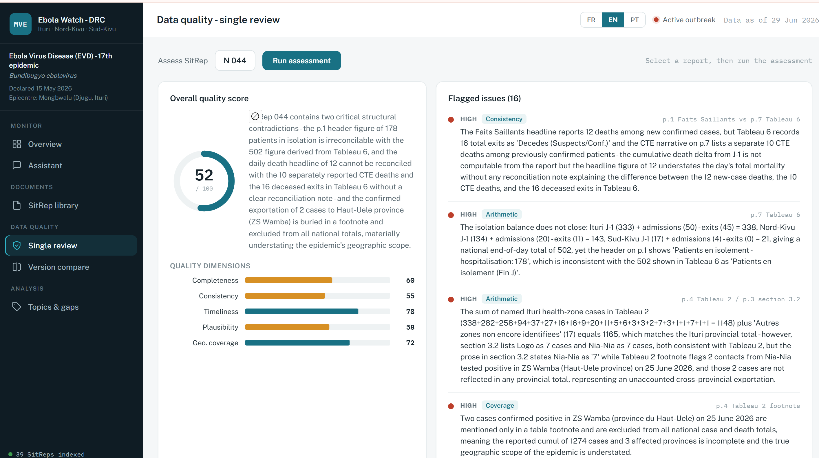
Single review (English) — score, dimensions and severity-tagged issues.

5 · Version comparison
Two reports are validated against each other before their numbers are trusted: cumulative totals must never decrease, day-to-day jumps must be plausible, and missing values that break comparability are flagged. The screen shows each shared metric with its delta and an ok / info / warn / alert flag, plus section-level changes and a one-line verdict.
[ Place a screenshot here: save it as docs/assets/screenshots/dq_compare_en.png, then rerun python scripts/make_feature_summary.py ]

6 · Topics & gaps analysis
The narrative 'défis et lacunes' of every report are extracted into themed items (financing, surveillance, vaccination, security, logistics, community engagement, human resources, laboratory) and synthesised across the whole series — showing which bottlenecks recur, which are worsening and which were resolved.
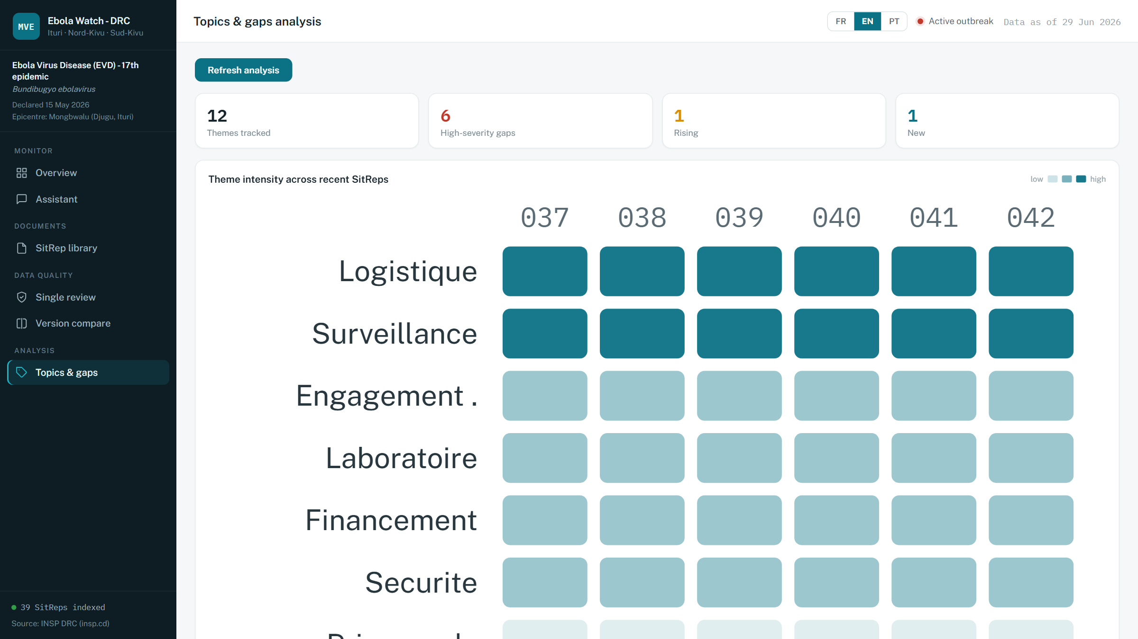
Topics & gaps (English) — recurring themes across the report series.

7 · Multilingual by design
The source reports are French; the interface and the assistant work in French, English and Portuguese. Answers are grounded in the French source text and delivered in the user's language. The interface translations themselves were AI-generated during development — the same GenAI capability that powers the product also helped build it.
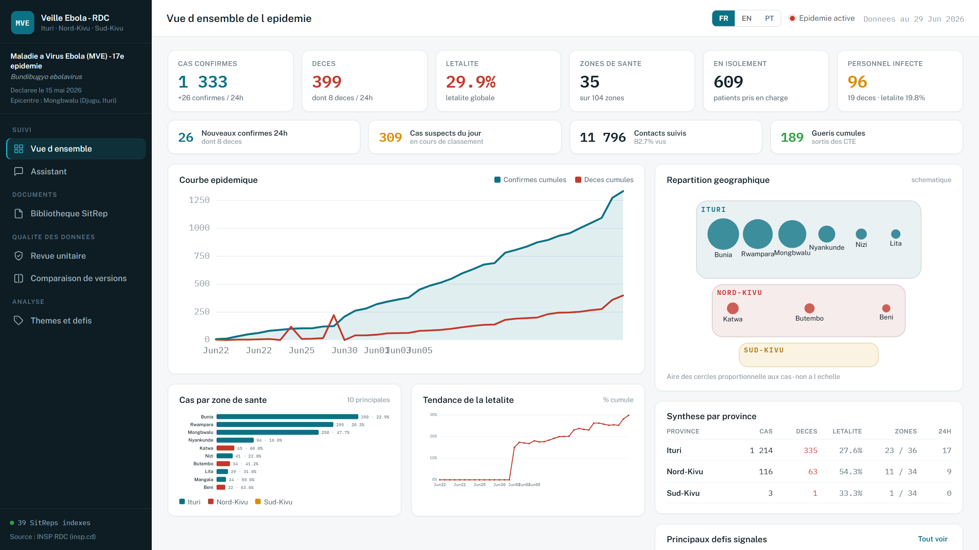
The same dashboard in French — one click on the language switcher.
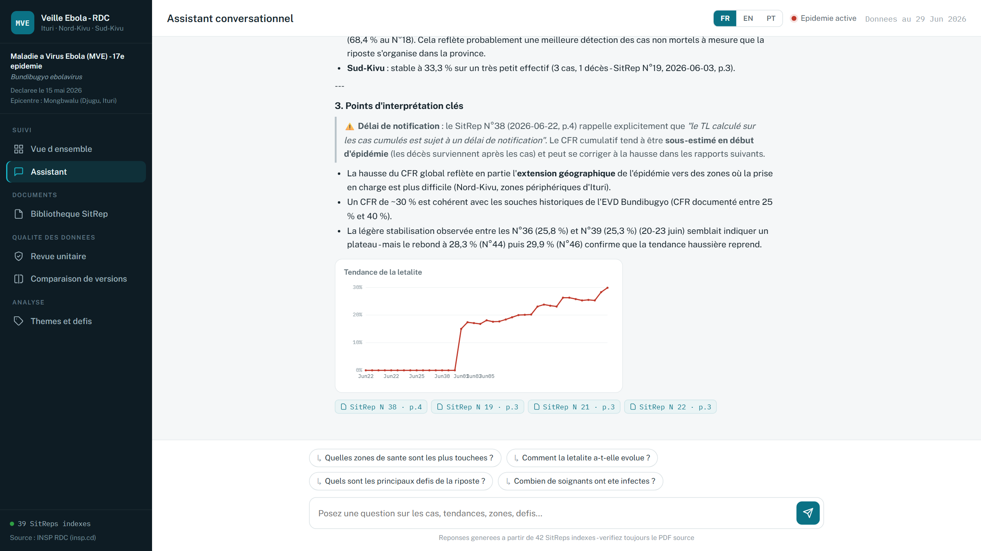
The assistant answering in French, grounded in the same French source reports.

