SITREP INTELLIGENCE — TECHNICAL GUIDE
How the system works, process by process
A grounded RAG application over the INSP situation reports of the 17th Ebola (MVE/BVD) outbreak in DR Congo. This guide explains the five key processes at a high level — enough to understand what happens, in what order, and where generative AI is (and is not) involved. It is written for readers who are not developers.
Models used: Anthropic Claude (Sonnet by default, Opus available for the hardest tasks) for reading, extraction, assessment and synthesis; Voyage AI (voyage-4, multilingual) for embeddings; ChromaDB as the local vector store.

1 · The SitRep library — adding a document
The library is the front door of the system. An analyst adds a report in one of three ways: an INSP web page URL, a direct PDF link, or a file upload. Everything else is automatic.
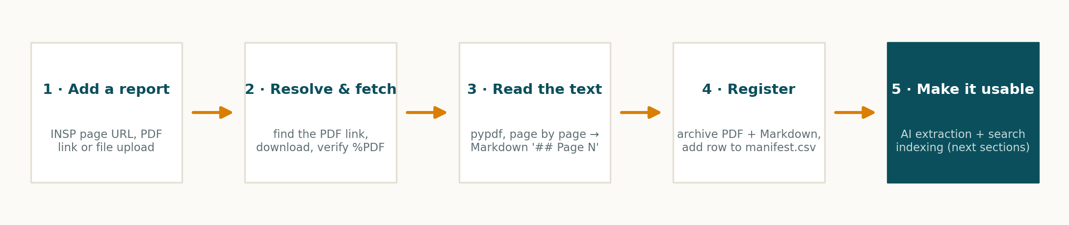
- Resolve & fetch. If given a web page, the system scans it for the PDF link. The file is downloaded and verified to really be a PDF before anything else happens.
- Read the text. pypdf extracts the text page by page. Each page becomes a '## Page N' section in a Markdown file — keeping page numbers is what makes page-level citations possible later.
- Detect number & date. The SitRep number (N°) and report date are parsed from the URL, the filename or the document text; the analyst can override both.
- Register. The PDF and Markdown files are archived and a row is added to manifest.csv — the library's simple, inspectable index.
- Make it usable. The report is then structurally extracted with Claude and indexed for semantic search (sections 2 and 3). These steps are best-effort: if an API key is missing, the upload is still saved and can be reprocessed later.
Where the AI is: only the last step — Claude turns the report text into a structured 'facts' record (and the indexing uses AI embeddings).
Where it is plain code: fetching, PDF-to-text conversion, number/date detection and the manifest are ordinary deterministic Python — cheap, fast, auditable.

2 · RAG — how the chat finds and uses the right text
RAG (Retrieval-Augmented Generation) means the model does not answer from memory: for every question, the system first retrieves the most relevant passages from the actual reports, and the model must answer from those passages only. This is what makes answers grounded and citable.

Indexing (top row) — done once per report
- Chunking. Each Markdown report is split on page boundaries, and any long page is further split into ~1,400-character pieces (about 350-400 tokens) with a 200-character overlap, so a sentence cut at a boundary still appears whole in one of the chunks. Every chunk keeps its SitRep number, date and page.
- Vectorisation with Voyage AI. Each chunk is sent to the voyage-4 embedding model, which returns a vector — a list of numbers that captures the meaning of the text. voyage-4 is multilingual, so French report text and an English question land in the same 'meaning space'.
- Storage. Vectors and their metadata are stored in a local ChromaDB collection using cosine similarity.

Question time (bottom row) — every chat turn
- Retrieve. The question is embedded with the same model, and Chroma returns the 8 most similar chunks.
- Answer. Claude receives the question plus those excerpts, with instructions to answer only from them and to cite SitRep N°, date and page for every figure. For exact numbers it can also call the query_data tool (section 6) instead of trusting narrative text.
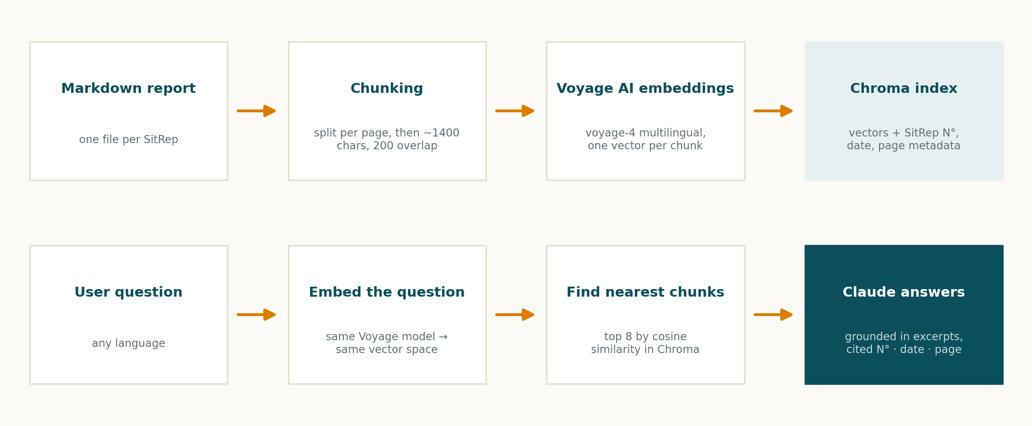
Where the AI is: the embedding model (meaning-aware search) and Claude's grounded, cited answering, including its decision to call tools.
Where it is plain code: chunking rules, the vector database, similarity search and citation bookkeeping are deterministic plumbing.

3 · Single-SitRep data quality assessment
One report is reviewed the way a careful epidemiologist would review it — but in seconds. Claude receives the complete report (not retrieved snippets, so nothing is missed) together with a detailed checklist prompt.
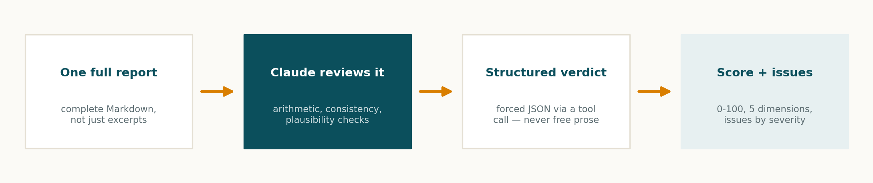
- Arithmetic. Do province rows sum to the national total? Do health-zone counts add up? Is CFR% consistent with cases and deaths? Does the isolation balance work out?
- Consistency. Do daily deaths reconcile with the change in cumulative deaths? Does the narrative agree with the tables? Are missing values ('ND') breaking comparability?
- Plausibility. Operational red flags — sudden drops, backlog rebounds, contact-tracing saturation.
- Output. The model must reply through a forced tool call that only accepts a fixed JSON shape: an overall score (0-100), five dimension scores (completeness, consistency, timeliness, plausibility, coverage), a list of issues each tagged High / Medium / Low with its location, and a one-sentence verdict.
Where the AI is: the review itself — Claude does the reading, arithmetic reasoning and judgement, guided by a versioned prompt (quality_single_structured.md).
Where it is plain code: the JSON schema enforcement, severity vocabulary and the UI that renders the score are fixed by the application, which is why the output is always displayable and comparable across reports.

4 · Two-SitRep comparison
Outbreak numbers are cumulative: totals should never go down, and day-to-day jumps have to be plausible. The comparison module checks a new report against an earlier one before the numbers are trusted.
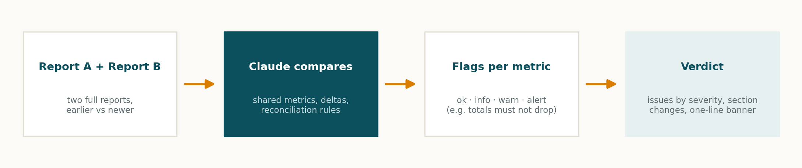
- Shared metrics. Claude lines up the indicators both reports share — confirmed cases, deaths, CFR%, affected health zones, isolation, contacts, laboratory — and computes the delta for each.
- Flags. Every metric is flagged ok / info / warn / alert: a cumulative total that decreases is an alert; a suspiciously large jump is a warning; an expected change is ok.
- Beyond numbers. It also reconciles deaths between the two dates, notes where 'ND' entries break comparability, and lists sections that were added, changed or dropped between the reports.
- Output. Again a forced JSON shape: the metric table with flags, issues by severity, section changes, and a one-line banner verdict (e.g. how many errors were found).
Where the AI is: the cross-report reasoning — alignment of metrics that may be worded differently, judgement about what counts as implausible.
Where it is plain code: the flag vocabulary, the JSON contract and the side-by-side UI.

5 · Topic extraction — gaps & challenges over time
Every SitRep buries its most strategic content in prose: the 'défis et lacunes' — gaps, constraints, unmet needs. Read one report and it is an anecdote; read forty and it is a pattern. This module makes the pattern visible.
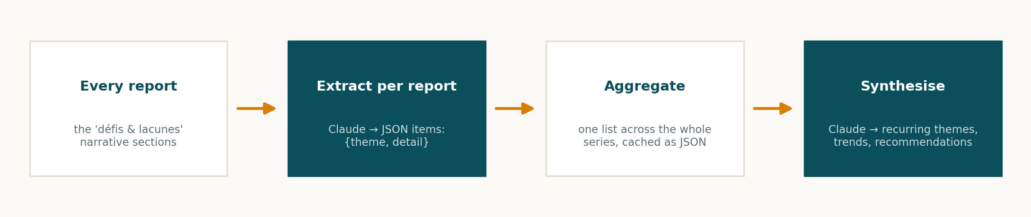
- Extract (per report). Claude reads each report and returns JSON items {theme, detail}, using a fixed theme vocabulary: Financing, Surveillance, Vaccination, Security, Logistics, Community Engagement, Human Resources, Laboratory.
- Aggregate. All items across the series are collected into one list (with SitRep number and date) and cached as JSON, so re-runs are instant.
- Synthesise. A second Claude call reads the aggregate and writes the strategic narrative: which themes recur most (and in how many reports), which are emerging or worsening, which were resolved, and 3-5 prioritised recommendations.
Where the AI is: both steps are generative — extraction of themes from prose, and the cross-series synthesis. This is the module that would be genuinely impossible without an LLM.
Where it is plain code: the theme vocabulary, aggregation and caching.

6 · Under the hood: the structured 'facts' datasets
Several features above rely on one supporting process worth knowing about. When a report is added, Claude also extracts a structured record of its numbers — totals, per-province and per-health-zone tables, and response-pillar tables (laboratory, contacts, IPC, vaccination) — into a JSON file per report. Two design rules keep this honest:
- Nullable by design. If a table is missing from the PDF, the field stays null. The model is explicitly forbidden from guessing.
- Cached per report. Each report's extraction is saved individually; adding one new report re-extracts only that report, then re-aggregates the time-series datasets (KPI, province, zone, pillars) that power the dashboard and the chat's query_data tool.

Appendix · Key settings at a glance
Chat / analysis model | Anthropic Claude — claude-sonnet-4-6 default; claude-opus-4-8 for demanding tasks (configurable)
Embedding model | Voyage AI voyage-4 (multilingual)
Vector store | ChromaDB, local persistent collection 'insp_sitreps'
Chunk size / overlap | ~1,400 characters (~350-400 tokens) / 200 characters
Chunks retrieved per question | top_k = 8
Citations | SitRep N° · report date · page, on every grounded figure
Report archive | data/sitreps/ — pdf/, md/, manifest.csv
Structured datasets | data/sitreps/datasets/ — per-report JSON + aggregated time-series
Prompts | prompts/*.md — externalised, versioned templates
Token efficiency | prompt caching on chat calls + per-turn history compaction (excerpts and tool payloads dropped once answered)

