Fullname: Hong That Nguyen Ton
ID: 1629958
CIFAR-10 Image Classification with a Multilayer Perceptron Report

1. Introduction
This report represents how we can train the Multilayer Perceptron (MLP) to classify the color images in CIFAR-10 into 10 classes. In addition, this project was run 19 more experiments. Each changes a single setting, and all share the same random seed and 10 epochs, so we can compare the effect of each change fairly.

2. Data and Preprocessing
CIFAR-10 includes 50,000 training images and 10,000 test images of 32×32 pixels with 3 color channels (RGB). Every class has 5,000 training images. Figure 1 shows the example about each specific class.
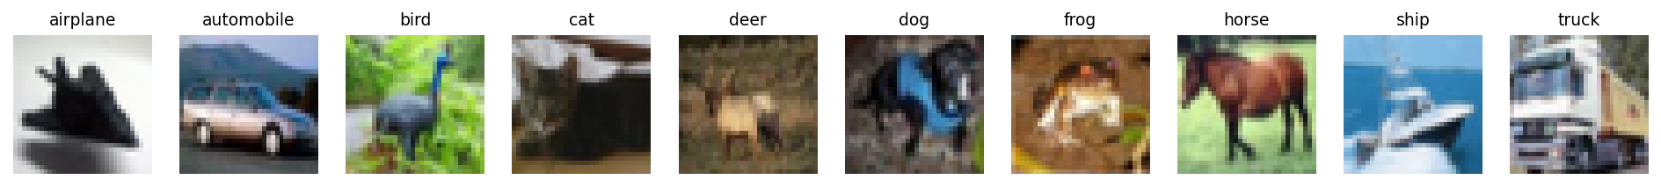
Figure 1. One sample image from each of the 10 CIFAR-10 classes.
- Scaling pixels to [0, 1]. The raw input pixels are uint8 integers from 0 to 255. Thus, we need to convert them to float32 and divided by 255 because first Dense layer produce very large weighted sums. Thus, that will lead to large gradients and unstable training result. Meanwhile, Keras initializes weights with the Glorot method, so the scaled inputs converge much more faster than manual manually.
- One-hot encoding the labels. The labels are labeled with integers from 0 to 9. Therefore, this project used utils.to_categorical to turn them into vectors of shape (N, 10).
- For example, label 3 (cat) becomes [0, 0, 0, 1, 0, 0, 0, 0, 0, 0]. This satisfy the requirement about the 10 unit softmax output.
This model hold 10% of the training set (~5,000 images) as validation_split = 0.1 to draw the learning curves.

3. Model Architecture and Parameter Count
The model follows the requirement:
Input (32, 32, 3) → Flatten → Dense 200 (ReLU) → Dense 150 (ReLU) → Dense 10 (softmax). Flatten makes each image into a vector of 32 × 32 × 3 = 3,072 values, the hidden layers learn the combinations of those pixels, and the output layer gives one probability per class.
Table 1. Layer shapes and parameter counts
Layer | Input shape | Output shape | Parameters
Flatten | (None, 32, 32, 3) | (None, 3072) | 0
Dense 1 (ReLU) | (None, 3072) | (None, 200) | 3072 × 200 + 200 = 614,600
Dense 2 (ReLU) | (None, 200) | (None, 150) | 200 × 150 + 150 = 30,150
Output (softmax) | (None, 150) | (None, 10) | 150 × 10 + 10 = 1,510
Total |  |  | 646,260

Parameters formula = inputs × units + units. About 95% of all parameters set in the first layer because every pixel connects to every neuron. Thus, that makes weakness of an MLP on images: many parameters, but there are no content about pixel’s neighbors.

4. Compilation
This model was compiled with the Adam optimizer (0.0005), and loss function is categorical_crossentropy. For one image, categorical cross entropy is
$$L =-\sum_{i=1}^{10}{\left(yi ×\log\left(pi\right)\right)}$$
where y: the one-hot label; p is the softmax output.
Since only true class has y = 1, the loss reduces to L = −log(p_{true}). Firstly, each image has exactly one class. Softmax is a probability distribution, the one-hot label is also a distribution, and cross entropy measures the distance between them. Secondly, model punishes the mistakes. For example, if the true class gets 0.9 during the loss is 0.105, but if it gets 0.01 during the loss is 4.61. Thirdly, the softmax is basicly p − y. Thus, binary cross entropy acts suitably multilabel requirement for regression.

5. Training
The model was trained with batch_size = 32, epochs = 10 and shuffle = True. With 45,000 training images, that is about 1,407 weight updates after every epoch, and that took about 48 seconds. Figure 2 shows the learning curves.
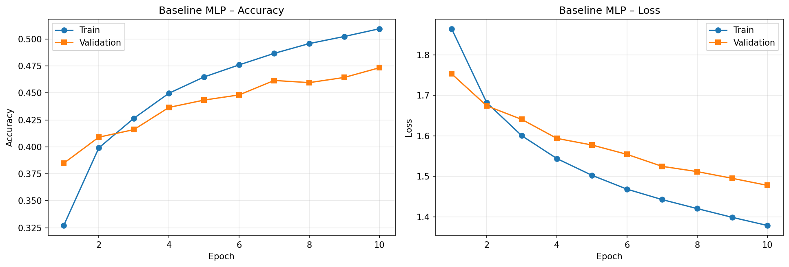
Figure 2. Training and validation accuracy (left) and loss (right) for the baseline MLP.
Training accuracy rose from 32.7% to 51.0% and validation accuracy from 38.5% to 47.3%, while validation loss fell steadily from 1.75 to 1.48. In epoch 1 validation accuracy is higher than training accuracy, because training accuracy is averaged over the epoch while the weights are still poor. From epoch 3 the training curve pulls ahead and the gap reaches 3.6 points at epoch 10. This is mild overfitting, since validation loss is still decreasing. Both curves are still improving at epoch 10.
How batch size and learning rate affect convergence. A small batch such as 32 gives a noisy gradient but many updates per epoch, so the model improves quickly per epoch and the noise often helps generalization. A large batch gives a better gradient and uses GPU better, but fewer updates. The learning rate sets the step size: too large and the loss diverges, too small and training is slow. Larger batches usually need a larger learning rate (tested in Section 7.5).

6. Evaluation and Visualization
On the test set, model.evaluate gave a test accuracy of 47.95%, about 4.8 times better than random guessing (10%). It is close to the final validation accuracy (47.3%), so the validation set was a good estimate. Class predictions come from model.predict, which returns a (10000, 10) array of probabilities, followed by np.argmax along axis 1. Figure 3 shows 10 random test images.
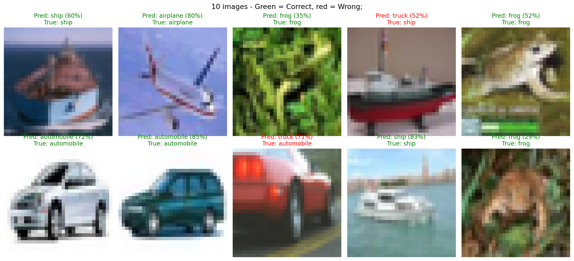
Figure 3. Ten random test images with predicted and true labels (green is correct, red is wrong).
8/10 images are correct. Both mistakes confuse vehicles: a ship and a red sports car were unpredicted well as trucks (52% and 71%). Because the MLP only sees raw colors at fixed positions, a large red body or gray can look like a truck. The two frogs were correct but with low confidence (29% and 35%) because they are signature with green background.

7. Impact of Hyperparameters, Regularization and Optimization
Entire 20 runs are summarized by Table 2 at the end of this section. Gap is actually training minus validation accuracy at epoch 10. A large gap points to overfitting, and a negative gap comes from Dropout, which is active only when it was measuring training accuracy.

7.1 Hidden units, depth and activation
Units and layers:
- The narrow model (100, 50) reached only 44.7% test accuracy with low training accuracy (46.7%), which is underfitting.
- The wide model (512, 256) has 2.6 times more parameters and reached 52.9% training accuracy, but its test accuracy (47.4%) can not beat the baseline and the gap grew to 4.7 points. So after removing the second hidden layer cost 2.4 points (45.5%).
- The three layer model had the highest training accuracy (53.8%), the largest gap (7.5 points), and the validation loss that stopped improving after epoch 7 so that is a clear sign of overfitting. It helps the model memorize images, because Flatten has already thrown away the spatial structure of the image.
Activation. LeakyReLU gave 46.4%, slightly below ReLU with a larger gap. ReLU units are rare in such a shallow network, so the small negative slope added nothing. tanh was the worst at 42.3% with the lowest training accuracy (44.7%)
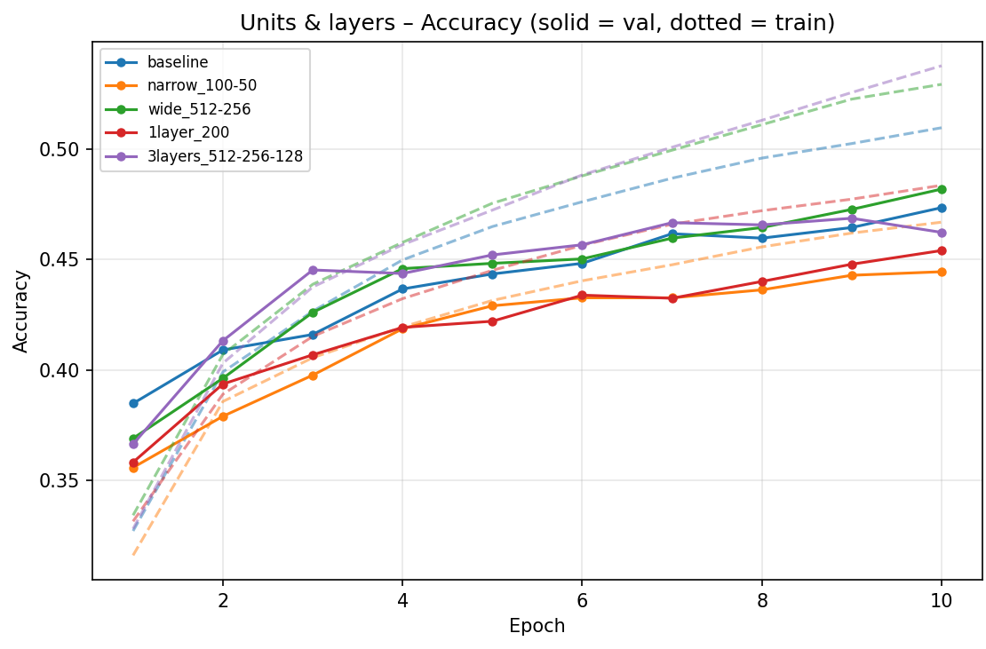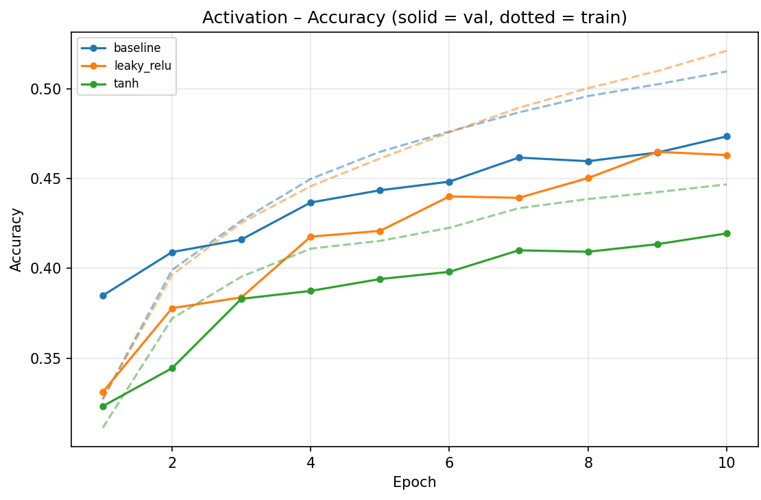
Figure 4. Accuracy when changing units and layers (left) and activation function (right). Solid lines are validation, dashed lines are training.

7.2 Regularization
Regularization was applied to the wide (512, 256) model because it overfits more.
- Dropout 0.2 removed the overfitting completely (gap of 2.0 points), but test accuracy dropped to 44.7% because the model learns more slowly and 10 epochs were not enough.
- Dropout 0.5 was far too strong: the model reached only 29.8% and its validation loss stayed flat around 1.95. L2 with 0.0001 was too weak to matter (gap still 4.7 points). L2 with 0.001 gave the best balance, cutting the gap from 4.7 to 2.1 points while losing only about 1 point of test accuracy (46.4%).
- Dropout 0.2 plus L2 behaved like Dropout alone (44.6%).
Therefore, regularization reduced overfitting as intended, but after only 10 epochs the wide model was not overfitting badly, so there was little accuracy to recover. It could be trade more with longer training.
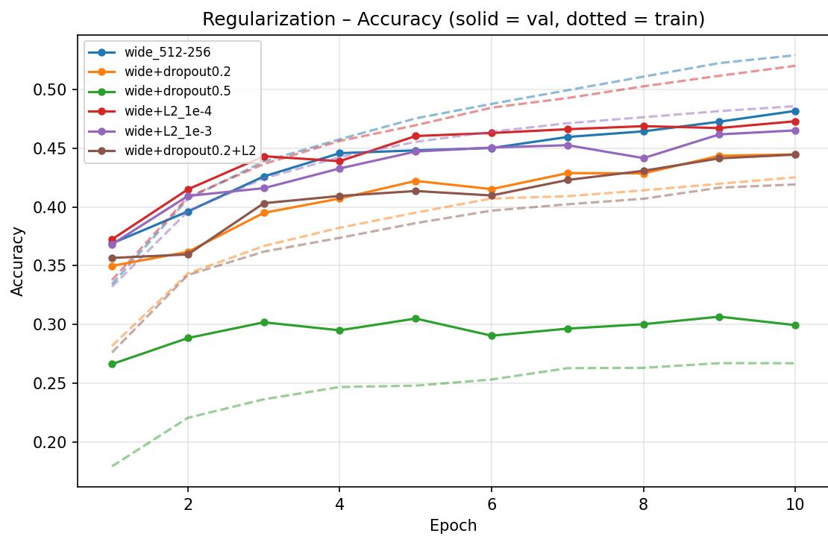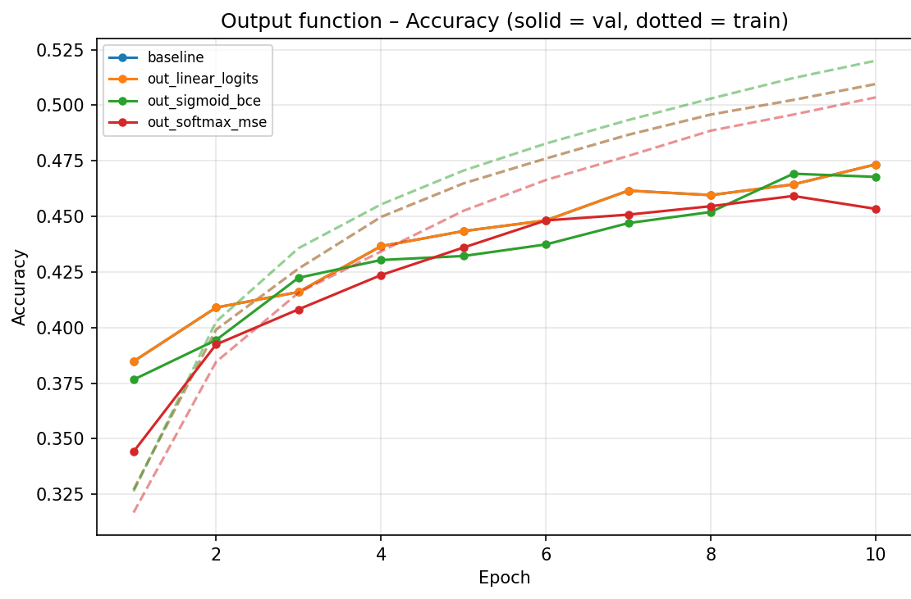
Figure 5. Accuracy with Dropout and L2 regularization on the wide model (left) and with different output functions (right).

7.3 Optimizer: Adam vs RMSprop
RMSprop reached 43.0% test accuracy and Adam reached 47.95%. Its validation loss was rose in epochs 9 and 10 (1.64 to 1.78) while training accuracy kept rising. Adam uses the same per parameter scaling same RMSprop but Adam adds momentum and bias correction so it converges more steadily.
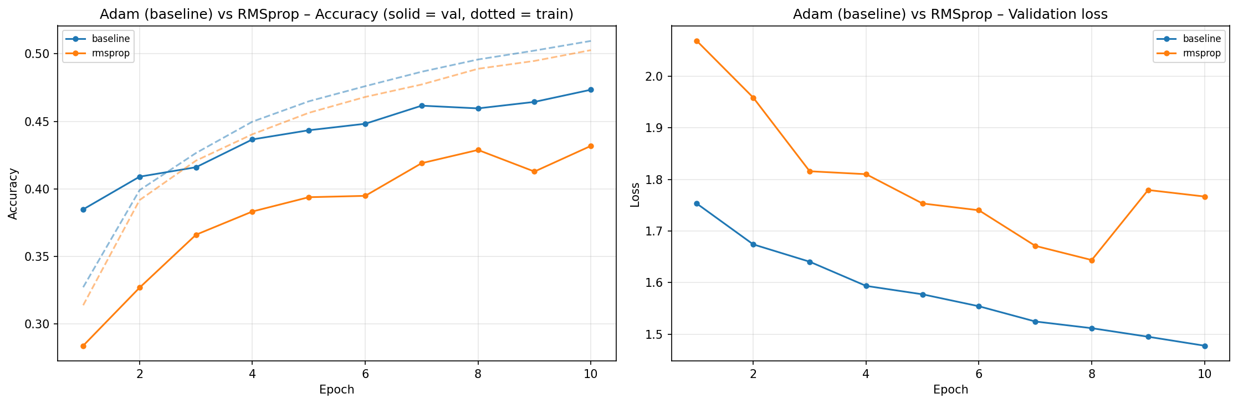
Figure 6. Adam (baseline) versus RMSprop with the same learning rate of 0.0005.

7.4 Output function
Three changes to softmax with categorical cross entropy were tested (Figure 5, right image). Each uses a different loss, so loss values are on different scales and accuracy is used for comparison. A linear output with cross entropy computed from logits gave exactly the baseline result (47.95%) with overlapping curves, because the softmax is simply moved inside the loss. The math is the same, only more numerically stable. A sigmoid output with binary cross entropy reached 47.3%. Softmax with MSE reached 46.0% and started slowest (34.4% validation accuracy after epoch 1 against 38.5%) because MSE through softmax gives weaker gradients. Softmax with categorical cross entropy remains the best choice.

7.5 Learning rate and batch size
A learning rate of 0.0001 was stable but slightly slower (46.7%). A learning rate of 0.005 was too large: training accuracy reached only 36.7%, validation accuracy non-stable and validation loss stayed near 1.8 because the steps kept overshooting, giving 35.6% on test. Finally, 0.0005 is a good choice for Adam here.
Batch sizes 128 and 512 give only 352 and 88 updates per epoch instead of 1,407, so they start slower (36.6% and 34.2% validation accuracy after epoch 1 against 38.5%). Their final test accuracy is almost the same (47.5% and 47.0%), but training took only 18 and 12 seconds instead of 48 because large batches use the GPU much better. Raising the learning rate with the batch size would be close the small gap.
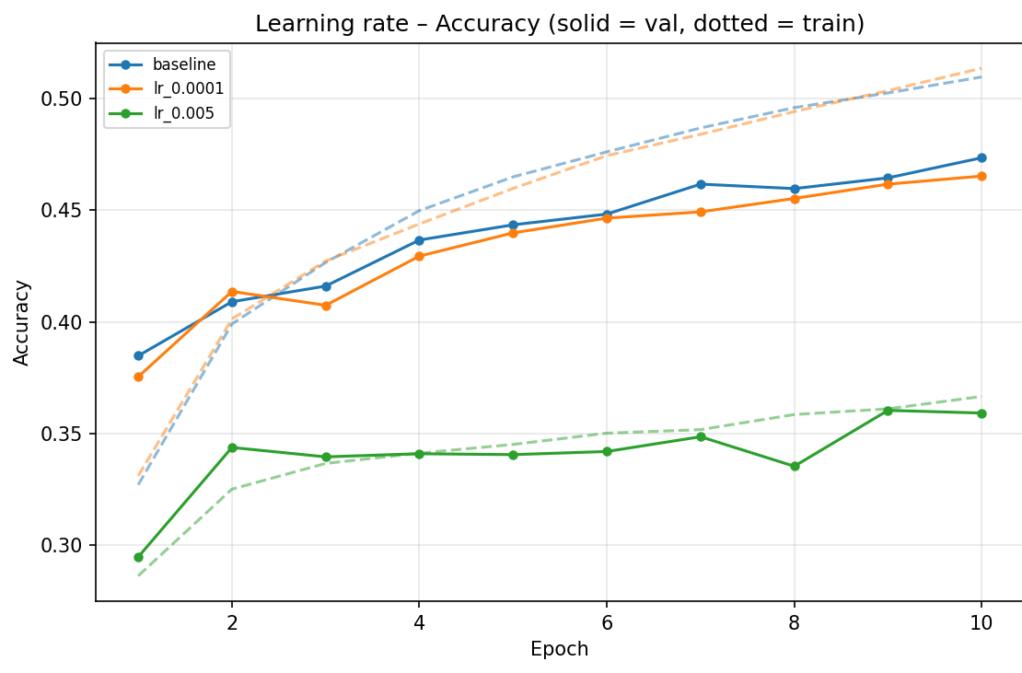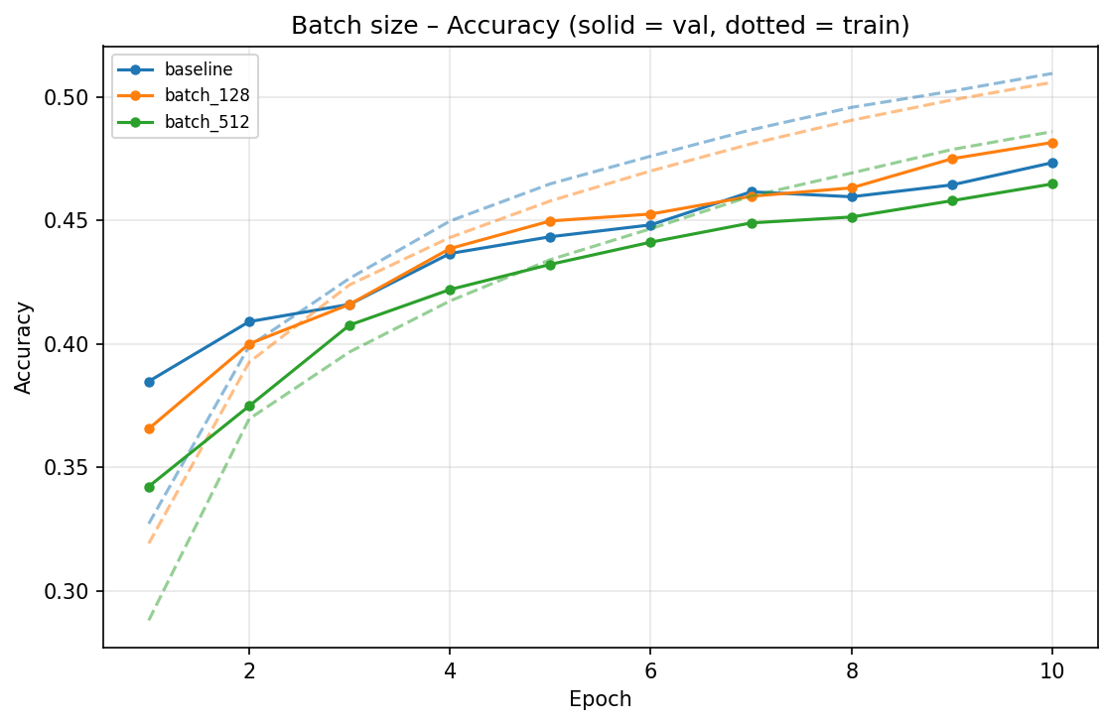
Figure 7. Accuracy for different learning rates (left) and batch sizes (right).
Table 2. Results of all experiments after 10 epochs.
Configuration | Params | Train acc | Val acc | Test acc | Gap | Time
Baseline (200, 150), ReLU, Adam | 646,260 | 51.0% | 47.3% | 47.9% | 3.6 | 48 s
Narrow (100, 50) | 312,860 | 46.7% | 44.4% | 44.7% | 2.2 | 47 s
Wide (512, 256) | 1,707,274 | 52.9% | 48.2% | 47.4% | 4.7 | 48 s
One hidden layer (200) | 616,610 | 48.4% | 45.4% | 45.5% | 2.9 | 45 s
Three hidden layers (512, 256, 128) | 1,738,890 | 53.8% | 46.2% | 47.8% | 7.5 | 51 s
LeakyReLU activation | 646,260 | 52.1% | 46.3% | 46.4% | 5.8 | 48 s
tanh activation | 646,260 | 44.7% | 41.9% | 42.3% | 2.7 | 48 s
Wide + Dropout 0.2 | 1,707,274 | 42.5% | 44.5% | 44.7% | −1.9 | 60 s
Wide + Dropout 0.5 | 1,707,274 | 26.7% | 29.9% | 29.8% | −3.2 | 51 s
Wide + L2 (0.0001) | 1,707,274 | 52.0% | 47.3% | 46.5% | 4.7 | 55 s
Wide + L2 (0.001) | 1,707,274 | 48.6% | 46.5% | 46.4% | 2.1 | 49 s
Wide + Dropout 0.2 + L2 (0.0001) | 1,707,274 | 41.9% | 44.5% | 44.6% | −2.5 | 52 s
RMSprop optimizer | 646,260 | 50.3% | 43.2% | 43.0% | 7.1 | 45 s
Linear output + CE (from logits) | 646,260 | 51.0% | 47.3% | 47.9% | 3.6 | 47 s
Sigmoid output + binary CE | 646,260 | 52.0% | 46.8% | 47.3% | 5.2 | 49 s
Softmax output + MSE | 646,260 | 50.4% | 45.3% | 46.0% | 5.0 | 46 s
Learning rate 0.0001 | 646,260 | 51.3% | 46.5% | 46.7% | 4.8 | 46 s
Learning rate 0.005 | 646,260 | 36.7% | 35.9% | 35.6% | 0.7 | 47 s
Batch size 128 | 646,260 | 50.6% | 48.2% | 47.5% | 2.4 | 18 s
Batch size 512 | 646,260 | 48.6% | 46.5% | 47.0% | 2.1 | 12 s

8. Conclusion
The baseline MLP reached 47.95% test accuracy, about 4.8 times better than random guessing, with only a bit overfitting after 10 epochs. There are not changes improved on it because reasonable variations stayed within about one point of 48%, while poor choices such as Dropout 0.5, a learning rate of 0.005, tanh or RMSprop clearly impact. Flattening removes the relationships between neighboring pixels, so a convolutional neural network sharing weights across positions would be the better next step for CIFAR-10.

