# Conversion and Seasoning of Timber

## Seasoning of timber

Green or unseasoned timber contains large amounts of water inside the cell cavities (free moisture) and the cell walls (combined moisture). Most of this moisture must be removed to prevent the timber from warping and shrinking too much. Timber that has a moisture content of about 15% is known as dry or seasoned timber.

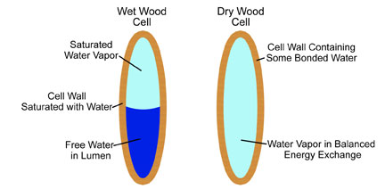Seasoning is the process by which the moisture content of the timber is reduced to equal the moisture content of the environment. This is known as equilibrium moisture content or EMC. It will vary from region to region but is generally between 10% and 15%.

Equilibrium

Moisture

Content

There are 3 ways that timber can be seasoned.

* Air seasoning
* Kiln seasoning
* 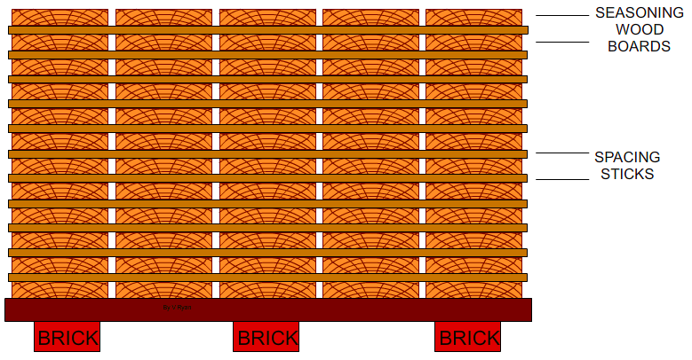Combined seasoning

### Air seasoning

Air seasoning is the traditional method of drying sawn timber. Because it depends on natural circulation of air, it is a very slow and inaccurate process. It may take up to one or two years to remove the moisture, depending on the size of the timber (about 6 months per 25mm of thickness).

### Kiln Seasoning

Kiln seasoning is carried out in large oven-like structures call kilns. Sawn timber is stacked on trolleys (using the air seasoning stacking system) and wheeled into a kiln. There it is dried by heated air driven by fans. The moisture level is controlled by a steam humidifier.

Because the temperature, air flow and moisture level can be controlled, green timber can be kiln-seasoned in as little as one to two weeks. The main advantage of this method is its speed. As well, seasoning defects are reduced, and insects and fungi in the timber are destroyed.

### Combined seasoning

To reduce the seasoning defects (particularly in hardwoods), it is common to combine the air seasoning and kiln-seasoning methods. The green timber is first air seasoned for about three months, to remove the water inside the cell cavities. It is then moved into a kiln to complete the seasoning process, which takes only three to seven days.

## Conversion of Timber

A tree that is going to be felled is marked by a spotter then felled by a logger. The main limbs and the crown are cut off and the log is taken to the mill. At timber conversion mills, the raw materials that have been harvest from the forest are processed into timber products. The waste materials are not thrown away but are reused. For example, the bark is used by landscapers.

There are 5 main groups of timber products:

* Sawn timbers
* Veneers and plywoods
* Round timbers
* Wood pulp
* Board products (particle board etc)

### Log breakdown for sawn timber

Logs are cut using on of these three methods:

#### Live Sawing

Live sawing is the simplest method of cutting a log into boards. Several parallel saw cuts are made without turning the log. There is very little waste. However, live-sawn timber distorts badly because of warping and shrinkage. It is used mainly for fence palings and packing cases.

#### Back Sawing

In back sawing, the saw cuts are at a tangent to the growth rings. Back sawing is usually used to produce good-quality timber, as it allows defects to the removed quite easily.

Back sawing shows off the grain in timbers, such as red cedar, that have distinct growth rings. Back-sawn timber also has good strength and therefore it is used for toll handles and for structural timber such as beams.

#### Quarter Sawing

In quarter sawing, timber is cut at right angles to the growth rings. Quarter sawn timber seasons slowly but wears well and retains its shape. Therefore, it is used in door frames, mouldings, and flooring boards. Quarter sawing also shows off the decorative figure in timbers such as silky oak and maple.

### Gang saws

A gang saw is a type of power saw that makes several cuts simultaneously. Typically, a gang saw operates as a saw and conveyor, pulling logs across its blades to cut an entire section into planks with one pass. Older versions of these tools used a reciprocating saw design, where the blades are perpendicular to the cutting surface, or a circular saw. The most common modern gang saw is the band saw.

## Questions:

1. List 3 reasons as to why timber is seasoned and how this is beneficial.
2. What is the fibre saturation point and when is this point reached?
3. Describe 2 advantages and disadvantages of each log breakdown method and complete the drawings showing the correct type of conversion.
4. Describe how a tree is felled and prepared for conversion.
5. Sketch a tree, show the method of felling, and indicate the direction of fall.
6. Sketch a basic gang saw
7. List 4 uses for timber converted by
   1. Live sawing
   2. Back sawing
   3. Quarter sawing
8. List 3 timbers that are converted by each method
   1. Live sawing
   2. Back sawing
   3. Quarter sawing