Software Requirements Specification

Version 1.0

January 15, 2016
DSL Website

Revision History

Date | Description | Author | Comments
15-Jan-2016 | Initial Document | Mefta Sadat | Please update if needed

Document Approval

The following Software Requirements Specification has been accepted and approved by the following:
Signature | Printed Name | Title | Date

Table of Contents

Revision History ii
Document Approval ii
Table of Contents iii
List of Figures iv
1.0. Introduction 4
1.1. Purpose 4
1.2. Scope of Project 4
1.3. Glossary 4
1.4. References 2
2.0. Overall Description 3
2.1 System Environment 3
2.2 Functional Requirements Specification 4
2.2.1 Visitor Use Case 4
Use case: View Site Pages 4
Use case: Add Comment 4
Use case: Share Social 4
2.2.2 Member Use case 5
Use case: Add & Modify Bio 5
Use case: Add & Modify Publications 5
2.2.3 Admin Use Case 5
Use case: Add & Modify People 6
Use case: Add & Modify Project 6
Use case: Add & Modify News 6
Use case: Add & Modify Events 7
Use case: Add & Modify General Information 7
2.3 User Characteristics 7
2.4 Non-Functional Requirements 7

List of Figures

Figure 1 - System Environment 3
Figure 3 - Admin Use Cases 6

Introduction

The introduction of the Software Requirements Specification (SRS) provides an overview of the entire SRS with purpose, scope, definitions, glossary and references of the SRS. The aim of this document is to gather and analyze and give an in-depth insight of a Research Group Website. The detailed requirements of the Data Science Lab – Research Group Website are provided in this document.

1.1. Purpose
The purpose of the document is to collect and analyze all assorted ideas that have come up to define the system, its requirements with respect to users. Also, we shall predict and sort out how we hope this product will be used in order to gain a better understanding of the project, outline concepts that may be developed later, and document ideas that are being considered, but may be discarded as the product develops.

1.2. Scope of Project
Primarily, the scope pertains to Data Science Lab’s dynamic website that will replace the existing static one. It will offer greater maintainability and functionalities than the previous system.

1.3. Glossary
Term | Definition
DSL | Data Science Lab
DSL Seminar | The weekly presentation of research works by DSL members.
Admin | Site Admin, will control everything
Member | DSL members who registered to the site
Visitor | People who will visit the site and not a member of DSL
Software Requirements Specification | A document that completely describes all of the functions of a proposed system and the constraints under which it must operate. For example, this document.

1.4. References
IEEE. IEEE Std 830-1998 IEEE Recommended Practice for Software Requirements Specifications. IEEE Computer Society, 1998.

2.0. Overall Description

2.1 System Environment
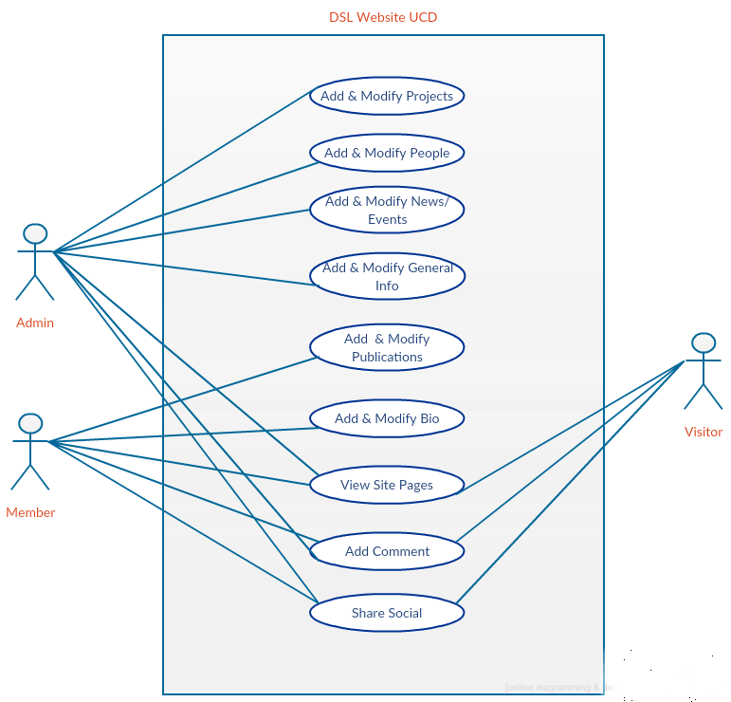
Figure 1 - System Environment

The DSL website has three active actors and one system. The Admin can add, edit or delete any user or information. The Member can add and update his bio or publications. Visitor can visit accessible web pages of the site. Some of the pages are accessible to the members only.

2.2 Functional Requirements Specification
This section outlines the use cases for each of the active actors separately. The admin is the main actor in this system. Members have more use cased than general visitors.

2.2.1 Visitor Use Case

Use case: View Site Pages
Diagram:
Visitor
View Site Pages

Brief Description
Visitors can view web pages which have public access. Moreover, they can share content from the DSL website to social media.

Use case: Add Comment
Diagram:

Visitor
Add Comment

Brief Description

Visitors can comment on news post on DSL website.

Use case: Share Social
Diagram:

Visitor
Share Social

Brief Description

Visitors can share DSL news or events on social media such as linked in, twitter or facebook.

2.2.2 Member Use case
All visitor use cases are applicable for the Member. Additional use cases are below:

Use case: Add & Modify Bio
Diagram:
Member
Add & Modify Bio

Brief Description
Member can add and modify a short description, cv, social profile, personal page and a photograph.

Use case: Add & Modify Publications
Diagram:
Member
Add & Modify Publications

Brief Description
Member can add and modify their own publication to the main list of publication.

2.2.3 Admin Use Case
All visitor use cases are applicable for the Admin. Additional use cases are below:

Figure 2 - Admin Use Cases
People
Admin
Project
News
Events
General Information

Add & Modify use cases

Use case: Add & Modify People

Brief Description
The admin can add new member to DSL website and grant special privileges and all sorts of access control. Admin can also modify any member role.

Use case: Add & Modify Project

Brief Description
The admin can add and modify research projects. There should be a photo, some text description and links about the project.

Use case: Add & Modify News

Brief Description
The admin can add and modify news. News should have photo, text or any other type of media. Recent news should be displayed on homepage.

Use case: Add & Modify Events

Brief Description
The admin should post and modify DSL events. There should be option to view the DSL calendar. Upcoming events should be displayed on homepage.

Use case: Add & Modify General Information

Brief Description
The admin can add and modify general information. General Information include:
- Information for prospective students
- Collaboration
- Funded Research
- About DSL
- About Dr. Bener (Wiki)
- Industry Partners

2.3 User Characteristics
- The Admin is expected to be familiar with all the functionalities of the website.
- The Members are expected to be able to modify their information using a form.
- The visitors should be internet literate people and should be familiar with basic website navigation.

2.4 Non-Functional Requirements
- Importing events from DSL website to Google Calendar or iClaendar.
- Twitter feed of DSL on Homepage
- Video Showcase of DSL on homepage
- Github feed of some of the repositories.

