Course |  | Applications of Mechanical Workshop/ AET530 |  |  |  |  | Teacher |  | Ali Altaweel |  |  | Campus |  | UAQ |  | (G-G10-11 Workshop)
Class |  | A10[ENI]/51 - A10[AET]/51 - A10[ENI]/01 |  |  |  | term |  | Term3 |  |  | Week & Date |  |  |  | W1,2 & P4 |  | (14-25) Apr 2025
CHAPTER, 1  Lesson/unit/topic & pages  (TOPIC1)  resources  (Twist drills, drill chucks, drill gauges and Vernier calipers) |  |  |  | Main learning focus (KPIs)  - Understanding Twist Drill Parts and Geometry.  - Workshop Tools and Equipment.  - Safety and Operational Practices.  - Metal Cutting with Sawing Machines. |  |  |  |  |  | C21st Skills: Real-Life Examples, Cross-Cutting Concepts  - Identify the types and uses of twist drills (e.g., parallel shank and tapered shank).  - Explain twist drill geometry, including clearance angle, helix angle, and point angle.  - Proper methods to install, secure, and remove drill chucks and tapered shank drills.  - Usage of drill gauges and Vernier calipers to measure drill bit sizes.  - Operate bench grinders for sharpening drill bits.  - Identify bench grinder components and use them safely
 |  |  |  | Success Criteria: Students will be ablet to:  - Identify the types and uses of twist drills.  - How to install, secure, and remove drill chucks and tapered shank drills. |  |  |  |  |  | Numeracy, Literacy, Culture & Heritage  - Numeracy skills can be applied when identifying twist drills and their geometry.  - Literacy is essential for understanding, communicating, and following workshop safety procedures.  - Culture & Heritage relates to understanding the significance of safety practices within the engineering profession and their historical development.
Opening | Time |  | STAGE |  | How will you engage students in learning? Make Connections…Brainstorm / Snowballing / Open Questioning / Structured Research / AI
 | 10 |  | WARM UP:  LEARNING OBJECTIVE QUESTION |  | 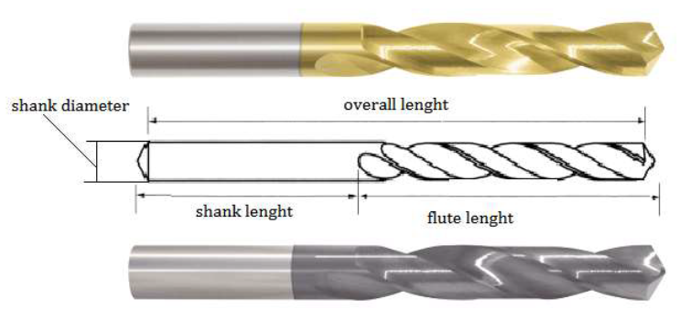  • Discussion Starter:  - Question: What are the essential features of twist drills?  - Brief explanation of drill types and their use in workshops.  • Interactive Image Analysis:  - Display images of different drill parts and ask students to identify their features.
Heart of the Lesson/unit/topic | 20 |  | FOCUSED INSTRUCTION: MODEL |  | Teacher Directed Activities: Are you using a variety of instructional techniques? Critical Thinking, Logic Steps, Solving Examples
The lesson begins with identifying and analyzing
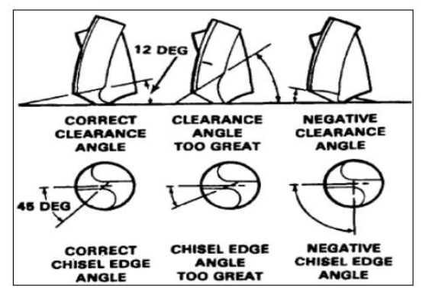
 Discussion Starter:
- Question: What are the types of twist drills?
- Brief explanation of drill types and their use in workshops.
 Interactive Image Analysis:
- Display images of different twist drill and ask students to identify their angles.

 | 20 |  | GUIDED INSTRUCTION: GUIDED PRACTICE |  | Teacher Directed Activities: Are you using a variety of instructional techniques? Critical Thinking, Logic Steps, Solving Examples
• Discussion Starter:
- Question: Identify different drill bits and their securing methods?
- Brief explanation of the parallel shank drill fits into an adjustable chuck in workshops.
• Interactive Image Analysis:
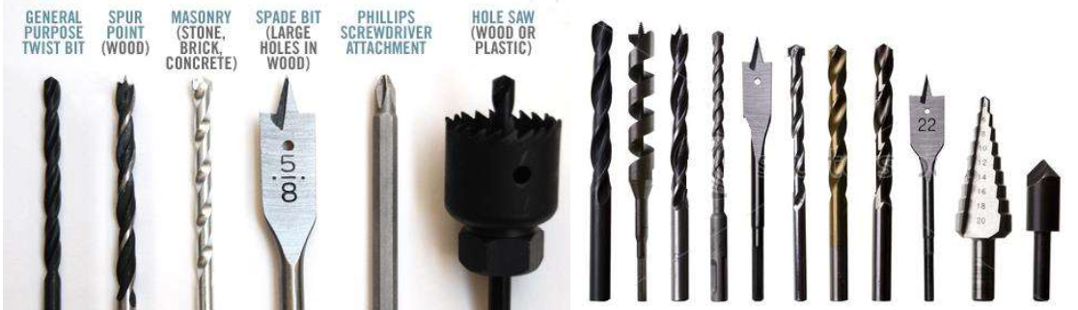
- Display images of different drill parts and ask students to identify their features.

 | Time |  | STAGE |  | Student Directed Activities: NEED HELP! Work collaboratively
 | 20 |  | COLLABORATIVE LEARNING: GROUP TASK |  | 1. Twist drill Types (PC4.3.1)  - Divide students into groups and assign Clearance angle, Helix angle and Point angle.  - Each group discusses and selects the correct Twist drill angles for their scenario.  - Groups role-play the steps to handle the angles.  - Debrief as a class, discussing the importance of identifying the Twist angle.  2. Twist drill angles (PC4.3.2)  - Divide students into groups and assign: how Tapered shank drill fixing and removal:  - Each group discusses and identify the correct way to fix and remove the tapered shank.  - Groups role-play the steps to practice.
 | 20 |  | INDEPENDENT LEARNING: INDIVIDUAL TASK |  | Student Directed Activities: WANT A CHALLENGE! - Work Independently
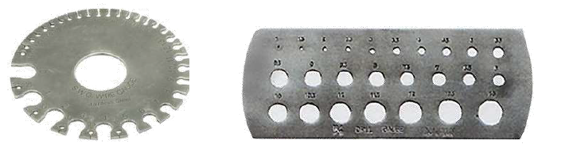
Hands-On Task:

- Students practice how to measure and find out the size of drill bit by using Drill bit gauge and Vernier calliper.

Closing | 10 |  | PROGRESS CHECK: INDEPENDENT PRACTICE |  | Independent Practice (Align Questions with KPIs) - Are Concepts Clearly Understood?
 |  |  |  |  | 1. Written Assessment  Multiple-choice, short answer.  Topics include:  - Twist drill types and their angles  2. Practical Demonstration  Students demonstrate:  - Workshop Tools and Equipment.  Assessment Tools:  - Practical Demonstration Rubric:  - Evaluate student performance based on accuracy, safety, and skill.  - Written Quiz:  - Short answers on twist drill parts, geometry, and safety precautions.  - Peer Feedback:  - Collaborative evaluation during group tasks. |  |  |  |  |  |  |  | Home Learning (Self learning/ Homework)  AET530-NQA-M1,2,3

Reflection (at the end of the lesson/unit/topic)
Recap success criteria: You can… (Remembered < Understood) (Applied < Analyzed) (Evaluated < Created). Challenges faced…
The success criteria were met as students successfully demonstrated understanding and application of workshop safety, tool handling, and drill geometry. Challenges included varied skill levels, but additional practice and guidance helped reinforce learning. Future lessons will focus on enhancing practical skills and boosting engagement through interactive tasks.

