EGB345 Control and Dynamic Systems JJF/25
Servo Motor Control Design Report
Instructions: replace the yellow highlighted with the requested items (that is, delete the yellow text).

Author Details | Darcy Stewart N11977965

Answers
Design Summary | Summary of parameters and task outcomes are:  Task 1 Km 6.8528  Alpha 3.2737  KTask1 0.8240  Task 3 Kfo 0.6869  Kso 0.4966  Task 4 Pc =XXX  Zc =XXX  Klead 3.2772
Task 1 | The behaviour of the open loop transfer function was initially analysed through taking the inverse Laplace transform of a step input. The inverse Laplace transform yielded the function of:  $$r(t)⊗g(t)=u(t)(2.093t-0.63913+0.6394e^{-3.2737t})$$  This step response indicates that in open loop the motor angle will increase indefinitely, suggesting that providing a step input would simply turn the motor on and make it turn in the “positive” direction. This analysis was supported by a plot of the step input in MATLAB included below.  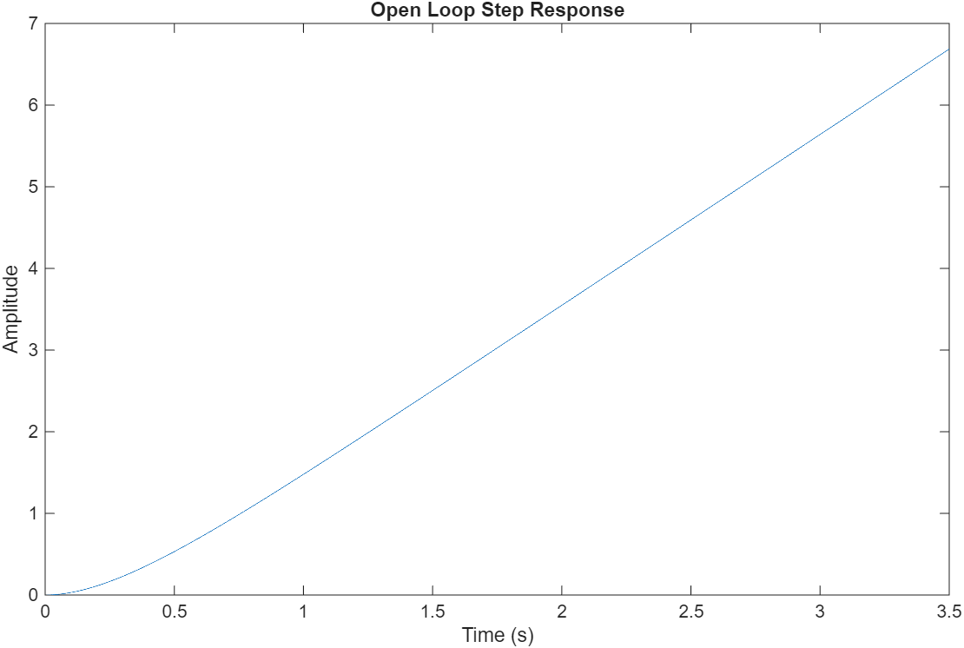  The graphed step response shows that the motors angle would continue to increase as time increased, supporting the mathematical analysis.  Following this the model of a closed loop system with negative feedback was developed in the interest of control. The model was developed using the formula of $G_{e}\left(s\right)=\frac{1}{1+G\left(s\right)H\left(s\right)}$ where $G_{e}(s)$ is the transfer function of the feedback system, $G(s)$ is the transfer function of the motor and $H(s)$ is the gain of the feedback. For the purposes of this report $H(s)$ is assumed to be 1. This model is correct however for an adjustable model a gain characteristic must be incorporated to tune the response to the desired output. This gain componene tcascades with
Task 2 | The requested items, see the task sheet.
Task 3 | The requested items, see the task sheet.
Task 4 | The requested items, see the task sheet.

