Individual Computer Lab Assignment
Due Date: Friday, week 13 @ 2359

Student ID: N11977965

Name: Darcy Stewart

Introduction and problem description
A dynamic problem can be split in two steps: (1) obtaining the equation(s) of motion and (1) solving it. To obtain the equation(s) of motion we use common dynamics theory, such as Newton’s second law. The equation of motion can then be solved through analytical or numerical techniques. So far, you have mostly looked at analytical solutions to problems, however, even for simple dynamics problems these can rapidly become complex and unwieldy. In actuality, the presence of a true analytical solution is rare in many real-world problems and rely on simplifications and assumptions (e.g. neglecting drag). Numerical solutions on the other hand can be readily used to solve simple and complex dynamics problems. For numerical solutions the main challenges become computational resources and the elegance of the model.

Elastic pendulum (also called spring pendulum or swinging spring) is a physical system where a particle of mass is connected by a spring. Compared with the ideal pendulum, not only angle, but also the length of string (spring) is changing in the process, which makes the problem nonlinear, and extremely difficult to solve analytically. An example is shown in Figure 1. A real world example of this is a bungee jump. In this assignment, we will explore numerical and analytical solutions to this problem.

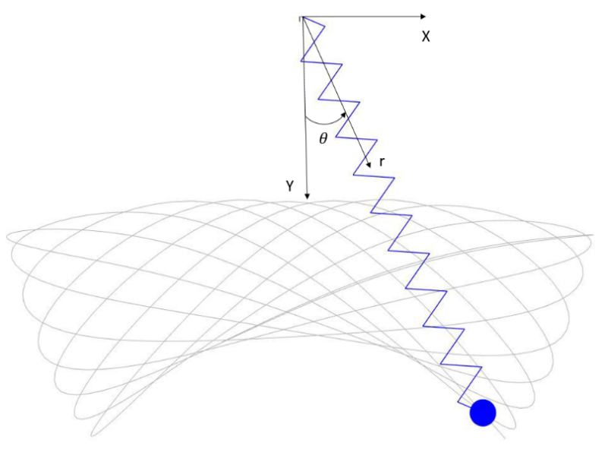
Figure 1. The schematic graph for an elastic pendulum. The grey curve is an example trajectory of the particle.

Table 1. Physical quantities in the system.
Property | Symbol | Quantity | Unit
Particle mass | $$m$$ | 0.1 | kg
Initial angle | $$θ_{0}$$ | 0.05 | $$rad$$
Initial angular velocity | $${\dot{θ}}_{0}$$ | 0.01 | rad/s
Unstretched length | $$l_{0}$$ | 20 | m
Initial length | $$r_{0}$$ | 22 | m
Initial radius velocity | $$\dot{r_{0}}$$ | 0.1 | m/s
Elastic coefficient | k | 20 | N/m

To simplify this solution, we will neglect drag and the mass of the spring. We will also focus on the 2D case.

For this assignment, provide your solutions in the boxes provided. Submit the full document as a PDF. You must also submit all you MATLAB code as an individual file.

Use of generative AI is permitted for the MATLAB-coding portion of this assignment, where it can be a useful tool to understand code, debug, etc. Use of generative AI is not permitted in the other sections.

1) Rectangular equations of motion (EOM) (3 points)
Draw the free body diagram for the elastic pendulum model in the Fig 1, and develop the equation of motion(s) for the particle in the rectangular coordinate system.
- Ensure you show all relevant terms and include the $x$-$y$ axis from the problem description (noting $y$ is pointing down).
- Write your EOM in the form of $0=…$ . In this case you should have two EOM, one for $x$ and $y$ respectively.
- To make later work easier, ensure the only variables in the EOM are $x$, $y$ and their derivatives (we can still have constant, e.g. $l_{0}$). So, for example, the change in length of the spring should be represented in terms of $x$ and $y$. Also, our trig functions ($\sin{θ}$, $\cos{θ}$) should be replaced with functions of $x$ and $y$, for example $\sin{θ}=\frac{opp}{hyp}=\frac{x}{\sqrt{x^{2}+y^{2}}}$.

Answer within this box. Change the size of the box if needed.
$$∑F_{y}= m\ddot{y}$$
$$∴m\ddot{y}= -F_{s}cos\left(θ\right)+F_{g}$$
$$F_{s}=KΔl=K\left(L-l_{0}\right)=K\left(\sqrt{x^{2}+y^{2}}-l_{0}\right)$$
$$\cos\left(θ\right)=\frac{y}{\sqrt{x^{2}+y^{2}}}$$
$$∴m\ddot{y}= -k\left(L-l_{0}\right)\frac{y}{\sqrt{x^{2}+y^{2}}}+mg$$
$$0=\ddot{y}+\frac{ky}{lm}\left(L-l_{0}\right)-g$$

$$∑F_{x}=m\ddot{x}$$
$$∴m\ddot{x}= -F_{s}\sin\left(θ\right)$$
$$\sin\left(θ\right)=\frac{x}{\sqrt{x^{2}+y^{2}}}$$
$$m\ddot{x}= -K\left(L-l_{0}\right)\frac{x}{\sqrt{x^{2}+y^{2}}}$$

$$\ddot{x}= -\frac{K\left(L-l_{0}\right)x}{mL}$$
$$0=\ddot{x}+\frac{K\left(L-l_{0}\right)x}{mL}$$
$$Find initial velocities$$
$$V_{y0}={\dot{r}}_{0}\cos\left(θ_{0}\right)+r_{0}\dot{θ}\sin\left(θ_{0}\right)$$
$$V_{y0}=0.11087 m/s$$
$$V_{x0}={\dot{r}}_{0}\sin\left(θ_{0}\right)+r_{0}θ̇cos⁡(θ_{0})$$
$$V_{x0}=0.2247$$

2) Finite difference equations (4 points)
Using the central difference approximations, convert your EOMs (rectangular coordinate system) into finite difference equations. Also, give your equations for initialisation, and give the first two values (as a number) of $x$ and $y$ (use $Δt=0.01$). Hint: recall that we can initialise using our initial velocity, using $x\left(2\right)=x\left(1\right)+Δt∙v_{x,0}$. Recall that in the polar coordinate system $v=\dot{r}e_{r}+r\dot{θ}e_{θ}$, which can be converted to rectangular coordinates. Hint: keep all work in radians. As the base SI unit for angle, this will make your working easier.

Answer within this box. Change the size of the box if needed.
For the purposes of this initial x is $x_{1}$ and initial y is $y_{1}$ this is to ensure compatibility with code
$$x_{1}=r_{0}\sin\left(θ_{0}\right)$$
$$x_{1}=22\sin\left({0.05}^{c}\right)$$
$$x_{1}≈2×0.05$$
$$x_{1}≈1.1$$

$$x_{2}=x_{1}+V_{x0}Δt$$
$$x_{2}=1.1+0.11087\left(0.01\right)$$
$$x_{2}=1.10111 m$$

$$y_{1}=r_{0}\cos\left(θ_{0}\right)$$
$$y_{1}=22\cos\left({0.05}^{c}\right)$$
$$y_{1}≈22$$

$$y_{2}=y_{0}+V_{y0}Δ$$
$$y_{2}= 22-0.155\left(0.01\right)$$
$$y_{2}=22.0022 m$$

3) Finite differences in MATLAB (3 points)
Create a finite difference simulation in MATLAB, which simulates the first 10 seconds of the system using a timestep of $Δt=0.1$ s. Plot the path (trajectory), $x$ vs $y$ of the particle. At this stage, your simulation may look a little ‘rough’ as we have not yet converged the model. Ensure you label your axes. Also, paste your code for this simulation below. Hint: you can use set(gca, 'YDir','reverse') to flip the y-coordinate on the (x,y) plot. This can make visualisation easier.

Answer within this box. Change the size of the box if needed.
(Include initialisation based on Question 3. Do not include the code part responsible for the plotting.)
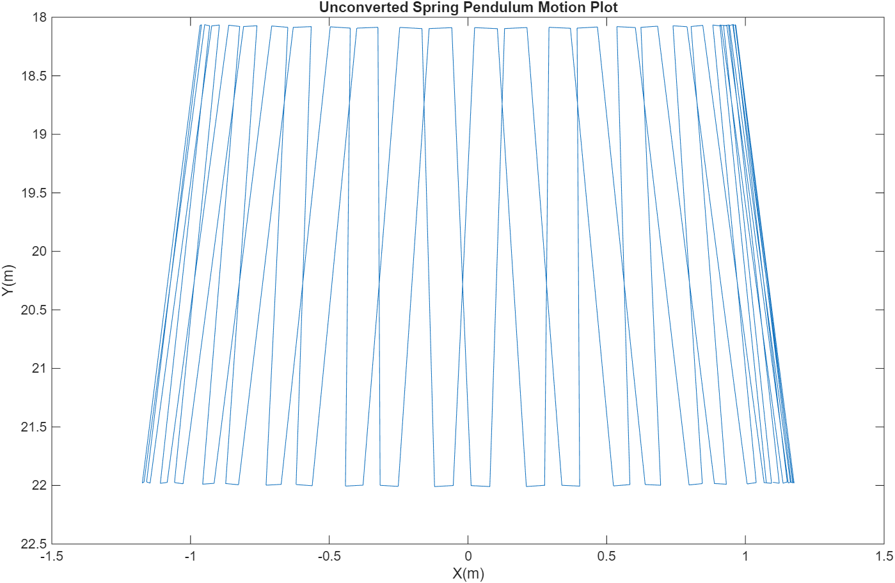

clear all;
m = 0.1; %kg
theta_0 = 0.05; %rad
theta_0_dot = 0.01; %rad/s
l0 = 20; %meters
r0 = 22; %meters
r0_dot = 0.1; % m/s

k = 20; %N/m
g = 9.8; %m/s2
x(1) = 22*sin(0.05);
y(1) = 22*cos(0.05);
x_dot0 = r0_dot*sin(theta_0) + r0*theta_0_dot*cos(theta_0);
y_dot0 = r0_dot*cos(theta_0) - r0*theta_0_dot*sin(theta_0);
dt = 0.1;
y(2) = y(1)+y_dot0*dt;
x(2) = x(1)+x_dot0*dt;
t = 0:dt:10;
for i = 2:length(t)-1
l = sqrt(x(i).^2+y(i).^2);
x_prev = x(i-1);
y_prev = y(i-1);
x_cur = x(i);
y_cur = y(i);
f_x = @(x_new)(m*((x_new-(2*x_cur)+x_prev) / (dt^2)) + k*(sqrt(x_cur^2+y_cur^2)-l0)*(x_cur/(sqrt(x_cur^2+y_cur^2))));
f_y = @(y_new)(m*((y_new-(2*y_cur)+y_prev) / (dt^2)) + k*(sqrt(x_cur^2+y_cur^2)-l0)*(y_cur/(sqrt(x_cur^2+y_cur^2)))-m*g);
x_new = fzero(f_x,x_cur);
y_new = fzero(f_y, y_cur);
x(i+1) = x_new;
y(i+1) = y_new;
end

4) Convergence study (2 points)
The accuracy of numerical solution is dependent on the timestep $Δt$. The accuracy and the computational cost both increase indefinitely as $Δt→0$. Because of this, in practical application of computational resources, we are only interested in $Δt$ which will provide results that do not change/benefit from any further increase in resolution.
Often, we will try to guess an initial timestep. With experience, this process becomes easier. Sometimes, we can also use our understanding of physics to give a good initial guess. For example, a ball dropped from 1 m will fall for 0.45 s, thus if we wanted 100 time-points in our simulation (an okay start), then a timestep of 0.0045 s may be a good guess. In our case, we could use the natural frequency of a pendulum as a good starting point. But, we haven’t yet explored the analytical solution, so we will use a more general approach.
Perform a convergence study using the provided table. Starting with a timestep of $Δt=0.1$ s, halve the timestep, until the change in position at $t=10$ s is less than 0.005 m. Ensure it is clear to the marker what timestep your model has converged.
For the converged model, plot $(t,x)$, $(t,y)$ and $(x,y)$ for the first 10 seconds. For reference, I have pasted a low-resolution image of what your converged plots should look like.

Answer within this box. Change the size of the box if needed.
(Include initialisation based on Question 3. Do not include the code part responsible for the plotting.)
$Δt$ (s) | $x(t=10)$ (m) | $y(t=10)$ (m) | Change (m)
0.1 | 1.0753 | 21.9750 | 3.91
0.05 | 1.0724 | 21.9982 | 0.9422
0.025 | 0.8906 | 18.41 | 0.2977
0.0125 | 0.8744 | 18.0885 | 0.0189
0.00625 | 0.8730 | 18.0769 | 0.00075

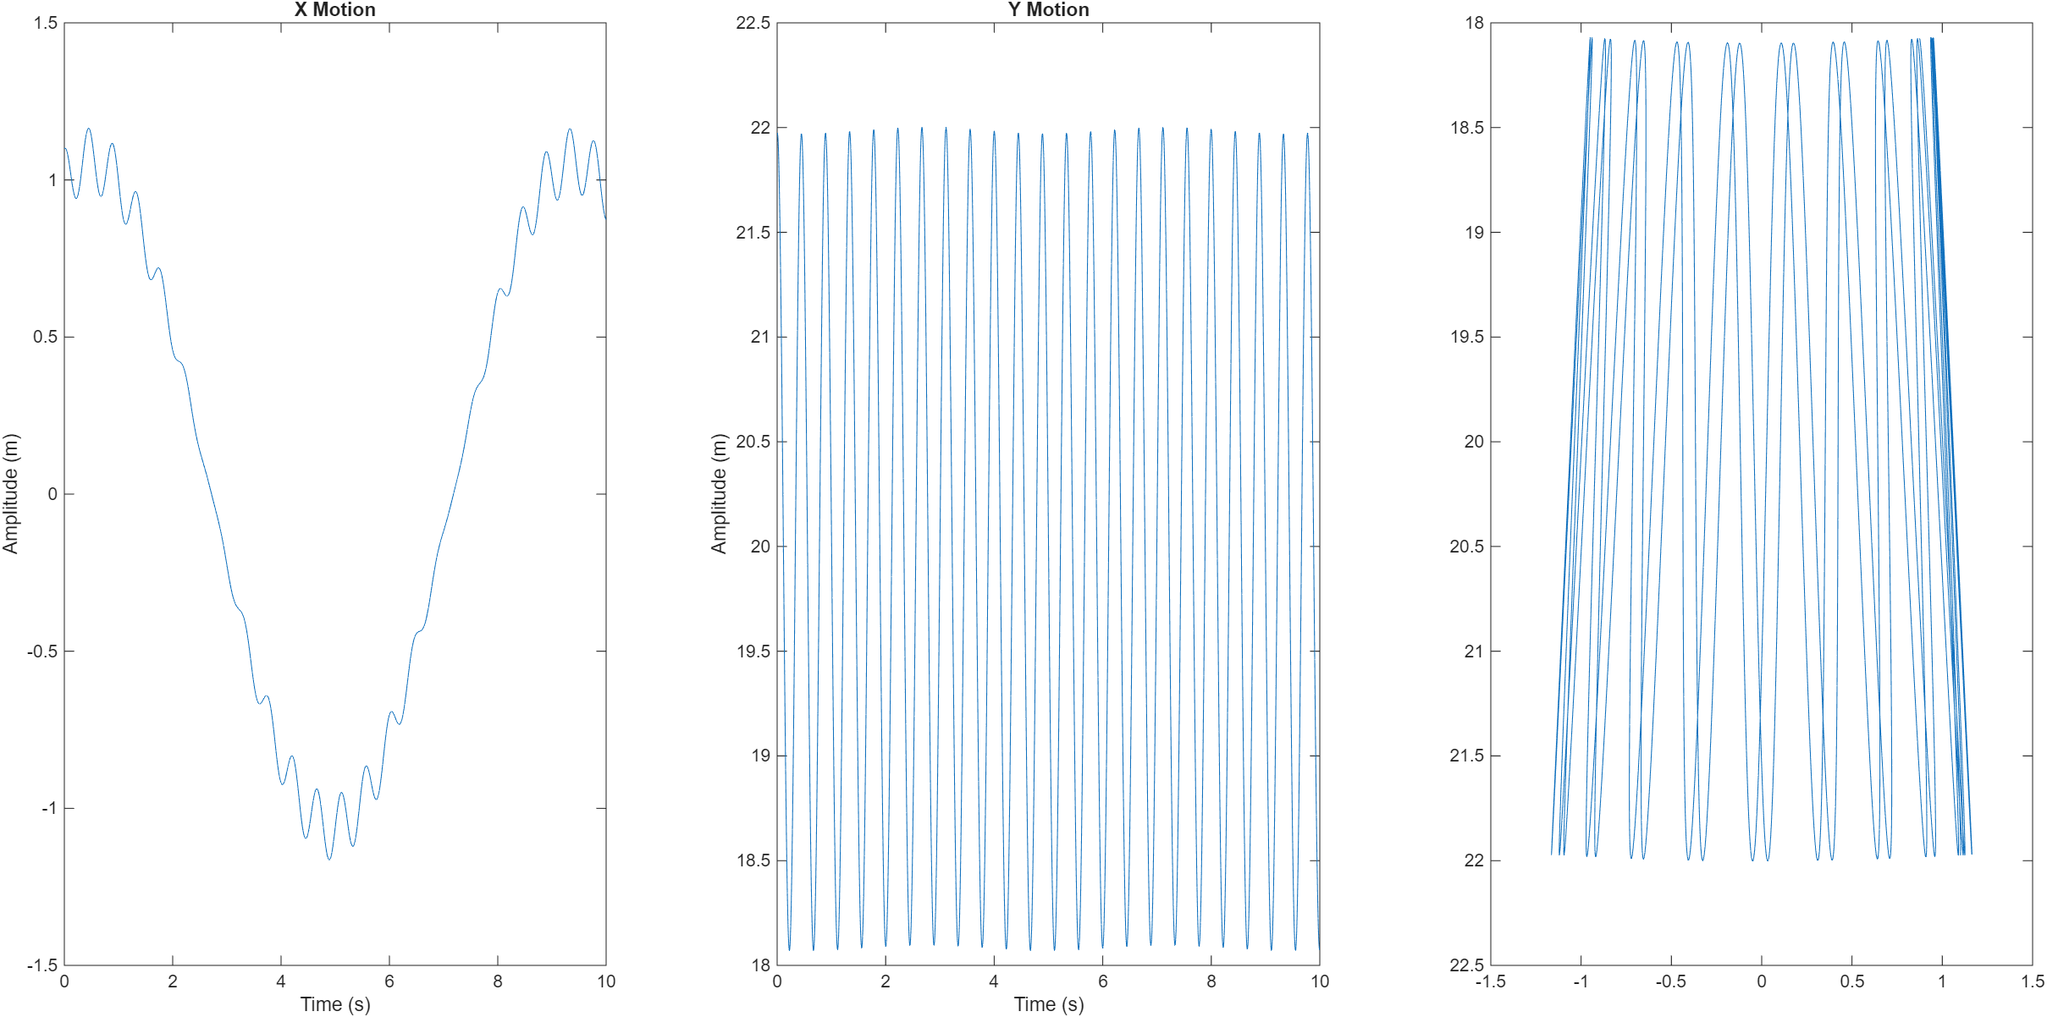

5) Polar equations of motion (3 points)
We will now work towards deriving an analytical solution for this system which we can later use to validate our model. While in our finite difference model we worked in the rectangular coordinate system, the analytical solution is simpler in polar coordinates.
Draw the free body diagram for the elastic pendulum model in the Fig 1, and develop the equation of motion(s) for the particle in the polar coordinate system.
- Ensure you show all relevant terms and include an axis.
- Write your EOM in the form of $0=…$ . In this case you should have two EOMs, one each for the $e_{r}$ and $e_{θ}$ directions respectively.
- Ensure the only variables in the EOM are $r$, $θ$ and their derivatives (this is unlike our earlier EOMs which were exclusively in terms of x, y and their derivatives.). Also, our trig functions ($\sin{θ}$, $\cos{θ}$) should be remain as trig functions in terms of $θ$.
Hint: Recall for polar coordinates $a_{r}=\ddot{r}-r{\dot{θ}}^{2}$, and $a_{θ}=r\ddot{θ}+2\dot{r}\dot{θ}$.
Answer within this box. Change the size of the box if needed.
$$∑F_{r}=ma_{r}$$
$$∴ma_{r}= -K\left(r-l_{0}\right)+mgcos(θ)$$
$$0= ma_{r}+K\left(r-l_{0}\right)-mgcos\left(θ\right)$$
$$a_{r}=\ddot{r}-r{\dot{θ}}^{2}$$
$$0= -m\left(\ddot{r}-r{\dot{θ}}^{2}\right)+K\left(r-l_{0}\right)-mgcos\left(θ\right)$$
$$0=m\ddot{r}-mr\dot{\dot{θ}}+K\left(r-l_{0}\right)-mgcos\left(θ\right)$$
$$∑F_{θ}=ma_{θ}$$
$$∴ma_{θ}= -mgsin\left(θ\right)$$
$$0= -ma_{θ}-mgsin\left(θ\right)$$
$$0=ma_{θ}-mgsin\left(θ\right)$$
$$0=m\left(r\ddot{θ}+2\dot{r}\dot{θ}\right)+mgsin\left(θ\right)$$

6) Analytical Solution (4 points)
We will now derive our analytical solution for our polar EOMs. Remember, an analytical solution is an exact solution where we directly solve the EOM (e.g. using algebra and calculus). However, our EOMs have non-linear components (e.g. $\sin{θ}$, $r{\dot{θ}}^{2}$, etc) which make an analytical solution challenging. As such, we need to make some assumptions as part of our solution.
- First, we apply small angle theorem which states for small angles $\sin{θ}≈θ$ and $\cos{θ}≈1$. Our solution now will only be valid for small angles. You can find more about small angle approximation and errors here. Note, for engineering this is a very good approximation, the error is less than 1% for angles less than 14$°$ for sin and angles less than 8$°$ for cos.
- Next, for the EOM in the radial direction we assume that the impact of centripetal acceleration is negligible ($r{\dot{θ}}^{2}≈0$). If we have small angle, it makes sense that the angular velocity ($\dot{θ}$) is small, and the square (${\dot{θ}}^{2}$) is even smaller (remember squaring a small number makes it smaller). Our radial EOM should now be a linear differential equation. This is generally valid for a stiff spring.
- For the EOM in the $θ$ direction, we assume changes in the spring length are negligible, such that $\dot{r}≈0$ and $r≈l_{0}$. Our $θ$ EOM should now be a linear differential equation. This is generally valid for a stiff spring and low mass.
- When solving differential equations, we do not ‘reinvent the wheel.’ Rather, we use known solutions derived by mathematicians. For example, for an ODE of the form

$$\ddot{x}\left(t\right)+a⋅(x\left(t\right)-C)=0 (a>0,C is a constant)$$
The solution is:
$$x\left(t\right)=A\cos\left(ω_{n}⋅t-ϕ\right)+C$$
Where:
Angular frequency | $$ω_{n}=\sqrt{a}$$
Amplitude | $$A=\sqrt{{(x_{0}-C)}^{2}+({{\dot{x}}_{0}/ω_{n})}^{2}}$$
Phase | $$ϕ=\operatorname{atan}\left(\frac{{\dot{x}}_{0}}{{(x}_{0}-C)ω_{n}}\right)$$
Use this solution to determine the analytical solution for $r(t)$ and $θ(t)$. Substitute in the constants from the problem description to show that the analytical solution is approximately:
$$r\left(t\right)=1.95\cos\left(14.14t-0.0036\right)+20.05 \\ θ\left(t\right)=0.052\cos\left(0.70⋅t-0.28\right)$$

Answer within this box. Change the size of the box if needed.
$$0=m\ddot{r}0-mr{\dot{θ}}^{2}+K\left(r-l_{0}\right)-mgcos(θ)$$
$$0=\ddot{r}-\frac{k}{m}\left(r-l_{0}\right)-g$$
$$0=\ddot{r}+\frac{k}{m}r-\frac{k}{m}l_{0}-g$$
$$0=\ddot{r}+\frac{k}{m}\left(r-\left(l_{0}+\frac{gm}{k}\right)\right)$$
$$ω_{n}=\sqrt{\frac{k}{m}}=14.14$$
$$c=l_{0}+\frac{gm}{k}=20.05$$
$$A=\sqrt{{\left(r_{0}-c\right)}^{2}+{\left(\frac{{\dot{r}}_{0}}{ω_{n}}\right)}^{2}}=1.95$$
$$ϕ=\tan^{-1}{(\frac{r_{0}}{\left(r_{0}-c\right)ω_{n}})}=0.0036$$
$$∴r\left(t\right)=1.95\cos\left(14.14t-0.0036\right)+20.05$$

$$0=m\left(r\ddot{θ}+2\dot{r}\dot{θ}\right)+mgsin\left(θ\right)$$
$$0=m\left(l_{0}\ddot{θ}+2\left(0\right)\right)+mgθ$$
$$0= ml_{0}\ddot{θ}+mgθ$$
$$0=\ddot{θ}+gθ$$
$$0=\ddot{θ}+gl_{0}(θ-0)$$
$$c=0$$
$$ω_{n}=\sqrt{\frac{g}{l_{0}}}=0.7$$
$$A=\sqrt{{\left(θ_{0}-c\right)}^{2}+{\left(\frac{\dot{θ}}{ω_{n}}\right)}^{2}}=0.052$$
$$ϕ\tan^{-1}\left(\frac{{\dot{θ}}_{0}}{\left({\dot{θ}}_{0}-c\right)ω_{n}}\right)=0.028$$

7) Model validation (analytical vs numerical) (2 points)
In engineering, it is important we validate our models. We often do this by comparing against trusted experimental or analytical data. In this case we have two models, an analytical model and a numerical model. Fortunately, the analytical model has already been validated against experimental data by Vitt and Gorelik (1933) among others, so we can trust our analytical model (within the boundary of its assumptions).
To validate the model, simulate the model for 10 s, and plot the analytical model against the numerical model (format similar to question 4). For reference, I have pasted a low-resolution image of what your you should expect. Provide a brief comment on the validity of the model. Note: Here, we are just comparing the models visually, in later units you will learn more rigorous approaches to validation.
To check the effect of the assumptions, consider the case where $m=10$ kg and $k=10$ N/m. Simulate the model for 60 s and plot against the analytical, and give a brief comment on the impact of the assumptions.
For this question and the remainder of the assignment, use a $Δt=0.003$ s. Ensure your plots are appropriately labelled.

Answer within this box. Change the size of the box if needed.
Comparison Plots
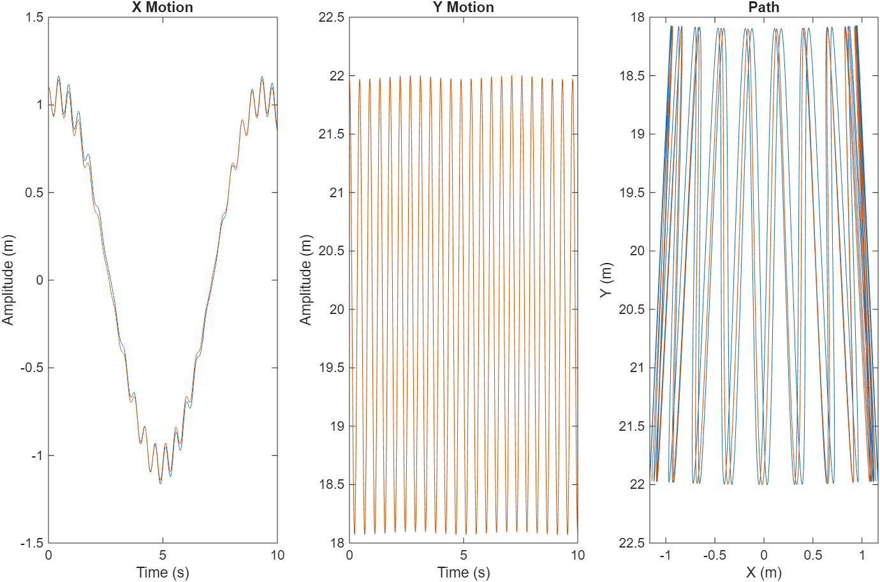

Plots with increased mass and spring constant
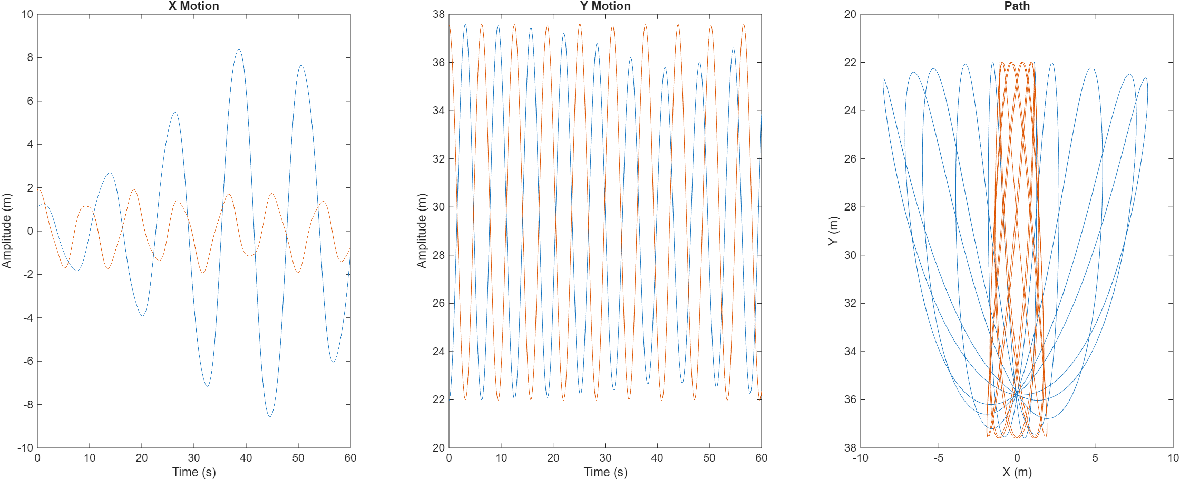

8) Real world application (4 points)
An advantage of methods like finite differences, is that it allows us to solve real world problems (fairly quickly and easily). One application for this is a bungee jumper (which is effectively an elastic pendulum). Using your already developed finite difference code, create a new code to simulate the bungee jumper, with the following changes and assumptions.
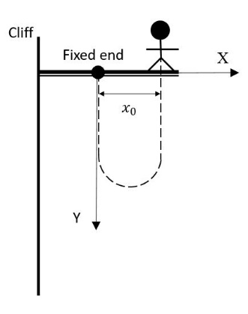
- The mass of the cord and drag can be ignored.
- The mass of the person is $m=60$ kg. The elastic coefficient is $k=20$ N/m. The unstretched length of the cord is $l_{0}=20$ m.
- To avoid entanglement, the initial distance between the two ends of the cord is $x_{0}=2$ m. The initial velocity is zero.
- When the cord is unstretched ($r<l_{0}$) there is no tension in the cord, $T=0$. When the cord is stretched, it applies a tension force $T=k\left(r-l_{0}\right)+5v_{y}$. To effectively represent this, we need a ‘function’ which we can use to switch on (activate) our tension. On approach is to use a sigmoid function $\left(\frac{1}{1+e^{-\left(r-l_{0}\right)}}\right)$. For values less that $l_{0}$ this returns 0, and for values greater than $l_{0}$ this returns 1 (you can plot this to see the actual shape). Our updated tension thus becomes $T=\left[k\left(r-l_{0}\right)+5v_{y}\right]∙\frac{1}{1+e^{-\left(r-l_{0}\right)}}$ where $r=\sqrt{x^{2}+y^{2}}$.
- Using this approach, we can replace our tension component in original model, with our updated tension equation.
- For this approach to work, we need to (1) first solve the $y$ EOM, (2) calculate the current $y$ velocity, (3) solve the $x$ EOM.
Note: We need to take this more complex approach because fzero can only solve for one unknown. This is not a limit of the finite difference method, but rather a limit of the functions we have learnt. A smarter approach would be to use the fsolve, which can solve multiple functions and variables simultaneously (alas, we haven’t learnt this).
Produce the following plots:
- The height above the ground as a function of time (the cliff top is 100 m above ground)..
- The velocity magnitude as a function of time.
- The acceleration magnitude as a function of time.
- The path of the jumper $(x,y)$.
For this question use a $Δt=0.003$ s and simulate for 120 s.

Answer within this box. Change the size of the box if needed.

Congratulations! You have created your very own simulation of bungee jumper. Models like this are useful in many real engineering applications. For example, now that we have created this model, we can assess safety through minimum height and maximum acceleration. We can also explore how different variables effect the simulation, such as different masses, and different bungee cord materials. We could also extend this model to consider other effects, such as drag, or three-dimensional behaviour. We will leave these challenges however for another day.

