Министерство образования Республики Беларусь

Учреждение образования
БЕЛОРУССКИЙ ГОСУДАРСТВЕННЫЙ УНИВЕРСИТЕТ
ИНФОРМАТИКИ И РАДИОЭЛЕКТРОНИКИ

Факультет информационных технологий и управления

Кафедра интеллектуальных информационных систем

Дисциплина: Общая теория интеллектуальных систем

Отчёт по лабораторной работе №1

СОЗДАНИЕ ПРОЦЕССОВ В ОС LINUX

Выполнил студент гр. 521703, подгр. 1 Т.Р. Меликов
Проверил ассистент, Каф.ВМ Н.А. Гуменный

Минск 2026
Вариант 14

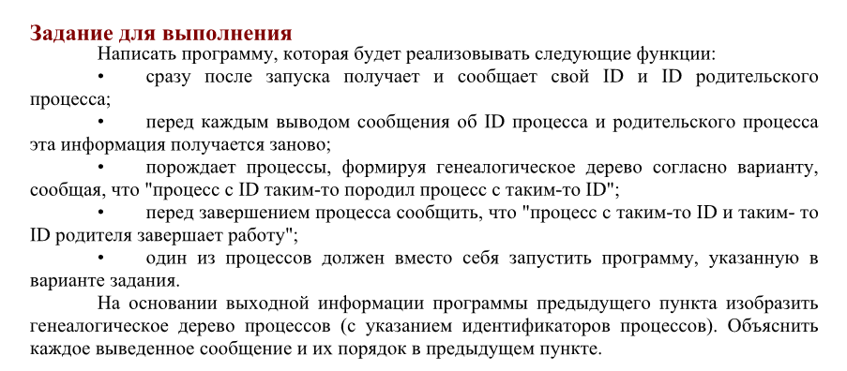

Код программы:

#include <iostream>
#include <unistd.h>
#include <sys/wait.h>
#include <cstdlib>

int main() {
std::cout << "Terminal with ID " << getppid() << " created Procces_1 with ID " << getpid() << "\n";
std::cout << " Procces_1 PID: " << getpid() << "\n";
std::cout << " Procces_1 PPID: " << getppid() << "\n\n";

pid_t pid = fork();

if (pid == 0) {
std::cout << " Procces_1 with ID " << getppid() << " created Procces_2 with ID " << getpid() << "\n";
std::cout << " Procces_2 PID: " << getpid() << "\n";
std::cout << " Procces_2 PPID: " << getppid() << "\n\n";

pid_t p3 = fork();

if (p3 == 0) {
std::cout << " Procces_2 with ID " << getppid() << " created Procces_3 with ID " << getpid() << "\n";
std::cout << " Procces_3 PID: " << getpid() << "\n";
std::cout << " Procces_3 PPID: " << getppid() << "\n\n";

pid_t p5 = fork();
if (p5 == 0) {
std::cout << " Procces_3 with ID " << getppid() << " created Procces_5 with ID " << getpid() << "\n";
std::cout << " Procces_5 PID: " << getpid() << "\n";
std::cout << " Procces_5 PPID: " << getppid() << "\n\n";

std::cout << " Procces_5 with ID: " << getpid() << " and parent ID: " << getppid() << " finished\n\n";
_exit(0);
}
else {
wait(nullptr);
std::cout << " Procces_3 with ID: " << getpid() << " and parent ID: " << getppid() << " finished\n\n";
_exit(0);
}
}
else {
pid_t p4 = fork();

if (p4 == 0) {
std::cout << " Procces_2 with ID " << getppid() << " created Procces_4 with ID " << getpid() << "\n";
std::cout << " Procces_4 PID: " << getpid() << "\n";
std::cout << " Procces_4 PPID: " << getppid() << "\n\n";

pid_t p6 = fork();

if (p6 == 0) {
std::cout << " Procces_4 with ID " << getppid() << " created Procces_6 with ID " << getpid() << "\n";
std::cout << " Procces_6 PID: " << getpid() << "\n";
std::cout << " Procces_6 PPID: " << getppid() << "\n\n";

pid_t p7 = fork();

if (p7 == 0) {
std::cout << " Procces_6 with ID " << getppid() << " created Procces_7 with ID " << getpid() << "\n";
std::cout << " Procces_7 PID: " << getpid() << "\n";
std::cout << " Procces_7 PPID: " << getppid() << "\n";
std::cout << " Whoami started: \n";
execlp("whoami", "whoami", nullptr);
}
else {
wait(nullptr);
std::cout << " Procces_6 with ID: " << getpid() << " and parent ID: " << getppid() << " finished\n\n";
_exit(0);
}
}
else {
wait(nullptr);
std::cout << " Procces_4 with ID: " << getpid() << " and parent ID: " << getppid() << " finished\n\n";
_exit(0);
}
}
else {
wait(nullptr);
wait(nullptr);
std::cout << " Procces_2 with ID: " << getpid() << " and parent ID: " << getppid() << " finished\n\n";
_exit(0);
}
}
}
else {
wait(nullptr);
std::cout << " Procces_1 with ID: " << getpid() << " and parent ID: " << getppid() << " finished\n\n";
}

return 0;
}

Результат программы:

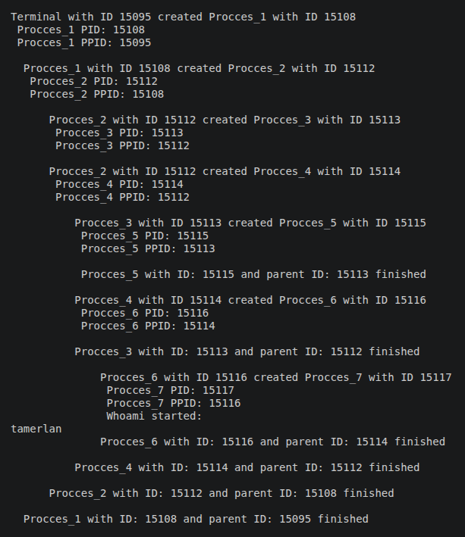

Генеалогическое дерево процессов:

Procces_1 (0)
│
└── Procces_2 (1)
├── Procces_3 (2)
│ └── Procces_5 (3)
└── Procces_4 (2)
└── Procces_6 (4)
└── Procces_7 (6) → whoami

