1. a) What are the main phases in the database design? What is done on each development phase?

* Initial phase -- characterize fully the data needs of the prospective database users.
* Second phase -- choosing a data model
  + Applying the concepts of the chosen data model
  + Translating these requirements into a conceptual schema of the database.
  + A fully developed conceptual schema indicates the functional requirements of the enterprise.
* Describe the kinds of operations (or transactions) that will be performed on the data.
* Final Phase -- Moving from an abstract data model to the implementation of the database

b) What is the entity-relationship (ER) data model?

Entity: a “thing” or “object” in the enterprise that is distinguishable from other objects

Entity Relationship Model (ER Modeling) is a graphical approach to database design. It is a high-level data model that defines data elements and their relationship for a specified software system.

2. a)Student(id, fullname(name, surname), faculty, has_dorm, gender, {number})

b) University(name, students_count, location),

Dormitory(stud_id, student_name, corpus, room_number, {number}),

Teacher(t_id, name(name, surname), course_id, experience, faculty),

OfficeOfRegistrar(registrar_id, fullname, {number}, faculty)

Course(course_id, coure_name, faculty, teacher)

3. Give examples for one-to-many, one-to-one, many-to-many, many-to-one relations. (Draw the examples as a scheme)

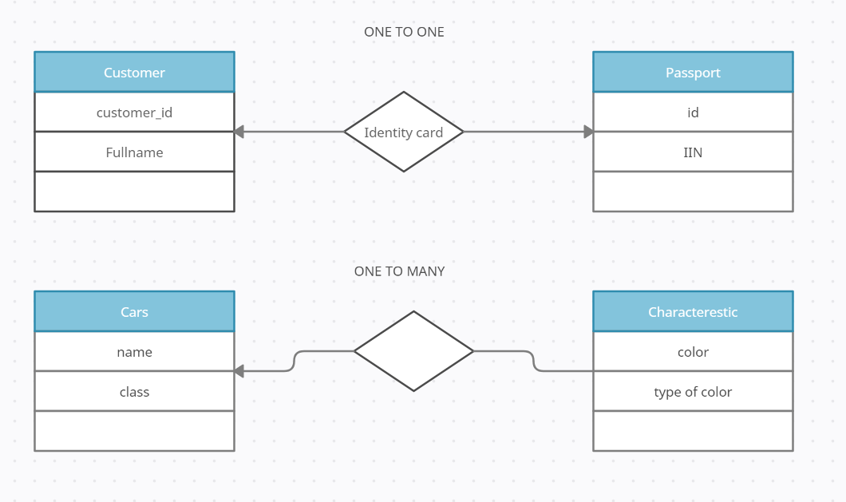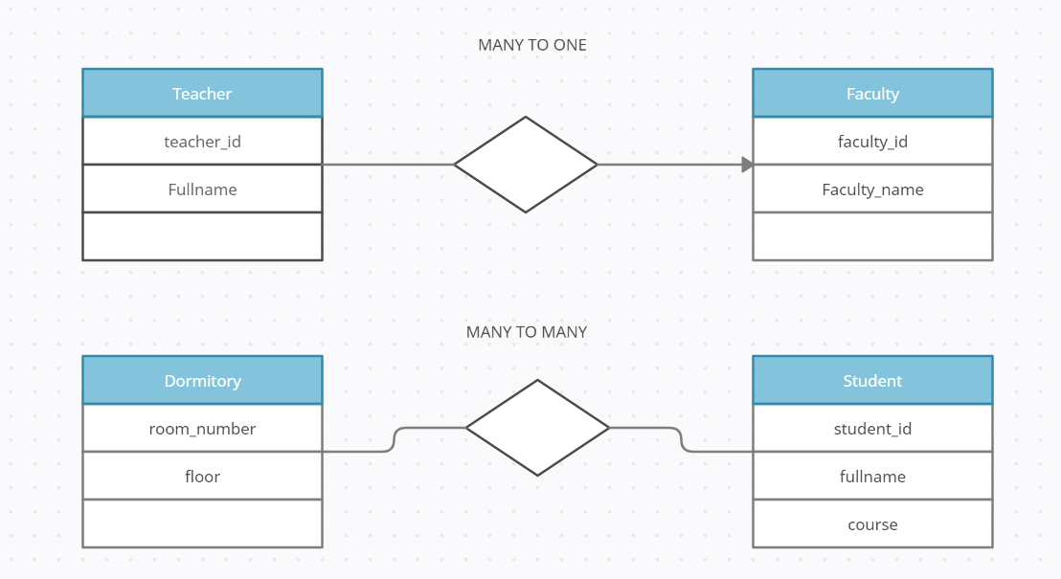

4. Create ER data model with relations using data from the second task.

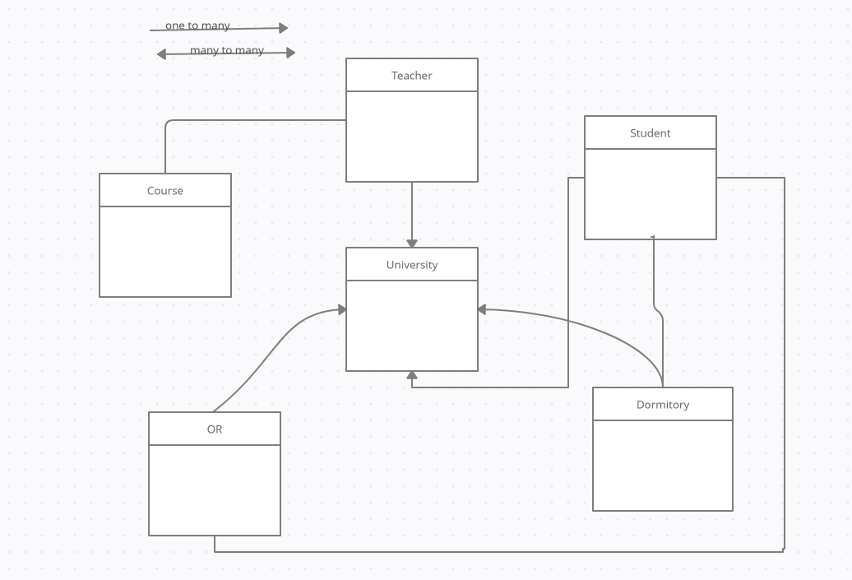

5. Create ER data model for IT company. (At least 5 entities and 8 relations)

