MDB Hello World With WildFly And Embedded Artemis MQ

# What is an MDB?

An MDB or Message Driven Bean is an Enterprise Bean that is capable of listening to JMS Messages and processing them asynchronously. It is a part of the Java EE Specification. In the days of yore, when Java EE ruled the roost, MDBs used to be one of the most sought-after programming paradigms. The fact that MDBs can take part in transactions with other resources like a Data Store, made it very attractive.

# Example Use Case

In this example, we are going to write a simple MDB that prints the JMS message that it receives, on the console. We would be packaging the MDB within a *war* file. We would then deploy the war in [WildFly](https://wildfly.org/). For the Message Broker, we would be using [ActiveMQ Artemis](https://activemq.apache.org/components/artemis/) that comes embedded within WildFly.

**Note:** ActiveMQ Artemis is actually an avatar of [HornetQ](https://hornetq.jboss.org/), the MQ that used to be embedded in JBoss. JBoss donated the source code to Apache, and thus Artemis was born.

# High Level Design

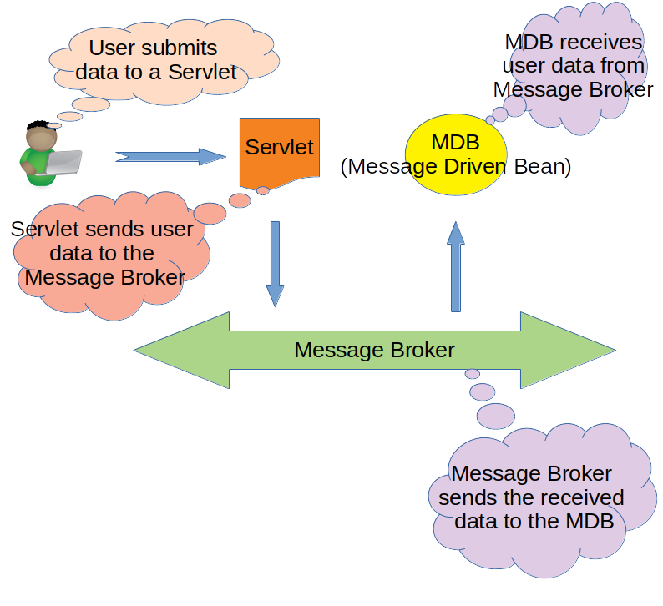

1. User submits Form Data to a Servlet
2. The Servlet then publishes this as a JSON Message to the Message Broker, Artemis MQ, in this case, through JMS API
3. The Message Broker notifies the MDB of the JMS Message it has received
4. The MDB receives the JMS Message and prints it on the console

# Implementation Details

This is a normal Spring MVC project. It has added dependencies for JMS and Wildfly. Let’s start from the pom.xml.

## The pom.xml

### Dependencies

Apart from the usual Spring Web MVC dependency, we also need the below dependencies for JMS/MDB:

|  |
| --- |
| <**dependency**>  <**groupId**>javax.servlet</**groupId**>  <**artifactId**>javax.servlet-api</**artifactId**>  <**version**>3.1.0</**version**>  <**scope**>provided</**scope**>  </**dependency**>  <**dependency**>  <**groupId**>javax.jms</**groupId**>  <**artifactId**>jms-api</**artifactId**>  <**version**>1.1-rev-1</**version**>  <**scope**>provided</**scope**>  </**dependency**>  <**dependency**>  <**groupId**>javax.ejb</**groupId**>  <**artifactId**>ejb-api</**artifactId**>  <**version**>3.0</**version**>  </**dependency**>  <**dependency**>  <**groupId**>org.wildfly</**groupId**>  <**artifactId**>wildfly-jms-client-bom</**artifactId**>  <**version**>18.0.0.Final</**version**>  <**type**>pom</**type**>  </**dependency**> |

### Plugins

We would need the war plugin to generate a war file. Since we would be taking advantage of the *Servlet 3.0* specification and forego a *web.xml*, we have to put the **failOnMissingWebXml** attribute as false.

|  |
| --- |
| <**plugin**>  <**artifactId**>maven-war-plugin</**artifactId**>  <**version**>2.4</**version**>  <**configuration**>  <**failOnMissingWebXml**>false</**failOnMissingWebXml**>  </**configuration**>  </**plugin**> |

The complete pom.xml can be found [here](https://github.com/paawak/blog/blob/master/code/mdb-demo/wildfly/wildfly-embedded-artemis-demo/pom.xml).

## The Web Application Initializer

Post *Servlet 3.0* specifications, a Java Web Application can be built with pure Java configuration, without a *web.xml*, for defining and mapping Servlets. Spring Web MVC takes it one step ahead and defines the interface *WebApplicationInitializer*, which can be implemented as below:

|  |
| --- |
| public class WebappInitializer implements WebApplicationInitializer {   @Override  public void onStartup(ServletContext servletContext) {   // Create the dispatcher servlet's Spring application context  AnnotationConfigWebApplicationContext dispatcherContext = new AnnotationConfigWebApplicationContext();  dispatcherContext.register(WebConfig.class);   // Register and map the dispatcher servlet  ServletRegistration.Dynamic dispatcher = servletContext.addServlet("dispatcher", new DispatcherServlet(dispatcherContext));  dispatcher.setLoadOnStartup(1);  dispatcher.addMapping("/");   }  } |

## The WebMvcConfigurer

The entry point of the annotation based Web Application Configuration is defined as below:

|  |
| --- |
| @Configuration @EnableWebMvc @ComponentScan("com.swayam.demo.mdb.artemis") public class WebConfig implements WebMvcConfigurer {   @Override  public void configureMessageConverters(List<HttpMessageConverter<?>> converters) {  Jackson2ObjectMapperBuilder jackson2ObjectMapperBuilder = new Jackson2ObjectMapperBuilder();  converters.add(new MappingJackson2HttpMessageConverter(jackson2ObjectMapperBuilder.build()));  Jaxb2RootElementHttpMessageConverter jaxb2RootElementHttpMessageConverter = new Jaxb2RootElementHttpMessageConverter();  converters.add(jaxb2RootElementHttpMessageConverter);  }   @Bean  public ViewResolver viewResolver() {  InternalResourceViewResolver viewResolver = new InternalResourceViewResolver();  viewResolver.setViewClass(JstlView.class);  viewResolver.setPrefix("/WEB-INF/jsp/");  viewResolver.setSuffix(".jsp");  return viewResolver;  }   @Bean  public static PropertySourcesPlaceholderConfigurer propertyConfig() {  return new PropertySourcesPlaceholderConfigurer();  }  } |

## Defining the JMS Queue and QueueSession

The *Queue* and the *QueueSession* are high level abstractions defined by the JMS Specification for sending messages to a Queue. These are defined in a Spring Configuration file as below:

|  |
| --- |
| @PropertySource("classpath:mdb.properties") @Configuration public class MdbConfig {   private static final Logger LOGGER = LoggerFactory.getLogger(MdbConfig.class);   @Autowired  private Environment environment;   @Bean  public JndiTemplate jndiTemplate() {  return new JndiTemplate();  }   @Bean  public QueueConnectionFactory queueConnectionFactory(JndiTemplate jndiTemplate) throws NamingException {  QueueConnectionFactory factory = jndiTemplate.lookup(environment.getProperty("ARTEMIS_JMS_CONNECTION_FACTORY"), QueueConnectionFactory.class);  LOGGER.info("got the connection factory");  return factory;  }   @Bean  public Queue jmsQueue(JndiTemplate jndiTemplate) throws NamingException {  Queue queue = jndiTemplate.lookup(environment.getProperty("ARTEMIS_QUEUE_LOOKUP"), Queue.class);  LOGGER.info("got the queue");  return queue;  }   @Bean(destroyMethod = "close")  @Scope("prototype")  public QueueConnection queueConnection(QueueConnectionFactory queueConnectionFactory) throws JMSException {  QueueConnection queueConnection = queueConnectionFactory.createQueueConnection(environment.getProperty("WILDFLY_USER"), environment.getProperty("WILDFLY_PASSWORD"));  LOGGER.info("created a connection");  return queueConnection;  }   @Bean(destroyMethod = "close")  @Scope("prototype")  public QueueSession queueSession(QueueConnection queueConnection) throws JMSException {  QueueSession queueSession = queueConnection.createQueueSession(false, QueueSession.AUTO_ACKNOWLEDGE);  LOGGER.info("created a queueSession");  return queueSession;   }  } |

## Sending JMS Messages From the Controller

Once the Queue and QueueSession has been configured, we can use them to post messages to the Queue.

|  |
| --- |
| @RestController @RequestMapping(path = "/rest") public class AuthorRestController {   private static final Logger LOGGER = LoggerFactory.getLogger(AuthorRestController.class);   private final ObjectMapper objectMapper = new ObjectMapper();   private final ApplicationContext applicationContext;  private final Queue queue;   public AuthorRestController(ApplicationContext applicationContext, Queue queue) {  this.applicationContext = applicationContext;  this.queue = queue;  }   @PostMapping(path = "/author", consumes = MediaType.APPLICATION_FORM_URLENCODED_VALUE)  public String save(AuthorRequest authorRequest) throws JsonProcessingException, NamingException, JMSException {  LOGGER.debug("authorRequest: {}", authorRequest);  postMessageToJMS(objectMapper.writeValueAsString(authorRequest));  return "success";  }   private void postMessageToJMS(String message) throws NamingException, JMSException {  QueueSession session = applicationContext.getBean(QueueSession.class);  QueueSender sender = session.createSender(queue);  TextMessage textMessage = session.createTextMessage(message);  sender.send(textMessage);  LOGGER.info("sent message: {}", textMessage);  }  } |

## Configuring the MDB Receive JMS Messages

Configuring the MDB is simple, and would require just a couple of annotations as shown below:

|  |
| --- |
| @MessageDriven(activationConfig = { @ActivationConfigProperty(propertyName = "destinationType", propertyValue = "javax.jms.Queue"),  @ActivationConfigProperty(propertyName = "destination", propertyValue = "jms/queue/mytest") }) public class AuthorRequestListenerBean implements MessageListener {   private static final Logger LOGGER = LoggerFactory.getLogger(AuthorRequestListenerBean.class);   @Override  public void onMessage(Message message) {   if (!(message instanceof TextMessage)) {  throw new UnsupportedOperationException("Expecting a " + TextMessage.class);  }   if (message instanceof TextMessage) {  TextMessage textMessage = (TextMessage) message;  try {  LOGGER.info("Text message received: {}", textMessage.getText());  } catch (JMSException e) {  LOGGER.error("exception reading messsage", e);  }  }   }  } |

## The standalone.xml

Lastly, we would need to modify the default *standalone.xml* that comes bundled with *WildFly*. First, copy the *$WILDFLY_HOME/standalone/configuration/standalone.xml* and rename it to *standalone-with-mq.xml*.

### Adding the ActiveMQ Messaging Extension

Under the *extensions* section, we would need to add the below extension:

|  |
| --- |
| <**extension** module="org.wildfly.extension.messaging-activemq"/> |

### Defining the ActiveMQ Messaging SubSystem

# We would need to define the new *subsystem* for ActiveMQ Messaging:

|  |
| --- |
| <**subsystem** xmlns="urn:jboss:domain:messaging-activemq:3.0">  <**server** name="default">  <**security-setting** name="#">  <**role** name="guest" send="true" consume="true" create-non-durable-queue="true" delete-non-durable-queue="true"/>  </**security-setting**>  <**address-setting** name="#" dead-letter-address="jms.queue.DLQ" expiry-address="jms.queue.ExpiryQueue" max-size-bytes="10485760" page-size-bytes="2097152" message-counter-history-day-limit="10"/>  <**http-connector** name="http-connector" socket-binding="http" endpoint="http-acceptor"/>  <**http-connector** name="http-connector-throughput" socket-binding="http" endpoint="http-acceptor-throughput">  <**param** name="batch-delay" value="50"/>  </**http-connector**>  <**in-vm-connector** name="in-vm" server-id="0">  <**param** name="buffer-pooling" value="false"/>  </**in-vm-connector**>  <**http-acceptor** name="http-acceptor" http-listener="default"/>  <**http-acceptor** name="http-acceptor-throughput" http-listener="default">  <**param** name="batch-delay" value="50"/>  <**param** name="direct-deliver" value="false"/>  </**http-acceptor**>  <**in-vm-acceptor** name="in-vm" server-id="0">  <**param** name="buffer-pooling" value="false"/>  </**in-vm-acceptor**>  <**jms-queue** name="ExpiryQueue" entries="java:/jms/queue/ExpiryQueue"/>  <**jms-queue** name="DLQ" entries="java:/jms/queue/DLQ"/>  <**connection-factory** name="InVmConnectionFactory" entries="java:/ConnectionFactory" connectors="in-vm"/>  <**connection-factory** name="RemoteConnectionFactory" entries="java:/jms/RemoteConnectionFactory" connectors="http-connector"/>  <**pooled-connection-factory** name="activemq-ra" entries="java:/JmsXA java:jboss/DefaultJMSConnectionFactory" connectors="in-vm" transaction="xa"/>  </**server**>  </**subsystem**> |

### Adding the MDB Resource Adapter

# Under the *subsystem* *ejb3* section, we would need to add the details of the Resource Adapter to be used to communicate with the ActiveMQ Messaging system. This is added just after the *session-bean* section:

|  |
| --- |
| <**mdb**>  <**resource-adapter-ref** resource-adapter-name="${ejb.resource-adapter-name:activemq-ra.rar}"/>  <**bean-instance-pool-ref** pool-name="mdb-strict-max-pool"/>  </**mdb**> |

This is how the complete *standalone-with-mq.xml* looks like:

<https://github.com/paawak/blog/blob/master/code/mdb-demo/wildfly/wildfly-embedded-artemis-demo/src/main/wildfly/standalone-with-mq.xml>

# Source Code

The complete source can be found here:

<https://github.com/paawak/blog/tree/master/code/mdb-demo/wildfly/wildfly-embedded-artemis-demo>

# Running the Demo

## Building the war

To build the war file, we do:

|  |
| --- |
| mvn clean package |

## Creating a Guest User in WildFly

Before we deploy the war file, we would need to create a user with a guest role in WildFly. This is done by invoking (from the command-prompt):

|  |
| --- |
| $WILDFLY_HOME/bin/add-user |

When prompted, follow the steps to create an *Application User* with the name **user**, password **user123**, and role **guest**.

## Deploying the war

Copy the *wildfly-embedded-artemis-demo.war* into the directory *$WILDFLY_HOME/standalone/deployments*.

## Starting WildFly with our custom configuration

Copy the *src/main/wildfly/standalone-with-mq.xml* into the *$WILDFLY_HOME/standalone/configuration/* directory. Then start WildFly with the below command:

|  |
| --- |
| $WILDFLY_HOME/bin/standalone.sh -c standalone-with-mq.xml |

After WildFly starts successfully, you can access the Author page here:

http://localhost:8080/wildfly-embedded-artemis-demo/author.html

Enter all fields and hit the *Save* button. On the WildFly console, you would see the Json Message:

|  |
| --- |
| Text message received: {"authorId":1,"authorFirstName":"aaaa","authorLastName":"bbbb","genreShortName":"cccc","genreName":"dddd"} |