Tasks:
1. Database & Collection Setup:
o Create a new database (e.g., studentDB)
o Create a collection (e.g., students)

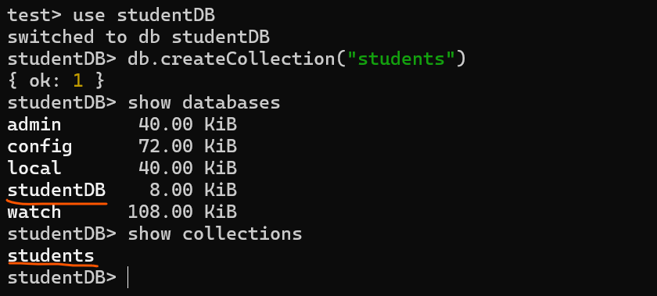

2. Insert Operations:
o Insert one document into the students collection.
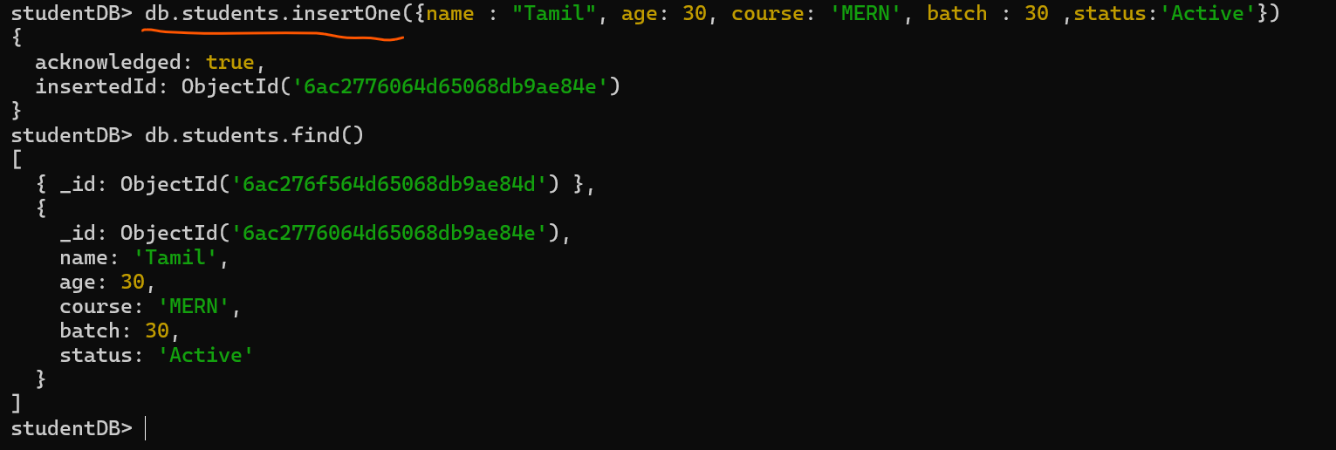

o Insert multiple documents with fields like name, age, course, status.
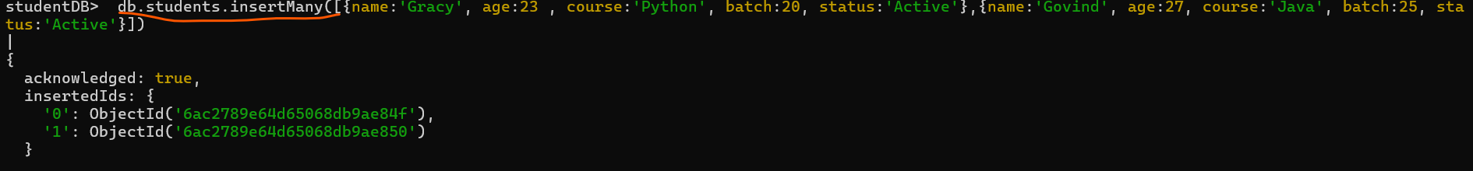

3. Read Operations:
o Fetch all documents from the collection.
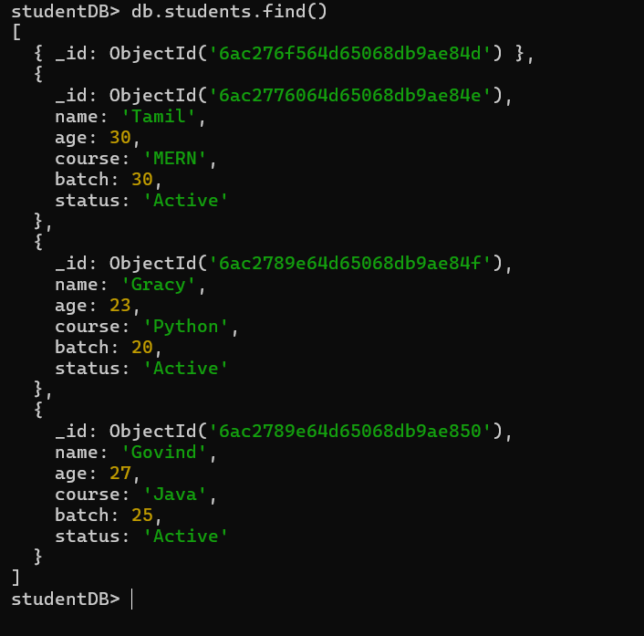
o Use filters to fetch specific data (e.g., students enrolled in “MERN Stack”).
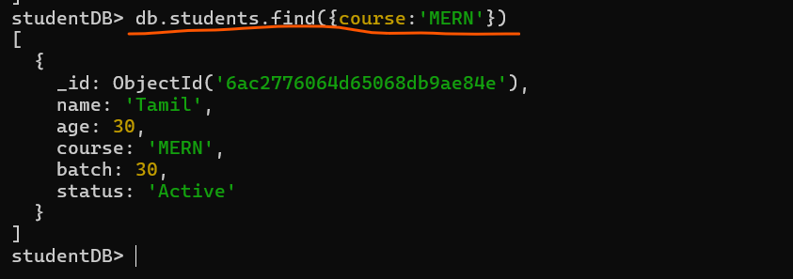

4. Update Operations:
o Update a single document (e.g., change the status of a student to completed).
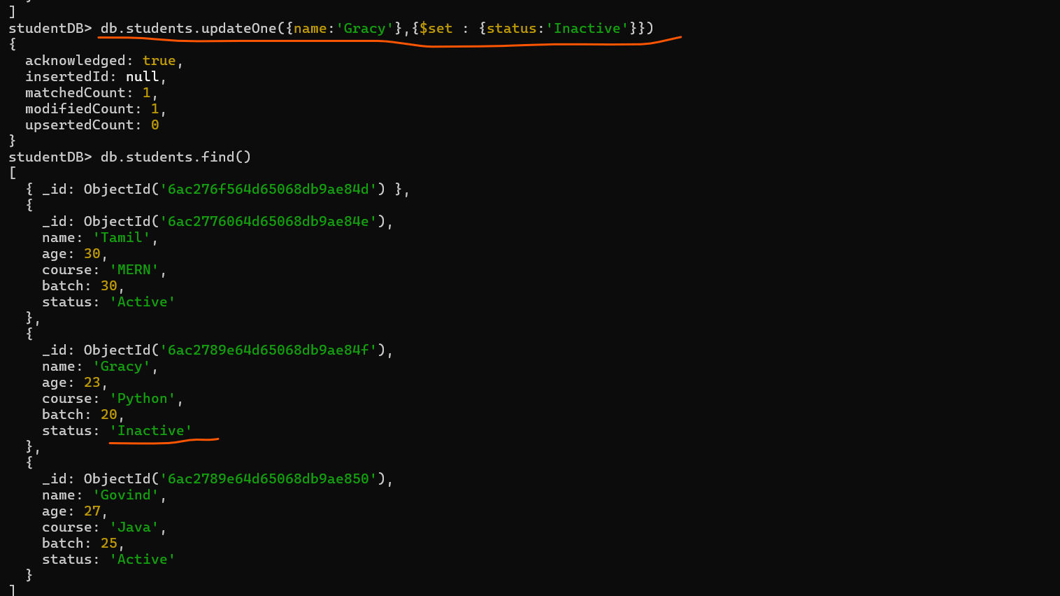
o Update multiple documents at once.
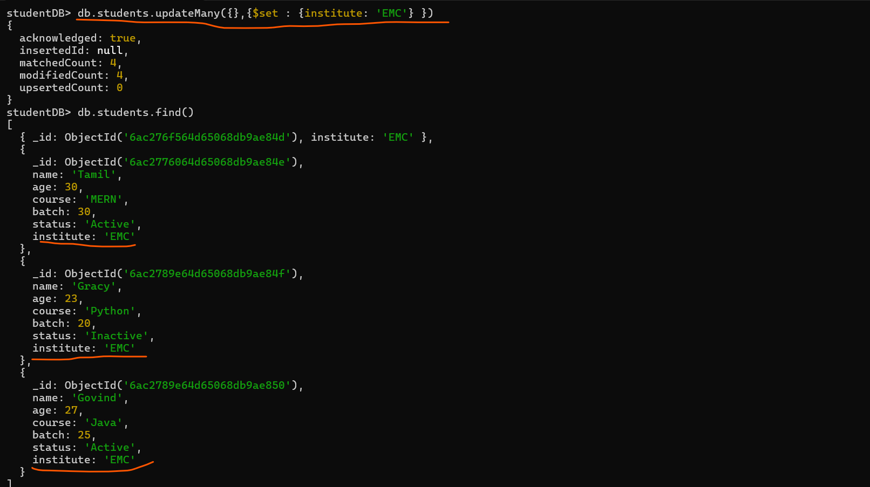

5. Delete Operations:
o Delete one document based on a condition.
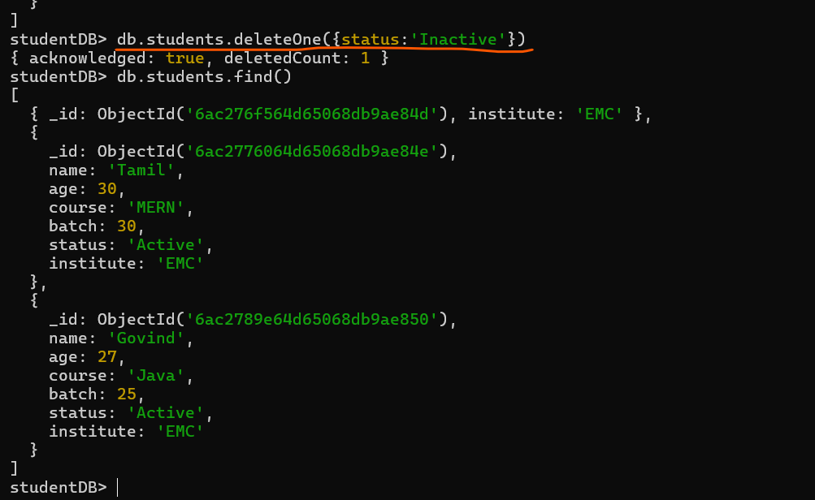
o Delete all documents in the collection (for practice purpose only).
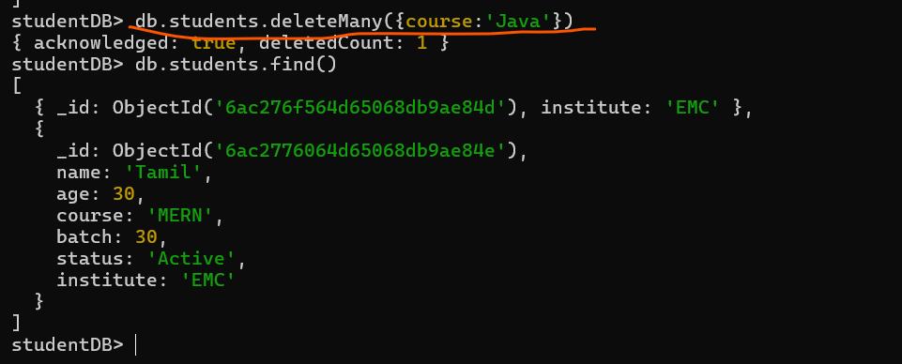

6. Query Operators:
o Practice using $gt, $lt, $in, $and, $or, $exists in different queries.
- gt
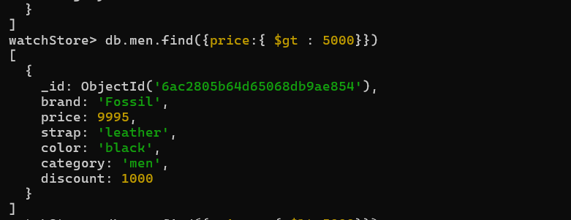

- $lt
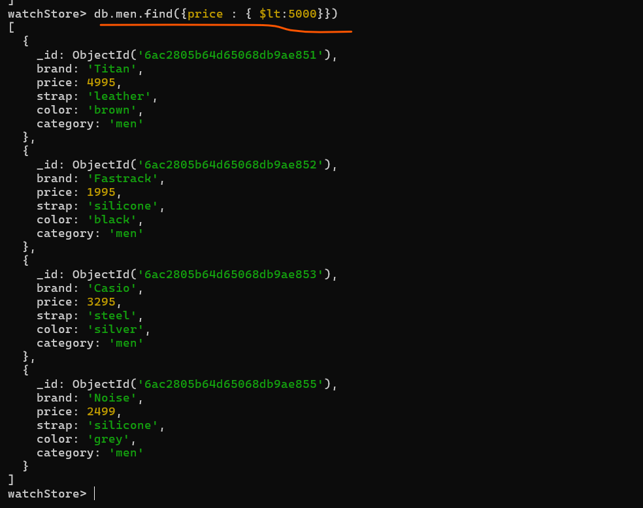

- $in
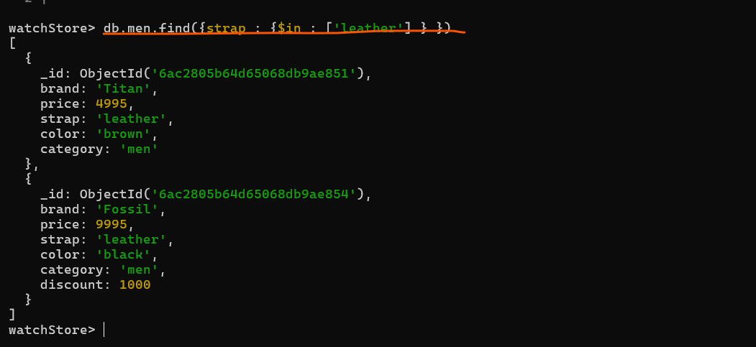

4.$and
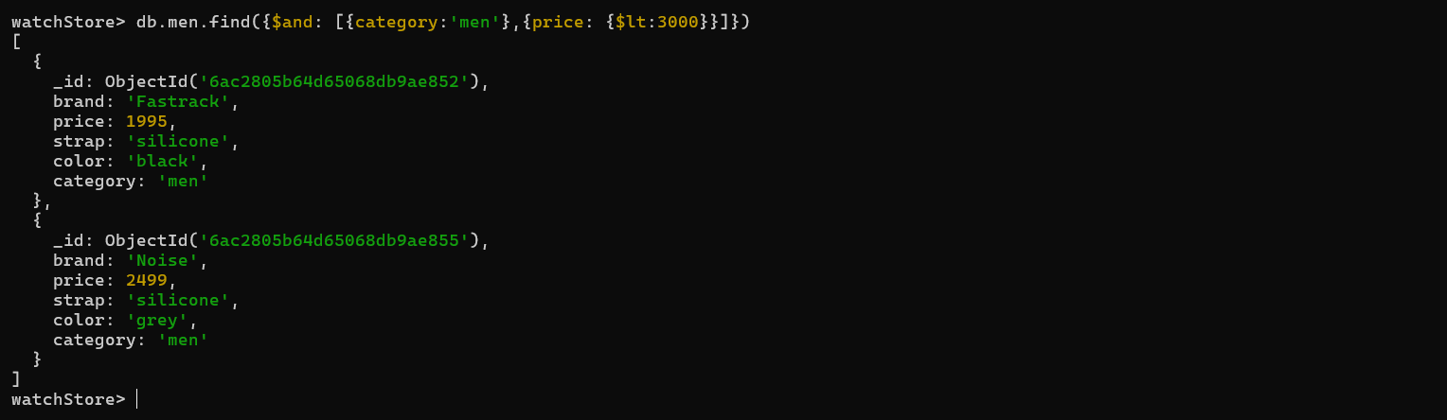
5.$or
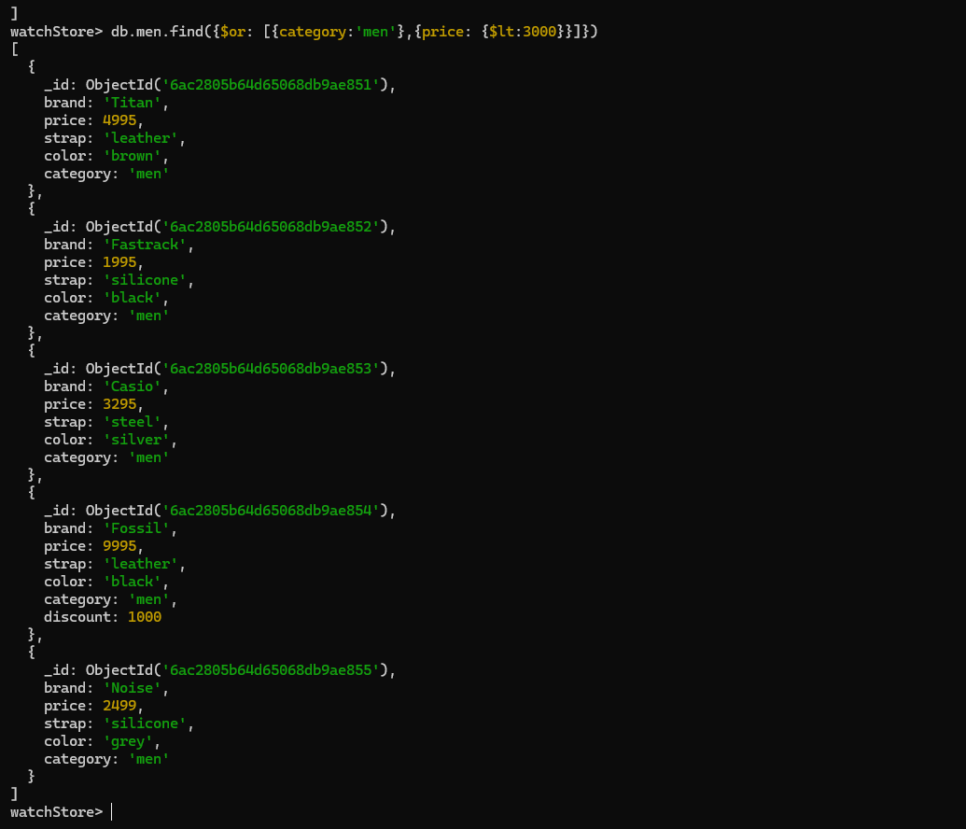

6.$exists
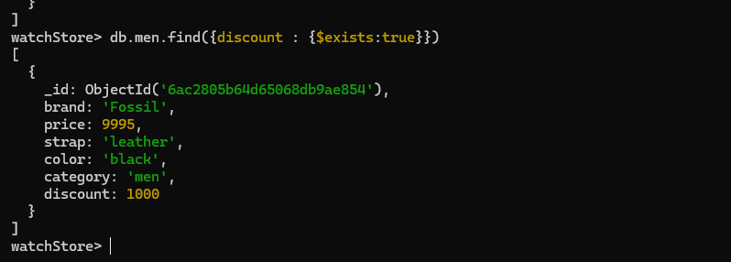
7.$push
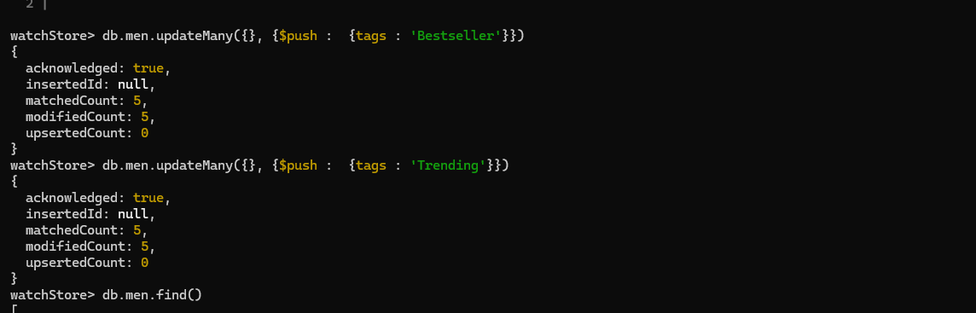
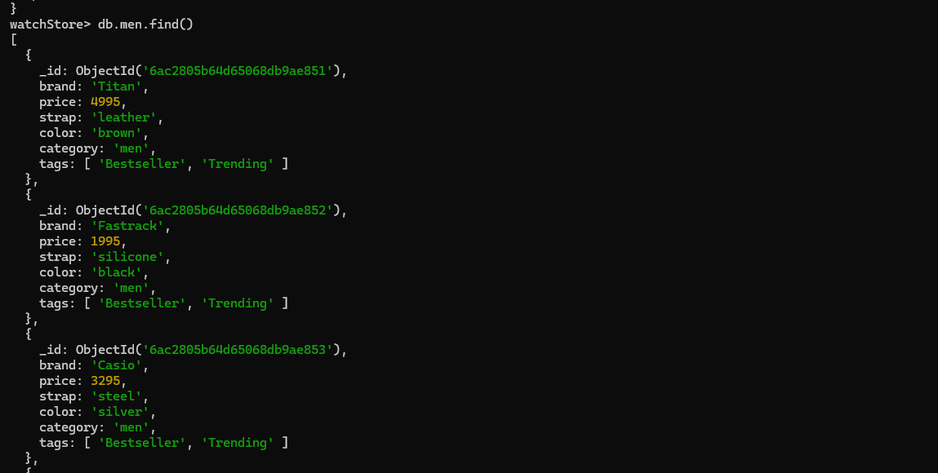

7. Use Case:
o Create a small use case like a Library System or E-Commerce product listing and apply insert, update, and search operations.
- Create database(watchStore) and collections(Men,Women,Smart)
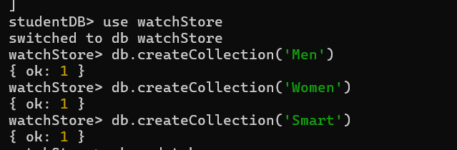
- Insert data to collections
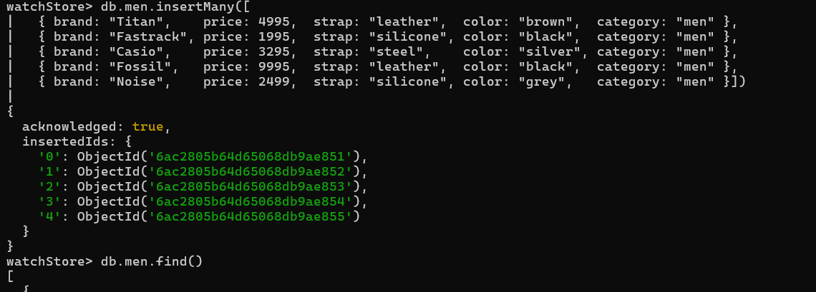
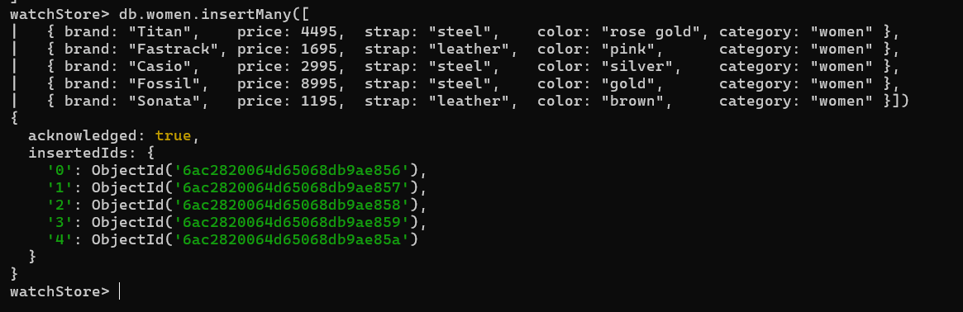
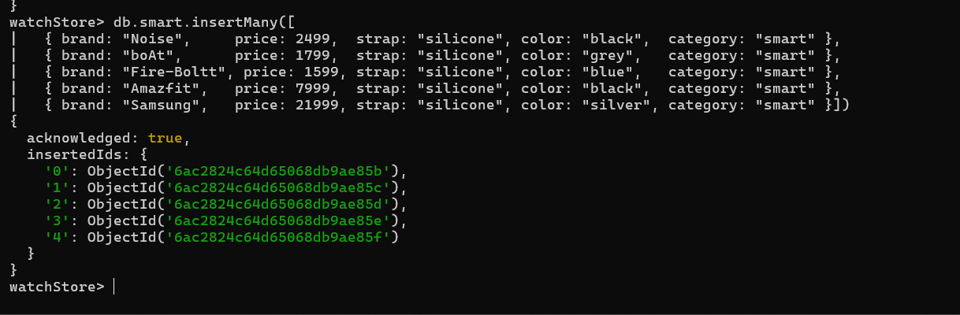

- Update data on collections
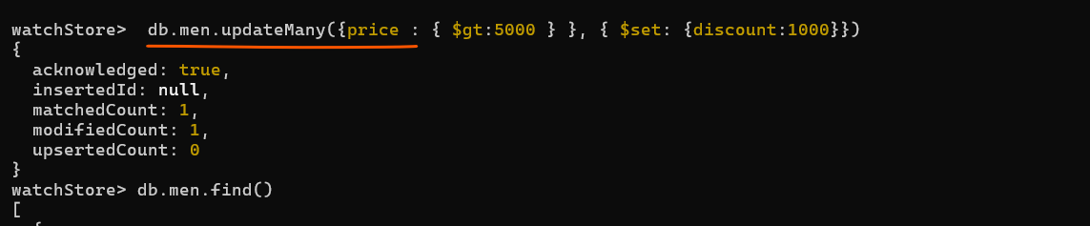
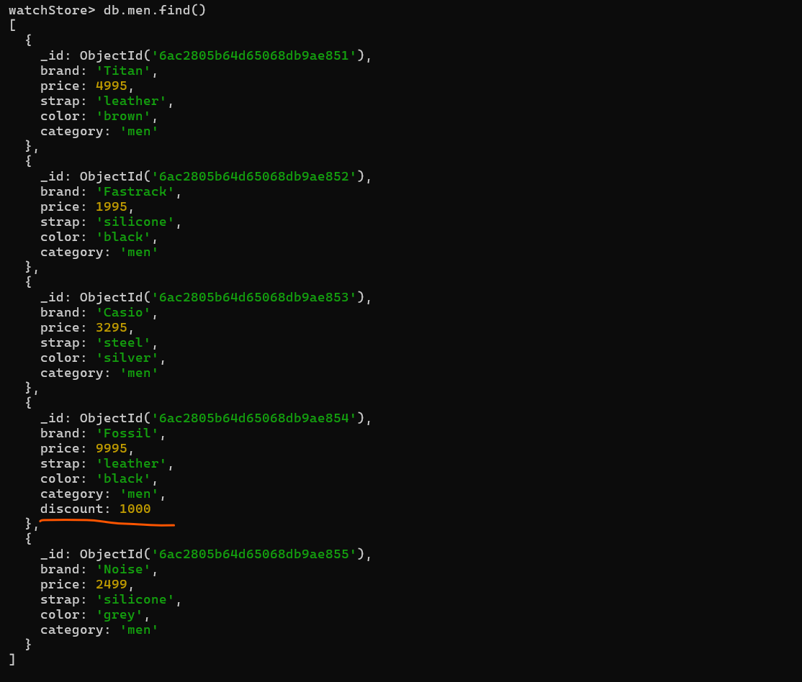

- Search data on collections
