**SENTIMENTAL ANALYSIS FOR MARKETING**

The goal of this project is to develop a sentiment analysis solution for a brand’s social media presence, enabling the brand to gain insights into customer sentiment, engagement, and trends. The project will use machine learning and natural language processing (NLP) techniques to analyze customer comments and interactions on social media platforms

T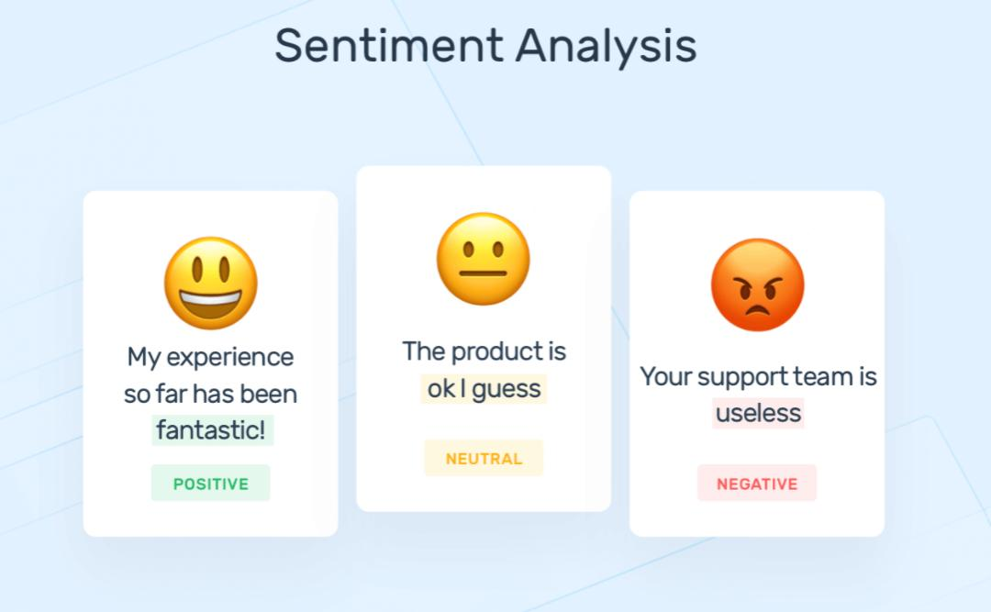his project will provide valuable insights into customer sentiment and help the brand make informed decisions to enhance its marketing strategies and engagement on social media.

* **Tools and technologies:**

Python, NLP libraries (NLTK, spaCy), machine learning frameworks (Scikit-Learn, TensorFlow), pre-trained language models (BERT, GPT-3).

**PROGRAM**:

from mpl_toolkits.mplot3d import Axes3D

from sklearn.preprocessing import StandardScaler

import matplotlib.pyplot as plt *# plotting*

import numpy as np *# linear algebra*

import os *# accessing directory structure*

import pandas as pd *# data processing, CSV file I/O (e.g. pd.read_csv)*

There is 1 csv file in the current version of the dataset:

In [2]:

print(os.listdir('../input'))

['database.sqlite', 'Tweets.csv']

*# Distribution graphs (histogram/bar graph) of column data*

def plotPerColumnDistribution(df, nGraphShown, nGraphPerRow):

nunique = df.nunique()

df = df[[col for col **in** df if nunique[col] > 1 **and** nunique[col] < 50]] *# For displaying purposes, pick columns that have between 1 and 50 unique values*

nRow, nCol = df.shape

columnNames = list(df)

nGraphRow = (nCol + nGraphPerRow - 1) / nGraphPerRow

plt.figure(num = None, figsize = (6 * nGraphPerRow, 8 * nGraphRow), dpi = 80, facecolor = 'w', edgecolor = 'k')

for i **in** range(min(nCol, nGraphShown)):

plt.subplot(nGraphRow, nGraphPerRow, i + 1)

columnDf = df.iloc[:, i]

if (**not** np.issubdtype(type(columnDf.iloc[0]), np.number)):

valueCounts = columnDf.value_counts()

valueCounts.plot.bar()

else:

columnDf.hist()

plt.ylabel('counts')

plt.xticks(rotation = 90)

plt.title(f'**{columnNames[i]}** (column **{i}**)')

plt.tight_layout(pad = 1.0, w_pad = 1.0, h_pad = 1.0)

plt.show()

*# Correlation matrix*

def plotCorrelationMatrix(df, graphWidth):

filename = df.dataframeName

df = df.dropna('columns') *# drop columns with NaN*

df = df[[col for col **in** df if df[col].nunique() > 1]] *# keep columns where there are more than 1 unique values*

if df.shape[1] < 2:

print(f'No correlation plots shown: The number of non-NaN or constant columns (**{df.shape[1]}**) is less than 2')

return

corr = df.corr()

plt.figure(num=None, figsize=(graphWidth, graphWidth), dpi=80, facecolor='w', edgecolor='k')

corrMat = plt.matshow(corr, fignum = 1)

plt.xticks(range(len(corr.columns)), corr.columns, rotation=90)

plt.yticks(range(len(corr.columns)), corr.columns)

plt.gca().xaxis.tick_bottom()

plt.colorbar(corrMat)

plt.title(f'Correlation Matrix for **{filename}**', fontsize=15)

plt.show()

*# Scatter and density plots*

def plotScatterMatrix(df, plotSize, textSize):

df = df.select_dtypes(include =[np.number]) *# keep only numerical columns*

*# Remove rows and columns that would lead to df being singular*

df = df.dropna('columns')

df = df[[col for col **in** df if df[col].nunique() > 1]] *# keep columns where there are more than 1 unique values*

columnNames = list(df)

if len(columnNames) > 10: *# reduce the number of columns for matrix inversion of kernel density plots*

columnNames = columnNames[:10]

df = df[columnNames]

ax = pd.plotting.scatter_matrix(df, alpha=0.75, figsize=[plotSize, plotSize], diagonal='kde')

corrs = df.corr().values

for i, j **in** zip(*plt.np.triu_indices_from(ax, k = 1)):

ax[i, j].annotate('Corr. coef = **%.3f**' % corrs[i, j], (0.8, 0.2), xycoords='axes fraction', ha='center', va='center', size=textSize)

plt.suptitle('Scatter and Density Plot')

plt.show()

nRowsRead = 1000 *# specify 'None' if want to read whole file*

*# Tweets.csv has 14640 rows in reality, but we are only loading/previewing the first 1000 rows*

df1 = pd.read_csv('../input/Tweets.csv', delimiter=',', nrows = nRowsRead)

df1.dataframeName = 'Tweets.csv'

nRow, nCol = df1.shape

print(f'There are **{nRow}** rows and **{nCol}** columns')

df1.head(5)

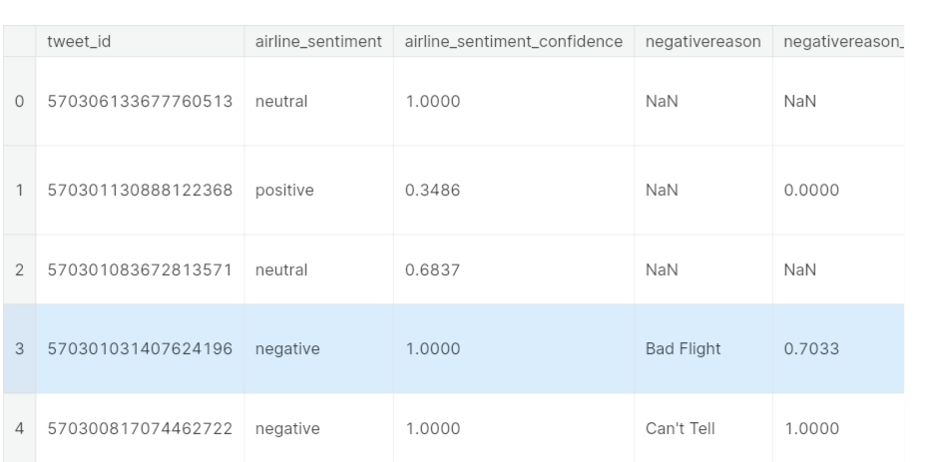

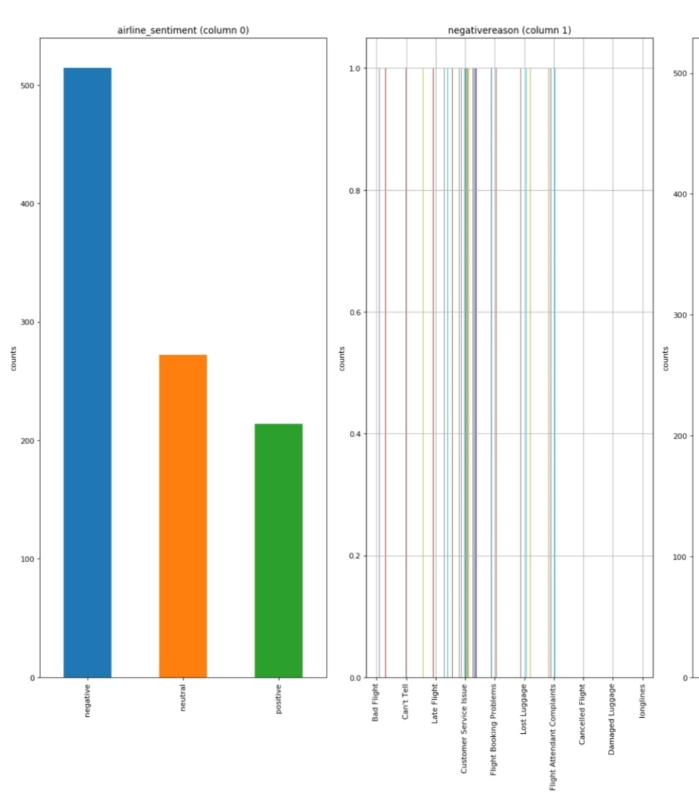 plotPerColumnDistribution(df1, 10, 5)

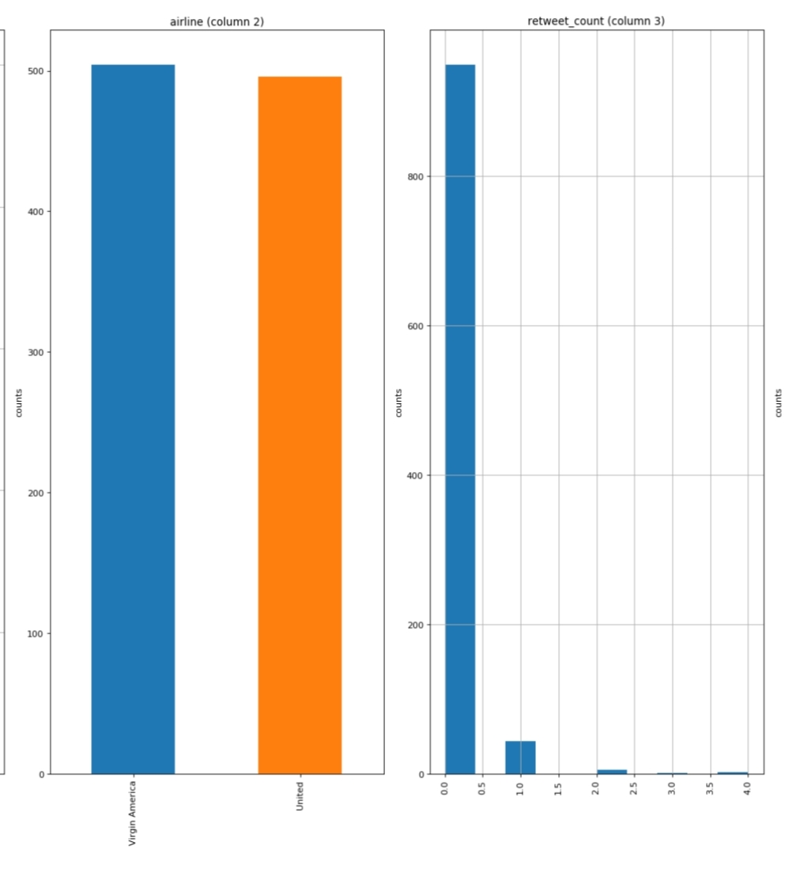

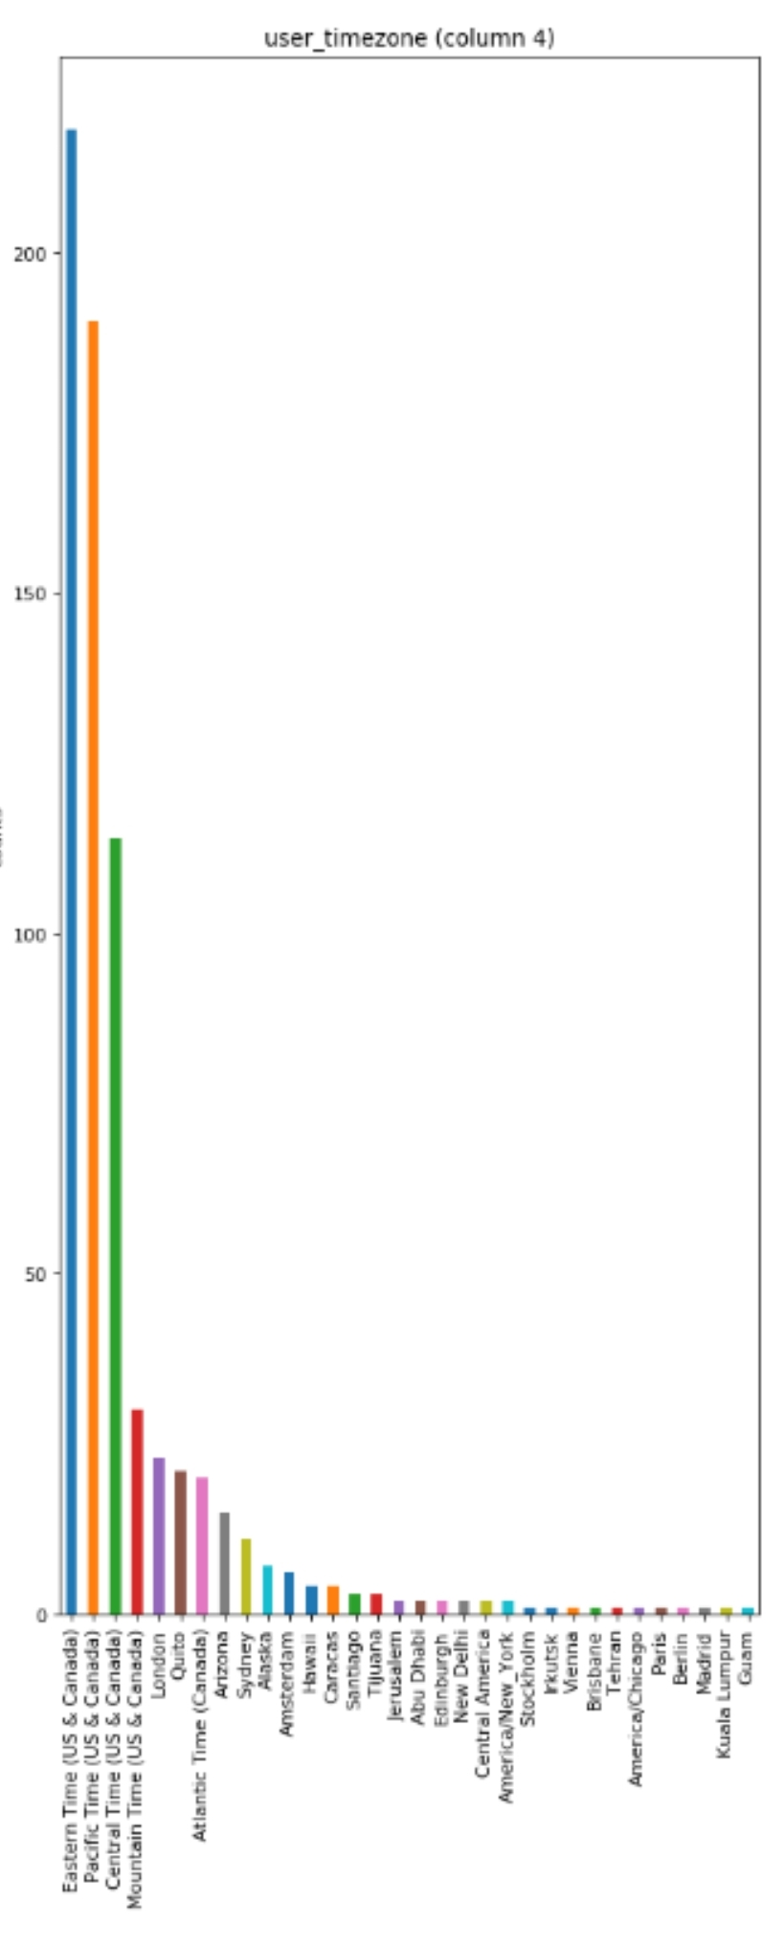

**Data Preprocessing:**

1. Clean and preprocess the social media data:
2. Remove special characters, URLs, and emojis.
3. Tokenize the text into words.
4. Convert text to lowercase.
5. Remove stopwords.
6. Perform stemming or lemmatization.

**CONCLUSION:**

Popular libraries and frameworks for building AI-based sentiment analysis models in Python include TensorFlow, PyTorch, Hugging Face Transformers, and spaCy. Pre-trained models like BERT and GPT have demonstrated remarkable performance in sentiment analysis tasks

AI-based sentiment analysis can provide valuable insights into customer sentiment, helping marketers make data-driven decisions and better engage with their target audience.