**SENTIMENTAL ANALYSIS FOR MARKETING**

The goal of this project is to develop a sentiment analysis solution for a brand’s social media presence, enabling the brand to gain insights into customer sentiment, engagement, and trends. The project will use machine learning and natural language processing (NLP) techniques to analyze customer comments and interactions on social media platforms

T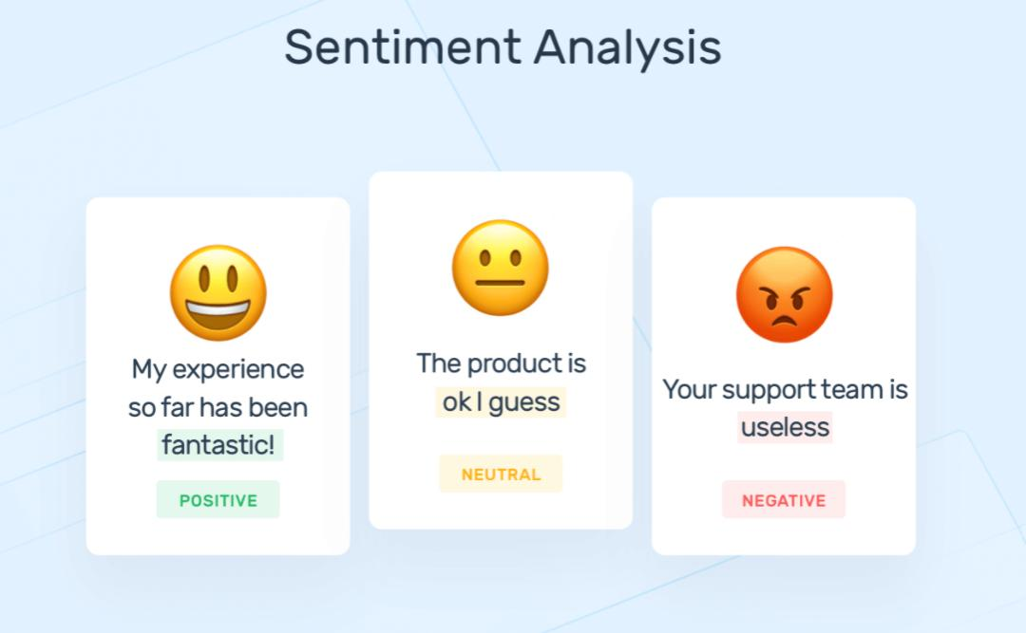his project will provide valuable insights into customer sentiment and help the brand make informed decisions to enhance its marketing strategies and engagement on social media.

Certainly, let’s continue:

**1. Multilingual Support (Optional):**

- If your application needs to handle multiple languages, ensure that your sentiment analysis model can work with multilingual data. You might need to adapt or use pre-trained models for different languages.

**2. Domain-Specific Models (Optional):**

- If your application operates in a specific domain (e.g., healthcare, finance, or gaming), consider training or fine-tuning your sentiment analysis model on domain-specific data. Domain-specific models can provide more accurate insights.

**3. Error Analysis:**

- Regularly conduct error analysis to understand the limitations and weaknesses of your sentiment analysis model. This can help you identify areas for improvement.

**4. User Interface and Reporting:**

- Create a user-friendly interface or reporting system for users to access the generated insights. Dashboards and reports can provide an easy way to visualize sentiment trends and insights.

**5. A/B Testing (Optional):**

- If your sentiment analysis solution is integrated into a larger product or service, consider conducting A/B tests to assess the impact of sentiment-related features or improvements on user engagement and satisfaction.

**6. Ethical Considerations:**

- Pay attention to ethical considerations, such as bias in the training data, privacy, and the responsible use of sentiment analysis results. Implement measures to mitigate biases and respect user privacy.

**7. Data Security and Compliance:**

- Ensure that your solution complies with data protection and privacy regulations, especially when handling sensitive or personal data.

**8. Feedback Integration:**

- Implement mechanisms for users to provide feedback on sentiment analysis results. This can help you continuously improve the accuracy and relevance of the insights generated.

**9. Documentation and Training:**

- Document your sentiment analysis solution and provide training or guidance to users, especially if it’s used by a team that may not be familiar with NLP techniques.

Building a sentiment analysis solution involves a combination of NLP techniques, machine learning, and thoughtful design to extract meaningful insights from text data. Be prepared to iterate and refine your solution over time to meet the evolving needs of your users and the changing landscape of sentiment in the data you analyze.

* **Tools and technologies:**

Python, NLP libraries (NLTK, spaCy), machine learning frameworks (Scikit-Learn, TensorFlow), pre-trained language models (BERT, GPT-3).

**PROGRAM**:

from mpl_toolkits.mplot3d import Axes3D

from sklearn.preprocessing import StandardScaler

import matplotlib.pyplot as plt *# plotting*

import numpy as np *# linear algebra*

import os *# accessing directory structure*

import pandas as pd *# data processing, CSV file I/O (e.g. pd.read_csv)*

There is 1 csv file in the current version of the dataset:

In [2]:

print(os.listdir('../input'))

['database.sqlite', 'Tweets.csv']

*# Distribution graphs (histogram/bar graph) of column data*

def plotPerColumnDistribution(df, nGraphShown, nGraphPerRow):

nunique = df.nunique()

df = df[[col for col **in** df if nunique[col] > 1 **and** nunique[col] < 50]] *# For displaying purposes, pick columns that have between 1 and 50 unique values*

nRow, nCol = df.shape

columnNames = list(df)

nGraphRow = (nCol + nGraphPerRow - 1) / nGraphPerRow

plt.figure(num = None, figsize = (6 * nGraphPerRow, 8 * nGraphRow), dpi = 80, facecolor = 'w', edgecolor = 'k')

for i **in** range(min(nCol, nGraphShown)):

plt.subplot(nGraphRow, nGraphPerRow, i + 1)

columnDf = df.iloc[:, i]

if (**not** np.issubdtype(type(columnDf.iloc[0]), np.number)):

valueCounts = columnDf.value_counts()

valueCounts.plot.bar()

else:

columnDf.hist()

plt.ylabel('counts')

plt.xticks(rotation = 90)

plt.title(f'**{columnNames[i]}** (column **{i}**)')

plt.tight_layout(pad = 1.0, w_pad = 1.0, h_pad = 1.0)

plt.show()

*# Correlation matrix*

def plotCorrelationMatrix(df, graphWidth):

filename = df.dataframeName

df = df.dropna('columns') *# drop columns with NaN*

df = df[[col for col **in** df if df[col].nunique() > 1]] *# keep columns where there are more than 1 unique values*

if df.shape[1] < 2:

print(f'No correlation plots shown: The number of non-NaN or constant columns (**{df.shape[1]}**) is less than 2')

return

corr = df.corr()

plt.figure(num=None, figsize=(graphWidth, graphWidth), dpi=80, facecolor='w', edgecolor='k')

corrMat = plt.matshow(corr, fignum = 1)

plt.xticks(range(len(corr.columns)), corr.columns, rotation=90)

plt.yticks(range(len(corr.columns)), corr.columns)

plt.gca().xaxis.tick_bottom()

plt.colorbar(corrMat)

plt.title(f'Correlation Matrix for **{filename}**', fontsize=15)

plt.show()

*# Scatter and density plots*

def plotScatterMatrix(df, plotSize, textSize):

df = df.select_dtypes(include =[np.number]) *# keep only numerical columns*

*# Remove rows and columns that would lead to df being singular*

df = df.dropna('columns')

df = df[[col for col **in** df if df[col].nunique() > 1]] *# keep columns where there are more than 1 unique values*

columnNames = list(df)

if len(columnNames) > 10: *# reduce the number of columns for matrix inversion of kernel density plots*

columnNames = columnNames[:10]

df = df[columnNames]

ax = pd.plotting.scatter_matrix(df, alpha=0.75, figsize=[plotSize, plotSize], diagonal='kde')

corrs = df.corr().values

for i, j **in** zip(*plt.np.triu_indices_from(ax, k = 1)):

ax[i, j].annotate('Corr. coef = **%.3f**' % corrs[i, j], (0.8, 0.2), xycoords='axes fraction', ha='center', va='center', size=textSize)

plt.suptitle('Scatter and Density Plot')

plt.show()

nRowsRead = 1000 *# specify 'None' if want to read whole file*

*# Tweets.csv has 14640 rows in reality, but we are only loading/previewing the first 1000 rows*

df1 = pd.read_csv('../input/Tweets.csv', delimiter=',', nrows = nRowsRead)

df1.dataframeName = 'Tweets.csv'

nRow, nCol = df1.shape

print(f'There are **{nRow}** rows and **{nCol}** columns')

df1.head(5)

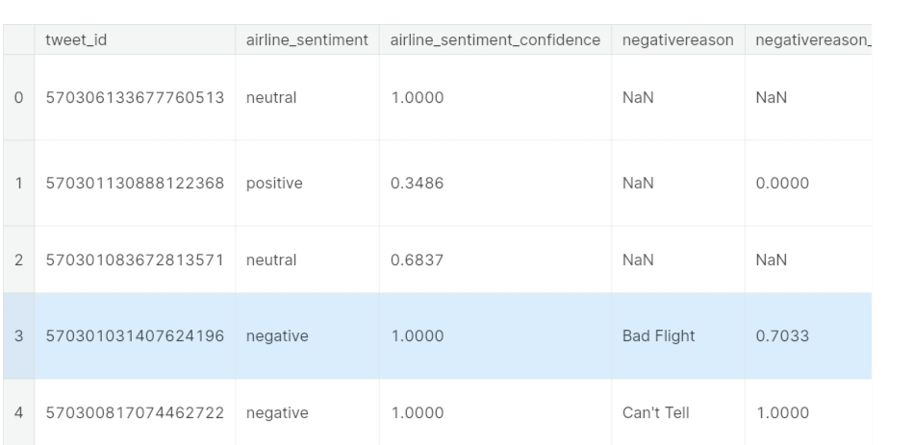

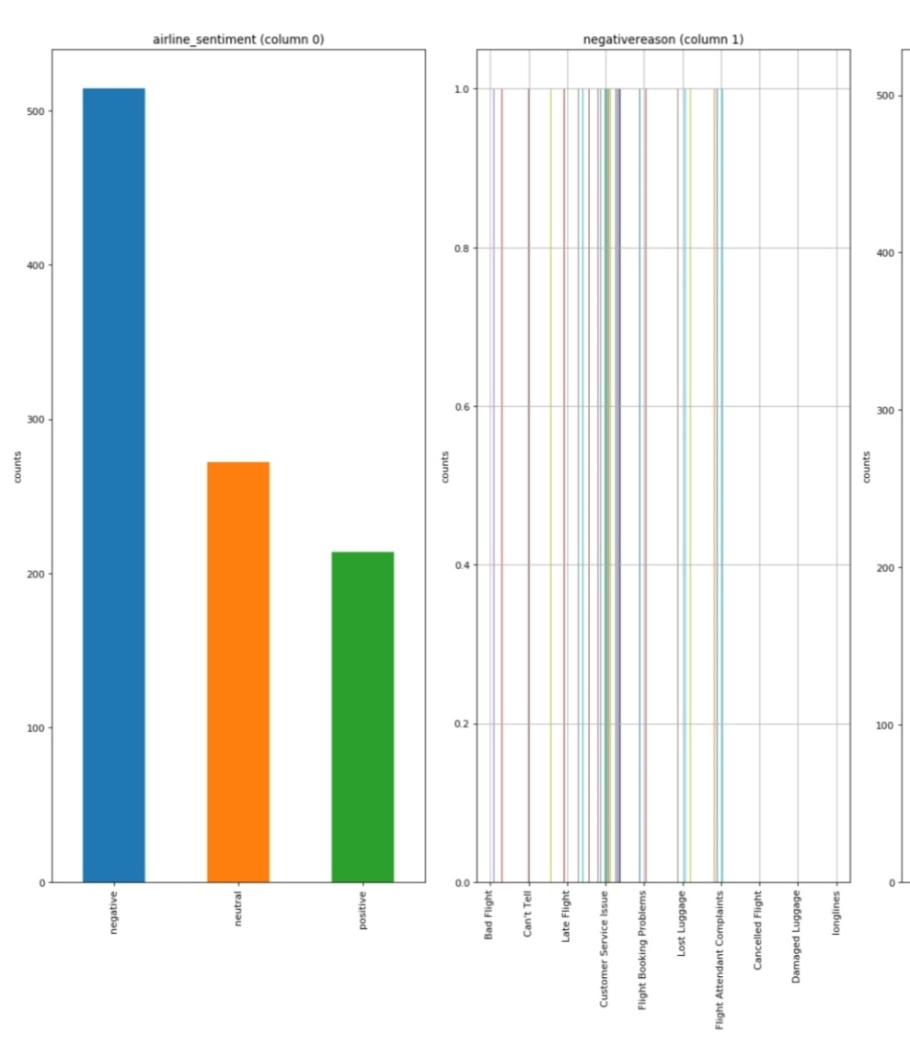 plotPerColumnDistribution(df1, 10, 5)

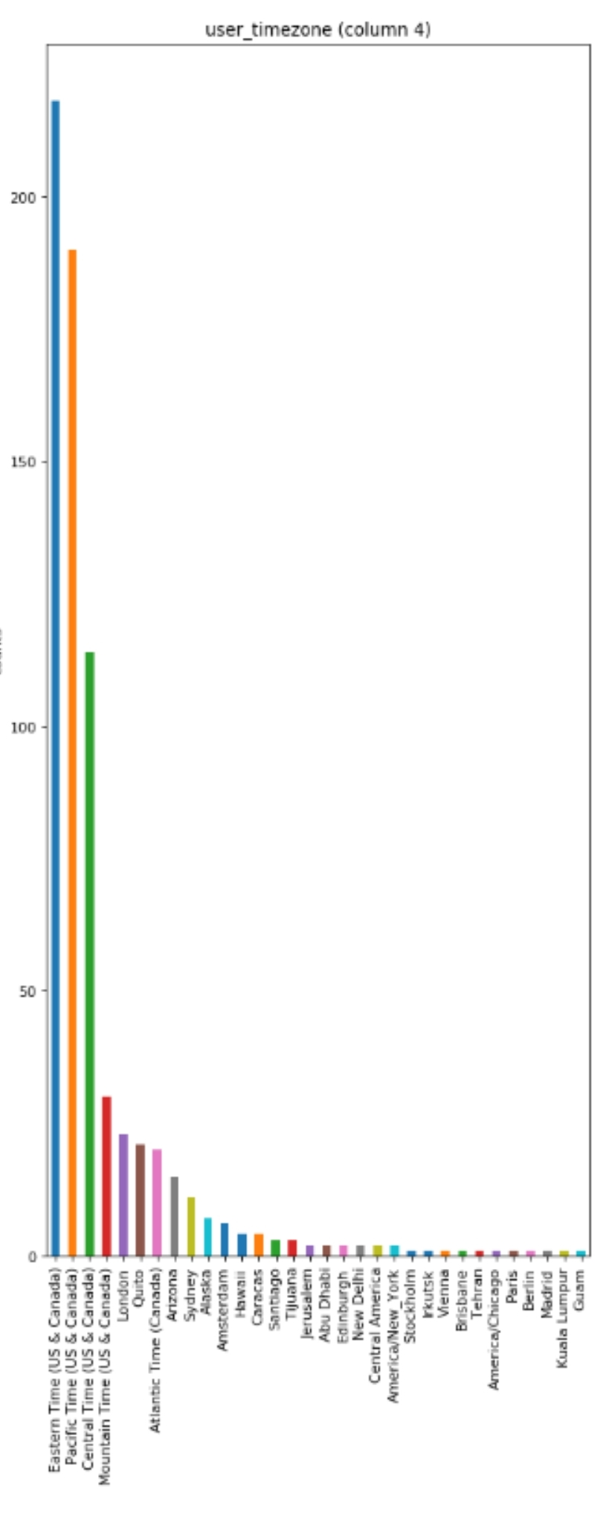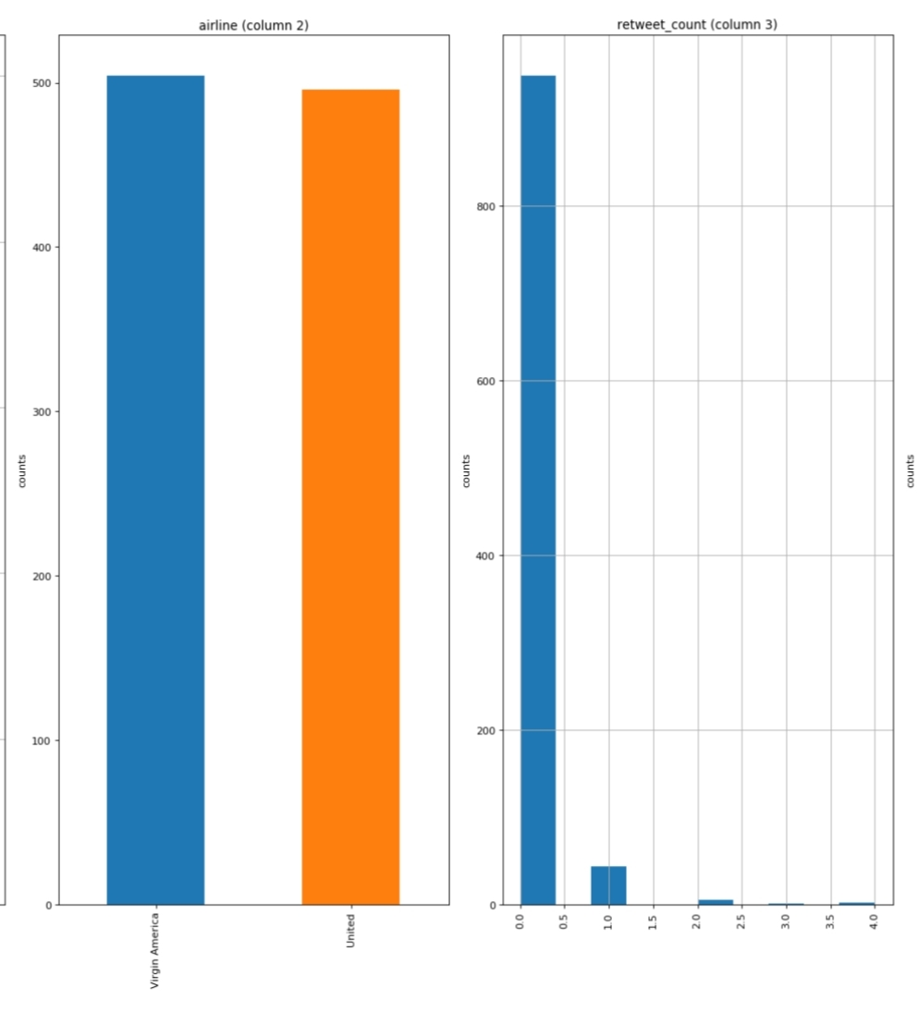

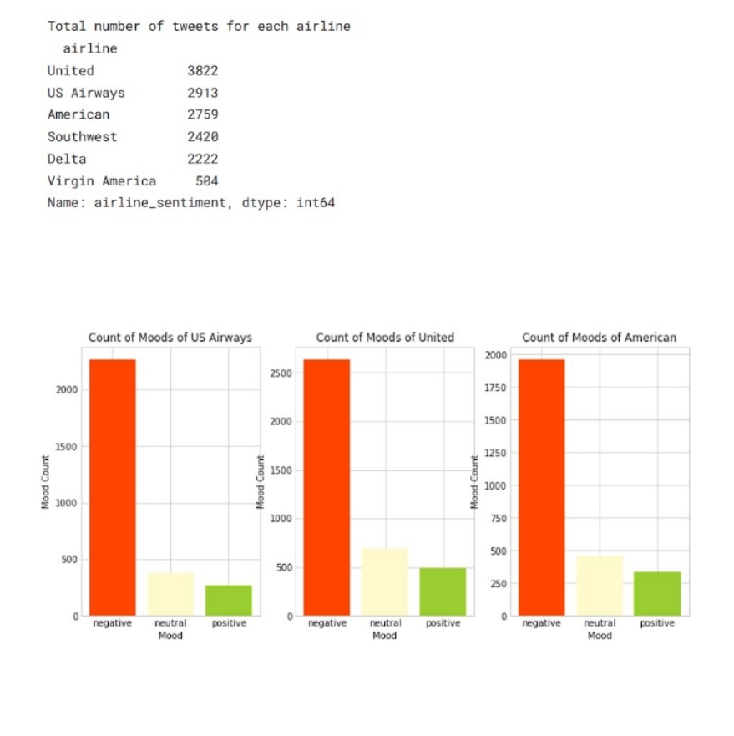

**Data Preprocessing:**

1. Clean and preprocess the social media data:
2. Remove special characters, URLs, and emojis.
3. Tokenize the text into words.

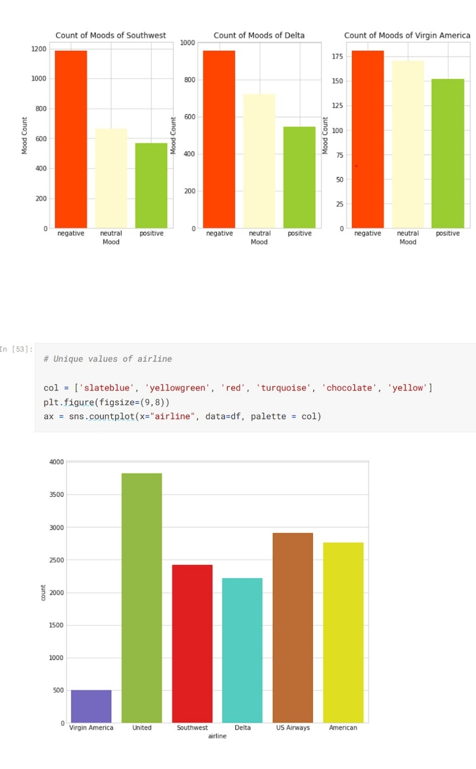

**CONCLUSION:**

Popular libraries and frameworks for building AI-based sentiment analysis models in Python include TensorFlow, PyTorch, Hugging Face Transformers, and spaCy. Pre-trained models like BERT and GPT have demonstrated remarkable performance in sentiment analysis tasks

AI-based sentiment analysis can provide valuable insights into customer sentiment, helping marketers make data-driven decisions and better engage with their target audience.