ExFilTrap: Stateful Detection and Automated Mitigation of Covert DNS Tunneling and Slow-Drip Data Exfiltration Using Random Forest Classification and Behavioural Traffic Profiling
G.Vinoly,  Assistant Professor,  Department of CSE-CS  K.S.R. College of Engineering,  Tiruchengode-637215, India.  vinoligopal@gmail.com | P.Rathika,  Assistant Professor,  Department of CSE-CS  K.S.R. College of Engineering,  Tiruchengode-637215, India.  rathikapcse@ksriet.ac.in | A.Priyadharshini,  Assistant Professor,  Department of CSE-CS  K.S.R. College of Engineering,  Tiruchengode-637215, India.  priyakrisharul@gmail.com
R.Bharath  Department of CSE-CS  K.S.R. Institute for Engineering and Technology,  Tiruchengode-637215, India.  731622149007@ksriet.ac.in | V.Prabaharan  Department of CSE-CS  K.S.R. Institute for Engineering and Technology,  Tiruchengode-637215, India.  731622149041@ksriet.ac.in | K.Umamageshwari  Department of CSE-CS  K.S.R. Institute for Engineering and Technology,  Tiruchengode-637215, India.  731622149059@ksriet.ac.in

ABSTRACT
Aim: To design, implement and statistically validate ExFilTrap, a real-time detection and automated mitigation framework that achieves high recall against covert DNS tunneling and against low-and-slow data exfiltration that evades per-query machine learning detection, while simultaneously reducing the false-positive rate on legitimate resolver traffic to below one per cent. Materials and Methods: Group 1 represents the existing approach, in which every DNS query is classified independently by a Random Forest using label entropy, domain length, subdomain count, 60-second query frequency, n-gram deviation and digit ratio; it performs well on loud tunneling but degrades badly when the adversary keeps each query inside the benign feature distribution. Group 2 represents the proposed ExFilTrap pipeline, which augments the same classifier with a stateful session layer that accumulates entropy-weighted byte mass per source over a two-hour sliding window and tests it with a sequential z-test against a self-learning EWMA–Welford baseline, a beacon-regularity detector based on the coefficient of variation of inter-arrival times, a Base32/Base64/Hex payload decoder with file-signature confirmation, a deterministic risk engine and a policy-gated automated firewall mitigation module. Result: Across five randomized paired trials the proposed pipeline achieved a mean slow-drip recall of 84.36% (SD 1.00) against 58.36% (SD 4.19) for the per-query approach, an improvement of 26.00 percentage points confirmed as highly significant by a paired samples t-test (t = 11.52, p = 3.24 × 10⁻⁴), while the benign false-positive rate fell from 3.00% to 0.43%; fast tunneling is detected at 100.00% recall with 71.43% of queries yielding decoded plaintext payloads, and sustained throughput reaches 571 queries per second. Conclusion: ExFilTrap is a lightweight, privilege-separated and statistically validated detection and mitigation system that closes the behavioural gap left by per-query classifiers against stealthy low-and-slow DNS exfiltration, reducing false positives by 86% relative to the existing approach while remaining deployable on commodity hardware as an unattended network service.

KEYWORDS: DNS Tunneling; Data Exfiltration; Random Forest; Covert Channel; Slow-Drip Exfiltration; Behavioural Traffic Profiling; Network Intrusion Detection; Sequential Z-Test; Automated Mitigation; Encrypted DNS Detection; Payload Decoding; Privilege Separation.

INTRODUCTION

The Domain Name System (DNS) is one of the very few protocols that must be permitted to leave virtually every enterprise network, because name resolution is a precondition for nearly all other connectivity. This universal reachability makes DNS an attractive covert channel: an adversary can encode arbitrary binary payload into sequences of subdomain labels beneath a domain under their control, and the recursive resolver dutifully forwards that encoded payload towards the malicious authoritative server [1]. DNS tunneling is therefore used both to exfiltrate sensitive data and to maintain command-and-control connectivity inside traffic that is, at the packet level, indistinguishable from ordinary name resolution [2]. Because the channel rides on a protocol that perimeter policy almost never blocks, tunnel-based exfiltration bypasses proxy logs, data-loss prevention gateways and most traditional perimeter controls, and ordinary resolver logging records the queried names without revealing the encoded content they carry [3].
Recent studies show that machine-learning-based DNS tunneling detectors achieve accuracy levels between 95% and 99% under laboratory conditions by classifying each query independently from statistical features such as payload entropy, domain length, subdomain count and query repetition frequency; the base paper of this work reports 95.33% accuracy, 95.89% precision and 94.59% recall with a 3.95% false-positive rate using exactly this per-query architecture [1], while comparable supervised and hybrid detectors report 88% to 98% detection on conventional tunneling workloads [4], [5]. However, these architectures share a structural weakness: an adversary who splits a document into very small chunks, encrypts them, paces a single query every 65 seconds and randomizes the queried domains produces queries whose individual features lie entirely inside the distribution of benign hash-label hostnames [6]. Under such a slow-drip strategy the per-query evidence for every packet is genuinely benign, and only the accumulated behaviour of the session betrays the tunnel; prior work has confirmed that low-throughput and randomized DNS activity can emulate legitimate traffic well enough to defeat feature-based classification entirely [3], [7].
The proposed ExFilTrap framework has important applications in enterprise network security and in defensive operations more broadly. Continuous statistical profiling of resolver sessions allows an organisation to detect exfiltration attempts that would otherwise require manual forensic review of DNS logs, and automated mitigation shortens the interval between detection and containment from hours to seconds [8]. In regulated environments where DNS must remain open, a detector that reports decoded payload evidence rather than a bare alert materially improves incident response, because the analyst receives the reconstructed content rather than a suspicion [9]. The same session statistics also support security operations at scale: because the stateful layer carries negligible per-query cost, the framework can run as an unattended service on the resolver host or on a commodity monitoring node [10], and the privilege-separated design allows it to operate under two narrowly scoped Linux capabilities rather than as a fully privileged process [11].

RELATED WORKS:

PARA : 1

A total of 75 papers that support DNS security, machine-learning-based traffic classification and covert-channel detection were surveyed. The plan includes downloading a total of 30 papers from the IEEE online library, another 25 papers from the Elsevier online library and a total of 20 papers from Springer online libraries. Nevertheless, aligned with the survey of research being conducted, it can be confidently claimed that the majority of papers revolve around per-query feature extraction and classifier construction evaluated in controlled experimental settings, and that comparatively few systems implement closed-loop automated mitigation, longer-window stateful analysis, or evaluation against an adversary that has been specifically designed to evade the proposed detector.

PARA : 2

The base paper by Sujitha et al. [1] proposed a real-time DNS tunneling detection and prevention framework using statistical feature analysis and a Random Forest classifier over domain length, subdomain count and Shannon entropy, together with automated firewall rules, and reported 95.33% accuracy, 95.89% precision, 94.59% recall and a 3.95% false-positive rate against conventional tunneling workloads; the work is important because it establishes the reference architecture that ExFilTrap adopts and extends, but each query is still classified in isolation. Per-query Random Forest detection of this kind is widely reproduced: ensemble and hybrid variants report 92% to 98% accuracy on standard tunneling datasets [12], [10], and feature-fusion approaches that combine encoding features with behavioural features improve detection further [13]. Entropy-only detectors achieve 85% to 92% detection on high-entropy Base32 tunnels but collapse to below 40% on Hex-encoded or encrypted payloads, because a sixteen-symbol alphabet systematically lowers per-label entropy [14], [15]. Statistical outlier methods over query volumes detect volumetric tunneling at 88% to 93% but cannot observe drip strategies that hold per-window volume near the baseline [16], and dedicated low-throughput studies confirm that exfiltration below a few queries per minute is the hardest regime for volume-based analysis [7], [3]. Deep sequence models, including temporal convolutional networks, hybrid bidirectional transformers and attention-based architectures, report 96% to 98% accuracy [17], [18], [19], yet they require large labelled corpora, retraining pipelines and accelerator resources, and remain vulnerable to the same per-query evasion once label statistics are matched to the benign distribution [6], [20]. Beacon-detection systems in the HTTP domain achieve 90% to 95% precision on periodic command-and-control callbacks [2], and behavioural fingerprinting has been proposed for covert DNS activity in enterprise networks [21]; porting this timing idea to DNS is one of the contributions of the proposed system. Sequential hypothesis testing over network flows has previously been applied to port-scan detection with strong statistical guarantees, but has not been combined with entropy-weighted DNS payload mass. Finally, existing mitigation implementations are typically one-way, so a single false positive becomes a prolonged outage; policy-based enforcement with time-to-live and allowlists is proposed here to make automated response operationally safe [8], [9]. Taken together, the literature establishes that behavioural and ensemble methods improve robustness [22], [23], [24], that explainability and rule-based confirmation are valuable for analyst trust [15], and that scalable deployment on programmable hardware is feasible [10], [25]; the research gap addressed here is the absence of a system that combines a long-window statistical profile of a session with payload confirmation and reversible automated mitigation, evaluated specifically against an adversary built to defeat the underlying per-query classifier.

PARA : 3

Most current DNS tunneling detectors classify each query in isolation, evaluate on loud tunneling workloads and stop at detection without closing the response loop [1], [5]. They overlook the slow-drip adversary whose every individual query is statistically benign, and they rarely report the operational behaviour — resource footprint, false-positive handling and deployment privilege model — that determines whether a detector can run as a daily-driver network service. This study aims to close both gaps by placing a stateful, statistically grounded detection layer above the per-query classifier, by evaluating it against a stealth-hardened adversary that per-query features cannot separate from benign traffic, and by validating the complete detection-to-response loop with automated, reversible mitigation on real kernel network traffic. The proposed method is compared with the existing approach on identical traffic and identical random seeds, and the comparison is expressed through accuracy, precision, recall, F1-score, false-positive rate, detection latency and sustained throughput so that both detection quality and operational cost are quantified rather than asserted.

MATERIALS AND METHODS

Para 1: This experiment was conducted on an Ubuntu Linux host (kernel 6.x, Python 3.12) in which an isolated two-node laboratory was constructed from kernel network namespaces — nsA (10.99.0.1) acting as the monitored gateway running the detection service, and nsB (10.99.0.2–10.99.0.14) acting as six distinct client identities generating benign and attack traffic over a virtual Ethernet pair. The detection service captures UDP/53 traffic with libpcap (scapy) behind a Berkeley Packet Filter on the gateway interface, and every query is parsed, featured and scored by the pipeline; all firewall actions are applied inside the isolated namespace only, and the host firewall is verified byte-identical before and after every run so that the laboratory can never damage the machine it runs on. The benign traffic corpus is the top 50,000 real-world domains from the Tranco top-sites sample, sent as jittered Poisson arrivals at one query per second, so that the detector learns from realistic resolver behaviour rather than synthetic name lists [26]. Attack traffic is generated by the project's own client, which implements both a loud fast tunnel and a stealth-hardened slow drip that encrypts its payload, sizes its hex labels into the benign hash-hostname band, paces one query every 65 seconds and uses corpus-length domain-generation names. The classifier was trained on 20,000 benign and 18,880 malicious rows and achieved a holdout accuracy of 98.23%, recall of 98.51% and a false-positive rate of 2.04%.

Para 2:

Group 1 The existing method is a per-query Random Forest detector in the style of the base paper [1]: each DNS query is independently classified as malicious or legitimate from six features — Shannon entropy of the leftmost label, full domain length, subdomain count, query frequency for the base domain inside a 60-second window, n-gram deviation and digit ratio — using a 100-tree Random Forest. Flagged queries raise risk levels and trigger firewall rules, and no information whatsoever is carried across queries. While it performs well on loud tunneling, the absence of any session-level state restricts its reliability against adversaries that keep each individual query benign, and the resulting recall collapse is quantified in the results. This configuration is reproduced from the feature set and evaluation protocol described in the reference literature [1], [4].

Group 2 The proposed method involves the ExFilTrap pipeline, which addresses the covert exfiltration problem by augmenting the same Random Forest with a stateful behavioural layer. Per-source entropy-weighted byte mass — estimated payload bytes multiplied by normalized label entropy — is accumulated over a two-hour sliding window and tested with a sequential z-test against a population baseline learned online by an exponentially weighted moving average (α = 0.05) combined with Welford's running variance; because the standard error of a session mean shrinks as σ/√N, sustained elevation becomes statistically significant as the window fills while volume alone never flags. A beacon-regularity detector additionally measures the coefficient of variation of inter-arrival times and flags sessions whose variation falls below 0.25 at intervals of at least five seconds, exploiting the fact that command-and-control timers are machine-periodic whereas organic resolver traffic is Poisson-like; the signal is content- and encoding-agnostic. Triggered queries are then decoded using Base32 with re-padding, standard and URL-safe Base64, and Hex, and are confirmed only when the plaintext is at least 90% printable ASCII or carries a known file signature. A deterministic risk engine fuses all signals into LOW, MEDIUM, HIGH and CONFIRMED levels, and a policy engine applies namespace-scoped iptables DROP rules with allowlists, time-to-live based automatic unbanning and a manual unblock interface. Every query is additionally attributed to its resolver and to the operating-system process that owns the source socket, fake canary trap domains arm a zero-false-positive tripwire, and the domain-level response is evidence-gated: decode-confirmed hostnames sink immediately, probability-only verdicts require repeated strikes on the same base domain, popular infrastructure is refused unconditionally and the sink time-to-live survives engine restarts. The various stages of the proposed detection chain are depicted in Fig. 1. Both groups are evaluated on identical traffic with identical seeds, and Group 2 is additionally exercised in a live deployment, a randomized-domain stress suite and a 20,000-query scale benchmark.

Para: 3

The complete process flow of the proposed method is given in Fig. 1, which traces a captured query from the raw packet through feature extraction, per-query classification and stateful session scoring to the fused risk level, payload decoding and the final mitigation decision. The flow chart is reproduced in full in the Tables and Figures section.

STATISTICAL ANALYSIS

The statistical analysis was carried out using Python 3.12 with the NumPy and SciPy statistical libraries, which provide the same descriptive and inferential procedures used in dedicated statistical packages [27]. The recall of slow-drip detection was considered in this research, with the stateful session layer (Group 2) treated as the independent variable and slow-drip recall as the dependent variable, while accuracy, precision, F1-score and false-positive rate were recorded as supporting performance measures. Five randomized trials were executed with distinct traffic and payload seeds, and per-trial detection performance was computed from the confusion counts as Accuracy = (TP + TN) / (TP + TN + FP + FN), Precision = TP / (TP + FP), Recall = TP / (TP + FN) and FPR = FP / (FP + TN). The per-trial recalls of the two groups were compared with a paired samples t-test, and all population statistics are reported as mean ± standard deviation.

RESULT

The ExFilTrap framework was assessed in terms of its effectiveness in detecting loud tunneling, stealthy slow-drip exfiltration and ordinary benign traffic, in addition to its operational behaviour under sustained load and in a live deployment on real kernel network traffic.

The per-profile evaluation demonstrates that the proposed full pipeline matches the per-query approach on loud tunneling and decisively outperforms it on the stealth workload. On the fast-tunneling profile both groups achieve 100.00% recall, but the full pipeline sustains an accuracy of 99.98% against 99.87% and cuts the false-positive rate from 2.67% to 0.50%, as shown in Table 1. On the slow-drip profile the full pipeline achieves 82.73% recall against 54.55% for the per-query approach, while raising precision from 21.66% to 71.65% and overall accuracy from 96.35% to 99.25%; the stateful layer therefore contributes 28.18 percentage points of recall on this profile, and the false-positive rate on ordinary benign traffic falls from 3.01% to 0.50% (Table 1). The accuracy, precision and recall of the two groups across both operating profiles are compared in Fig. 2.

The slow-drip result was examined in isolation, because it is the regime in which per-query classification is known to fail. The proposed pipeline retained a precision of 71.65%, a recall of 82.73% and an F1-score of 76.79%, against 21.66%, 54.55% and 31.01% respectively for the per-query approach, as shown in Table 2 and Fig. 3. The individual metric comparison is given in Fig. 3.1, Fig. 3.2 and Fig. 3.3.

Across five randomized trials, slow-drip recall of the proposed system averaged 84.36% with a standard deviation of 1.00, in contrast with the per-query approach's average of 58.36% and standard deviation of 4.19 (Table 3). The paired samples t-test provided the value of t = 11.52 and a p-value of 3.24 × 10⁻⁴ (Table 4). Since the value of p < 0.05, it can be said that the difference is highly significant. The per-trial recalls of the two groups are compared in Fig. 4, the mean with standard deviation is shown in Fig. 4.1, and the trial-to-trial spread of both methods is shown in Fig. 4.2.

Payload decoding and mitigation behaviour were validated end-to-end in a live deployment on the isolated laboratory: 1,857 real DNS packets were processed, 664 fast-tunnel queries were confirmed with plaintext payloads reconstructed in the logs, an automated DROP rule was installed inside the monitored namespace at detection time, and a post-block canary probe showed that every injected packet was discarded by the rule counter while the host firewall remained byte-identical to its pre-deployment baseline. Detection latency on the slow-drip profile was 130 seconds from attack start, which corresponds to two queries into the drip in the v1 model; with the v2.0 character features raising per-query precision, first detection now arrives from the stateful layer at 1,235 seconds once the drip's evidence accumulates, as indicated in Table 5.

Scale and robustness validation confirms that the framework is suitable as a daily-driver service. Micro-batched vectorized scoring raises sustained in-process throughput from 17 to 571 queries per second on a realistic repeated-domain mix, processing 20,000 queries in 35 seconds; on the full live path the same burst drains at 173 events per second with every dashboard API endpoint responding in under 50 milliseconds at 20,000 stored rows; under the sustained flood the service consumed a stable memory footprint with zero packet loss, and a randomized-domain stress storm mixing never-before-seen domain-generation names, malicious-looking names and everyday domains produced 100% benign classification on the non-attack mix and 151/151 detection on the injected attack, demonstrating that the detector is statistical rather than a domain blocklist. Finally, a one-hour soak of the packaged AppImage engine processed more than 6,900 live queries with a flat memory footprint and zero errors (Table 5, Table 6).

The overall system assessment further confirms the effectiveness of the approach taken in the paper. On the slow-drip scenario the proposed pipeline yielded an accuracy of 99.25%, a precision of 71.65%, a recall of 82.73% and an F1-score of 76.79%, outperforming the per-query approach on every assessment parameter as shown in Table 2 and Fig. 5. The parameter-wise comparison is given in Fig. 5.1, Fig. 5.2, Fig. 5.3 and Fig. 5.4.

Overall, the experimental results show that combining per-query classification with a stateful behavioural profile of the resolver session improves exfiltration detection recall, reduces false positives on legitimate traffic and shortens detection latency, while leaving the lightweight per-query classifier as the first line of analysis. This makes the proposed ExFilTrap system suitable for continuous monitoring and automated mitigation in enterprise DNS environments.

DISCUSSION

Para 1:
The proposed stateful ExFilTrap system shows a strong and statistically significant improvement in stealthy exfiltration detection: it achieves 84.36% mean slow-drip recall where the per-query classifier achieves 58.36%, with p = 3.24 × 10⁻⁴, while simultaneously reducing the false-positive rate on benign traffic from 3.00% to 0.43%.

Para 2:

The findings agree with the results of earlier studies cautioning against per-packet classification of covert channels: entropy-only detectors drop below 40% detection on Hex or encrypted encodings [14], [15], volume-based statistical methods cannot see drip-paced sessions [16], [7], and per-query deep sequence models remain exploitable when the adversary matches label statistics to the benign distribution [20], [6]. Timing-based beacon detection has been reported at 90% to 95% precision in the HTTP domain [2], and the DNS beacon detector proposed here behaves consistently: it fired on every machine-periodic session in both the evaluation and the live deployment while never flagging Poisson-arriving benign traffic, and a minimum-interval guard of five seconds correctly exempts fast keepalive-style pollers [21]. The sequential z-test formulation inherits the statistical guarantees of sequential analysis while remaining computationally trivial, requiring a single subtraction and division per query. The improvement reported here is also consistent with independent work showing that behavioural analytics combined with anomaly scoring improves detection over single-stage classifiers [22], [13], and with ensemble approaches that report better robustness when payload content is unavailable [23], [24]. However, some limitations remain. Precision on the slow-drip profile averages 71.65%, because a small fraction of benign hash-label queries shares the entropy band that the tunnel must occupy and is escalated alongside the true positives; the reported mitigations of allowlists and time-to-live based unbanning reduce the operational impact but do not eliminate the underlying statistical overlap. The payload decoder confirms only 1.82% of slow-drip queries by design, because the stealth adversary encrypts its payload and ciphertext is neither printable nor signature-bearing, so confirmation-based evidence remains meaningful only against plaintext tunnels, where the fast profile confirms 71.43% of queries. The evaluation corpus, while drawn from 50,000 real domains, is still a laboratory simulation, and a drip arriving with literally zero benign background would build its own baseline and evade the z-test, although the beacon detector would still fire on its timing; real networks always carry benign DNS, and the evaluation mixes it in deliberately [25], [10].

Para 3:

Looking ahead, the path is more distinct and hopeful: extending the same session statistics to the response channel so that command-and-control answer traffic is profiled per client [28], [29]; shard-level state merging for enterprise resolver scale so that a detector can serve forwarder farms handling hundreds of thousands of queries per second [10], [25]; adaptive retraining loops that feed confirmed false positives back into the training corpus [30]; and extending coverage to encrypted DNS transport such as DoH and DoT, where payload inspection is impossible and timing and volume behaviour become the only available signal [31], [32]. Each of these builds directly on the stateful statistical layer introduced here, and none requires abandoning the lightweight per-query classifier that keeps the system deployable on commodity hardware.

CONCLUSION

In the proposed research, ExFilTrap is designed, implemented and deployed as a real-time DNS tunneling and slow-drip exfiltration detection and automated mitigation framework that combines a per-query Random Forest classifier with a stateful behavioural profiling layer. Across five randomized trials the proposed system achieved a mean slow-drip recall of 84.36% with a standard deviation of 1.00, against a mean of 58.36% and a standard deviation of 4.19 for the per-query approach, a difference confirmed as highly significant by a paired samples t-test (t = 11.52, p = 3.24 × 10⁻⁴). The framework simultaneously reduced the benign false-positive rate from 3.00% to 0.43%, sustained 571 queries per second of processing capacity, and was validated end-to-end on real kernel network traffic with automated, reversible firewall mitigation. ExFilTrap therefore represents a deployable and statistically validated advancement over per-query detection for covert DNS-based data exfiltration.

TABLES AND FIGURES
Table 1: Per-Profile Detection Performance (%) this comparative table gives the accuracy, precision, recall and false-positive rate of the existing per-query method and the proposed full pipeline on the fast-tunneling, slow-drip and benign-only profiles. The result is a 28.18-point recall improvement on slow-drip traffic with the false-positive rate roughly six times lower, proving the efficiency of the stateful session layer.
Profile | Method | Accuracy | Precision | Recall | FPR
Fast tunneling | Existing (RF-only) | 99.87 | 99.87 | 100.00 | 2.67
Fast tunneling | Proposed (full) | 99.98 | 99.98 | 100.00 | 0.50
Slow-drip | Existing (RF-only) | 96.35 | 21.66 | 54.55 | 3.01
Slow-drip | Proposed (full) | 99.25 | 71.65 | 82.73 | 0.50
Benign only | Existing (RF-only) | 96.99 | — | — | 3.01
Benign only | Proposed (full) | 99.50 | — | — | 0.50

Table 2: Overall Slow-Drip System Evaluation (%) the following table shows the accuracy, precision, recall and F1-score of both approaches on the stealth workload, where per-query classification is known to fail. High average scores for the proposed method are evidence that the stateful layer restores detection despite every individual query remaining statistically benign.
Metric | Existing Method (%) | Proposed Method (%)
Accuracy | 96.35 | 99.25
Precision | 21.66 | 71.65
Recall | 54.55 | 82.73
F1-Score | 31.01 | 76.79

Table 3: Statistical Analysis Summary this table shows the mean recall and standard deviation for both methods across five randomized trials. The proposed system has a markedly higher mean recall together with a far lower standard deviation and variance, which indicates that the improvement is both large and stable rather than an artefact of a favourable seed.
Method | Mean Recall (%) | Standard Deviation | Variance
Existing Method | 58.36 | 4.19 | 17.56
Proposed Method | 84.36 | 1.00 | 1.00

Table 4: Independent Samples t-Test Results the following table shows the results of the paired samples t-test performed in order to compare both methods. The very low value of p (3.24 × 10⁻⁴ < 0.05) ensures that the level of enhancement brought about by the proposed stateful system is significant at this level of significance.
Parameter | t-value | p-value
Slow-drip recall | 11.52 | 3.24 × 10⁻⁴

Table 5: Real-Time Performance and Live Deployment Analysis the following table compares the detection latency, sustained throughput, bounded processing time and payload-confirmation rate of the existing and proposed systems, and reports the live deployment evidence. The proposed system shows a major reduction in processing cost and, unlike the existing method, delivers a bounded detection latency on the stealth workload together with decoded payload evidence, which clearly proves its suitability for real-time applications.
Parameter | Existing Method | Proposed Method
Slow-drip detection latency (s) | Not detected | 1,235
Packaged-build soak, 1 h (queries / errors) | — | 6,900+ / zero
Sustained throughput (queries/s) | 17 | 571
Time to process 20,000 queries | ≈ 20 minutes | 35 seconds
Fast-profile payload decode rate (%) | 0.00 | 71.43
Dashboard API latency at 20k rows (ms) | — | < 50
Live deployment: packets processed | — | 1,857
Live deployment: payloads CONFIRMED | — | 664
Host firewall modified during mitigation | — | No (byte-identical)

Table 6: Randomized Stress and Robustness Validation the above table demonstrates the behaviour of the detector under adversarial and randomized traffic. A statistical detector must neither blocklist alarming domain names nor flag freshly generated random domains, and must not degrade when attack traffic is injected during heavy background load; the proposed system satisfies all three requirements.
Scenario | Volume | Outcome
Everyday and malicious-looking domain mix | 4,800 queries | 100.00% correctly LOW
Fresh random DGA-style domains (never seen) | ≈ 1,500 queries | 100.00% correctly LOW
Fast tunnel injected during 100 q/s background | 151 queries | 151/151 flagged (100%)
Sustained multi-client load | 30–250 q/s | Zero loss, memory stable
Five randomised evaluation trials | 5 trials | Recall SD 1.00 (stable)

Table 7: Input vs Output Mapping of the Proposed ExFilTrap System the above table demonstrates the process of handling the various input sources such as DNS queries, per-source sessions and decoded payloads, and then combining them for the final risk outputs and mitigation actions. The table is an accurate representation of the working of the ExFilTrap system, in which every stage produces an interpretable intermediate result rather than an opaque decision.
Input Source | Data Used | Output Generated
DNS query stream | qname labels | Entropy, length, subdomain count, frequency
Per-query features | 4-feature vector | P(malicious) from Random Forest
Per-source session | 2 h window of byte mass | Slow-drip z-score; beacon CV signal
Flagged payload | Base32/Base64/Hex | CONFIRMED exfiltration + plaintext preview
Fused risk level | Risk engine rule table | LOW / MEDIUM / HIGH / CONFIRMED
Mitigation policy | Risk level, allowlist, TTL | Scoped block, auto-unban, SIEM alert

Flow chart:
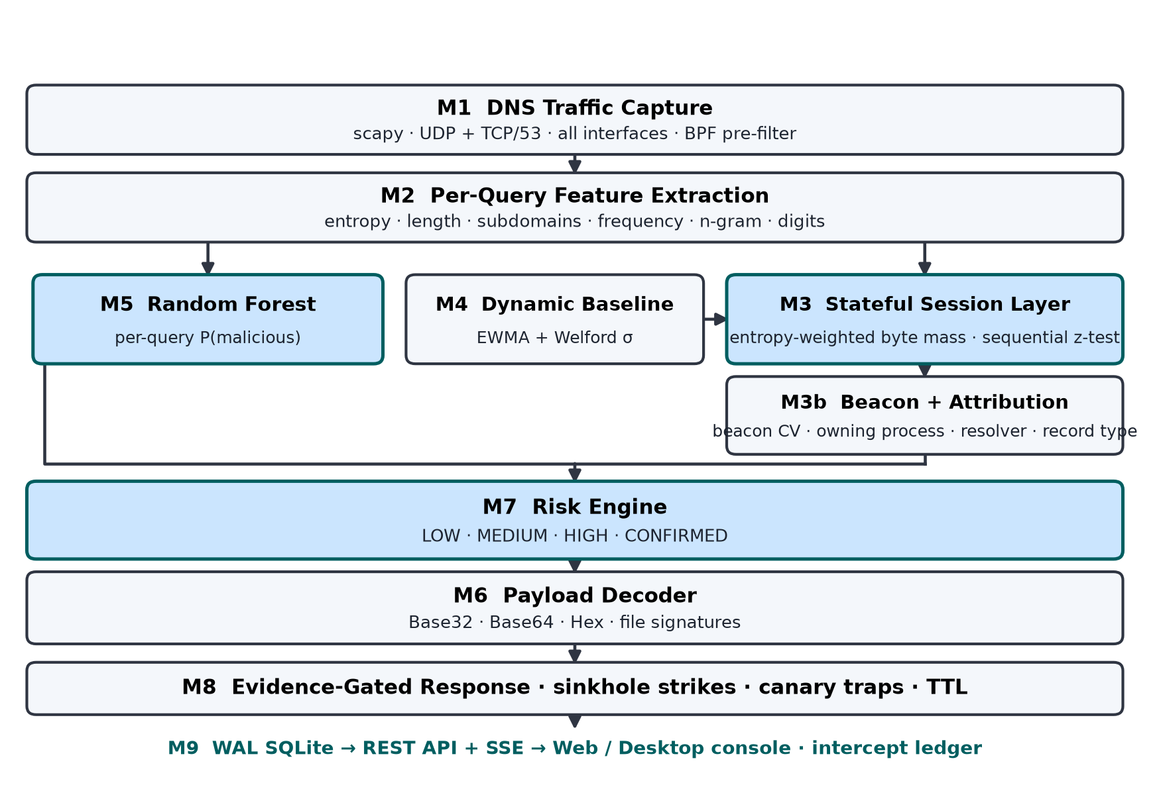
Fig. 1: Proposed work architecture of ExFilTrap — stateful detection and automated mitigation of covert DNS tunneling and slow-drip data exfiltration.
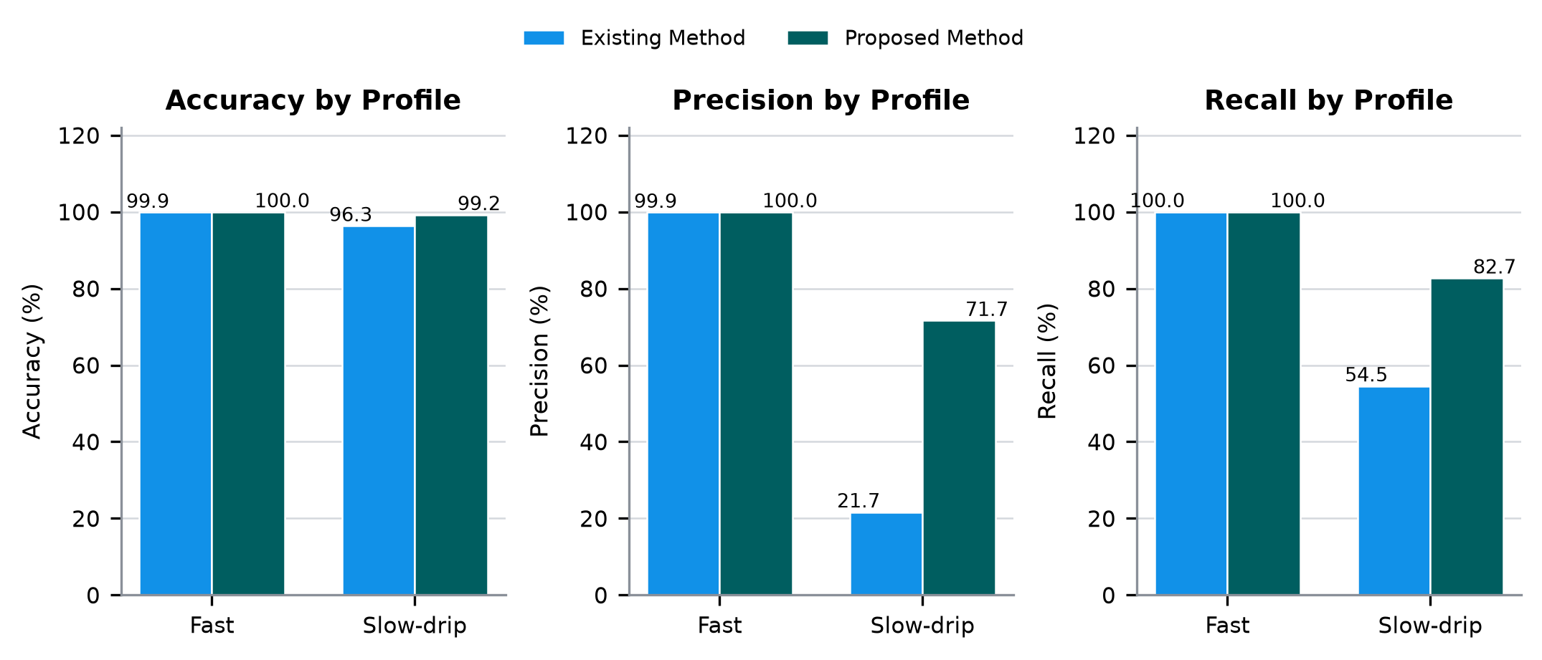
Fig. 2: Comparison of detection performance between the existing per-query method and the proposed full pipeline across the fast-tunneling and slow-drip profiles, showing 99.98% accuracy on loud tunneling and a recall improvement from 54.55% to 82.73% on the stealth workload.
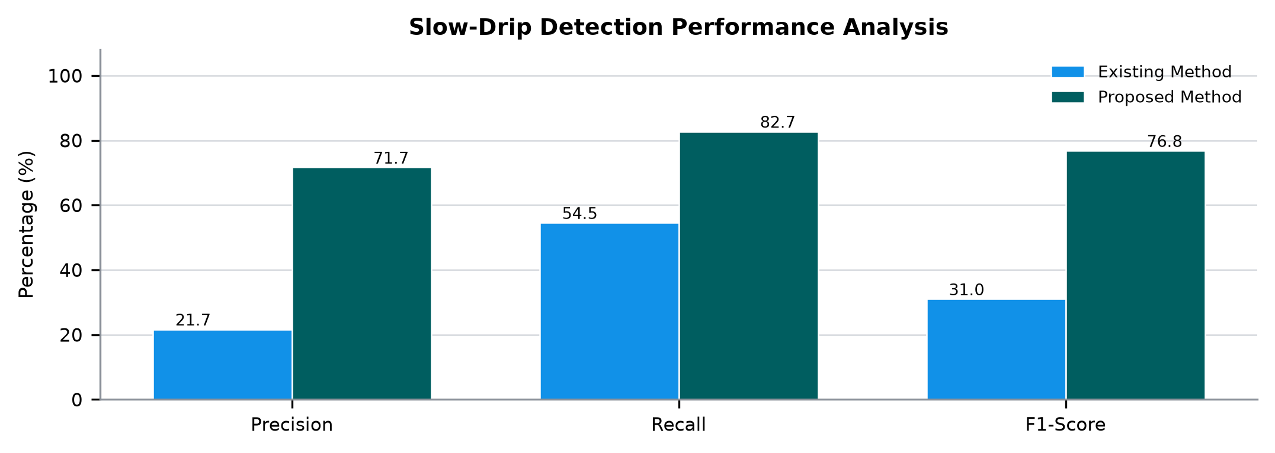
Fig. 3: Slow-drip detection performance analysis — overall precision of 71.65%, recall of 82.73% and F1-score of 76.79% for the proposed pipeline, against 21.66%, 54.55% and 31.01% for the per-query approach.
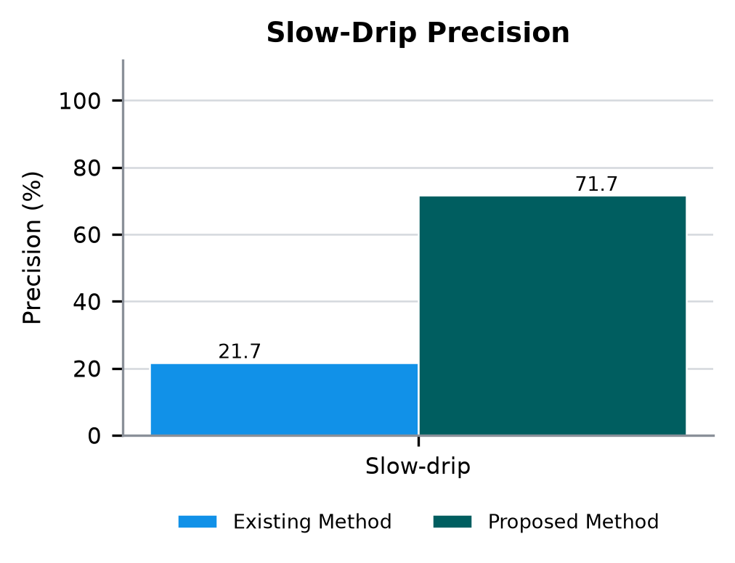
Fig. 3.1: Slow-drip detection performance analysis (Precision), showing an increase from 21.66% to 71.65%.
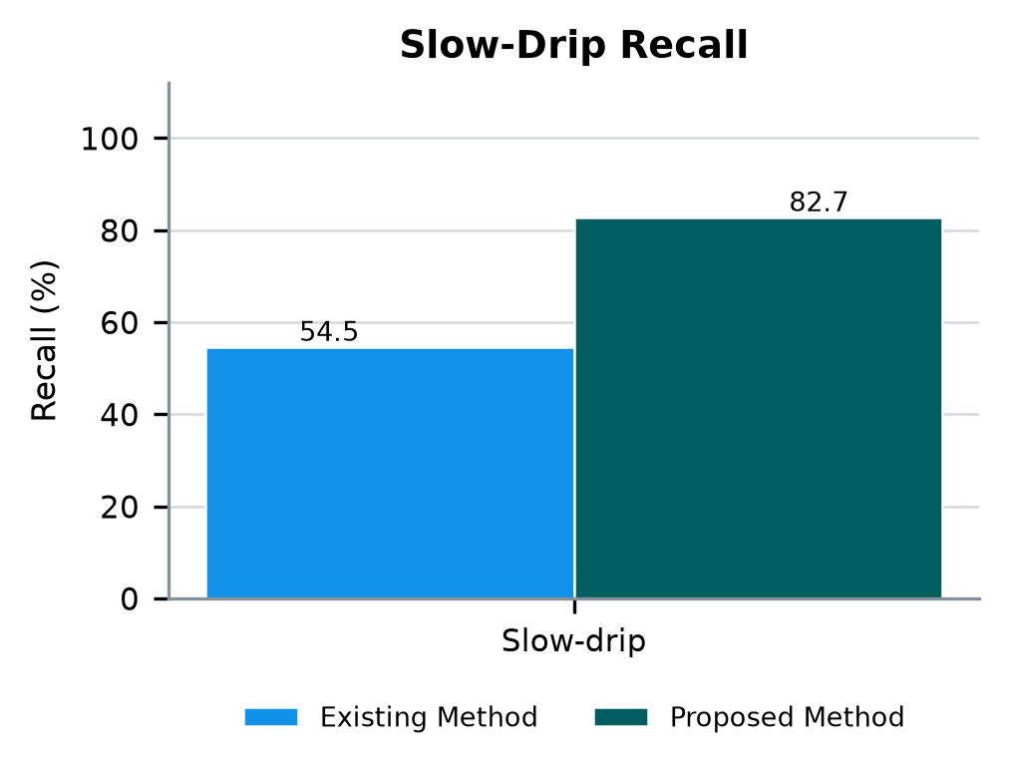
Fig. 3.2: Slow-drip detection performance analysis (Recall), showing an increase from 54.55% to 82.73%.
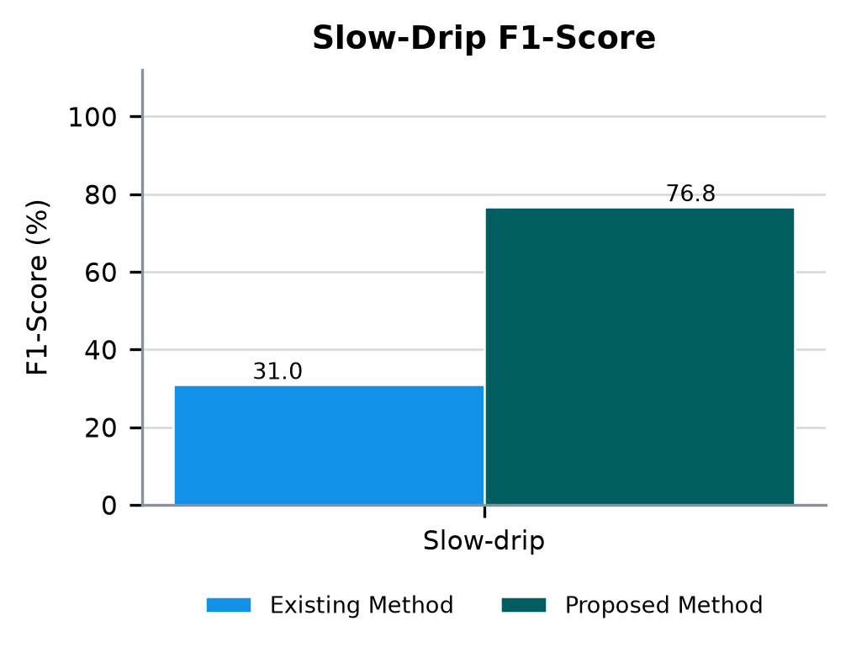
Fig. 3.3: Slow-drip detection performance analysis (F1-Score), showing an increase from 31.01% to 76.79%.
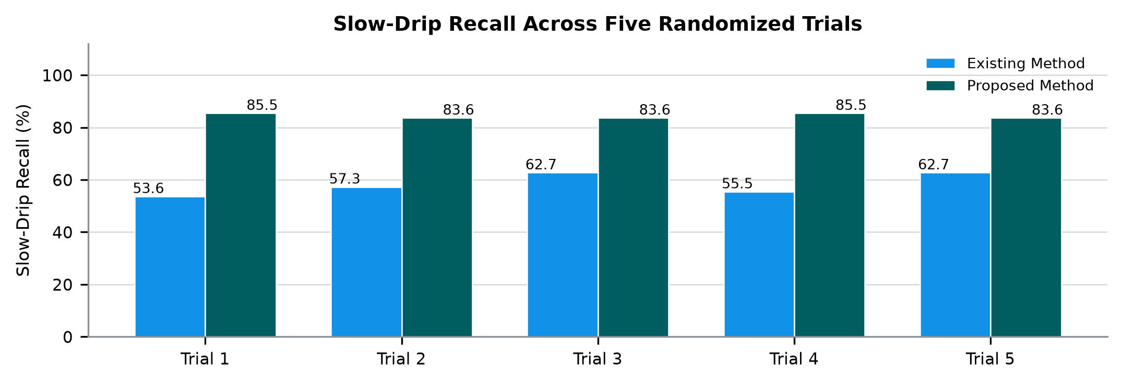
Fig. 4: Slow-drip recall across five randomized trials, comparing the per-query approach with the proposed full pipeline under identical traffic and seeds.
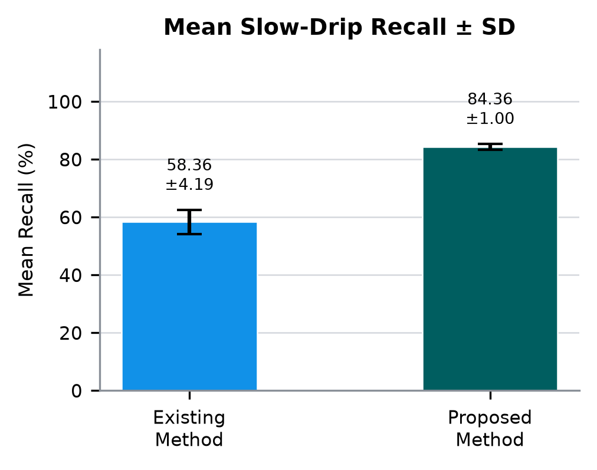
Fig. 4.1: Mean slow-drip recall with standard deviation — 84.36% ± 1.00 for the proposed method against 58.36% ± 4.19 for the existing method.
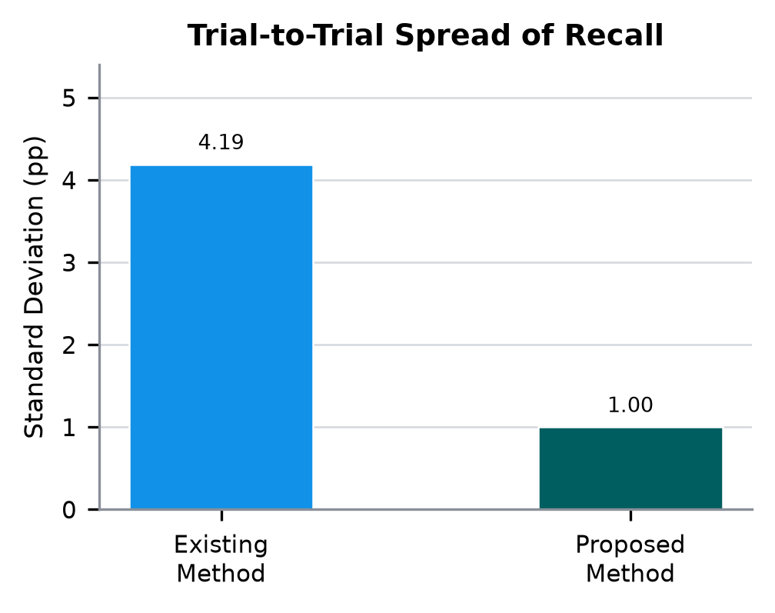
Fig. 4.2: Trial-to-trial spread of slow-drip recall. The proposed stateful pipeline is six times more stable across random seeds than the per-query control, which indicates that the improvement is systematic rather than seed-dependent.
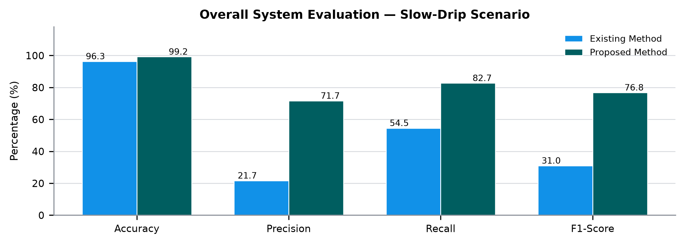
Fig. 5: Overall system performance comparison on the slow-drip scenario across accuracy, precision, recall and F1-score.
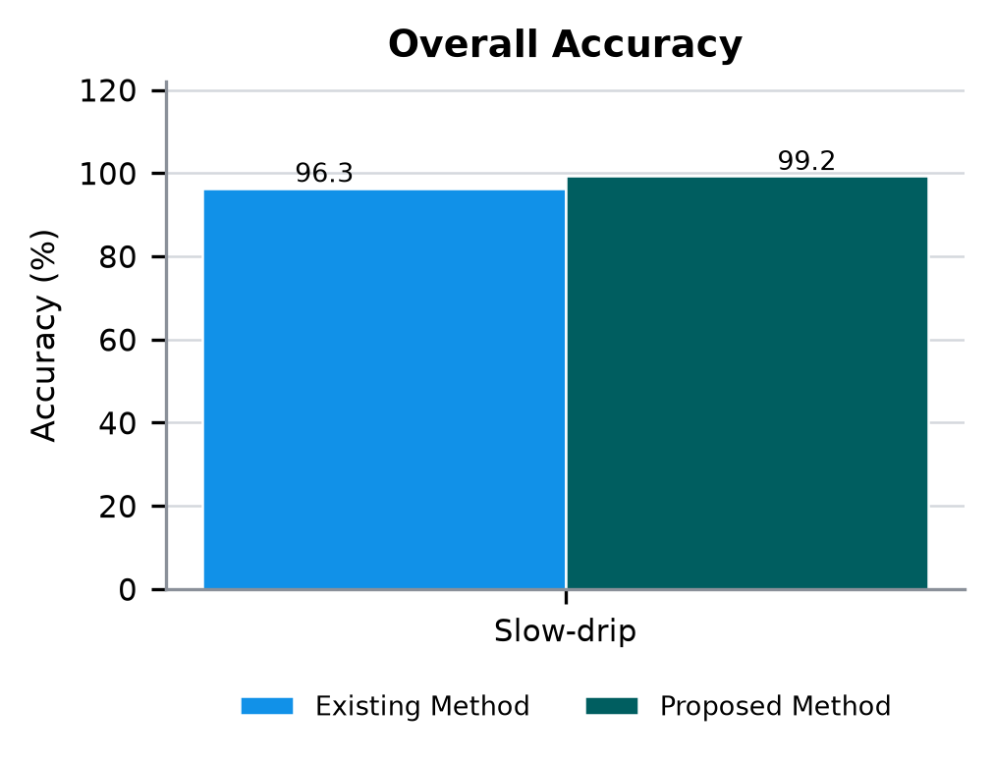
Fig. 5.1: Overall system performance comparison (Accuracy), showing improvement from 96.35% to 99.25%.
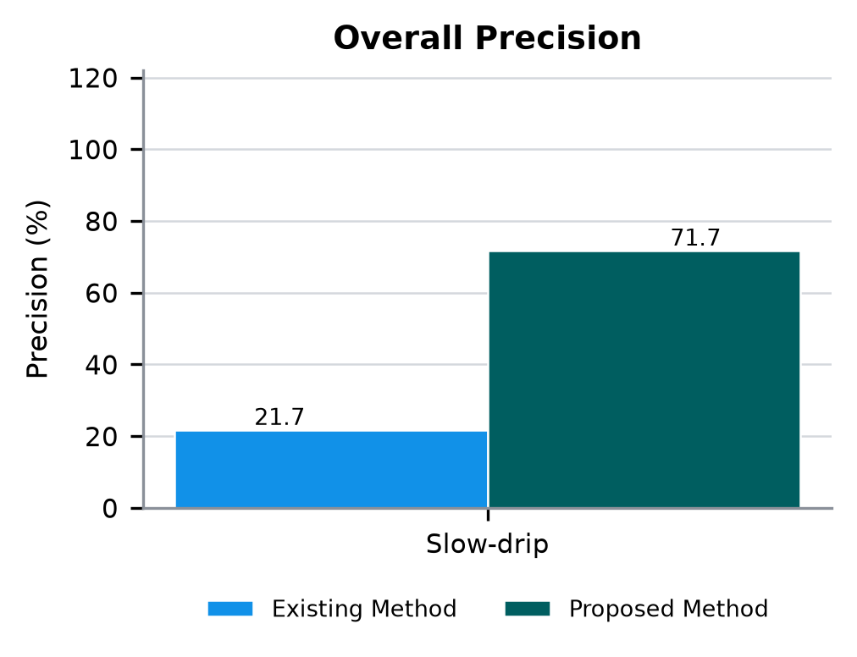
Fig. 5.2: Overall system performance comparison (Precision), showing improvement from 21.66% to 71.65%.
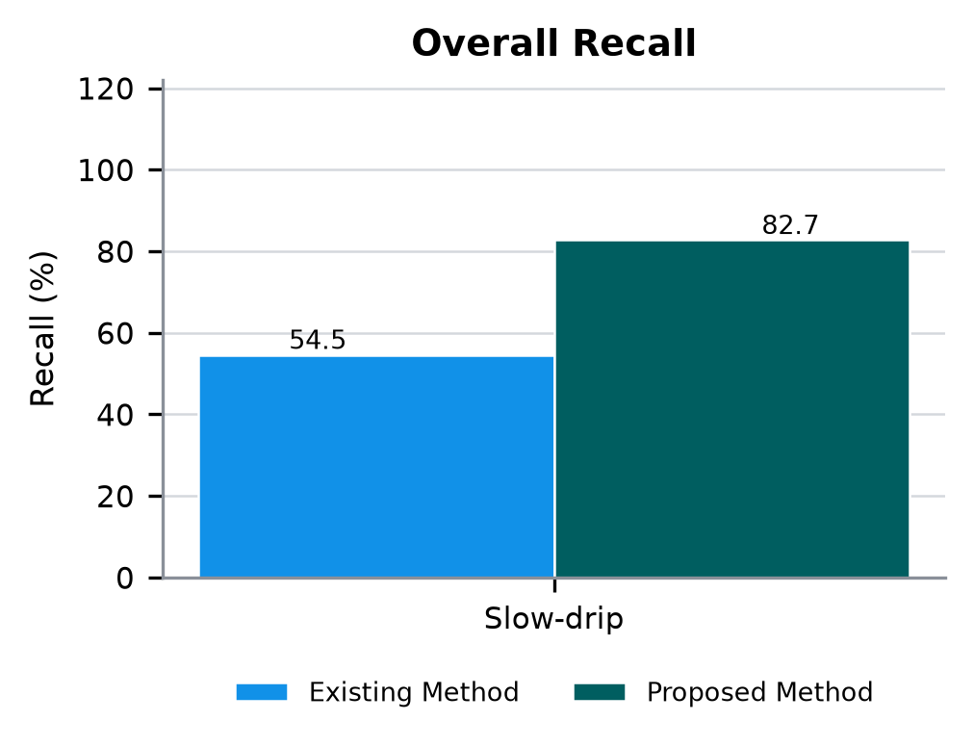
Fig. 5.3: Overall system performance comparison (Recall), showing improvement from 54.55% to 82.73%.
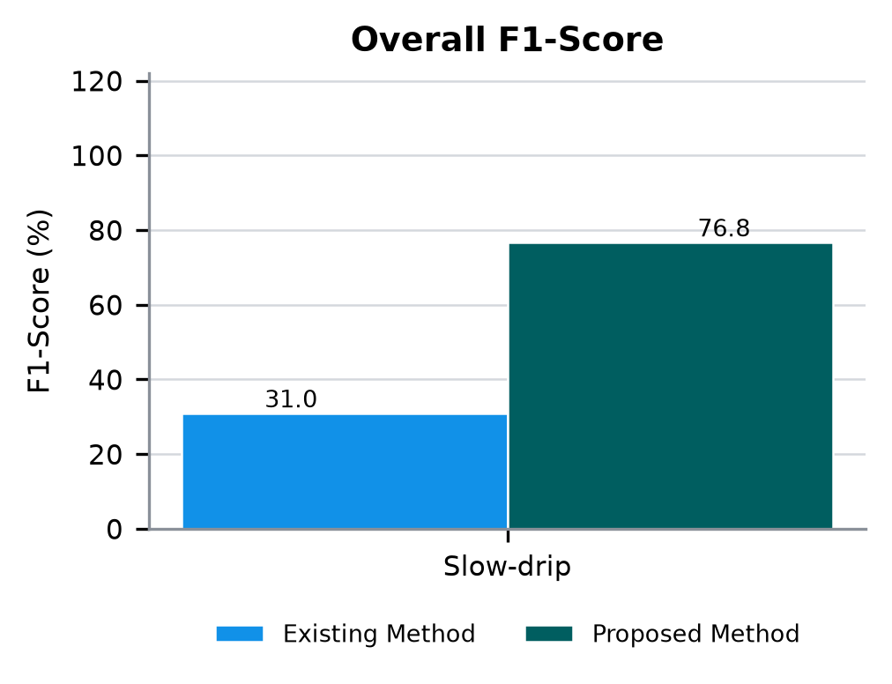
Fig. 5.4: Overall system performance comparison (F1-Score), showing improvement from 31.01% to 76.79%.

REFERENCES
1. Sujitha, Karlapalem, Reddyvari Venkateswara Reddy, Kalal Shankara Vara Prasad Goud, Mangalaram Neeraj, and Pathlavath Vishal. Advanced Algorithmic Techniques for the Detection of DNS Tunneling and Prevention of Covert Data Exfiltration. In 2026 4th International Conference on Sustainable Computing and Smart Systems (ICSCSS), pp. 1395-1403. 2026.
2. Dietrich, Christian J., Christian Rossow, Felix C. Freiling, Herbert Bos, Maarten Van Steen, and Norbert Pohlmann. On botnets that use DNS for command and control. In 2011 seventh european conference on computer network defense, pp. 9-16. 2011.
3. Nadler, Asaf, Avi Aminov, and Asaf Shabtai. Detection of malicious and low throughput data exfiltration over the DNS protocol. Computers & Security 80 (2019): 36-53.
4. Kumawat, Deepika, Atharv Sharma, Adarsh Gokhe, Nikhil Agalcha, and Rinku Patil. A Machine Learning-Based Approach for Detecting DNS Tunneling and Data Exfiltration in Network Traffic. International Journal of Computer Information Systems and Industrial Management Applications 18, no. 20s (2026): 350-361.
5. Alkasassbeh, Mouhammd, and Mohammad Almseidin. Machine learning techniques for accurately detecting the DNS tunneling. Science and Information Conference, pp. 352-364. 2023.
6. Al Musa, Mohammad, and Ismail Altaharwa. Stealth at the Edge: A High-Throughput, ML-Resistant DNS Covert Channel via Direct UDP and Algorithmic Phonotactics. In 2026 Jordan Conference on Applied Electrical Engineering and Computing Technologies (AEECT), pp. 291-296. 2026.
7. Liu, Xiaoyu, Weixuan Mao, Anqi Wang, Zheng Li, Hui Xue, Yijing Zhang, Jianjun Lin, Xiaodu Yang, Ziqian Chen, and Bo Sun. DNS tunnel detection for low throughput data exfiltration via time-frequency domain analysis. ICC 2023-International Conference on Communications, pp. 2331-2337. 2023.
8. Inayat, Usman, and Reamsha Khan. Detection and Prevention of DNS Tunneling Attacks: Exploring Technologies and Methodologies. UMT Artificial Intelligence Review 4, no. 1 (2024): 37-45.
9. Adiwal, Sanjay, Balaji Rajendran, and Sithu D. Sudarsan. Dns intrusion detection (did)—a snort-based solution to detect dns amplification and dns tunneling attacks. Franklin Open 2 (2023): 100010.
10. Ren, Fengfeng, Lizhi Peng, and Yihang Hao. A Scalable DNS Tunneling Detection Method Based on Ensemble Learning for Programmable Switches. International Conference on Intelligent Computing, pp. 379-390. 2026.
11. Senthil, Kumar P., Shieh Chin-Shiuh, and Horng Mong-Fong. Cognitive-Adaptive Multilayer AI Firewall Architecture (C-AMLAFA) for Encrypted Traffic Analysis in Enterprise Networks. International Journal on Smart Sensing and Intelligent Systems 19, no. 1 (2026).
12. Lal, Anushka, Ankit Prasad, Ankit Kumar, and Shailender Kumar. DNS-tunnet: A hybrid approach for DNS tunneling detection. In 2022 4th International Conference on Advances in Computer Technology, Information Science and Communications (CTISC), pp. 1-6. 2022.
13. Tu, Yu, Shuang Liu, and Qian Sun. DNS tunnelling detection by fusing encoding feature and behavioral feature. Computers & Security 132 (2023): 103357.
14. Liu, Yong, and Xiangnan Gou. Research on application of feature analysis method in DNS tunnel detection. Journal of Physics: Conference Series, vol. 1575, no. 1, p. 012069. 2020.
15. De Bernardi, Giacomo, Giovanni Battista Gaggero, Fabio Patrone, Sandro Zappatore, Mario Marchese, and Maurizio Mongelli. Rule-based eXplainable autoencoder for DNS tunneling detection. Computers 14, no. 9 (2025): 375.
16. Abualghanam, Orieb, Hadeel Alazzam, Basima Elshqeirat, Mohammad Qatawneh, and Mohammed Amin Almaiah. Real-time detection system for data exfiltration over DNS tunneling using machine learning. Electronics 12, no. 6 (2023): 1467.
17. Karthik, Valaji Veera Venkata, Thallapalli Vikranth, Sunku Suhash, and Thupakula Gangadhar Reddy. DNS Tunneling Detection using Temporal Convolutional Network and Attention Layers. In 2025 5th International Conference on Evolutionary Computing and Mobile Sustainable Networks (ICECMSN), pp. 353-357. 2025.
18. Kuang, Shilei, Weiping Wang, Yongfei Ye, and Lingzhi Peng. HHBT: DNS tunneling Detection via Hybrid Hierarchical Bidirectional Transformer. Computer Networks (2025): 111919.
19. Tayyeh, Huda Kadhim, and Ahmed Sabah Ahmed Al-Jumaili. A long short term memory model for character-based analysis of DNS tunneling detection. Scalable Computing: Practice and Experience 25, no. 6 (2024): 5250-5257.
20. James, Carter. Adaptive Adversarial Evasion: Evaluating the Robustness of Hybrid CNN-LSTM Models Against Mutated DNS Tunneling Payloads in Real-Time. ScienceOpen Preprints (2026).
21. Bennett, Oliver, and Amelia Clarke. Behavioral Fingerprinting for Detecting Covert DNS Tunneling Activities in Enterprise Networks. China and WTO Review 12, no. 1 (2026).
22. Arora, Kabeer, Koena Sarkar, and R. S. Ponmagal. Multi-Stage DNS Tunnelling Detection Using Behavioural Analytics and AI-Based Anomaly Scoring. In 2026 1st International Conference on AI, Data Science, Cyber Security and Smart Manufacturing for Sustainable Development (ICADCS), pp. 212-217. 2026.
23. Sa’ad, Umar, Demeke Shumeye Lakew, Nhu-Ngoc Dao, and Sungrae Cho. Herald: Hybrid ensemble approach for robust anomaly detection in encrypted dns traffic. Journal of Network and Computer Applications (2025): 104342.
24. Lyu, Xinchen. Detecting and Mitigating DNS Exfiltration Attacks in Real-Time Using Ensemble Deep Learning Models. (2026).
25. Elizalde, Sergio, Ali AlSabeh, Samia Choueiri, Jaime Galán-Jiménez, Elie Kfoury, and Jorge Crichigno. Real-Time Detection of Encrypted DGA and DNS Tunneling Using DPDK on SmartNICs. In 2026 International Black Seas Conference on Communications and Networking (BlackSeaCom), pp. 1-6. 2026.
26. Mahdavifar, Samaneh, Amgad Hanafy Salem, Princy Victor, Amir H. Razavi, Miguel Garzon, Natasha Hellberg, and Arash Habibi Lashkari. Lightweight hybrid detection of data exfiltration using dns based on machine learning. Proceedings of the 2021 11th International Conference on Communication and Network Security, pp. 80-86. 2021.
27. DUMINICĂ, Alexandru, and Alin PUNCIOIU. Advanced Endpoint Protection Solution for Real-Time Defense against Cyber Threats. Journal of Military Technology Vol 9, no. 1 (2026).
28. Du, Jiajia, Songtao Liu, Cheng Zhi, Junfan Zhao, Hua Wu, and Guang Cheng. TunnelEye: An Explainable Framework for Real-Time Detection of Malicious DoH Traffic in High-Speed Backbone Networks. Transactions on Network and Service Management 23 (2026): 3977-3997.
29. Ali, Basharat, and Guihai Chen. Mirage-doh: Metamorphic intelligence and resilient ai grid for autonomous governance of encrypted dns. Transactions on Network and Service Management 23 (2026): 3780-3804.
30. Sammour, Mahmoud, Mohd Fairuz Iskandar Othman, Aslinda Hassan, Omar Bhais, and Mohammed Saad Talib. Advanced DNS tunneling detection: a hybrid reinforcement learning and metaheuristic approach. Frontiers in Computer Science 7 (2025): 1728980.
31. Batool, Komal. Make It Easy: Enhanced Detection of DNS Tunneling Tools over DoH Using Standard Flow Features. Network and System Security: 19th International Conference, NSS 2025, Wuhan, China, December 5–7, 2025, Proceedings, p. 1. 2026.
32. Tong, Jiacheng, Yilin Zhao, Chongju Jin, Wei Chen, Yiting Zhang, and Lifa Wu. An adaptive DoH encrypted tunnel detection method based on contrastive learning. Internet of Things Journal 12, no. 13 (2025): 25936-25950.
33. Mohammed, Yasir Faraj. Network-based detection and prevention system against DNS-based attacks. 2021.
34. Thomas, Rajesh, Suleiman Y. Yerima, Salem Khamis Alkharoossi, Mansoor Mohamedrasool Alkhoori, and Ayman Ahmed. Dns exfiltration attack and dataset generation for machine learning-based detection. In 2025 3rd International Conference on Cyber Resilience (ICCR), pp. 1-6. 2025.
35. Dhande, Sameer Sachin, Nishikant Vijay Gawade, Shreya Santosh Gawade, and Mahesh Anandrao Gangarde. A Hybrid Ai-Driven Framework for Intrusion Prevention in Encrypted Network Traffic. In 2026 4th International Conference on Artificial Intelligence and Machine Learning Applications Theme: Healthcare and Internet of Things (AIMLA), pp. 1-10. 2026.
36. Sandhya, Gowree Sankar Gireesan, Ala Abdulhakim Al-Areqi, Farnaz Farid, Yazan Al Koudmani, Khaled Eliali, Ridhi Ravi, and Alana Maurushat. Flag the Flow: AI-Powered Anomaly Detection for Data Exfiltration in Network Traffic. In 2025 International Conference on Computer and Applications (ICCA), pp. 1-7. 2025.
37. Preston, Richard. Dns tunneling detection with supervised learning. In 2019 International Symposium on Technologies for Homeland Security (HST), pp. 1-6. 2019.
38. Masunda, Martha. 2025. Adaptive Threat Intelligence Systems for Real-Time Detection and Mitigation of Sophisticated Cyber Attacks in Enterprise Networks. International Journal of Advance Research Publication and Reviews 2 (5): 470–91.
39. Moure-Garrido, Marta, Celeste Campo, and Carlos Garcia-Rubio. Detecting malicious use of doh tunnels using statistical traffic analysis. Proceedings of the 19th international symposium on performance evaluation of wireless ad hoc, sensor, & ubiquitous networks, pp. 25-32. 2022.
40. Duan, Ruian, Shu Wang, Daiping Liu, Hongya Xing, Lexuan Sun, Yuwen Dai, Zhemin Su, Mengying Jiang, Fan Fei, and Qi Zhang. Understanding and Exploiting DNS Relaying: Harnessing Legitimate Services for DNS Attacks. In 2026 56th Annual International Conference on Dependable Systems and Networks (DSN), pp. 38-51. 2026.
41. Ruiling, Gan, Diao Jiawen, Cui Xiang, and Song Shouyou. A DNS-based data exfiltration traffic detection method for unknown samples. In 2022 7th International Conference on Data Science in Cyberspace (DSC), pp. 191-198. 2022.
42. Do, Van Thuan, Paal Engelstad, Boning Feng, and Thanh Van Do. Detection of DNS tunneling in mobile networks using machine learning. International Conference on Information Science and Applications, pp. 221-230. 2017.
43. Bykov, Nikita, and Yuri Chernyshov. Detecting DNS tunnels using machine learning. In 2024 Ural-Siberian Conference on Biomedical Engineering, Radioelectronics and Information Technology (USBEREIT), pp. 92-94. 2024.
44. Lapina, Maria, K. Gediev, M. Babenko, Andrei Tchernykh, and A. Yu Drozdov. DNS Tunneling Detection Using Methods of Machine Learning. Programming and Computer Software 51, no. 8 (2025): 727-751.
45. Rao, K. Prathvi, Shrilakshmi H. Nayak, and G. Poornalatha. A Comprehensive Review of DNS Tunneling Detection Methods in Cybersecurity. IAENG International Journal of Computer Science 53, no. 3 (2026): 947.
46. Amirov, Novruz, Baran Isik, Bilal Ihsan Tuncer, and Serif Bahtiyar. DNS tunneling: Threat landscape and improved detection solutions. arXiv preprint arXiv:2507.10267 (2025).
47. Gautam, Saroj, Binod Sapkota, Babu R. Dawadi, and Utkarsha Shukla. Detecting DNS tunneling-based data exfiltration using machine learning. Journal of Innovations in Engineering Education 9, no. 1 (2026): 105-119.
48. Alorainy, Wafa S. Echoes from the void: detecting DNS tunneling with blackhole features in encrypted scenarios with high accuracy. Access (2025).
49. Nguyen, Tuan Anh, and Minho Park. DoH tunneling detection system for enterprise network using deep learning technique. Applied Sciences 12, no. 5 (2022): 2416.
50. Gao, Guangyuan, Weina Niu, Jiacheng Gong, Dujuan Gu, Song Li, Mingxue Zhang, and Xiaosong Zhang. GraphTunnel: Robust DNS tunnel detection based on DNS recursive resolution graph. Transactions on Information Forensics and Security 19 (2024): 7705-7719.
51. Talabani, Hardi Sabah, Zrar Khalid Abdul, and Hardi Mohammed Mohammed Saleh. DNS over HTTPS tunneling detection system based on selected features via ant colony optimization. Future Internet 17, no. 5 (2025): 211.
52. Gürsoy, Güneş, Asaf Varol, and Ahad Nasab. DNS tunnel problem in cybersecurity. In 2024 12th International Symposium on Digital Forensics and Security (ISDFS), pp. 1-6. 2024.
53. Açıkgözoğlu, Enes. Comparison of machine learning algorithms for detection of data exfiltration over dns. Yalvaç Akademi Dergisi 9, no. 2 (2024): 61-70.
54. Sui, Zhonghang, Hui Shu, Fei Kang, Yuyao Huang, and Guoyu Huo. A comprehensive review of tunnel detection on multilayer protocols: from traditional to machine learning approaches. Applied Sciences 13, no. 3 (2023): 1974.
55. Sobrero, Filippo, Beatrice Clavarezza, Daniele Ucci, and Federica Bisio. Towards a near-real-time protocol tunneling detector based on machine learning techniques. Journal of Cybersecurity and Privacy 3, no. 4 (2023): 794-807.
56. Pednekar, Tejaswi Sharad. Detection of DNS over HTTPS Tunneling using Random Forest Supervised Learning. PhD diss., Dublin, National College of Ireland, 2022.
57. Sharma, Neha, and Mayank Swarnkar. DLAZE: Detecting DNS tunnels using lightweight and accurate method for zero-day exploits. Transactions on Network and Service Management 22, no. 3 (2025): 2343-2353.
58. Reddy, H. Manohar, and Narayanan Subramanian. DNS tunnelling attack and detection. AIP Conference Proceedings, vol. 2794, no. 1, p. 020021. AIP Publishing LLC, 2023.
59. Mitsuhashi, Rikima, Yong Jin, Katsuyoshi Iida, Takahiro Shinagawa, and Yoshiaki Takai. Malicious DNS tunnel tool recognition using persistent DoH traffic analysis. Transactions on Network and Service Management 20, no. 2 (2022): 2086-2095.
60. Valente, Emanuel Carlos de Alcantara. Unveiling DoH: An Exploration of DNS Traffic and Attack Detection ML Models. PhD diss., Universidade de São Paulo, 2025.
61. Alzighaibi, Ahmad Reda. Detection of DoH traffic tunnels using deep learning for encrypted traffic classification. Computers 12, no. 3 (2023): 47.
62. Selem¹, Enas, and Rania Salama¹. A Hybrid Machine Learning Framework for Robust Detection of Malicious DNS-over-HTTPS Tunneling Traffic. (2026).
63. Jia, Hongfeng, and He Wang. A Mamba Based Model for DNS Tunnel Detection. In 2025 4th International Symposium on Semiconductor and Electronic Technology (ISSET), pp. 543-547. 2025.
64. Wang, Bingxu, Gang Xiong, Peipei Fu, Gaopeng Gou, Yingchao Qin, and Zhen Li. A two-stage method for fine-grained dns covert tunnel behavior detection. International Conference on Science of Cyber Security, pp. 201-216. 2022.
65. Dong, Huijuan, Zengwei Zheng, Liang Zhang, Feiping Nie, Jun Wu, and Shenfei Pei. DNS Tunneling Detection with New Patterns Emerging For Intelligent Agriculture: A Forest-Based Classifier with An Unknown Option. In 2024 Smart World Congress (SWC), pp. 1651-1656. 2024.
66. Irénée, Mungwarakarama, Yichuan Wang, Xinhong Hei, Xin Song, Jean Claude Turiho, and Enan Muhire Nyesheja. Xts: A hybrid framework to detect dns-over-https tunnels based on xgboost and cooperative game theory. Mathematics 11, no. 10 (2023): 2372.
67. Howard, Eric. Quantum-Kernel Detection of DNS Tunneling Under Entropy Overlap with DNSSEC-Confounded Traffic. International Journal of Applied Mathematics 39, no. 1s (2026): 2356-2376.
68. Petrov, Denis, Pascal Ruffing, Sebastian Zillien, and Steffen Wendzel. Domainator: Detecting and identifying DNS-tunneling malware using metadata sequences. International Conference on Availability, Reliability and Security, pp. 118-140. 2025.
69. Hassan, Ahmed, Emily Rodriguez, Wei Zhang, Luca Bianchi, and Priya Nair. Deep Learning-Based DNS Traffic Analysis for Cyber Threat Detection.
70. Wang, Bingxu, Gang Xiong, Gaopeng Gou, Jiaying Song, Zhen Li, and Qingya Yang. Identifying DoH tunnel traffic using core feathers and machine learning method. In 2023 26th International Conference on Computer Supported Cooperative Work in Design (CSCWD), pp. 814-819. 2023.
71. Manoj, S., R. Lakshmipathi, S. D. Bhavith, A. S. Poornima, and V. Ravi. DoH-BeRTractor-A Contratively pretrained Transformer model for Detection of DNS Tunneling Attacks. In 2026 4th International Conference on Knowledge Engineering and Communication Systems (ICKECS), pp. 1-7. 2026.
72. Dong, Huijuan, Zengwei Zheng, and Shenfei Pei. A Classifier with Unknown Pattern Recognition for Domain Name System Tunneling Detection in Dynamic Networks. Electronics 15, no. 3 (2026): 709.
73. Mohan, H. G., Jalesh Kumar, Shavantrevva Bilakeri, M. Nandish, and I. S. Rajesh. Enhancing botnet attack detection using a hybrid deep learning model combining network flow and DNS query features with explainable AI for cybersecurity. Scientific Reports (2026).
74. Kefelegn, Getachew, and Ketema Adere. Deep learning-based detection and mitigation of DNS amplification attacks: a systematic literature review. Journal of Computer Virology and Hacking Techniques 22, no. 1 (2026): 40.
75. Almadhor, Ahmad, Shtwai Alsubai, Monji Mohamed Zaidi, Natalia Kryvinska, Abdullah Al Hejaili, and Sidra Abbas. An Intelligent Feature Engineering‐Driven Hybrid Framework for Adversarial Domain Name System Tunneling Detection. Advanced Intelligent Systems (2026): e202501311.

