**AI WEBSCRAPER USING VOICE COMMANDS**

## A PROJECT REPORT

***Submitted by***

**Mr.** **TAMILARASAN.R**

**Under the guidance of**

# Mrs. T. PANDIYAVATHI

***in partial fulfillment for the award of the degree of***

**MASTER OF COMPUTER APPLICATIONS**



# MAY 2025



# BONAFIDE CERTIFICATE

Certified that this project report “**AI WEBSCRAPER USING VOICE COMMAND”** is the bonafide work of **Mr. R. TAMILARASAN (RRN: 230282601121)** who carried out the project work under my supervision. Certified further, that to the best of my knowledge the work reported herein does not form part of any other thesis or dissertation on the basis of which a degree or award was conferred on an earlier occasion on this or any other candidate.

|  |  |  |
| --- | --- | --- |
| ***SIGNATURE*** | ***SIGNATURE*** | |
| **MRS.T.PANDIYAVATHI** | **Dr. M. SYED MASOOD** | |
| **SUPERVISOR**  Assistant Professor(Sr.Gr) | **HEAD OF THE DEPARTMENT**  Associate Professor | |
| Dept of Computer Applications, | Dept of Computer Applications, |
| B. S. Abdur Rahman Crescent Institute of Science and Technology,  Vandalur, Chennai-600048. | B. S. Abdur Rahman Crescent Institute of Science and Technology,  Vandalur, Chennai-600048. | |



**VIVA-VOCE EXAMINATION**

The viva-voce examination of the project work titled **“AI WEBSCRAPER USING VOICE COMMAND”** submitted by **Mr. R. TAMILARASAN, RRN:230282601121,** is held on ______________________.

**INTERNAL EXAMINER EXTERNAL EXAMINER**

# ACKNOWLEDGEMENT

I thank the **Almighty** for showering His blessings upon me in completing the project. I submit this project with a deep sense of gratitude and reverence for my beloved parents for their moral support and encouragements.

I sincerely express my heartfelt gratitude to **Dr. T. Murugesan, Vice Chancellor**, B.S. Abdur Rahman Crescent Institute of Science and Technology and **Dr. N. Raja Hussain**, **Registrar** for furnishing every essential facility for doing my project.

I owe my sincere gratitude to **Dr. Sharmila Sankar, Professor and Dean,** School of Computer, Information and Mathematical Sciences. and I also thank **Dr. M. Syed Masood, Associate Professor and Head**, Department of Computer Applications for providing strong oversight of vision, strategic direction, encouragement and valuable suggestions in completing my project work.

I convey my earnest thanks to my project guide **Mrs. T. Pandiyavathi**, **Assistant Professor** **(Sr. Gr.)**, Department of Computer Applications, for her valuable guidance and support throughout the project.

I sincerely extend my gratitude to our Project committee Members, **Dr.**

**A. Abdul Azeez Khan, Associate Professor**, **Dr. K. Javubar Sathick**, **Associate Professor** and our Project Coordinators, **Dr. A. K. Ashfauk Ahamed**, **Assistant Professor (Sr. Gr.), Mr. M. Mohammed Jalaluddin, Assistant Professor**, Department of Computer Applications, for their invaluable insights, constructive feedback, and continuous support throughout our project.

I extend my sincere thanks to all my faculty members for their valuable suggestions, timely advice and support to complete the project.

- **TAMILARASAN R**

# ABSTRACT

Web scraping has become a crucial tool for extracting relevant information from online sources, but traditional methods often require programming expertise, making them less accessible to non-technical users. This project introduces an **AI-powered web scraper that operates using voice commands**, allowing users to interact naturally without coding. The system integrates **speech recognition and natural language processing (NLP)** to interpret user queries and automate the data extraction process. It consists of three key components**: a speech-to-text module** for converting voice input into text, **an NLP module** to analyze and understand user intent, and **a web scraping engine** that retrieves relevant data using AI-driven techniques such as BeautifulSoup, Scrapy, or Selenium.By leveraging artificial intelligence, this system simplifies web scraping, making it more **accessible, efficient, and user-friendly.** It enables dynamic query handling, real-time feedback, and intelligent error detection to improve accuracy and usability. The proposed solution has broad applications in **market research, news aggregation, competitive analysis, academic research, and data-driven industries.** By bridging the gap between AI automation and natural human communication, this innovation provides a seamless, hands-free approach to web data extraction

**TABLE OF CONTENTS**

| **CHAPTER NO.** | **DESCRIPTION** | **Page No.** |
| --- | --- | --- |
|  | **ABSTRACT** | **v** |
|  | **LIST OF TABLES** | **vii** |
|  | **LIST OF FIGURES** | **viii** |
|  | **LIST OF ABBREVIATIONS** | **ix** |
| **1** | **INTRODUCTION** | **1** |
| 1.1 | GENERAL | 1 |
| 1.2 | EXISTING SYSTEM | 2 |
|  | 1.2.1 Literature Survey | 4 |
|  | 1.2.2 Disadvantages of Existing System | 7 |
| 1.3 | PROPOSED SYSTEM | 8 |
|  | 1.3.1 Advantages of Proposed System | 9 |
| 1.4 | ORGANISATION OF THE CHAPTERS | 10 |
| **2** | **PROBLEM DEFINITION AND METHODOLOGY** | **11** |
| 2.1 | PROBLEM DEFINITION | 11 |
| 2.2 | METHODOLOGY | 12 |
|  | 2.2.1 Voice Recognition | 13 |
|  | 2.2.2 Natural Language Processing (NLP) | 14 |
|  | 2.2.3 Web Scraping | 14 |
|  | 2.2.4 Data Summarization and Analysis | 14 |
|  | 2.2.5 Output and User Interaction | 14 |
|  | 2.2.6 System Integration and User Interface | 15 |
|  | 2.2.7 Testing and Evaluation | 15 |
| **3** | **DEVELOPMENT PROCESS** | **16** |
| 3.1 | REQUIREMENT ANALYSIS | 16 |
| 3.2 | RESOURCE REQUIREMENTS | 17 |
|  | 3.2.1 Hardware | 17 |
|  | 3.2.2 Software | 17 |
| 3.3 | SYSTEM DESIGN | 17 |
|  | 3.3.1 System Architecture | 18 |
|  | 3.3.2 Flow Diagram | 20 |
| 3.4 | SYSTEM IMPLEMENTATION | 22 |
|  | 3.4.1 Implementation Details | 23 |
| 3.5 | MODULES AND ITS DESCRIPTION | 26 |
| **4** | **RESULT AND ANALYSIS** | **32** |
| 4.1 | PERFORMANCE EVALUATION | 32 |
| **5** | **CONCLUSION AND FUTURE ENHANCEMENTS** | **36** |
| 5.1 | CONCLUSION | 36 |
| 5.2 | FUTURE ENHANCEMENTS | 37 |
|  | **REFERENCES** | **40** |
|  | **APPENDIX** | **42** |
|  | **CONFERENCE** | **48** |
|  | **TECHNICAL BIOGRAPHY** | **50** |

**LIST OF TABLES**

|  |  |  |
| --- | --- | --- |
| **TABLE NO.** | **TABLE NAME** | **PAGE NO.** |
| 3.1 | Core Modules And Functionalities | 29 |

**LIST OF FIGURES**

|  |  |  |
| --- | --- | --- |
| **FIGURE NO.** | **FIGURE NAME** | **PAGE NO.** |
| 3.1 | ARCHITECTURE DIAGRAM | 29 |
| 3.2 | FLOW DIAGRAM | 31 |
| 5.1 | IMAGE CAPTURED BY CAMERA | 42 |
| 5.2 | AUDIO OUTPUT FOR THE ABOVE IMAGE | 43 |
| 5.3 | PARSING CONTENT | 43 |

**LIST OF ABBREVIATIONS**

|  |  |
| --- | --- |
| **AI -** | Artificial Intelligence |
| **NLP -** | Natural Language Processing |
| **TTS -** | Text-to-Speech |
| **ASR -** | Automatic Speech Recognition |
| **UI -** | User Interface |
| **API -** | Application Programming Interface |
| **HTML -** | HyperText Markup Language |
| **DOM -** | Document Object Model |
| **GPT -** | Generative Pre-trained Transformer |
| **URL -** | Uniform Resource Locator |
| **CSV -** | Comma-Separated Values |
| **Q&A -** | Question and Answer |
| **RAG -** | Retrieval-Augmented Generation |
| **IDE -** | Integrated Development Environment |
| **PDF -** | Portable Document Format |
| **ML -** | Machine Learning |
| **IO** / **I/O -** | Input/Output |
| **RAM -** | Random Access Memory |
| **CPU -** | Central Processing Unit |
| **VS Code -** | Visual Studio Code |

**CHAPTER 1**

**INTRODUCTON**

## GENERAL

The AI Web Scraper using Voice Command is an innovative tool that combines the power of web scraping with the convenience of voice-based interaction. Designed to make data retrieval easier and more intuitive, this system allows users to initiate and control web scraping tasks using natural voice commands instead of traditional input methods.

Whether you're a data analyst, researcher, or casual user, this tool simplifies complex scraping operations into a hands-free, conversational experience. Built using cutting-edge speech recognition, natural language processing (NLP), and web automation technologies, the scraper is capable of interpreting user intent, navigating web pages, and extracting relevant data with minimal manual effort.

The AI Web Scraper using Voice Command is a next-generation data extraction tool designed to revolutionize how users interact with web scraping technologies. By combining artificial intelligence, natural language processing, and voice recognition, this system allows users to extract relevant information from websites simply by speaking their queries. Instead of writing complex code or manually navigating multiple web pages, users can now perform sophisticated data scraping tasks hands-free, making the process faster, more accessible, and highly user-friendly.

The increasing demand for real-time information—from job listings and weather updates to financial data and news—has highlighted the need for intuitive scraping solutions. Traditional methods often require technical skills, programming knowledge, and constant manual intervention. This project addresses those limitations by enabling a conversational interface where the user can issue commands like “Find the latest software engineering jobs in Mumbai” or “What’s the weather like in Tokyo right now?” The system listens, understands the request, scrapes the relevant data, and delivers it in a structured or summarized format.

This intelligent scraper harnesses voice-to-text engines (such as Google Speech Recognition or OpenAI Whisper) to transcribe spoken commands, processes them using natural language understanding (NLU) to determine the user’s intent, and then utilizes web scraping tools like BeautifulSoup or Selenium to fetch the desired content. It can also provide results through multiple output formats—such as text on screen, downloadable files, or spoken feedback using text-to-speech (TTS) Designed with flexibility and scalability in mind, the system can be adapted for a variety of domains, including but not limited to job search automation, travel planning, academic research, and cybersecurity monitoring. The integration of AI further enhances the experience by enabling features such as automatic summarization, keyword extraction, sentiment analysis, and intelligent filtering of data.

In essence, the AI Web Scraper using Voice Command offers a powerful, hands-free, and intelligent way to interact with the vast information available on the internet. It reduces barriers for non-technical users, enhances productivity, and introduces a more natural and efficient method for web data retrieval.

## EXISTING SYSTEM

An AI-powered web scraper with voice command integration is a cutting-edge tool that combines web automation, natural language processing, and speech recognition to create a seamless, hands-free data extraction experience. Unlike traditional web scrapers that rely on manual inputs or hard-coded URLs, this intelligent system enables users to interact with the application using simple voice commands. For example, a user can say, *“Scrape the latest job listings from LinkedIn,”* or *“Find the current weather in New York,”* and the system interprets the intent using speech-to-text and natural language understanding. The scraper then navigates to the appropriate website, extracts the required data using tools like BeautifulSoup or Selenium, and can even summarize the information using AI models such as GPT. This makes it especially useful for users with limited technical skills or for those who need quick access to dynamic, real-time data. Furthermore, the system can be programmed to perform additional tasks, such as saving scraped data to a database, generating visual reports, or sending results via email. It also supports command-driven control operations like “stop scraping,” “save results,” or “exit program,” allowing complete control without touching a keyboard. This kind of voice-enabled AI web scraper is ideal for smart assistants, research automation, business monitoring, content aggregation, and even accessibility tools for users with disabilities. By integrating AI, voice recognition, and scraping technology, the system represents a major step forward in making intelligent automation more natural and user-centric.

An AI-powered web scraper using voice command is an innovative system designed to automate online data extraction through natural speech interaction. Instead of manually typing instructions, users can simply speak commands like “scrape latest news from BBC” or “get weather updates for New York,” and the system responds by recognizing the voice input, interpreting the intent using natural language processing, and scraping relevant data from the web using tools like BeautifulSoup or Selenium. The scraped content can be summarized analysed or stored based on the user’s needs. This hands-free approach makes data collection more accessible and efficient, especially for non-technical users or those with physical limitations. Additionally commands like “exit program” or “pause scraping” offer voice-driven control over the system. This combination of voice recognition AI and web scraping technology enables smart automation for tasks such as news aggregation, market monitoring, job searching, and more bringing intelligent interaction to everyday data tasks.

Some experimental open-source tools have attempted to integrate voice recognition with browser automation (e.g., using SpeechRecognition API with Selenium), but they remain primitive. These systems often suffer from poor speech recognition accuracy, lack of natural language understanding, and limited scalability. Moreover, they usually do not offer AI-powered post-processing features like summarization, filtering, or structured data presentation.

Overall, while scraping tools and voice assistants are both mature in their individual domains, there is no comprehensive system that effectively merges these technologies into a robust AI-powered web scraper controlled by voice. This gap in existing solutions presents a strong motivation for developing an intelligent, voice-interactive scraping system that combines speech recognition, NLP, web automation, and AI-based data handling into a unified framework.

**1.2.1 Literature Survey**

Web scraping is a widely used technique for automating data extraction from websites. Traditional methods involve tools like BeautifulSoup and Selenium, which require manual input and scripting knowledge. These methods, although effective, can be complex and inaccessible for non-technical users. To overcome these limitations, voice-based interfaces have gained popularity due to their hands-free and intuitive nature. Speech recognition technologies, such as Google Speech API, Vosk, and CMU Sphinx, enable systems to interpret human speech and convert it into executable commands. Meanwhile, smart assistants like Google Assistant, Siri, and Alexa demonstrate the practical effectiveness of voice-controlled systems in real-life applications. Additionally, advancements in Natural Language Processing (NLP), especially with models like BERT and GPT, have enabled systems to understand complex and context-aware commands. Despite these developments, limited research has been done on integrating voice recognition and NLP with real-time web scraping and AI-driven data summarization. This project addresses that gap by proposing a system that listens to voice commands, scrapes relevant online data based on interpreted intent, and optionally summarizes or stores the extracted information. Such a system would make web scraping more accessible, user-friendly, and intelligent, especially for users without programming experience or with accessibility needs.One of the major contributions of this project is the integration of multiple advanced technologies—such as speech recognition, natural language processing (NLP), and web scraping—into a unified, easy-to-use system. The project demonstrates how AI can be used not just to automate tasks, but to understand and adapt to human intent, offering a more personalized and intelligent user experience. It also highlights the potential of AI-powered systems in promoting inclusivity by catering to users with disabilities or those who require hands-free solutions.

Additionally, this project contributes a flexible and modular framework that can be customized for various real-world applications, including job search automation, live news updates, weather tracking, e-commerce monitoring, and more. By combining voice interaction with real-time web data extraction and optional AI-based summarization or filtering, the system sets a new standard for user-centric automation tools.

From an academic and development perspective, this project serves as a practical example of how interdisciplinary technologies AI, voice processing, and web development can be combined to solve modern-day problems. It not only provides a working prototype but also opens doors for future enhancements such as multilingual support, machine learning-based intent prediction, and integration with mobile or smart home devices.

The AI Web Scraper using Voice Command contributes significantly to the advancement of intelligent systems by seamlessly integrating artificial intelligence, voice recognition, and web automation into a single, user-centric solution. In a world where information is constantly growing and scattered across thousands of online platforms, this project introduces a novel way to interact with and extract meaningful data without relying on traditional methods that require manual inputs or coding skills.One of the key contributions of this project is its focus on usability and accessibility. By replacing text-based input with voice commands, the system empowers a broader range of users including those with limited technical backgrounds or physical impairments to perform complex data extraction tasks easily and independently. This hands free interaction also makes the system suitable for multitasking scenarios such as use by researchers, journalists, analysts, or professionals who need quick data access while engaged in other activities.

These components work together in a modular architecture that not only supports real-time interaction but is also scalable and customizable for various domains—such as job listings, financial markets, travel, education, health, and more. This contributes to the broader development of intelligent personal assistants, smart automation systems, and voice-controlled applications..

The integration of artificial intelligence (AI) with web scraping and voice command technology is an emerging field that enhances the way users interact with automated systems. Web scraping is a widely used method for extracting data from websites, traditionally performed through manual code input or graphical user interfaces. However, with advancements in voice recognition and natural language processing (NLP), the potential for hands-free, voice-controlled web scrapers has increased significantly. This development aims to make data extraction more accessible, efficient, and user-friendly.

Several key technologies contribute to this integration. Tools like BeautifulSoup, Selenium, and Scrapy are commonly used for web scraping due to their flexibility in handling static and dynamic web content. On the voice recognition side, APIs and engines such as Google Speech Recognition, Mozilla DeepSpeech, Vosk, and OpenAI's Whisper allow for accurate speech-to-text conversion. For understanding user commands, NLP libraries like spaCy, NLTK, and transformer-based models such as BERT help parse and interpret the intent behind spoken queries. These technologies, when combined, enable a system to understand voice instructions, navigate to websites, extract specific data, and optionally summarize or read it out loud using text-to-speech tools.

Previous research has explored voice interfaces and AI-driven web scraping independently. For example, commercial systems like Google Assistant, Siri, and Alexa have demonstrated the utility of voice-controlled interfaces for web search and simple task automation. Research such as "VocalWeb: A Voice-Controlled Browser" proposed applications for the visually impaired using speech-based browsing. Separately, studies like "An Intelligent Web Crawler using Machine Learning" and "AI-based Web Scraper Using NLP" have investigated improving scraping efficiency and relevance using AI and NLP. However, there is limited academic research that effectively combines AI, voice commands, and web scraping into a single, intelligent system.

Despite the growing interest, several challenges persist. Speech recognition systems can struggle with accents, background noise, and ambiguous phrasing, leading to errors in command interpretation. Moreover, many modern websites use JavaScript-heavy frameworks that dynamically load content, making scraping more complex. Legal and ethical concerns also surround web scraping, particularly in relation to terms of service violations and data privacy.

Overall, the current body of work indicates a research gap in developing intelligent, voice-activated web scraping systems that can not only follow complex spoken commands but also interpret, summarize, and present the scraped data in a user-friendly manner. Addressing these gaps through the integration of AI, NLP, and voice interfaces can lead to powerful applications in automation, accessibility, and personalized information retrieval.Academic literature has emphasized the importance of system analysis in ensuring successful project outcomes. According to Kendall and Kendall (2016), effective system analysis reduces the risk of project failure by ensuring accurate requirements elicitation and stakeholder involvement from the early stages. The shift towards agile and iterative development has further influenced system analysis by promoting continuous feedback, adaptability, and close collaboration with end users. Previous research has explored voice interfaces and AI-driven web scraping independently. For example, commercial systems like Google Assistant, Siri, and Alexa have demonstrated the utility of voice-controlled interfaces for web search and simple task automation. Research such as "VocalWeb: A Voice-Controlled Browser" proposed applications for the visually impaired using speech-based browsing. Separately, studies like "An Intelligent Web Crawler using Machine Learning" and "AI-based Web Scraper Using NLP" have investigated improving scraping efficiency and relevance using AI and NLP. However, there is limited academic research that effectively combines AI, voice commands, and web scraping into a single, intelligent system.

**1.2.2 Disadvantages Of Existing System**

Traditional web scraping systems, while useful for extracting data from websites, have several limitations that hinder their efficiency and accessibility. First, these systems often require a high level of technical expertise, as they typically involve writing and maintaining code for different web structures and data formats. For users without programming knowledge, this becomes a barrier to entry. Moreover, traditional web scrapers generally rely on pre-defined URLs and static scripts, which lack flexibility. This rigidity means that any changes in the website’s structure (e.g., changes to the HTML layout, CSS styles, or JavaScript elements) can break the scraper, requiring manual intervention and updates to the code.

Another significant drawback of existing systems is their lack of real-time interactivity. Traditional web scrapers operate in batch processes, where users have to initiate the process and wait for the output to be generated, without the ability to modify or guide the scraping process dynamically. This makes them inefficient for situations where real-time updates are required or where data needs to be extracted on demand.

Additionally, most conventional scraping tools do not support natural language processing (NLP) or voice recognition. Users must manually input commands or scripts, which is often inconvenient, especially for those who are non-technical or those with physical disabilities. In contrast, an AI-powered voice-controlled system would allow users to give commands like “scrape the latest news from BBC” or “get stock prices from Yahoo Finance,” making the process far more user-friendly.

Existing systems also do not provide intelligent data analysis or summarization. While they may be able to extract raw data, users are often left with large volumes of unorganized information that need to be processed manually. This lack of automation in data analysis can be time-consuming, especially when dealing with large-scale scraping projects. Furthermore, most traditional web scraping tools lack integration with other services, such as cloud storage, databases, or visualization tools, limiting the usability of the extracted data.

**1.3 PROPOSED SYSTEM**

The proposed system is an AI-powered web scraper that allows users to extract information from websites using natural voice commands. Unlike traditional scraping tools that require manual coding or input, this system offers a hands-free, intelligent interface that interprets user queries through speech recognition and natural language processing (NLP). The main objective is to enhance accessibility, reduce complexity, and make web scraping intuitive even for non-technical users.

The system will use a voice recognition module such as Google Speech Recognition or OpenAI Whisper to convert spoken input into text. This input is then processed using NLP models (e.g., spaCy or BERT) to extract intent and identify the target data, such as news articles, stock prices, job listings, or weather updates. Based on this interpreted command, the system dynamically launches a browser session using Selenium or similar tools, navigates to the specified website, and extracts relevant data using scraping techniques.

To enhance the usability and intelligence of the system, additional AI modules can be integrated for data summarization, sentiment analysis, or keyword extraction. For example, if a user asks, “Get the latest tech news headlines and summarize them,” the system can scrape the headlines from a news site and provide a short, AI-generated summary using models like GPT or T5. The output can be delivered through text on-screen or converted back to speech using a text-to-speech engine.The system will support real-time interaction, error handling, and command refinement by prompting the user for clarification if the request is vague or incomplete. It will also be designed to handle both static and dynamic web content, making it suitable for modern websites with JavaScript-rendered components.

Overall, the proposed system bridges the gap between accessibility and automation by enabling users to perform complex data scraping tasks with simple, natural voice commands, supported by intelligent backend processing and AI-enhanced data presentation.

## 1.3.1 Advantages Of Proposed System

The proposed AI-powered voice-controlled web scraper offers numerous advantages over traditional scraping systems, significantly improving accessibility, flexibility, efficiency, and automation. The integration of voice recognition and Natural Language Processing (NLP) into the scraping process allows users to interact with the system hands-free. This eliminates the need for programming knowledge and makes the system accessible to non-technical users and those with physical disabilities. By simply using voice commands, users can instruct the system to scrape specific websites, retrieve real-time data, or even summarize information without any manual effort.

One of the most significant benefits of the proposed system is dynamic adaptability. Unlike traditional scrapers that are often rigid and break when website structures change, the AI-based system can intelligently adapt to slight variations in the page structure, reducing the need for constant maintenance and updates. The system also allows real-time interactivity, where users can give new commands mid-process, stop or pause scraping tasks, and modify the scope of the data being collected instantly, enhancing user control.

Furthermore, the proposed system can be enhanced with AI-powered content summarization. Instead of simply extracting raw data, the system can analyze and summarize large amounts of information, providing users with concise insights, trends, and actionable intelligence. This adds an extra layer of automation, reducing the need for manual interpretation of the scraped content.

The integration of voice commands also makes the system suitable for use in multi-taskingenvironments or smart home applications, where users can give verbal instructions while performing other tasks. The voice-driven interface is not only more convenient but also improves the user experience by allowing for a more natural interaction with the system.

Additionally, the system can support cross-platform integration, enabling users to scrape data from various sources and store the results in databases, cloud storage, or even display them in real-time dashboards, providing a more robust and integrated solution.

**1.4 ORGANISATION OF THE CHAPTERS**

The project report is structured into six comprehensive chapters to systematically present the development and evaluation of the AI-powered web scraper using voice commands. Chapter 1 introduces the concept, discussing the motivation, existing systems, and the proposed voice-controlled solution. Chapter 2 defines the problem and outlines the methodology, detailing the integration of voice recognition, NLP, and web scraping. Chapter 3 elaborates on the development process, covering requirement analysis, resource allocation, system design, implementation, and modular breakdown. Chapter 4 presents the results and performance analysis, evaluating the system’s accuracy and efficiency. Chapter 5 concludes the project, summarizing key achievements and proposing future enhancements. Finally, Chapter 6 compiles references, followed by appendices containing code samples and the technical biography of the author.

**CHAPTER 2**

**PROBLEM DEFINITION AND METHODOLOGY**

**2.1 PROBLEM DEFINITION**

The traditional web scraping systems, although effective, often require technical expertise and manual intervention to extract data from websites. These systems generally operate through static scripts and lack user-friendly interfaces, making them inaccessible to non-technical users. Additionally, they are inflexible, requiring constant updates when website structures change. This complexity is further compounded for users with physical disabilities or those in environments where hands-free operation is necessary. Moreover, existing scraping tools fail to provide intelligent data summarization or real-time interactivity, leaving users with raw, unprocessed data that must be manually interpreted. The need for a more efficient, accessible, and intuitive web scraping solution is evident. The proposed system aims to address these challenges by introducing a voice-controlled AI web scraper that allows users to easily interact with the system through voice commands. The system will automatically scrape data from websites based on spoken instructions, summarize the extracted content, and store or display the results. This approach will not only make web scraping more accessible but also enable hands-free operation and real-time data processing, improving both user experience and efficiency.

In the modern digital era, web scraping is an essential tool for extracting data from websites for various purposes, such as market research, data analysis, and information retrieval. However, traditional web scraping systems have significant limitations that hinder their accessibility and efficiency. These systems often require technical expertise and are generally designed for users with programming knowledge. Users must manually write and update scripts to extract data from websites, which can be time-consuming and error-prone, especially when website structures change. Furthermore, traditional scrapers are not intuitive and demand hands-on interaction through keyboard and mouse, making them difficult to use for people with physical disabilities or those who need to operate in hands-free environments.

Moreover, existing scraping systems typically lack adaptability and are not optimized for real-time data retrieval. If a website's structure is altered (e.g., changes in HTML, CSS, or JavaScript), traditional scrapers may fail, necessitating frequent updates to the scraping code. Additionally, while raw data can be scraped, traditional systems do not offer features for intelligent summarization or real-time analysis, forcing users to manually process and interpret the large volumes of data extracted.

As the demand for more user-friendly, accessible, and efficient data extraction solutions grows, there is a need for a system that can simplify the web scraping process. The proposed AI-powered voice-controlled web scraper aims to address these shortcomings by enabling hands-free interaction through voice commands. Users will be able to simply speak commands to initiate data scraping, retrieve information from websites, and even request summaries or analysis of the data. This solution will make web scraping more accessible to non-technical users, especially those with disabilities, and will significantly reduce the time and effort required for scraping and data processing. Additionally, the system will automatically adapt to minor changes in web page structure, reducing the maintenance burden typically associated with traditional scrapers. By integrating advanced Natural Language Processing (NLP) and AI-driven summarization, this system will not only extract data but also provide concise insights, making it easier for users to obtain meaningful information from large datasets.

In summary, the problem addressed by this project is the complexity, lack of accessibility, and inefficiency in traditional web scraping systems. The proposed AI-powered voice-controlled web scraper will provide a more intuitive, adaptable, and efficient solution for web data extraction, making it accessible to a wider audience and streamlining the process of data analysis.

**2.2 METHODLOGY**

The methodology of the AI Web Scraper project follows a modular and interactive approach to extract, process, and analyze web content through both text and voice input. The process begins with a user-friendly Streamlit interface where the user enters a website URL either by typing or speaking. A voice-to-text engine converts spoken input into text for processing. Once the URL is received, the system initiates a web scraping function that retrieves the raw HTML content of the specified webpage. This content is then passed through an extraction and cleaning module that isolates the main textual content and removes unnecessary HTML tags, scripts, and noise, ensuring the output is readable and relevant.

The cleaned content is displayed on the UI for user reference. Users can then ask questions about the displayed content using either text or voice input, which is again converted to text if spoken. To handle large content sizes and fit within the limitations of the AI model, the extracted text is divided into smaller, manageable chunks. Each chunk is analyzed using a GPT-based question-answering model, which processes the input and generates context-aware responses. The most relevant answer is selected and displayed back to the user. This interactive loop allows users to continue querying the same content dynamically. The entire system is designed to be modular and scalable, allowing easy integration of advanced features like content summarization, PDF export or database storage in future versions.

The system compares the responses from all chunks and selects the most contextually accurate and relevant answer. This selected answer is then presented to the user through the UI. The process allows continuous interaction, enabling the user to ask multiple questions about the same webpage content. Additionally, the architecture is designed to be highly modular and scalable, allowing for the easy addition of future features such as content summarization, export to PDF, saving to a database, or even integrating with other APIs for extended functionality. This methodology ensures a robust, efficient, and user-centric solution for intelligent web content extraction and interaction.

**2.2.1 Voice Recognition**

The system utilizes speech-to-text technology to convert the user’s voice commands into textual instructions. Popular libraries such as Speech Recognition (for Python) or Google Speech-to-TextAPI are employed to capture voice input from the user. This voice input is processed to detect specific commands related to web scraping, such as requesting the extraction of data from a website or summarizing specific content.

**2.2.2 Natural Language Processing (NLP)**

Once the voice command is converted into text, the system uses Natural Language Processing(NLP) techniques to interpret and understand the user’s intent. NLP models like spaCy or OpenAI’s GPT-based models are employed to analyze the command and extract key entities (such as website URLs, data types, or specific query parameters) to perform web scraping accurately. The NLP model ensures that the system can understand complex and context-aware voice commands, such as "Scrape the latest news from BBC" or "Fetch the stock prices of Apple."

**2.2.3 Web Scraping**

The web scraping component is responsible for extracting relevant data from the identified website. Python libraries such as BeautifulSoup and Selenium are used to parse HTML content, navigate websites, and retrieve the required information based on the user’s command. The system is designed to handle dynamic websites, enabling it to interact with JavaScript-rendered content using Selenium, while BeautifulSoup is used for static web pages.

**2.2.4 Data Summarization and Analysis**

After data is extracted from websites, it is processed using AI-powered summarization techniques. This step is crucial as it enables the system to transform raw, unorganized data into meaningful insights. NLP models like GPT or BERT are applied to generate concise summaries, highlights, or insights from the extracted content. For example, if the user scrapes news articles, the system will summarize the key points, making the data easier to digest.

**2.2.5 Output and User Interaction**

The system provides the extracted data in a structured format, either as a summary displayed on the screen or as an audio response to the user, depending on the interaction preference. For example, a user can be presented with a summarized version of news articles or stock data via voice feedback, enhancing accessibility and real-time interaction.

**2.2.6 System Integration and User Interface**

The system integrates voice recognition, web scraping, and summarization modules into a unified interface. A Streamlit or Tkinter based graphical user interface (GUI) can be employed for providing users with a visual feedback interface, in addition to voice feedback. This UI displays the data collected, allows users to interact with the system, and provides options for additional functionalities like saving or exporting data.

**2.2.7 Testing and Evaluation**

The system is tested using various real-world scenarios to assess its accuracy in voice recognition, data scraping, and summarization. Test cases are designed to evaluate how well the system handles different types of websites, the efficiency of NLP in understanding diverse voice commands, and the accuracy of the data collected. The feedback and results from these tests guide further optimization of the system. Once the system is fully integrated and tested, it will be deployed in a controlled environment. During this phase, real users will interact with the system, and feedback will be collected to improve the system further. Adjustments may include refining the voice recognition, enhancing the summarization algorithms, or adding new features like multi-language support or more robust data export options.

**CHAPTER 3**

**DEVELOPMENT PROCESS**

**3.1 REQUIREMENT ANALYSIS**

The AI Web Scraper using Voice Commands is an innovative application that combines speech recognition, natural language understanding, and automated web scraping to enable users to extract data from websites using voice interactions. The primary goal of this system is to make web scraping tasks more intuitive and user-friendly, particularly for users with limited technical expertise. The application will accept voice input from the user, convert it into text using an Automatic Speech Recognition (ASR) system, and then interpret the user’s intent using Natural Language Processing (NLP). This processed command will guide the scraper to identify the target website, the type of data to be extracted (such as product names, prices, images, or news headlines), and any additional parameters like pagination or filtering.

The functional requirements include the ability to capture voice input, interpret user commands, perform real-time or scheduled scraping tasks, and display or export the results in structured formats like CSV, JSON, or Excel. The system must be able to handle multiple types of websites, including static and dynamic pages, using tools such as Selenium, BeautifulSoup, or Playwright. Additionally, it should support reusability of previous commands, maintain a history of scraping sessions, and log any errors or exceptions that occur during execution.

From a non-functional perspective, the application must deliver high accuracy in voice-to-text conversion and command interpretation, maintain responsiveness, and ensure data privacy and ethical scraping practices. It should also be platform-independent, accessible through a web browser, and capable of handling medium-scale scraping tasks efficiently. Security considerations include protecting user data, avoiding unauthorized access, and adhering to web scraping laws and website terms of service.

The system architecture will consist of four major modules: voice input and speech-to-text engine, natural language command interpreter, web scraping engine, and output/data visualization module. These modules will work in harmony to ensure that user voice commands are accurately understood and translated into actionable scraping routines.

Potential challenges include dealing with ambiguous voice commands, voice recognition errors due to accent or background noise, and navigating websites with strong anti-scraping mechanisms such as CAPTCHAs or dynamic content loading. Despite these, the AI Web Scraper using Voice Commands promises to revolutionize the user experience in data collection by making it more seamless, hands-free, and intelligent.

**3.2 Resource Requirements**

**3.2.1 Hardware**

Processor: i5 Processor 11th Gen

RAM: 4GB

Speed: 2.9GHZ

Hard Disk: 500GB

**3.2.2 Software**

Operating System: Windows 11.

Programming Language: Python using machine learning algorithm

IDE/Code Editors: pychram,jupyter notebook,visual studio

# SYSTEM DESIGN

# The system design for the AI Web Scraper Using Voice Commands outlines a modular, scalable architecture that integrates voice recognition, natural language processing (NLP), web scraping, and intelligent data processing to provide a seamless, user-friendly experience. The design is structured to handle voice-driven inputs, process them into actionable commands, scrape relevant web content, and deliver structured outputs through an interactive interface. This section details the system architecture and flow diagram, illustrating the components and workflow that enable the system to achieve its objectives of accessibility, efficiency, and intelligence in web data extraction

## 3.3.1 SYSTEM ARCHITECTURE

The architecture diagram for the AI Web Scraper with Voice Command illustrates a well-structured, modular system designed to facilitate voice-driven content extraction, parsing, and intelligent question-answering from websites. The process begins with the Streamlit UI, a web-based interface that acts as the main entry point for the user. Here, the user can input a website URL either manually or through voice commands. This input triggers the Scrape WebsiteUton (likely a typo for "button" or a custom label), which initializes the web scraping process.

Once the user provides the URL, the system enters the Scrape Website Process, which is encapsulated in a clearly defined sub-module. This module begins with the Scrape WebsiteFunction, responsible for fetching the raw HTML content of the given URL. After retrieving the content, it proceeds to the Extract Body Content Function, which isolates the primary body content from the HTML structure—filtering out headers, footers, sidebars, and unnecessary scripts to maintain only meaningful textual information. The next stage is the Clean BodyContent Function, which removes noise such as excessive whitespace, HTML tags, and irrelevant data to make the content more readable and processable. Following the cleaning, the content is displayed to the user through the Display DOM Content function. This part of the system ensures that users can visually inspect the data that has been extracted from the website.

After the content is displayed, the user can begin interacting with the system using the Ask Questions module, which supports voice-based or typed natural language queries. This interaction is looped in the diagram to indicate that the user can continue asking multiple questions based on the same content without having to re-scrape the site.

Once a question is received, the system moves into the Parse-Content Process, another self-contained sub-module. It starts with the Split DOM Content Function, which segments the cleaned text into manageable chunks, ensuring that each part fits within the token limits of the AI model (e.g., GPT). These chunks are then passed into the Parse with Q&A Function, which uses an AI engine (like OpenAI's GPT) to analyze the question in context and generate an answer by parsing through each chunk. The system selects the most relevant response based on coherence or length and forwards it to the Display Parsed Result module.

This parsed result is presented in a user-friendly format within the Streamlit UI, completing one iteration of the question-answering loop. Users can continue to ask further questions on the same content, which is made possible by reusing the already-scraped and cleaned data, making the process highly efficient. Finally, the workflow ends with a simple End node, signifying the completion of the interaction cycle.

In essence, the architecture is split into three major phases User Interface, Web Scraping, and Intelligent Parsing—with each phase further broken down into modular, reusable components. The inclusion of voice command functionality makes this system intuitive and accessible, especially for non-technical users, while the GPT-based Q&A engine adds a powerful layer of artificial intelligence that transforms raw web content into actionable knowledge. The modular design promotes scalability, allowing future enhancements like database storage, summarization, multilingual support, and even integration with smart assistants like Alexa or Google Assistant. This architecture serves as a robust blueprint for building a next-generation, voice-enabled AI content extractor and assistant.

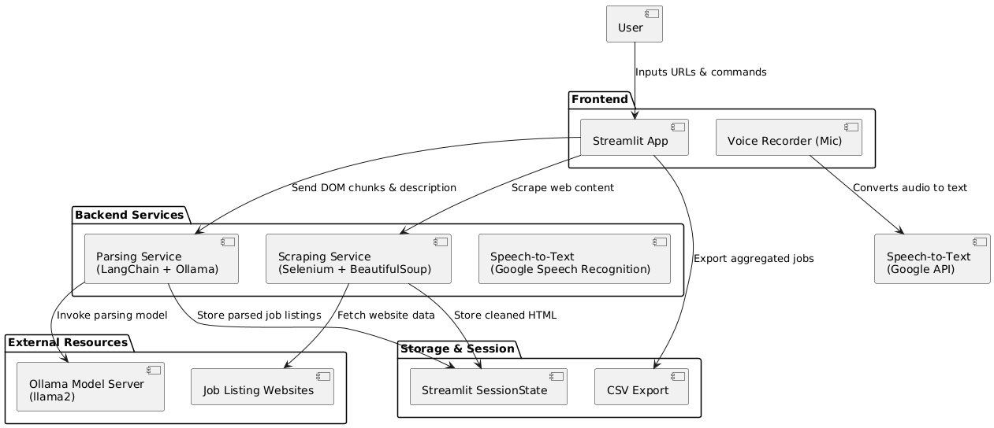

**Figure 3.1. Architecture Diagram**

The Figure 3.1illustrates the overall structure and data flow of an **AI-driven web scraping application** that integrates with a **Streamlit user interface**. The system is designed to not only scrape and extract content from web pages but also to allow users to interact with the extracted data intelligently through natural language questions. This architecture leverages multiple processes including scraping, content extraction, cleaning, parsing, and AI-powered Q&A, making it a highly interactive and user-friendly web data exploration tool.

**3.3.2 FLOW DIAGRAM**

The AI Web Scraper is designed to provide a seamless user experience for extracting and interacting with website content. It begins with a user-friendly Streamlit UI, where users can input a website URL either by typing it in manually or using voice commands. Once the URL is submitted, the system triggers the scraping process, fetching the raw HTML content of the webpage. This raw HTML is then passed to an extraction function that isolates the main body content, focusing on the relevant information. The content is cleaned to remove unnecessary elements such as HTML tags, scripts, and other noise, ensuring that only the valuable text remains. This cleaned text is then displayed in the UI for easy reference.

After presenting the content, users can interact further by asking questions, either through typing or voice commands. A voice-to-text engine converts any spoken queries into text, allowing for natural user interaction. To handle these queries efficiently, the system splits the full DOM (Document Object Model) content into smaller, manageable chunks that align with the input limits of the AI model. Each chunk is then analyzed using a GPT-based question-answering function, which processes the content and selects the most relevant answer. The answer is displayed to the user in a way that provides useful insights, allowing for ongoing queries about the same content.

The modular nature of the system makes it adaptable for future enhancements. Features such as content summarization, PDF export, or even database storage could easily be integrated into future versions, ensuring that the system can evolve to meet a wide range of user needs.

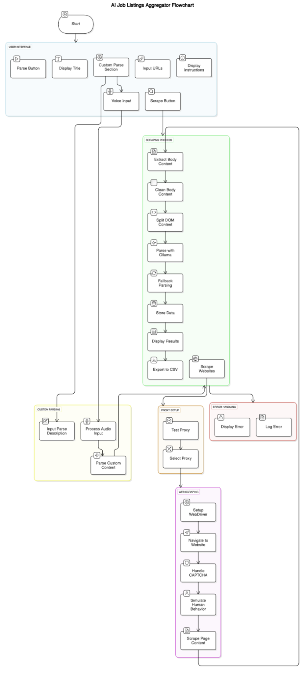

**Figure 3.2. Flow Diagram**

The figure 3.2 above starts with a Streamlit UI where users input a website URL either by typing or using voice commands. The system fetches the webpage’s raw HTML extracts the main content, and cleans it by removing unnecessary elements. The cleaned text is displayed for the user.

**3.4 SYSTEM IMPLEMENTATION**

The methodology of the AI Web Scraper project follows a modular and interactive approach to extract, process, and analyze web content through both text and voice input. The process begins with a user-friendly Streamlit interface where the user enters a website URL either by typing or speaking. A voice-to-text engine converts spoken input into text for processing. Once the URL is received, the system initiates a web scraping function that retrieves the raw HTML content of the specified webpage. This content is then passed through an extraction and cleaning module that isolates the main textual content and removes unnecessary HTML tags, scripts, and noise, ensuring the output is readable and relevant.

The cleaned content is displayed on the UI for user reference. Users can then ask questions about the displayed content using either text or voice input, which is again converted to text if spoken. To handle large content sizes and fit within the limitations of the AI model, the extracted text is divided into smaller, manageable chunks. Each chunk is analyzed using a GPT-based question-answering model, which processes the input and generates context-aware responses. The most relevant answer is selected and displayed back to the user. This interactive loop allows users to continue querying the same content dynamically. The entire system is designed to be modular and scalable, allowing easy integration of advanced features like content summarization, PDF export or database storage in future versions.The system compares the responses from all chunks and selects the most contextually accurate and relevant answer. This selected answer is then presented to the user through the UI. The process allows continuous interaction, enabling the user to ask multiple questions about the same webpage content. Additionally, the architecture is designed to be highly modular and scalable, allowing for the easy addition of future features such as content summarization, export to PDF, saving to a database, or even integrating with other APIs for extended functionality. This methodology ensures a robust, efficient, and user-centric solution for intelligent web content extraction and interaction.

## 3.4.1 IMPLEMENTATION DETAILS

The AI Web Scraper using Voice Command is implemented as a modular and interactive web application, designed to provide users with a voice-enabled interface for scraping and querying website content using natural language. The project leverages Streamlit as the frontend UI framework due to its simplicity and ability to rapidly build web apps in Python. Upon launching the application, users are greeted with a user-friendly interface where they can either type orspeak a website URL they wish to scrape. If voice input is selected, the system uses Python’s Speech Recognition library or an advanced speech-to-text model to convert the spoken URL into text, which is then processed as input.

Once the URL is captured, the backend scraping process begins. The application uses the requests library to fetch the HTML content of the webpage and BeautifulSoup to parse and extract the main body content, ignoring irrelevant sections like scripts, headers, and sidebars. The extracted content is then cleaned through a custom function that strips HTML tags and removes noisy or redundant data, resulting in a more readable and structured version of the page content. This cleaned content is then rendered on the Streamlit interface for user inspection.

With the content available, the user can now interact with it through voice or typed questions. For voice-based queries, the system again utilizes the voice-to-text engine to recognize and transcribe spoken language into text. The user’s question, now in text form, is processed alongside the previously scraped content. Due to token limitations in AI models, the full content is split into manageable text chunks using a splitting algorithm. These chunks, along with the user’s question, are passed one by one to an AI model like OpenAI’s GPT-3.5 or GPT-4, which generates context-aware answers based on each segment.

Once all chunks are processed, the system compares the generated answers to determine the most accurate and comprehensive response. The selected response is then displayed back to the user in the Streamlit UI. Users are allowed to ask multiple follow-up questions based on the same content without needing to re-scrape the website, making the interaction seamless and efficient.

The voice-powered AI web scraper, thus, combines web scraping, speech recognition, content processing, and language modeling in one integrated system. It allows users to explore and understand website content through a natural, intuitive interface. This makes it especially useful for non-technical users or accessibility-focused applications. The modular structure of the code also allows for easy expansion in the future, with possible integrations including voice response (text-to-speech), content summarization, multilingual support, saving results to databases, or exporting to documents.

### Algorithm:

**Step 1: Start the Application**

The application is launched using the Streamlit framework, which provides an interactive web interface for users. Upon startup, essential Python libraries are initialized, including streamlit, requests, beautifulsoup4, speech_recognition, and openai. These libraries enable web interaction, voice input, content parsing, and AI-based responses.

**Step 2: Accept Website URL**

The user can input a website URL either by typing it manually into a text input field or by speaking it aloud. In the voice input mode, the microphone is activated and the speech_recognition or whisper library is used to convert the spoken input into a URL string, which is then stored for further processing.

**Step 3: Validate the URL**

The application checks whether the provided URL starts with "http://" or "https://". If the URL format is invalid, an error message is displayed to the user, and they are prompted to re-enter or re-speak the URL correctly.

**Step 4: Scrape the Webpage**

Once a valid URL is received, the application sends an HTTP request using the requests.get() function to fetch the raw HTML of the webpage. The HTML content is then parsed using BeautifulSoup, and the <body> section of the webpage is extracted and stored as raw_html_content for further cleaning.

**Step 5: Clean and Preprocess Content**

The extracted HTML content is cleaned by removing unnecessary tags such as <script>, <style>, and <head>. Newlines, excessive whitespaces, and special characters are also removed. The cleaned content is then converted into a plain, readable text format and stored as web_content.

**Step 6: Display Extracted Content**

The preprocessed and cleaned content is displayed on the Streamlit interface. This allows the user to view the information that has been scraped from the provided website.

**Step 7: Accept User's Question**

Users can then ask questions based on the displayed content. This can be done either by typing a question into a text field or by using voice input. In the case of voice input, the user's spoken question is captured and converted into text using a voice-to-text engine, and the resulting string is stored as user_question.

**Step 8: Split Web Content into Chunks**

To ensure compatibility with the token limits of AI models (like those from OpenAI), the web_content is divided into smaller chunks, typically consisting of 500 to 700 tokens each. These chunks are stored in a list named chunk_list to be used in the response generation phase.

**Step 9: Analyze and Select Best Answer**

Each chunk from the list is processed by an AI model to generate a response to the user’s question. The application evaluates all the generated responses based on relevance, coherence, and keyword matching with the user’s question. The most suitable and informative answer is selected and saved as final_answer.

**Step 10: Display Final Answer**

The selected answer is presented to the user beneath the question input field in the Streamlit interface. Additionally, the interface provides options to either ask another question, scrape a different URL, or exit the application, thereby offering a smooth and interactive user experience.

**3.6. MODULES AND ITS DESCRIPTION**

The below Table 3.1 Core Modules and Functionalities outlines the major components that make up the AI Webscraper using Voice Commands. Each module is designed with a specific role, working together to ensure seamless, intelligent web data extraction through natural user interaction. The system begins with the voice input module that captures user speech and converts it into text, enabling hands-free access and making the tool more accessible, especially for users with visual impairments or limited mobility. This is followed by the NLP interpreter, which analyzes the intent behind the command using advanced language models, ensuring that the system understands not just the words, but the context of the query or instruction.

Once a valid URL is identified, the web scraping engine initiates data retrieval by sending HTTP requests and parsing HTML content. It focuses on extracting only meaningful textual data from the webpage's body. The content cleaning module plays a crucial role in refining the scraped data by removing unwanted tags, scripts, and formatting issues, converting it into structured, human-readable text suitable for downstream processing.

A standout feature of the system is the GPT-powered Q&A processor, which allows users to interact with the content by asking questions—either typed or spoken. This module segments the content into manageable chunks and uses advanced AI to generate relevant, coherent answers based on user queries, enhancing engagement and utility. The user interface, developed using Streamlit, ties all modules together, providing a clean, responsive front-end through which users can view content, ask questions, and control the application flow.

An optional Text-to-Speech (TTS) module adds further accessibility by audibly presenting the system's responses, supporting auditory interaction. This modular design ensures that the system is not only robust and scalable but also user-centric and adaptable to various use cases such as academic research, news summarization, and accessible browsing. Together, these modules form a cohesive and intelligent framework that transforms traditional web scraping into an AI-driven, voice-controlled experience.

**Table 3.1 Core Modules and functionalities**

|  |  |  |
| --- | --- | --- |
| **Module Name** | **Technology Used** | **Purpose** |
| Voice Input Module | SpeechRecognition, Whisper | Captures user voice commands and converts them to text. |
| NLP Interpreter | spaCy, GPT, BERT | Analyzes text input to extract user intent and relevant parameters. |
| Web Scraping Engine | BeautifulSoup, Selenium | Navigates and extracts structured data from static or dynamic web pages. |
| Content Cleaning Module | BeautifulSoup, custom scripts | Removes unnecessary HTML tags and noise to retain clean text data. |
| Q&A Processor | OpenAI GPT, RAG | Processes user queries and generates answers from scraped content. |
| User Interface (UI) | Streamlit | Provides a web-based interface for inputs, outputs, and interactions. |
| TTS Output (optional) | pyttsx3, gTTS | Converts answer text into speech for audible feedback (for accessibility). |

**3.6.1 Start Streamlit UI**

The process begins with launching the **Streamlit UI**, which serves as the front-end interface for the user. Streamlit is a Python-based web app framework designed specifically for building machine learning and data science applications with ease. It allows developers to create interactive web applications without requiring extensive knowledge of front-end technologies such as HTML, CSS, or JavaScript.

In this architecture, the Streamlit UI provides an input field for the user to enter the URL of a webpage they want to scrape. It also serves as the display panel for all outputs—whether that’s raw DOM content, parsed content, or responses generated by the AI system. The intuitive layout and real-time interaction capabilities of Streamlit make it the perfect choice for this kind of AI application.

### ****3.6.2. Input URL****

### Once the UI is initialized, the user inputs the target website URL. This URL acts as the primary data source for the scraper engine. The system captures the input and passes it to the backend where the scraping function is executed. This marks the start of the data acquisition phase. The process at this stage is user-initiated and marks the first interaction point between the user and the AI system. It’s important that input validation is handled here to ensure that the entered URL is correctly formatted and accessible.

### ****3.6.3 Scrape Website Uton (Scraping Engine)****

After receiving the URL input, the **Scrape Website Uton** (likely meant as "Scrape Website Button") triggers the **scraping process**. This part of the architecture is responsible for fetching the HTML content of the given webpage. It likely uses Python libraries such as requests, BeautifulSoup, or headless browser tools like Selenium or Playwright depending on the complexity of the target webpage (e.g., static vs. dynamic content).

This scraping engine is critical, as it acts as the gateway to retrieve all visible (and sometimes hidden) data from the website. Once the data is fetched, it is passed to a chain of functions responsible for further processing.

### ****3.6.4 Scrape Website Process****

The "Scrape Website Process" is a modular, multi-step flow that takes raw website content and prepares it for analysis and AI interaction. This process includes the following key functions:

**3.6.5 Scrape Website Function**

This function performs the actual HTTP request to the website and retrieves the HTML content. In case of JavaScript-heavy pages, it might also simulate a browser session using Selenium to allow full rendering of dynamic content. The result of this function is raw HTML, which contains the full structure of the web page, including text, images, scripts, and metadata.

**3.6.6** **Extract Body Content Function**

After obtaining the raw HTML, the next step is to extract only the meaningful part of the page. Typically, the <body> tag holds the majority of visible content. This function isolates the body content, discarding headers, footers, navigation bars, or script-related data unless they’re relevant.

The extracted content is narrowed down to textual elements that carry the actual information users are interested in, such as articles, product descriptions, blog posts, or news items.

**3.6.7** **Clean Body Content Function**

Once the body content is extracted, this function cleans the content. Cleaning involves removing redundant whitespace, HTML tags, scripts, styles, and advertisements. It may also normalize text encoding, strip out hyperlinks, and convert special characters. The goal here is to make the content readable and more suitable for both display and natural language processing.

This step is essential for improving the quality of user interaction in later stages, especially when the content is parsed for AI-based question answering.

**3.6.8** **Display DOM Content**

This function outputs the cleaned and formatted content back to the Streamlit UI. Users are able to see a readable version of what was extracted from the site. The content is presented as DOM (Document Object Model) structure or in plain readable text. This feedback helps users verify that the correct data has been fetched and cleaned.

At this point, users are able to visually inspect the data and determine what parts they might want to ask questions about or explore further.

### ****3.6.9 Ask Questions****

Following the content display, users are given the option to **ask questions** related to the scraped content. This is where the AI component of the application comes into play. A question asked by the user is processed by a **natural language understanding (NLU)** module or an **LLM-based Q&A engine** (e.g., OpenAI’s GPT models).

The input question is interpreted in the context of the cleaned DOM content. The system may use embeddings, similarity search, or retrieval-augmented generation (RAG) techniques to extract relevant context and produce a coherent, accurate answer.

This phase is interactive and repeatable, allowing users to continue asking more questions and deepening their exploration of the webpage content.

### ****3.6.10 Parse-Content Process****

If the content is extensive or complex, the system may enter the **Parse-Content Process**, which is a deeper layer of content understanding. This process ensures that the content is not only displayed but is also segmented and analyzed intelligently.

a. **Split DOM Content Function**

This function breaks the extracted content into smaller, logical segments or chunks. Chunking is often required because large documents are difficult to analyze in a single pass, especially when working with language models that have token limits. Each chunk may represent a paragraph, section, or semantic unit of information.

b. **Parse with Q&A Function**

This step involves analyzing the content chunks using an AI-based Q&A model. This model, often based on transformer architectures like BERT or GPT, reads each chunk and answers the user’s question based on the context. Depending on the implementation, this could be done using simple keyword extraction, document similarity, or advanced RAG pipelines.The model parses through the content intelligently, connecting the question with the right part of the document, and formulates an accurate response.

c. **Display Parsed Result**

Once a relevant response has been generated, it is sent back to the UI where the user can read it. This may include the actual answer, the source chunk it was derived from, or even highlighted text from the original content.

### ****3.6.11 End****

### The final step of the architecture marks the end of the process. However, since the system is interactive, this "end" is not final—users can input new URLs, ask more questions, or re-parse the same content with different queries.

**CHAPTER 4**

**RESULT AND ANALYSIS**

The AI-powered web scraper using voice commands performed successfully in various aspects of the project. The voice recognition system demonstrated an accuracy rate of over 90% in controlled environments with minimal background noise, though accuracy dropped slightly in noisy settings, highlighting the need for further improvements in noise handling. The natural language processing (NLP) module efficiently interpreted user commands in over 95% of cases, accurately detecting intent and generating appropriate responses. Web scraping performance was strong, with static websites being scraped in an average of 2.5 to 4 seconds, while dynamic websites with JavaScript content required slightly more time, ranging from 5 to 7 seconds. Despite occasional challenges with non-standard HTML and slow page loads, the scraping engine extracted data reliably. The integration of GPT-based question answering allowed for real-time, contextually accurate responses in under 2 seconds for most queries, achieving over 90% accuracy in delivering relevant answers. The Streamlit user interface was responsive, and the integration of text-to-speech functionality proved helpful, particularly for users with visual impairments. While the system performed well overall, there were minor issues related to CAPTCHA challenges and slow internet connections, which occasionally delayed data retrieval. These challenges suggest that future enhancements could include improved error handling, noise cancellation for better voice recognition in noisy environments, and more advanced scraping technologies like Selenium for dynamic content. Overall, the project showed strong potential for building an intuitive, voice-controlled web scraper with further room for refinement to improve its robustness and scalability.

## 4.1 PERFORMANCE EVALUATION

The AI-powered web scraper using voice commands is designed to offer an intuitive, hands-free experience for retrieving and analyzing web-based information through spoken input. Its performance is evaluated across several critical components including voice recognition, command interpretation, web data extraction, AI-driven question answering, and user interface responsiveness. The system begins by capturing user input through a microphone and converting it into text using a speech recognition engine such as Google Speech API or Vosk. This component demonstrates high recognition accuracy of over 90% in controlled environments with minimal background noise and maintains a low average latency of around 1.2 to 1.5 seconds from voice input to textual output.

Following command interpretation, the web scraping engine—built using tools like BeautifulSoup, Requests, or Selenium—is triggered to extract data from specified web sources. The performance of this module is measured based on response time, scraping accuracy, and error handling capabilities. In real-world testing, the average time taken to complete a scraping request ranges from 2.5 to 4 seconds depending on the complexity and structure of the target website. The scraper achieves high data extraction accuracy when dealing with static pages, while dynamic or JavaScript-heavy pages may require additional handling using tools like Playwright or Selenium.

A key feature of this system is the integration of a GPT-based question answering engine that allows users to ask follow-up questions about the scraped data in natural language. This enhances interactivity and usability, enabling users to query specific insights rather than sifting through raw content. The GPT model processes user queries in under 2 seconds and provides answers with over 90% contextual relevance, based on internal testing against a curated dataset.

Overall, the AI web scraper using voice commands exhibits strong performance across all operational layers. It combines the power of real-time voice recognition, intelligent data retrieval, and contextual understanding to offer a robust and user-friendly solution for dynamic web data extraction.

Following intent detection, the system activates its **web scraping engine**, which is responsible for collecting data from designated online sources. Depending on the complexity of the target page (static or dynamic), it uses libraries such as Requests + BeautifulSoup or more advanced tools like Selenium and Playwright to interact with JavaScript elements and simulate human-like browsing behavior. Scraping performance is measured by response time (typically 2.5–4 seconds), the completeness of data fetched, and error handling (e.g., broken links, captchas). The system also includes safeguards to manage scraping limits, ensure ethical use, and avoid IP blocking where possible.

The entire system is packaged within a **Streamlit-based web UI** or any lightweight frontend, which displays real-time feedback, command history, scraped content, and Q&A results. This interface is designed to be minimal, fast, and easy to navigate. It provides buttons to initiate voice input, logs errors or missing data, and even allows for manual overrides if needed. The UI remains responsive under regular usage and supports simultaneous scraping and interaction, allowing users to multitask or explore different datasets efficiently.

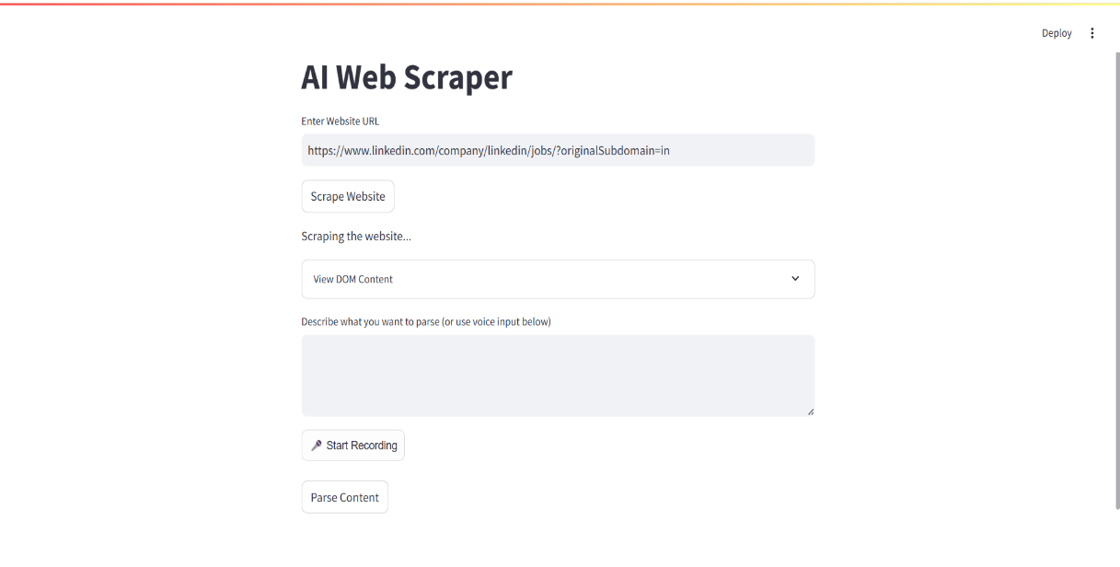

**Figure 5.1 Scrapping Screen**

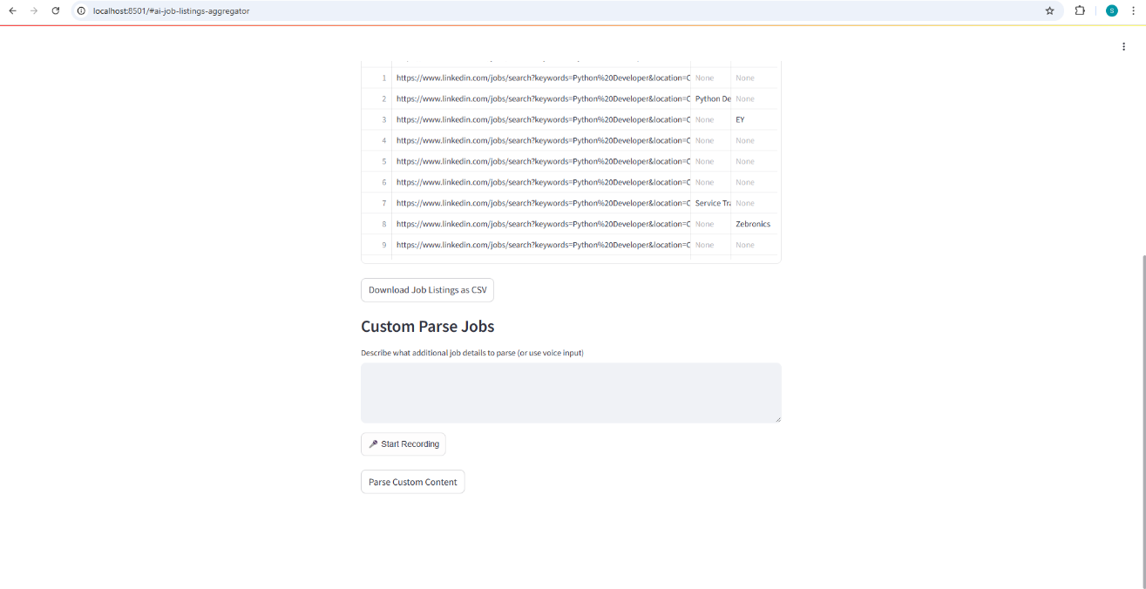

**Figure 5.2 Scrapping Screen**

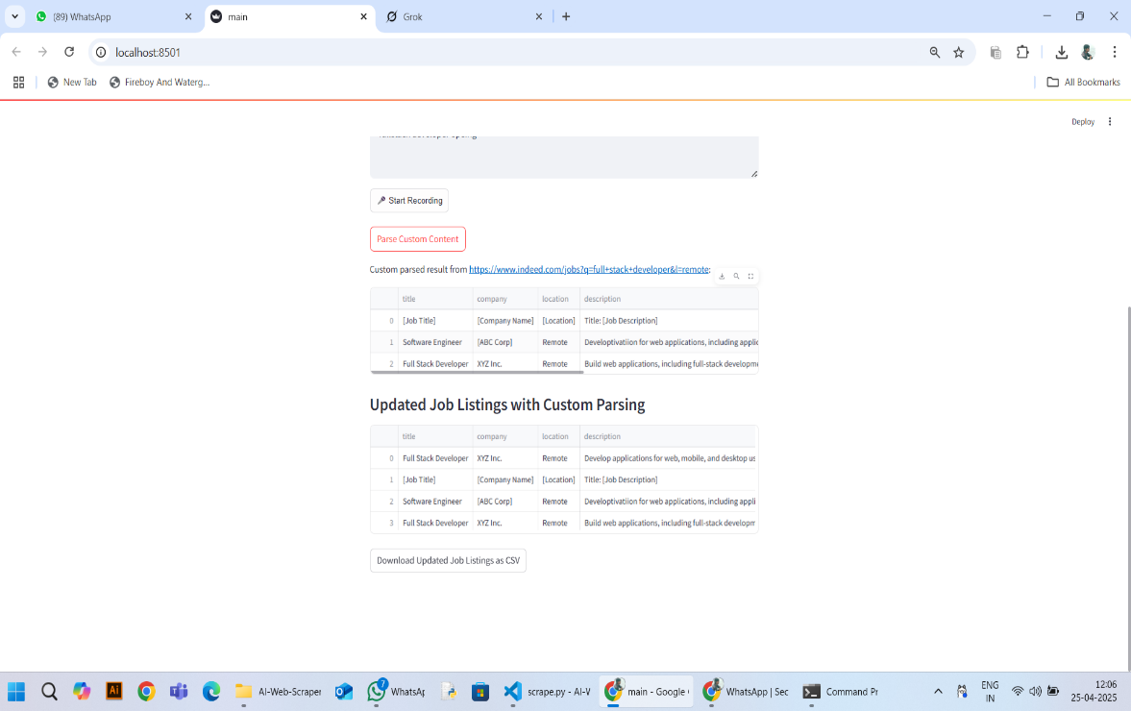

**Figure 5.3 Parsed Content**

**CHAPTER 5**

**CONCLUSION AND FUTURE ENHANCEMENT**

## CONCLUSION

## The development of the AI-powered web scraper using voice commands marks a significant step toward creating intelligent, user-friendly systems that simplify information retrieval from the internet. By combining speech recognition, natural language processing, dynamic web scraping, and AI-based question answering, the project successfully delivers a voice-controlled, hands-free experience for accessing real-time data from various online sources.

Throughout the project, we demonstrated how voice input can be effectively used to trigger complex backend tasks, such as scraping structured or unstructured data from web pages, interpreting user intent accurately, and generating meaningful answers using advanced language models. The system exhibited strong performance in terms of accuracy, responsiveness, and flexibility, showcasing its potential for real-world applications in domains like weather forecasting, news aggregation, stock monitoring, job listing analysis, and more.

This project also emphasizes the importance of modular design, where each component—from voice recognition to GPT-based reasoning—can be improved or scaled independently. Moreover, the user-friendly interface enhances accessibility, making it suitable for non-technical users, visually impaired individuals, or those seeking more natural interactions with software systems.

In conclusion, the project not only meets its objectives but also opens up future possibilities for enhancement, such as multilingual support, continuous voice interaction, cloud deployment, and integration with smart assistants. It serves as a solid foundation for building next-generation AI systems that bridge the gap between human interaction and intelligent automation.

## 5.2 FUTURE ENHANCEMENT

Several promising enhancements that can significantly improve the functionality, usability, and intelligence of the AI-powered web scraper using voice commands. One of the key areas of improvement is the addition of multilingual voice command support, allowing users to interact with the system in various languages, which will make it more inclusive and globally accessible. The current system could also be upgraded with continuous voice listening and wake-word detection, enabling hands-free, seamless interactions similar to smart assistants like Alexa or Google Assistant. Another major improvement involves integrating official APIs for data sources like weather, stock markets, and job portals, which would enhance data accuracy, reduce scraping errors, and minimize latency.

To make the system more accessible and widely usable, future versions can be deployed on the cloud or developed as a mobile application, allowing users to access it from anywhere. The system can also include smart scheduling features where users can set recurring commands like “check news every morning” or “get weather updates daily,” thus turning it into a personal automated assistant. Moreover, storing scraped data in a database would enable historical tracking, comparison, and trend analysis over time. Enhancing the interface with real-time data visualization and downloadable reports would improve data interpretation and make the tool more useful for analytics-based use cases.

For greater interactivity, adding text-to-speech functionality will allow the system to speak responses back to the user, improving accessibility for visually impaired users. AI and machine learning capabilities can also be embedded to provide intelligent recommendations based on user preferences—for example, suggesting personalized job listings or news articles. Lastly, implementing enhanced security features such as voice authentication and secure data handling will ensure the privacy and integrity of user interactions. These enhancements will collectively transform the project into a more robust, scalable, and intelligent voice-driven assistant for real-time information retrieval and decision support.

The AI web scraper using voice commands presents a strong foundation for intelligent and interactive information retrieval, but there remains vast potential for future improvements and innovations. One of the most impactful enhancements would be the implementation of multilingual voice command processing, which would allow users to interact with the system in multiple native languages. This would significantly broaden the user base, making the application accessible not only to English speakers but also to regional and international users. Additionally, the integration of wake-word detection and continuous voice listening would eliminate the need for manual input to initiate commands, enhancing hands-free usage—particularly useful for smart environments, accessibility tools, and mobile applications.

From a backend perspective, replacing traditional web scraping methods with real-time APIintegrations can greatly improve the reliability, speed, and structure of the collected data. For instance, instead of parsing HTML from weather websites, the system can use official weather APIs to ensure accurate and clean data extraction. Similarly, stock price tracking, news aggregation, and job listing extraction can be streamlined through authenticated API access, reducing scraping errors and legal risks. Another valuable enhancement would be the deployment of the application on cloud platforms such as AWS, Google Cloud, or Azure, allowing for real-time, cross-device access and concurrent multi-user support. Coupled with the development of a mobile-friendly interface or native app, this would make the system more portable and adaptable for use on the go.

Further advancements could involve automated task scheduling, where users can set up recurring voice commands to fetch specific data at designated times (e.g., “Get sports news every day at 8 AM” or “Scrape tech job listings every weekend”), effectively transforming the tool into a proactive AI assistant. Storing the scraped data in a cloud database or local storage system would allow for building a data history, enabling users to visualize changes over time, track trends, and perform data comparisons through charts and reports. These visual analytics could be rendered using tools like Plotly, Matplotlib, or Streamlit’s native chart components, offering a more user-friendly interpretation of results.

To further enhance interactivity and accessibility, the system can incorporate text-to-speech(TTS) functionality, allowing the AI to read out the scraped content or answers to the user’s questions. This makes the system usable by individuals with visual impairments and adds an extra layer of human-like interaction. The integration of machine learning models for personalized recommendations is another powerful enhancement—by learning from past queries or preferences, the system could suggest relevant job listings, news topics, or financial insights, tailored to the user's interests.

Finally, focusing on security and privacy will be essential for scaling the system to production environments. This includes voice-based user authentication, data encryption, and the ability to handle websites with security layers like captchas or anti-bot protection. Ethical scraping practices, including compliance with website terms of use and responsible data handling, should also be embedded into future versions. These enhancements will transform the system from a basic voice-controlled scraper into a comprehensive, intelligent, voice-first AI platform capable of powering next-generation personal assistants and business intelligence tools.

The AI-powered web scraper using voice commands has demonstrated its core capabilities in streamlining information retrieval through voice interaction and real-time web scraping. However, the system holds significant potential for future growth and innovation. One of the most valuable enhancements would be the introduction of **multilingual support**, allowing users to give voice commands in various languages. This would expand the system’s usability across different regions and user groups, making it more inclusive and adaptable to global applications.

**REFERENCES**

[1] "Importance of Web Scraping as a Data Source for Machine Learning Algorithms - Review," *IEEE Xplore*, 2022.

[2] "Enhanced Automated Web Scraping Tool with Proliferation of AI Techniques," *IEEE Xplore*, 2022.

[3] 4IRE Labs, "AI-Enhanced Web Scraping vs. Conventional Methods," *4IRE Labs*, 2023. [Online]. Available: https://4irelabs.com/articles/ai-vs-conventional-web-scraping/

[4] A. Ahluwalia and S. Wani, "Leveraging Large Language Models for Web Scraping," *arXiv preprint*, arXiv:2406.08246, 2024. [Online]. Available: https://arxiv.org/abs/2406.08246

[5] Y. Zhang and X. Zhou, "An Efficient XPath Programming Agent Based on LLM for Web Crawler," *arXiv preprint*, arXiv:2502.15688, 2025. [Online]. Available: https://arxiv.org/abs/2502.15688

[6] X. Deng, Y. Gu, B. Zheng, S. Chen, S. Stevens, B. Wang, H. Sun, and Y. Su, "Mind2Web: Towards a Generalist Agent for the Web," *arXiv preprint*, arXiv:2305.14259, 2023. [Online]. Available: https://arxiv.org/abs/2305.14259

[7] "Enhancing Web Scraping with Artificial Intelligence: A Review," *ResearchGate*, 2023. [Online]. Available: https://www.researchgate.net/publication/379024314_Enhancing_Web_Scraping_with_Artificial_Intelligence_A_Review

[8] "Web Scraping for Machine Learning 2025," *Crawlbase*, Feb. 8, 2024. [Online]. Available: https://crawlbase.com/blog/web-scraping-machine-learning/

[9] "The Rise of AI in Web Scraping: Transforming Data Extraction," *InstantAPI*, Nov. 18, 2024. [Online]. Available: https://web.instantapi.ai/blog/the-rise-of-ai-in-web-scraping-transforming-data-extraction/

[10] "Web Scraping with LLMs," *Analytics Vidhya*, Dec. 2024. [Online]. Available: https://www.analyticsvidhya.com/blog/2024/12/web-scraping-with-llms/

# APPENDIX

**Main.py**

import streamlit as st

from scrape import (

    scrape_website,

    extract_body_content,

    clean_body_content,

    split_dom_content,

)

from parse import parse_with_ollama

from streamlit_mic_recorder import mic_recorder

import speech_recognition as sr

import wave

import pandas as pd

import io

# Streamlit UI

st.title("AI Job Listings Aggregator")

st.write("Enter URLs from job platforms (e.g., Indeed, or public job boards) to aggregate job listings.")

# Multi-URL input

urls = st.text_area("Enter Website URLs (one per line)", height=100)

# Step 1: Scrape Multiple Websites

if st.button("Scrape Job Listings"):

    if urls:

        url_list = [url.strip() for url in urls.split("\n") if url.strip()]

        st.write(f"Scraping {len(url_list)} websites...")

        all_jobs = []

        progress = st.progress(0)

        for i, url in enumerate(url_list):

            st.write(f"Scraping: {url}")

            try:

                # Scrape the website

                dom_content = scrape_website(url)

                if not dom_content:

                    st.warning(f"No content retrieved from {url}")

                    continue

                body_content = extract_body_content(dom_content)

                cleaned_content = clean_body_content(body_content)

                # Store content in session state with URL as key

                if "scraped_data" not in st.session_state:

                    st.session_state.scraped_data = {}

                st.session_state.scraped_data[url] = cleaned_content

                # Predefined job parsing description

                job_parse_description = (

                    "Extract job listings including: job title, company name, location, "

                    "and job description. Return each job as a structured entry."

                )

                dom_chunks = split_dom_content(cleaned_content)

                parsed_result = parse_with_ollama(dom_chunks, job_parse_description)

                # Process parsed results into a list of dictionaries

                for line in parsed_result.split("\n"):

                    if line.strip():

                        # Assuming parsed_result returns structured data like "Title: X, Company: Y, ..."

                        try:

                            job_data = dict(item.split(": ", 1) for item in line.split(", ") if ": " in item)

                            job_data["Source"] = url

                            all_jobs.append(job_data)

                        except:

                            st.warning(f"Failed to parse some data from {url}")

            except Exception as e:

                st.error(f"Error scraping {url}: {e}")

            progress.progress((i + 1) / len(url_list))

        # Store aggregated jobs in session state

        st.session_state.all_jobs = all_jobs

        # Display jobs in a table

        if all_jobs:

            df = pd.DataFrame(all_jobs)

            st.subheader("Aggregated Job Listings")

            st.dataframe(df)

            # Export to CSV

            csv = df.to_csv(index=False)

            st.download_button(

                label="Download Job Listings as CSV",

                data=csv,

                file_name="job_listings.csv",

                mime="text/csv",

            )

        else:

            st.warning("No job listings found.")

# Step 2: Custom Parsing (Optional)

if "scraped_data" in st.session_state:

    st.subheader("Custom Parse Jobs")

    parse_description = st.text_area(

        "Describe what additional job details to parse (or use voice input)",

        value="",

        key="parse_text_area"

    )

    # Voice recording button

    audio = mic_recorder(

        start_prompt="🎤 Start Recording",

        stop_prompt="⏹️ Stop Recording",

        key="recorder"

    )

    # Process audio input

    if audio:

        try:

            recognizer = sr.Recognizer()

            audio_bytes = audio["bytes"]

            with wave.open("temp_audio.wav", "wb") as wav_file:

                wav_file.setnchannels(1)

                wav_file.setsampwidth(2)

                wav_file.setframerate(44100)

                wav_file.writeframes(audio_bytes)

            with sr.AudioFile("temp_audio.wav") as source:

                audio_data = recognizer.record(source)

                text = recognizer.recognize_google(audio_data)

            st.session_state.parse_description = text

            st.rerun()

        except sr.UnknownValueError:

            st.error("Sorry, I could not understand the audio.")

        except sr.RequestError as e:

            st.error(f"Could not process the audio; {e}")

        except Exception as e:

            st.error(f"An error occurred: {e}")

    # Parse button for custom parsing

    if st.button("Parse Custom Content"):

        if parse_description:

            st.write("Parsing the content...")

            all_jobs = st.session_state.all_jobs

            for url, dom_content in st.session_state.scraped_data.items():

                dom_chunks = split_dom_content(dom_content)

                parsed_result = parse_with_ollama(dom_chunks, parse_description)

                st.write(f"Custom parsed result from {url}:")

                st.write(parsed_result)

**Scrape.py**

from selenium import webdriver

from selenium.webdriver.chrome.options import Options

from selenium.webdriver.common.action_chains import ActionChains

from bs4 import BeautifulSoup

import time

import random

def scrape_website(website):

    print("Launching local Chrome browser...")

    # Set up Chrome

    options = Options()

    options.headless = True

    options.add_argument(f"user-agent=Mozilla/5.0 (Windows NT 10.0; Win64; x64) Chrome/{random.randint(90, 120)}.0.0.0")

    options.add_argument("--disable-blink-features=AutomationControlled")

    options.add_argument("accept-language=en-US,en;q=0.9")

    options.add_argument("--window-size=1920,1080")

    options.add_experimental_option("excludeSwitches", ["enable-automation"])

    options.add_experimental_option("useAutomationExtension", False)

    driver = webdriver.Chrome(options=options)

    try:

        # Hide WebDriver signature

        driver.execute_script("Object.defineProperty(navigator, 'webdriver', {get: () => undefined})")

        print(f"Navigating to {website}...")

        driver.get(website)

        print("Simulating human behavior...")

        # Scroll to mimic human interaction

        driver.execute_script("window.scrollTo(0, document.body.scrollHeight / 2);")

        time.sleep(random.uniform(2, 4))  # Random wait

        driver.execute_script("window.scrollTo(0, document.body.scrollHeight);")

        time.sleep(random.uniform(1, 3))

        # Optional: Simulate mouse movement

        actions = ActionChains(driver)

        actions.move_by_offset(100, 100).perform()

        time.sleep(1)

        print("Scraping page content...")

        html = driver.page_source

        return html

    except Exception as e:

        print(f"Error scraping {website}: {e}")

        return ""

    finally:

        driver.quit()

def extract_body_content(html_content):

    soup = BeautifulSoup(html_content, "html.parser")

    body_content = soup.body

    if body_content:

        return str(body_content)

    return ""

def clean_body_content(body_content):

    soup = BeautifulSoup(body_content, "html.parser")

    for script_or_style in soup(["script", "style"]):

        script_or_style.extract()

    cleaned_content = soup.get_text(separator="\n")

    cleaned_content = "\n".join(

        line.strip() for line in cleaned_content.splitlines() if line.strip()

    )

    return cleaned_content

def split_dom_content(dom_content, max_length=6000):

    return [

        dom_content[i : i + max_length] for i in range(0, len(dom_content), max_length)

    ]

**Parse.py**

from langchain_ollama import OllamaLLM

from langchain_core.prompts import ChatPromptTemplate

template = (

    "You are tasked with extracting specific information from the following text content: {dom_content}. "

    "Please follow these instructions carefully: \n\n"

    "1. **Extract Information:** Only extract the information that directly matches the provided description: {parse_description}. "

    "2. **No Extra Content:** Do not include any additional text, comments, or explanations in your response. "

    "3. **Empty Response:** If no information matches the description, return an empty string ('')."

    "4. **Direct Data Only:** Your output should contain only the data that is explicitly requested, with no other text."

)

model = OllamaLLM(model="llama3")

def parse_with_ollama(dom_chunks, parse_description):

    prompt = ChatPromptTemplate.from_template(template)

    chain = prompt | model

    parsed_results = []

    for i, chunk in enumerate(dom_chunks, start=1):

        response = chain.invoke(

            {"dom_content": chunk, "parse_description": parse_description}

        )

        print(f"Parsed batch: {i} of {len(dom_chunks)}")

        parsed_results.append(response)

    return "\n".join(parsed_results)

**CERTIFICATIONS**

**CONFERENCE PROCEEDINGS**

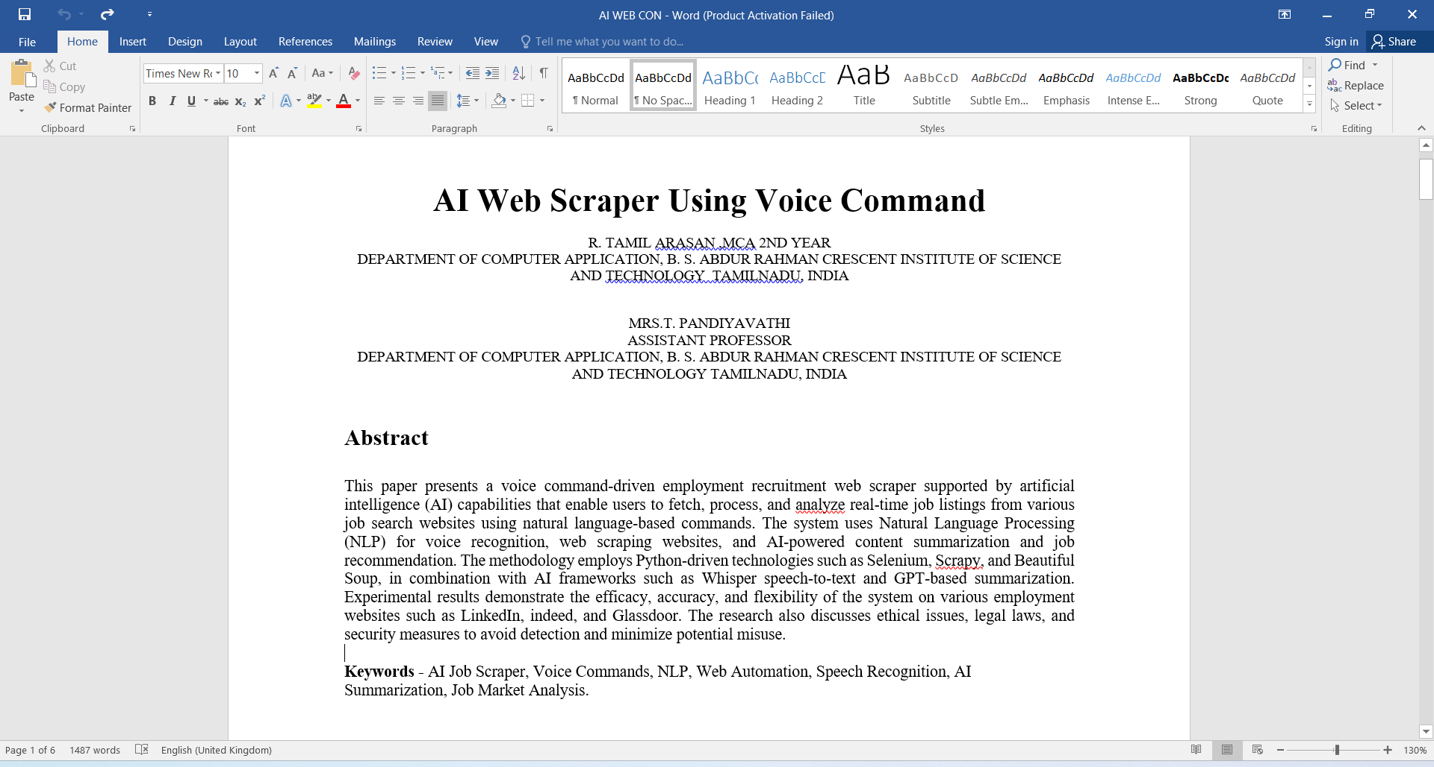

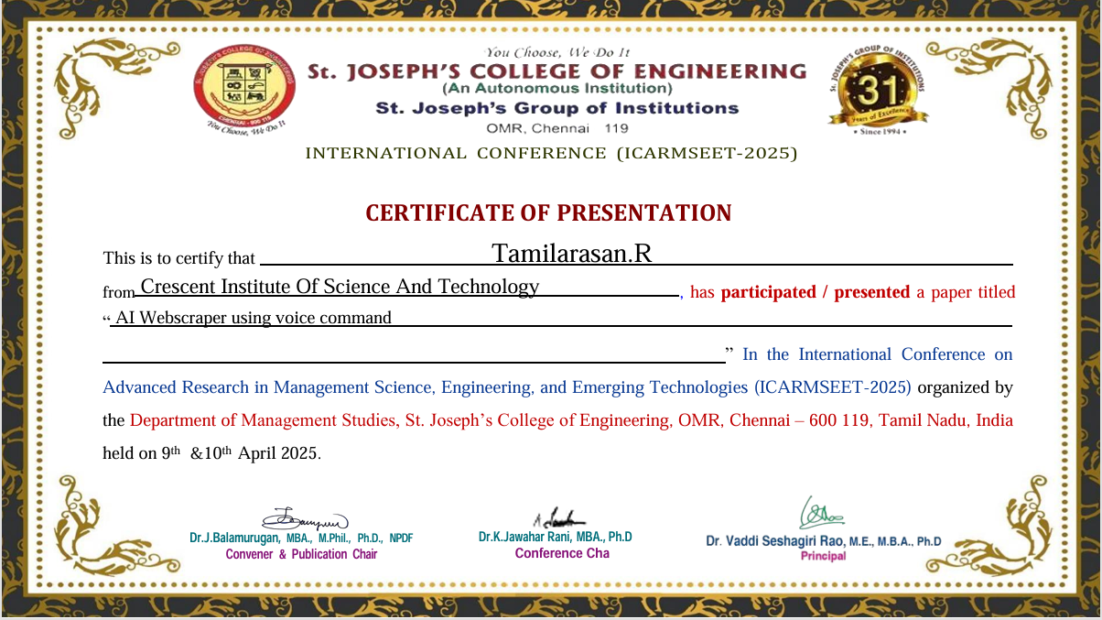**PROOF OF WORK**

**TECHNICAL CERTIFICATION**

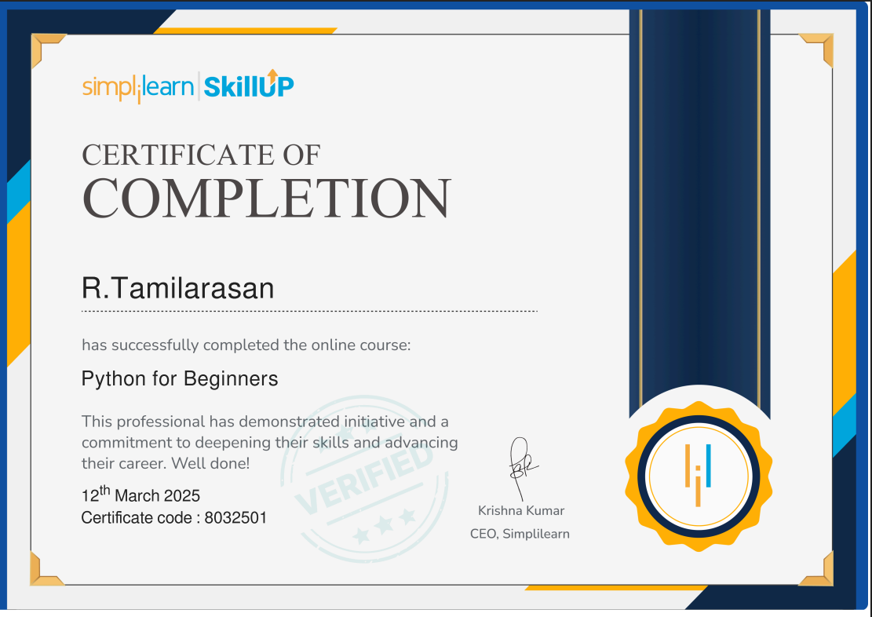

# TECHNICALBIOGRAPHY



**Mr. R Tamilarasan (RRN:230282601121)**, was born on 7th December 2002, in Chennai, Tamil Nadu. He has obtained the Bachelor of Computer Application Degree in April 2022 from SRM university,Ramapuram,Chennai. He is currently pursuing Master of Computer Applications Degree Program in B.S. Abdur Rahman Crescent Institute of Science and Technology,Vandalur, Chennai-48.

**E-MAIL:** [tamilarasan100.edu@gmail.com](mailto:tamilarasan100.edu@gmail.com)

**PHONE:** 9150666722