**Write a code for connecting JDBC to MySql and execute to display the table.**

**SQL Code:**

CREATE DATABASE ATM;

USE ATM;

CREATE TABLE ACCOUNT(

ID INT PRIMARY KEY,

ATM_PIN INT,

BANK_NAME VARCHAR(30)

);

INSERT INTO ACCOUNT VALUES(1001,2922,"STATE BANK OF INDIA");

INSERT INTO ACCOUNT VALUES(2001,2213,"INDIAN BANK");

INSERT INTO ACCOUNT VALUES(3001,1237,"BANK OF BARODA");

SELECT * FROM ACCOUNT;

**Output:**

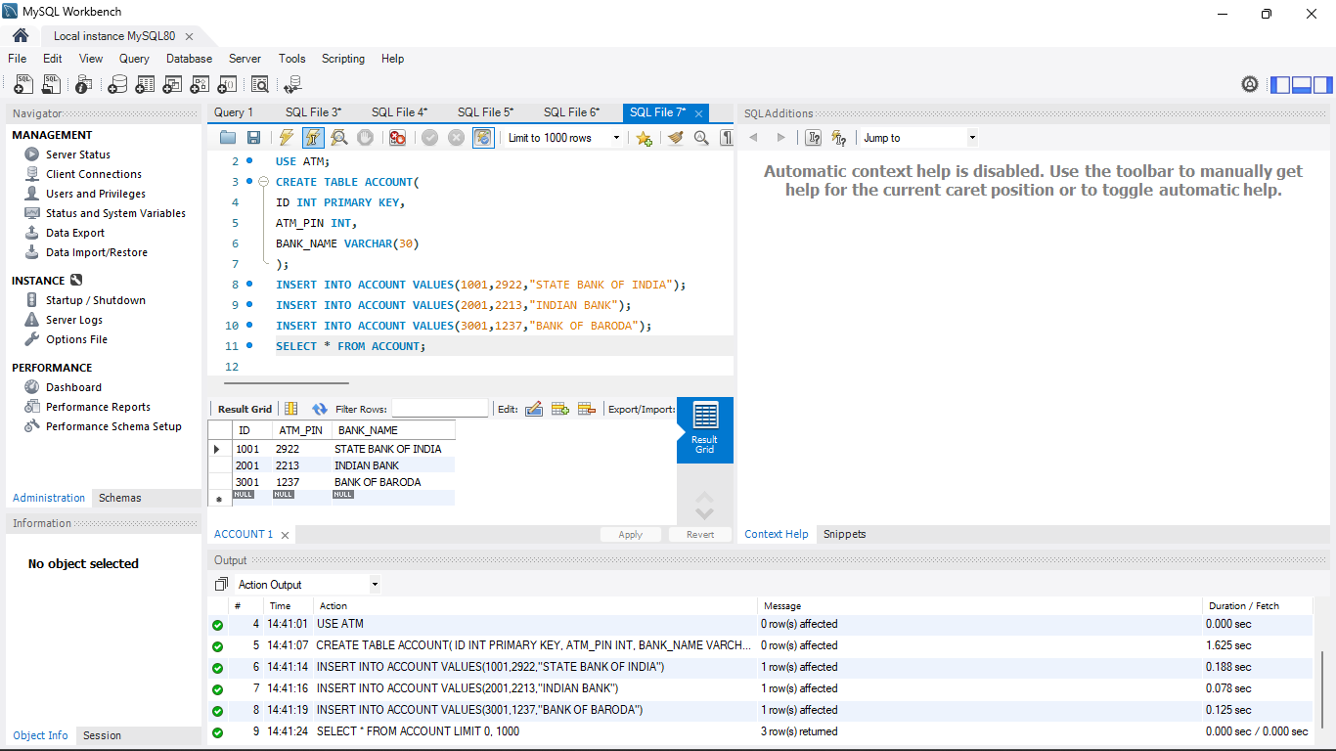

**Code for Connecting JDBC:**

package tamil;

import java.sql.*;

class BASE{

public Statement s;

BASE() throws ClassNotFoundException, SQLException{

Class.forName("com.mysql.cj.jdbc.Driver");

Connection con =

DriverManager.getConnection("jdbc:mysql://localhost:3306/ATM","root","Tamil19@");

s = con.createStatement();

}

public void insert(String query) throws SQLException{

s.executeUpdate(query);

}

public void select(String query) throws SQLException{

ResultSet result = s.executeQuery(query);

while(result.next()){

System.out.println(result.getString(1) + "\t" +

result.getString(2) + "\t" + result.getString(3));

}

}

}

public class Main{

public static void main(String[] args) throws ClassNotFoundException,

SQLException {

BASE show = new BASE();

show.select("SELECT * FROM ACCOUNT");

}

}

**Output:**

