Lab Layout for BGSW – SDS Labs at COB-SEZ2 Location, Coimbatore

SDS-EMS-COB-SEZ2-C-111-non-ACL-Lab:

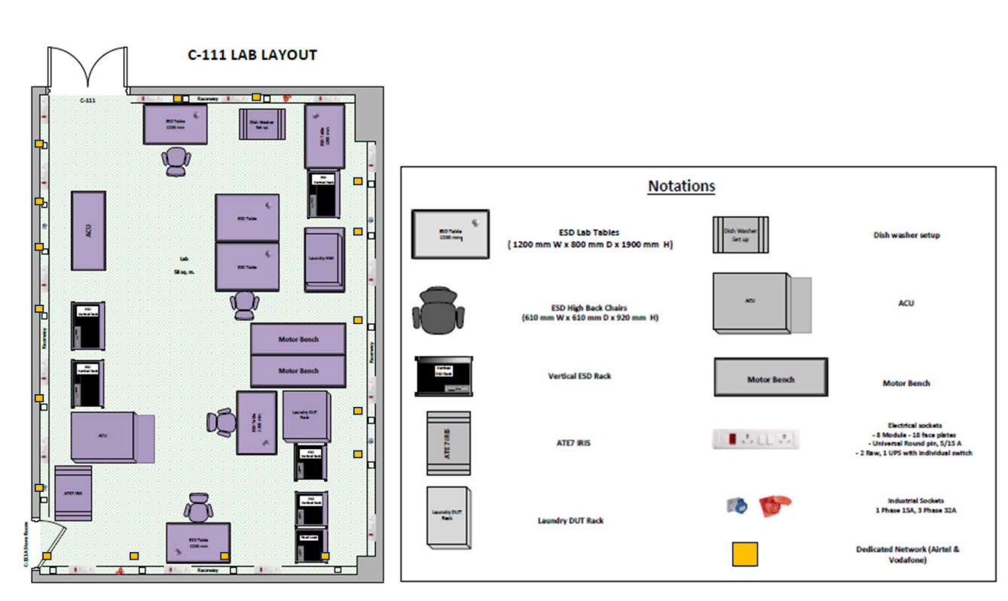

SDS-EMS-COB-SEZ2-C-115-non-ACL-Lab:

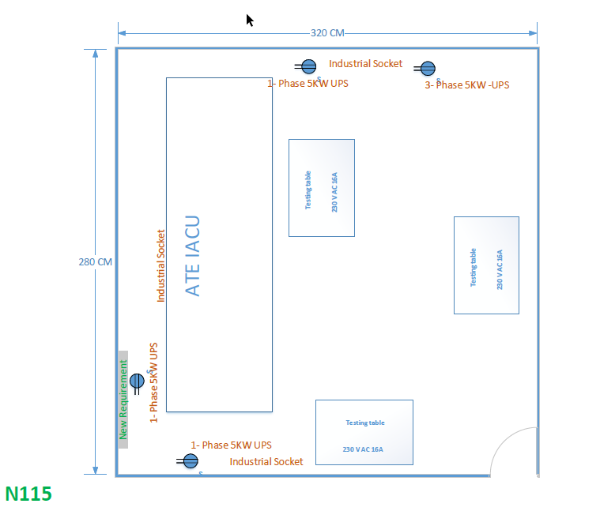

SDS-EMS-COB-SEZ2-C-204-non-ACL-Lab:

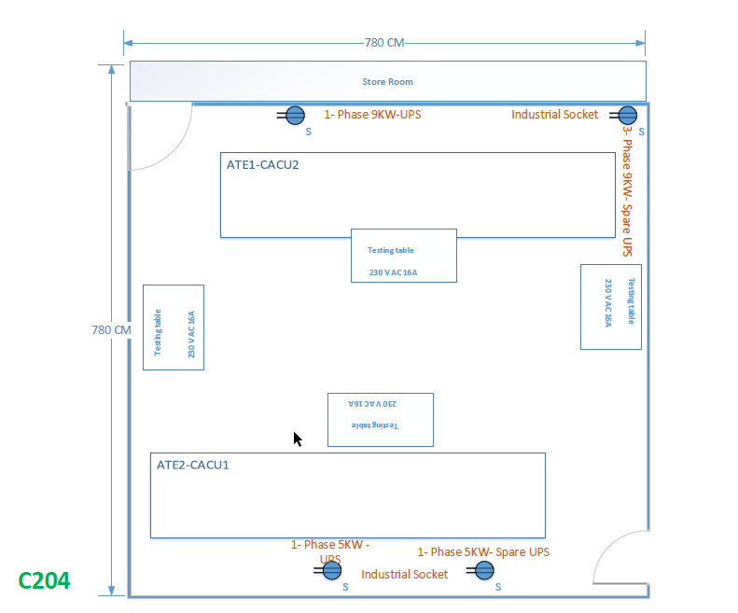

Revison History:

Date / Version No. | Prepared/Editor | Description of amendment | Reviewer
18 Aug 2026 / /DTL Ver 1.0  /Issue Ver 1.0 | Manikandan  Kumar | New lab layout has been updated | Dahal Raj Kumar

