**DAX (Data Analysis Expressions)**

**1. What is DAX?**

DAX stands for **Data Analysis Expressions**. It is a formula language used in Microsoft Power BI, Excel Power Pivot, and SQL Server Analysis Services (SSAS) Tabular models. DAX helps users create new information from the data already present in the model by building custom calculations and expressions.

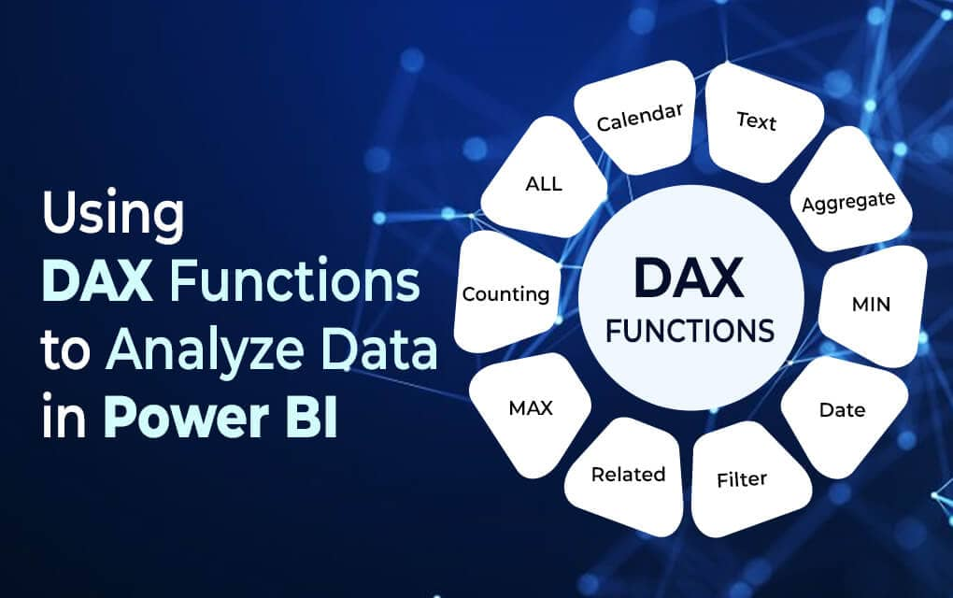

Key features of DAX:

* Designed to work with relational data.
* Enables dynamic aggregation and filtering.
* Supports complex calculations and measures.

**Common Graphical Representations in Power BI:**

1. **Bar Chart** – Compares values across categories (e.g., sales by product).
2. **Column Chart** – Like bar charts but vertical; good for comparing data over time.
3. **Line Chart** – Ideal for showing trends over a time period.
4. **Pie Chart / Donut Chart** – Shows proportions or percentage share of a whole.
5. **Table and Matrix** – Tabular formats for detailed data with rows and columns.
6. **Cards** – Show a single value like total revenue or number of customers.
7. **Gauge** – Shows progress toward a goal or target.
8. **Map Visuals** – Display geographical data (e.g., sales by country).
9. **Slicer** – Not a visual chart but a filtering tool for interactive reports.
10. **Scatter Chart** – Displays relationships between two numerical values.

**Purpose:**

Graphical representations in Power BI help:

* Summarize large volumes of data
* Make data more understandable
* Spot trends, outliers, and patterns
* Enable interactive dashboards and storytelling with data

**2. Types of Operators in DAX**

Operators in DAX are used to perform calculations or comparisons.

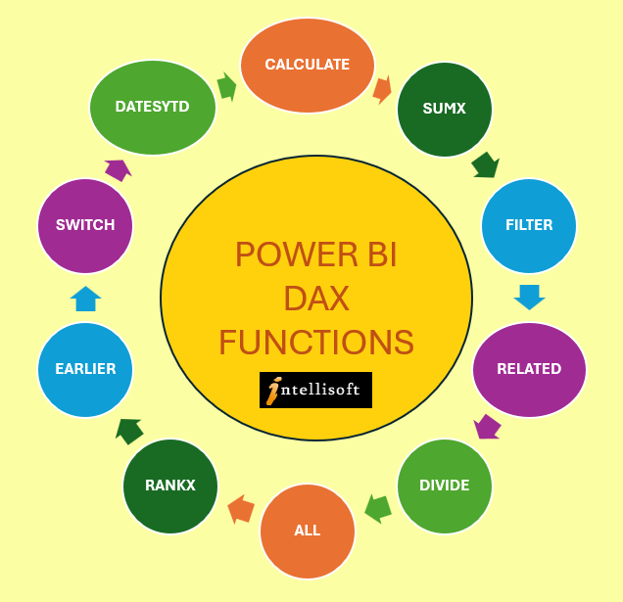

**a. Arithmetic Operators:**

* + (Addition)
* - (Subtraction)
* * (Multiplication)
* / (Division)
* ^ (Exponentiation)
* 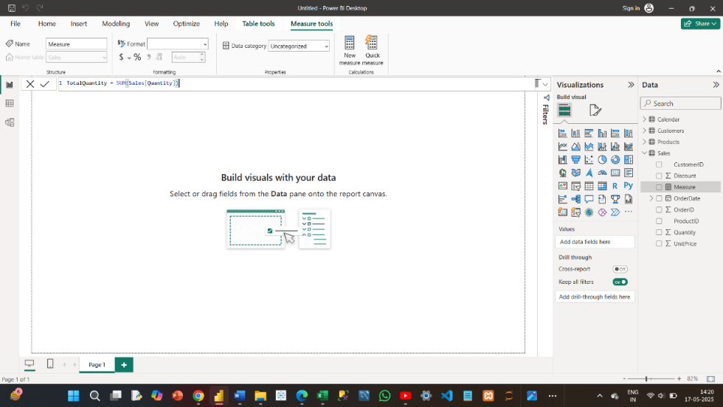
* 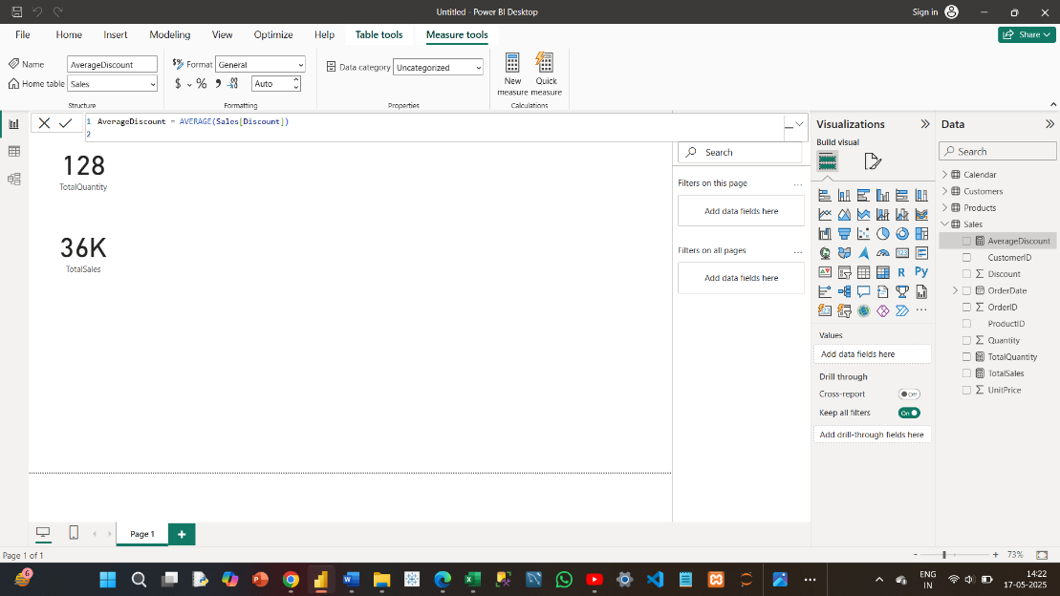

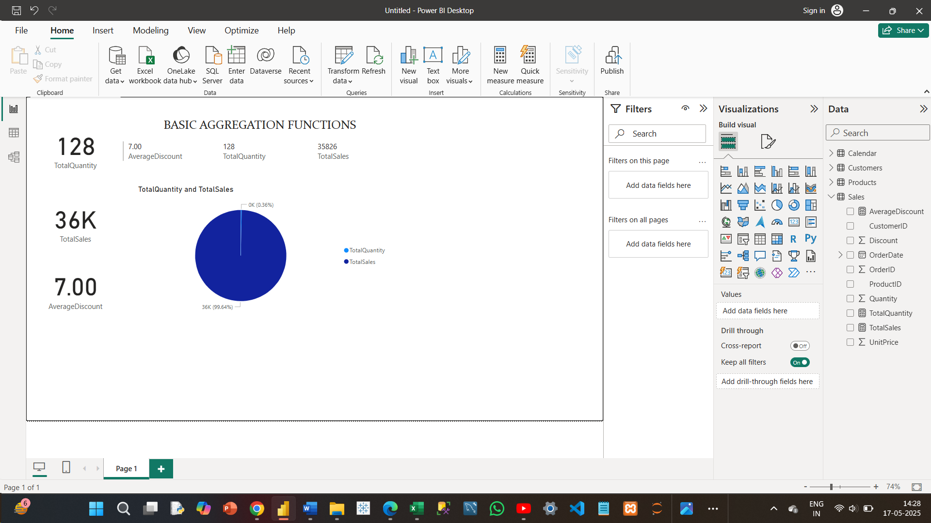

**b. Comparison Operators:**

* = (Equal to)
* <> (Not equal to)
* > (Greater than)
* < (Less than)
* >= (Greater than or equal to)
* <= (Less than or equal to)

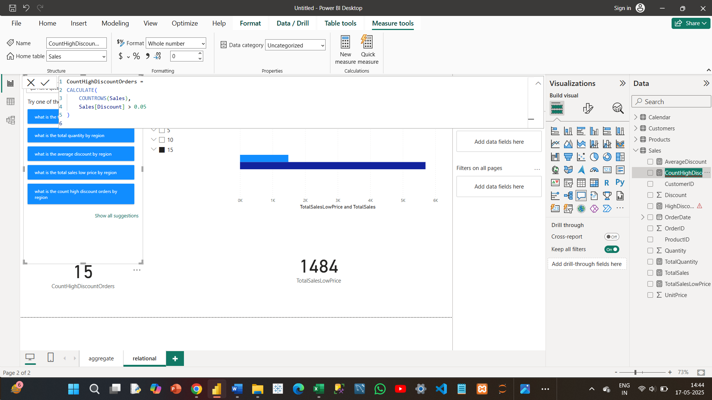

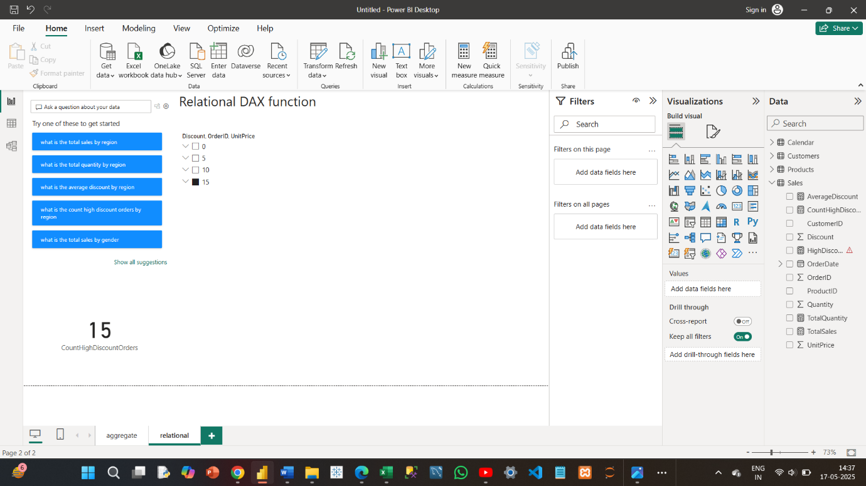

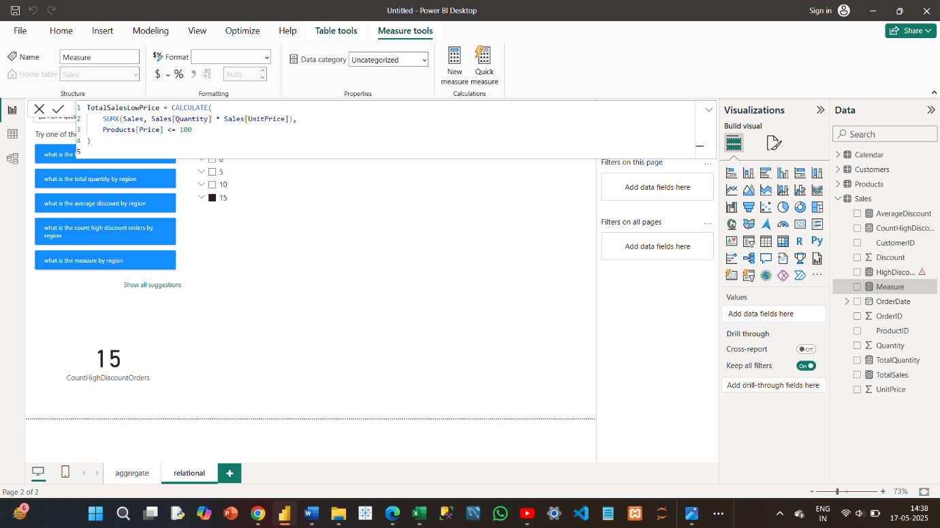

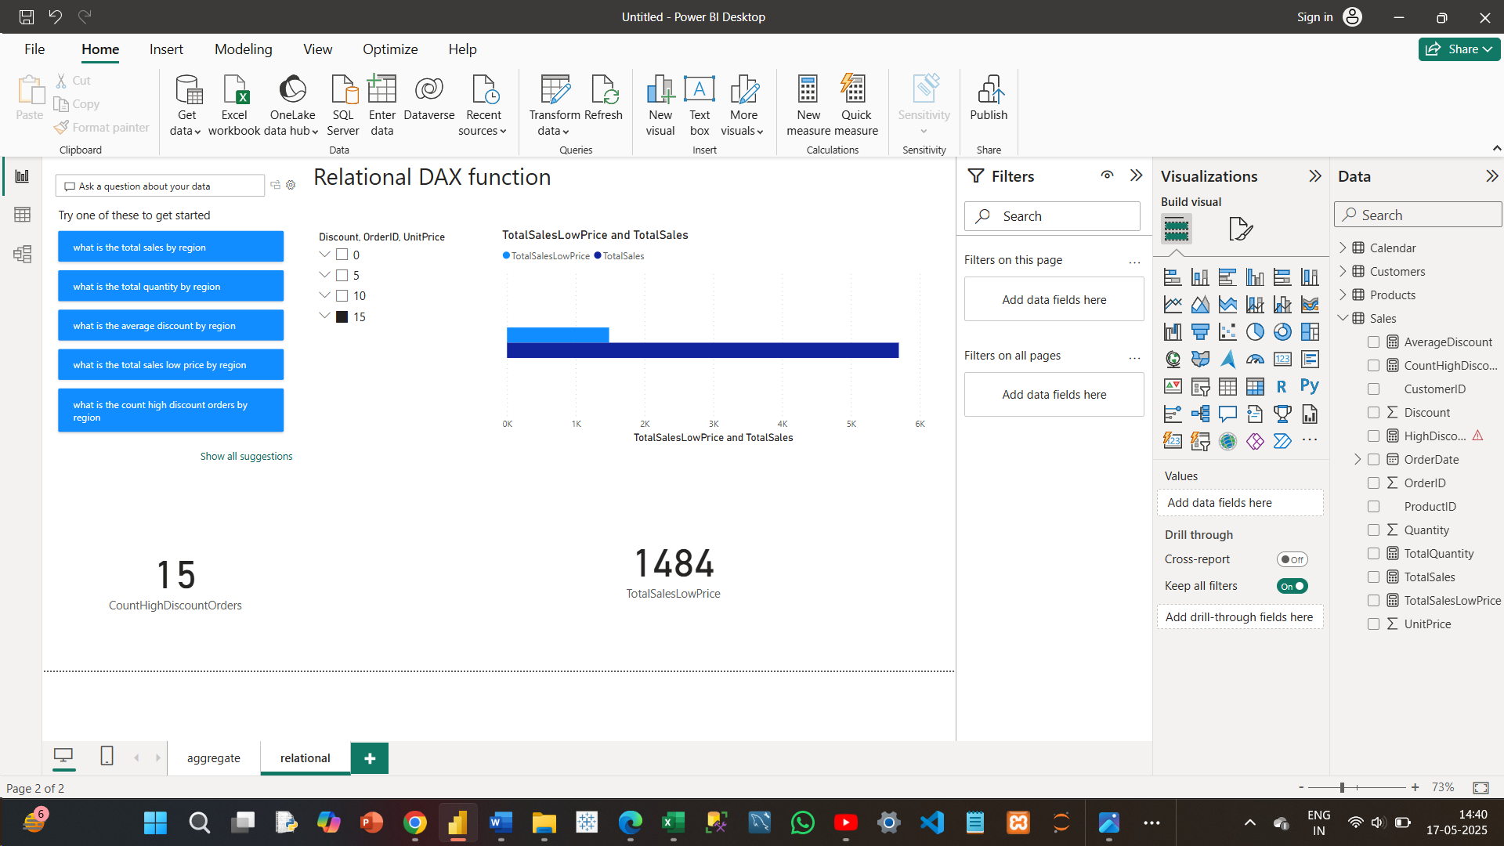

**c. Text Concatenation Operator:**

* & (Used to join two strings)

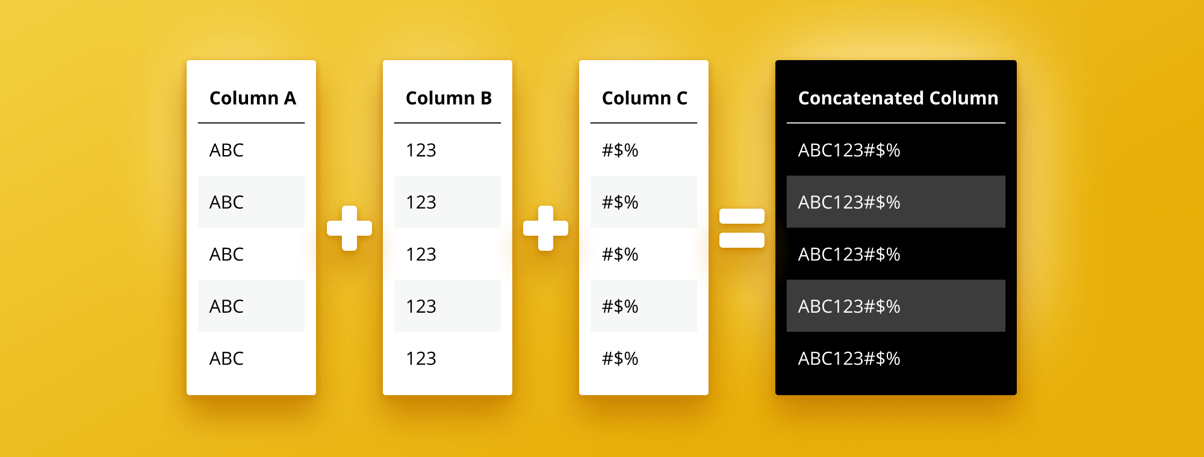

**d. Logical Operators:**

* && (AND)
* || (OR)
* NOT() (NOT function)

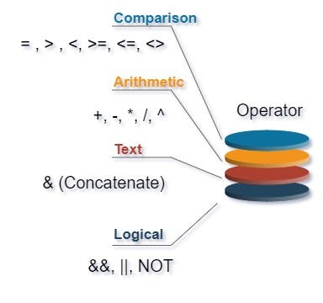

**3. Aggregation and Statistical Functions in DAX**

DAX provides a rich set of functions to perform data aggregation and statistical analysis:

**Aggregation Functions:**

* SUM() – Adds all the numbers in a column.
* AVERAGE() – Returns the average of all the numbers.
* MIN() – Returns the smallest value.
* MAX() – Returns the largest value.
* COUNT() – Counts the number of values.
* DISTINCTCOUNT() – Counts the number of distinct values.

**4. DAX Functions Used in My Project**

In my Power BI data analysis project, I have used the following DAX functions:

* CALCULATE() – To change the context of a calculation.
* FILTER() – To apply specific filters to data tables.
* SUMX() – To perform row-wise aggregation over an expression.
* RELATED() – To fetch related values from another table.
* IF() – To perform logical tests.
* DIVIDE() – For safe division.
* DISTINCTCOUNT() – To count distinct records.
* RANKX() – To assign ranking based on values.

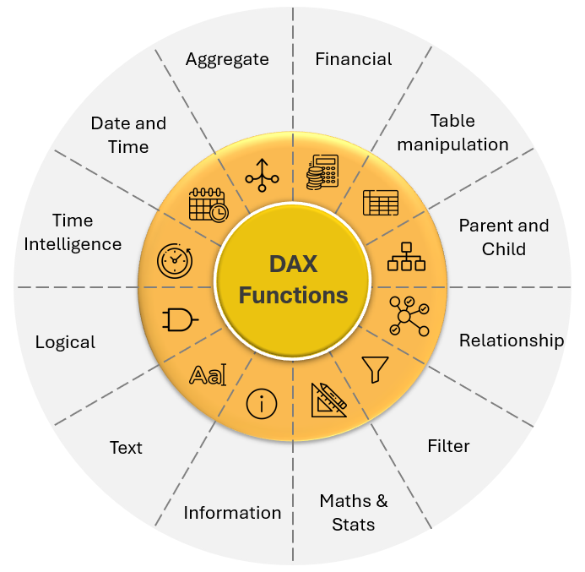

**5. Graphical Presentation Overview**

**Graphical representation** refers to the **visual display of data** using various types of **charts, graphs, maps, and visuals** to help users understand trends, patterns, and insights at a glance.

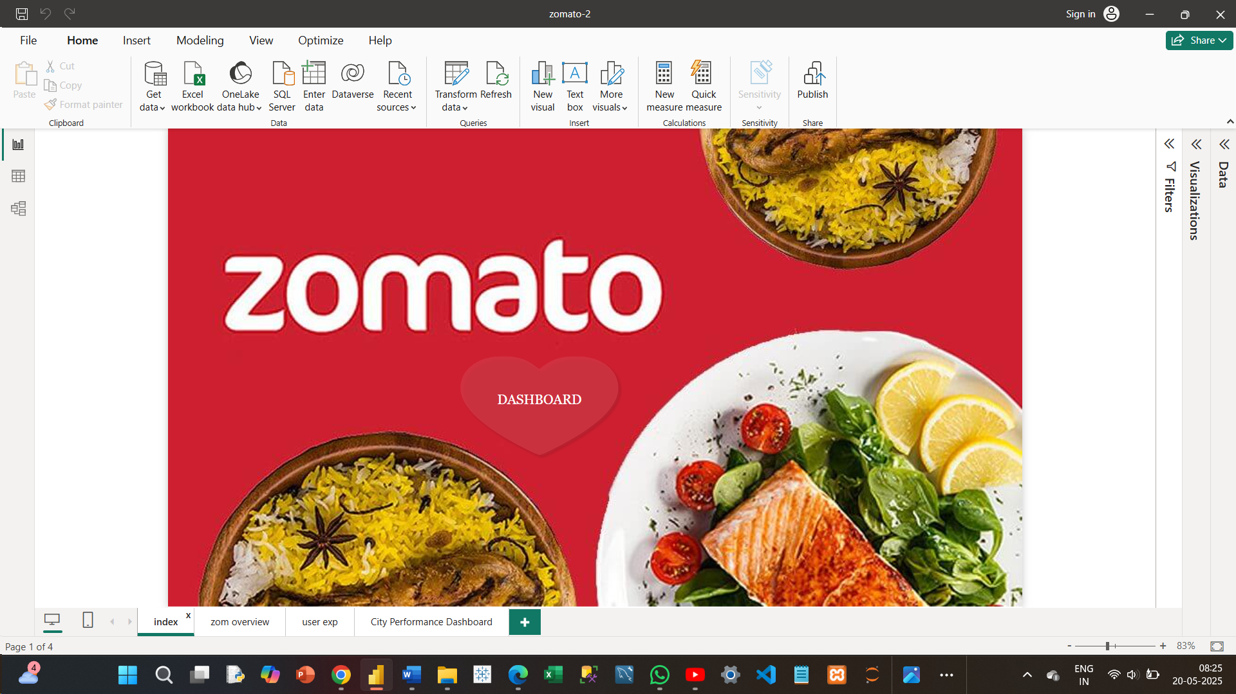

Interactive dashboard . which navigate to the next page . through **BUTTON**

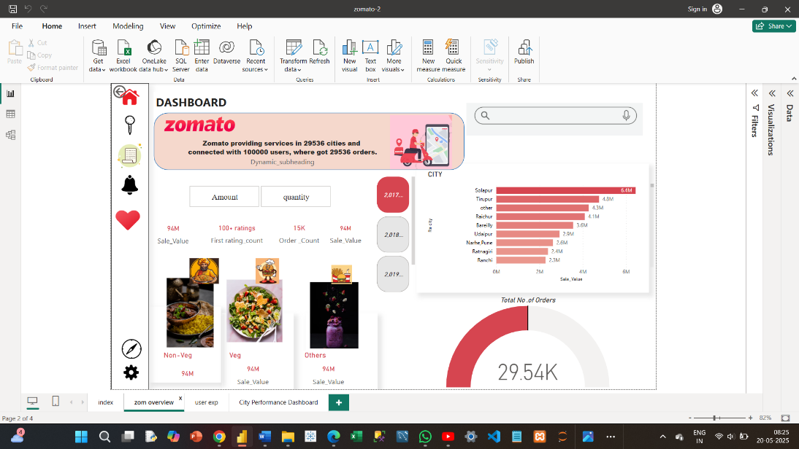

From this page to this page .