## **RELIEVING/EXPERIENCE LETTER**

DATE 17/05/2021

## **TO WHOMSOEVER IT MAY CONCERN**

This is to certify that Venkatesh Giri bearing Employee Code TWEI0009 is been working with us from (12/10/2020) (DD/MM/YYYY) to (30/04/2021) (DD/MM/YYYY) as Senior IT Recruiter (US). Kindly, contact us if you need any details.

Yours Cordially,

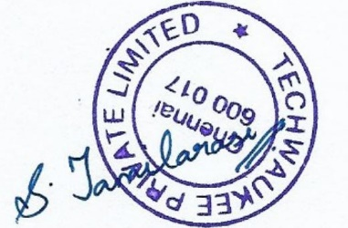

HR Management

Tamilarasi. S