**SQL Practices**

1. **List Department details (ID, Name, Location) which does not have any employees**

**Solution**: Use xx1553_departments and xx1553_employees. Get the department_id which are not in employees table. It results the departments which doesn’t have employees.

**Query**: SELECT

department_id,

department_name,

location_id

FROM

xx1553_departments

WHERE

department_id NOT IN (

SELECT

department_id

FROM

xx1553_employees);

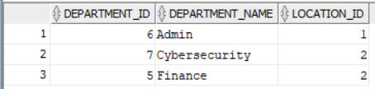

1. **List all employees whose salary is greater than average salary of all employees**

**Solution**: Use xx1553_employees table. First write sub-query for average salary of all employees and write the outer query to get salary of each employees and apply the condition where salary of each employees greater than the inner sub-query.

**Query**: SELECT

first_name || last_name AS emp_name,

salary

FROM

xx1553_employees

WHERE

salary > (

SELECT

AVG(salary) FROM xx1553_employee);

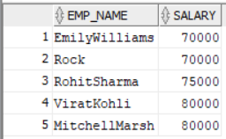

1. **List all employees who are getting the lowest salary**

**Solution**: Use xx1553_employees table. First write sub-query to lowest salary and write the outer query to get salary of each employees where salary is equal to inner sub-query.

**Query**: SELECT

first_name || last_name AS emp_name,

salary

FROM

xx1553_employees

WHERE

salary = (

SELECT

MIN(salary)

FROM

xx1553_employees

);

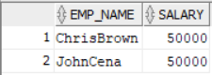

1. **List customer wise sales**

**Solution**: Here we should take two tables, xx1553_customers & xx1553_sales. Join two tables by equi join using common column in both tables called Customer_id. Perform Group by function using Customer_name and perform aggregation function(sum) on sale_amount.

**Query**: SELECT

c.customer_name,

SUM(s.sale_amount) sales

FROM

xx1553_customers c,

xx1553_sales s

WHERE

c.customer_id = s.customer_id

GROUP BY

c.customer_name;

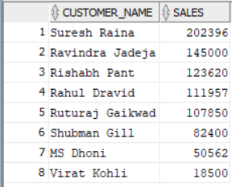

1. **List Year wise, month wise Sales**

**Solution**: Use xx1553_sales table. Extract year from sale_date. Perform Group by function on year and aggregation (sum) on sale_amount column. Hence get the required year wise sales.

**Query**: SELECT

to_char(sale_date, 'YYYY') AS year,

SUM(sale_amount) AS sales

FROM

xx1553_sales

GROUP BY

to_char(sale_date, 'YYYY');

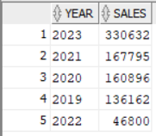

**Solution**: Use xx1553_sales table. Extract month from sale_date. Perform Group by function on month and aggregation (sum) on sale_amount column. Hence get the required month wise sales.

**Query**: SELECT

to_char(sale_date, 'MON') AS month,

SUM(sale_amount) AS sales

FROM

xx1553_sales

GROUP BY

to_char(sale_date, 'MON');

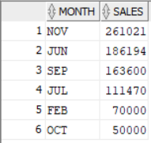

1. **List Year wise, month wise Direct Sales, Online Sales separately**

**Solution**: Use xx1553_sales table. Extract year from sale_date. Perform Group by function on year and aggregation (count *). In where condition give sale_mode = ’Direct Sales’ . Hence get the required year wise Direct Sales count.

**Query**: SELECT

to_char(sale_date, 'YYYY') AS year,

COUNT(*) AS sales_count

FROM

xx1553_sales

WHERE

sale_mode = 'Direct Sales'

GROUP BY

to_char(sale_date, 'YYYY');

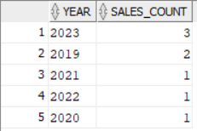

**Solution**: Use xx1553_sales table. Extract year from sale_date. Perform Group by function on year and aggregation (count *). In where condition give sale_mode = 'Online Sales’ . Hence get the required year wise Online Sales count.

**Query**: SELECT

to_char(sale_date, 'YYYY') AS year,

COUNT(*) AS sales_count

FROM

xx1553_sales

WHERE

sale_mode = 'Online Sales'

GROUP BY

to_char(sale_date, 'YYYY');

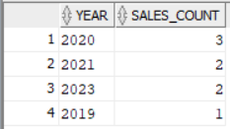

**Solution**: Use xx1553_sales table. Extract month from sale_date. Perform Group by function on month and aggregation (count *). In where condition give sale_mode = ’Direct Sales’ . Hence get the required month wise Direct Sales count.

**Query**: SELECT

to_char(sale_date, 'MON') AS month,

COUNT(*) AS sales_count

FROM

xx1553_sales

WHERE

sale_mode = 'Direct Sales'

GROUP BY

to_char(sale_date, 'MON');

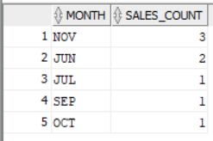

**Solution**: Use xx1553_sales table. Extract month from sale_date. Perform Group by function on month and aggregation (count *). In where condition give sale_mode = 'Online Sales’ . Hence get the required month wise Online Sales count.

**Query**: SELECT

to_char(sale_date, 'MON') AS month,

COUNT(*) AS sales_count

FROM

xx1553_sales

WHERE

sale_mode = 'Online Sales'

GROUP BY

to_char(sale_date, 'MON');

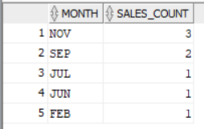

1. **List customers who are exceeding their credit limits**

**Solution**: Use xx1553_customers table. Check current_balance with credit_limit using where condition. If current_balance is greater than credit_limit, print respective customer_name.

**Query**: SELECT

customer_name

FROM

xx1553_customers

WHERE

current_balance > credit_limit;

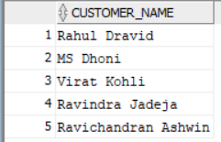

1. **List all employees who were holding more than one Job in various periods in the company**

**Solution**: Use xx1553_job_history table and xx1553_employees table. Join two tables by equi join using same column in both tables called employee_id.

Perform Group by in employee_id, company_id, company_name from xx1553_job_history table and first_name and last_name from xx1553_employees table.

Perform having function and give condition count(*) greater than 1.

In select statement, give employee_id, company_id, company_name from xx1553_job_history table and concatinating first_name and last_name from xx1553_employees table and perform aggregation function (count (*)).

Hence, we get employees who were holding more than one Job in various periods in the company.

**Query**: SELECT

jh.employee_id,

e.first_name || e.last_name AS name,

jh.company_id,

jh.company_name,

COUNT(*) employed_times_in_same_company

FROM

xx1553_job_history jh,

xx1553_employees e

WHERE

e.employee_id = jh.employee_id

GROUP BY

e.first_name || e.last_name,

jh.employee_id,

jh.company_name,

jh.company_id

HAVING

COUNT(*) > 1;

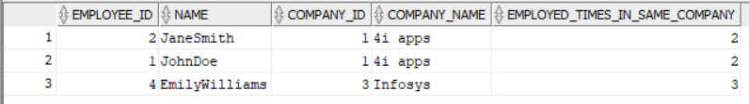

1. **List all employees with their first job**

**Solution**: Use xx1553_job_history table. By using over partition by, group employee_id.

Order by employee_id and start_date.

Use count as aggregation function. Naming alias as ct to count function. Store this in a with clause as temp.

Write another query using this with clause temp and xx1553_employees table. Perform inner join to get name of the employees using common column called employee_id.

After that in where clause give a condition called ct=1.

By then, able to get all employees with their first job.

**Query**: WITH temp AS (  
 SELECT  
 employee_id,  
 start_date,  
 company_name,  
 job_id,  
 COUNT(*)  
 OVER(PARTITION BY employee_id  
 ORDER BY  
 employee_id, start_date  
 ) AS ct  
 FROM  
 xx1553_job_history  
 )  
 SELECT  
 t.employee_id, first_name || ' ' || last_name as employee_name,  
 t.company_name, start_date, t.job_id  
 FROM  
 temp t join xx1553_employees e  
 on t.employee_id=e.employee_id  
 WHERE  
 ct = 1;

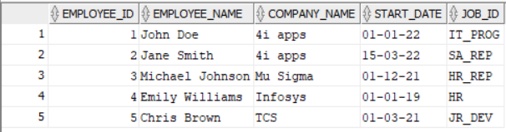

1. **How any “orderable” products available**

**Solution**: Use xx1553_inventories table. Give condition as quantity is not null in where clause.

By then, able to get orderable products.

**Query**: SELECT

product_id,

quantity

FROM

xx1553_inventories

WHERE

quantity IS NOT NULL;

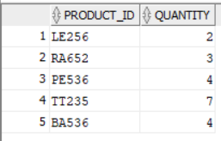

1. **[How to find top three highest salary in emp table in oracle?](http://stackoverflow.com/questions/2943429/how-to-find-top-three-highest-salary-in-emp-table-in-oracle)**

**Solution**: Use xx1553_employees table. Get distinct salary. Because many employees may get different salaries. Order by salary in descending and used fetch condition to fetch first three rows.

**Query**: SELECT DISTINCT

salary

FROM

xx1553_employees

ORDER BY

salary DESC

FETCH FIRST 3 ROWS ONLY;

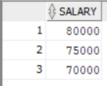

1. **SQL Query to find fifth highest salary with empno**

**Solution**: Use xx1553_employees table. Using dense_rank() function, rank the employee_salaries.

Why particularly dense_rank means...?. Dense_rank won’t skip the rank. If two or more employees have the same salary means, Rank will be same for those employees.

By then, we can be able to get the fifth highest salary with minimum one employee.

Created with clause as cte. By using cte, in where clause give rnk=5.

It fetches the fifth highest salary.

**Query**: WITH cte AS (

SELECT

employee_id,

salary,

DENSE_RANK()

OVER(

ORDER BY

salary DESC

) rnk

FROM

xx1553_employees

)

SELECT

*

FROM

cte

WHERE

rnk = 5;



1. **What is the total on-hand quantity of all products**

**Solution**: Use xx1553_inventories table. By aggregation function(sum), we can be able to add total on-hand quantity of all products.

**Query**: SELECT

SUM(quantity) total_on_hand_quantity

FROM

xx1553_inventories;



1. **List the products does not have stock**

**Solution**: Use xx1553_inventories and xx1553_products table. xx1553_products table shows the name of all products.

xx1553_inventories table provides stock of those products. Join two tables using equi join. Give condition quantity is not null. By then, we can get products that do not have stock.

**Query**: SELECT

product_name

FROM

xx1553_inventories i,

xx1553_products p

WHERE

p.product_id = i.product_id

AND i.quantity IS NULL;

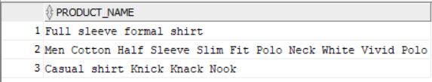

1. **List the items which can be ordered**

**Solution**: Use xx1553_inventories table. In where clause, put quantity is not null. By then, we can be able to list the items which can be ordered.

**Query**: SELECT

product_id

FROM

xx1553_inventories

WHERE

quantity IS NOT NULL;

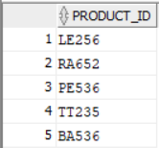

1. **Get the order details for one order**

**Solution**: Use xx1553_orders table. Randomly select one order (order_id=2) and retrieve details of that order using where clause.

**Query**: SELECT

*

FROM

xx1553_orders

WHERE

order_id = 2;



1. **Verify whether the order_total is calculated correctly or not**

**Solution**: Use xx1553_orders table. In this table quantity, unit price, total price are mentioned.

Using case when multiply quantity and unit price column, if result is equal to total price column, then print correct. vice versa.

**Query**: SELECT

quantity,

unit_price,

total_price,

CASE

WHEN ( quantity * unit_price ) = total_price THEN

'CORRECT'

ELSE

'INCORRECT'

END calculated_correctly_or_not

FROM

xx1553_orders;

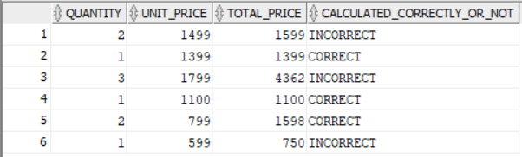

1. **List the items which are ordered**

**Solution**: Use xx1553_products and xx1553_orders table. Retrieve the product id which is present in xx1553_orders table using in operator. Then able to get the items which are ordered.

**Query**: SELECT

product_id,

product_name

FROM

xx1553_products

WHERE

product_id IN (

SELECT

product_id

FROM

xx1553_orders

);

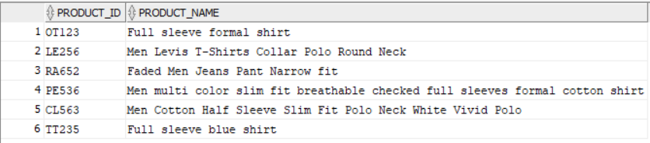

1. **List of items which are not yet ordered**

**Solution**: Use xx1553_products and xx1553_orders table. Retrieve the product id which is not present in xx1553_orders table using not in operator. Then able to get the items which are not yet ordered.

**Query**: SELECT

product_id,

product_name

FROM

xx1553_products

WHERE

product_id NOT IN (

SELECT

product_id

FROM

xx1553_orders

);

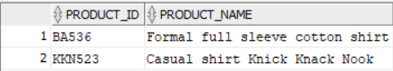

1. **List the Order details where items are ordered less than the list price**

**Solution**: Use xx1553_orders and xx1553_products table. Retrieve the order details where unit price which is mentioned in xx1553_orders table is less than product price which is mentioned in xx1553_products table.

**Query**: SELECT

*

FROM

xx1553_orders o

WHERE

unit_price < (

SELECT

product_price

FROM

xx1553_products p

WHERE

o.product_id = p.product_id

);



1. **List the Order details where items are ordered less than the minimum price**

**Solution**: Use xx1553_orders and xx1553_products table. Retrieve the order details where unit price mentioned in xx1553_orders table is less than the minimum product price of xx1553_products table using where clause.

**Query**: SELECT

*

FROM

xx1553_orders

WHERE

unit_price < (

SELECT

MIN(product_price)

FROM

xx1553_products

);



1. **Find the profit of each order line (compare minimum price with order)**

**Solution**: Use xx1553_orders and xx1553_products table. Join two tables by equi join using common column called product id. Calculate a new column called outcome_price by subtracting product price of xx1553_products table from unit price of xx1553_ordres table.

Create another column called profit_loss using case when.

In profit_loss column, print profit if the value of outcome price is greater than 0 and loss if it is less than 0. if it is equal to 0 print No profit/loss.

**Query**: SELECT

p.product_price,

unit_price AS sale_price,

( o.unit_price - p.product_price ) AS outcome_price,

CASE

WHEN ( o.unit_price - p.product_price ) > 0 THEN

'profit'

WHEN ( o.unit_price - p.product_price ) < 0 THEN

'loss'

ELSE

'No profit/loss'

END profit_loss

FROM

xx1553_orders o,

xx1553_products p

WHERE

o.product_id = p.product_id;

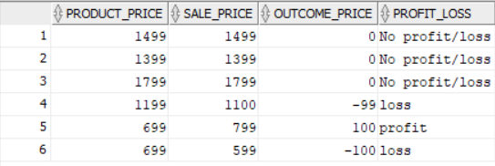

1. **Find the profit of each order and its %**

**Solution**: Use xx1553_orders and xx1553_products table. Join two tables by equi join using common column called product id. Calculate a new column called profit_loss by subtracting product price of xx1553_products table from unit price of xx1553_ordres table.

Using case when, if the value of profit_loss column is greater than 0 then divide the value by product_price and multiply by 100. Otherwise print 0.

Results the profit percentage.

**Query**: SELECT

product_price,

unit_price - product_price AS profit_loss,

CASE

WHEN ( unit_price - product_price ) > 0 THEN

round(((unit_price - product_price) / product_price) * 100)

ELSE

0

END profit_percent

FROM

xx1553_products p,

xx1553_orders o

WHERE

p.product_id = o.product_id;

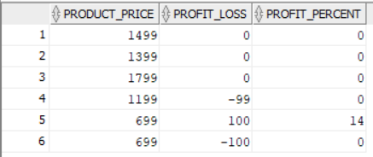

1. **Create table xx100_product by copying only orderable items from product master**

**Solution**: Create a new table called xx100_product using create table syntax.

Write query to get orderable items by searching product_id from xx1553_orders table in xx1553_products.

**Query**: CREATE TABLE xx100_product

AS

(

SELECT

*

FROM

xx1553_orders

WHERE

product_id IN (

SELECT

product_id

FROM

xx1553_products

)

);

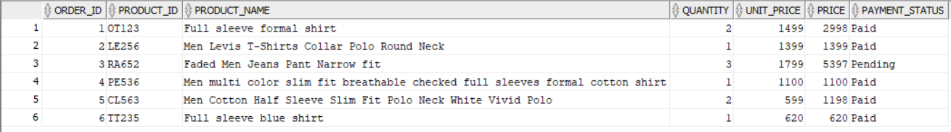

1. **Take backup of employee master**

**Solution**: To take backup, we can create view as backup_employess for xx1553_employees table.

**Query**: CREATE OR REPLACE VIEW backup_employees AS

SELECT

*

FROM

xx1553_employees;

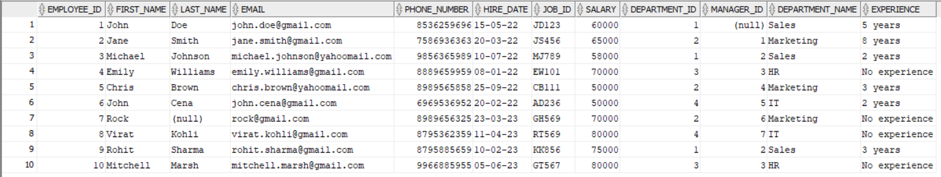

1. **Create table xx100_employee with (id, full_name, salary) and copy data from employee master**

**Solution**: Create a table called xx100_employee with columns called id, full_name, salary with create table syntax from xx1553_employees table.

**Query**: CREATE TABLE xx100_employee

AS

(

SELECT

employee_id AS id,

first_name || last_name AS full_name,

salary

FROM

xx1553_employees

);

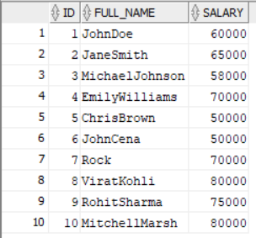

1. **In new table xx100_employee increment salary by 10%**

**Solution**: Create a new table called xx100_employee.

Create a new column called salary_increment_by_10_percent in select statement by calculating 10% of salary and adding the value to salary.

Results in salary increment by 10 percent.

**Query**: SELECT

salary,

salary * ( 10 / 100 ) AS ten_percentage,

salary + ( salary * ( 10 / 100 ) ) AS salary_increment_by_10_percent

FROM

xx100_employee;

