1.What are the two values of the Boolean data type? How do you write them?

Ans: The Boolean types are “True” and “False”, and I will write as True False

2. What are the three different types of Boolean operators?

Ans: and, or, not

3. Make a list of each Boolean operator's truth tables (i.e., every possible combination of Boolean values for the operator and what it evaluates ).

Ans:

|  |  |  |  |  |  |  |
| --- | --- | --- | --- | --- | --- | --- |
| **A** | **B** | **A and B** | **A or B** |  | **C** | **not C** |
| True | True | True | True | True | False |
| True | False | False | True | False | True |
| False | True | False | True |  |  |
| False | False | False | False |  |  |

4. What are the values of the following expressions?

(5 > 4) and (3 == 5) Ans=False

not (5 > 4) Ans= False

(5 > 4) or (3 == 5) Ans=True

not ((5 > 4) or (3 == 5)) Ans=False

(True and True) and (True == False) Ans=False

(not False) or (not True) Ans=True

5. What are the six comparison operators?

Ans:

1. **<**
2. **<=**
3. **>**
4. **>=**
5. **==**
6. **!=**

6. How do you tell the difference between the equal to and assignment operators? Describe a condition and when you would use one.

Ans: Equal to operator is to verify the condition whether the A and B are equal or not (Here we use ==), whereas the assignment operator assigns a value to a variable (Here we use =)

Assignment operator

Equal to operator

7. Identify the three blocks in this code:

spam = 0

if spam == 10:

print('eggs')

if spam > 5:

print('bacon')

else:

print('ham')

print('spam')

print('spam')

Ans:

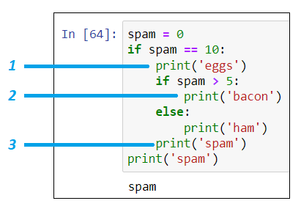

8. Write code that prints Hello if 1 is stored in spam, prints Howdy if 2 is stored in spam, and prints Greetings! if anything else is stored in spam.

9.If your programme is stuck in an endless loop, what keys you’ll press?

Ans: Restart Kernel (Esc+0+0)

10. How can you tell the difference between break and continue?

Ans:

Break- It will break the conditional loop and stop it will not go to next statement/loop

Continue- It will skip for that particular condition in the loop and executes remaining loops as well.

11. In a for loop, what is the difference between range(10), range(0, 10), and range(0, 10, 1)?

Ans: All the 3 statements are same

12. Write a short program that prints the numbers 1 to 10 using a for loop. Then write an equivalent program that prints the numbers 1 to 10 using a while loop.

Ans:

for i in range(10):

print (i)

i=0

while (i<=10):

print(i)

i=i+1

13. If you had a function named bacon() inside a module named spam, how would you call it after importing spam?

Ans:

spam.bacon()