Date: 30/09/2023 Project ID:au611421205048

Project Title: **SMART PARKING**

PHASE-1

PROBLEM DEFINITION

By using **ultrasonic sensors** be able to keep a record of the number of cars parked inside of a parking garage. Consequently, once a car enters a parking garage followed by a parking space, a ping ultrasonic sensor will then be able to determine if a car is parked in the space or not.

**Smart Parking** is a parking solution that can include in-ground Smart Parking sensors, cameras or counting sensors. These devices are usually embedded into parking spots or positioned next to them to detect whether parking bays are free or occupied.

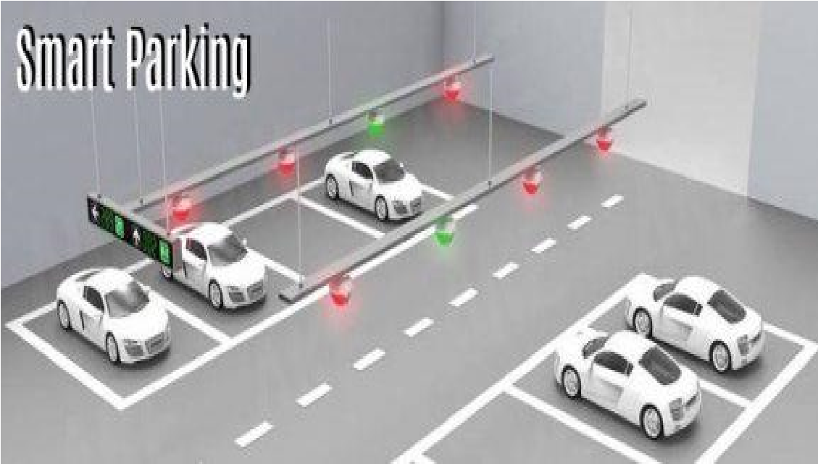This happens through real-time data collection. The data is then transmitted to a smart parking mobile application or website, which communicates the availability to its users.

**Advantages of Smart Parking for Drivers**

**Optimizing the driving experience:** Using a Smart Parking system [saves a lot of time for drivers](https://parkeagle.com/2019/03/19/what-are-the-benefits-of-smart-parking-for-drivers/) since they know where to find a vacant parking spot. The amount of time you spend while looking for a parking spot will be minimized.

**Safety:** The use of Smart Parking Sensors can optimize safety within cities. As a result of placing, for instance, on-ground sensors on parking bays, people will not be as stressed as when they are looking for parking spaces

In general, Smart Parking solutions, such as sensors, give municipalities and company the opportunity to make parking a more fluid and efficient process. Furthermore, it saves people a great amount of time, money, and reduces the frustration that a person might have when wanting to find a parking spot.