PL/SQL PROGRAMMING AND

UNIT TESTING

EXERCISE 1: CONTROL STRUCTURES

1. IF-ELSIF-ELSE

ESTIMATION OF BONUS FOR THE EMPLOYEE BASED ON THEIR SALARY

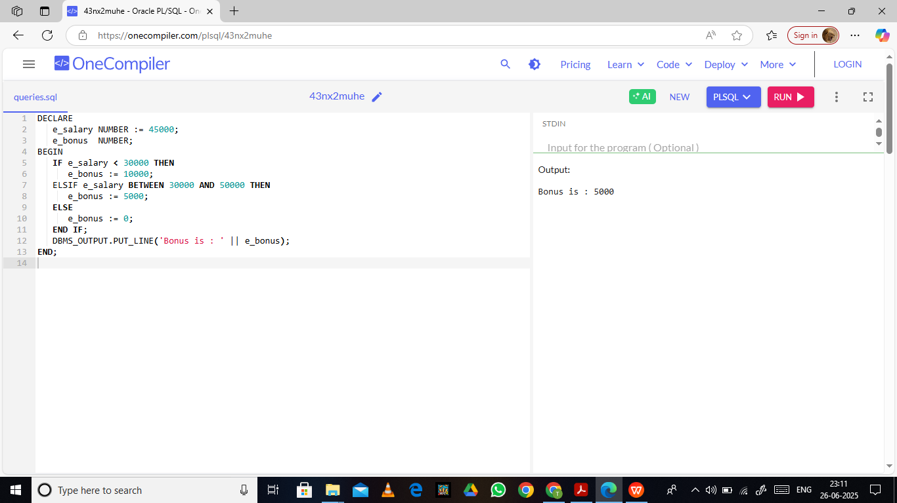

1. FOR LOOP

FOR LOOP TO PRINT EVEN NUMBERS

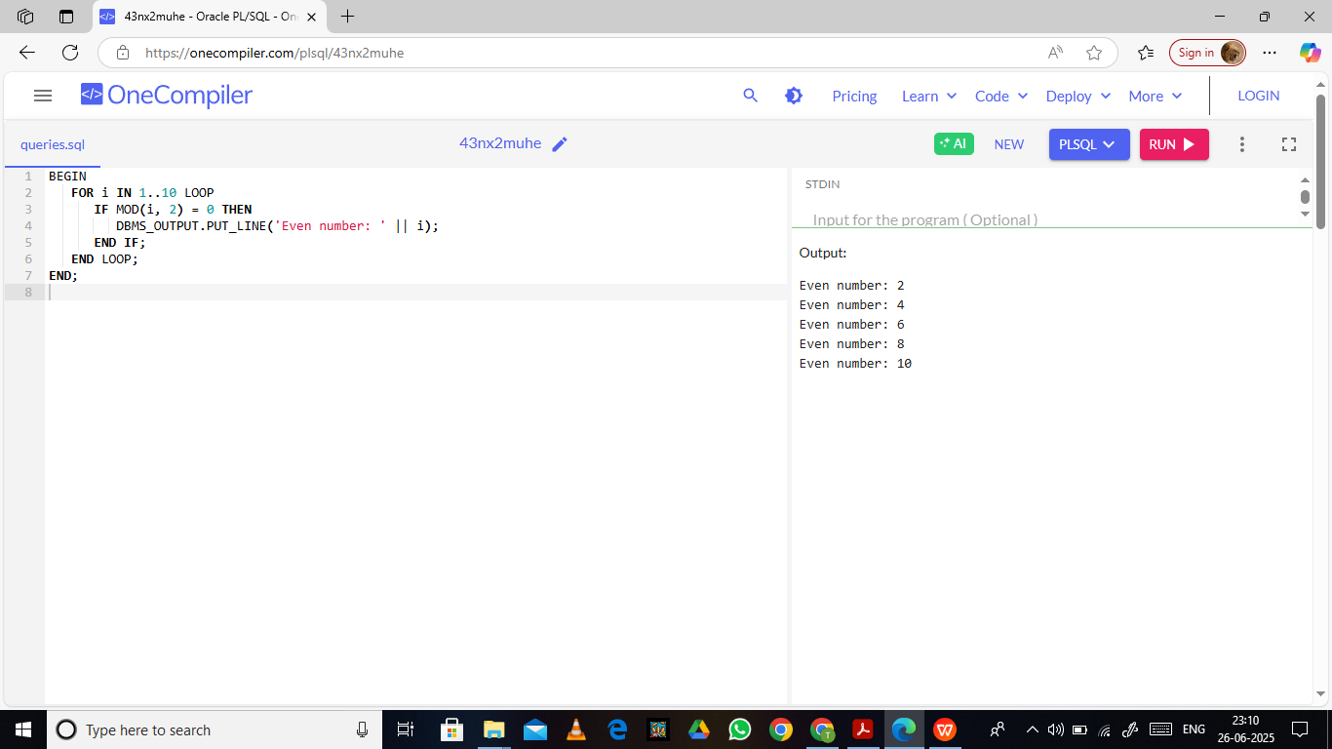

1. WHILE LOOP

PROGRAM TO PRINT FIRST 5 NUMBERS USING WHILE LOOP.

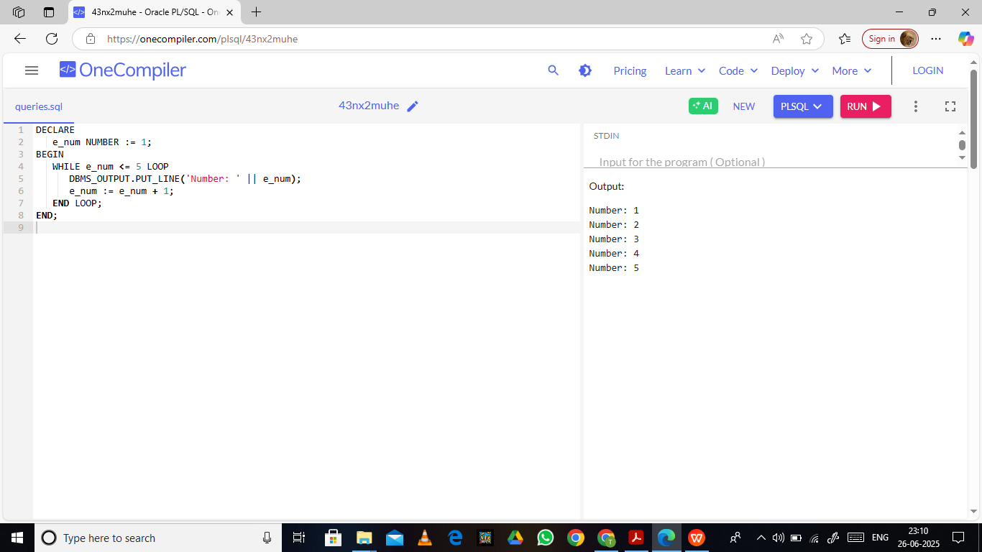

1. GOTO STATEMENT

SIMPLE PROGRAM TO IMPLEMENT GOTO STATEMENT.

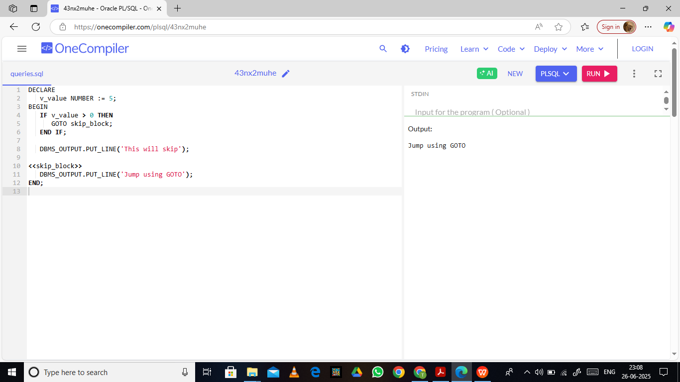

EXERCISE 2 : STORED PROCEDURES

1. PROCEDURE TO ESTIMATE SQUARE OF A GIVEN NUMBER.

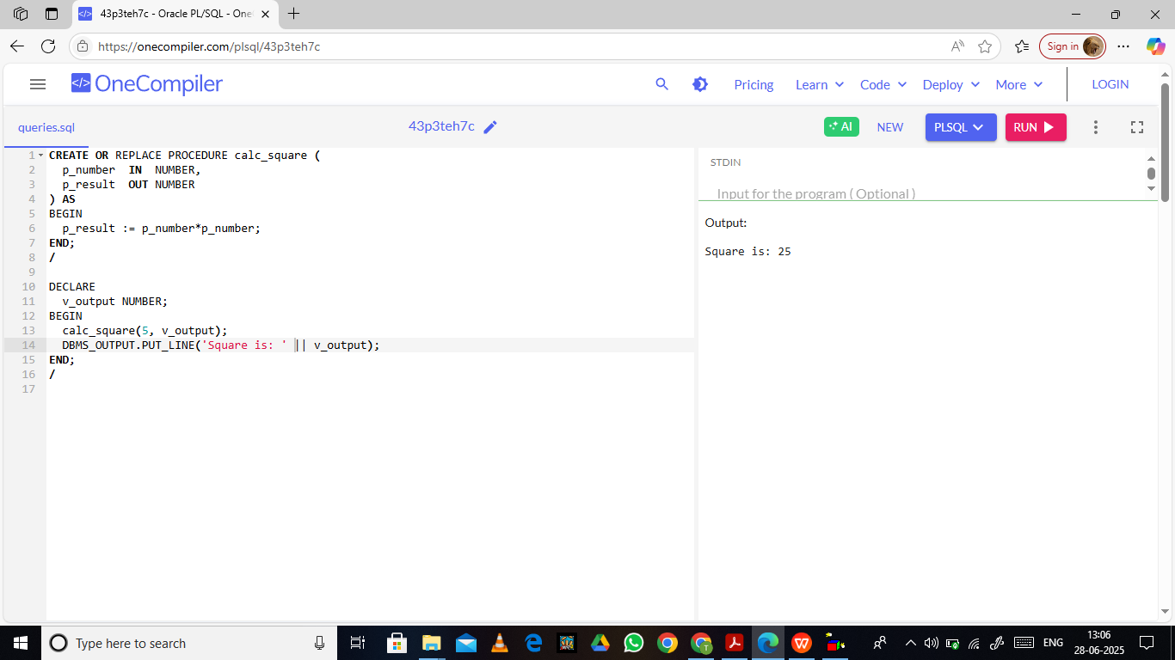

1. PROCEDURE TO CALCULATE GRADE FOR A STUDENT BY THEIR MARKS AWARDED.

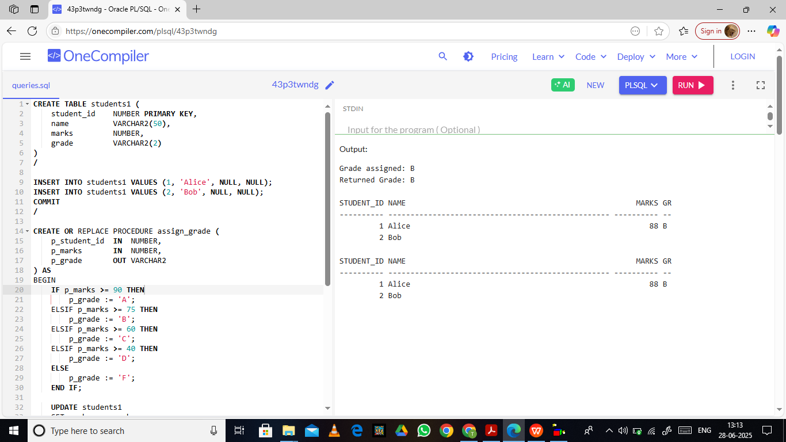

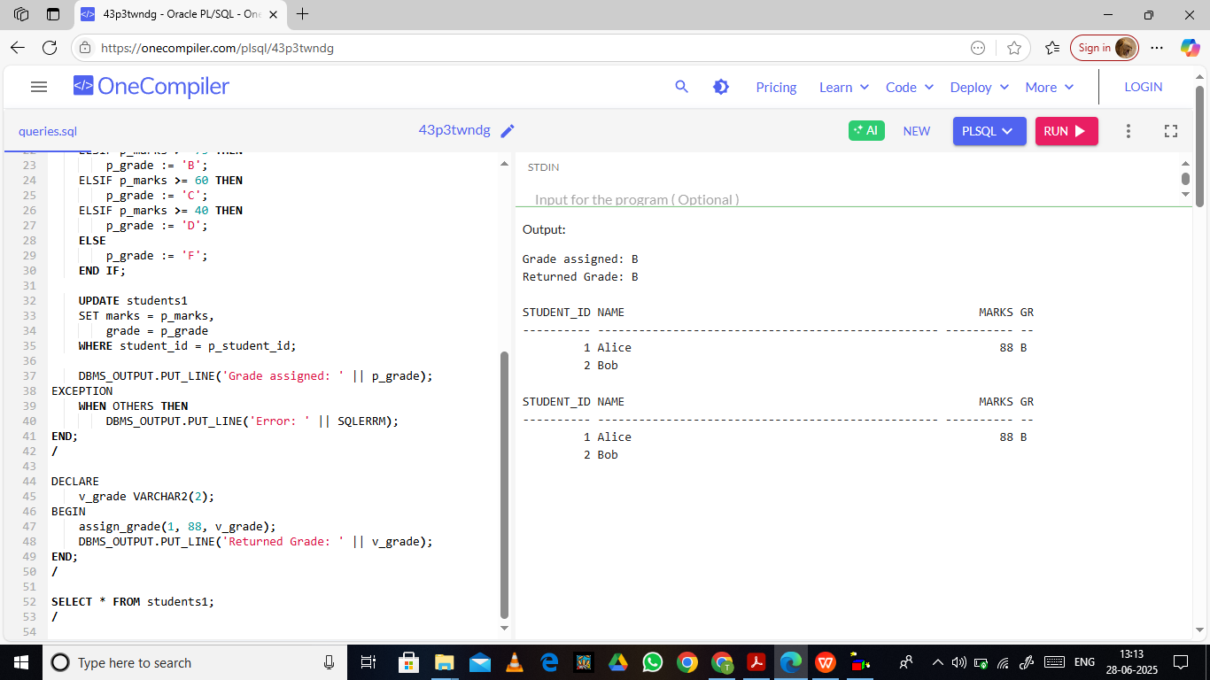

1. PROCEDURE TO FIND DIFFERENCE OF A GIVEN NUMBER.

