**Hands on 1**

**Create a Spring Web Project using Maven** 

Follow steps below to create a project: 

1. Go to <https://start.spring.io/>
2. Change Group as “com.cognizant”
3. Change Artifact Id as “spring-learn”
4. Select Spring Boot DevTools and Spring Web
5. Create and download the project as zip
6. Extract the zip in root folder to Eclipse Workspace
7. Build the project using ‘mvn clean package -Dhttp.proxyHost=proxy.cognizant.com -Dhttp.proxyPort=6050 -Dhttps.proxyHost=proxy.cognizant.com -Dhttps.proxyPort=6050 -Dhttp.proxyUser=123456’ command in command line
8. Import the project in Eclipse "File > Import > Maven > Existing Maven Projects > Click Browse and select extracted folder > Finish"
9. Include logs to verify if main() method of SpringLearnApplication.
10. Run the SpringLearnApplication class.

**Code:**

**HomeController.java**

**package** **com.example.controller**;

**import** **org.springframework.stereotype.Controller**;

**import** **org.springframework.web.bind.annotation.RequestMapping**;

**import** **org.springframework.ui.Model**;

@**Controller**

**public** **class** HomeController {

    @**RequestMapping**("/")

**public** **String** home(**Model** model) {

        model.addAttribute("message", "Welcome to Spring MVC!");

**return** "home";

    }

}

**Web.xml:**

**package** **com.example.controller**;

**import** **org.springframework.stereotype.Controller**;

**import** **org.springframework.web.bind.annotation.RequestMapping**;

**import** **org.springframework.ui.Model**;

@**Controller**

**public** **class** HomeController {

    @**RequestMapping**("/")

**public** **String** home(**Model** model) {

        model.addAttribute("message", "Welcome to Spring MVC!");

**return** "home";

    }

}

**dispactcher-servlet.xml**<beans *xmlns*="http://www.springframework.org/schema/beans"

*xmlns:mvc*="http://www.springframework.org/schema/mvc"

*xmlns:context*="http://www.springframework.org/schema/context"

*xmlns:xsi*="http://www.w3.org/2001/XMLSchema-instance"

*xsi:schemaLocation*="

          http://www.springframework.org/schema/beans

          http://www.springframework.org/schema/beans/spring-beans.xsd

          http://www.springframework.org/schema/context

          http://www.springframework.org/schema/context/spring-context.xsd

          http://www.springframework.org/schema/mvc

          http://www.springframework.org/schema/mvc/spring-mvc.xsd">

    <context:component-scan *base-package*="com.example.controller" />

    <mvc:annotation-driven />

    <bean *class*="org.springframework.web.servlet.view.InternalResourceViewResolver">

        <property *name*="prefix" *value*="/WEB-INF/views/" />

        <property *name*="suffix" *value*=".jsp" />

    </bean>

</beans>

**Home.jsp:**

<%@ taglib uri="http://java.sun.com/jsp/jstl/core" prefix="c" %>

<html>

  <head><title>Home Page</title></head>

  <body>

    <h2>${message}</h2>

  </body>

</html>

**Pom.xml:**

<project *xmlns*="http://maven.apache.org/POM/4.0.0"

*xmlns:xsi*="http://www.w3.org/2001/XMLSchema-instance"

*xsi:schemaLocation*="http://maven.apache.org/POM/4.0.0

                             http://maven.apache.org/xsd/maven-4.0.0.xsd">

    <modelVersion>4.0.0</modelVersion>

    <groupId>com.example</groupId>

    <artifactId>spring-web-demo</artifactId>

    <version>1.0-SNAPSHOT</version>

    <packaging>war</packaging>

    <name>Spring Web Demo</name>

    <dependencies>

*<!-- Spring Web MVC -->*

        <dependency>

            <groupId>org.springframework</groupId>

            <artifactId>spring-webmvc</artifactId>

            <version>5.3.32</version>

        </dependency>

*<!-- JSTL -->*

        <dependency>

            <groupId>javax.servlet</groupId>

            <artifactId>jstl</artifactId>

            <version>1.2</version>

        </dependency>

*<!-- Servlet API -->*

        <dependency>

            <groupId>javax.servlet</groupId>

            <artifactId>javax.servlet-api</artifactId>

            <version>4.0.1</version>

            <scope>provided</scope>

        </dependency>

    </dependencies>

    <build>

        <finalName>spring-web-demo</finalName>

    </build>

</project>

**Output:**

**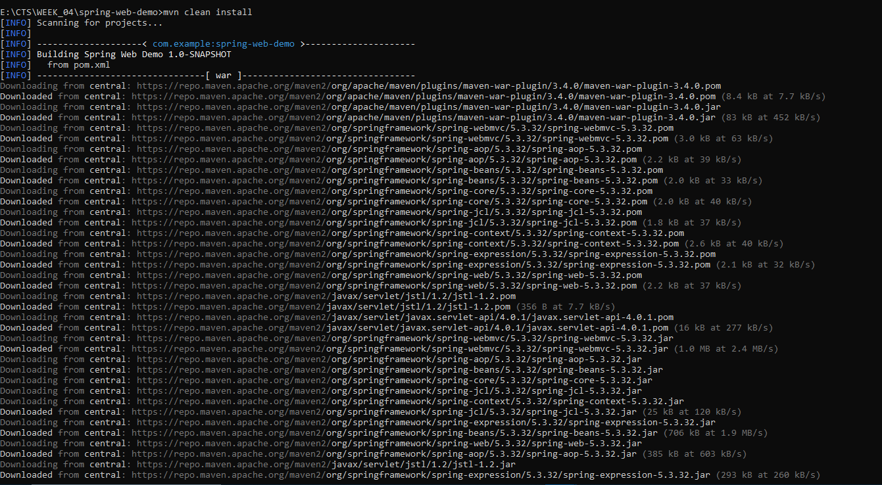  
  
  
  
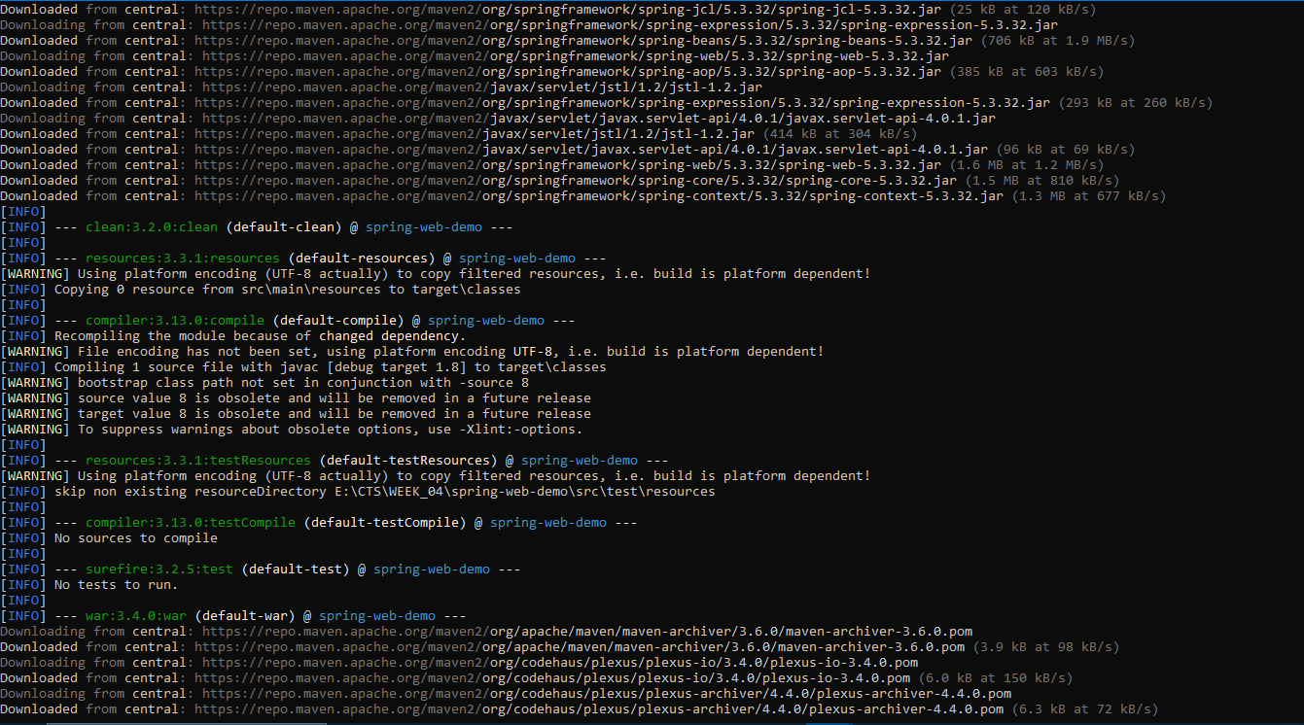**

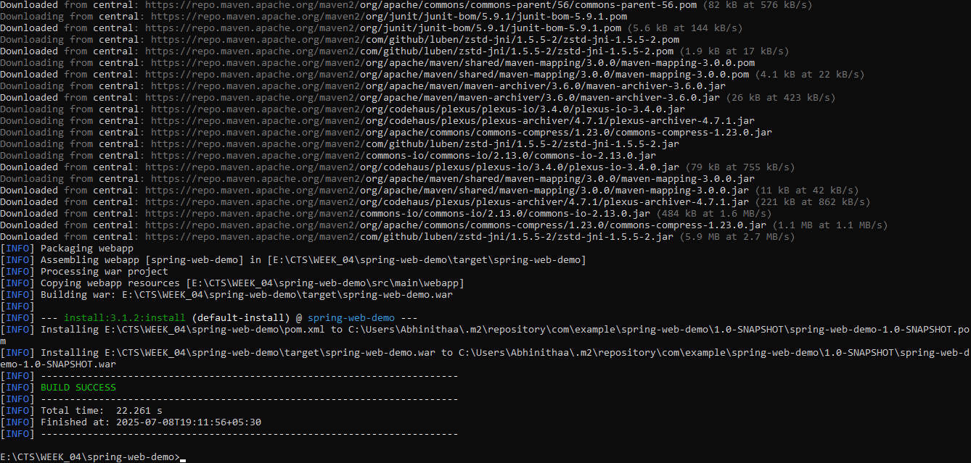

**Hands on 2**

**Spring Core – Load SimpleDateFormat from Spring Configuration XML**   
  
SimpleDateFormat with the pattern ‘dd/MM/yyyy’ is created in multiple places of an application. To avoid creation of SimpleDateFormat in multiple places, define a bean in Spring XML Configuration file and retrieve the date.  
  
Follow steps below to implement:

* Create spring configuration file date-format.xml in src/main/resources folder of 'spring-learn' project
* Open https://docs.spring.io/spring-framework/docs/current/spring-framework-reference/core.html#beans-factory-metadata
* Copy the XML defined in the section of previous step URL and paste it into date-format.xml
* Define bean tag in the XML with for date format. Refer code below.

**Code:**

**Pom.xml:**

<project *xmlns*="http://maven.apache.org/POM/4.0.0"

*xmlns:xsi*="http://www.w3.org/2001/XMLSchema-instance"

*xsi:schemaLocation*="http://maven.apache.org/POM/4.0.0

                             http://maven.apache.org/xsd/maven-4.0.0.xsd">

    <modelVersion>4.0.0</modelVersion>

    <groupId>com.example</groupId>

    <artifactId>spring-country-xml</artifactId>

    <version>1.0-SNAPSHOT</version>

    <dependencies>

*<!-- Spring Core -->*

        <dependency>

            <groupId>org.springframework</groupId>

            <artifactId>spring-context</artifactId>

            <version>5.3.32</version>

        </dependency>

    </dependencies>

</project>

**Country.java:**

**package** **com.example**;

**public** **class** Country {

**private** **String** name;

**private** **String** capital;

*// Getters and Setters*

**public** **String** getName() {

**return** name;

    }

**public** **void** setName(**String** name) {

        this.name **=** name;

    }

**public** **String** getCapital() {

**return** capital;

    }

**public** **void** setCapital(**String** capital) {

        this.capital **=** capital;

    }

    @**Override**

**public** **String** toString() {

**return** "Country{name='" **+** name **+** "', capital='" **+** capital **+** "'}";

    }

}

**Country.xml:**

<?xml *version*="1.0" *encoding*="UTF-8"?>

<beans *xmlns*="http://www.springframework.org/schema/beans"

*xmlns:xsi*="http://www.w3.org/2001/XMLSchema-instance"

*xsi:schemaLocation*="

         http://www.springframework.org/schema/beans

         http://www.springframework.org/schema/beans/spring-beans.xsd">

    <bean *id*="country" *class*="com.example.Country">

        <property *name*="name" *value*="India"/>

        <property *name*="capital" *value*="New Delhi"/>

    </bean>

</beans>

**App.java:**

**package** **com.example**;

**import** **org.springframework.context.ApplicationContext**;

**import** **org.springframework.context.support.ClassPathXmlApplicationContext**;

**public** **class** App {

**public** **static** **void** main(**String**[] args) {

**ApplicationContext** context **=** **new** ClassPathXmlApplicationContext("country.xml");

**Country** country **=** context.getBean("country", Country.class);

        System.out.println("Loaded Country: " **+** country);

    }

}

**Output:**



