**Handson - 1**

1. **Configuring a Basic Spring Application**

User.java

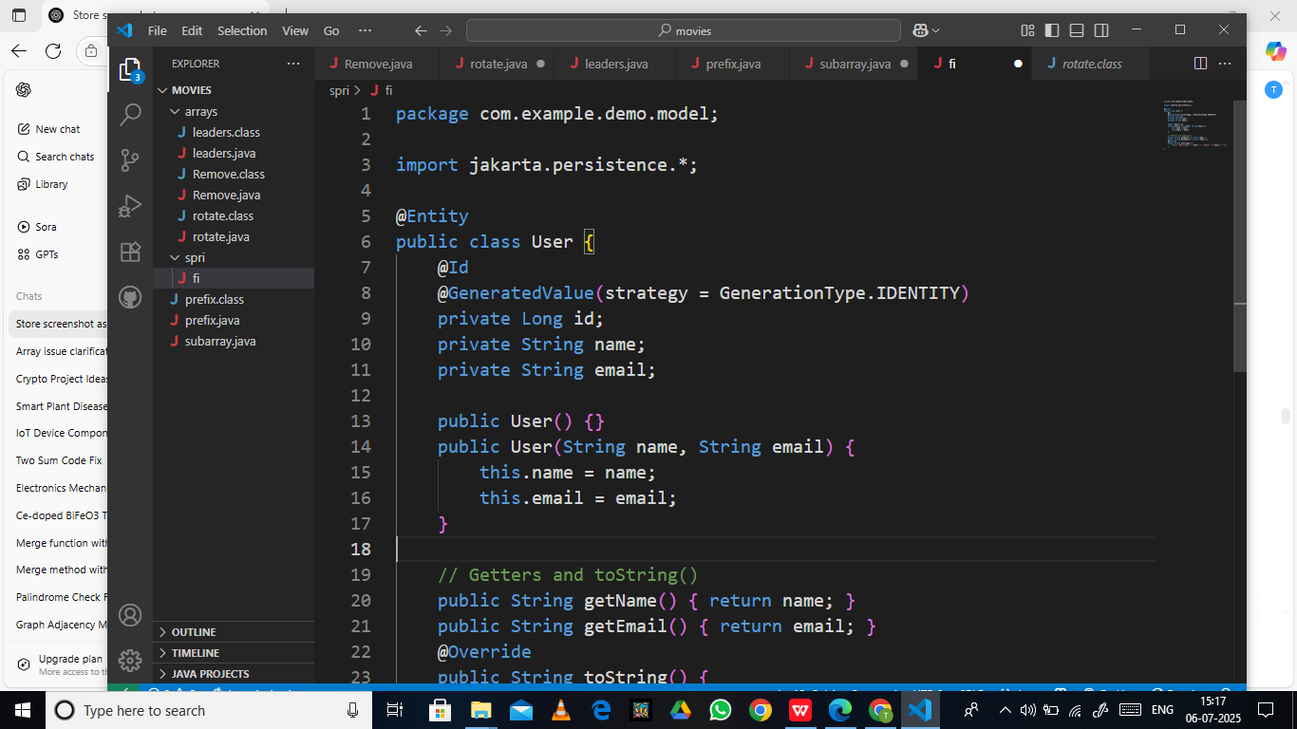

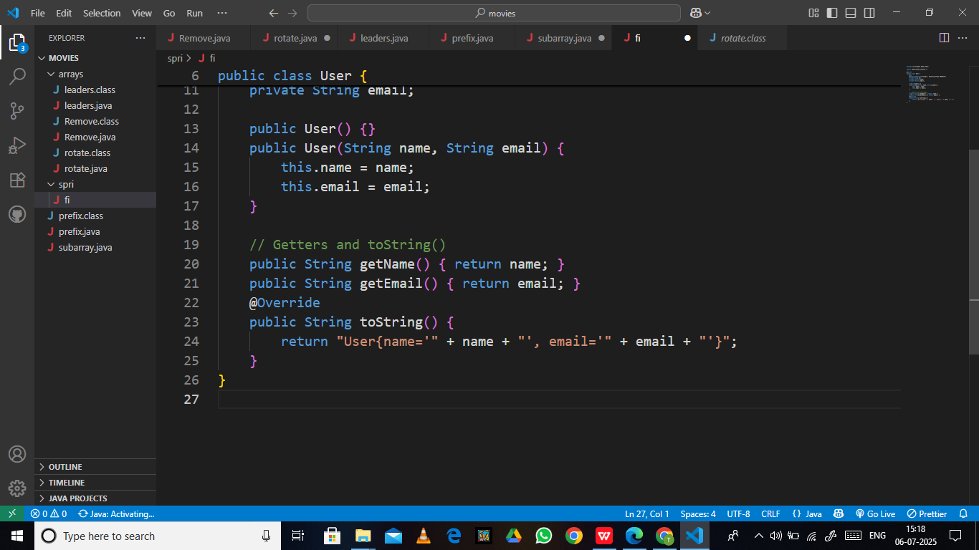

UserRepository.java

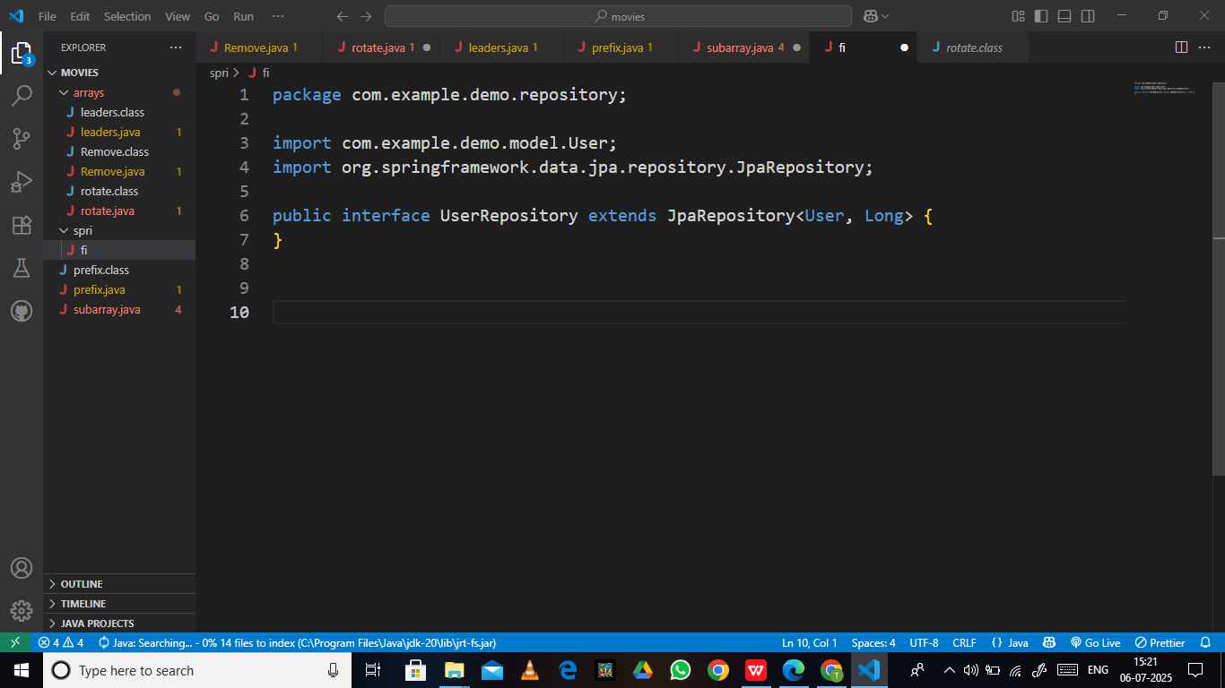

DataLoader.java

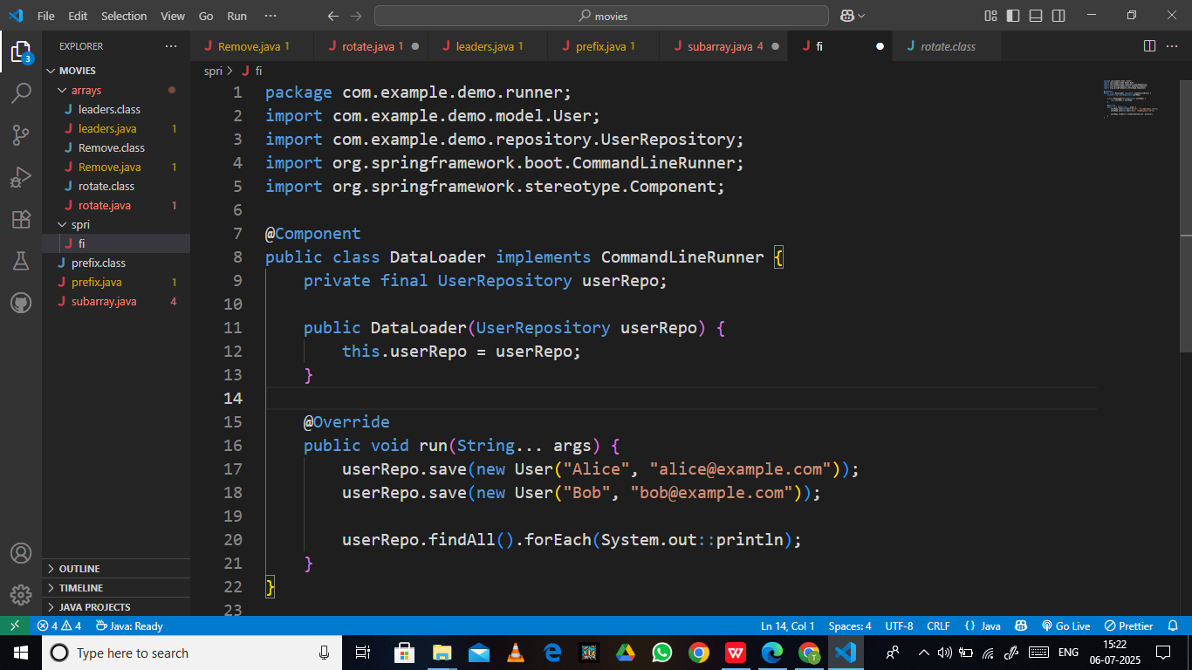

DemoApplication.java

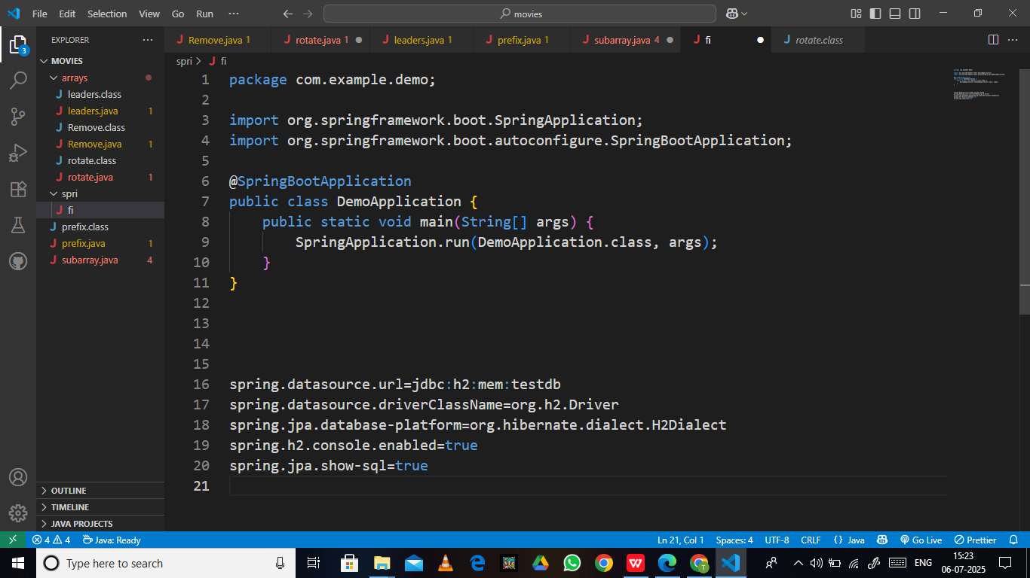

application.properties



Dependency Injection (pom.xml):

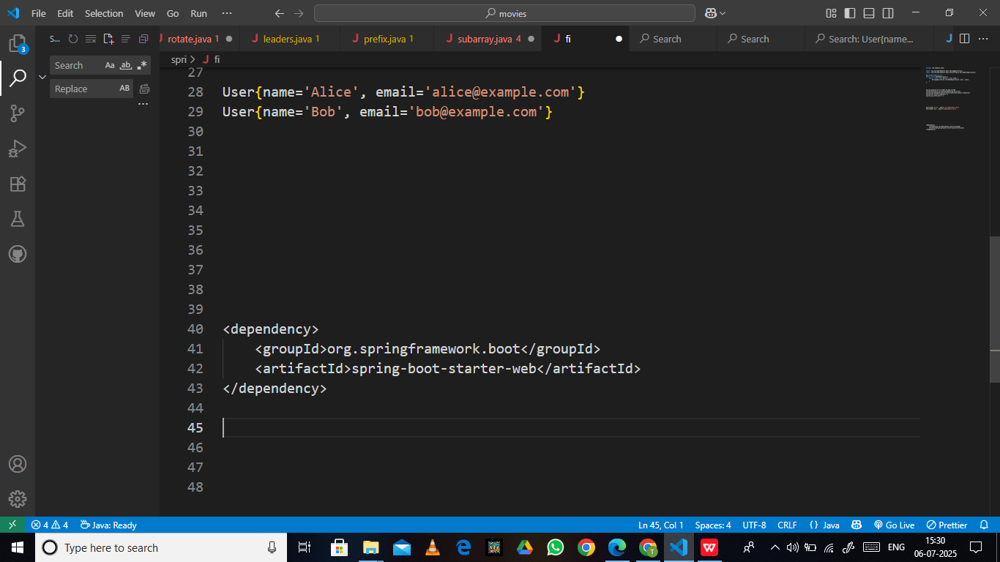

Output:

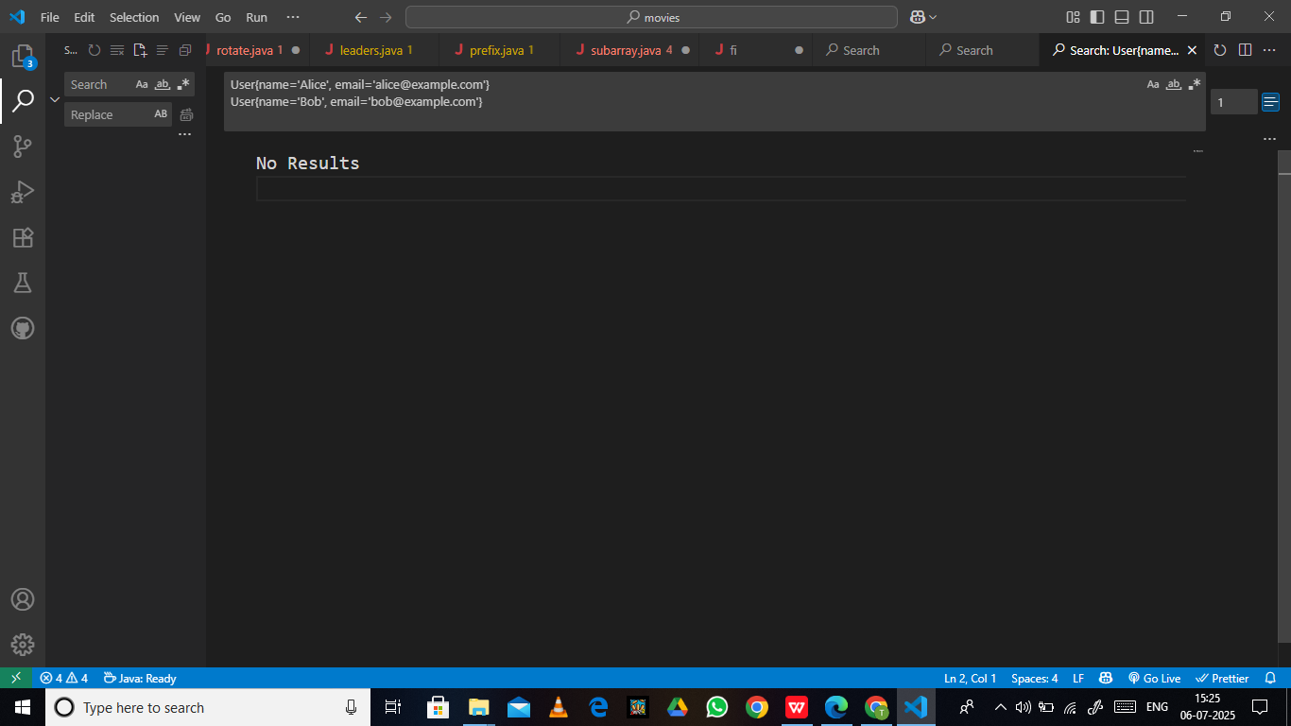

Handson-2

2.Difference between JPA, Hibernate and Spring Data JPA code needed

Book.java

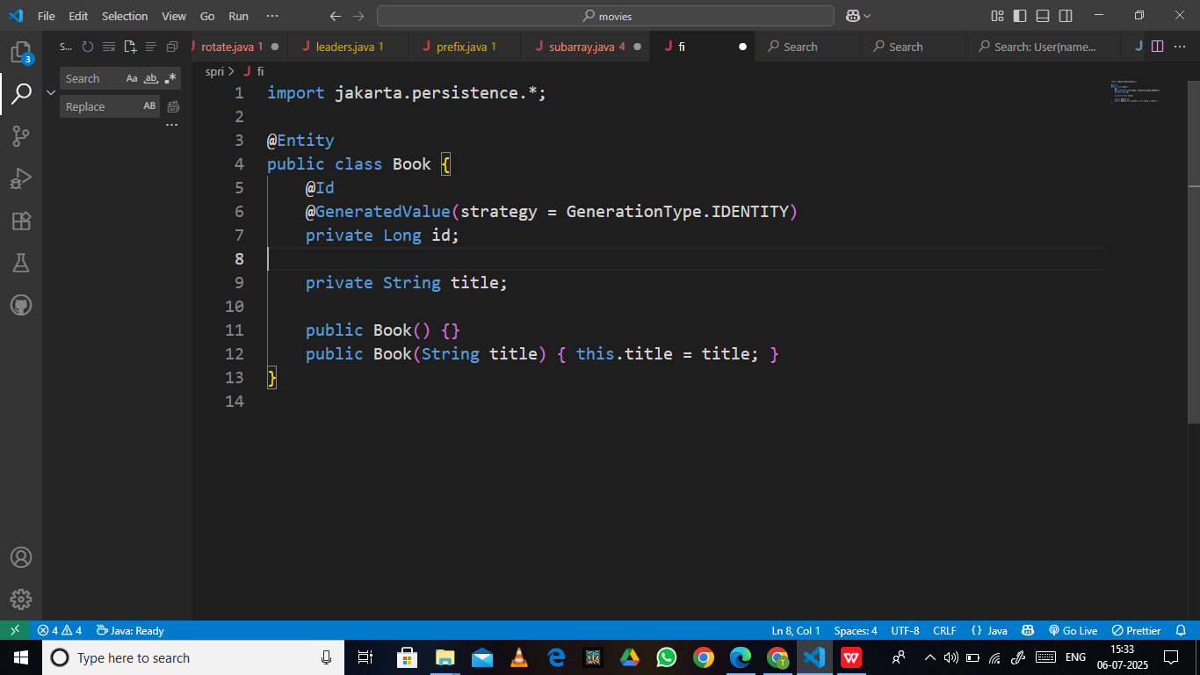

Main.java

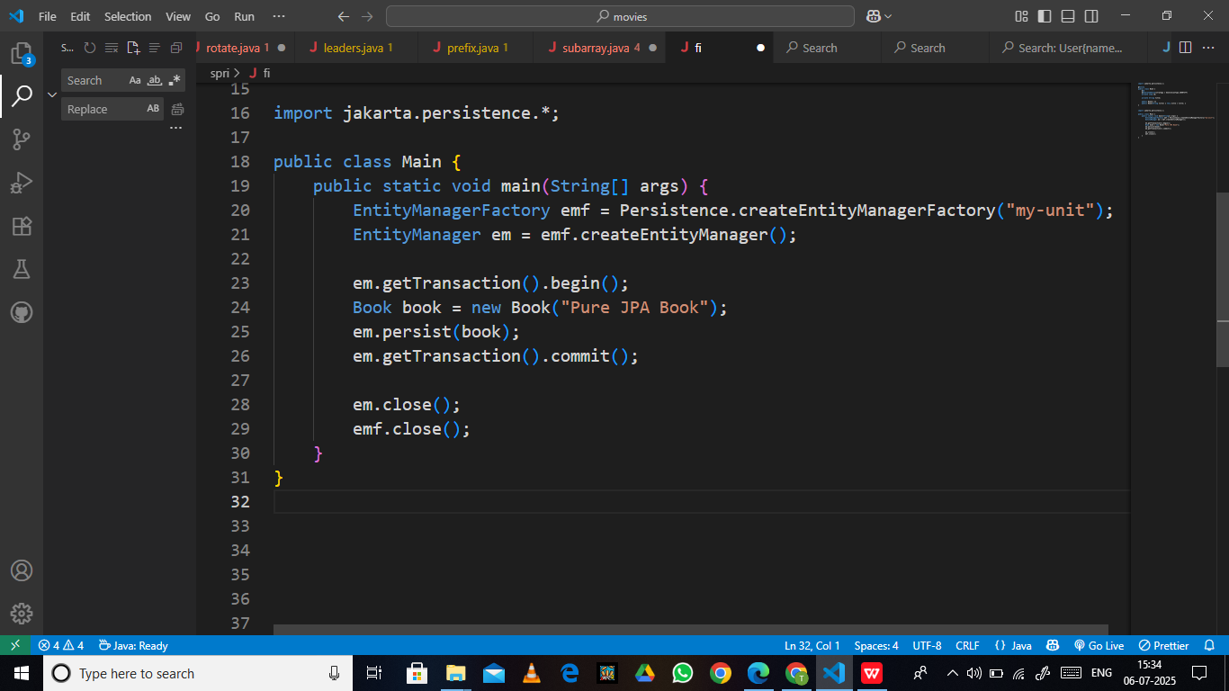

Persistence.xml

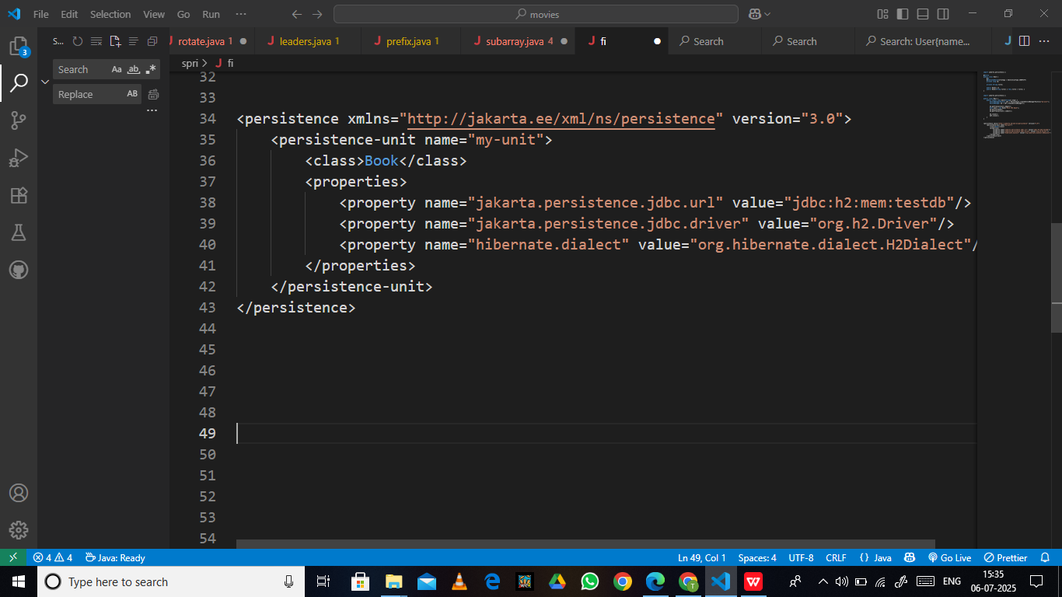

1. Hibernate

Book.java

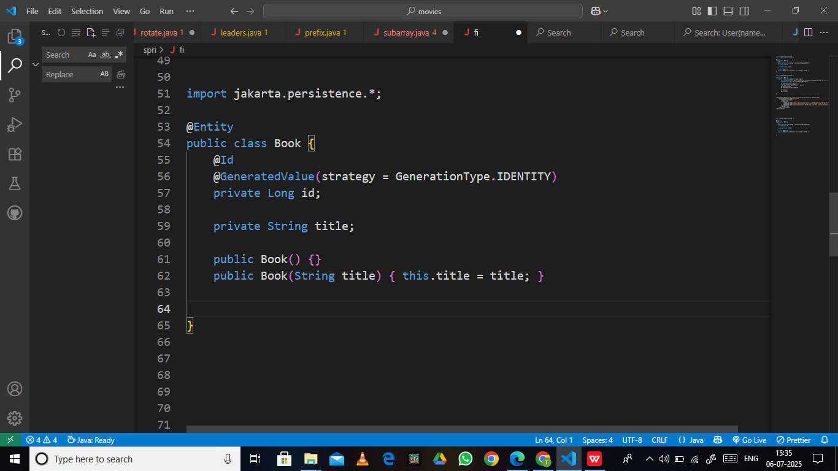

main.java

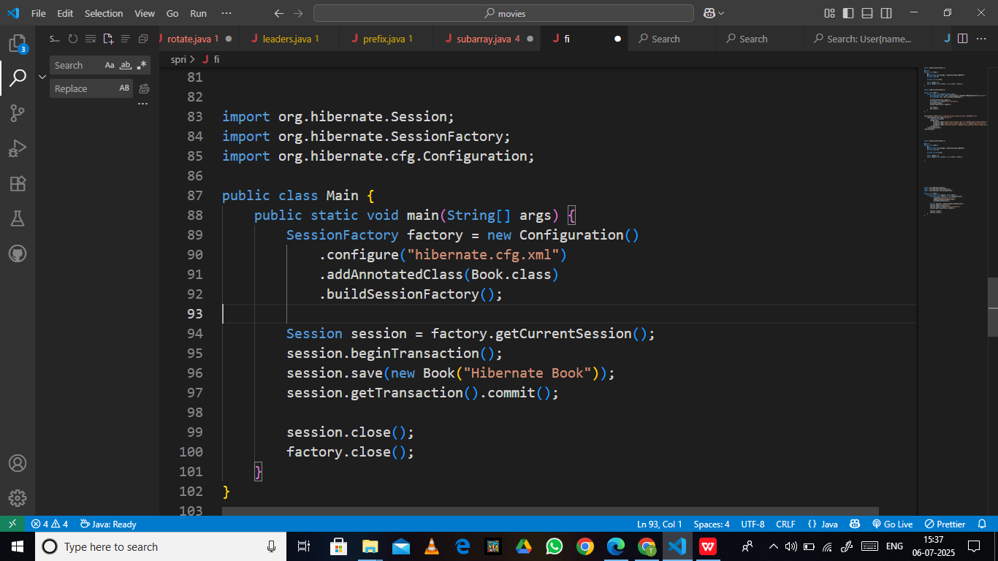

Hibernate.cfg.xml

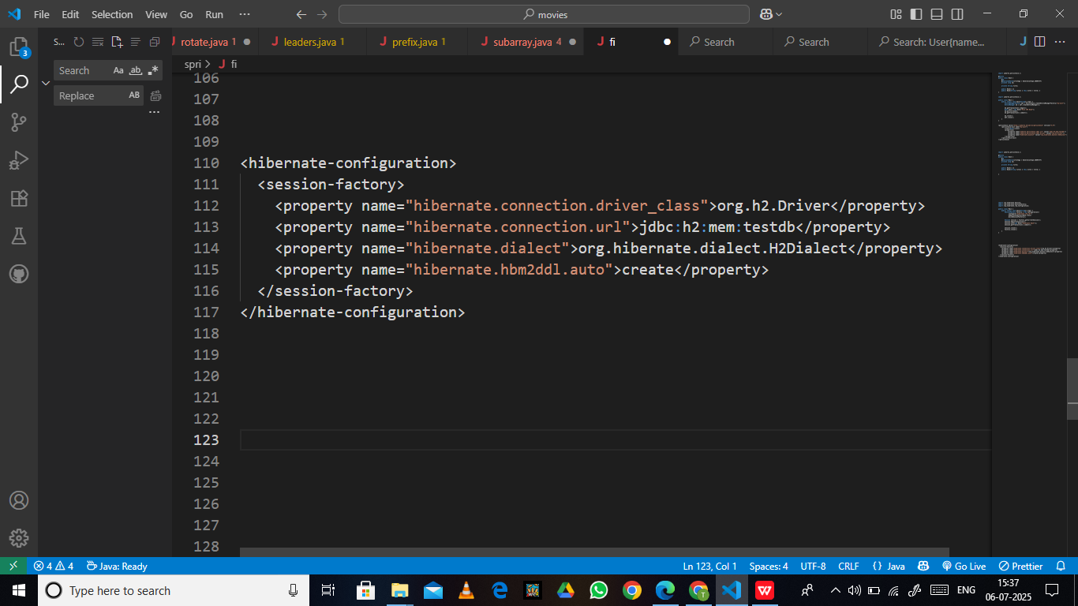

1. Spring Data JPA

**Spring Data JPA** is part of the **Spring ecosystem**.  
It builds on **JPA** and **Hibernate**, making database access.

· **Simpler**

· **Faster to develop**

· **Less boilerplate code**

Book.java

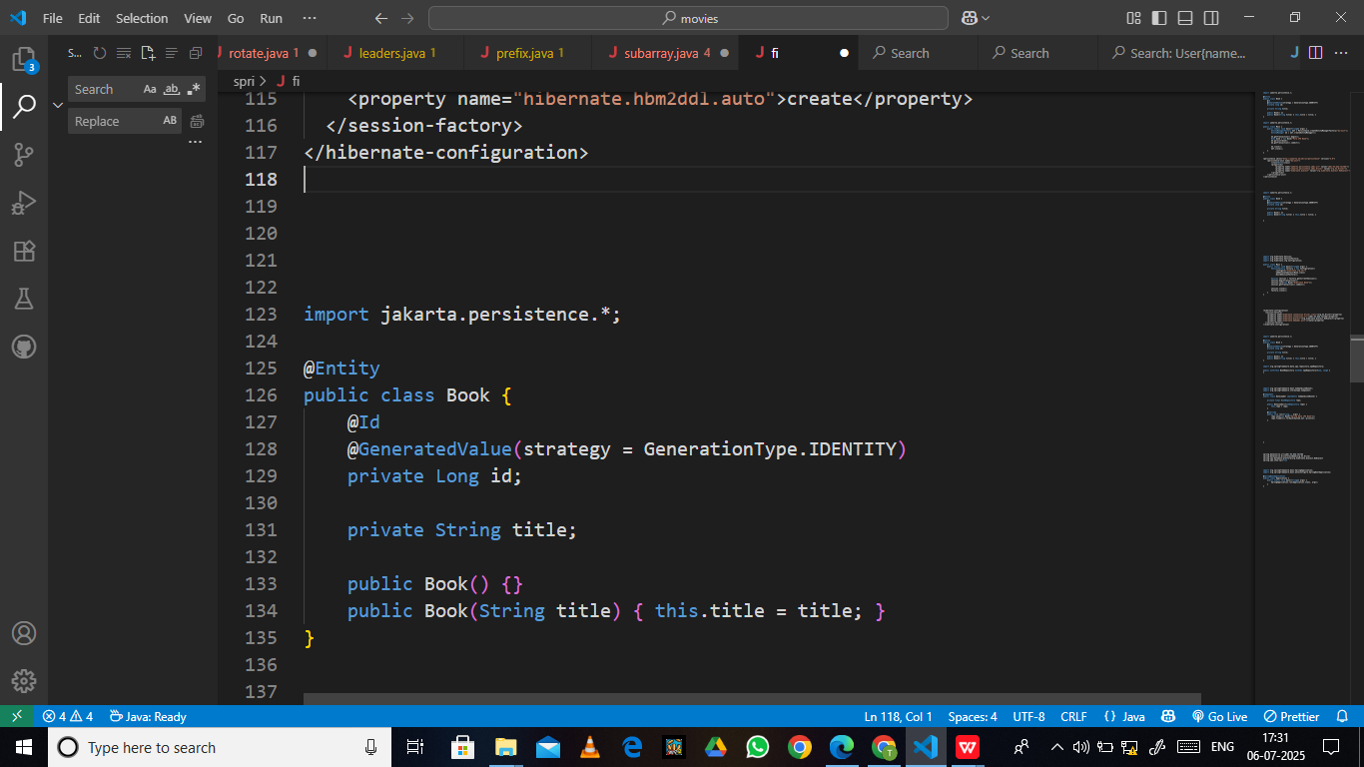

bookRepository.java

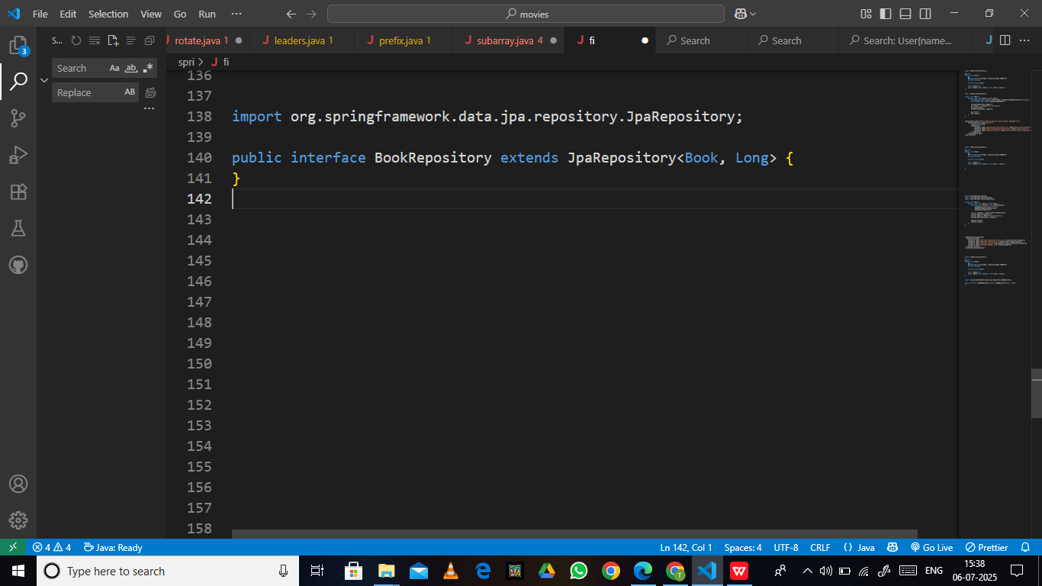

dataLoader.java

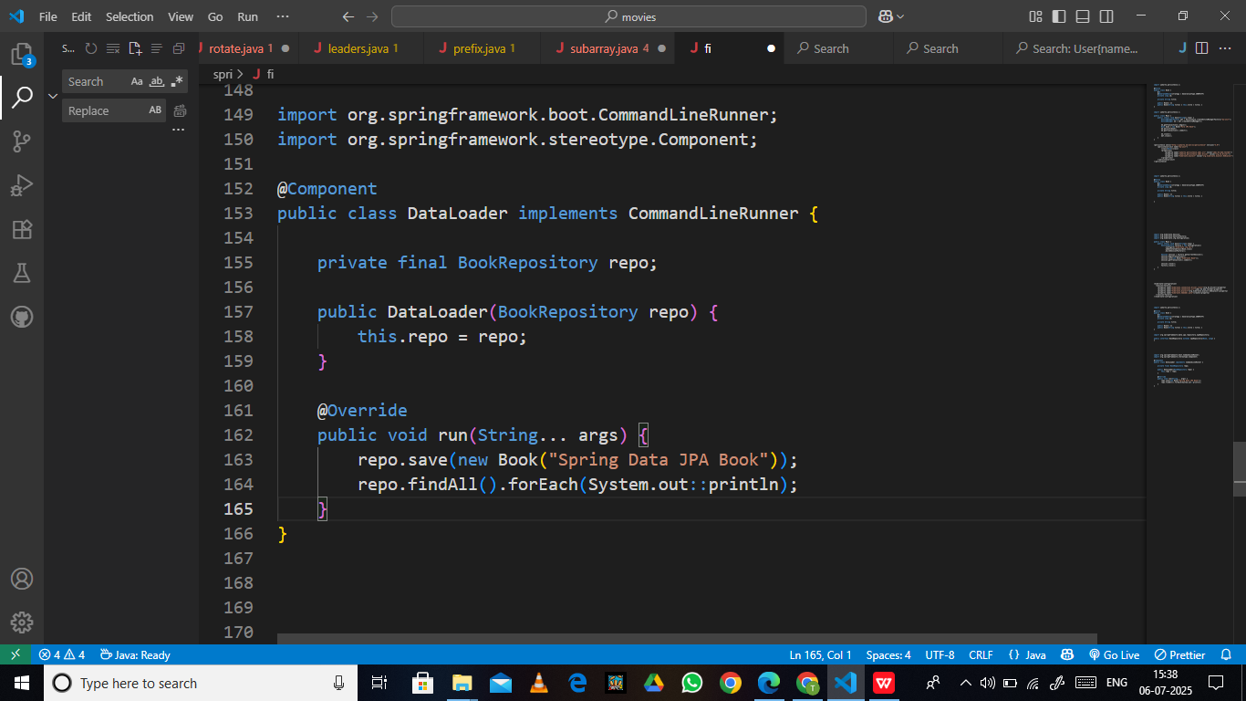

Application.properties

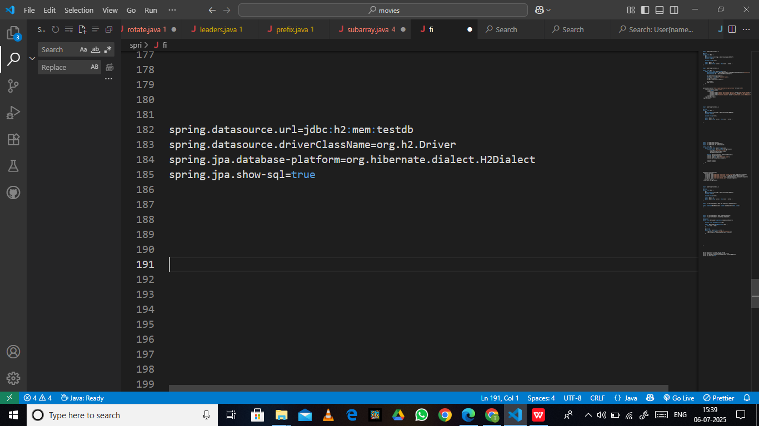

Application.java

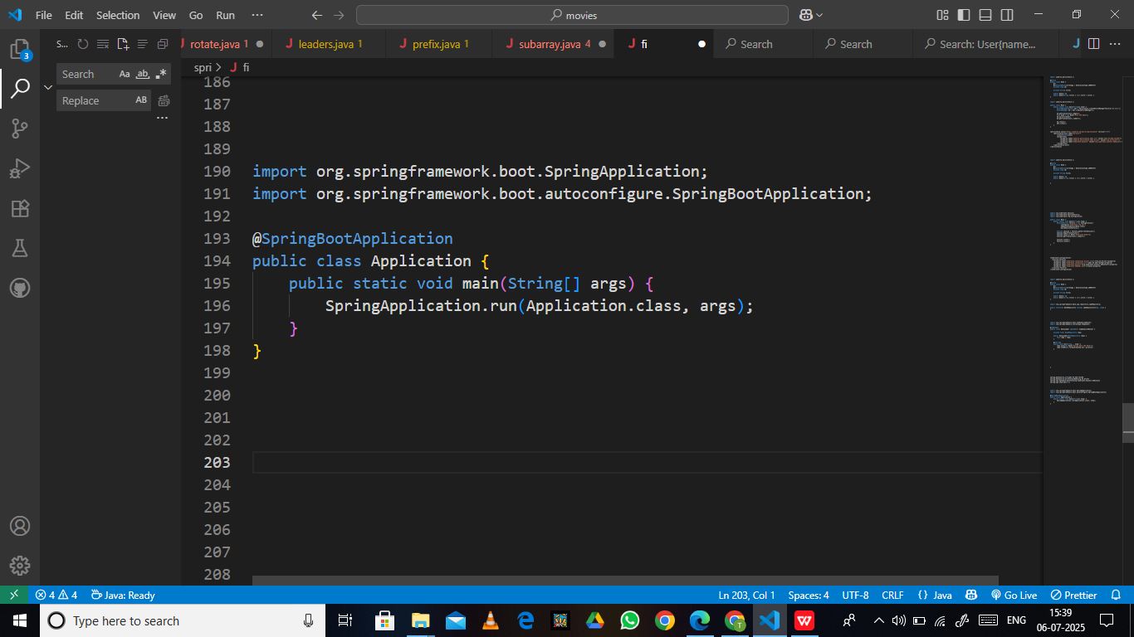

Difference between JPA, Hibernate, Spring Data JPA.

| **Feature** | **JPA** | **Hibernate** | **Spring Data JPA** |
| --- | --- | --- | --- |
| **Type** | Specification (API) | Implementation of JPA | Abstraction over JPA + Hibernate |
| **Who provides it?** | Jakarta EE (previously Oracle) | Hibernate ORM project | Spring Framework |
| **Boilerplate Code** | High | Medium | Very Low |
| **Config Required** | persistence.xml | hibernate.cfg.xml | Auto-config via Spring Boot |
| **Save object** | em.persist() | session.save() | repo.save() |
| **Implementation needed** | Yes (e.g., Hibernate) | No (it's an implementation) | Uses JPA + Hibernate internally |
| **Session/EntityManager** | EntityManager | Session (Hibernate-specific) | Hidden |
| **Query options** | JPQL, Criteria API | JPQL, HQL, Criteria | JPQL + Derived Queries |
| **Ease of use** | Low | Medium | High |
| **Integration** | With frameworks manually | With frameworks manually | Seamless with Spring Boot |
| **Learning curve** | Steep | Medium | Easy (abstracts away complexity) |