FitBuddy AI
Project Report

1. Brainstorming & Ideation Phase
Idea: FitBuddy AI is a fitness app that uses AI to make workout plans, track progress, and give coaching tips.
Main Point: It joins fitness tracking with an AI coach. The AI changes the plan based on the user's goal and progress.
Who Will Use It: People who want to get fit, beginners, gym users, and people who work out at home.
What Makes It Special: AI-made workout and diet plans, feedback on exercise form, progress tracking, and an AI chat coach.

Feature Ideas
- AI makes workout plans (for weight loss, muscle gain, or stamina)
- AI gives food/diet tips
- Tracks progress and shows simple reports
- Chat with an AI coach for help and motivation
- Checks exercise form using camera (future plan)
- Connects with fitness watches/bands (steps, heart rate, sleep)

2. Requirement Analysis Phase

What the App Must Do
- Let users sign up, log in, and add their profile (age, weight, goal, health notes)
- Create AI workout plans
- Give AI diet tips
- Show progress and reports
- Let users chat with the AI coach
- Connect with fitness devices (steps, heart rate, etc.)
- Send workout reminders

How the App Must Perform
- Work well even with many users at once
- Keep health data safe and private (secure login)
- Give fast replies from the AI
- Stay online and working almost all the time (99.9%)
Tools We May Use: Node.js/Python, PostgreSQL/MongoDB, OpenAI/Claude AI, Redis, Docker, Google Fit/Apple Health.

3. Project Design Phase
App Structure: Made of small parts (services) — User part, AI Coach part, Plan part, Report part, Notification part.
Database: Stores Users, Workout Plans, Diet Plans, Progress Logs, Chat History, Device Data.
API Design: Simple web links (endpoints) with version numbers, like /api/v1/...
AI Design: A layer that sends user info to the AI and gets back workout plans or chat replies.
Security: Safe login (OAuth2/JWT), data is locked/encrypted, only the right people can see certain data.
Diagrams Needed: App structure diagram, database diagram, and Data Flow Diagram (DFD).

Data Flow Diagram (DFD) — Level 0 (Simple Overview)
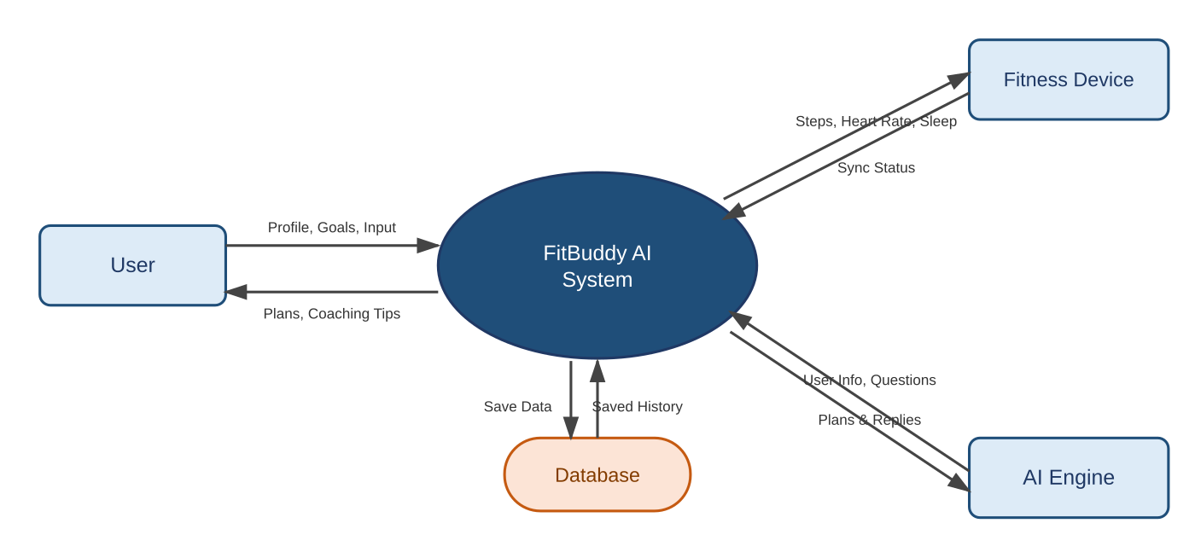
Figure 1: Level 0 DFD — how data moves between the User, the FitBuddy AI System, the Fitness Device, the AI Engine, and the Database.

Data Flow Diagram (DFD) — Level 1 (More Detail)
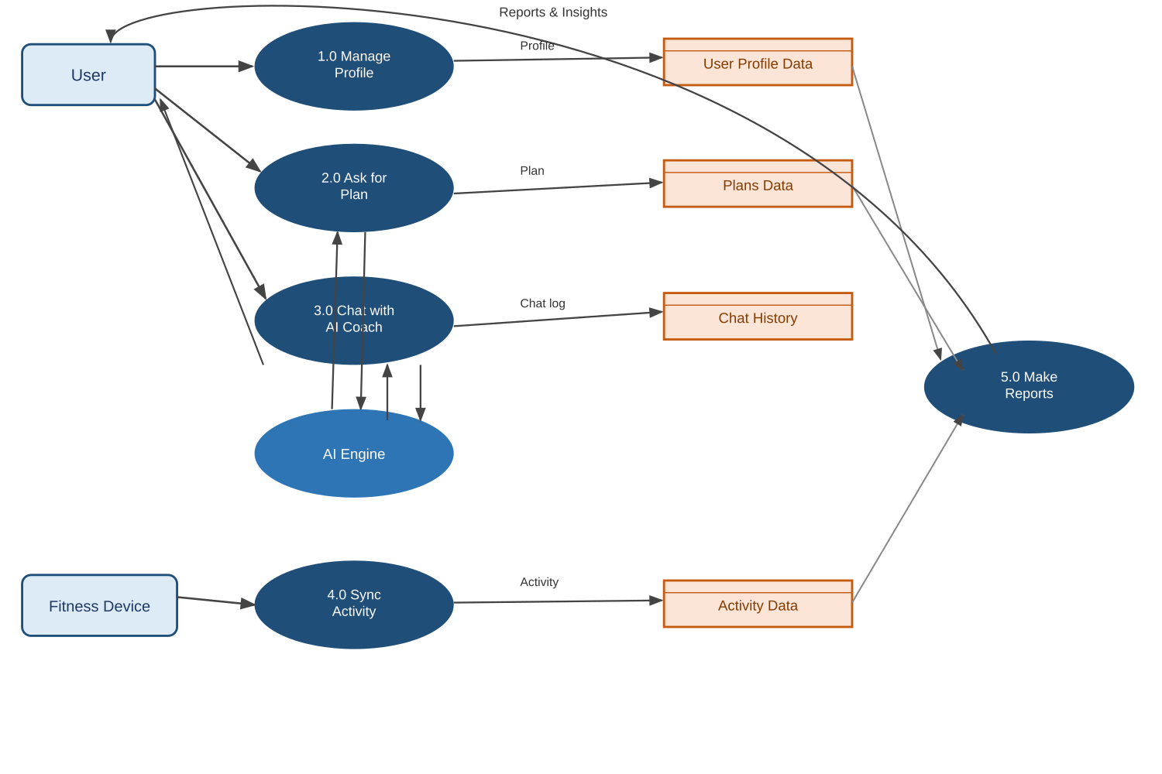
Figure 2: Level 1 DFD — breaks the system into 5 processes and shows how data flows between them and the data stores.

4. Project Planning Phase
Team: Backend Developer, AI Developer, App/Frontend Developer, DevOps, Tester, Writer.

Time Plan (Example)
Possible Problems: AI cost/limits, device connection issues, keeping health data safe.
Tools to Track Work: Jira/Trello, GitHub, CI/CD (auto build & test tools).

5. Project Development Phase
- Set up the project files and auto-build tools.
- Build login and profile pages/APIs.
- Add AI for workout plans, diet tips, and chat coaching.
- Connect fitness devices to send data.
- Build progress tracking and reports.
- Save AI answers to make the app faster and cheaper to run.
- Review code and improve it step by step.

6. Project Testing Phase
Unit Testing: Check each small part works correctly.
Integration Testing: Check that user data, AI, and device data work together.
Load Testing: Check the app works well when many people use it at once.
Accuracy Testing: Check AI plans follow good fitness/diet rules.
Security Testing: Check logins are safe and data is protected.
User Testing (UAT): Let real users try the app and give feedback.

7. Project Documentation Phase
API Docs: Write clear notes for every API (Swagger/OpenAPI).
Technical Docs: Explain app structure, diagrams, and setup steps.
User Guide: Show users how to set goals, use the AI coach, and connect devices.
Change Log: Keep a list of updates and versions.

8. Project Demonstration Phase
- Show a live or recorded demo of the app's main features.
- Show how the AI makes plans and chats with the user.
- Show the device sync and progress reports.
- Share test results and how well the app performs.
- Take feedback and questions for future updates.
This is a short and simple overview. Each part can be explained in more detail later.

