THECHAISHOP@CO
Salesforce Application Demonstration Document
Prepared from the provided demonstration video

Application Platform | Salesforce Developer Edition
Application Name | TheChaiShop&Co
Main Areas Demonstrated | Customer Accounts, Employer Accounts, Enterprise Accounts, Email Template, Flow Builder and Dashboard
Document Purpose | To describe the major screens and functionality demonstrated in the video

Table of Contents
1. Introduction
2. Application Overview
3. Customer Accounts
4. Employer Accounts
5. Enterprise Accounts
6. Emergency Alert Email Template
7. Flow Builder
8. Dashboard and Sales View
9. Overall Workflow
10. Conclusion

1. Introduction
TheChaiShop@Co is demonstrated as a Salesforce-based business application. The video shows how different business records and Salesforce features can be organized in one application. The demonstration includes customer information, employee information, enterprise information, email templates, automation-related configuration, and a dashboard for viewing sales information.

2. Application Overview
The application is accessed through Salesforce Developer Edition. The navigation bar provides separate sections for Employer Account, Customer Accounts, Enterprise Accounts, Reports, Dashboards and Chatter. This structure allows users to move between operational records and analytical information from a single interface.
Module | Purpose
Customer Accounts | Stores and displays customer account records.
Employer Account | Stores employee-related details such as gender, phone, email, date of birth, designation and salary.
Enterprise Accounts | Maintains enterprise/business information and related customer or sales details.
Email Template | Provides a reusable emergency alert email message.
Flow Builder | Provides the Salesforce automation workspace used in the application.
Dashboards | Displays summarized business information such as customer versus enterprise sales.

3. Customer Accounts
The Customer Accounts section displays a list of customer records. In the video, the Recently Viewed list contains a customer record named 'Archana tea customer'. The page also provides actions such as New, Import, Change Owner and Assign Label. These options support basic customer-record management.
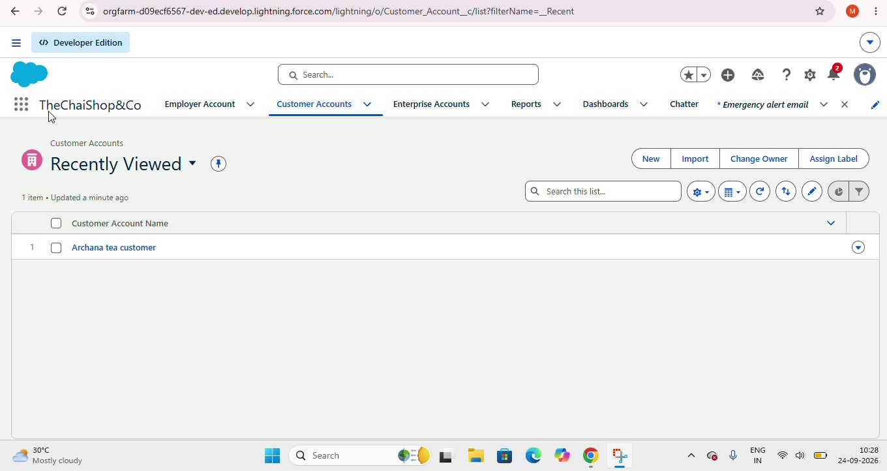
Figure 1: Customer Accounts – Recently Viewed customer record

4. Employer Accounts
The Employer Account page displays an employee record named 'Demo employee'. The visible details include gender, phone number, email ID, date of birth, Aadhaar number, PAN details, designation and salary. The record page also provides actions for creating a new contact, editing the record and creating a new opportunity.
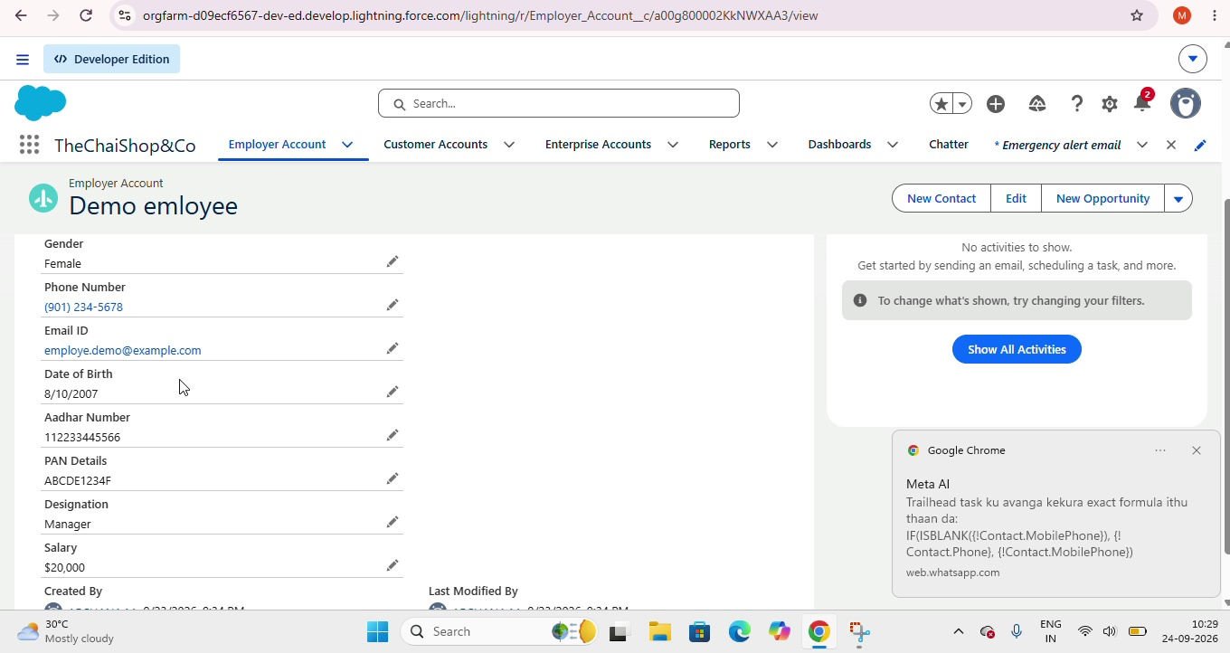
Figure 2: Employer Account – Employee details

5. Enterprise Accounts
The Enterprise Accounts section contains enterprise-level records. The video shows a record named 'Demo enterprise'. Its details include enterprise account name, enterprise name, owner, phone number, email ID, address and type of items. The page also includes Related and Details tabs and an Activity panel.
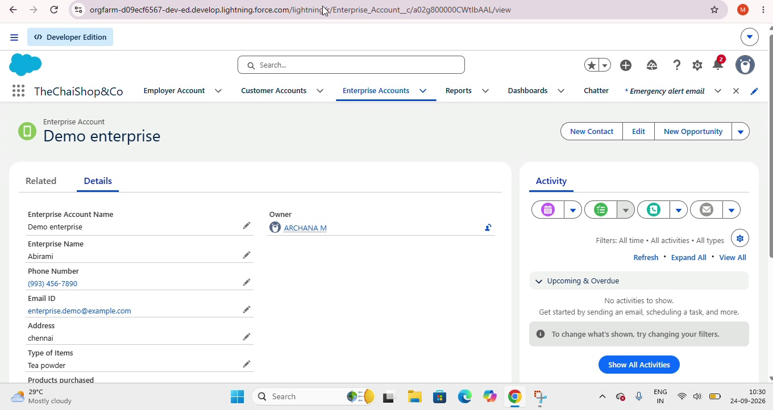
Figure 3: Enterprise Account – Details and Activity

6. Emergency Alert Email Template
The video also demonstrates an email template named 'Emergency alert email'. The template contains information such as the template name, description, folder, subject and HTML message content. The subject shown is 'emergency alert notification'. The message begins with a user greeting and informs the recipient that an emergency situation has been detected. The template can be edited, cloned or deleted.
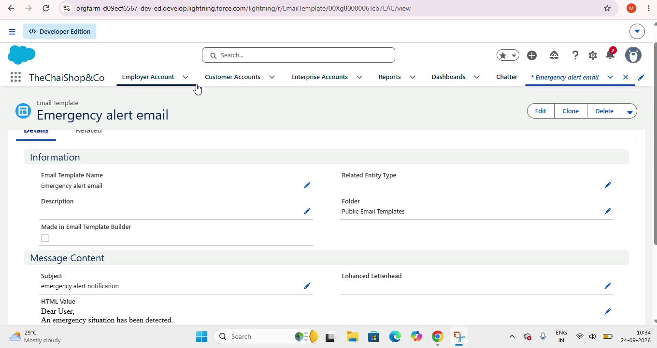
Figure 4: Emergency Alert Email Template

7. Flow Builder
During the demonstration, Salesforce Flow Builder is opened as part of the application configuration. Flow Builder is used in Salesforce to design automated business processes by connecting actions and logic. In this application, it forms part of the automation/configuration area shown in the video.

8. Dashboard and Sales View
The Dashboard section contains a dashboard named 'Customer Vs Enterprise Sales'. The dashboard is shown in the Recent dashboards list and is stored under Private Dashboards. This provides a centralized place for viewing business information and comparing sales-related data between customer and enterprise categories.
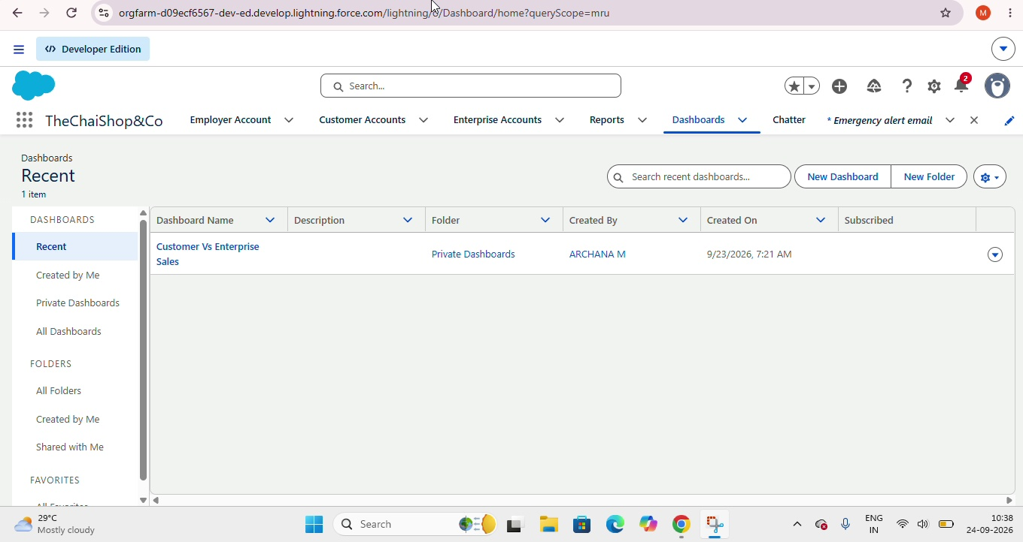
Figure 5: Dashboard – Customer Vs Enterprise Sales

9. Overall Workflow
The demonstrated application can be understood as a connected Salesforce workflow:
- Open the TheChaiShop&Co Salesforce application.
- Manage customer records through Customer Accounts.
- Maintain employee information through Employer Account.
- Maintain business-level information through Enterprise Accounts.
- Create and manage reusable email templates for notifications.
- Use Salesforce automation tools such as Flow Builder.
- Use dashboards to view summarized business and sales information.

10. Conclusion
The video demonstrates a structured Salesforce application that combines record management, communication templates, automation configuration and dashboard-based reporting. The use of separate account sections makes business data easier to organize, while the email template and Flow Builder support automation-oriented operations. The dashboard provides a summarized view of sales information for business analysis.

