**Data Science:**

Central Tendency

The given Placement.csv contains the students details with Gender, salary and all marks.

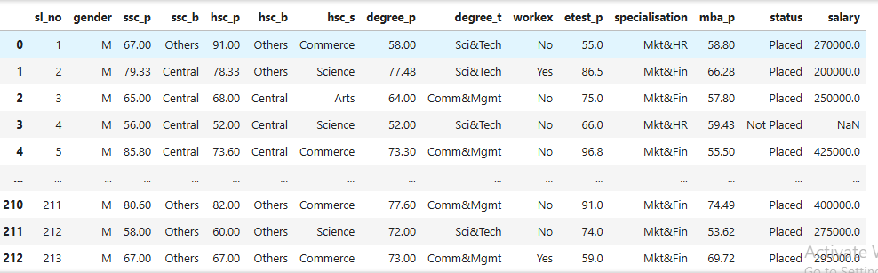

**Given**:

List of Students who had passed already earning Salary.

**Expected**:

With the existing Mark and salary details, User has to analyze the expected salary for the future.

Based on this analysis, students can able to set expectation for their salary.

Below output gives us the Mean, Median and Mode for all Students marks and Salary. This will helps the user to analyze the salary range.

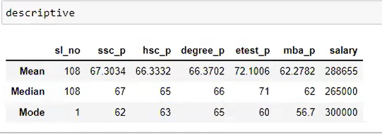

1. Students who had studied in SSC_P got average mark of 67.30 and the 67-mark obtained by 62 Students.
2. Students who had studied in HSC_P got average mark of 66.33 and the 65-mark obtained by 63 Students.
3. Students who had studied in degree_P got average mark of 66.37 and the 66-mark obtained by 65 Students.
4. Students who had studied in etest_P got average mark of 72.1 and the 71-mark obtained by 60 Students.
5. Students who had studied in mba_P got average mark of 62.2 and the 62-mark obtained by 56 Students.
6. Based on this analysis, if student obtains the above marks in each exam will get 265000 as salary