# 

# **Department of Computer Science and Engineering Islamic University of Technology (IUT)** A subsidiary organ of OIC

# **Documentation Report**

# Software Project Lab-II

|  |  |
| --- | --- |
| **Submitted By**  **Group-13**  **Shadman Habib (200042117)**  **Tamim Afnan (200042148)**  **Humaira Ibnat (200042164)** | **Submitted To**  **Rafid Haque**  Lecturer  Department of Computer Science and  Engineering  Islamic University of Technology |

**Date Of Submission: 22/05/2023**

**Table of Content**

1. **Introduction**
2. **Purpose**
3. **Intended Audience**
4. **Conclusion**
5. **Inception**

* **Identifying Stakeholders**
* **Identifying Business value**
* **Existing Solution**
* **Defying the Problem**
* **Feasibility**

1. **Elicitation**

**a. A bounded statement of scope for the system or product.**

**b. A list of customers, users, and other stakeholders who**

**participated in the requirements-gathering phase**

**c. A description of the system’s technical environment.**

**d. Quality Function Deployment**

**i. In Users (Travelers) Perspective**

**ii. In Admin’s Perspective**

1. **Usage Scenario**
2. **Travelers**
3. **Admin**

1. **Use-Case Modelling**

**a. Login- Sign Up with Authentication**

**b. Reset Password**

**c. Search Hotel**

**d. Reserve Hotel**

**e. Cancel Booking**

**f. Add Hotel (Admin)**

**g. Add Room (Admin)**

**h. Register**

**i. Update Hotels (Admin)**

**j. Delete Hotel (Admin)**

1. **Sequence Diagram**

**10. Conclusion**

**Introduction**

The travel industry has witnessed significant transformations in recent years, primarily due to the proliferation of digital platforms. These platforms have revolutionized the way people book accommodations and have made it easier for travelers to discover and reserve their ideal stays. However, there remains an untapped opportunity for a web application that specifically caters to the diverse needs of travelers worldwide. This is where our web app, Allogio steps in.

Allogio is a comprehensive hotel booking platform that empowers travelers to find and book their perfect accommodations seamlessly. This application aims to bridge the gap in the market by offering a user-friendly interface and a vast selection of accommodations to suit every traveler's preferences. Whether you're seeking a luxury hotel, a cozy bed and breakfast, or a budget-friendly hotel, Allogio is here to make your travel planning experience efficient, convenient, and tailored to your specific needs.

**Purpose**

The purpose of this document is to provide a brief overview of Allogio’s Software  
Requirement Specification. It includes functional, non-functional, and supporting  
requirements that will establish a baseline for developing the system. The main  
objective of the SRS is to serve as an official method of communication between users, developers, and stakeholders. The SRS will continue to develop over time as users and developers collaborate to validate, clarify, and expand its contents.

**Intended Audience**

The SRS report is created for multiple audiences and serves different purposes. After  
discussing with all the stakeholders involved, this SRS provides a clear set of  
guidelines and documentation for:

● The users and admins who will refer to this SRS to ensure that the product  
developed by the developer team meets their requirements.

● The project managers of the developer team who will use this SRS to plan  
project milestones and delivery dates, and monitor the development progress.

● The designers who will use this SRS to create the system's design and refer  
back to it throughout the design process to ensure it meets the customer's  
needs.

● The developers who will use this SRS to develop the system's functionality and  
link the requirements defined in this SRS to the software they create.

● The testers who will use this SRS to derive test plans and test cases for each  
requirement and ensure that the software developed meets all the documented  
requirements. The idea is to essentially carry out unit tests and acceptance  
tests of the different components.

● The testers who will run their tests on the completed portions of the software  
to ensure that they meet the requirements documented in this SRS, and again  
on the entire system when it is complete to verify that all the requirements  
have been fulfilled. The idea is to carry out integration tests and acceptance  
tests of the different QFDs.

**Conclusion**

We were able to systematically identify stakeholders and requirements through our

study. We were able to target the users who will use our product particularly thanks

to this procedure. The generated document will help all parties engaged in the

software's development by allowing convenient usage and providing a clear

knowledge of the software's purpose. Developers and testers will have a better

awareness of their duties and development will proceed more smoothly with properly

established guidelines. The ongoing evolution and improvement of the software will

be facilitated by effective communication between all stakeholders and developers.

**Inception**

**Identifying stakeholders**

**● Who else do you think I should talk to?**

**Ans:** You can talk to our business analyst first. Then we will head to talk to our developer.

● **Who will use the solution?**

**Ans:** The intended audience for the web app "Allogio" includes a wide range of travelers, both leisure and business-oriented, who seek booking accommodations for their trips.

**Identifying Business value**

**● What will be the economic benefit of a successful solution?**

The business value of the Allogio app lies in its ability to provide a centralized platform for booking accommodations, offering convenience, efficiency, and an extensive selection of options to travelers. By consolidating various accommodations into one user-friendly application, Allogio streamlines the booking process, saving users time and effort. This can lead to increased customer satisfaction and loyalty.

The economic benefit of a successful solution like Allogio is multifaceted. Firstly, it can drive revenue through commissions or fees charged to accommodation providers for facilitating bookings. As the user base grows, the app can attract more accommodations to join the platform, expanding its offerings and attracting a larger customer base.

Secondly, a successful solution like Allogio can boost the tourism and hospitality industry by encouraging more people to travel and explore different destinations. By making it easier for travelers to find and book accommodations, the app contributes to the overall growth of the tourism sector.

Additionally, the app can generate economic benefits by fostering competition among accommodation providers, leading to better pricing and improved services. This can benefit both travelers and providers, creating a win-win situation.

Furthermore, a successful solution like Allogio can have a positive impact on local businesses, such as restaurants, shops, and attractions, as it promotes travel and brings more tourists to different regions. This increased footfall can lead to higher revenue for these businesses, thus contributing to the local economy.

Overall, the economic benefits of a successful solution like Allogio include increased revenue streams, growth in the tourism industry, improved competitiveness, and positive impacts on local businesses and economies.

**Existing Solution**

**● Is there another source for the solution that you need?**

**Ans:** Yes, there is a platform named ‘Booking.com’ which is a close solution to our project. But it allows all types of hotles from different countries on their platform. But we are only based in Bangladesh and our platform will be only for Bangladeshi tourist spot based platform.

**Defining the Problem**

**● What problem are you solving in the project you have chosen?**

**Ans:** For our project we are going to make a hotel booking or rental platform only

based on the Bangladesh. It will solve the problems of getting in touch with bangla

music by providing the following features:

· User-friendly Interface: The app will have an intuitive and easy-to-navigate interface, ensuring a seamless user experience.

· Accommodation Search: Users can search for accommodations based on their destination, travel dates, number of guests, and specific preferences such as price range, amenities, and accommodation type.

· Detailed Accommodation Listings: Each accommodation listing will provide detailed information about the property, including photos, descriptions, amenities, available room types, and guest reviews.

· Filters and Sorting Options: Users can apply filters to refine their search results based on criteria such as price, rating, distance, and specific amenities they require. Sorting options will allow users to arrange the search results based on their preferences.

· Booking Management: The app will enable users to manage their bookings, view upcoming and past reservations, modify or cancel bookings when needed, and receive confirmation details.

· Reviews and Ratings: Users can read and leave reviews and ratings for accommodations they have booked, providing valuable feedback for other travelers.

· Real-time Availability and Instant Booking: The app will display real-time availability of accommodations, allowing users to book instantly and receive immediate confirmation.

· Undo Reservation and Instant Update: The app will display real-time availability of accommodations, allowing users to book instantly and receive immediate confirmation.

**Feasibility**

**● Is it possible to solve the problem?**

**Ans**:.Yes, it is feasible and the reason is: There are various frameworks, api’s and technologies that have already been implemented to deal with similar features thus slightly simplifying the process of implementation.

**Elicitation**

**● A bounded statement of scope for the system or product.**

**Ans**: The scope of the platform includes a wide range of travelers, both leisure and business-oriented, who are seeking to book accommodations for their trips, and

advertiser. Anyone who is interested in travelling can use this platform to search and book a spot in the hotel during his travel period.

Our platform will support only Bangladeshi tourist spot and nearby hotels as our goal is to unleash Bangladeshi beauty to the world of tourism and to the people who found of it.

**● A list of customers, users, and other stakeholders who participated in the**

**requirements-gathering phase.**

**Ans:**

1. Customer/User : Travelers

2. Developers

3. Admin

**● A description of the system’s technical environment.**

**Ans:**

● Web based application using REACT Native, Express, Node and MongoDB

● MongoDB database would allow more easy authentication provided via google account. for the users to widen the user base to allow more easy access without unnecessary complications from the user’s end.

● Node also has various testing options to effectively perform integration and

unit testing.

**Quality Function Deployment**

**In Users (Travelers) Perspective,**

· Login and register to their account

· Search for the desired hotel nearby the destination

· Sort by cost of the room hotel.

· Book a room in the hotel in real time for a certain amount of people.

· Undo reservation if needed

**In Admin’s Perspective,**

· Add a new hotel to the list after consulting the hotel manager & proper inquiry

· Update information of the already existing solution list

· Delete any hotel info if necessary.

**Usage Scenario**

The overall system would be used for travel enthusiastic people to look for their budget friendly place. Here the end-users are

· Travelers

· Admin

**Traveles:**

A traveler is a user of this web application who can register here and create his account with his email account, where he will get an OTP via an email. This supports the authentication of the user to ensure the security as well as email validity.   
After the registration process, the user can login to his account with his validate email and password.   
The user can search for hotels by name. Or he can search for tourist spots, where the available hotels will be shown to him.  
User can sort and filter the hotel rooms according to the cost which will help them to find the suitable and budget friendly hotel room for them.   
The user can book their suitable hotel according to their choice, if it is available in real time as well as they can cancel the reservation any time they want.

**Admin:**

An admin is an important character for this web based application according to our project. If any hotel company owner can add his hotels to our website, our admin can help him to do so by doing proper validation. As well as, he can update and remove data of an already existing hotel.

**Use-Case Diagram**

**Use case: Login- SignUp**

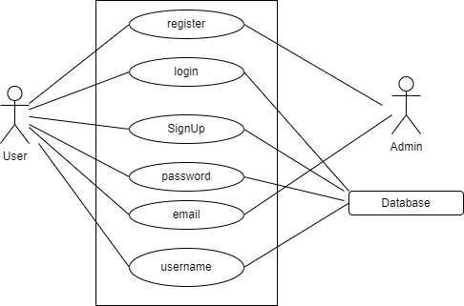

**Use-Case: Reset Password**

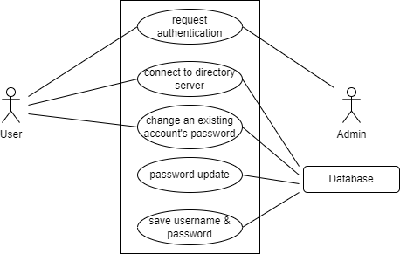

**Use-Case: Search Hotel**

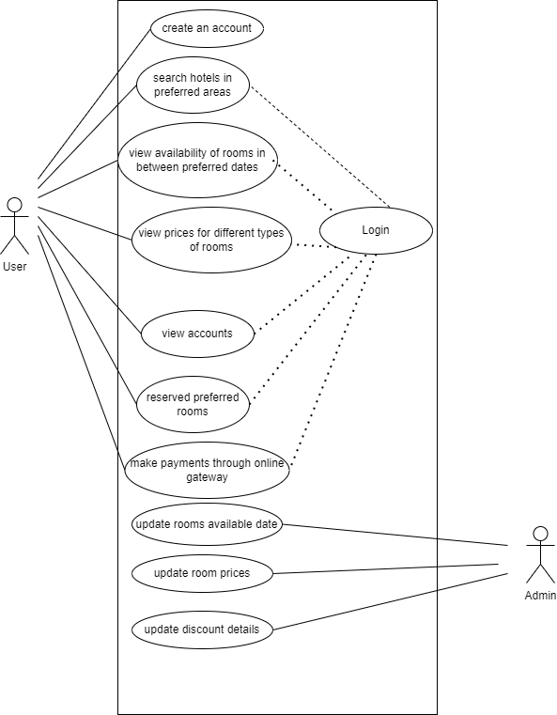

**Use-Case: Reserve Hotel**

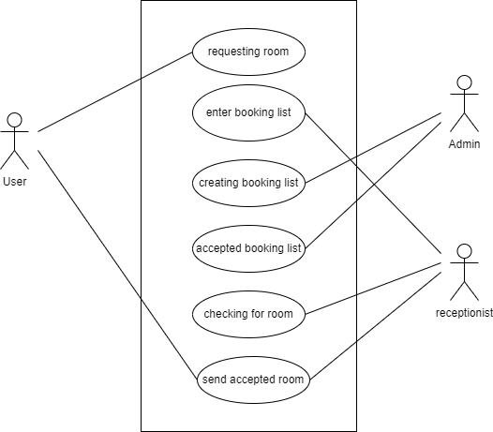

**Use-Case: Cancel Booking**

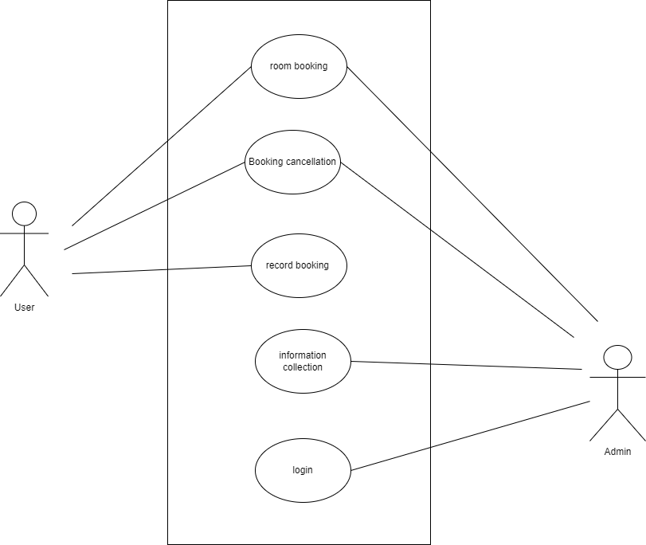

**Use-Case: Add Hotel (Admin)**

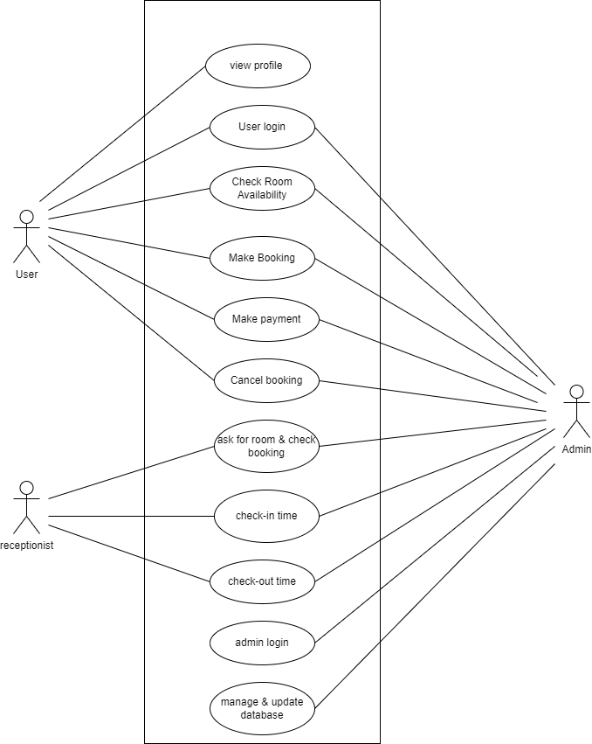

**Use-Case: Add Rooms (Admin)**

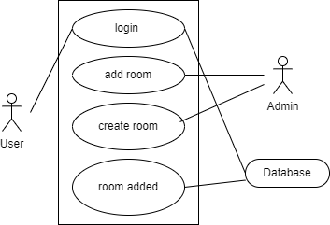

**Use-Case: Register**

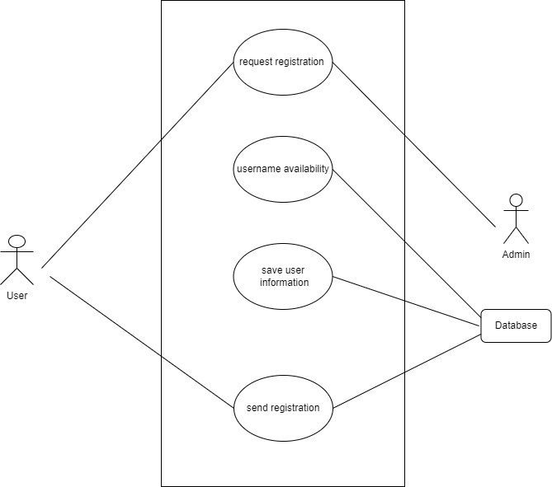

**Use-Case: Update Hotel (Admin)**

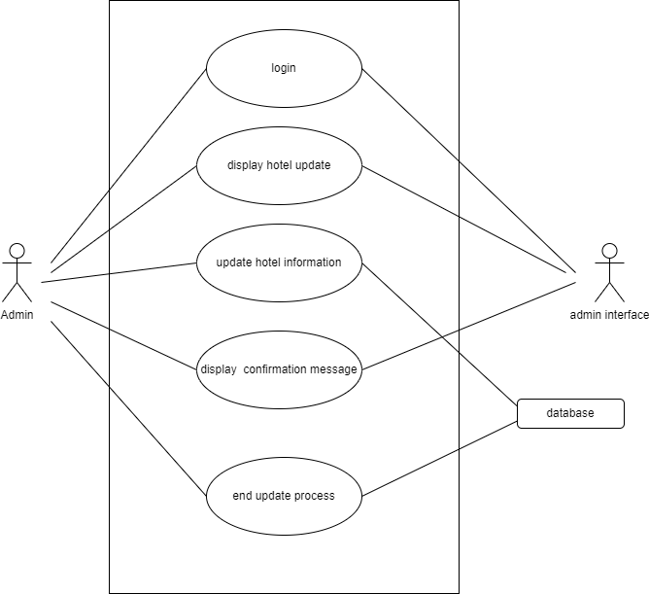

**Use-Case: Delete Hotel (Admin)**

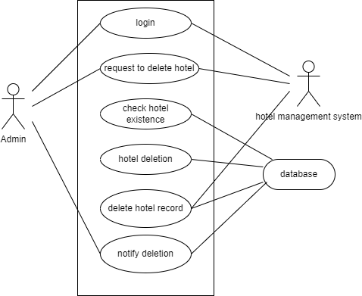

**Sequence Diagram**

**1. Login/Sign-Up with Authentication:**

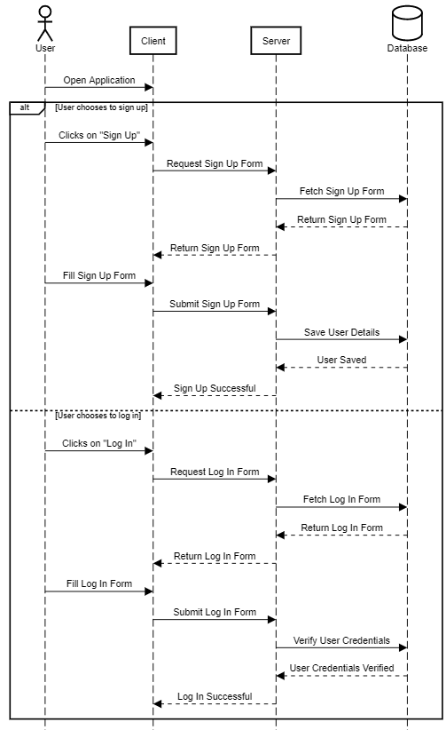

**2.Reset Forgot Password:**

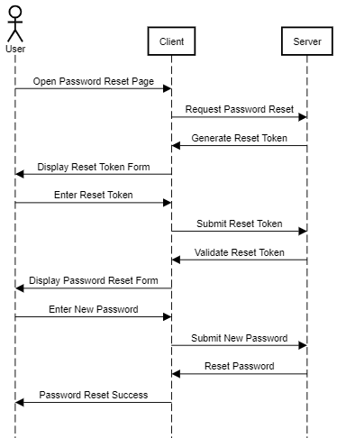

**3.Register:**

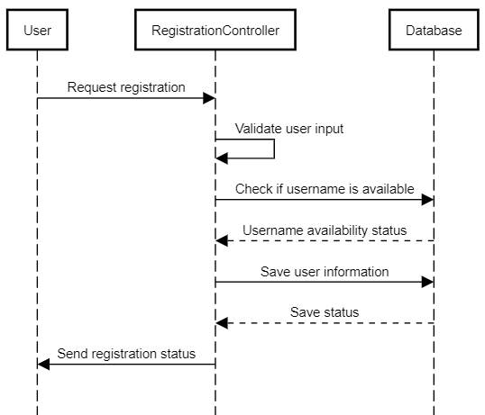

**4.Search For Hotels & List According to Option :**

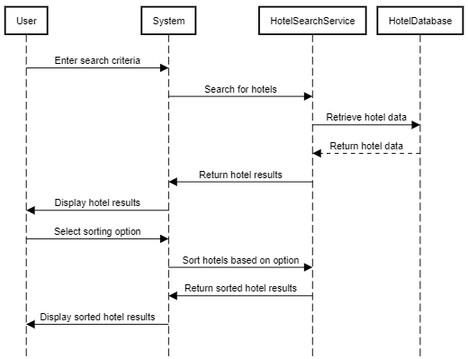

**4.Reserve a Room:**

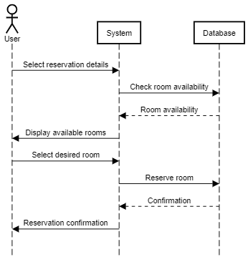

**5.Cancel Booking:**

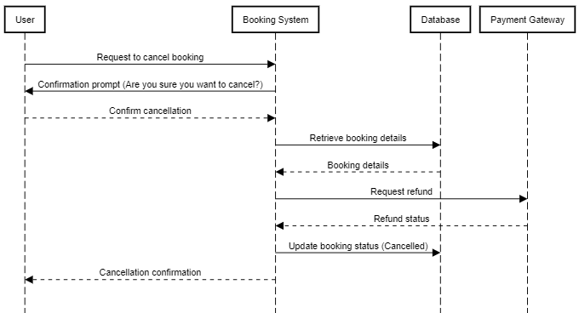

**6.Add Hotels(Admin) :**

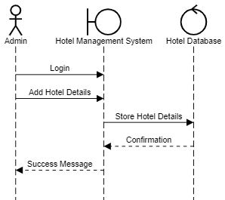

**7.Add Rooms(Admin):**

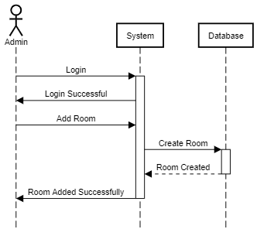

**9.Update Hotels (Admin):**

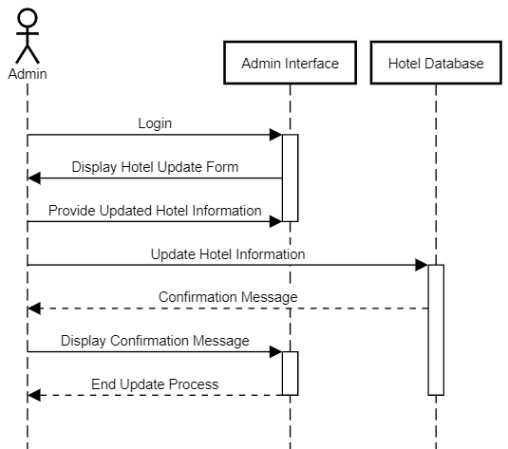

**8.Delete Hotels(Admin):**

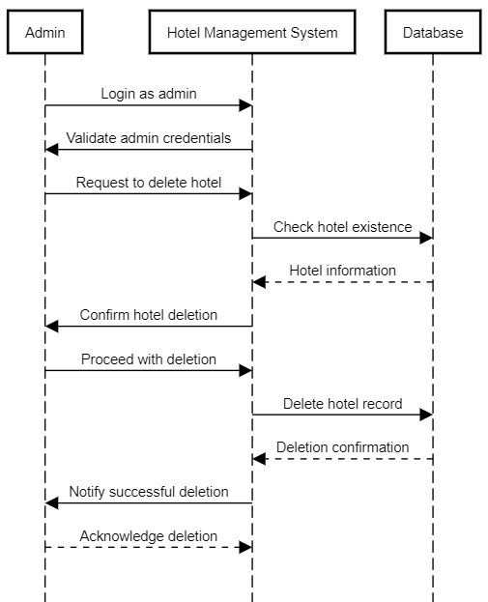

**Conclusion**

This document is intended for the academic purpose of summarizing the outcome of SWE 4402 Software Requirements and Specifications (SRS) Course with a real life project what we try to execute in our Software Project Lab II. This is a document of an existing project and most of the existing solution of this project has been implemented. Originally, the goal of this document is to teach the basic aspects of software requirement collection and documenting these requirements to be made easily readable while maintaining certain industry standards.

Throughout this project, for the skills acquired and the various experiences shared we thank our course supervisor, Rafid Haque Sir. And we produced this document as a culmination of our fourth semester’s SRS course.

**25**