\*\* Mockplus decided that it didn’t want to let me export to .jpg, so I had to snip the views and paste them into MS Word.

Start View

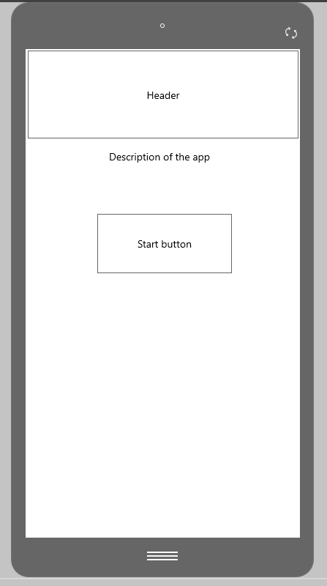

Quiz View

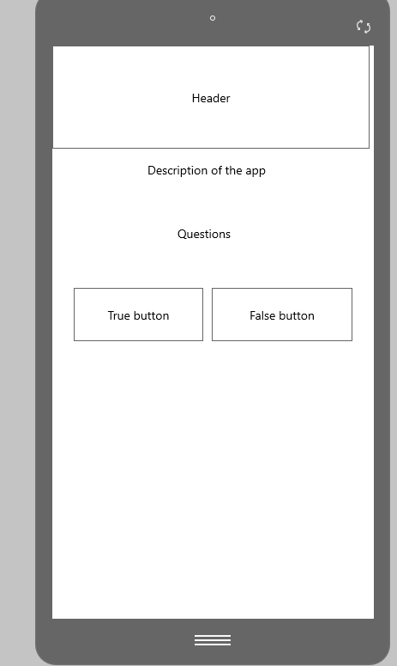

End View

